CERBERUS SYSTEM
Citation Analysis System
Project Report
submitted for the partial fulfilment of grade for the course
Data Structures and Algorithms - 3 (25CS2103E)
A.Y. 2026–2027
Submitted by
Bandla Vinay — 2520030437
Sai Sashank — 2520030454
Ganesh — 2520030252
Team Number: 20
Section: 07
Under the guidance of
Dr. S. Madhavi
Project Guide, Department of Computer Science Engineering

Hyderabad-500090, Telangana, India.

K L (Deemed to be) University
DEPARTMENT OF COMPUTER SCIENCE ENGINEERING

DECLARATION
We hereby declare that the project report entitled “CERBERUS SYSTEM – Citation Analysis System” is a bonafide record of the work carried out by Bandla Vinay (2520030437), Sai Sashank (2520030454), and Ganesh (2520030252) in partial fulfilment of the requirements of the course Data Structures and Algorithms – 3 (25CS2103E) at K L (Deemed to be) University during the academic year 2026–2027.
The work presented in this report is based on the team's implementation of a data-structures-driven citation analysis system. The core graph, hash table, traversal, matching, ranking, path-analysis, flow-analysis, persistence, reporting, and testing components were implemented as part of the project.
The report has been prepared for academic evaluation and has not been submitted in the same form to any other department, university, or institute.

Bandla Vinay — 2520030437
Sai Sashank — 2520030454
Ganesh — 2520030252

K L (Deemed to be) University
DEPARTMENT OF COMPUTER SCIENCE ENGINEERING
CERTIFICATE
This is to certify that the project report entitled “CERBERUS SYSTEM – Citation Analysis System” is a bonafide work done and submitted by Bandla Vinay (2520030437), Sai Sashank (2520030454), and Ganesh (2520030252) in partial fulfilment of the requirements for the award of the degree of Bachelor of Technology in Computer Science Engineering at K L (Deemed to be) University during the academic year 2026–2027.
The project has been developed for the course Data Structures and Algorithms – 3 (25CS2103E), Team 20, Section 07, under the guidance of Dr. S. Madhavi.

Signature of the Supervisor | Signature of the HOD | Signature of the External Examiner

ACKNOWLEDGEMENT
The successful completion of this project was made possible through the guidance, support, and encouragement received throughout its development.
We express our sincere gratitude to our project guide, Dr. S. Madhavi, for her guidance, technical direction, and continuous encouragement during the development of the CERBERUS SYSTEM. Her support helped us maintain a clear focus on implementing the data structures and algorithms from first principles.
We also thank the Department of Computer Science Engineering and the faculty members of K L (Deemed to be) University for providing the academic environment and facilities required to carry out this project.
We acknowledge the support of our teammates, classmates, friends, and family members whose cooperation contributed to the completion of the project and documentation.

Bandla Vinay — 2520030437
Sai Sashank — 2520030454
Ganesh — 2520030252

TABLE OF CONTENTS
S.No. | Contents | Page No.
1. | ABSTRACT | 6
2. | INTRODUCTION | 7
3. | LITERATURE SURVEY | 8–9
4. | PROBLEM STATEMENT AND OBJECTIVES | 10
5. | HARDWARE AND SOFTWARE REQUIREMENTS | 11
6. | IMPLEMENTATION | 12–15
7. | RESULTS & DISCUSSION | 16–17
8. | CONCLUSION & FUTURE SCOPE | 18
9. | REFERENCES | 19

Note: The Geotagged Project Evidence section in the Results & Discussion chapter is intentionally left as a placeholder for the team to complete with the required geotagged photograph.

1. ABSTRACT
CERBERUS SYSTEM is a data-structures-driven Citation Analysis System that models academic literature as a directed graph, where each research paper is represented as a vertex and each citation relationship is represented as a directed edge. The system is designed to explore citation relationships, identify influential papers, analyse citation flow, search paper metadata, generate reports, and discover useful paths through a research corpus. Unlike solutions that rely heavily on framework-provided collections and graph libraries, the core engine implements its own dynamic array, linked list, stack, queue, open-addressing hash table, graph representation, sorting, string matching, graph traversal, path analysis, and maximum-flow components. The system also provides CSV persistence and an interactive console interface. The implemented algorithms include BFS and DFS traversal, KMP, Rabin–Karp, Wagner–Fischer edit distance, merge sort, Edmonds–Karp maximum flow, recursive all-path enumeration, and Held–Karp bitmask dynamic programming for an optimal citation path. The default corpus contains 75 research papers and 91 citation edges. The project's ten automated test suites report 529 successful assertions with zero failures. The result is a compact academic system demonstrating how fundamental data structures and algorithms can be combined to solve a practical scholarly-network analysis problem.
Team Name: CERBERUS SYSTEM
Team Number: 20 | Section: 07
Team Members: Bandla Vinay (2520030437), Sai Sashank (2520030454), Ganesh (2520030252)

2. INTRODUCTION
Academic research does not grow as an isolated collection of papers. A new paper normally builds on earlier work, cites existing methods, and becomes a reference point for later research. As the literature grows, the relationships among papers form a large citation network. Finding influential papers, tracing a citation chain, or understanding how research moves between connected areas can become difficult when the information is treated only as a list of documents.
CERBERUS SYSTEM addresses this problem by converting a research corpus into a directed graph. Each paper becomes a vertex and each citation becomes a directed edge from the citing paper to the cited paper. Once the network is represented this way, standard graph problems become meaningful scholarly-analysis operations: reachability can reveal connected literature, shortest routes can narrate citation chains, path enumeration can expose alternate routes, maximum flow can approximate the number of edge-disjoint citation chains, and ranking can identify highly cited papers.
A central design goal of the project is to demonstrate the underlying Data Structures and Algorithms rather than hide them behind library abstractions. The repository explicitly avoids java.util collections in its core engine and uses custom structures such as DynamicArray, LinkedList, ArrayStack, ArrayQueue, and HashTable. The graph uses an adjacency-list representation, while paper identifiers are mapped to vertex indices using an open-addressing hash table.
The system is organised into presentation, reporting, algorithm, core-engine, and persistence layers. This separation keeps the algorithms independent from the console interface and allows the same graph engine to support search, traversal, flow analysis, ranking, reporting, and persistence. The current repository also documents a roadmap for a zero-dependency web delivery layer, but the present academic report focuses on the implemented core system and its verified behaviour.

2.1 Project Scope
- Represent scholarly papers and citations as a directed graph.
- Implement fundamental data structures without relying on java.util collections in the core engine.
- Provide exact and fuzzy paper search using custom matching algorithms.
- Support BFS/DFS exploration, citation-chain narration, all-path enumeration, and optimal multi-paper path analysis.
- Analyse citation flow using Edmonds–Karp maximum flow.
- Generate citation reports, persist data using CSV, and verify the implementation through dedicated test suites.

3. LITERATURE SURVEY

OpenAlex
OpenAlex provides a large open catalogue of scholarly works and explicitly models citation relationships: each work can expose the works it references and the works that cite it. This makes it a strong real-world example of treating scholarly literature as a connected dataset rather than only a search result list. CERBERUS SYSTEM adopts the same graph-oriented idea at a smaller academic-project scale, but implements the graph and algorithms directly.
Reference: https://openalex.org/

Semantic Scholar
Semantic Scholar is a scholarly discovery system that connects research papers through metadata, references, citations, and related research. Its paper-discovery workflow demonstrates the practical value of navigating literature through relationships instead of relying only on keyword search. CERBERUS SYSTEM focuses on the algorithmic foundation behind this kind of exploration by implementing its own graph traversal and search components.
Reference: https://www.semanticscholar.org/

Connected Papers
Connected Papers provides a visual exploration of papers related to a selected origin paper. Its graphs use relationships such as co-citation and bibliographic coupling to identify clusters of related research. CERBERUS SYSTEM differs in that its primary graph is an explicit directed citation graph, allowing direct citation paths, reachability, flow analysis, and optimal directed routes to be studied.
Reference: https://www.connectedpapers.com/

ResearchRabbit
ResearchRabbit is built around the citation network and helps researchers explore how papers connect over time, including earlier work, later work, and related clusters. This reinforces the usefulness of citation networks for literature discovery. CERBERUS SYSTEM similarly treats the citation network as the main computational object, while concentrating on hand-built DSA techniques such as BFS, DFS, hashing, sorting, and dynamic programming.
Reference: https://www.researchrabbit.ai/
Literature survey observation: Existing scholarly tools generally provide large-scale search, recommendation, visualisation, or bibliometric analysis. CERBERUS SYSTEM is intentionally narrower and educational: it reconstructs the essential graph-processing ideas with custom data structures and algorithms so that the computational mechanics remain visible and testable.

3. LITERATURE SURVEY (CONTINUED)

Litmaps
Litmaps uses citation networks to help researchers discover relevant literature, see how articles connect, organise sources, and identify gaps. Its literature maps demonstrate how citations and references can become a navigational structure. CERBERUS SYSTEM implements a compact version of this graph-navigation concept through traversal, chain narration, all-path enumeration, and report generation.
Reference: https://www.litmaps.com/

VOSviewer
VOSviewer is a network-visualisation tool used for bibliometric networks such as citation, co-citation, bibliographic-coupling, and co-authorship networks. It demonstrates the importance of representing scholarly relationships as networks that can be explored visually. CERBERUS SYSTEM currently uses a custom ASCII graph renderer and keeps the visual layer lightweight while concentrating on the underlying algorithms.
Reference: https://www.vosviewer.com/

CiteSpace
CiteSpace is a visual analytics approach to literature and citation networks, commonly used to identify structures, clusters, and evolving research areas. It represents a broader research-analytics direction in which citation relationships become a source of insight rather than simple bibliography metadata. CERBERUS SYSTEM targets the foundational algorithmic layer needed to compute paths, reachability, rankings, and flow in such networks.
Reference: https://citespace.podia.com/

The Lens
The Lens provides scholarly search and citation exploration at large scale, including forward and backward citation relationships and a scholarly citation graph. Its functionality illustrates the value of analysing who cites a work and which works a paper cites. CERBERUS SYSTEM reproduces selected graph-analysis ideas on an academic-scale dataset while keeping the implementation dependency-free.
Reference: https://www.lens.org/

3.1 Identified Gap and Project Positioning
The reviewed systems are designed primarily for practical scholarly discovery, large-scale bibliometrics, visual analysis, or research management. CERBERUS SYSTEM occupies a different position: it is an academic DSA implementation that deliberately exposes the structures and algorithms normally hidden by production libraries. The project therefore serves as a controlled environment for demonstrating graph representation, custom hashing, string matching, traversal, sorting, dynamic programming, maximum flow, persistence, and testing on a realistic citation-network problem.

4. PROBLEM STATEMENT AND OBJECTIVES

4.1 Problem Statement
To design and implement a data-structures-driven citation analysis system that represents academic papers and their citation relationships as a directed graph and provides efficient search, traversal, ranking, path, flow, reporting, and persistence operations without relying on standard collection frameworks in the core engine.

4.2 Problem Description
Research literature contains many interconnected papers, but simple lists or manual inspection make it difficult to trace citation relationships, identify influential work, compare alternate routes, or analyse the flow of influence. The project addresses this by modelling the literature as a graph and applying hand-built DSA techniques to the resulting network.

4.3 Objectives
- Model every paper as a graph vertex and every citation as a directed edge.
- Build reusable custom data structures including dynamic array, linked list, stack, queue, and open-addressing hash table.
- Implement BFS and DFS traversal for reachability and lineage analysis.
- Provide exact and fuzzy search using KMP, Rabin–Karp, and Wagner–Fischer edit distance.
- Rank papers and generate author/year reports using stable merge sort and aggregation.
- Analyse citation flow between two papers using Edmonds–Karp maximum flow.
- Enumerate simple citation paths and identify Hamiltonian paths where applicable.
- Find a minimum-cost route through a requested subset of papers using Held–Karp bitmask dynamic programming.
- Persist and restore graph state through a two-section CSV format.
- Validate the complete implementation through self-contained automated test suites.

4.4 Key Constraints
- No java.util collections in the core DSA engine.
- No third-party dependencies or build tools are required.
- Path enumeration is capped at 10,000 paths to bound worst-case work.
- Optimal citation-path requests are capped at 20 papers because of exponential DP state growth.
- Reports are read-only with respect to the core graph and hash-table state.

5. HARDWARE AND SOFTWARE REQUIREMENTS

5.1 Hardware Requirements
- Computer/laptop capable of running a Java Development Kit (JDK 17 or newer).
- At least 4 GB RAM recommended for comfortable compilation, testing, and dataset handling.
- Keyboard and terminal access for the interactive console application.
- Storage sufficient for the Java source tree, CSV datasets, research-paper corpus, and generated output.

5.2 Software Requirements
- Java Development Kit (JDK) 17 or newer; the repository documentation verifies the project with Temurin 17.0.20.
- Java compiler and runtime: javac and java.
- Git for repository management.
- Git Bash, PowerShell, zsh, or another terminal capable of running the documented commands.
- No Maven or Gradle build tool is required.
- No third-party Java dependencies are required for the core application.

5.3 Dataset and Input
The default citation dataset is stored in citation_data.csv and contains 75 research papers and 91 citation edges. The CSV uses a papers section containing identifiers, titles, authors, years, and citation counts, followed by a citations section containing citing-paper and cited-paper identifiers. The application automatically loads this dataset when it starts.

5.4 Execution
find src -name '*.java' > /tmp/srcfiles.txt
javac -d out @/tmp/srcfiles.txt
java -cp out main.Main

6. IMPLEMENTATION
The implementation follows a layered architecture consisting of the presentation layer, reporting layer, algorithm layer, core engine, and persistence layer. The following modules are representative excerpts from the implemented repository.

6.1 Module 1 — Directed Citation Graph
Graph.java stores papers as vertices and citation relationships as directed adjacency-list edges. A custom HashTable maps paper IDs to vertex indices, allowing average constant-time ID lookup. Duplicate vertices are prevented by ID and duplicate citation edges are ignored.
public int addVertex(Paper paper) {
if (paper == null) {
throw new IllegalArgumentException("Paper cannot be null");
}
int existingIndex = findIndexById(paper.getId());
if (existingIndex != -1) return existingIndex;

int newIndex = vertices.size();
vertices.add(paper);
adjacency.add(new DynamicArray<>());
idIndex.put(paper.getId(), newIndex);
return newIndex;
}

public void addEdge(int fromIndex, int toIndex) {
validateVertexIndex(fromIndex);
validateVertexIndex(toIndex);
DynamicArray<Integer> neighbors = adjacency.get(fromIndex);
if (!neighbors.contains(toIndex)) {
neighbors.add(toIndex);
edgeCount++;
}
}

6.2 Module 2 — Custom Hash Table
HashTable.java implements open addressing with linear probing, tombstone deletion, polynomial rolling hashing, and resizing at a 0.7 load threshold. This structure provides the ID-to-index mapping used by the graph and supports insert, lookup, update, and removal without java.util.HashMap.
private int hash(String key) {
long h = 0;
for (int i = 0; i < key.length(); i++) {
h = (h * HASH_BASE + key.charAt(i)) % HASH_PRIME;
}
return (int)(h % capacity);
}

public V get(String key) {
if (key == null) return null;
int idx = findSlot(key);
if (idx == -1) return null;
return table[idx].value;
}

6.3 Module 3 — BFS / DFS Graph Traversal
GraphTraversal uses the custom ArrayQueue for BFS and ArrayStack for iterative DFS. BFS supports level-wise reachability and shortest-hop citation-chain reconstruction. DFS supports deep lineage exploration and is also used as the basis for bounded simple-path enumeration.
visited[startIndex] = true;
queue.enqueue(startIndex);

while (!queue.isEmpty()) {
int current = queue.dequeue();
visitOrder.add(current);

DynamicArray<Integer> neighbors = graph.getNeighbors(current);
for (int i = 0; i < neighbors.size(); i++) {
int neighbor = neighbors.get(i);
if (!visited[neighbor]) {
visited[neighbor] = true;
queue.enqueue(neighbor);
}
}
}

6. IMPLEMENTATION (CONTINUED)

6.4 Module 4 — Edmonds–Karp Maximum Flow
EdmondsKarp.java models the citation network as a unit-capacity flow network. Breadth-first search is used to locate augmenting paths in the residual network. Each successful augmentation increases the total flow and updates the forward and reverse flow values. For this implementation the documented complexity is O(V·E²).
while (bfsAugmentingPath(capacity, flow, vCount, source, sink, parent)) {
int bottleneck = Integer.MAX_VALUE;

for (int v = sink; v != source; v = parent[v]) {
int u = parent[v];
int residual = capacity[u][v] - flow[u][v];
if (residual < bottleneck) bottleneck = residual;
}

for (int v = sink; v != source; v = parent[v]) {
int u = parent[v];
flow[u][v] += bottleneck;
flow[v][u] -= bottleneck;
}

totalFlow += bottleneck;
}

6.5 Additional Algorithms
Component | Purpose | Algorithm | Complexity
KMPMatcher | Exact substring search | KMP | O(n+m)
RabinKarpMatcher | Multi-pattern title scan | Rolling hash | O(n+m) average
FuzzyMatcher | Typo-tolerant search | Wagner–Fischer | O(m·n)
MergeSort | Citation ranking | Stable merge sort | O(n log n)
GraphTraversal | All simple paths | Backtracking | O(V!) worst-case; capped
GraphTraversal | Optimal subset route | Held–Karp bitmask DP | O(2^k·k²)
ReportGenerator | Reports and aggregation | Sort + grouping | O(V log V)
CsvHandler | Persistence | CSV read/write/merge | I/O dependent

6.6 Optimal Citation Path
The optimal-path feature accepts a subset of paper IDs and searches for the minimum-cost directed route that visits the requested papers. Pairwise shortest-hop distances are obtained through level-order graph sweeps, after which Held–Karp bitmask dynamic programming selects the cheapest visiting order. The route may pass through intermediate papers that were not explicitly requested. The implementation caps a request at 20 papers and returns a clear no-path message when the requested subset cannot be connected.

6.7 Persistence and Reporting
CsvHandler stores the graph as a two-section CSV consisting of papers followed by citations. ReportGenerator computes top cited papers, top authors, and year trends while preserving the read-only nature of the reporting layer. GraphRenderer produces ASCII representations of citation paths.

7. RESULTS & DISCUSSION
The implemented system was verified using ten self-contained test suites. The repository records 529 successful assertions with zero failures, demonstrating that the custom data structures, graph algorithms, matching algorithms, persistence layer, rendering layer, and integration edge cases passed their documented checks.
Test Suite | Assertions | Result
DataStructuresTest | 85 | 85 / 85
HashTableTest | 158 | 158 / 158
GraphTest | 73 | 73 / 73
MaxFlowTest | 14 | 14 / 14
MergeSortTest | 40 | 40 / 40
StringMatchingTest | 33 | 33 / 33
CsvTest | 28 | 28 / 28
IntegrationEdgeCasesTest | 32 | 32 / 32
GraphRendererTest | 30 | 30 / 30
ReportTest | 36 | 36 / 36
TOTAL: 529 / 529 assertions passed — 0 failures

7.1 Dataset and Functional Results
- Default graph loaded: 75 research papers and 91 citation edges.
- Interactive console provides 13 menu options, including add paper, add citation, search, traversal, flow analysis, reports, persistence, chain narration, all-paths, and optimal citation path.
- Sample optimal-path execution for P102,P101,P104 produced P102 → P101 → P104 with total cost 2.
- Search supports exact matching and fuzzy matching; reports provide top papers, top authors, and yearly trends.
- Path enumeration is deliberately bounded at 10,000 paths to prevent unbounded output on highly connected graphs.

7.2 Output Evidence
APPLICATION SCREENSHOT — CERBERUS SYSTEM WEB INTERFACE
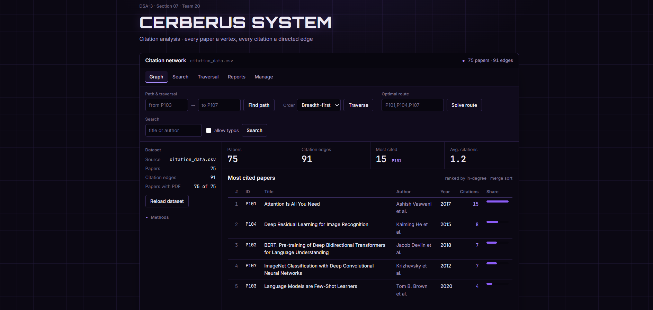
CERBERUS SYSTEM web interface showing the citation network dashboard, search, traversal, route solving, and citation statistics.

To be inserted by the project team.

7. RESULTS & DISCUSSION (CONTINUED)

7.3 Algorithmic Interpretation
The results demonstrate that the project is not only a paper database but a graph-processing system. A citation relationship can be traversed, searched, ranked, narrated, enumerated, and treated as a flow network. The optimal-path feature further shows how graph shortest paths can be combined with dynamic programming to solve a constrained multi-paper routing problem.

7.4 Geotagged Project Evidence
GEOTAGGED PROJECT PHOTOGRAPH
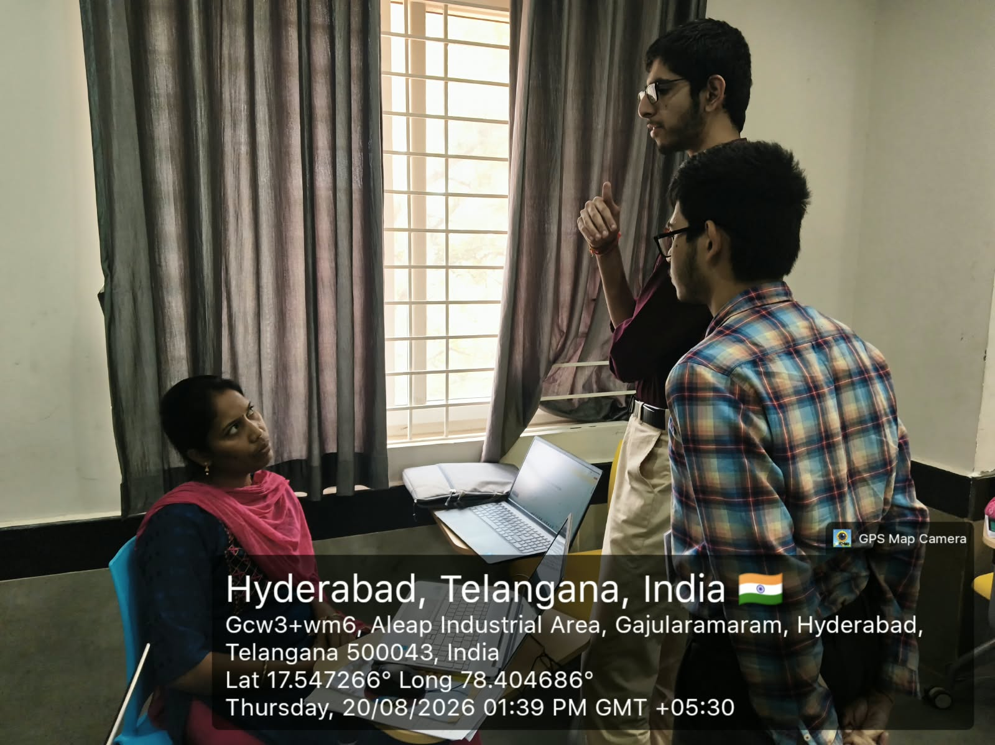 | 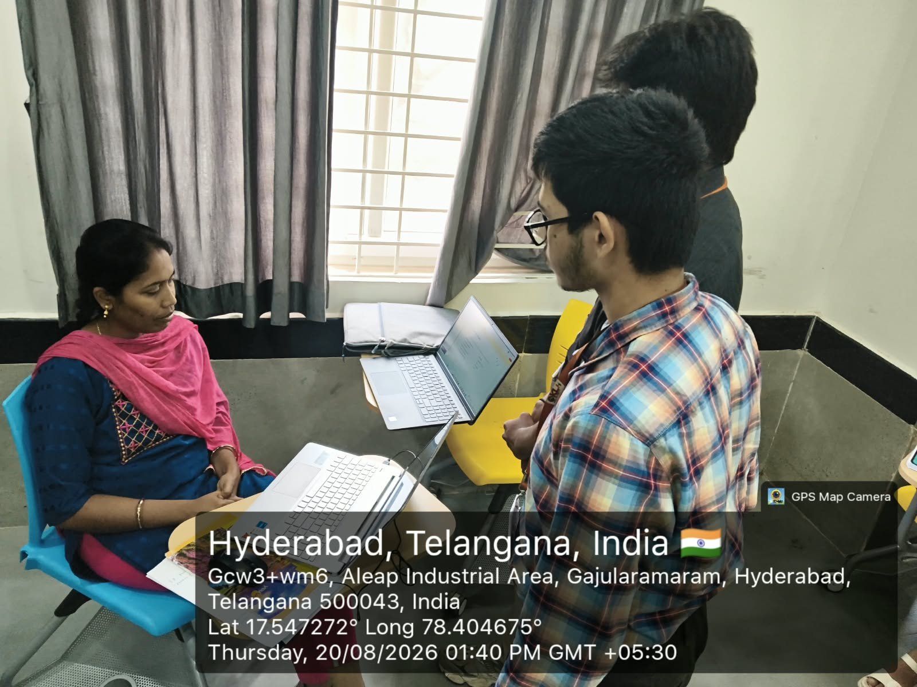
Geotagged project evidence captured in Hyderabad, Telangana, India: 20 August 2026, 1:39 PM and 1:40 PM (GMT +05:30).

7.5 Discussion
The strongest outcome of the implementation is the integration of multiple DSA concepts into one coherent application. The custom structures are reused across modules instead of being isolated demonstrations: the dynamic array supports graph adjacency and other structures, the queue supports BFS and Edmonds–Karp, the hash table supports paper-ID lookup, merge sort supports reporting, and the graph becomes the common computational model for traversal, paths, and flow analysis.

8. CONCLUSION & FUTURE SCOPE

8.1 Conclusion
CERBERUS SYSTEM successfully demonstrates how fundamental Data Structures and Algorithms can be applied to a realistic academic citation-analysis problem. The project models papers and citations as a directed graph and builds the surrounding functionality using custom data structures and hand-built algorithms. The implementation covers graph representation, hashing, BFS, DFS, exact and fuzzy string matching, merge sort, maximum flow, bounded path enumeration, bitmask dynamic programming, CSV persistence, reporting, and automated testing.
The documented test pass of 529 assertions with zero failures provides evidence that the implemented components and their integration scenarios behave as intended for the project's test corpus. The project therefore meets its central objective of creating a dependency-free, data-structures-driven citation analysis engine while keeping the underlying algorithms visible and inspectable.

8.2 Future Scope
- Interactive visual graph explorer for browsing citation networks dynamically.
- PDF export for generated citation reports.
- Bulk import support for BibTeX and RIS bibliographic data.
- Zero-dependency web front-end using the JDK HttpServer, hand-rolled JSON, HTML, CSS, and vanilla JavaScript.
- Improved visual analytics for citation clusters, influence flow, and temporal trends.
- Support for larger corpora with profiling-guided optimisation of path and flow operations.
- Additional algorithms such as Dinic's maximum-flow method when performance measurements justify the added complexity.
- Richer scholarly metadata and external dataset ingestion while retaining the educational custom-DSA core.

8.3 Current Project Position
The repository roadmap already identifies interactive graph exploration, PDF report export, bulk bibliographic import, and a zero-dependency web front-end as future extensions. These items can be developed without changing the central graph/data-structure model.

9. REFERENCES
1. CERBERUS SYSTEM repository — README, architecture, algorithms, complexity, testing, roadmap and team information. https://github.com/venkataramavinaybandla-crypto/DSA-3_Projects
2. OpenAlex — Works and citation data documentation. https://help.openalex.org/data/works/
3. Semantic Scholar — Scholarly literature discovery platform. https://www.semanticscholar.org/
4. Connected Papers — Visual exploration of related academic papers. https://www.connectedpapers.com/about
5. ResearchRabbit — Citation-network based literature discovery and review. https://learn.researchrabbit.ai/en/articles/12439939-how-to-get-started-with-researchrabbit
6. Litmaps — Citation-network based literature review and literature mapping. https://www.litmaps.com/about/us
7. VOSviewer — Bibliometric network construction and visualisation. https://www.vosviewer.com/
8. VOSviewer Online Documentation — Citation and bibliometric network visualisation. https://app.vosviewer.com/docs/
9. The Lens — Scholarly works search and citation exploration. https://about.lens.org/scholarly-search-analysis/
10. The Lens — Citation network analysis. https://about.lens.org/portfolio-items/citation-network-analysis/

Source note: Project-specific facts in this report were taken from the DSA-3_Projects repository and the supplied university report template. Literature-survey descriptions were checked against the cited official sources.

