1. BASIC TAGS

2. FORMATTING TAGS

3. LIST TAGS

4. LINK TAGS

5. image and graphics

6. Audio and video tag

7. table

8. form

9. frame

10. semantic and non-semantic

11. meta

12. programming

=====================================================================================================================

Attributes of body:

bg color, text, left margin, top margin, background, title

FORMATTING TAGS:

<H1></H1>--> level1

<H2></H2>--> level2

<H3></H3>-->level 3

<H4></H4>--> level 4

<H5></H5>--> level 5

<H6></H6>--> level 6

ATTRIBUTES OF H1 TO H6

=======================

1. ALIGN="LEFT/RIGHHT/CENTER" => IT IS USED TO Specify the alignment. The default is left.

2.title="..." => It is used to specify tooltip text.

<marquee></marquee> This tag is used to scroll the text at the top of the text in the browser

Attributes of <marquee> tag

=============================

1. bg color

2. behavior="scroll/slide/ a"

scroll amount is used to speed value

loop=" " It is used to specify how many times it should be scroll

width=" => specify rjr, marquee width

heigt=" => It is used to specify marquee height

hspace=""=> specify horizontal space

vspace=""=> specify vertical space

direction="left\right\up\down"=> specify the text direction

title=" => it is used to specify tooltip text

FORMATTING TAGS

===============================

<font></font>==> it is defined to font

<b>..</b>=> it is used to define the bold text

<i>..</..i> it is used to define italic text

<u>..</u>=> it is used to define underline

<br>==> It is used brake line

<center>...</center> => it is used to define center alignment

ATTRIBUTE OF FONT TAGS

==========================

1.face=" ==> It is used to specify the font name

2.size=" => It is used to specify the font size

3.color=" => It is used to specify the text color

FORMATTING TAGS

================

<SUB></sub> ==> It is used to define subscripted text.

<sup></sup>==> it is used to define superscripted text

<del></del>==> it is used to define deleted text.

<strike></strike> ==> It is used to define strike the text

<hr>=> It is used to define horizontal rules

<p> It is used to define the paragraph

<bdo></bdo>=> it is used to define override text direction BDO standard BI direction override

<pre></pre> It is used to define performed text

<progress></progress> => It is used to define progress ber.

<abbr></abbr> => It is used to define the abbreviation of the text

<adress></adress>It is used to define contact information

Attributes of HHR tag

=========================

color

width

height

size==> It is used to specify thickness.

align="left/right/center"

Attributes of BDO tag

======================

1.dir="ltr/rtl" it is used to specify the text direction

ltr=left to right

rtl=right to left

attributes for <abbr> tag

==============================

1.title=" It is used to specify the tooltip text

Attributes of progress ta

==========================

1.max=" value" => it is used to specify the maximum value of the task.

2. value=" => it is used to specify how much value of the task will be downloaded

Entities:

=========

this are used for reserved character such as => <,>,&,',",...etc

list of entities:

================

1. &lt;=> it is suse to represent to less than symbol

2.&gt; => it is used to represent to greater than symbol.

3. &amp; => It is used to ampersand symbol

4.&quot; => it is displayed double quotes.

5.&apos; =< it is used to repe=resent single quote

6. &nbsp; => it is used to represent display non-breaking space

7. &pound; => it is used to represent pound currency symbol

&yen; => it is used to display currency symbol;

9.&euro; It displays the euro symbol

10. &cent; => display cent currency symbol

11.&reg; => It displays a registered symbol

12. &copy; it displays copyright symbol

13. 7alpha; => alpha symbol

14. &beta;=> beta symbol

15. &gamma; => gamma symbol

16. &spades; => spade symbol

17. &diams; => diamond symbol

18. &clubs; => club symbol

19. &hearts; => heart symbol

HTML LIST

===============

There are 3 types of lists:

1. ordered list

2. unordered list

3. description list

list tags

===========

1.<ol>.</ol> => define ordred list

2. <uL>.</ul> define unordered list

3. <li> => It is used to define a list of items

4. <dl> ..</dl> describe description list

5. <dt>...</dt> define description terms

6. <dd> ...</dd> define data description

Attributes of OL tag

==============

type="1/A/a/I/i" => it is used to define specifi type

staer="" => to specify where the list should begin. it allows decimal numbers only

Attributes of ul tag

=====================

type="disc/circle/square/none" => it is used to specify the type.. default is disc

hyperlinks:

=============

hyperlinks are underlined words or locations on the web page that lead to another document.

There are 2 types of hyperlinks:

1. Page jump links

2. Bookmark hyperlinks

page jump hyperlinks

=====================

there are 2 types of page jump hyperlinks

1. internal hyperlink

2. external hyperlink

internal hyperlink:-

===================

The link between 2 different web pages on the same website is called an internal hyperlink

external hyperlink

========================

The link between two different web pages on different websites is called an external hyperlink.

Bookmark hyperlink

===============

The link between 2 different locations on the same web page is called a bookmark hyperlink.

Link Tags:

===============

<a>...</a> => It is used to define a hyperlink. It is called an anchor tag.

<nav>....</nav> => It is used to create a set of navigation tags.

<link > => It is used to create a link between a web page and an external resource.

Attributes of <a> tag

=======================

1. href="..." => it is used to specific the hyperlink reference

2. target="_blank/_self" => It is used to specify whether the page should

display in the same window in another window

Here _blank indicates another window or tab.&_self indicates the same window

default is _self.

3. atbindex="..." => It is used to specify tab index.

4. name=" => It is used to specify the hyperlink name that is required to create a bookmark link name.

by default, unvisited links appear in blue, visited hyperlinks appear in purple & active links appear in red color

These colors can be changed by using the following attributes of the body tag

1.link="." => specify unvisited hyperlink color.

2.vlink="." => specify visited hyperlink color.

2. alink=" => specify active hyperlink color.

To create a bookmark hyperlink follow the following links:

1. the value of the href and name attribute must be the same link

2. the value of the href attribute must begin with the #symbol

by using a link tag we can create a favicon

favicon is a small image that appears with the title in a title bar in the browser window.

Attribute to link tag:

======================\

1. rel ="icon" => It is used to specify the relationship between the HTML page and the external resource

2. href="..." => It is used to specify the external resource file patch

Image and graphics tags:

========================

1.<img> => It is used to define an image

2.<map> </map> => it is used to define an image tag

image map means an image with clickable areas

3.<area> => It is used to specify the area of the pixel to click

4.<svg> ..</svg> => It is used to define a drawing area it allows you to draw circles, squares, rectangles,.. etc..

5.<circle> ..</circle> => used to draw cycle

6. <rect>..<rect> => used to draw rectangle

7. <line>..</line> => used to draw line

8. <text> ..</text> => It is used to display text in a graphics area.

svg stands for scalable vector graphics.

Attributes of image tag:

=====================

1. src=" "=> specify the source file path

2. width=" => it is used to specify image width

3. eight="" => used to specify image height

Attribute of line tag

=======================

x1= It refers x1 coordinate

x2= It refers x2 coordinate

y1= It refers y1 coordinate

y2= It refers y2 coordinate

stroke= it describes the color of the stroke

stroke-width= it shows the width of the stroke

Audio& video tag

================

1.<audio> ...</audio> => it should contain embed audio content.

2.<video>........../</video> => it should contain some embed video content

3. <source>........</source> => used to define multiple audio and video resources

Note: the browser will close from top to bottom order.

Attributes of audio and video tags

===================================

1.src="." => It is used to specify the file path

2. width="" => it specifies width of pixel

3. height= " => it specifies the height in Pixel

4. autoplay= "=> it is used to specify that it should also automatically whenever it is loaded

5. controls => it is used to display audio controls

6. muted

7. loop => It is used to specify that it should play again whenever it has been finished

table tags

==========

1.<table> </table> => it is used to create a table

2.<tr></tr> => it is used to define row win a table

3.<th> </th> =>it is used to define header cell in a table

4.<td></td> => It is used to define a data cell in a table

5.<caption> </caption> => it is used to specify the table caption

6.<thead> </thead> => it is used to group a header content

7.<tbody></tbody> => used to group body content

8.<foot></foot> => used to group body content

9.<col > </col> => it is used to format columns

10. <colgroup></colgroup> => used to group columns for formatting

Attributes of table tag

==============================

1. border=" => It is used to specify the border in Pixel

2. bordercolor=" => It is used to specify the border-color

3. width=" => It is used to specify the border width

4. height=" => It is used to specify the table width

Attributes of tr, th, td tags

===============================

1. align="left/right/center" =>used to specify the text alignment

in the tag center is the default

in the td tag, left is the default

HTML Form tags

================

HTML forms are used to accept the data dynamically from the user, passed to the server

to process & to get the response from the server.

The many HTML forms are.

1. login form

2. registration

3. feedback

4. contact

5. application... etc.

Form tags

==========

1. <form> </form> => it is used to create a form. Here form is a container for many input fields.

2. <input>=> It is used to define the input field. For example, text, password, check box, radio button, and drop-down list.

3. <label> </label> => It is used to create a label for the input field.

4. <select> => It is used to create drop-down lists (combo box allows single selection & list box allows multiple selections.

5.<option> => used to specify the option that can be selected.

6. <optgroup> => It is used to group related options.

**Attributes for input tag**

=============================

1. type=" => It is used to specify the input field type.

2.name= "” => It is requested to specify tr parameter name.

Value of “**type**” attribute:

1. text =>used to define a single-line text field

2. password => used to define password field.

3. submit=> used to submit button

4. reset => It is used to define the reset button

In HTML both submit and reset buttons have default functionality.

Whenever the submit button is clicked then the value of the action attribute is executed in a <form> tag

Whenever a reset button is clicked ten all form field data are erased & default values are stored

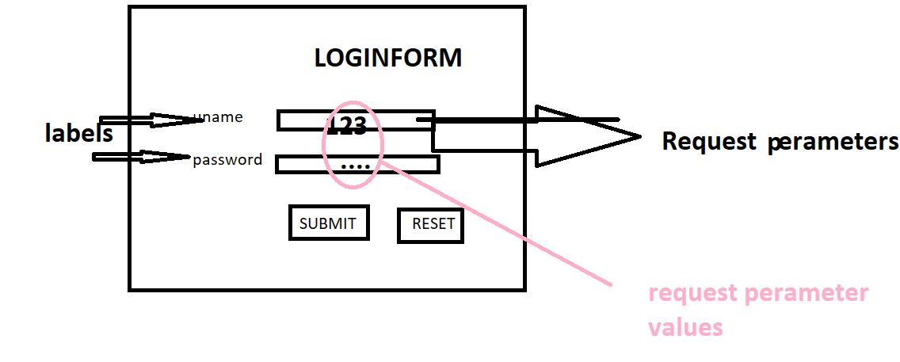

Attributes of the label tag:

1.For=” “ => it is used to specify the field name.

Attributes for the form tag:

1. Action=” => It is used to specify the server file name

Here the value of the action attribute is executed whenever the submit button is clicked

2.Method=”” => It is used to specify the http method name.

There are 7 HTTP methods:

1. get

2. post

3. put

4. delete

5. head

6. options

7. trace

NOTE: default is GET

Difference between GET and POST

Get post

1. It includes for request parameter in a 1. It includes the request parameter in a request header in a packet, the request parameter in a request body In a packet
2. 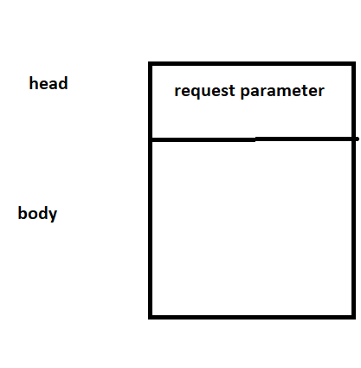 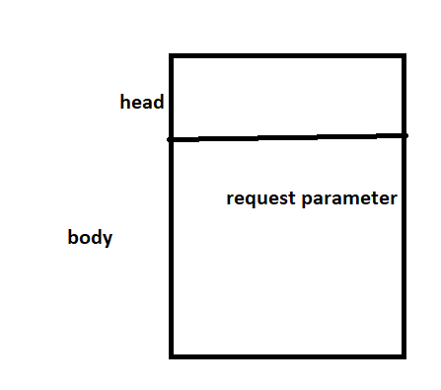
3. In this method, the request parameter is displayed 3. In this method, request parameters are   
   in an address bar. it is not displayed.

4. In this approach size of the data is limited. 4. in this approach, the size of the data is not limited

5. It supports text only. 5. It supports all types of data.

6. it is not secure. 6. It is secure.

7. get request can be cached. 7. Post request never cached.

8. GET requests are stored in browser history. 8. Post requests are not stored in a browser history.

9. GET requests can be bookmarked. 9. Post requests cannot be bookmarked.

Attribute of type value:

=========================

12. email => It is used to create an input field that allows to enter email ID

13. tel => Create an input field that allows you to enter a telephone number

14. number => numeric input field that allows numbers only

15. url => It is used to create an input field that allows URLs

16. Search => It is used to create an input field that allows to enter search keyword

17. button => It is used to create a range field. it is like a slider

18. image =>used to create a submit with an image

19. range => used to create a range field. it is like a slider

20. hidden => used to create hidden from the file.

21. color => used to create an input field that allows select color

22. file => It is used to create an input field that allows the selection of file

Attribute of input tag:

========================

4.pattern="" => used to specify

5.min=" => It is used to specify the minimum value in the number field

6. max= " => It is used to specify the maximum value in the number field

7. step=" => It is used to specify the inter value in the number field.

8.multiple=” => It is allowed to select more than one file

9.src=” => It is used to specify the image path for the image field

10. width=” It is used to specify image width

11. height=” => it is used to specify the image height

12. disabled => It is used to specify that the input field should be disabled.

13. novalidate=> It is used to specify that the input field should not be validated when submitted.

14. autocomplete=” on/off” =>It is used to specify autocomplete mode. The default is on**.**

15. placeholder=” => used to specify the hint.

16. autofocus=> It is used to specify that the cursor should be placed in that particular input field when the program is executed.

17. minlength=”” => It is used to specify the minimum no. of character.

18. maxlength=”” => It is used to specify the maximum no. of character.

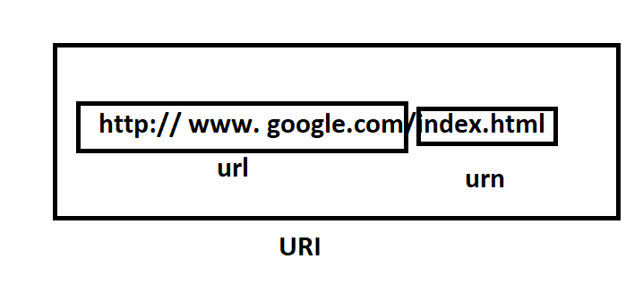

URL stands for uniform resource locator

URN stands for the uniform resource name

URI stands for resource identifier

or

universal resource identifier

HTTP:

========

HTTP stands for hypertext transfer protocol.

it transfers hypertext.

hypertext means HTML text

that is used by browsers & servers to communicate on the web.

HTTP:

=======

HTTPS stands for hypertext in an encrypted format.

WWW:

It stands for World Wide Web.

It indicates the browser searching for servers worldwide.

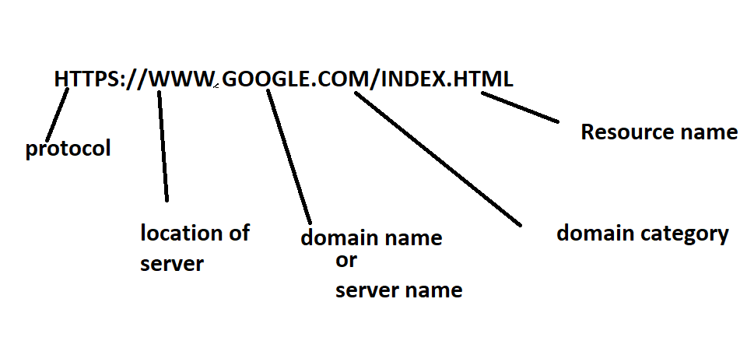

Attribute of **form** tag:

1. Novalidate=” “=> It is used to specify that the form should be validated when submitted.
2. Autocomplete=” off/on=> used to specify that auto-complete mode. The default is on.
3. Target=” blank/_self” => used to specify that the responses should display in the same window or a new window
4. Name=” “=> used to specify the format name.

Attributes for <select > tag:

1. Name=” => It is used to specify the request parameter name.
2. Multiple =” => used to specify that multiple values can be selected
3. Size =” => used to specify how many options should be displayed at a time. The default size is 4.

Attributes of <optgroup> tag:

1.label=”” => used to specify the label to the option =group.

**Sematic and non-semantic tags**

Semantic tags are used to describe content

Non-semantic tags are used to divide content into designs

These tags are used by browsers, search engines & UI (user interface) developers to recognize the content.

List of semantic tags:

1.<header>………</header> => It is used to specify header information like company name, company logo, and author information. Etc.

2. <footer> </footer> => It is used to specify footer information like company address, mail, mobile number, copyright information…etc

3. <main></main> => It is used to specify the main content

4. <article></article> => it is an alternative <main> tag

5. <section></section> => used to divide main content into no. of modules.

List of non-semantic tags:

1.<div> </div> => used to create a division in a content.

2. <span></span> => used to mark a part of the text.

**Meta tags:**

Meta tags are used to define metadata.

Metadata means data about data.

Here metadata includes character set, software information, author information, program description, search keywords, and language. Etc.

Here metadata used y browsers, search engines & UI developers to get data about the document.

List of <meta> tag:

1.<meta> => It is used to specify the mega data.

2.<base> => used to specify default URL default target for all hyperlinks in a document.

Attribute of meta tag:

1.charset=” => it is used to character set. Eg: UTF-8 stands for Unicode text format 8 bits. It includes all capital symbols, small letters, digits & special symbols.

2.name=”” => It is used to specify the metadata name including author, keyword, d=generator, and descriptions. Etc.

3.content=” => used to specify the metadata value.

4. http-equiv => used to specify how long the page has to be refreshed.

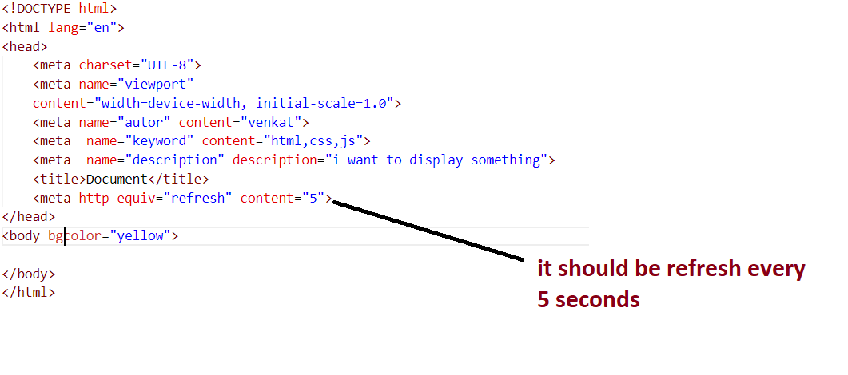

Attributes of <base> tag:

1. Href=” => It is used to specify the default URL for all hyperlinks in an HTML document.
2. Target=” “=> It is used to specify the default target for all hyperlinks in html document

**Programming tags:**

1. <style></style> => used to embed CSS styles
2. <script> </script> => used to embed client-side script code. e.g.:js
3. <noscript> </noscript> => used to specify alternative content to user. This content is displayed whenever the browser does not support the script code.

<!DOCTYPE html>:

It indicates html5 version of tags used in this HTML document to the browser.

Deprecated tags in HTML 5:

1.<marquee> </marqee>

2.<font> </font>

3. <strike> </strike>

4.<u> </u>

5.<frameset> </frameset>

6.<frame>

7.<center></center>

Deprecated attributes in HTML:

1. Bgcolor=””
2. Text=””
3. Background=””
4. Link=””
5. Alink=””
6. Vlink=””
7. Align=””
8. Hspace=””
9. Vspace=””
10. Widt=””
11. Height=””

Global attributes:

Global attributes can be used in all HTML tags.

1.id=”” => It is used to specify the id for an element. It is required while using CSS

2. class=”” => It is used to specify the class name. it also allows you to write multiple class names.

It is also required while using CSS code.

3. Style=”” => It is used to specify the inline CSS code.

1. Title=” ” =>used to specify the tooltip text.
2. Hidden=”” =>used to hide content
3. Contenteditable=”” => it is used to specify whether content is editable or not. The default is false.