SQL: Sequence query language

Examples on SQL are Mysql, postgresSQl
Examples on non-sql are MongoDB

These are called relational database management system (RDMS)

Classification of SQL are : 1) Data definition language (DDL)
- Data manipulation language (DML)
- Data control language (DCL)

- Data definition language (DDL): It allows you to perform various operations on the database such as CREATE, ALTER, and DROP,TRUNCATE objects.

It consists of SQl commands that can be used to define the database schema.
- Data Manipulation Language(DML) – It allows you to access and manipulate data. It helps you to SELECT, INSERT, UPDATE, DELETE and retrieve data from the database.

- Data Control Language(DCL) – It allows you to control access to the database. Example – GRANT, REVOKE access permissions.

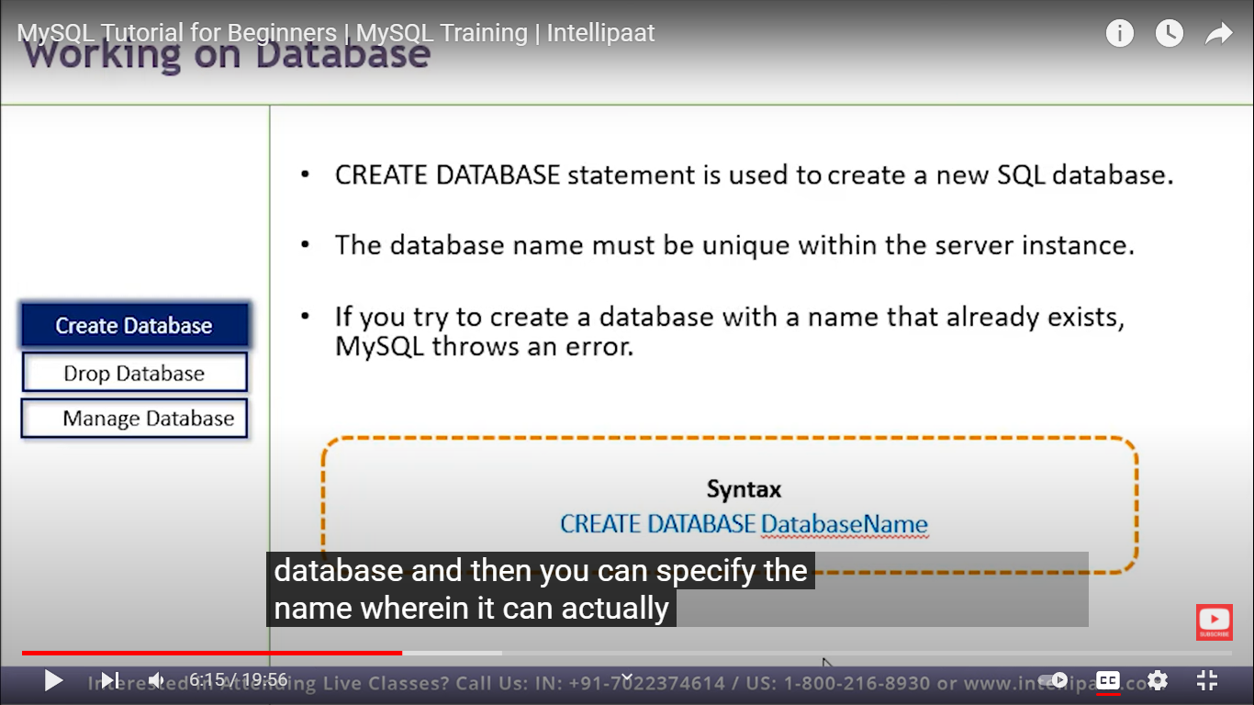
EX: create database ‘database-name’;

DROP database is nothing but to delete the database
EX: drop database ‘database-name’;

- Use table #to move on that particular database.

- Select * from city # in that databse select this table I.e.,city.

DATATYPES: Datatypes are attributes that specifies the type of data of any object.

- Numeric
- Data and time
- Character strings
- Unicode Char strings.
- Binary.

WORKING WITH TABLES
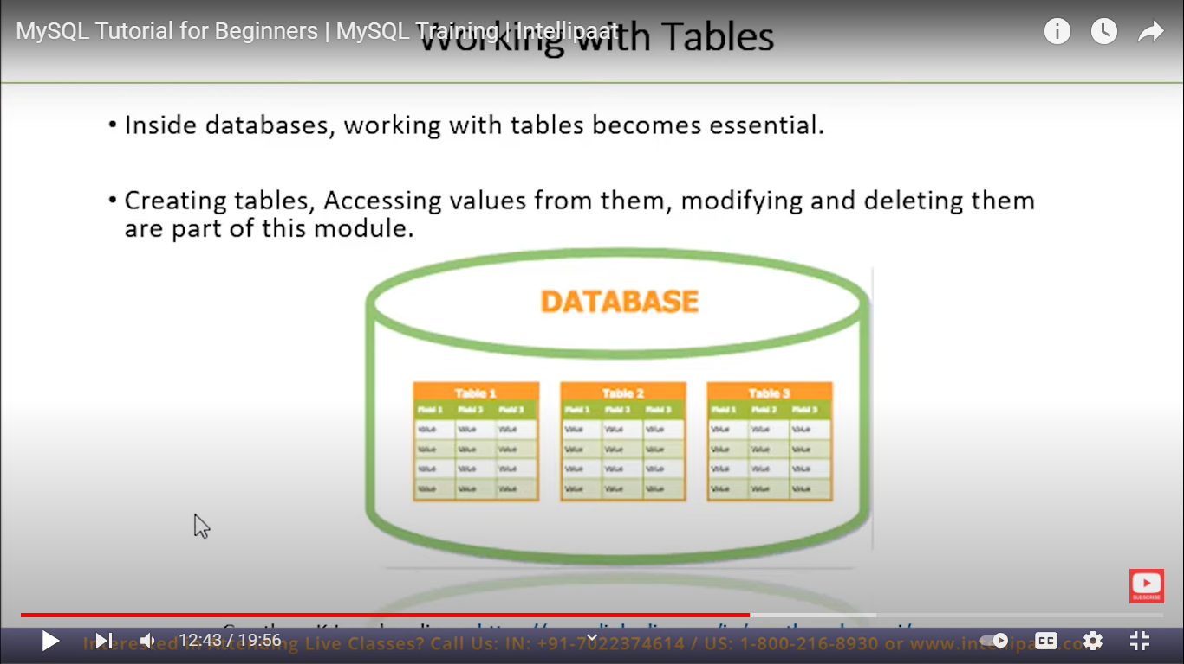

WORKING WITH TABLES
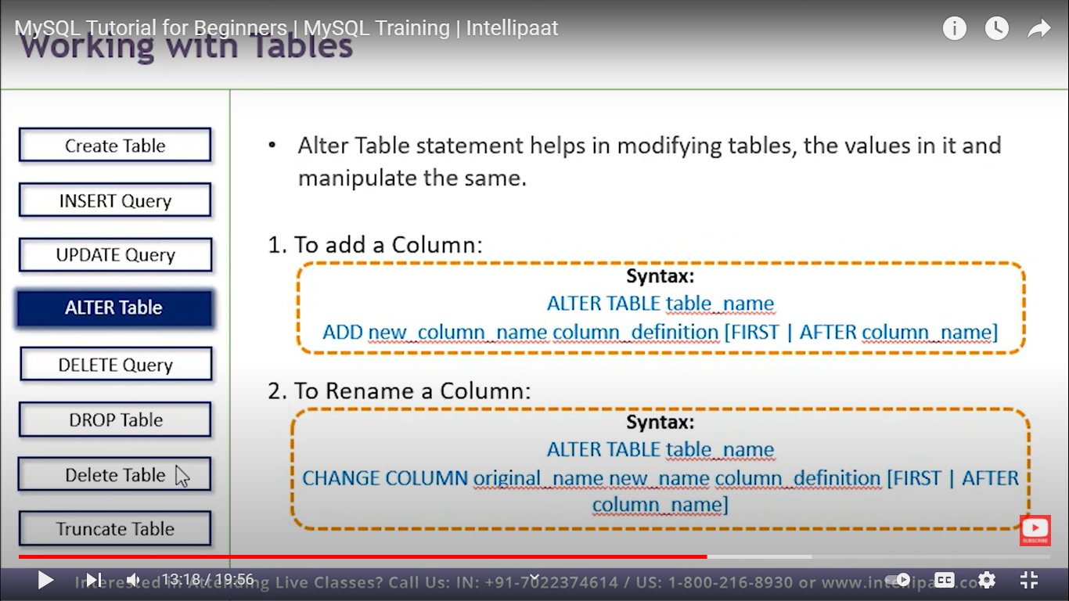

TABLE CONSTARINTS

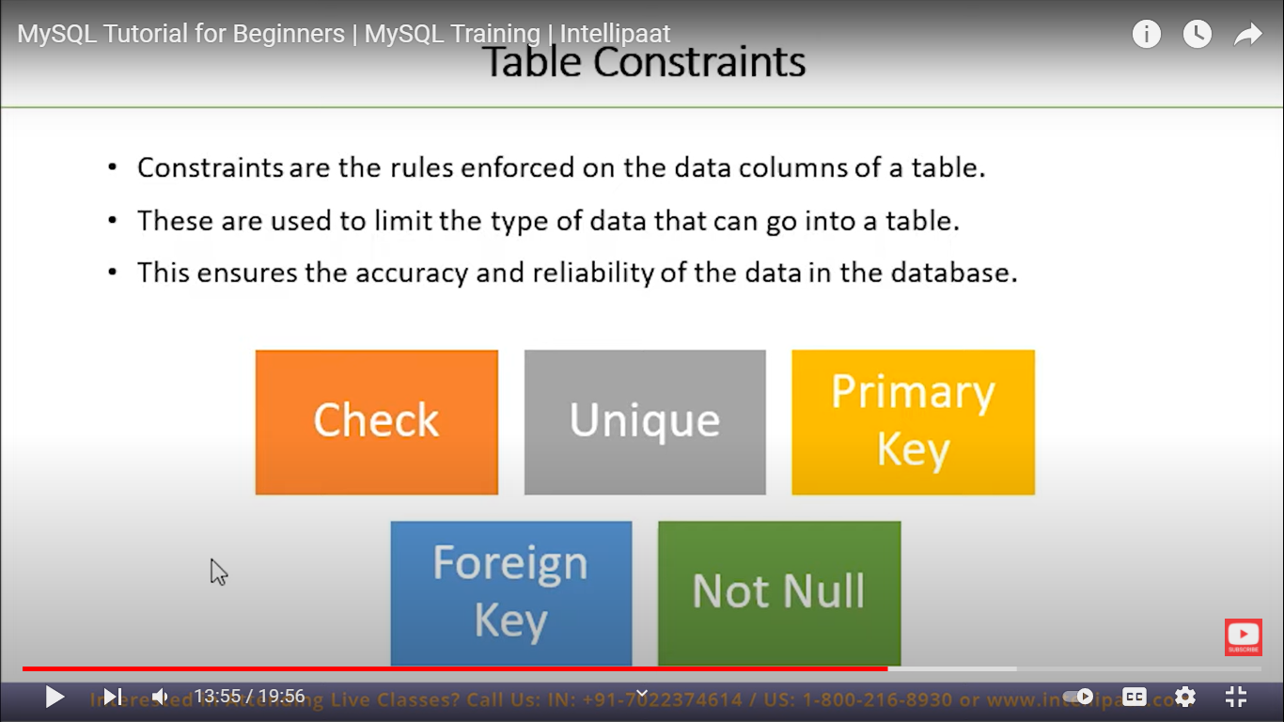

SQL STATEMENTS

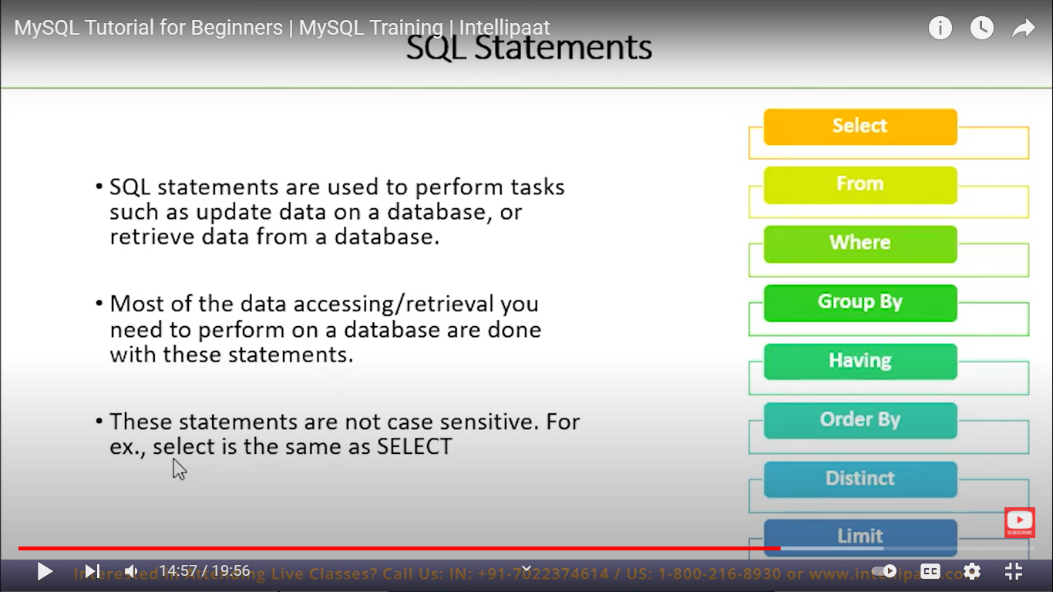

SQL JOINS

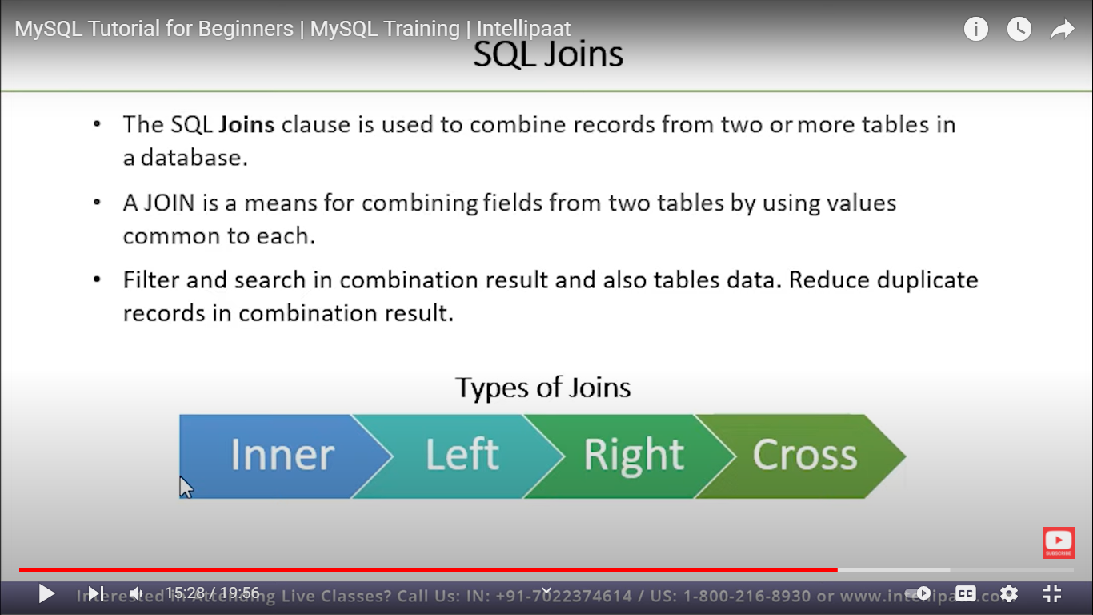

DATE FUNCTIONS

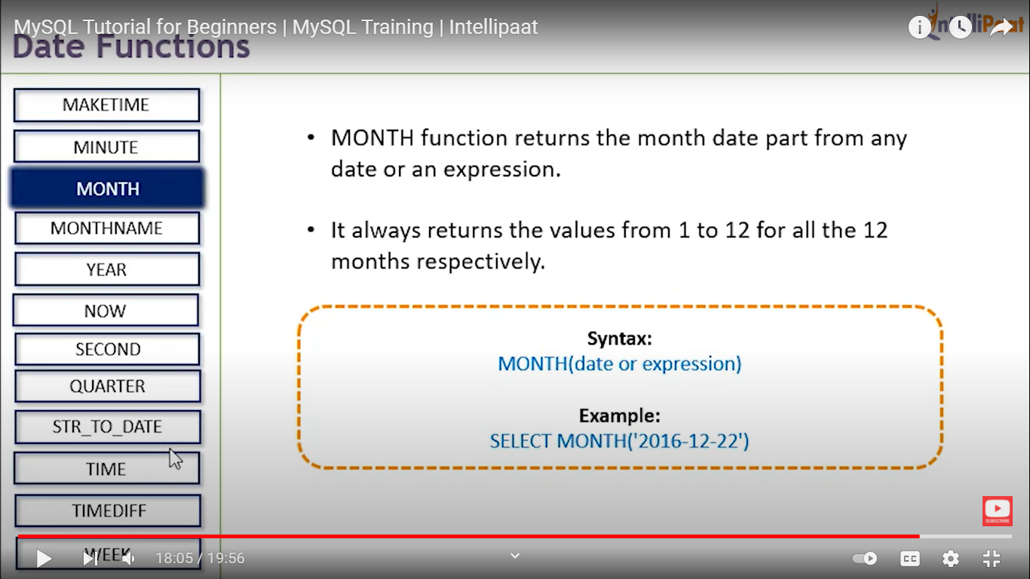

NUMERIC FUNCTIONS

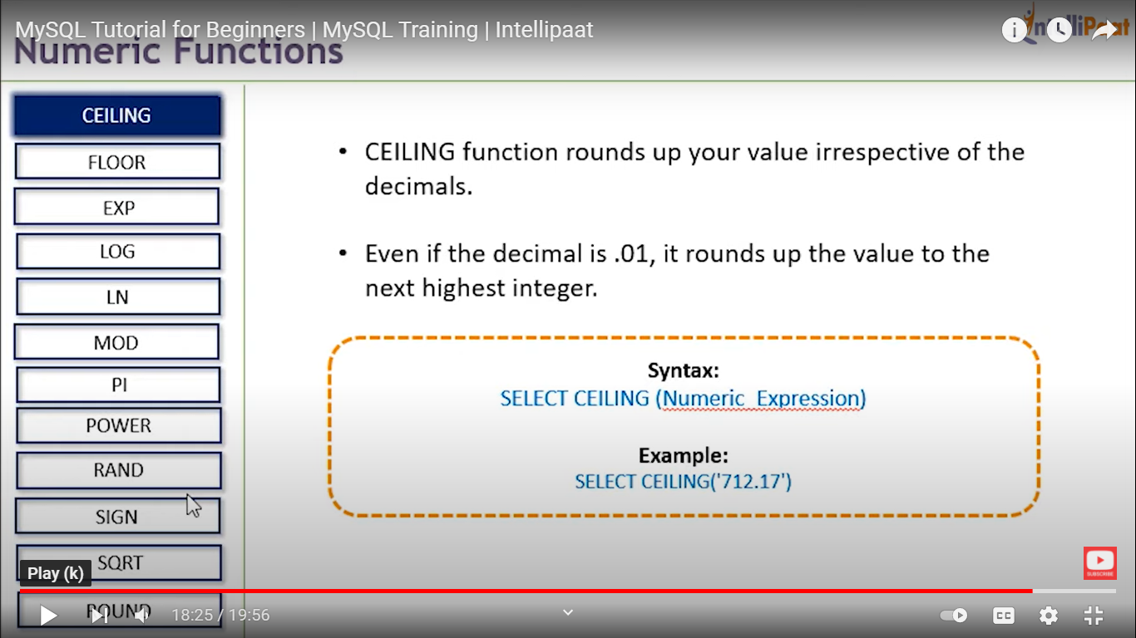

STRING FUNCTIONS

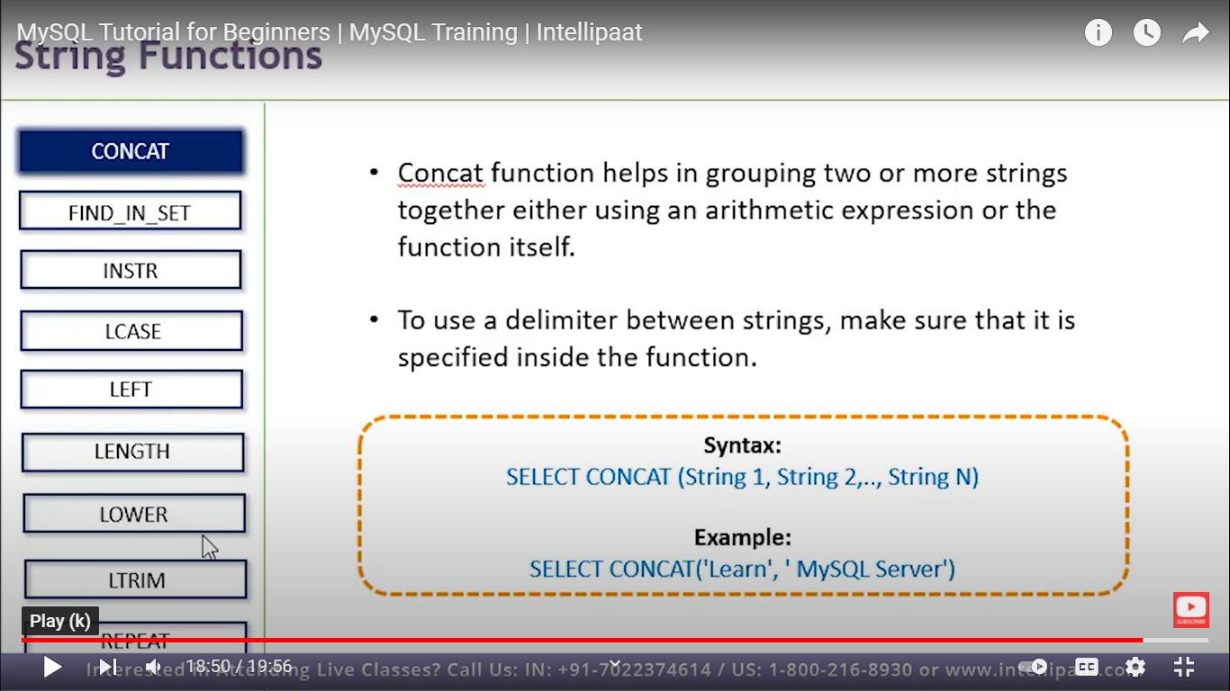

A primary key is a column or a set of columns in a table whose values uniquely identify a row in the table. ... A foreign key is a column or a set of columns in a table whose values correspond to the values of the primary key in another table.

