PayLink: Simulated Peer-to-Peer Banking Transfers
Project Midterm Report · CS 5600 Advanced Database Systems · Fall 2026
Sai Kadamati and Siddhardth

Executive overview
PayLink is a database-driven banking simulation for sending money to another person, moving funds between owned accounts, and reviewing activity. Its central question is: how can a relational database preserve correct balances when transfers overlap, fail, or are submitted repeatedly? It uses synthetic accounts and USD amounts only; it does not connect to real banks or move real money.
The implementation follows the submitted proposal: Next.js/React with TypeScript for the frontend, Python/FastAPI for the backend, and PostgreSQL with five core tables. The schema and deployment instructions target a private database schema on Supabase. The current implementation supports account registration and sign-in, masked account summaries, exact recipient lookup by username/email/phone, a review-before-send flow, internal transfers, shared ownership, searchable activity, CSV download, and basic SQL-driven insights.
Status of evidence: production build and 19 database/API integration checks passed locally. Actual Chromium interactions exercised transfers and verified database changes. Local PostgreSQL 15 is verified; a public website and hosted Supabase database have not yet been provisioned or validated, because no authenticated Supabase/hosting connection is available in the session. Hosted deployment remains a required open item, not a completed milestone. Screenshots show the locally running implementation and are labeled accordingly.
This report documents the generated implementation. The division between Sai and Siddhardth below is recommended responsibility and review ownership, not an assertion that either teammate independently authored the generated work. The team should confirm its own actual contributions and understanding before submitting or recording.

1. Requirements and course alignment
The project description establishes a many-to-many relationship between users and bank accounts through account holders, including joint accounts. Banks maintain multiple accounts. Transfers must verify ownership, account status, and sufficient funds; update both balances together; and handle duplicate requests safely. The SQL lecture’s project guidance specifies at least four tables, at least one one-to-many and one many-to-many relationship, appropriate keys/constraints, an ER model, and a relational schema. PayLink supplies five tables and both required relationship types.
The course emphasizes relational design, normalization, advanced SQL, storage/indexing, query optimization, transactions, concurrency control, recovery, and advanced web database development. PayLink demonstrates these through a relational model and FD analysis, constraints, joins and aggregation, window functions, B-tree access plans, row locking, atomic updates, and integration tests. It does not claim to have demonstrated NoSQL, warehousing, machine learning, crash recovery, or production performance tuning.

2. System architecture and implementation
The browser communicates with the Next.js application using same-origin /api requests. Next.js forwards those to FastAPI. FastAPI verifies a signed HttpOnly session cookie, derives the acting user from the session, and uses parameterized psycopg queries against PostgreSQL. The acting user’s ID is never trusted from an arbitrary browser field.
A dedicated paylink_api database role can read the application schema, insert registered users, and call carefully scoped account-opening and transfer functions. It cannot directly update balances, delete history, or insert transfer rows. Tables enable row-level security; backend-only policies allow the trusted service role’s necessary reads/registration. PUBLIC cannot execute the balance-changing functions. Supabase’s browser/Data API roles are not granted access to the private schema. These controls assume the backend role remains confidential; its credentials are privileged and must not enter the browser.
Passwords are hashed with Argon2id. The backend uses signed HS256 sessions with expiration, issuer, and audience validation. Cookies are SameSite=Strict and HttpOnly, with Secure enabled for hosted HTTPS. Mutation endpoints check the configured origin and reject cross-site fetches. A basic in-process login limiter supports the single-worker academic deployment. This is a teaching system, not a complete security or compliance solution; email/phone verification, distributed limiting, password recovery, administrative account management, and session revocation are future work.
The UI uses a consistent neutral palette, a single blue action color, masked account identifiers, explicit simulation labels, a transfer review screen, visible errors, receipt IDs, and empty states. It separates sent, received, and internal activity. A user who jointly owns both endpoints sees an internal transfer. The monthly money-in/out metrics exclude internal movements, while the weekly volume chart deliberately includes both legs and explains that distinction.

3. ER model and relational schema
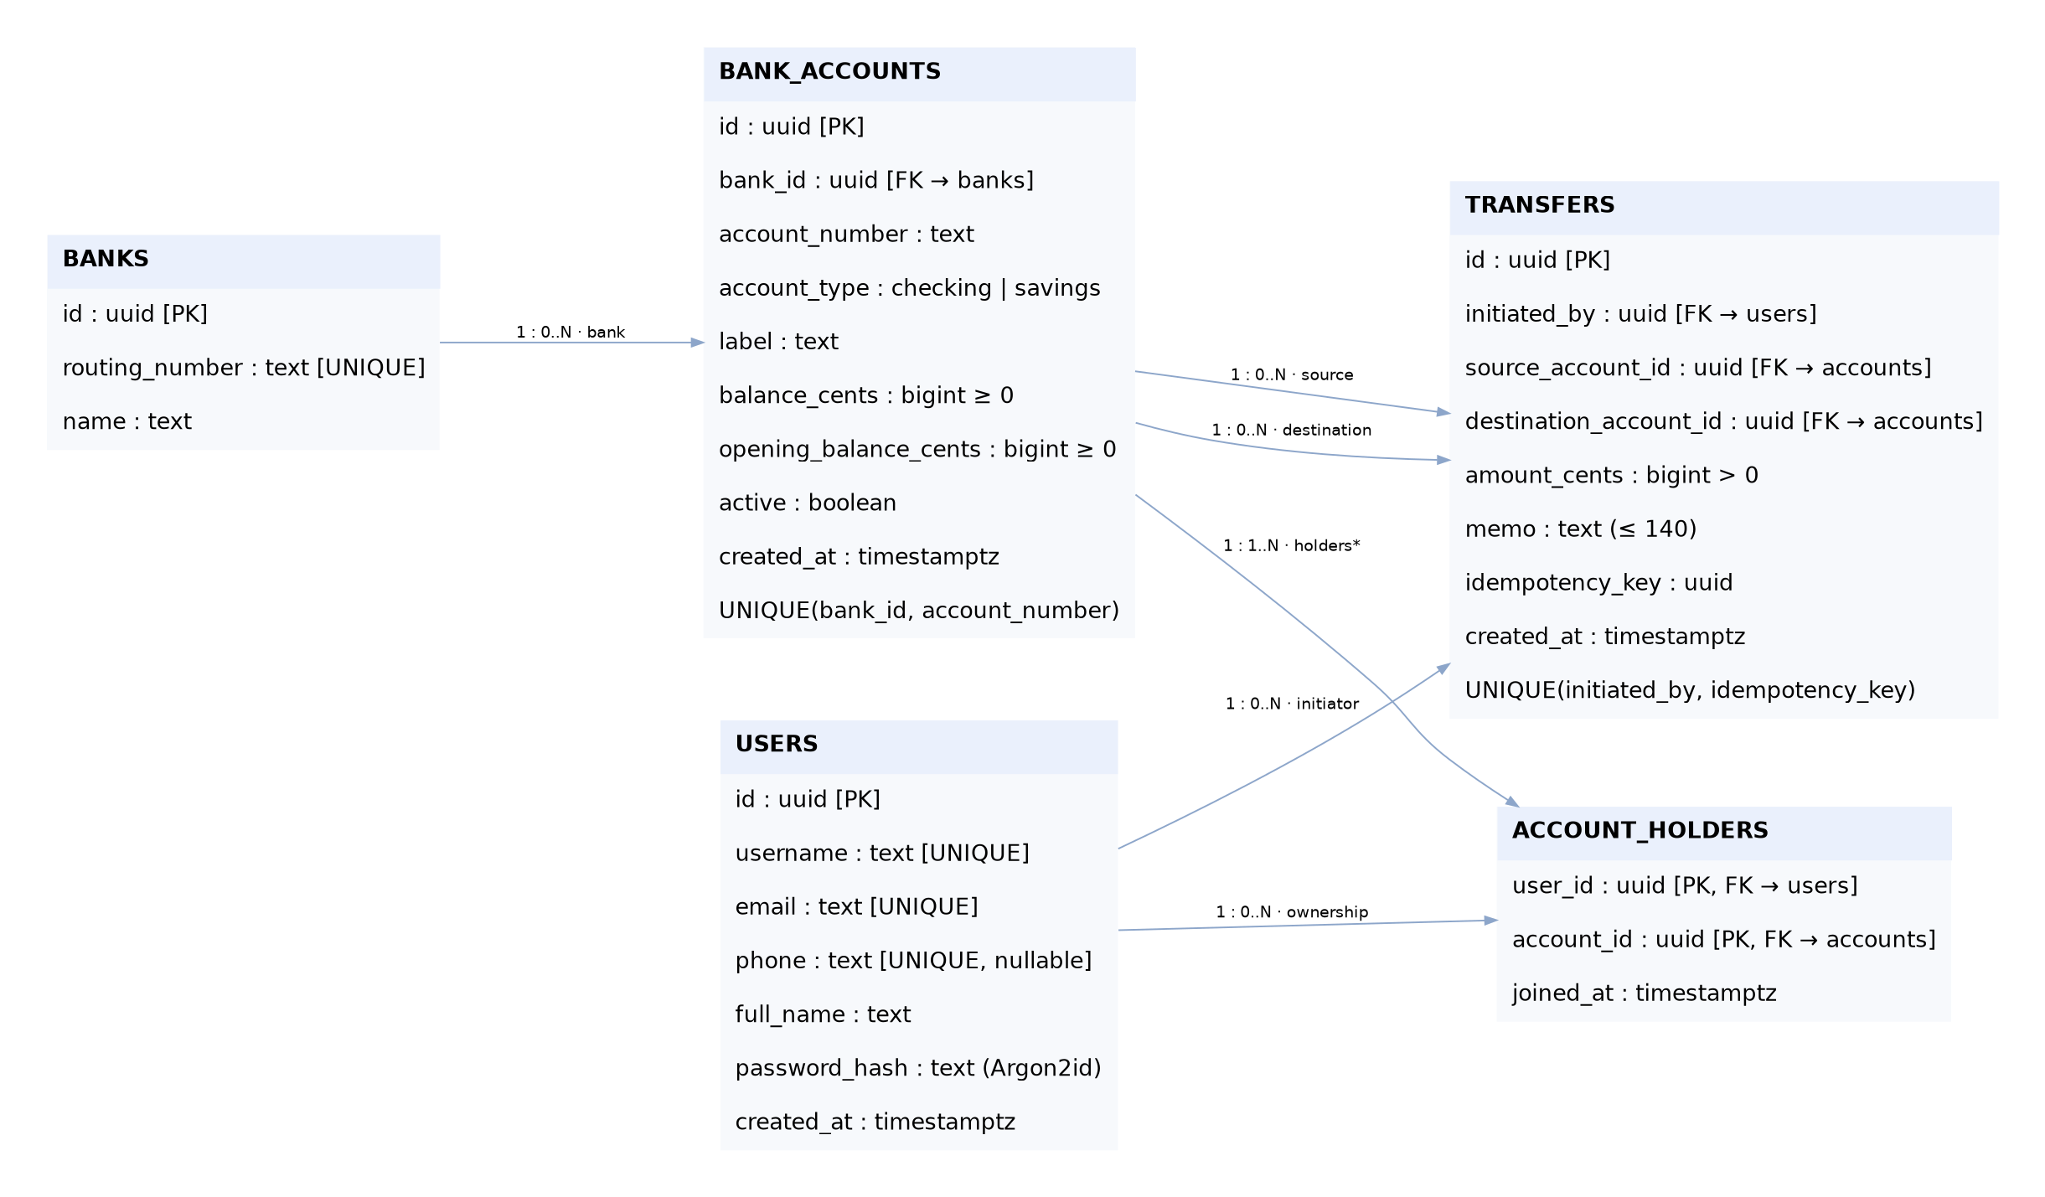
PayLink logical ER model. Native editable source: er-diagram.drawio.
Entity | Primary/alternate keys | Purpose
Users | UUID PK; username and email UNIQUE | Identity and authentication information. Phone is optional and unique when present.
Banks | UUID PK; routing_number UNIQUE | A bank’s independent descriptive facts.
BankAccounts | UUID PK; UNIQUE(bank_id, account_number) | One balance and account state per simulated account.
AccountHolders | Composite PK(user_id, account_id) | Ownership bridge, including joint accounts.
Transfers | UUID PK; UNIQUE(initiated_by, idempotency_key) | Completed transfer event connecting two different accounts.
The Bank→Account relationship is one-to-many. Users↔Accounts is many-to-many, represented by two FKs and a composite key. An account can send and receive many transfers; a transfer has one source, destination, and initiator. The account-opening function creates the account and first owner atomically. The ER model’s intended minimum of one owner is a workflow invariant, not a minimum-cardinality constraint enforced by a simple FK.
Domain checks restrict account types to checking/savings, enforce nonnegative balances and positive transfer amounts, require different source/destination accounts, and bound notes to 140 characters. All amounts use integer USD cents. Account numbers are synthetic strings, unique within a bank. Identifiers, timestamps, and account ownership are not packed into repeating text fields.

4. Normalization analysis
A hypothetical wide ownership relation has candidate key (user_id, account_id). It repeats user identity details for each account and bank details for each owner/account. User details depend only on user_id; account facts depend only on account_id. Those partial dependencies motivate separation into Users, Accounts, and AccountHolders to satisfy 2NF. The transitive dependency account_id → bank_id → bank_name, routing_number motivates the separate Banks relation for 3NF.
The final design’s main functional dependencies are:
- user_id → user attributes; username and email are alternate determinants.
- bank_id → routing_number, bank_name; routing_number is an alternate determinant.
- account_id → bank_id, account_number, type, label, balances, active, created_at; (bank_id, account_number) → account_id.
- (user_id, account_id) → joined_at.
- transfer_id → transfer attributes; (initiated_by, idempotency_key) → transfer_id.
Every nontrivial determinant is a superkey in its own relation, so the design is in BCNF under the stated dependencies. An optional UNIQUE phone is not treated as an unconditional candidate key because multiple NULLs are permitted. Sample data is not used to infer extra dependencies.
The ownership decomposition is lossless: each split shares an attribute that determines the extracted relation (user_id for Users, account_id for Account facts, bank_id for Banks). The local FD constraints remain in individual relations, making this decomposition dependency-preserving for the declared FD set. Transfers is a separate event relation; joining all ownership rows to every event would multiply joint-owner rows rather than prove losslessness.
Ownership authorization, active status, sufficient balance, and money conservation are cross-row business invariants, not consequences of BCNF. Their enforcement belongs in the transaction. A stored current balance is a deliberate materialized aggregate. A read-only reconciliation query checks that each balance equals opening balance plus incoming transfers minus outgoing transfers. The measured seed state has zero discrepancies. Detailed assumptions and the full dictionary appear in database-design.md.

5. Atomicity, concurrency, and duplicate handling
The backend calls execute_transfer inside a database transaction. The function validates inputs, locks the user/idempotency-key pair, returns an existing identical transfer when appropriate, checks source ownership, and locks the two accounts in deterministic UUID order. It then verifies active status and sufficient funds, debits the source, credits the destination, and inserts one completed event. Failure rolls back all changes. The backend returns success only after commit.
READ COMMITTED plus explicit FOR UPDATE locks prevents lost updates for the supported transfer workflow. Competing payments serialize at the source row; the second checks the resulting balance. Opposing A→B and B→A requests lock accounts in the same order, reducing deadlock risk. A transaction-scoped advisory lock coordinates simultaneous retries of the same idempotency key, even when conflicting requests specify different account pairs. The unique initiator/key constraint is a further safeguard.
New-account creation allocates $1,000 in clearly labeled simulated starting funds, with at most four held accounts per user. That allocation changes the simulation’s total supply by design. Transfers between existing accounts conserve supply. The current design records completed transfers only; rejected attempts do not become successful history rows. A separate security/audit event model and a full double-entry ledger are possible extensions, not present claims.
PostgreSQL supplies WAL-based durability and transactional recovery. Tests demonstrate rollback after balance mutations and on rejected operations. They do not establish backup restore, power-failure recovery, or hosted point-in-time recovery.

6. Advanced SQL, indexes, and physical observations
The included SQL exercises demonstrate bank totals using joins and GROUP BY, jointly held accounts using HAVING, exact recipient lookup, a UNION ALL/CTE reconciliation, and a deterministic running balance using SUM(...) OVER (... ROWS UNBOUNDED PRECEDING). Storage inspection uses PostgreSQL relation/index-size functions and catalog statistics.
Two composite B-tree indexes cover outgoing and incoming account histories ordered by timestamp and ID. The reverse ownership index supports account-to-owner queries; the ownership PK supports user-to-account lookup. Primary and alternate keys create their own indexes.
A real local microbenchmark temporarily inserted 20,000 synthetic transfers in a transaction, measured the same outgoing-history query with and without its composite index, then rolled back the fixture rows and index drop. The captured run used an index scan with four shared buffer hits and approximately 0.036 ms execution time. Without that index, PostgreSQL used a sequential scan plus top-N sort, with 386 shared buffer hits and approximately 3.582 ms. These measurements describe one warm local run, not hosted performance or a general speed guarantee. The benchmark concerns the outgoing-history query, not every query used by the UI. Tiny real demo datasets may correctly use sequential scans.

7. Validation and limitations
The production Next.js build passed. The 19 local database/API checks passed, including:
- Atomic debit/credit and supply conservation; insufficient-funds rollback.
- Eight simultaneous identical requests returning one transfer; rejection of conflicting payloads.
- Two competing spends unable to overdraw; twenty opposing transfers completing without a deadlock.
- Non-owner/inactive-account rejection, positive amount validation, FK integrity, and nonnegative balance constraints.
- Joint-owner spending, denial of direct balance UPDATE, and rollback after the transfer function’s mutations or a destination credit-limit failure.
- Authentication, cookie attributes, origin checks, masked account responses, and rejection of fractional cents.
The browser workflow uses real Chromium rather than mocked screenshots. It exercises sending, review, confirmation, receipt lookup, reload persistence, CSV download, own-account movement, account creation, second-user receipt, mobile navigation, and registration. Database queries independently assert the exact committed amount and both balance deltas. Test fixtures are subsequently removed and balances restored. Current result files and screenshots, rather than this prose alone, are the evidence of completed checks.
The full local Supabase database image exceeded Docker’s storage limit; local validation therefore uses standard PostgreSQL 15.19. The supplied migrations target Supabase PostgreSQL without requiring Supabase Auth. No Supabase tools or usable hosted database/hosting credentials were exposed. Consequently a live website, hosted writes/reads, Supabase dashboard screenshots, and remote revalidation remain uncompleted required work. A local screenshot must not be described as a hosted Supabase demonstration.
Other limits include a latest-200 history/export cap, no pagination beyond it, single-worker rate limiting, no owner invitation/revocation UI, no immutable audit ledger, no real banking, and no automated production recovery test. The user requested a public live demonstration; the team must resolve hosted access before claiming that deliverable.

8. Team ownership and incremental milestones
Milestone | Increment | Sai — assigned ownership | Siddhardth — assigned ownership | Current evidence
1. Model the domain | Proposal, assumptions, five entities, cardinalities | Keys, dependencies, integrity rules | ER diagram, relationship translation, requirements review | Editable ER model and design notes supplied; team review pending.
2. Build the data layer | Versioned DDL, account ownership, seeds | Tables, migration, transaction functions | Sample data review, join/aggregation queries, dictionary | Schema recreation and local data checks executed.
3. Integrate the application | Authentication, accounts, transfers, history | FastAPI, Argon2id/session identity, parameterized DB calls | Next.js UI, transfer review, activity, CSV, mobile layout | Build and functional implementation verified locally.
4. Validate and prepare demo | Concurrency, rollback, indexes, evidence | Integration tests, reconciliation, query plans | Browser interactions, screenshots, report/video assembly, deployment configuration | Local evidence supplied; public deployment and hosted Supabase acceptance pending.
These are proposed responsibility assignments for internal knowledge transfer. Each teammate should review/run the assigned components, record actual changes and explanations, and revise the attribution accordingly. Generated code alone does not establish an individual’s contribution.

9. Next work: milestones 5–7
Milestone 5 — Complete hosted acceptance and operational readiness. Connect the selected Supabase project in primary-org, provision the restricted backend role, deploy FastAPI/Next.js, and rerun transfer/concurrency checks against isolated hosted identities. Capture both the public UI and corresponding Supabase rows, demonstrate zero reconciliation discrepancies, and record a real deployment URL. Add startup monitoring and a backup/restore drill.
Milestone 6 — Strengthen the financial and account model. Evaluate a separate immutable double-entry ledger and rejected-attempt audit records, add pagination and reversal workflows, formalize account lifecycle rules, and implement authenticated joint-owner invitations/revocations with coordinated locking. Each extension requires an updated ER/normalization and invariant analysis.
Milestone 7 — Measure scale and complete course evaluation. Introduce representative skewed workloads, repeat EXPLAIN/BUFFERS and concurrency measurements, compare indexed plans with justified alternatives, run multi-worker security/load checks, and document recovery evidence. Refine accessibility and the final presentation based on measured results.

References and assistance disclosure
- Team-provided Project Proposal: PayLink — Simulated Peer-to-Peer Banking Transfers.
- Yu Luo, CS 5600 Advanced Database Systems Syllabus, Fall 2026.
- Yu Luo, supplied lectures 01 Introduction, 02 Relational Model, 03 SQL, 04 Advanced SQL, 06 Database Design (E/R), 07 Database Design Theory, and 08 Database Design Theory.
- PostgreSQL documentation, Explicit Locking, Transaction Isolation, Constraints, and Using EXPLAIN: https://www.postgresql.org/docs/15/. Framework references: https://fastapi.tiangolo.com/, https://nextjs.org/docs, https://supabase.com/docs/guides/database.
Disclosure draft for team confirmation: “OpenAI Codex assisted with generating and revising the PayLink implementation, database design documentation, diagrams, validation scripts, and presentation materials. The team reviewed, tested, and can explain the submitted work [retain this sentence only after doing so]. Course lecture materials and the submitted proposal informed the design.” The course syllabus requires authorization and acknowledgment of substantive AI use. Confirm applicable instructor permission and edit this disclosure to accurately describe actual assistance and team work; the assistant has not confirmed instructor approval.

