Convolutional Neural Network based Brain Tumor Detection

In this paper author is using Convolution Neural Network (CNN) algorithm to predict brain tumor disease as CNN algorithm works like human brain and can analyse images to detect minute tumor. Many existing algorithms are available but they trained on small dataset size so its prediction accuracy is not good. To overcome from this problem author of this paper has used 3 modules such as Augmentation, Image Processing and training and classification of tumor using CNN.

1. Augmentation: using this module we will increase dataset size by generating new images and this technique will apply Rotations, Shifts, Flips, Brightness, Zoom on each image to create multiple different copies from that image
2. Image Processing: using this module we will read all images and then resize all images to equal size and then normalize pixel values and then convert RGB Colour image to Grey colour format.
3. Applying CNN Algorithm: Processed images will be input to CNN algorithm with two different classes such as ‘Yes’ (presence of tumor) and ‘No’ (No tumor presence). CNN will get trained with all images by using two class label. CNN consists of multiple layers

Input Layer: this layer will accept size of images with colour or grey format

Convolution2D Layer: this layer accept integer values as FILTERS which will filter image that many times to extract important pixels from images

MaxPooling2D Layer: this layer will collect all filtered pixels from CNN layer and then convert to single dimensional array. Using this filtered pixels CNN will get trained

Batch Normalization: filtered pixels will get normalized

Dense Layer: this is the output layer which predict either of two classes as YES or NO.

In below screen I am showing dataset images used in this project

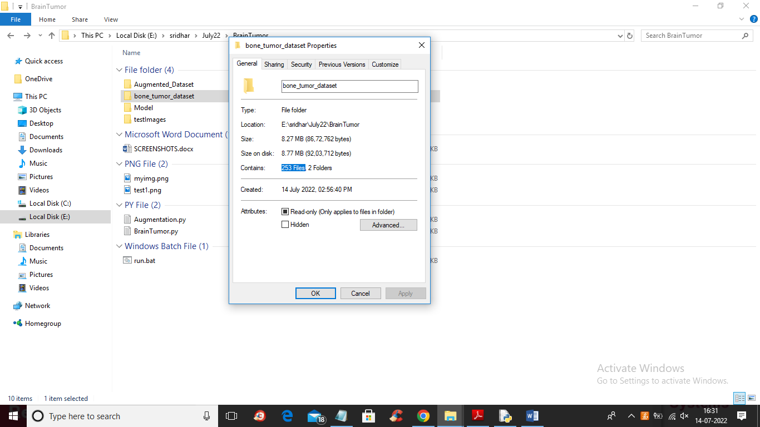

In above screen in ‘bone_tumor_dataset’ folder we can see it contains only 253 images and after applying Augmentation we got more than 2500 images and in below screen you can see Augmented dataset images length

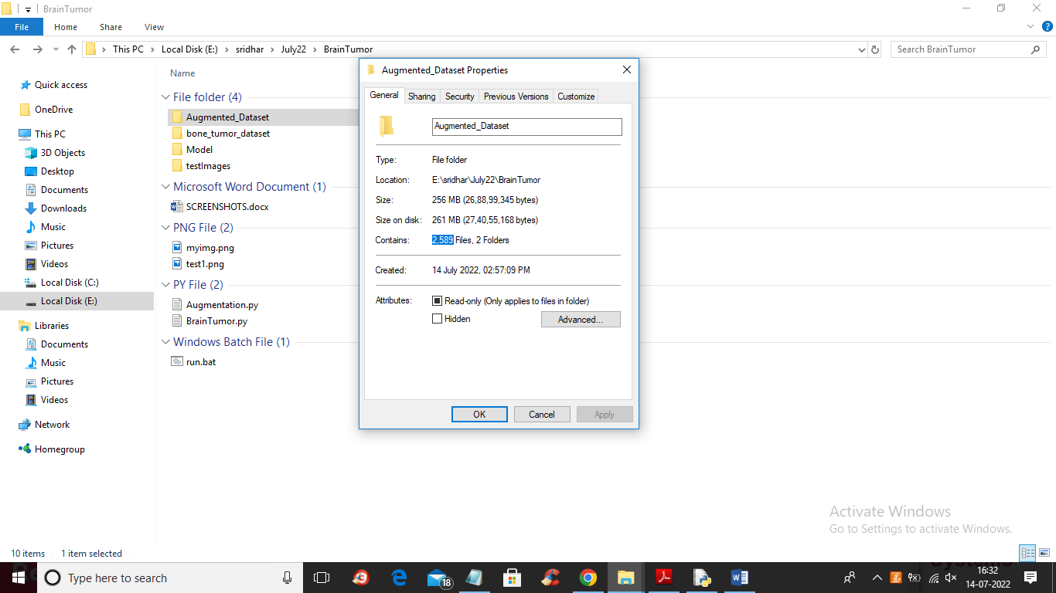

In above screen you can see after augmentation 253 images increased to 2589 and now just go inside ‘AugmentationDataset’ folder to view those images

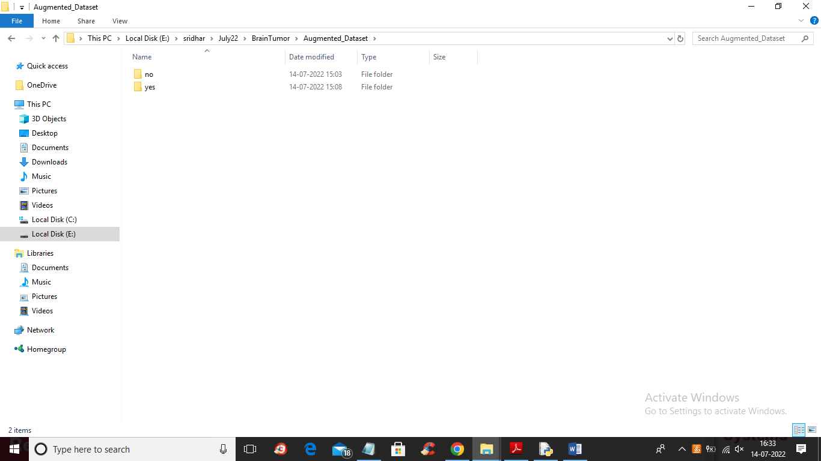

In above screen we have 2 folders called ‘Yes or No’ and just go inside any folder to view images

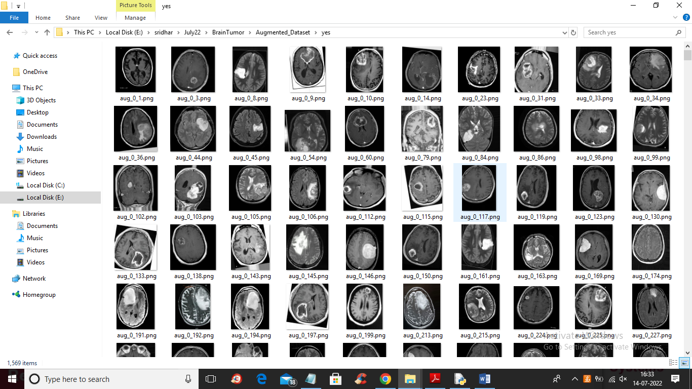

In above screen you can see images with tumor and by using above images we will trained CNN algorithm.

You can see augmentation code in ‘Augmentation.py’ file and don’t run this code as I already generated images.

To implement this project we have designed following modules.

1. Upload Brain Tumor Images Dataset: using this module we will upload augmented images folder
2. Dataset Preprocessing & Features Extraction: using this module we will read each image and then resize to equal size, and then convert image to Grey format and then normalize pixel values and then extract features from each image and then this features will be input to CNN
3. Train CNN Brain Tumor Detection Model: all processed images features will be input to CNN and then trained a model and then apply test data to calculate prediction accuracy
4. Brain Tumor Prediction: using this module we will upload test image and then CNN will predict weather image is normal or contains tumor and if contains tumor then it will crop tumor region and then display Life span time
5. Training Accuracy Graph: using this module we will plot CNN training accuracy and loss graph.

SCREEN SHOTS

To run project double click on ‘run.bat’ file to get below screen

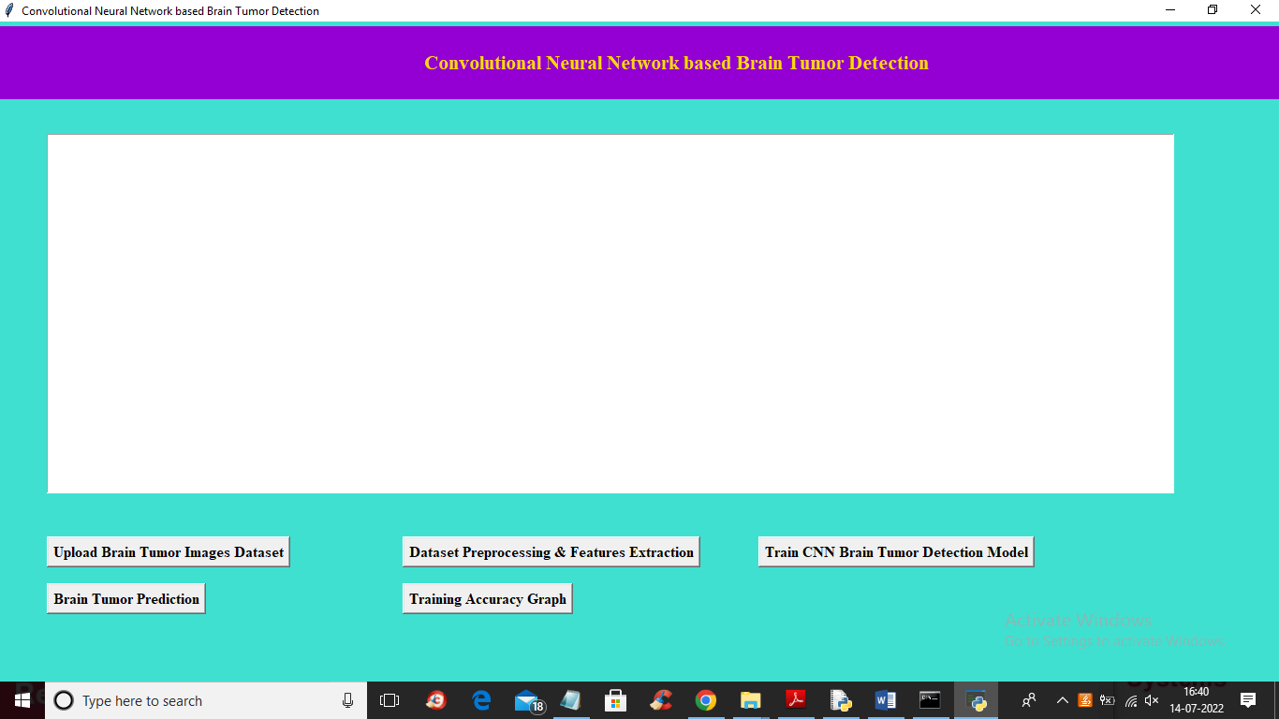

In above screen click on ‘Upload Brain Tumor Images Dataset’ button to upload dataset and get below screen

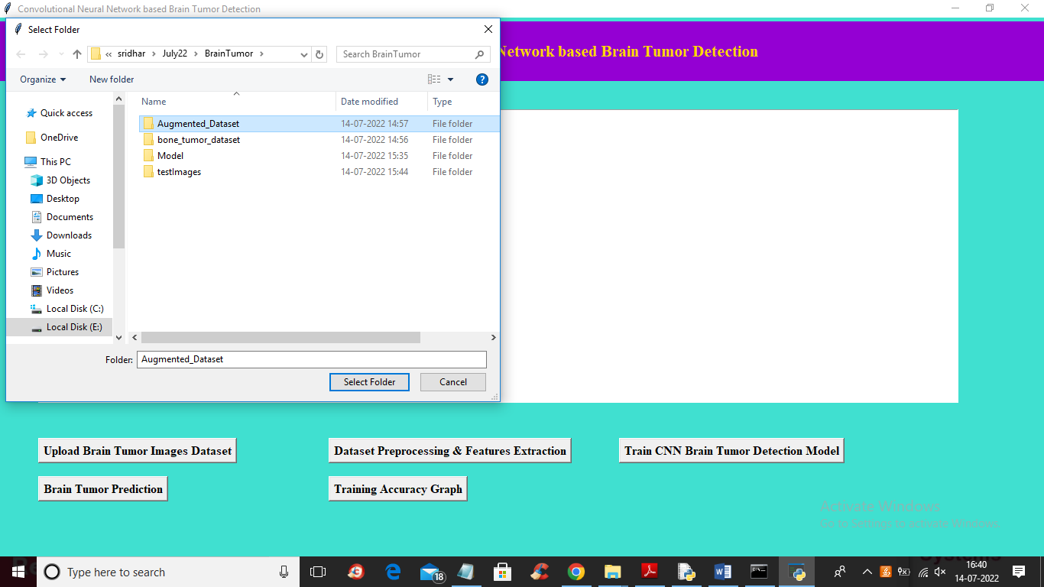

In above screen selecting and uploading ‘Augmented Dataset’ folder and then click on ‘Select Folder’ button to load dataset and get below output

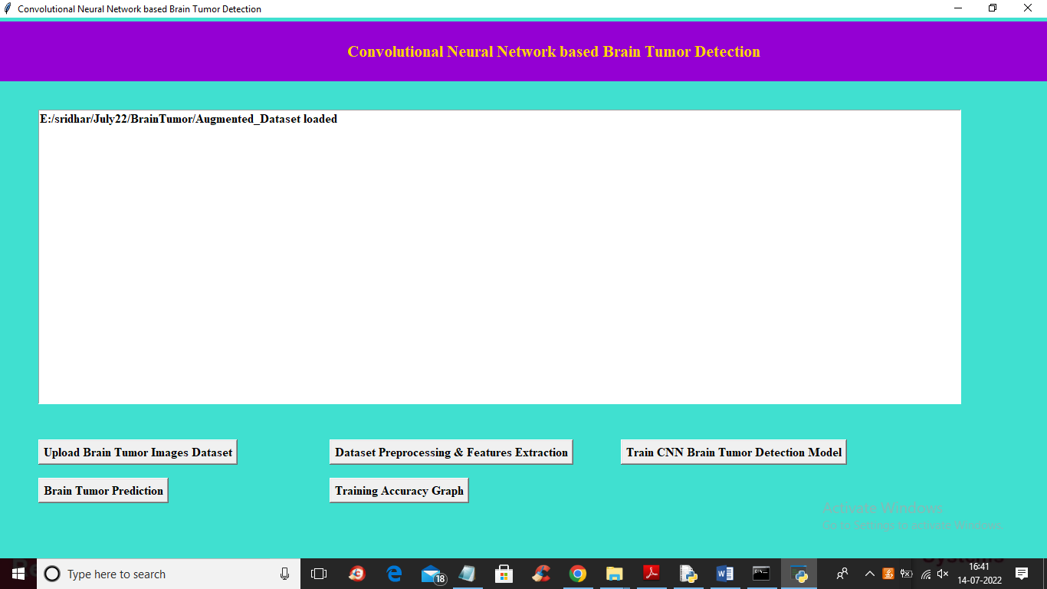

In above screen dataset loaded and now click on ‘Dataset Preprocessing & Features Extraction’ button to read all images and then process them

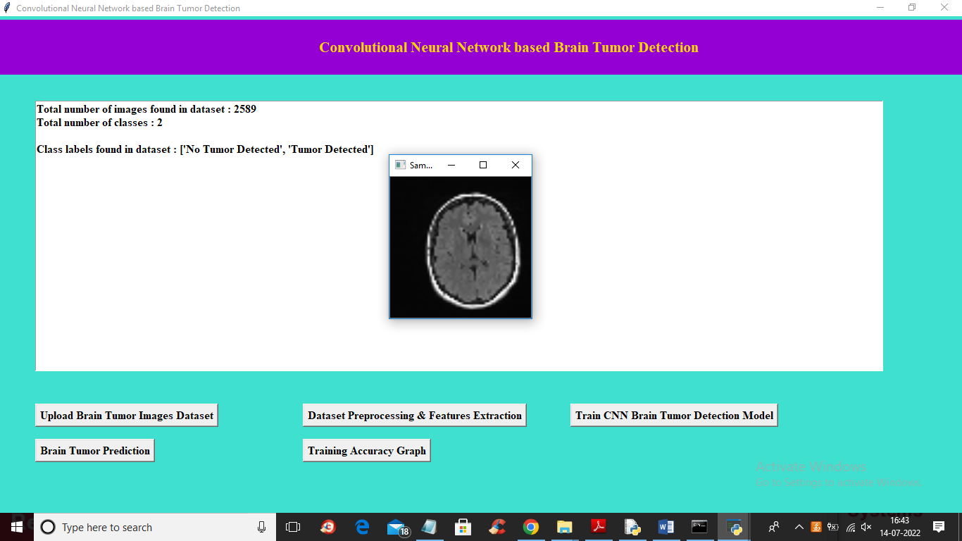

In above screen we can see application processed all 2589 images which has 2 classes such as Yes (Detected Tumor) or No (No Tumor detected) and then displaying sample processed image to check images are loaded properly and now close above image and then click on ‘Train CNN Brain Tumor Detection Model’ button to train CNN on processed images and get below output

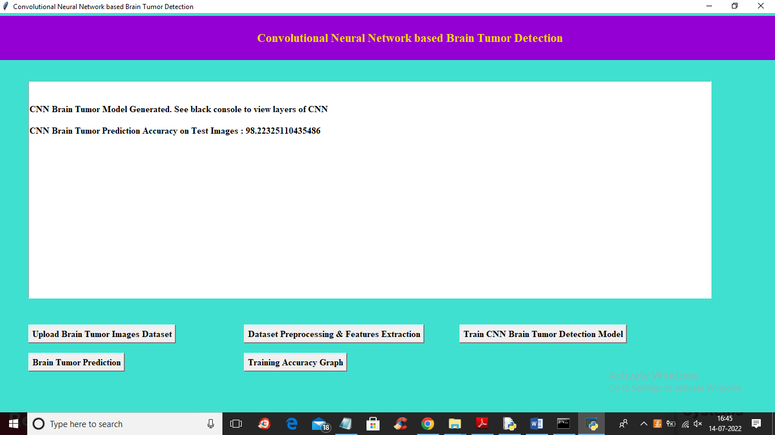

In above screen CNN training completed and we got its accuracy as 98% and now click on ‘Brain Tumor Prediction’ button to upload test image and get below output

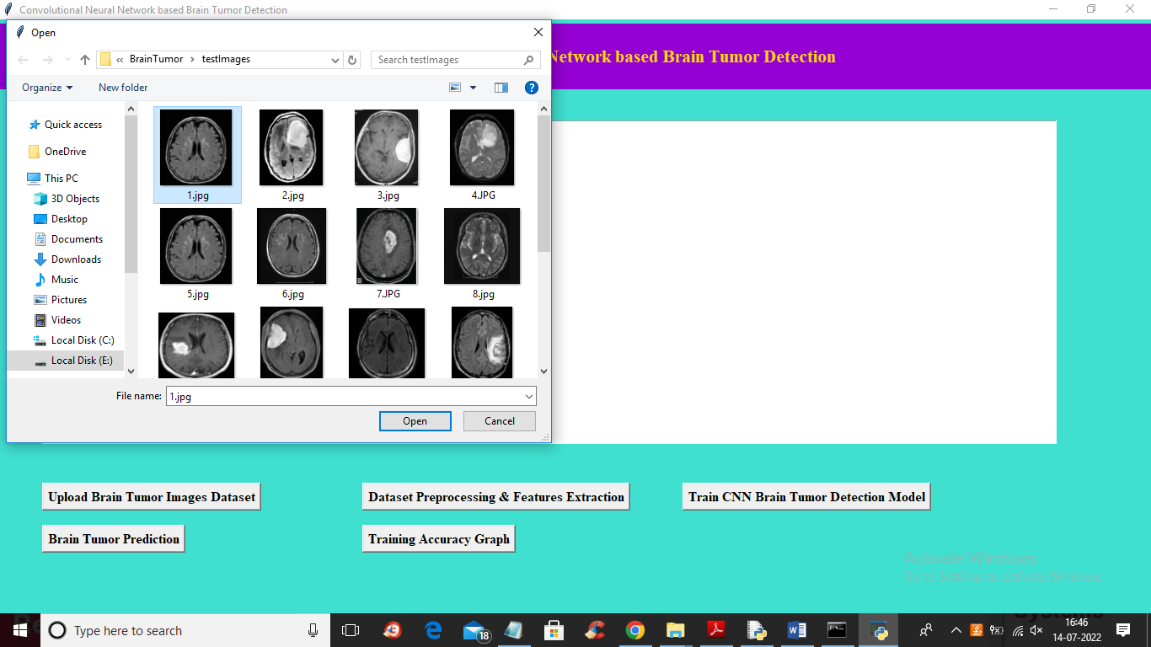

In above screen selecting and uploading ‘1.jpg’ file and then click on ‘Open’ button to get below output

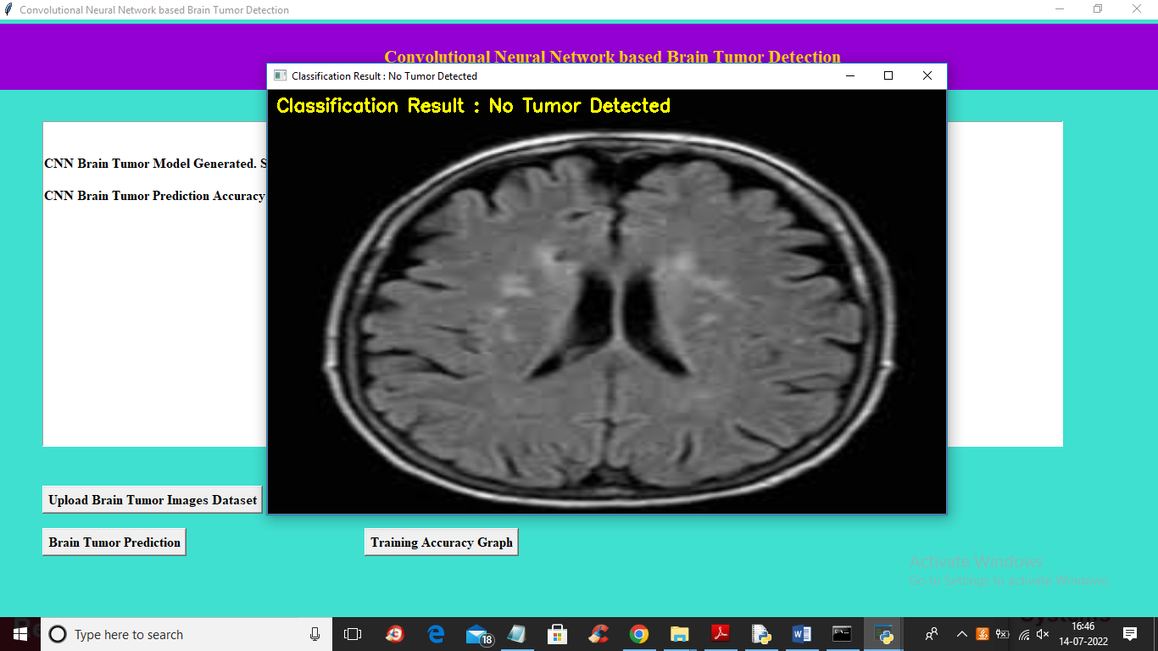

In above screen we can see CNN classification result as ‘No Tumor Detected’ and now upload other images and test

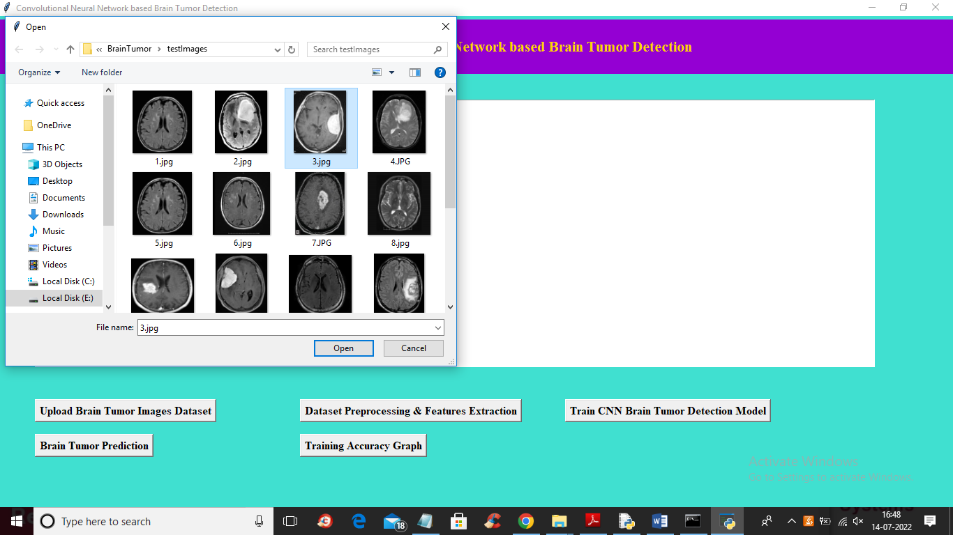

In above screen selecting and uploading ‘3.jpg’ file and then click on ‘Open’ button to get below output

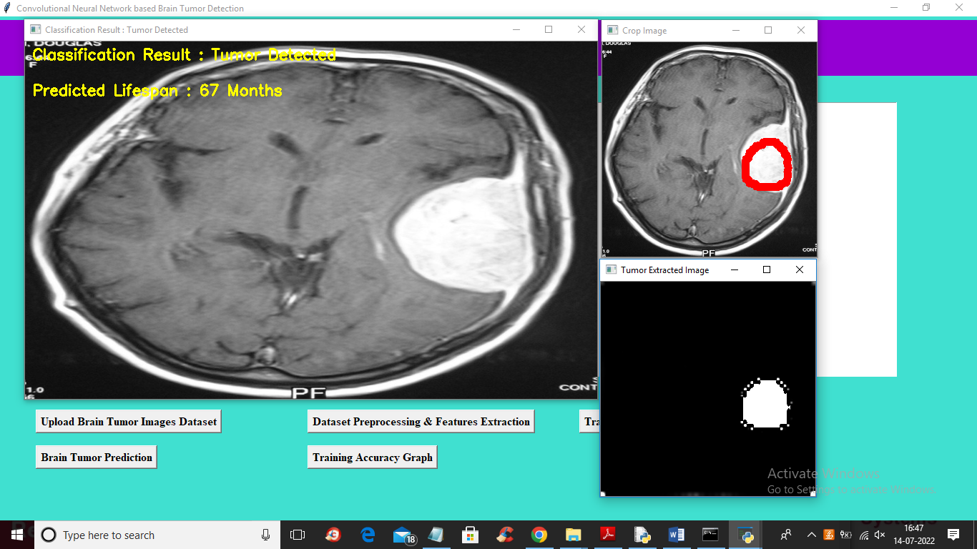

In above screen in first big image displaying classification result as ‘Tumor Detected’ with life span as 67 months and in second image we are cropping tumor region with red circle and then in 3rd image we are displaying cropped part of tumor. Similarly you can upload and test other images like below output

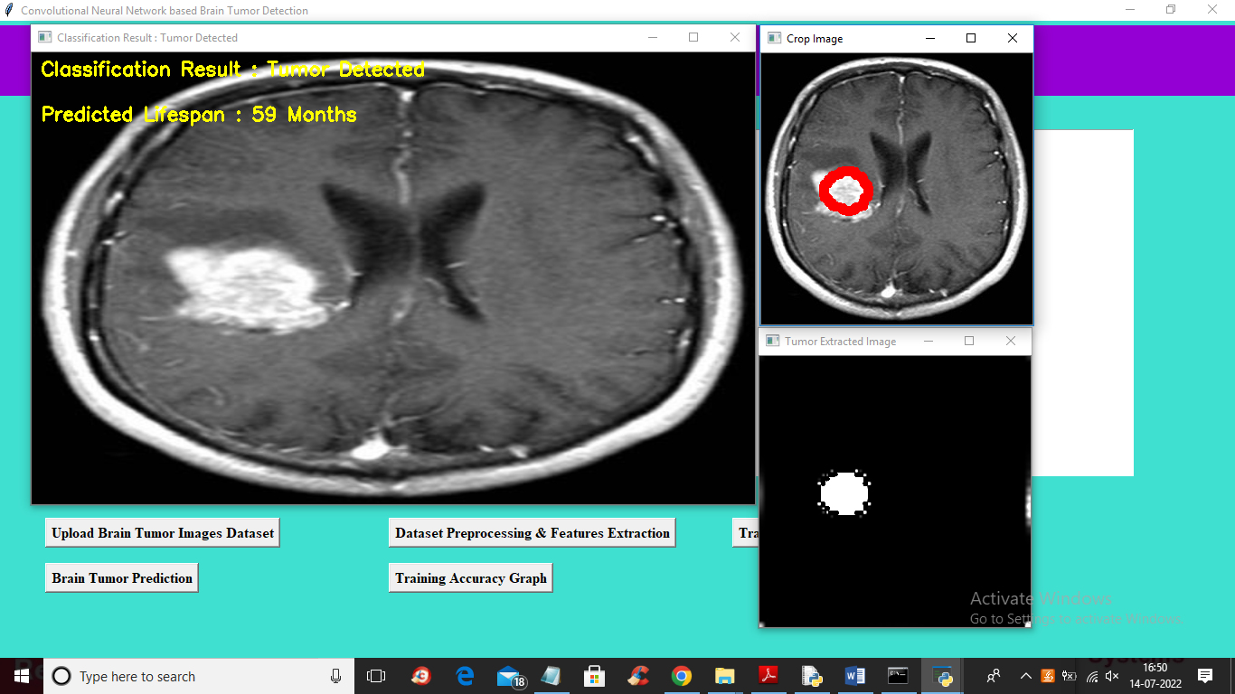

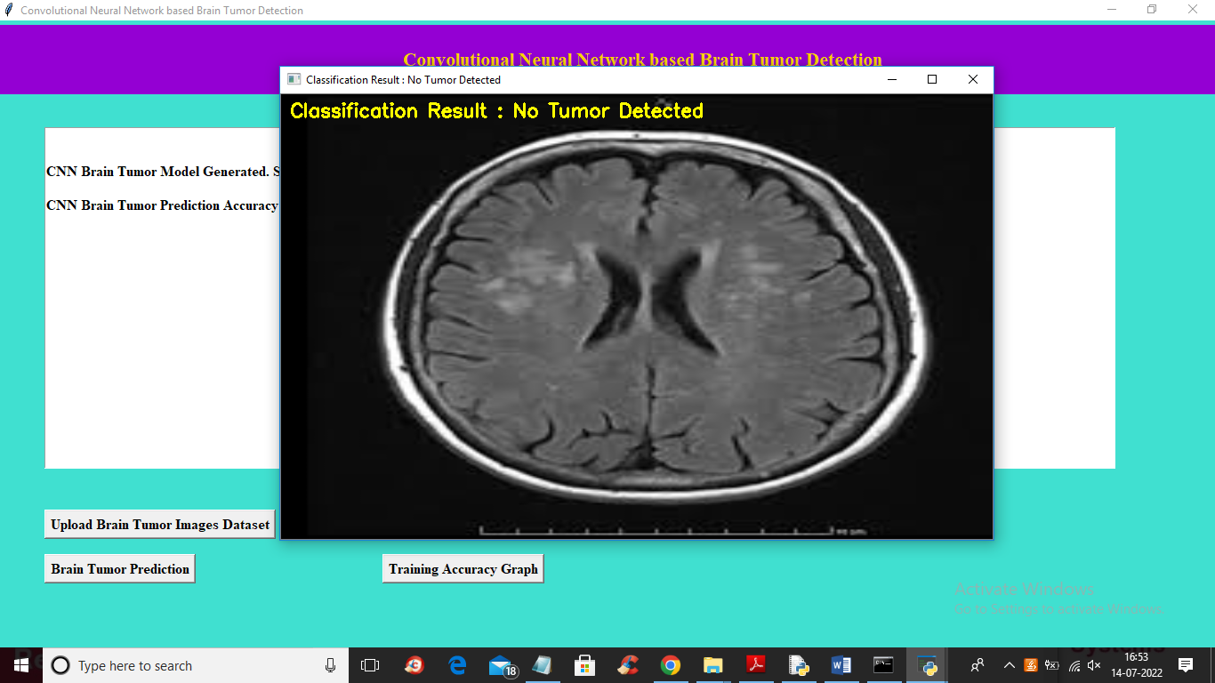

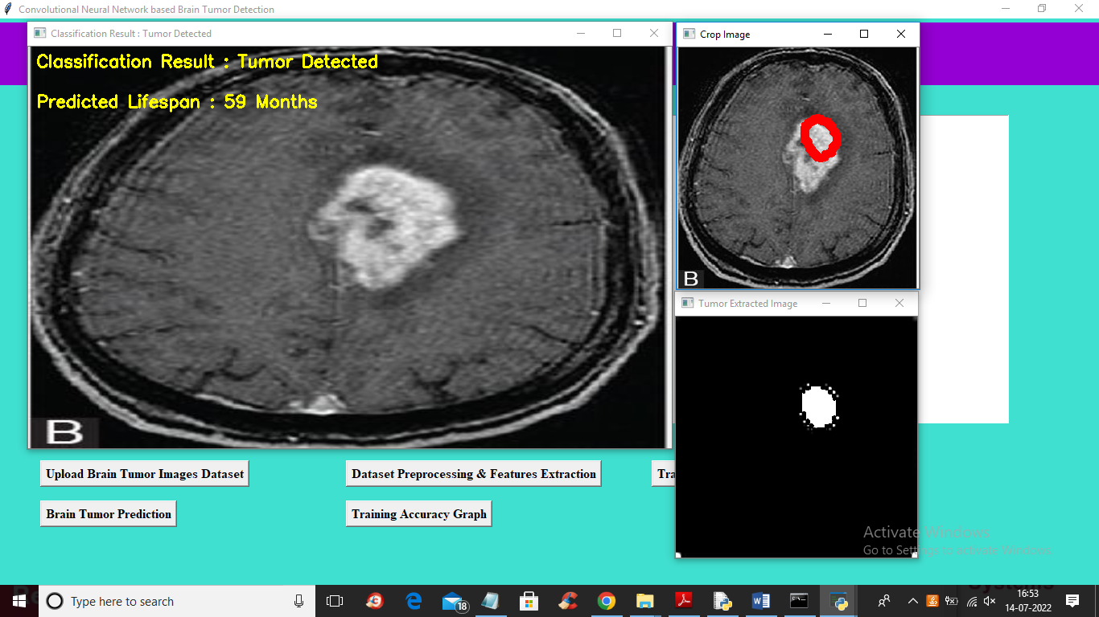

Now click on ‘Training Accuracy Graph’ button to get below graph

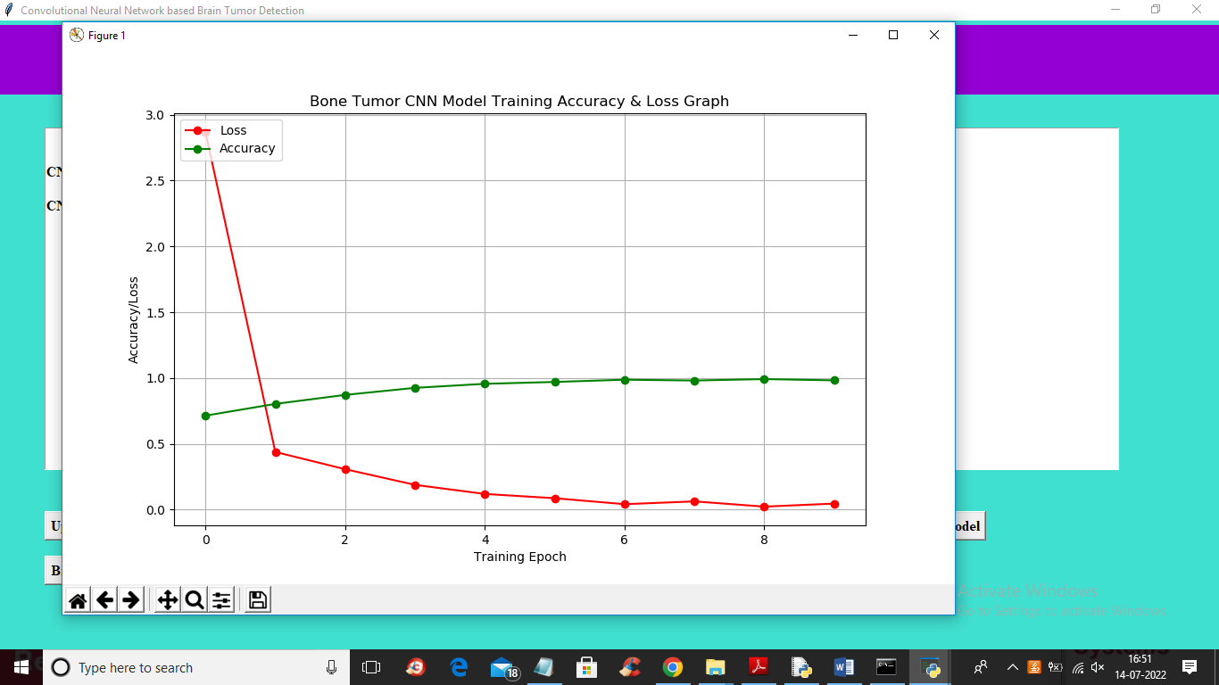

In above CNN training graph x-axis represents EPOCH and y-axis represents accuracy and loss values and green line represents ACCURACY and red line represents LOSS and in above graph we can see with each increasing epoch accuracy got increase and reached close to 1 and loss values get decreased and reached to 0.