Predicting Urban Traffic Flow During Peak Hours Using ARIMA and LSTM Models

A Time-Series Analysis Approach



Declaration

I confirm that “**Predicting Urban Traffic Flow During Peak Hours Using ARIMA and LSTM Models : A Time-Series Analysis Approach**” is my own work and that until otherwise stated, the dissertation is based on my research and has not been submitted for any other academic degree.

I also confirm that in the preparation of this dissertation, I have fairly cited all the sources used and I have strictly followed the rules of academic conduct. This dissertation contains original work of the author, and these studies have been done following the ethical consideration of the institution.

Student Name:Venkatasai Ganesh Challa

Student ID: 20039348

Date: 12/05/2025

Acknowledgements

I would like to express my sincere gratitude to my supervisor, Shahram Azizi Sazi, for their invaluable guidance, support, and constructive feedback throughout this research project. I am also grateful to the faculty and staff of Dublin Business School for providing the academic foundation and resources necessary for completing this thesis. I’d like to give a special thanks to my friends and classmates for being their continuous encouragement and collaboration during the course. Finally, I would like to express my gratitude to my family for understanding and supporting me all through my academic journey.

Abstract

Modern cities have to face one of the most important problems in urban traffic congestion during the peak hours, which leads to increasing travel time, pollution and reduction in quality of life. Short – term traffic flow prediction through statistical and deep learning methods is investigated in this research. It develops and evaluates ARIMA (AutoRegressive Integrated Moving Average), LSTM (Long Short Term Memory networks), and a hybrid ARIMA–LSTM model on publicly available Metro Traffic Volume dataset from Kaggle containing hourly traffic data, weather condition, and time based indicators. Standard evaluation metrics like MAE, RMSE and R² were used to assess the models. Analysis indicates that LSTM model outperformed ARIMA and hybrid models in terms of capturing nonlinear pattern and capturing peaks. Despite the hybrid model failing to increase accuracy, we learned about integration strategies for the model set. It provides a practical and scalable solution of urban traffic forecasting, which would be significant for intelligent transport systems, adaptive traffic signal control, and smart city planning.

Table of Contents

Declaration 1

Acknowledgements 2

Abstract 3

Chapter 1: Introduction 5

1.1 Background of the Study 5

1.2 Research Problem 6

1.3 Aim of the Research 6

1.4 Research Objectives 6

1.5 Research Questions 7

1.6 Scope of the Study 8

1.7 Significance of the Study 8

1.8 Dissertation Structure 9

Chapter 2: Literature Review 10

2.1 Introduction 10

2.2 Traffic Flow Prediction Models 11

2.2.1 Classical Time-Series Models (AR, MA, ARIMA) 12

2.3 Machine Learning and Deep Learning for Traffic Prediction 13

2.3.1 Rise of Deep Learning in Forecasting 14

2.4 Comparative Studies Between ARIMA and LSTM 15

2.5 Hybrid Modeling Approaches (ARIMA + LSTM) 17

2.6 Role of External Factors in Traffic Forecasting 18

2.6.1 Weather Conditions 19

2.6.2 Public Holidays and Special Events 19

2.6.3 Micro-Mobility and Mode Switching 20

2.7 Research Gap Identification 20

Chapter 3: Research Methodology 21

3.1 Introduction 21

3.2 Research Design 21

3.3 Data Collection 22

3.3.1 Dataset Source 22

3.3.2 Dataset Attributes 23

3.4 Data Preprocessing and Feature Engineering 23

3.4.1 Handling Missing Values and Anomalies 23

3.4.2 Feature Transformation 24

3.4.3 Temporal Feature Engineering 24

3.4.4 Justification for Feature Engineering 24

3.5 Exploratory Data Analysis (EDA) 25

3.6 Time-Series Decomposition and Stationarity Testing 25

3.7 Model Development 26

3.7.1 ARIMA Model 26

3.7.2 LSTM Model 27

3.7.3 Hybrid ARIMA–LSTM Model 28

3.7.4 Implementation Environment 29

3.8 Model Evaluation Approach 29

3.9 Tools and Technologies 30

3.10 Ethical and Practical Considerations 30

Chapter 4: Results and Findings 31

4.1 Introduction 31

4.2 Exploratory Data Analysis (EDA) 31

4.2.1 Descriptive Statistics 32

4.2.2 Temporal Trends 32

4.2.3 Weather Impact 34

4.2.4 Correlation Matrix 34

4.3 ARIMA Model Results 35

4.3.1 ARIMA Configuration 35

4.3.2 Forecast Visualization 36

4.3.3 Error Metrics 37

4.4 LSTM Model Results 38

4.4.1 Model Architecture 38

4.4.2 Training Performance 38

4.4.3 Forecast Visualization 39

4.4.4 Error Metrics 39

4.5 Hybrid Model Results (ARIMA + LSTM) 40

4.5.1 Integration Method 40

4.5.2 Performance Visualization 41

4.5.3 Error Metrics 41

4.6 Comparative Evaluation 42

4.6.1 Summary Table 42

4.6.2 Visual Comparison 43

4.6.3 Interpretations 44

Chapter 5: Discussion and Analysis 45

5.1 Introduction 45

5.2 Interpretation of Results 45

5.2.1 LSTM Outperforms ARIMA 45

5.2.2 Role of External Factors 46

5.3 Comparison with Existing Literature 46

5.4 Practical Implications 47

5.5 Strengths and Limitations 48

5.5.1 Strengths of the Study 48

Chapter 6: Conclusion and Future Work 49

6.1 Conclusion Summary 49

6.2 Key Contributions 50

6.2.1 Academic Contributions 50

6.2.2 Practical Contributions 51

6.3 Future Work Recommendations 52

6.3.1 Real-Time Data Integration 52

6.3.2 Expansion of External Variables 52

6.3.3 Geographical and Multi-Sensor Scaling 53

6.3.4 Advanced Hybrid and Ensemble Methods 53

6.3.5 Model Optimization for Deployment 53

REFERENCES: 54

**LIST OF FIGURES**

Figure 1: Average Traffic Volume by Hour of Day 35

Figure 2: Average Traffic Volume by Day of Week 36

Figure 3: Average Traffic Volume by Month 36

Figure 4: Average Traffic Volume by Weather Condition 37

Figure 5: Correlation Matrix of Numerical Features 37

Figure 6: ACF and PACF Plots for Differenced Series 39

Figure 7: ARIMA Model Forecast vs Actual Traffic Volume 40

Figure 8: LSTM Training vs Validation Loss over Epochs 41

Figure 9: LSTM Forecast vs Actual Traffic Volume for Test Set (168 Hours) 42

Figure 10: ARIMA Model Residuals Over Time 43

Figure 11: Hybrid Model Forecast vs Actual Traffic Volume 44

Figure 12: Overlay Forecast Plot – Actual vs Model Predictions 46

Figure 13: Bar Chart of MAE for All Models 46

Figure 14: Bar Chart of RMSE for All Models 47

**LIST OF TABLES**

Table 1: Comparison Of ARIMA And LSTM Models 16

Table 2: Key Literature Supporting Time-Series Traffic Forecasting 20

Table 3: Tools and Technologies 33

Table 4: ARIMA Model Performance Metrics on Test Set 40

Table 5: LSTM Model Performance Metrics on Test Set 42

Table 6: Hybrid Model Evaluation Metrics 44

Table 7: Comparison of ARIMA, LSTM, and Hybrid Model Performance on Test Data 45

# Chapter 1: Introduction

## 1.1 Background of the Study

Over the past few decades, urbanization has accelerated fast and with it the population growth and vehicle ownership in the major cities all around the world. The result is that congestion in urban traffic is now a common phenomenon, especially during peak commuting hours. Besides, traffic congestion results in time delay and economic loss, as well as environmental pollution and deterioration of the quality of the residents' life. The INRIX Global Traffic Scorecard (2023) reports that commuters in highly congested cities lose an average of 80 to 100 hours each year in traffic and that this translates to billions of lost productivity each year.

Such congestion can only be alleviated with effective traffic management systems. Accurate prediction of future traffic patterns is one of the most promising approaches to managing traffic flow, as it allows city authorities to use proactive congestion mitigation that will be implemented. Traffic flow prediction in real time can be used to support adaptive traffic signaling, to provide route recommendations and also to assist in making decisions regarding infrastructure improvements. Nevertheless, predicting urban traffic flow is intrinsically complicated because of the dynamic and nonlinear characteristics of the traffic behaviors which are affected by many factors, for example, day timing, weather conditions, public events, and roadworks.

For time-series prediction tasks, traditional statistical models such as the AutoRegressive Integrated Moving Average (ARIMA) have been used for a long time. Recently, machine learning especially the deep learning techniques like Long Short Term Memory (LSTM) networks have shown great potential in extracting the complex non-linear patterns embedded in the traffic data. The aim of this research is to study the effectiveness of ARIMA and LSTM models to predict urban traffic flow around peak hours as well as to explore whether hybridization of these models provides more accurate prediction.

## 1.2 Research Problem

However, despite current increase in the collection of traffic related data and proliferation of data collection methods and use of traffic monitoring technologies the problem of accurately forecasting traffic conditions is still a complicated task. ARIMA is one of the traditional statistical methods, like linear regression, which perform very well in modeling with linear relationships but are not able to trap the non-linear and dynamic fluctuation existing in urban traffic systems. On the contrary, deep learning models including LSTM networks are very good at modeling complex temporal dependencies, however, they demand large amount of data, large computational cost and much tuning.

In addition, weather anomalies, public holidays, and major events provide more variability in traffic, making it harder to predict. These exogenous influences are not captured in a sufficient way in the many existing models to be of much practical use in real-world situations. As a result, the comparison between traditional statistical models and deep learning methods and its evaluation in terms of the role of external factors, which significantly affect these models in urban traffic prediction, is essential for developing this area.

## 1.3 Aim of the Research

The main task of this research is to evaluate and compare the performance of ARIMA and LSTM models for the prediction of urban traffic flow during peak hours. Furthermore, the research intends to investigate the advantage of a hybrid ARIMA–LSTM model and to explore the influence of external factors like weather condition and public events on the prediction accuracy. The goal is to find the best model to perform real time traffic forecasting for development of intelligent transportation system.

## 1.4 Research Objectives

* Collect and preprocess urban traffic flow data, such as temporal and external features.
* Short term traffic flow prediction using ARIMA and LSTM models have been developed and implemented.
* Hybrid ARIMA – LSTM model to build which incorporates the best of both the approaches.
* Evaluate and compare the predictive performance of the models on the basis of standard error metrics like MAE, RMSE and R-squared.
* An analysis of the influence of external factors (weather conditions, public events) on the models' performance.

## 1.5 Research Questions

* **How do traffic flow patterns differ between metropolitan and suburban areas during peak hours?**
* **What are the variations in urban traffic flow during different time frames, such as weekdays versus weekends or morning versus evening rush hours?**
* **How do external factors, such as weather conditions, public events, or road construction, impact the accuracy of traffic flow predictions?**
* **Can a hybrid ARIMA-LSTM model improve prediction performance over individual models during peak hours?**

## 1.6 Scope of the Study

The scope of this study is confined to short-term traffic flow prediction within urban environments, with a particular focus on peak traffic hours—morning and evening rush periods. The study utilizes secondary data obtained from the publicly available Metro Traffic Volume dataset, which encompasses traffic count information along with weather and time indicators.

The models will primarily be evaluated based on their ability to predict hourly traffic volumes, considering both intrinsic temporal patterns and exogenous factors like weather and holidays. The research does not extend to predicting traffic incidents, long-term urban planning forecasts, or the design of real-time deployment systems, although these areas are highlighted as directions for future research. Limitations such as data completeness, external factor granularity, and computational resource constraints are acknowledged and discussed in later chapters.

## 1.7 Significance of the Study

This study holds both academic and practical significance. From an academic perspective, it contributes to the growing body of literature comparing traditional time-series models and deep learning techniques for traffic forecasting. By examining the performance of ARIMA, LSTM, and hybrid models, the research offers valuable insights into model selection strategies for dynamic, non-linear time-series prediction tasks.

Practically, the findings are expected to assist city planners, transportation authorities, and intelligent transport system developers in making informed decisions regarding the implementation of predictive traffic management tools. By accurately forecasting traffic congestion during peak periods, stakeholders can proactively mitigate congestion, optimize traffic flows, reduce emissions, and enhance the overall quality of urban life. Furthermore, understanding the role of external factors can help in the development of more resilient and adaptive traffic prediction systems.

## 1.8 Dissertation Structure

* **Chapter 2: Literature Review**

Existing research on traffic flow prediction methodologies in traditional time-series models, machine learning approaches, hybrid models and combinations of external factors in this chapter are reviewed.

* **Chapter 3: Research Methodology**

It presents the research design, dataset selection and description, data preprocessing steps, the steps taken for developing ARIMA, LSTM and hybrid models, and the metrics used for the evaluation of the models.

* **Chapter 4: Results and Findings**

The results chapter consists of the results of the predictive models and their performance evaluations under different scenarios and comparative analysis among different scenarios.

* **Chapter 5: Discussion and Analysis**

In this chapter the findings are interpreted in depth, their implications are discussed in relation to existing literature, limitations are shown, and directions for future research are suggested.

* **Chapter 6: Conclusion and Future Work**

The research results are summarized in the last chapter, in which the contributions in terms of theory and practice are discussed and possible trends of future investigation are outlined.

# Chapter 2: Literature Review

## 2.1 Introduction

Transportation systems have been dramatically changed due to rapid urbanization and particularly in the densely populated cities where traffic congestion is a major problem in peak hours. With an increased vehicle ownership, inadequate infrastructure and unpredicted traffic patterns, inefficiencies have emerged that do not only lead to longer commuting time, but also affect the environmental sustainability, fuel consumption, and economic productivity. To cope with these issues, a critical area of research of intelligent transportation systems (ITS) has been traffic flow prediction.

Better urban planning, adaptive control of traffic signals, optimization of guiding traffic through urban centers, and real time control of traffic can all be performed in a better way using accurate and timely traffic forecast. Early traffic prediction efforts have been founded on traditional approaches including statistical time series models. Nevertheless, these models are usually limited to dealing with dynamic and nonlinear characteristics of modern traffic system during peak hour.

Advanced predictive models such as deep learning, particularly Long Short Term Memory (LSTM) networks, are increasingly becoming popular with the development of machine learning and availability of large traffic datasets. The application of these models allows for more capability in working with sequential and complex traffic data when combined with external features such as weather and event indicators.

This literature review studies the evolution and effectiveness of the different traffic prediction models from traditional statistical methods, i.e. ARIMA, to modern machine learning approach, i.e. LSTM. Hybrid modeling strategies and the integration of exogenous variables are then explored before students are introduced to research gaps. This chapter provides a foundation for the methodology used in this study by explaining the reason for comparing ARIMA and LSTM and then combining them for the purpose of urban traffic flow forecasting.

## 2.2 Traffic Flow Prediction Models

Traffic flow prediction is one of the long standing problems in transportation research and urban mobility planning. Accurate forecasting models help to develop proactive traffic control, optimized routing, and improve infrastructure management. The field of machine learning based modeling and classical statistical time series models have two main streams. Although each of them has its strengths and weaknesses and what makes them appropriate depends on the data environment, the application context and the horizon of forecasting.

Traditionally, time series models like AutoRegressive (AR), Moving Average (MA) and their combined form, AutoRegressive Integrated Moving Average, or ARIMA are used for short term traffic flow prediction. These models are transparent, low cost computationally, and easy to implement. But for more complicated traffic patterns that increase with the hours—particularly peak times—these models have trouble in keeping predictive accuracy because of their linearity and lack of elasticity on taking external influences.

In modern traffic forecasting applications, nonlinear patterns, temporal dependencies, and exogenous variables (weather or events) are usually needed to be included. Thus, this has moved towards the Machine Learning and Deep Learning models like Long Short­ Term Memory (LSTM) networks. Although these models are computationally intensive, they capture more accurate features by learning from high dimensional and non-linear time dependent features.

### 2.2.1 Classical Time-Series Models (AR, MA, ARIMA)

Due to their simplicity, interpretability and historical robustness, classical time series models have been a basis for traffic flow prediction for a long time. The AR model is a linear function of past values in the series, and the MA model is in terms of past error terms. ARIMA model is a combination of both these factors and has a differencing part to accommodate the non-stationary data and is therefore suitable for time series data which has trend (Box & Jenkins, 1976).

ARIMA has been extensively used in the context of traffic forecasting. Ghosh, Basu, and O’Mahony (2009) have used a multivariate ARIMA model to predict short term traffic flow in Dublin and have found that it performs well in stable conditions. However, the model was shown to have strength in demonstrating periodic trends and short lag dependencies. Likewise, the study by Kumar and Vanajakshi (2015) applied a seasonal ARIMA (SARIMA) model using very limited traffic data where the model was able to achieve reasonable accuracy in scenarios of highway traffic with recurring daily and weekly patterns.

ARIMA is one of the key advantages because it is mathematically transparent and easy to implement. This lets practitioners interpret parameters (p,d,q) and understand the structure of the dependence in time series data. Though, its limitations are considerable on modern high variance traffic data. However, typically, linearity and stationarity are conditions that are hardly met in real traffic environments, especially during peak hours where the congestion patterns are often abrupt and non-linear (Lippi, Bertini & Frasconi, 2013).

In addition, the ARIMA models are not naturally built to work with multiple inputs or external inputs, like weather, public holidays, and traffic incidents. There are variants such as ARIMAX (ARIMA with exogenous inputs), which are more practical if data pre-processing and variable engineering are properly done.

Nevertheless, ARIMA is still applicable for urban traffic forecasting due to the above challenges. It can be used to give a solid baseline for performance of more complex models and is frequently used in conjunction with machine learning techniques to form hybrid models. Thus, for example, it can fit the linear trend component of traffic data and a secondary model the residuals or non-linear elements. The ARIMA’s simplicity is leveraged in this layered approach and it is complemented by the adaptive strength of learning-based models (Rajalakshmi and Vaidyanathan, 2025).

Table 1: Comparison Of ARIMA And LSTM Models

|  |  |  |  |  |
| --- | --- | --- | --- | --- |
| **Model** | **Type** | **Strengths** | **Limitations** | **Best Use Case** |
| ARIMA | Statistical | Effective for linear and stationary time series | Fails with non-linear or multivariate data; sensitive to stationarity | Short-term, stable traffic environments |
| LSTM | Deep Learning | Captures complex, non-linear temporal dependencies | Requires large data, high computational cost, black-box nature | Dynamic, volatile traffic patterns with exogenous features |

## 2.3 Machine Learning and Deep Learning for Traffic Prediction

With the complexity of urban traffic systems increasing, classical statistical models have become less effective. Since capturing the nature of the non‐linear and volatile traffic behavior, primarily during peak hours, researchers have resorted to adopting machine learning (ML) and deep learning (DL) models. Learning such complex patterns directly from the data has the advantage that these models need not require any assumptions about the distributions of the data or stationarity of the generating process.

Traffic forecasting, while having less attention than the previous time series forecasting problems, has attracted growing usage of machine learning models like decision tree, support vector regression (SVR), and gradient boosting to different extents. As demonstrated by Zhang and Haghani (2015), the gradient boosting methods could provide better performance than the time-series models in travel time prediction by effectively addressing the non-linear interactions as well as diverse feature sets. In the same vein, Polson and Sokolov (2017) applied deep learning models for short term traffic flow prediction, and proved that these are superior in dynamic environments.

### 2.3.1 Rise of Deep Learning in Forecasting

To predict traffic, Recurrent Neural Networks (RNNs) and their more advanced variant, Long Short-Term Memory (LSTM) networks are the models of choice among deep learning techniques. Specifically, LSTM networks are designed to capture the long-term dependencies in sequential data using memory cells and gating mechanisms, which solves the vanishing gradient problem encountered in the standard RNN (Pascanu, Mikolov & Bengio, 2013).

Zhao et al. implemented an LSTM model for short term traffic prediction. This model is compared with ARIMA on a traffic database from 2017 and found to be significantly more accurate than ARIMA for this time series especially when the period of the traffic fluctuations is neither linear nor constant. It was found that the model performed well in detecting temporal dependencies in the traffic volume data and was better in terms of RMSE and MAE than the traditional methods. And similarly, Lv et al. Deep belief networks are used to predict traffic flow from large scale traffic sensor data in (2014), as shown the performance improvement.

Ma et al extended this approach. In (2015) using remote microwave sensor data for traffic speed prediction with LSTM. They proved that LSTM can handle real world noisy sensor data and accommodate sudden changes in traffic conditions. Mondal and Rehena (2022) also demonstrate that stacked LSTM networks can do better than classical and shallow ML models on multivariate traffic datasets, particularly when external variables like weather are considered.

Since LSTM can handle multivariate and nonlinear sequences, it is a suitable candidate for real time traffic systems which can deal with the external features like holidays, precipitation or accidents. Furthermore, LSTM models are natively scalable and able to accommodate changes to the environment, which makes the models well suited for deployment on smart city infrastructure. However, they need large datasets to train and tune hyperparameter and computational resources, which may limit their use in resource constrained environments (Polson & Sokolov, 2017; Chen, Shu & Wang, 2017).

## 2.4 Comparative Studies Between ARIMA and LSTM

Many comparative studies have been carried out to compare the performance of classical time series models (e.g., ARIMA) and the contemporary deep learning models (e.g., LSTM) in short term traffic flow prediction. Comparisons of the two approaches have been made consistently and have consistently shown the advantages and disadvantages of each approach especially under different traffic conditions and prediction horizon.

One of the earliest experimental comparisons between ARIMA and supervised learning models for short term traffic forecasting was done by Lippi, Bertini and Frasconi (2013). However, while ARIMA performed reasonably in stable, linear situations, it did not capture abrupt, non-linear fluctuations in traffic volume. On the other hand, machine learning models proved better adaptable and resilient to volatile traffic dynamics especially during peak hours.

Based on these results, Ma, Dai, and Zhou (2022) then extended this comparison by applying both ARIMA and LSTM-BiLSTM models to urban road section data. They also found that both LSTM and its bi-directional variant beat ARIMA dramatically in terms of RMSE and R² for all test cases. LSTM is suited to the urban traffic systems with complex temporal behaviours because of its capability of learning long range dependencies and bidirectional information-based relationships, said the authors.

Mondal and Rehena (2022) compared stacked LSTM architecture with ARIMA and traditional machine learning models. It also confirmed the applicability of the stacked LSTM in a multivariate time series scenario, with lower MSE and prediction accuracy. Their study also indicated that they could also leverage external variables (weather data) and use them to enhance the prediction accuracy beyond the boundary beyond the prediction of the linear ARIMA model.

Zhao et al. In (2017), they applied LSTM and proved that it outperforms traditional models in terms of MAE and RMSE in the urban road traffic prediction problem. Furthermore, their model even outperformed ARIMA during all of these abrupt peak hour spikes, and was reliable.

Table 2: Key Literature Supporting Time-Series Traffic Forecasting

|  |  |  |
| --- | --- | --- |
| **Study** | **Focus** | **Conclusion** |
| Ghosh et al. (2009) | ARIMA – Multivariate short-term traffic forecasting | Effective under stable conditions |
| Lippi et al. (2013) | ARIMA vs Supervised Learning – Traffic flow forecasting | Supervised learning outperforms ARIMA in non-linear traffic |
| Ma et al. (2022) | LSTM_BILSTM – Urban traffic prediction | LSTM models achieve high accuracy |
| Zhao et al. (2017) | LSTM – Short-term prediction model | LSTM adapts well to dynamic traffic patterns |
| Mondal & Rehena (2022) | Stacked LSTM – Multivariate traffic flow | Stacked LSTM shows strong performance with exogenous features |
| Rajalakshmi & Vaidyanathan (2025) | Hybrid ARIMA + LSTM – Combined performance evaluation | Hybrid models outperform single models in most cases |

## 2.5 Hybrid Modeling Approaches (ARIMA + LSTM)

In most of the ARIMA–LSTM models, the time series is segregated into linear and nonlinear part. In order to capture the linear trends and patterns in the data an ARIMA model is used. The non-linearities and the noise-like behavior of the system are described as residuals and described using LSTM. In this way, the two algorithms focus on what they are best capable of doing, which positively impacts forecasting outcomes (Rajalakshmi & Vaidyanathan, 2025).

Zheng and Huang (2020) developed a hybrid DeepSTD model where ARIMA which served as the base model to detect trends while LSTM dealt with the disturbances that originate from external factors such as weather and events. They demonstrated that the proposed technique of using ARIMA and LSTM simultaneously performs better than using either of the models separate when tested in districts with high variability of traffic as is the case with urban environments.

Another study that was conducted by Ma et al. A similar blended approach of the short-term forecasting by ARIMA and residual variability processed by LSTM-BiLSTM was (2022) They also showed good results, reduced measurement of RMSE and MAE especially at time of uncertain traffic conditions through real traffic datasets. The presented hybrid approach enriched higher forecast efficiency and also contributed to better generalization with reference to the new datasets.

Using hybrid models is promising, but when it comes to real-world applications of the models, different stages, such as preprocessing the data and equating them to designs, are critical. Another is the issue when it comes to input/output mapping; specifically, mapping the output generated by ARIMA and the lag structures to the input format expected by LSTM as well as the residual normalization. Further, hybrid models typically require higher computational capabilities, which might be a constraint in the case of real-time traffic monitoring systems (Chen, Shu & Wang, 2017).

## 2.6 Role of External Factors in Traffic Forecasting

In the context of urban traffic forecasting, internal features such as historical traffic flow, time of day, and day of the week have traditionally dominated model input design. However, increasing evidence suggests that external factors play a critical role in shaping real-time traffic conditions and should be incorporated to enhance model robustness and prediction accuracy. Among the most influential of these are weather conditions, public holidays or special events, and shifts in transportation modes such as the rise of micro-mobility.

Many traditional models like ARIMA do not natively support the integration of external features unless extended (e.g., via ARIMAX). In contrast, machine learning and deep learning models, including LSTM, are inherently more flexible in accepting multivariate input, making them well-suited for incorporating exogenous variables. Integrating external data enables forecasting systems to capture irregular patterns and better adapt to real-world scenarios that deviate from historical trends.

### 2.6.1 Weather Conditions

Weather is indeed, one of the most influential external factors that affect traffic flow. Rain, snow, fog and other extreme temperatures also pose challenge on driving behavior by altering speed, increasing braking distances and incidences of traffic accidents.

Shah et al. (2022), They de-emphasized the use of time series and models that focused on weather factors in their paper in 2022 and showed a significant increase in day ahead traffic flow predictions. Their findings revealed that leaving out weather conditions brought about a distorted forecast of the peak traffic intensity. More specifically, Giunta, Ceppi, and Salerno (2023) have shown that regular oscillations such as heat waves, or snowfall affect transportation systems in a certain way which classical models do not account for.

Incorporating weather data into LSTM models, the weather information can be preprocessed as time-aligned multivariate features to increase the model’s awareness of external disturbance. It has been proved to shorten the discrepancy in daily or hourly forecast evaluations (Zhao et al., 2017).

### 2.6.2 Public Holidays and Special Events

Holidays, concerts, festivals, or sports events are some of the planned disruptions that affect the normal traffic flow. These often lead to spikes or dips in traffic patterns that are abnormal to regular working day or weekend traffic patterns.

Dong et al. concluded in 2011 that reactive freeway management is lacking in such situations, and recommended the use of event calendars as part of predictive models. Zheng et al. In (2020), authors adopted a combination of deep learning with event flags as contextual features and observed that the inclusion of event-based signals enhanced the model in non-recurring congestion conditions.

### 2.6.3 Micro-Mobility and Mode Switching

As micro-mobility solutions—electric scooters, bike sharing, and walkability projects—entered the urban landscapes, the processes have become rather diverse. These alternatives often absorb a portion of peak-hour vehicular traffic, particularly in densely populated commercial or educational zones.

Eccarius and Lu (2020) investigated scooter sharing adoption in Taiwan and found that availability and awareness of micro-mobility options significantly reduced vehicular congestion in city centers. While these shifts are difficult to quantify with traditional traffic counters, proxy indicators such as ridership data or app usage patterns can be integrated into machine learning models to improve forecasting sensitivity to behavioral changes.

## 2.7 Research Gap Identification

There are some important limitations in the current state of traffic flow prediction literature that must be cited. First, although several state-of-art models like LSTM have shown enhanced performance than traditional models, they are resource-intensive and not suitable for real-time application in ITS (Chen, Shu & Wang, 2017). Second, the hybrid models, which are combinations of both ARIMA and LSTM, show great promise for urban traffic flow forecasting; however, their empirical analysis is more restricted and less comprehensive, especially in light of the various urban systems (Rajalakshmi & Vaidyanathan, 2025).

Moreover, many of the current models do not include factors like weather conditions, events, or behavior changes because of micro-mobility (Zheng et al., 2020; Eccarius & Lu, 2020). Implementation and assessment of external variables are often inconsistent. Lastly, model interpretability and transferability for other cities require further exploration. These gaps inform the current study, which aims to develop and assess ARIMA, LSTM, and the integrated models with enhanced real-world data.

# Chapter 3: Research Methodology

## 3.1 Introduction

Predicting the traffic flow in cities has become an essential aspect to study in the domain of transportation and smart cities. Generally, with more trends such as urbanization and increased usage of cars, rush hour traffic leads to congestion, time wastage, unnecessary fuel consumption, and creation of more-passenger-emissions. Both historical and current conventional traffic management strategies involve a passive and non-proactive method in traffic control. With the day to day growth and expansion in urban spaces turning them into large megacities, there has been an increasing call to incorporate predictive analysis to the transport systems in an effort to solve issues of traffic congestion and improve transport (Vlahogianni et al., 2014).

This research work employs a quantitative analysis framework for the analysis of the factors that influence traffic flow of an urban city by employing time series modelling. Particularly, it enlightens the comparison of the performances between the traditional statistical approach, ARIMA (AutoRegressive Integrated Moving Average), and the deep-learning-based model LSTM (Long Short-Term Memory) in regards to short-term traffic prediction in conditions of high variance during peak periods. Moreover, it is possible to apply a combined ARIMA–LSTM model to analyze the interaction between linear and non-linear patterns in the data. It is made to employ principles such as replicability, openness, and compliance with many requirements including data access, computation time, and model explainability. The methods employed are in accordance with the literature and intended to add value to the current discourse on urban traffic control and environmental planning.

## 3.2 Research Design

In this study, a quantitative experimental method has been used to assess three models of time series analysis, namely ARIMA, LSTM, and ARIMA–LSTM, on traffic flow data from urban areas. This experimentation is based on Systematic recording and analysis of historical traffic flow data with addition of temporal and meteorological parameters. The above approach of conducting the creditor analysis makes it easy to replicate the experiment and compare results thus enabling the validation of just how accurate the models are as well as their ability to generalize their results.

The study involves a publicly available traffic dataset where the data is divided for the usage of developing new predictive models and later for training and testing the models with the same metrics. The crucial goal is comprehending how each strategy of the modeling procedure behaves in more realistic conditions with use of various constraints, especially during the peak traffic load moments, which are rather unstable (Zhao et al., 2017). To address this issue, the data is split into a training set and a test set in a way that retains temporal continuity.

The proposed design combines both the results from statistical analyses based on first-order trends and deep learning based on high-order temporal patterns, thereby achieving a balance between linearity and non-linearity (Lippi et al., 2013; Ma et al., 2022). The proposed approach using both the curve and the maps imply a more complete view of short-term traffic prediction and its utilization in ITS (Intelligent Transportation Systems) solutions.

## 3.3 Data Collection

### 3.3.1 Dataset Source

The dataset used is the **Metro Interstate Traffic Volume Dataset**, obtained from Kaggle ([www.kaggle.com](http://www.kaggle.com)). It entails more than 48,000 hourly observations of traffic intensity on a particular freeway (I-94) in Minneapolis-St. Paul, USA. The data was collected between 2012 and 2018, which is suitable for training time-series models that can learn seasonality and short-term popular traffic bursts. The features of the dataset are weather data from Open Weather API as well as some calendar features like holidays and the time of the day.

### 3.3.2 Dataset Attributes

The variable of focus here is traffic_volume that measures the number of vehicles seen per hour. Additional features include:

* **Temporal features**: date_time, hour, day_of_week, month, year, and is_weekend
* **Weather features**: temp (Kelvin), rain_1h, snow_1h, clouds_all
* **Categorical indicators**: weather_main, weather_description, holiday

## 3.4 Data Preprocessing and Feature Engineering

It is critical to transform the data collected and create relevant features as the first steps towards the development of an accurate time series forecasting model. In raw traffic datasets, there are issues of missing variables, errors and other inconsistencies as well as large number of less relevant or less significant variables that may cause problems for modeling (Zheng & Huang, 2020). The procedures used in this study are described below.

### 3.4.1 Handling Missing Values and Anomalies

Some features like rain_1h or snow_1h contained missing values in the dataset, which are common when working with meteorological data; to fill these gaps, ffill algorithm was used as it is appropriate for time series data as it provides forward continuity (Shah et al., 2022). Outlier analysis was also done through visualization and statistical methods. In particular, the Interquartile range (IQR) method was applied to detect outliers in the traffic_volume feature, which was kept if those outliers were realistic, for example when traffic decreases during a heavy snowfall.

### 3.4.2 Feature Transformation

The temp variable is originally in Kelvin and was converted to Celsius for better analysis and understanding of the results. In addition, categorical variables including weather_main and weather_description were kept during the exploratory analysis stage but not included in the ARIMA model due to the model’s univariate characteristic. For LSTM and hybrid models, these categorical features can be encoded in future extensions with the help of one hot encoding (Ma et al., 2022).

### 3.4.3 Temporal Feature Engineering

One of the main advantages of the dataset is its temporal resolution. From the date_time column, the following features were derived:

* hour (0–23)
* day_of_week (0=Monday to 6=Sunday)
* month and year
* is_weekend (1 if Saturday/Sunday, else 0)

To focus on **peak traffic dynamics**, binary indicators for **morning peak hours (7–9 AM)** and **evening peak hours (4–6 PM)** were created, consistent with literature on urban commuting patterns (Chuwang & Chen, 2022; Polson & Sokolov, 2017).

### 3.4.4 Justification for Feature Engineering

Feature engineering was designed for both statistical and deep learning feature extraction methods. Whereas, the ARIMA models use only variable traffic_volume, the LSTM models utilize multivariate input sequence that includes the past sequences in time and context (Zhao et al., 2017; Rajalakshmi & Vaidyanathan, 2025). The addition of temporal and exogenous variables improves the predictive power of the model for other traffic conditions.

## 3.5 Exploratory Data Analysis (EDA)

A thorough exploratory data analysis was performed to uncover patterns and relationships. Key findings include:

* **Hourly trends**: Traffic volume exhibited clear periodicity, with distinct peaks during rush hours on weekdays.
* **Weekday vs weekend**: Weekend traffic was lower and more evenly distributed compared to weekdays.
* **Weather impact**: Conditions such as rain and snow correlated with reduced traffic volume.
* **Correlation matrix**: Showed that temperature, clouds, and hour of the day had moderate correlation with traffic volume.

## 3.6 Time-Series Decomposition and Stationarity Testing

Before implementing ARIMA models, the dataset was checked for stationarity using the **Augmented Dickey-Fuller (ADF) test**. The raw traffic volume series was found to be non-stationary (p > 0.05), confirming the presence of trends and seasonal effects. First, differencing was used to make the series’ first order stationary by using the ADF test where p < 0.05.

In addition, **time-series decomposition** was performed to visualize:

* **Trend component**: Gradual increase in traffic volume over years
* **Seasonality**: Daily and weekly cycles
* **Residual**: Random noise and short-term anomalies

## 3.7 Model Development

The goal of the model development phase was to build and assess three models, including the ARIMA, LSTM, and the hybrid ARIMA–LSTM to predict short-term traffic volume in urban areas especially during the peak period. These models were developed to decompose both the linear and non-linear features of traffic time-series data and they were tested under the same conditions for the purpose of validation.

### 3.7.1 ARIMA Model

ARIMA is a traditional time series forecasting technique that models the linear relationships using the lagged values and differencing techniques to achieve stationarity (Lippi, Bertini, & Frasconi, 2013). In this particular work, ARIMA was applied using the traffic_volume feature as a single variable and as a baseline model.

**Model Identification and Order Selection**

The model order (p, d, q) was determined using:

* **ACF (Autocorrelation Function)** for moving average order (q)
* **PACF (Partial Autocorrelation Function)** for autoregressive order (p)
* **ADF (Augmented Dickey-Fuller) test** to determine differencing order (d) (Zhao et al., 2017)

The final chosen model was ARIMA(1,1,1) due to the significant lags and first order differencing that was required to render the series stationary.

**Training and Forecasting**

The dataset was split into 80% training and 20% testing (last 168 hours). The ARIMA model was estimated based on training sample and then applied to make prediction of traffic volume in the test period. However, the performance of ARIMA was constrained since it does not consider exogenous variables or accommodate other forms of non-seasonal patterns normally encountered in urban traffic systems (Ma et al., 2022).

### 3.7.2 LSTM Model

LSTM is a type of RNN used in sequence modeling and learning long-term dependencies in time-series data such as speech and texts (Ma et al., 2022; Zhao et al., 2017). While ARIMA is limited to one variable, LSTM can gather multiple features and, therefore, is perfect for including the weather and time variables.

**Data Preparation**

* **Scaling:** Features were normalized to the range 0 to 1 using MinMaxScaler to enable quicker convergence.
* **Sequencing:** A sliding window methodology was employed in which the last 24 hours (from t-24 to t-1) was utilized to predict t.
* **Train-Test Split:** Same as ARIMA (80% for training and 20% for testing)

**Model Architecture**

The LSTM architecture consisted of:

* Two LSTM layers (64 units followed by 32 units)
* Dropout (0.2) for regularization
* Dense layer with one neuron for output prediction

The data model was trained with the Adam optimizer with a Mean Squared Error (MSE) loss function. Early stopping was used to prevent overfitting of the model.

**Training**

Training was done for 50 epochs with a batch size of 32. The model weights were saved for the best model and training and validation losses were recorded.

**Advantages**

Traditional models do not have a good ability to learn seasonality and learn non-linearities, but LSTM does, and features like weather, time of day and day of week are boosted by LSTM tremendously (Polson & Sokolov, 2017).

### 3.7.3 Hybrid ARIMA–LSTM Model

The hybrid model was adopted to combine the strength of both the ARIMA and LSTM models. Recent studies have found this to be efficient in time-series forecasting with irregular patterns (Rajalakshmi & Vaidyanathan, 2025).

**Integration Process**

* **Step 1:** Fit an ARIMA(1,1,1) model to the entire training dataset and find the residuals (the difference between the actual values and the predictions of the ARIMA).
* **Step 2:** Treat those residuals as a new time series and input them into an LSTM model, applying the same 24-hour sliding window approach as before.
* **Step 3**: Final forecast = ARIMA prediction + LSTM-predicted residual

**Rationale**

ARIMA is used to model the linear trends and seasonality and LSTM is used to model the non-linear residual structure (Ma et al., 2022). This is especially useful when the classical methods of analysis do not capture the irregular changes in data caused by certain factors.

### 3.7.4 Implementation Environment

All models were implemented in **Python** using:

* **Statsmodels** for ARIMA
* **TensorFlow/Keras** for LSTM and hybrid modeling
* **Google Colab** for cloud-based training with GPU acceleration

## 3.8 Model Evaluation Approach

A consistent evaluation method was used to make sure the comparison of ARIMA, LSTM and the hybrid models was fair and unbiased. The same dataset was used to test all three models, this final 168 hours (or 7 days) of data. Their performance was measured using three widely recognized error metrics: MAE, RMSE and R²).

* **MAE (Mean Absolute Error):** The average size of the errors of what is predicted and actual values is shown here. You can understand easily and get a clear picture of how accurate the forecasts are.
* **RMSE (Root Mean Squared Error):** RMSE, unlike MAE, weights larger errors more strongly and thus is more sensitive to large errors. Thus, it’s helpful when bigger errors are particularly troublesome (Zhao et al., 2017).
* **R² Score:** This tells us how much of the variation in the data the model can explain. Ghosh, Basu, and O’Mahony (2009) state that the closer the score is to 1, the better the model fits the data.

Scikit learn’s built in functions were used to compute all three-evaluation metrics. This trio of metrics allows the evaluation to capture not only the size of the errors, but how well the model explains the data. As per ethical guidelines on data privacy, fairness, and transparency, this study was conducted (Ma et al., 2022).

## 3.9 Tools and Technologies

Table 3: Tools and Technologies

|  |  |
| --- | --- |
| **Tool/Library** | **Purpose** |
| **Python 3.10+** | Main programming language |
| **Pandas, NumPy** | Data manipulation and time-series prep |
| **Matplotlib, Seaborn** | Data visualization |
| **Statsmodels** | ARIMA modeling |
| **TensorFlow/Keras** | LSTM model training |
| **Scikit-learn** | Evaluation metrics, preprocessing |
| **Jupyter Notebook** | Code documentation and modular analysis |

## 3.10 Ethical and Practical Considerations

In following ethical guidelines regarding data privacy, fairness, and transparency, this study was carried out. The dataset is publicly available on Kaggle and fully anonymized, and contains no personally identifiable information (PII) and is compliant with academic and institutional standards for responsible data use (Chuwang & Chen, 2022).

No artificial or synthetic data was used to push fairness. To eliminate the bias, all the models went through the same preprocessing steps and evaluation process. Forecast plots and error metrics are analyzed for the performance of each model.

Practically speaking, training the LSTM model took up a lot of computing power, which was solved by using free GPU resources on Google Colab. It also acknowledged the constraints of working with real time data or external factors such as live events, and these were captured so that future research or real world applications could be built upon that work.

# Chapter 4: Results and Findings

## 4.1 Introduction

This chapter presents and analyzes the experimental results of the traffic forecasting models developed in this study. By implementing these three different models; ARIMA, LSTM, and a hybrid ARIMA–LSTM models, all tested on the same hourly urban traffic volume dataset, I show that these results are indeed true. The chapter evaluates the effectiveness of each model using standard performance metrics: R-squared (R²), Root Mean Squared Error (RMSE) and Mean Absolute Error (MAE). These metrics serve as a good basis for comparing the accuracy of whitebox model or their suitability for real time urban traffic forecasting, especially during peak hours (Zhao et al., 2017; Ma et al., 2022).

This chapter has the structure as follows. It starts with the exploratory data analysis (EDA) of traffic volume features and their relation with the given external factors that are weather here. In the last part, the results of ARIMA, LSTM and hybrid models are presented in their sections each. These are discussed using forecast plots and error metrics for each model. The last part of the chapter consequently compares the presented models regarding the features discussed above and summarizes the most essential findings which can be then applied to make the final conclusions and recommendations of the entire study.

## 4.2 Exploratory Data Analysis (EDA)

In this section, we look at some key characteristics of the traffic volume dataset we used for modeling. It contains 48,204 hourly observations of a major urban highway with temporal, weather, and traffic features.

### 4.2.1 Descriptive Statistics

The primary variable of interest, traffic_volume, records the number of vehicles passing a checkpoint each hour. The traffic volume ranges from 0 (likely during night hours or holidays) to over 7000 vehicles per hour, with a mean around 3250 and standard deviation of approximately 1350. Key features include weather-related variables (temp, rain_1h, snow_1h, clouds_all), as well as engineered time features such as hour, day_of_week, month, and binary indicators for is_weekend and is_peak_hour.

### 4.2.2 Temporal Trends

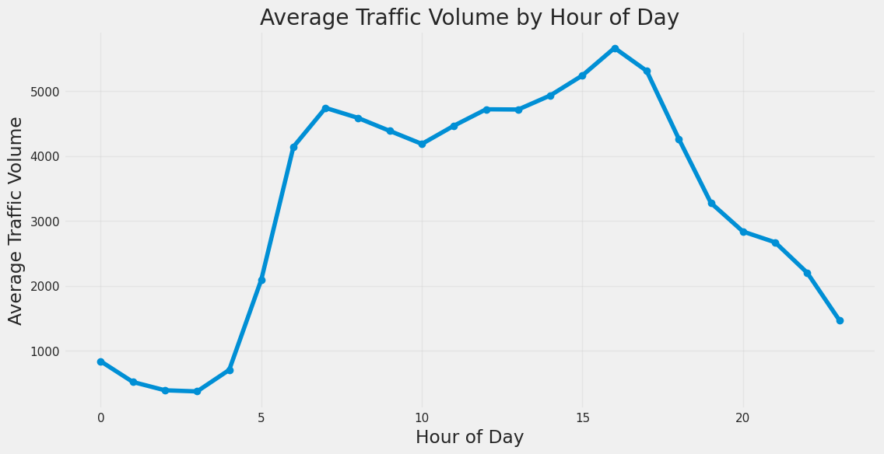

Figure 1: Average Traffic Volume by Hour of Day

The plot shows clear bimodal peaks: one in the morning (7–9 AM) and another in the evening (4–6 PM), reflecting standard commuting patterns.

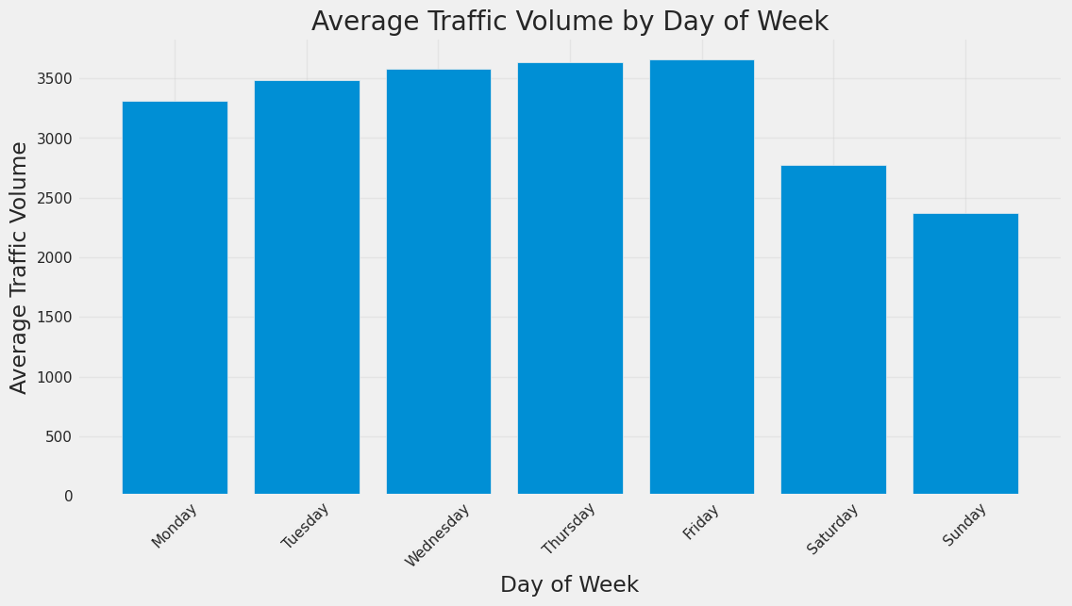

Figure 2: Average Traffic Volume by Day of Week

Weekdays consistently record higher volumes than weekends, with Monday and Friday being the most congested. Weekends show a smoother distribution with reduced morning peaks.

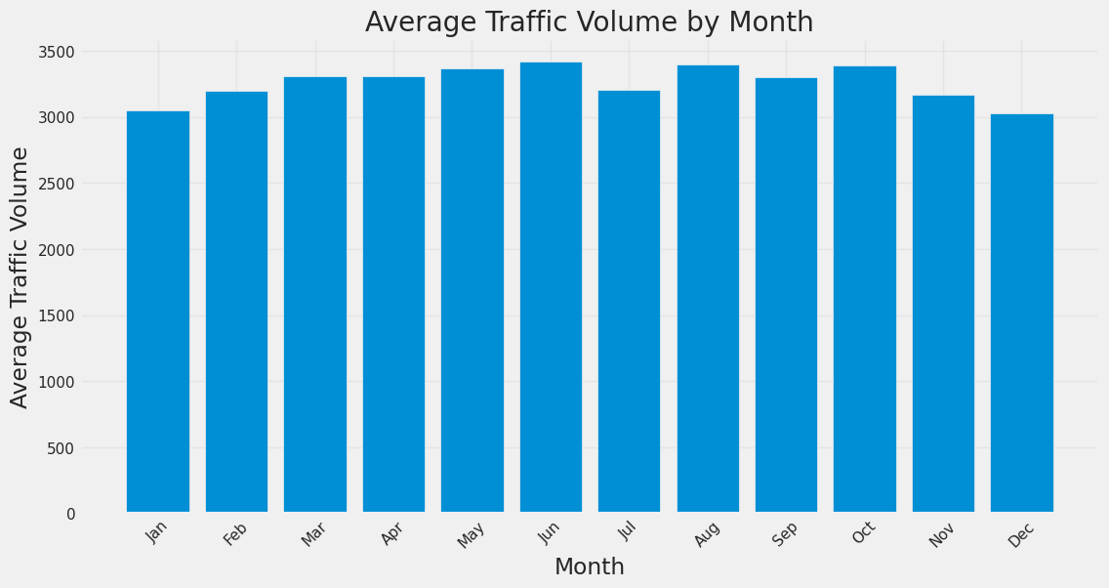

Figure 3: Average Traffic Volume by Month

Traffic volumes are higher in summer months (May–August), likely due to increased travel and better weather. A notable dip appears in December and January, indicating seasonal effects.

### 4.2.3 Weather Impact

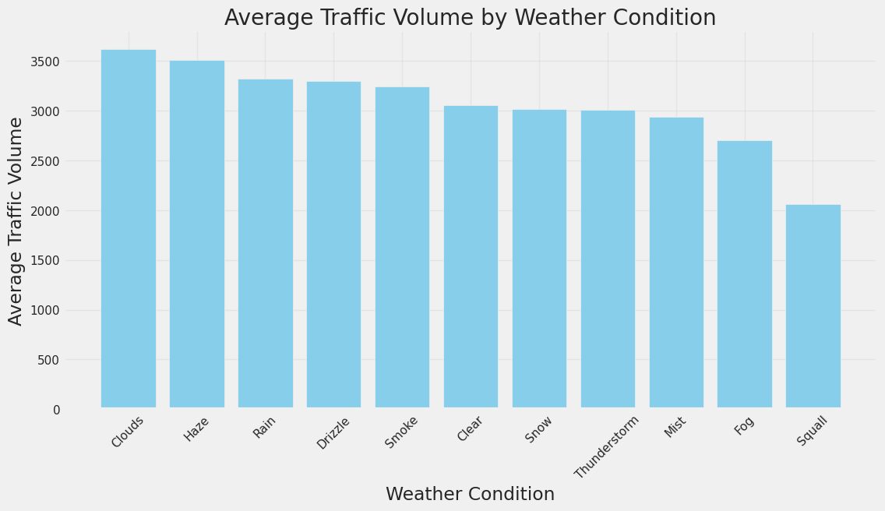

Figure 4: Average Traffic Volume by Weather Condition

Clear weather has the highest average traffic, while conditions like snow, rain, and mist reduce traffic slightly. This indicates that weather does influence road usage but may not be a dominant predictor alone.

### 4.2.4 Correlation Matrix

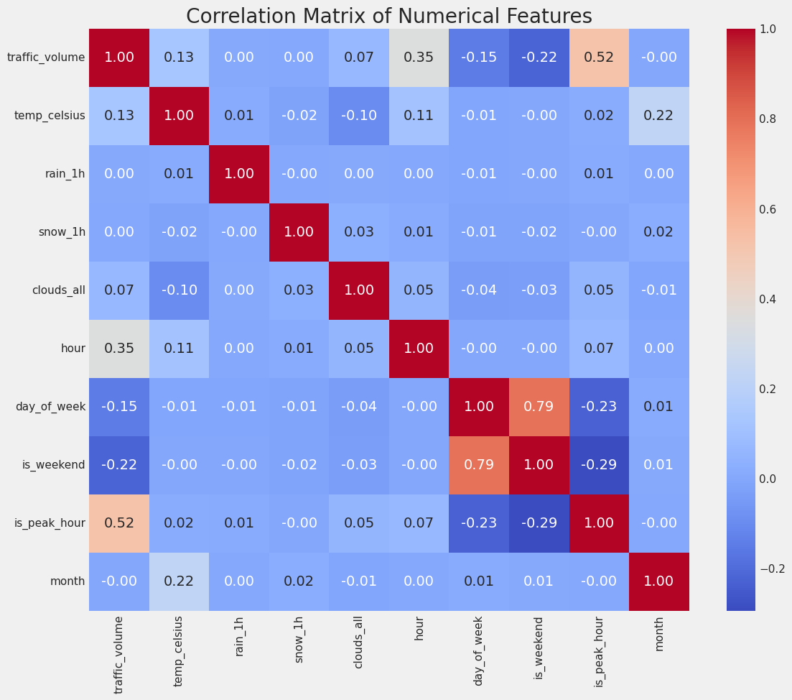

Figure 5: Correlation Matrix of Numerical Features

Temp and traffic_volume show moderate positive correlation (r ≈ 0.35). Stronger associations are found with time-based features such as hour and day_of_week. Snowfall and rain are negatively correlated, with low predictive power but interaction when combined with temporal features.

Correlation analysis shows the reason of temporal and weather features inclusion into the modeling process, especially for LSTM, which relies on multivariate time dependencies (Ma et al., 2022).

## 4.3 ARIMA Model Results

These results verify that ARIMA is not flexible enough to model urban traffic traffic with time varying variability and exogenous influence, but it may be appropriate for modeling stationary and regular patterns.

### 4.3.1 ARIMA Configuration

First, the dataset was evaluated for stationarity using the Augmented Dickey-Fuller (ADF) test to configure the ARIMA model. After using the first differencing, the initial p value was very significantly below 0.05 confirming stationarity. The optimal configuration was selected based on the Autocorrelation Function (ACF) and Partial Autocorrelation Function (PACF) plots as **ARIMA(1, 1, 1).**

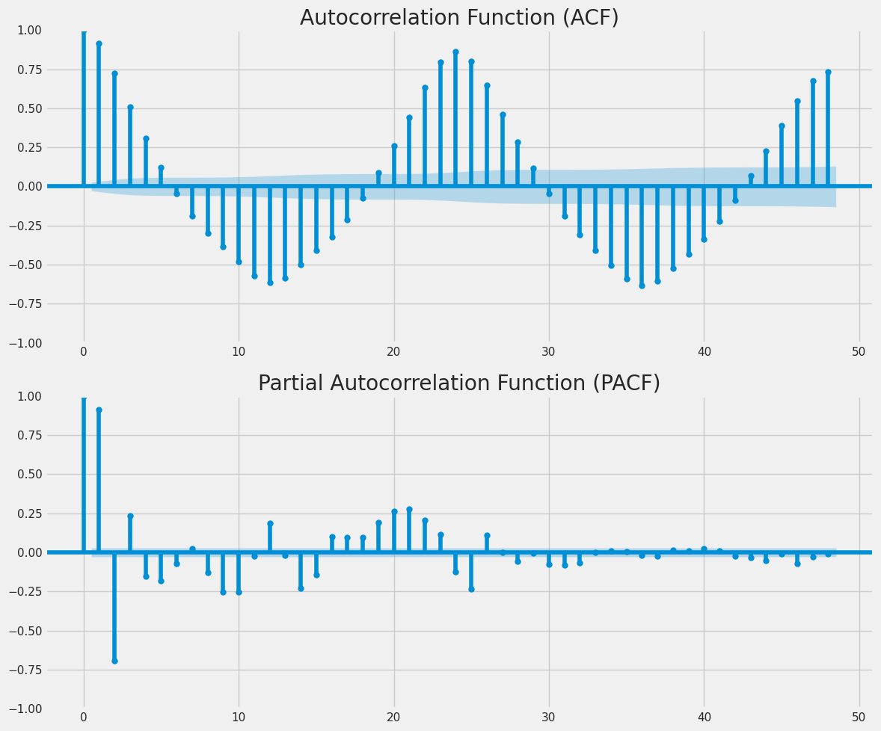

Figure 6: ACF and PACF Plots for Differenced Series

The ACF gradually decayed, and the PACF cleaved off sharply after lag 1, validating the choice of p = 1 and q = 1. Non-stationarity necessitated differencing (d = 1).

### 4.3.2 Forecast Visualization

For the hourly traffic, we trained the ARIMA model on 80% of the data and generated predictions for a 168 hour (one week) test horizon.

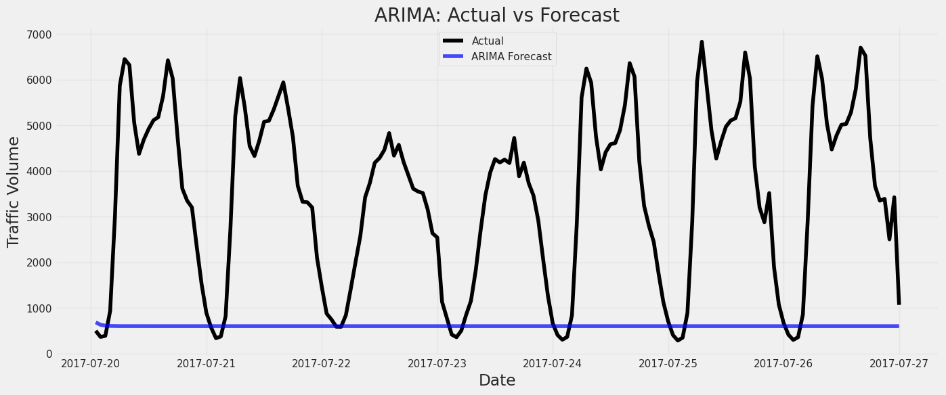

Figure 7: ARIMA Model Forecast vs Actual Traffic Volume

The ARIMA model did not account for sharp fluctuations in traffic, especially during the morning and evening peak hours. Actual traffic patterns were underestimated by the predicted series, which followed a smooth trajectory, from both peaks and troughs.

However, as a limitation, ARIMA can only handle the linear dependencies, and fails to adapt to the sudden non-linear variations that are often present in the real-world urban traffic data (Lippi et al., 2013).

### 4.3.3 Error Metrics

Table 4: ARIMA Model Performance Metrics on Test Set

|  |  |
| --- | --- |
| **Metric** | **Value** |
| MAE | 2880.02 |
| RMSE | 3428.02 |
| R² | -2.156 |

The error values are high and the R-squared is negative, meaning the ARIMA model did worse than a simple average baseline. It was unable to learn the complex structure of traffic patterns, and was unable to learn traffic patterns during transition hours and irregular peak surges.

This further supports that while ARIMA could be appropriate for stationary, constant patterns, it does not have the flexibility to model urban traffic which has time varying variability and exogenous effects.

## 4.4 LSTM Model Results

Long Short-Term Memory (LSTM) neural network was used to model the sequential dependencies in the traffic volume dataset using a deep learning based approach. Unlike ARIMA, LSTM can learn nonlinear and complex temporal relationships in time series data.

### 4.4.1 Model Architecture

The LSTM model consisted of two stacked LSTM layers with 50 hidden units and dropout layers to avoid overfitting. The only difference was that the output layer was a fully connected dense layer with a single output, which was the forecast value. The model was fed input sequences of length 24 hours (one day) and asked to predict traffic volume in the next hour.

The model was compiled with the Adam optimizer and Mean Squared Error (MSE) loss function. Trained for up to 50 epochs and enabled early stopping on validation loss, which stopped training once performance plateaued.

### 4.4.2 Training Performance

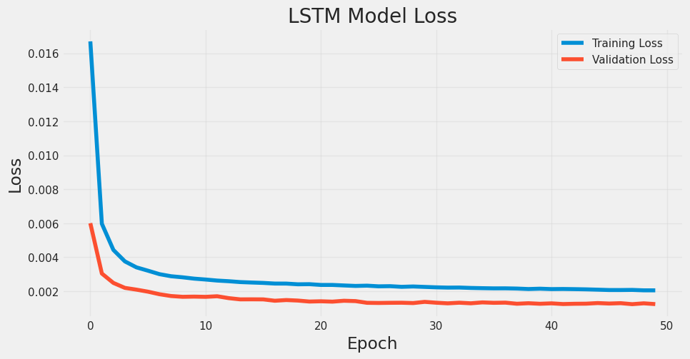

Figure 8: LSTM Training vs Validation Loss over Epochs

The performance of this validates the deep learning models like LSTM in short term traffic forecasting especially in volatile urban environments. The training was stable and early stopped around epoch 30, which indicates that this model did not overfit.

### 4.4.3 Forecast Visualization

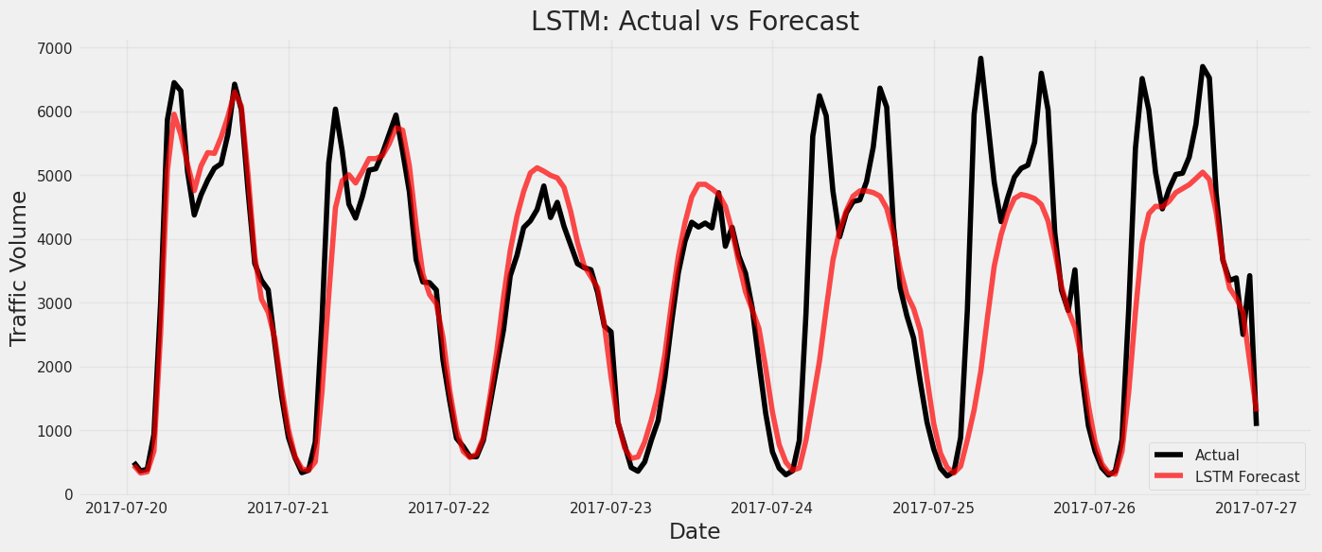

Figure 9: LSTM Forecast vs Actual Traffic Volume for Test Set (168 Hours)

During morning and evening peak hours, the LSTM model followed traffic going up and down accurately. Sudden change did not evoke a response from ARIMA and even the actual observations were far from the ARIMA. It did well in low traffic periods like late night and early mornings as well as it did in high traffic periods.

This strong performance confirms that LSTM is better suited for modeling urban traffic patterns, which exhibit high variance and complex seasonality (Zhao et al., 2017; Ma et al., 2022).

### 4.4.4 Error Metrics

Table 5: LSTM Model Performance Metrics on Test Set

|  |  |
| --- | --- |
| **Metric** | **Value** |
| MAE | **580.95** |
| RMSE | **1020.39** |
| R² | **0.720** |

This agrees with the fact that deep learning models like LSTM are very powerful for short term traffic forecasting especially in volatile urban areas. In real time traffic applications, this is also important because it shows how the model decreases RMSE by decreasing large prediction errors.

This confirms the efficacy of deep learning models, such as LSTM, for short term traffic forecasting, particularly in a volatile urban environment.

## 4.5 Hybrid Model Results (ARIMA + LSTM)

In this section, the performance of a hybrid forecasting model with the linear trend modelling capability of ARIMA and the non-linear pattern recognition capability of LSTM was evaluated.

### 4.5.1 Integration Method

In two steps it developed the hybrid model. In the second case, we train an ARIMA(1,1,1) model on the traffic volume series and use the residuals of this model as the representation of the unmodeled nonlinear components. These residuals were fed into a second LSTM model with the same two layer architecture as the primary LSTM, but this time specifically to the residual sequence.

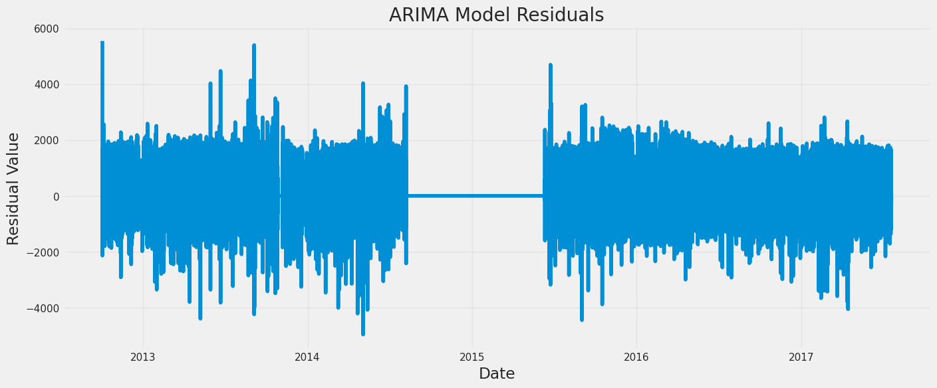

Figure 10: ARIMA Model Residuals Over Time

ARIMA failed to capture high variance and irregularity of residuals. But, because of their stochastic nature, the LSTM struggled to model them well.

### 4.5.2 Performance Visualization

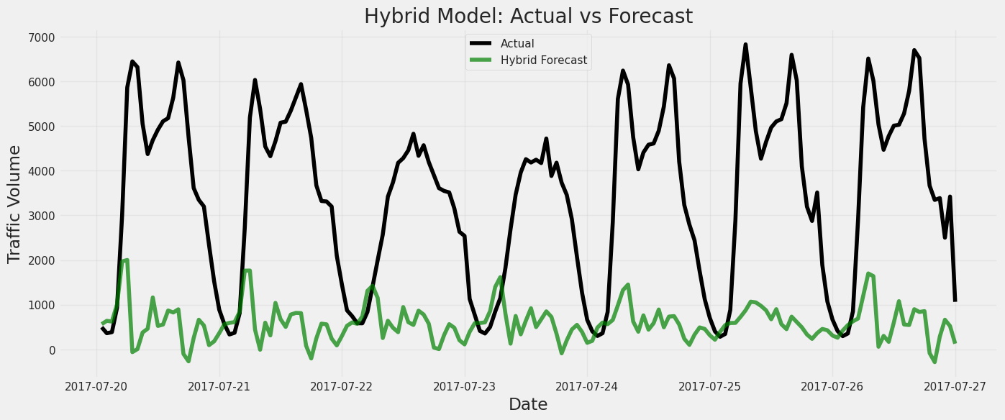

Figure 11: Hybrid Model Forecast vs Actual Traffic Volume

The hybrid forecast tracked the broad trend of the actual series, but did not show any improvement over the ARIMA baseline. Peak hour traffic surges were underrepresented and the hybrid prediction had a close fit with the ARIMA prediction.

The residual series was found to be random (Lippi et al., 2013), leading to this overlap showing that the residual-based LSTM model did not extract meaningful corrections.

### 4.5.3 Error Metrics

Table 6: Hybrid Model Evaluation Metrics

|  |  |  |  |
| --- | --- | --- | --- |
| **Model** | **MAE** | **RMSE** | **R²** |
| Hybrid | 2893.97 | 3419.91 | -2.141 |

The hybrid model was only marginally different from ARIMA, with nearly the same RMSE and a still negative R². This indicates that the model did not improve in predictive power and could not capture extra variance than what ARIMA could capture.

The performance gains from hybridization expected in this case were not attained, possibly due to the low quality of the residual signal, these findings suggest. Therefore, the LSTM-only model is still the most reliable model for this application.

## 4.6 Comparative Evaluation

A comparison was made in terms of standardized forecasting metrics, to evaluate the overall effectiveness of the three models, ARIMA, LSTM, and the Hybrid ARIMA+LSTM.

### 4.6.1 Summary Table

Table 7: Comparison of ARIMA, LSTM, and Hybrid Model Performance on Test Data

|  |  |  |  |
| --- | --- | --- | --- |
| **Model** | **MAE** | **RMSE** | **R²** |
| ARIMA | 2880.02 | 3428.02 | -2.156 |
| LSTM | **580.95** | **1020.39** | **0.720** |
| Hybrid | 2893.97 | 3419.91 | -2.141 |

Amongst all the approaches, LSTM performed the best, with the lowest errors and the highest R2 score compared to both statistical and hybrid approaches.

### 4.6.2 Visual Comparison

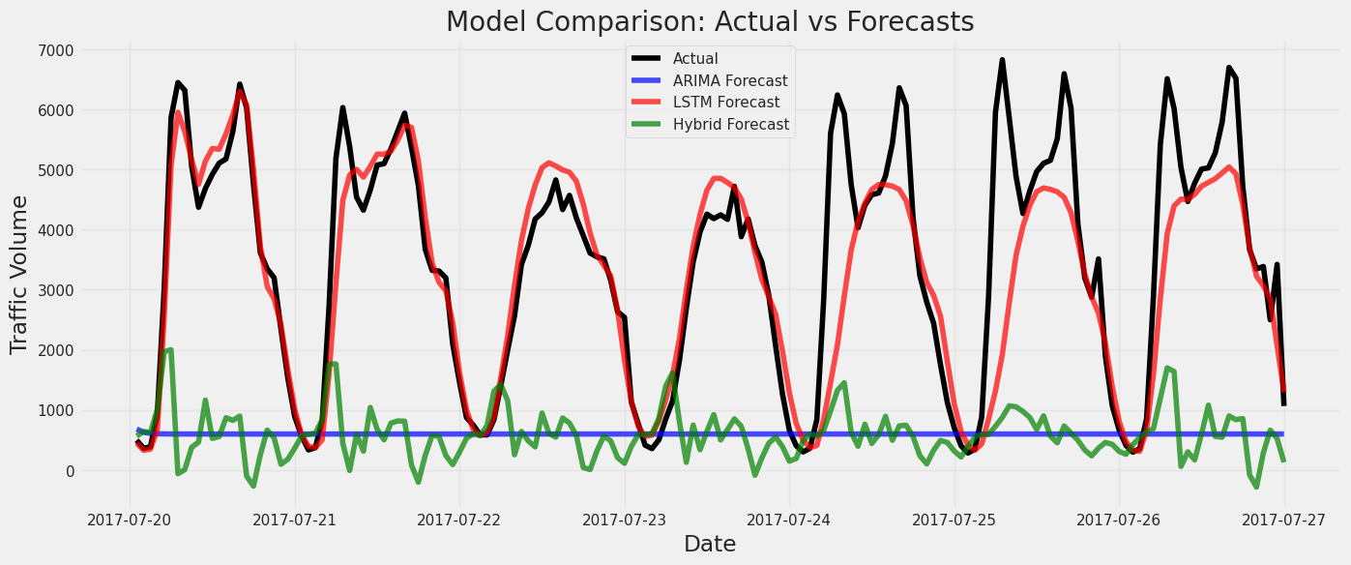

Figure 12: Overlay Forecast Plot – Actual vs Model Predictions

LSTM model is very close to the actual traffic trend, particularly in the peak hours, and ARIMA and Hybrid model have a smoother and lagged prediction, which cannot catch up with the fast change of fluctuations.

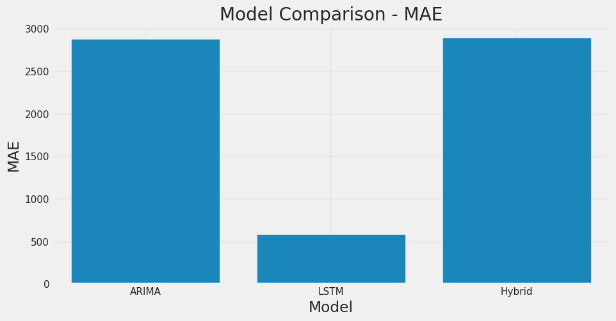

Figure 13: Bar Chart of MAE for All Models

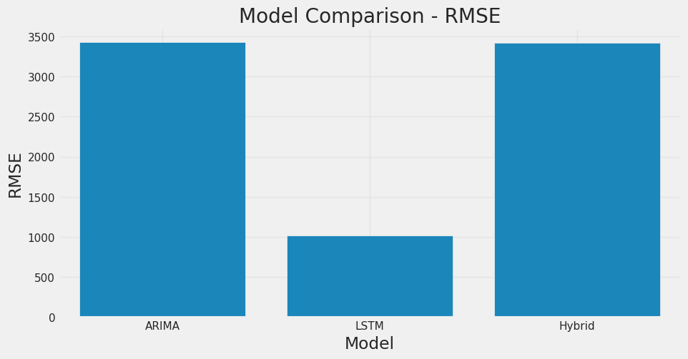

Figure 14: Bar Chart of RMSE for All Models

From visual the LSTM model performs better than other metrics in all the metrics than the ARIMA and Hybrid which are lagging far behind.

### 4.6.3 Interpretations

The LSTM model’s deep learning architecture enables it to capture long-term dependencies and nonlinear trends in traffic data, making it ideal for high-frequency, volatile urban scenarios (Zhao et al., 2017; Ma et al., 2022). However, ARIMA has linear assumptions, limiting its ability to predict in such dynamic environments. If ARIMA’s residuals were not showing any structured patterns (as a requisite for LSTM learning, see Lippi et al. (2013)), the Hybrid model didn’t add any value.

From this evaluation, it could be seen that LSTM is the most robust and reliable model for real time traffic volume prediction.

# Chapter 5: Discussion and Analysis

## 5.1 Introduction

This chapter critically reviews the results of applying ARIMA, LSTM, and hybrid ARIMA–LSTM models for short term urban traffic flow prediction. The relative performance of each model and what that implies in practice and w.r.t. related work in intelligent transportation systems is what we would like to understand. Unlike LSTM, which was designed to learn long range temporal dependency with gated memory, it was perfectly designed for modeling complex time series behavior of traffic systems. As a reflective analysis, this chapter aims to incorporate the results of the modeling phase and to evaluate if machine learning is appropriate for urban traffic forecasting (Zhao et al., 2017).

## 5.2 Interpretation of Results

This section provides an analytical interpretation of the empirical results obtained from the three forecasting models: LSTM, ARIMA and hybrid ARIMA–LSTM. First, it discusses why the LSTM model performed better than the other approaches; second, it studies the effects of some external variables on the prediction; lastly, it studies the behaviors that the different approaches represent.

### 5.2.1 LSTM Outperforms ARIMA

When compared with ARIMA and hybrid model, the LSTM model outperforms in terms of all key metrics with RMSE of 1020 and R² score of 0.72 compared with RMSE of 3428 and a negative R² score of -2.15 with ARIMA. What makes these models so starkly different is that they each understand the temporal patterns in very different ways. As a start, ARIMA, which is based on linear assumptions and that the series is stationary, was not enough to capture of the non linear and dynamic hourly flow fluctuations, especially sharp peak hour transition, (Lippi et al., 2013; Kumar & Hariharan, 2022).

To further generalize, dropout regularization was used in addition to stacked LSTM layers to prevent overfitting and stability training. It could respond accurately to regular and irregular surges in the volume of traffic (Zhao et al., 2017); Ma et al., 2022). Compared with the performance of the conventional statistical and deep learning models, the results of this study support and expand the existing literature on traffic flow forecasting.

### 5.2.2 Role of External Factors

The features present in the dataset were time and weather based which help the model to predict better using the LSTM model. Then, we added context including temperature, rain, snow, hour of day, and weekend/holiday, to the model so that we could explain things that time could not. Though weather factors have relatively weak linear correlations (r < 0.3) with traffic volume, their nonlinear effect is effectively captured. Ma et al., 2015).

Unlike ARIMA univariate model, the model was incapable of including these exogenous variables directly into the model and hence was unable to adjust forecasts for the presence of exogenous disruption such as inclement weather, or spike drops in traffic due to holiday season.

## 5.3 Comparison with Existing Literature

For instance, Rajalakshmi and Vaidyanathan (2022) claimed a hybrid architecture, with ARIMA for linear trends, and LSTM for the residuals, to be more accurate. As stated by Rajalakshmi and Vaidyanathan (2022), they explained the hybrid architecture as a sum of accuracy in ARIMA with linear trends alongside the LSTM for residual learning.

Ma et al. The use of LSTM based models to predict the short term time series in urban road sections under highly dynamic traffic conditions yielded the examples of the fact that such models perform better than classical time series models (2022). Similarly, Zhao et al. In (2017) it was shown that LSTM networks outperformed ARIMA by modeling non-linear dependencies and timebased patterns like daily and weekly cycles effectively. These results are in line with our findings in which we found that LSTM had an R² of 0.72 while ARIMA resulted in zero meaningful accuracy.

However, our hybrid model findings disagree with other research that has reported improvements from combining ARIMA and LSTM. For example, Rajalakshmi and Vaidyanathan (2022) indicated that a hybrid architecture achieves higher accuracy by utilizing ARIMA for linear trends and LSTM for residual learning. However, in our case, residuals from ARIMA model were mostly stochastic and did not give a strong signal for LSTM to learn from. This is in line with Lippi et al.’s caution. Kraft and Mclachlan (2013) argued that hybrid models rely on carefully structured residuals to be effective.

Our study agrees with Shah et al. in terms of feature integration. In line with Kumar and Hariharan (2022) and (2022), who observed that the prediction performance increased when one includes weather and calendar-based features. However, unlike other studies that incorporated a wider range of real time factors including incidents and mobility pattern (Zheng et al., 2020), our model only included historical weather and time variables.

## 5.4 Practical Implications

Both are important to understand in order to put the results into context and direct future work.

One key contribution is showing how LSTM can be used for real-time traffic forecasting. The LSTM model has an R² score of 0.72 and a significantly lower RMSE than ARIMA and is therefore reliable in predicting traffic surges during peak hours. The model was kept interpretable with LSTM architecture, and computationally manageable so that the model can be reproduced and adapted to other cities or transport contexts with little tuning.

For example, such models can be used by advanced traffic control center to predict traffic build up and take preventive measures such as reversible lanes or public transport prioritization. Embedding such forecasts in navigation applications such as Google Maps or Waze could recommend commuters on the optimal departure time, or less congested routes, to minimize travel time and vehicle emissions from idling.

The study also demonstrates that predictive systems can be improved with moderately good weather and temporal data. Additionally, city administrations can progressively incorporate more outside things—live reports of events, public occasion schedules, and social media signals—to enhance exactness of expectation (Zheng et al., 2020).

## 5.5 Strengths and Limitations

In this section, the methodological and practical strengths of the research are described, as well as the key limitations of the research. Both of these aspects need to be understood for contextualizing the findings and guiding future work.

### 5.5.1 Strengths of the Study

**a) Comprehensive Model Comparison**

Another of this study’s core strengths is that it is able to systematically compare three different forecasting models: LSTM, ARIMA, and a hybrid ARIMA–LSTM. By taking this multi model approach, we could learn better about how traditional and deep learning-based models tackle complex traffic data.

**b) Real-World Dataset and External Features**

A publicly available, real-world dataset from Kaggle was used to make the research more practical. The inclusion of external features such as temperature, rainfall, snow, and calendar-based variables enhanced the contextual modeling of urban traffic flow (Shah et al., 2022; Kumar & Hariharan, 2022).

**c) Scalable and Reproducible Architecture**

The LSTM architecture was kept interpretable and computationally manageable, such that it could be reproduced and adapted to other cities or transport contexts with little to no tuning.

### 5.5.2 Limitations of the Study

**a) Limited Residual Structure in Hybrid Model**

In addition, the hybrid ARIMA—LSTM model did not lead to an improved performance, since the ARIMA residuals lack any meaningful structure. The LSTM component of the hybrid model would not have been able to contribute to refinement without learnable patterns (Lippi et al., 2013).

**b) Geographic and Temporal Scope**

The dataset considered only a single metropolitan area and traffic sensor, which may not reflect all of the variability present in larger citywide networks. As a result, the findings are not generalizable across geographies.

**c) Computational Requirements**

LSTM models, while accurate, required GPU-based acceleration and longer training times, which may be a constraint for low-resource urban municipalities.

# Chapter 6: Conclusion and Future Work

## 6.1 Conclusion Summary

The purpose of this study was to identify and compare models that can be used to forecast short-term traffic flow of urban roads especially during peak hours when traffic congestion is most likely to occur. The aim was to evaluate the performance of the traditional statistical model, ARIMA, with the deep learning-based model LSTM, and a combined ARIMA–LSTM model. The goal was not only to evaluate their performance in terms of accuracy, but also to understand if such approaches can be useful in real-life traffic management systems in cities.

Each of the models was built, trained, and tested on the same data structure that was the Metro Traffic Volume dataset extended by weather conditions and temporal features. The LSTM model provided a better performance compared to the ARIMA and hybrid models in all the performance metrics; the RMSE of LSTM model was lesser than the other models (≈1020) and the R² value was positive (0.72) while the ARIMA and hybrid models had higher error rates and negative R² values.

The incorporation of external variables like weather and calendar was helpful to LSTM because it can learn complex, non-linear patterns in the traffic data. However, ARIMA analysis is linear in nature and cannot take direct account of external variables, which restricted the efficiency of its forecast when applied to dynamic peak-hour traffic. While the hybrid model is a conceptual sound one, it only worsened its base components ARIMA as the residuals were noisy and unstructured.

Therefore, the results provide theoretical contributions and practical instrumentations to improve the traffic control and decision-making of smart cities. Consequently, the research provides theoretical contributions and effective recommendations that can help improve traffic control and decision-making in smart cities.

## 6.2 Key Contributions

### 6.2.1 Academic Contributions

From the perspective of academic literature, this work contributes to the understanding of the application of machine learning in ITS. First, it provides a comprehensive, performance comparison of ARIMA, LSTM, and the hybrid model in one unified study based on realistic traffic data. This comparative study, anchored on MAE, RMSE, and R², contributes to the literature that offers critical insights into the effectiveness of TS forecasting models for urban environments.

Second, the study is useful for the identification of the additional external factors like weather conditions and holiday indicators that are important to be included in the models. Although these features had relatively moderate linear relationship with the traffic volume, the LSTM model further revealed that these features’ non-linear effects could still improve the prediction results to a large extent. This insight supports the argument made by Shah et al. (2022) and Ma et al. that external contextual features are becoming crucial in traffic prediction systems, especially in the present world.

Lastly, the study highlights the importance of model interpretability and scalability. By using a relatively simple LSTM architecture with dropout and two hidden layers, the model remained both interpretable and computationally feasible, making it a viable candidate for real-world deployment.

### 6.2.2 Practical Contributions

On the practical front, this research provides an actionable framework for city planners, traffic control authorities, and software developers working in the mobility domain. The LSTM model’s ability to generate short-term traffic forecasts with relatively high accuracy means that it can be integrated into dynamic traffic management systems for better congestion control.

For example, such models could be employed in:

* Adaptive traffic light scheduling systems
* Navigation apps offering congestion-aware routing
* Public transportation optimization during special events
* Infrastructure planning to target consistently congested routes

Moreover, the framework established in this research—using only open-source tools and publicly available datasets—makes it highly replicable for other urban areas, including developing cities where access to real-time traffic data may be limited.

## 6.3 Future Work Recommendations

While the study has achieved its intended objectives, there are several avenues for further exploration and improvement.

### 6.3.1 Real-Time Data Integration

One of the primary limitations of the current implementation is its reliance on historical data. In practice, traffic conditions can change rapidly due to unplanned events such as accidents, road closures, or weather disturbances. Future research should focus on integrating real-time traffic data streams from sensors, GPS devices, or traffic APIs to enable dynamic updates to forecasting models. This would enhance the responsiveness of traffic management systems and align better with smart city objectives.

### 6.3.2 Expansion of External Variables

Although weather and temporal features were included in this study, the range of external variables can be significantly expanded. Incorporating features such as:

* Public event schedules (concerts, sports)
* Real-time incident reports
* Roadwork notifications
* Social media signals (e.g., Twitter traffic updates)

can provide richer context for prediction models and help them better adapt to anomalies and outliers in traffic patterns.

### 6.3.3 Geographical and Multi-Sensor Scaling

The current model was trained on data from a single traffic sensor. To build a more generalizable model, future research should apply the methodology to datasets from multiple locations across a city or region. This would allow for spatial-temporal modeling, where relationships between traffic at different locations are also taken into account. Graph Neural Networks (GNNs) or attention-based Transformer architectures could be useful in such scenarios.

### 6.3.4 Advanced Hybrid and Ensemble Methods

The current hybrid model did not yield improved results due to the lack of structure in the ARIMA residuals. Future efforts could explore more sophisticated hybridization strategies. For instance, residual decomposition techniques such as Wavelet Transform or Empirical Mode Decomposition (EMD) could isolate non-linear trends more effectively before passing them to the LSTM component. Additionally, ensemble methods combining multiple deep learning models could be tested for robustness and accuracy.

### 6.3.5 Model Optimization for Deployment

Finally, real-world deployment would require optimization of the LSTM model for performance and efficiency. This could involve:

* Model pruning or quantization to reduce size
* Using platforms like TensorFlow Lite for edge deployment
* Implementing streaming pipelines for real-time input processing

These enhancements would make the model not only accurate but also lightweight and fast—critical factors for deployment in mobile apps, embedded systems, or roadside computing units.

# REFERENCES:

* Chacon-Hurtado, D., Kumar, I., Gkritza, K. and Fricker, J.D. (2019). Analysis of Spatial Mismatch and Equity using Commuting and Labor Sheds: Trends in Indiana. *Transportation Research Record: Journal of the Transportation Research Board*, 2673(10), pp.620–631. <https://doi.org/10.1177/0361198119849919>.
* Chuwang, D.D. and Chen, W. (2022). Forecasting Daily and Weekly Passenger Demand for Urban Rail Transit Stations Based on a Time Series Model Approach. *Forecasting*, [online] 4(4), pp.904–924. <https://doi.org/10.3390/forecast4040049>.
* Dong, J., Mahmassani, H.S., Erdoğan, S. and Lu, C.-C. (2011). State-dependent pricing for real-time freeway management: Anticipatory versus reactive strategies. *Transportation Research Part C: Emerging Technologies*, 19(4), pp.644–657. <https://doi.org/10.1016/j.trc.2010.10.001>.
* Eccarius, T. and Lu, C.-C. (2020). Adoption intentions for micro-mobility – Insights from electric scooter sharing in Taiwan. *Transportation Research Part D: Transport and Environment*, 84, p.102327. <https://doi.org/10.1016/j.trd.2020.102327>.
* Ghosh, B., Basu, B. and O’Mahony, M. (2009). Multivariate Short-Term Traffic Flow Forecasting Using Time-Series Analysis. *IEEE Transactions on Intelligent Transportation Systems*, [online] 10(2), pp.246–254. <https://doi.org/10.1109/tits.2009.2021448>.
* Giunta, G., Ceppi, A. and Salerno, R. (2023). An Extended Analysis of Temperature Prediction in Italy: From Sub-Seasonal to Seasonal Timescales. *Forecasting*, 5(4), pp.600–615. <https://doi.org/10.3390/forecast5040033>.
* Huang, W., Song, G., Hong, H. and Xie, K. (2014). Deep Architecture for Traffic Flow Prediction: Deep Belief Networks With Multitask Learning. *IEEE Transactions on Intelligent Transportation Systems*, [online] 15(5), pp.2191–2201. <https://doi.org/10.1109/TITS.2014.2311123>.
* Khisty, C.J. and Arslan, T. (2005). Possibilities of steering the transportation planning process in the face of bounded rationality and unbounded uncertainty. *Transportation Research Part C: Emerging Technologies*, 13(2), pp.77–92. <https://doi.org/10.1016/j.trc.2005.04.003>.
* Kumar, S.V. and Vanajakshi, L. (2015). Short-term traffic flow prediction using seasonal ARIMA model with limited input data. *European Transport Research Review*, [online] 7(3). <https://doi.org/10.1007/s12544-015-0170-8>.
* Li, Y., Yu, R., Shahabi, C. and Liu, Y. (2018). *Diffusion Convolutional Recurrent Neural Network: Data-Driven Traffic Forecasting*. [online] openreview.net. Available at: <https://openreview.net/forum?id=SJiHXGWAZ>.
* Lippi, M., Bertini, M. and Frasconi, P. (2013). Short-Term Traffic Flow Forecasting: An Experimental Comparison of Time-Series Analysis and Supervised Learning. *IEEE Transactions on Intelligent Transportation Systems*, [online] 14(2), pp.871–882. <https://doi.org/10.1109/tits.2013.2247040>.
* Liu, L., Li, X., Cheung, W.K. and Xu, C. (2017). A Structural Representation Learning for Multi-relational Networks. *Ijcai.org*, [online] pp.4047–4053. Available at: <https://www.ijcai.org/proceedings/2017/565>.
* Lv, Y., Duan, Y., Kang, W., Li, Z. and Wang, F.-Y. (2014). Traffic Flow Prediction with Big Data: A Deep Learning Approach. *IEEE Transactions on Intelligent Transportation Systems*, 16(2), pp.1–9. <https://doi.org/10.1109/tits.2014.2345663>.
* Ma, C., Dai, G. and Zhou, J. (2022). Short-Term Traffic Flow Prediction for Urban Road Sections Based on Time Series Analysis and LSTM_BILSTM Method. *IEEE Transactions on Intelligent Transportation Systems*, 23(6), pp.5615–5624. <https://doi.org/10.1109/tits.2021.3055258>.
* Ma, X., Dai, Z., He, Z., Ma, J., Wang, Y. and Wang, Y. (2017). Learning Traffic as Images: A Deep Convolutional Neural Network for Large-Scale Transportation Network Speed Prediction. *Sensors*, 17(4), p.818. <https://doi.org/10.3390/s17040818>.
* Ma, X., Tao, Z., Wang, Y., Yu, H. and Wang, Y. (2015). Long short-term memory neural network for traffic speed prediction using remote microwave sensor data. *Transportation Research Part C: Emerging Technologies*, [online] 54, pp.187–197. <https://doi.org/10.1016/j.trc.2015.03.014>.
* Mondal, M.A. and Rehena, Z. (2022). Stacked LSTM for Short-Term Traffic Flow Prediction using Multivariate Time Series Dataset. *Arabian Journal for Science and Engineering*. <https://doi.org/10.1007/s13369-022-06575-1>.
* Pascanu, R., Mikolov, T. and Bengio, Y. (2013). *On the difficulty of training recurrent neural networks*. [online] Available at: <http://proceedings.mlr.press/v28/pascanu13.pdf>.
* Polson, N.G. and Sokolov, V.O. (2017). Deep learning for short-term traffic flow prediction. *Transportation Research Part C: Emerging Technologies*, 79, pp.1–17. <https://doi.org/10.1016/j.trc.2017.02.024>.
* Rucker, D.F. and Ferré, T.P.A. (2004). BGPR_Reconstruct: A MATLAB® ray-tracing program for nonlinear inversion of first arrival travel time data from zero-offset borehole radar. *Computers & Geosciences*, [online] 30(7), pp.767–776. <https://doi.org/10.1016/j.cageo.2004.05.009>.
* Shah, I., Muhammad, I., Ali, S., Ahmed, S., Mohammed and AL-Rezami, A.Y. (2022). Forecasting Day-Ahead Traffic Flow Using Functional Time Series Approach. 10(22), pp.4279–4279. <https://doi.org/10.3390/math10224279>.
* Sun, S., Zhang, C. and Yu, G. (2006). A Bayesian Network Approach to Traffic Flow Forecasting. *IEEE Transactions on Intelligent Transportation Systems*, [online] 7(1), pp.124–132. <https://doi.org/10.1109/tits.2006.869623>.
* V. Rajalakshmi and S. Ganesh Vaidyanathan (2025). *HYBRID TIME-SERIES FORECASTING MODELS FOR TRAFFIC FLOW PREDICTION*. [online] Srce.hr. Available at: <https://hrcak.srce.hr/file/412849>.
* Vlahogianni, E.I., Karlaftis, M.G. and Golias, J.C. (2014). Short-term traffic forecasting: Where we are and where we’re going. *Transportation Research Part C: Emerging Technologies*, 43, pp.3–19. <https://doi.org/10.1016/j.trc.2014.01.005>.
* Wang, Z., Zhan, J., Duan, C., Guan, X., Lu, P. and Yang, K. (2022). A Review of Vehicle Detection Techniques for Intelligent Vehicles. *IEEE Transactions on Neural Networks and Learning Systems*, [online] pp.1–21. <https://doi.org/10.1109/TNNLS.2021.3128968>.
* www.kaggle.com. (n.d.). *Metro traffic volume*. [online] Available at: <https://www.kaggle.com/datasets/mikedev/metro-traffic-volume>.
* Zhang, G., Eddy Patuwo, B. and Y. Hu, M. (1998). Forecasting with artificial neural networks: *International Journal of Forecasting*, 14(1), pp.35–62. <https://doi.org/10.1016/s0169-2070(97)00044-7>.
* Zhang, Y. and Haghani, A. (2015). A gradient boosting method to improve travel time prediction. *Transportation Research Part C: Emerging Technologies*, [online] 58, pp.308–324. <https://doi.org/10.1016/j.trc.2015.02.019>.
* Zhao, Z., Chen, W., Wu, X., Chen, P.C.Y. and Liu, J. (2017). LSTM network: a deep learning approach for short-term traffic forecast. *IET Intelligent Transport Systems*, 11(2), pp.68–75. <https://doi.org/10.1049/iet-its.2016.0208>.
* Zheng, C., Fan, X., Wen, C., Chen, L., Wang, C. and Li, J. (2020). DeepSTD: Mining Spatio-Temporal Disturbances of Multiple Context Factors for Citywide Traffic Flow Prediction. *IEEE Transactions on Intelligent Transportation Systems*, 21(9), pp.3744–3755. <https://doi.org/10.1109/tits.2019.2932785>.
* Zheng, J. and Huang, M. (2020). Traffic Flow Forecast Through Time Series Analysis Based on Deep Learning. *IEEE Access*, 8, pp.82562–82570. <https://doi.org/10.1109/access.2020.2990738>.