Microwave Medical Image Segmentation for Brain Stroke Diagnosis: Imaging-Process-Informed Image Processing

Many algorithms exists to detect and segment strokes from brain but all those algorithms work well on MRI and CT images but those algorithms detection will be inaccurate when comes to Microwave Medical images (MMI). MMI is an advance imaging technique which can detect minor brain tissues also which can help in accurate detection of strokes.

In propose work author employing novel image processing technique called DBIM (distorted born iterative method) whose segmentation is more accurate than existing technique like OTSU. The DBIM technique is utilized to reconstruct the stroke area of the brain. Due to the nonlinear relationship between actual and estimated dielectric constants resulting from DBIM, the microwave medical image lacks a clearly defined boundary, posing a challenge to accurately segment it using traditional methods. DBIM method achieves effective image segmentation by improving the traditional threshold method.

MMI images are not available on internet so I took sample image from paper to detect and segment stroke or tumor region.

SCREEN SHOTS

To run project double click on ‘run.bat’ file to start python webserver and get below screen

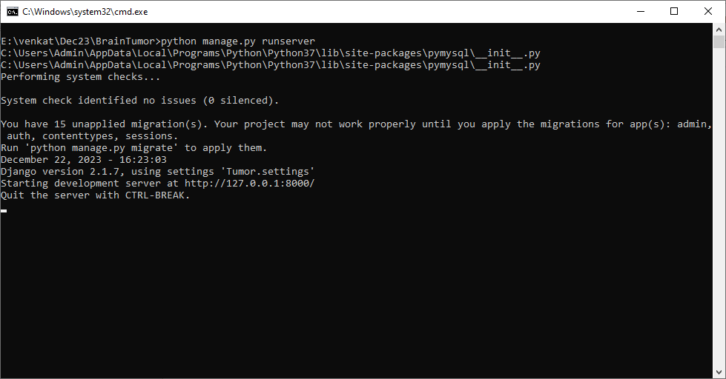

In above screen python server started and now open browser and enter URL as <http://127.0.0.1:8000/index.html> and press enter key to get below page

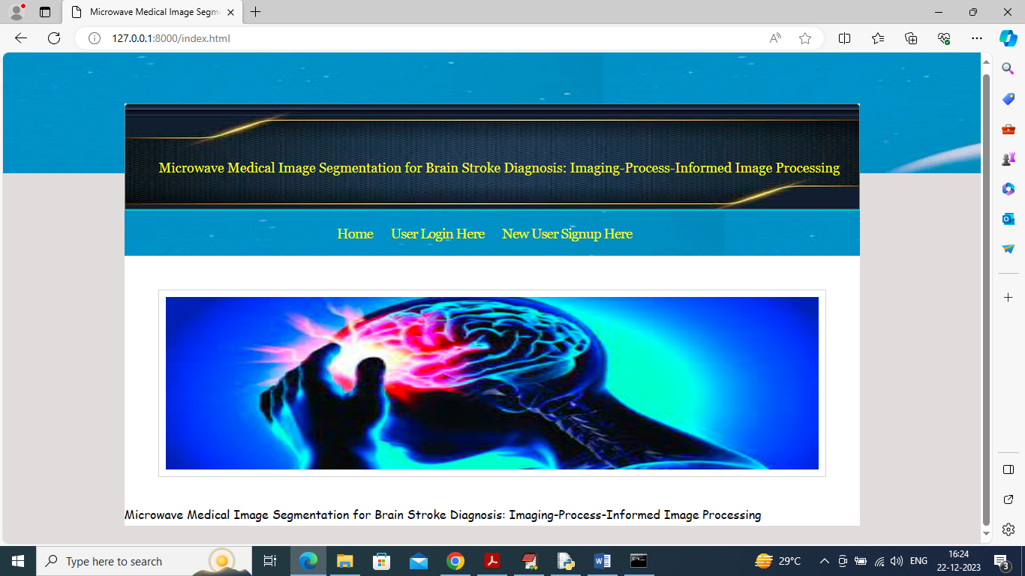

In above screen click on ‘New user Signup Here’ link to get below page

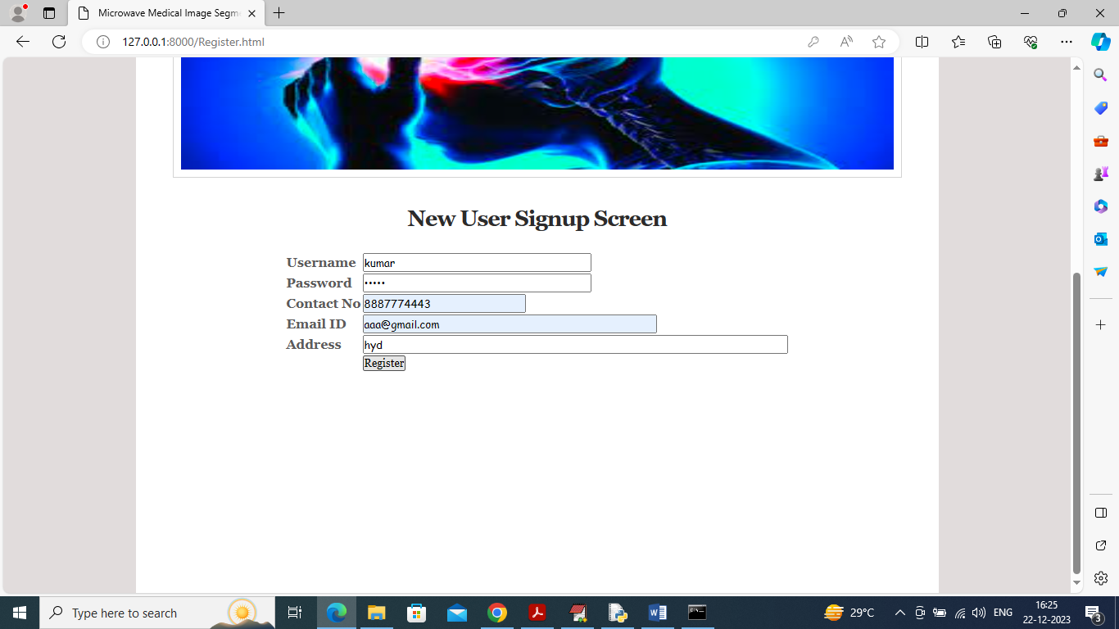

In above screen user entering sign up details and then press button to get below page

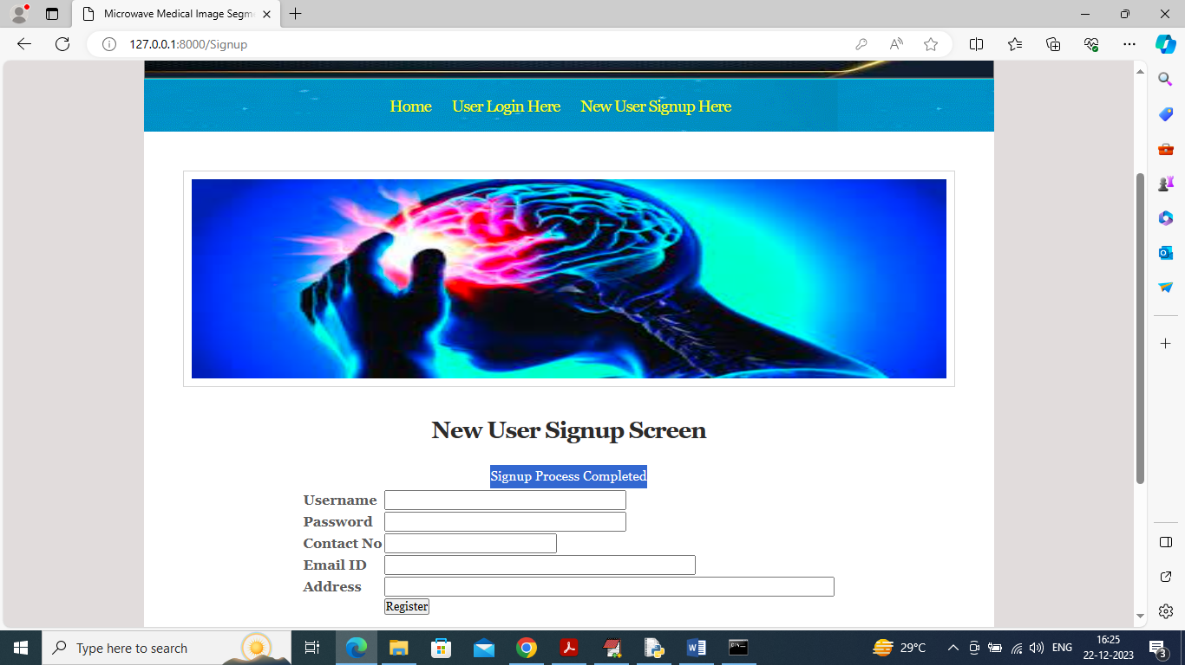

In above screen signup task completed and now click on ‘Login Here’ link to get below page

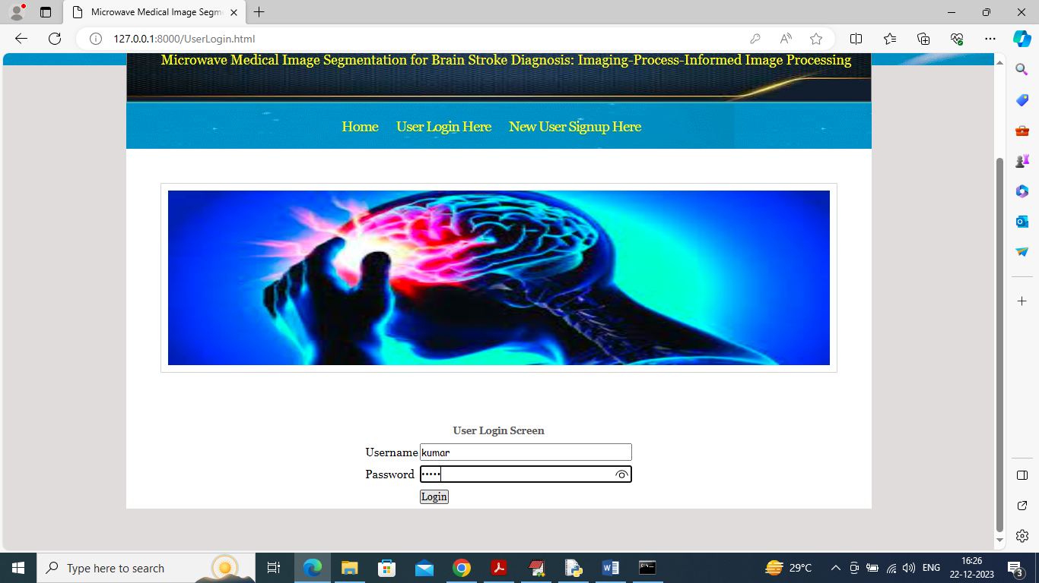

In above screen user is login and after login will get below page

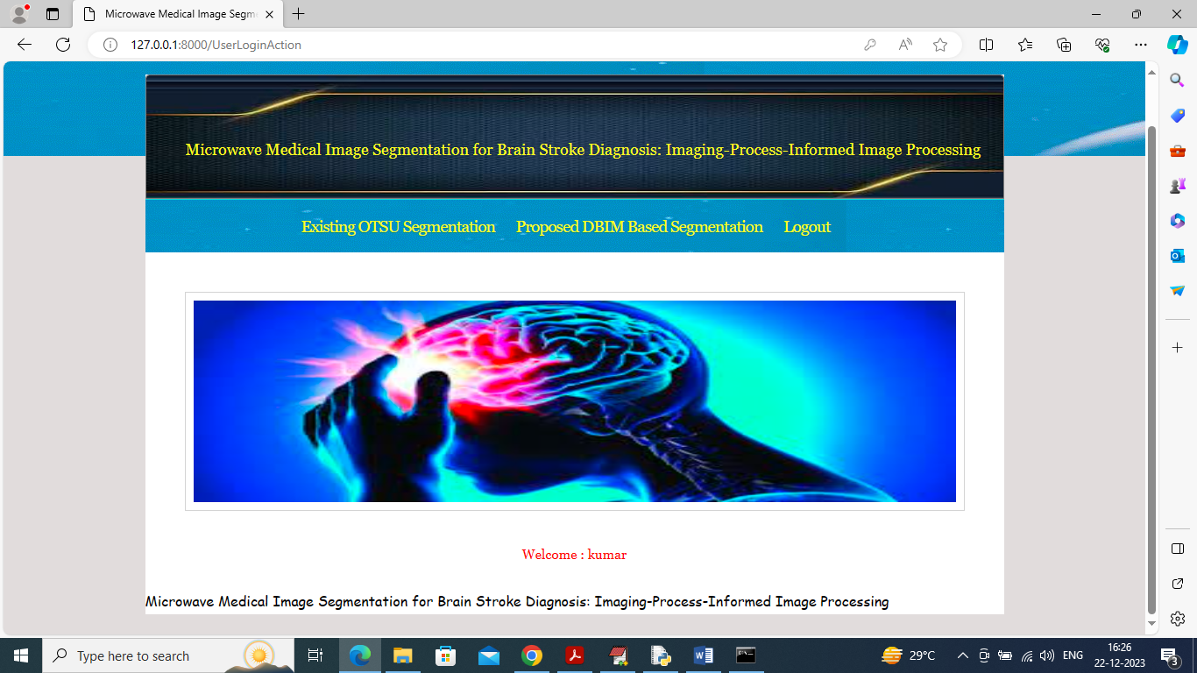

In above screen click on ‘Existing OSTU Segmentation’ link to upload microwave image and then segment using OTSU technique

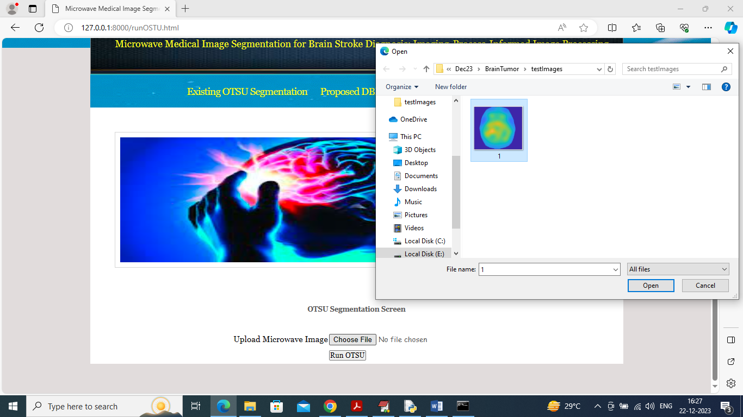

In above screen selecting and uploading ‘microwave medical image’ and then click on ‘Open’ and ‘Run OTSU’ button to get below output

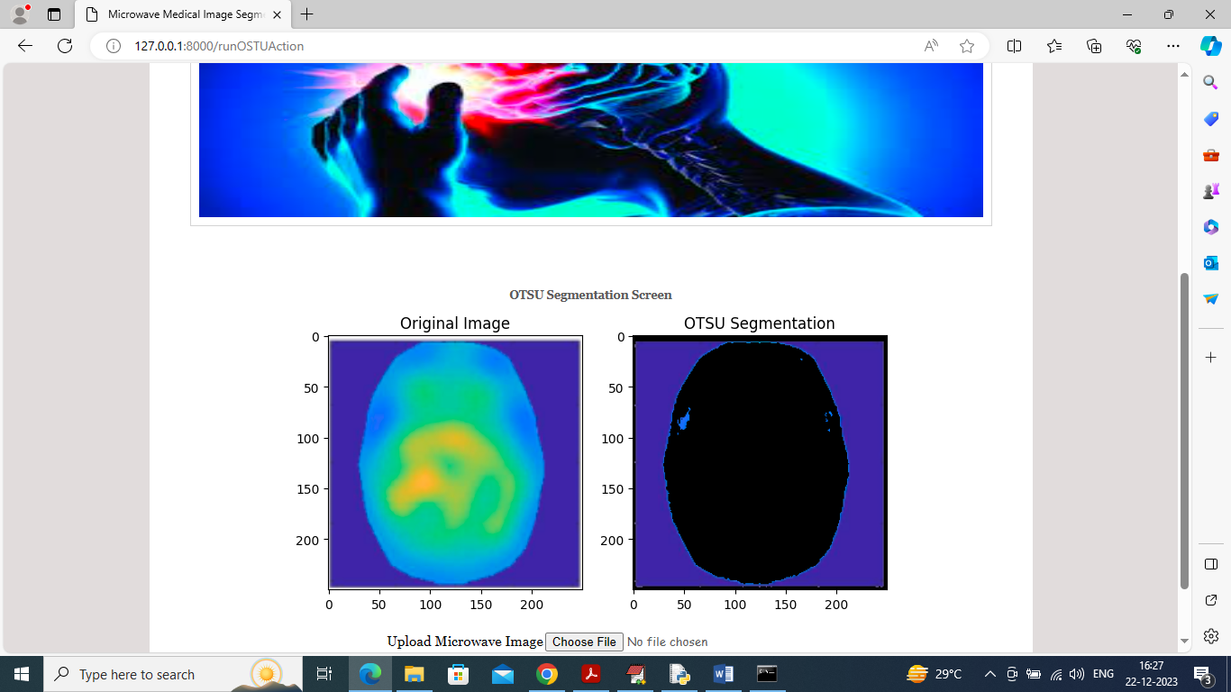

In above screen first image is the original image and second is the OTSU segmented image and in above image can see OTSU segmentation is not correct and now click on ‘Proposed DBIM Based Segmentation’ link to get below page

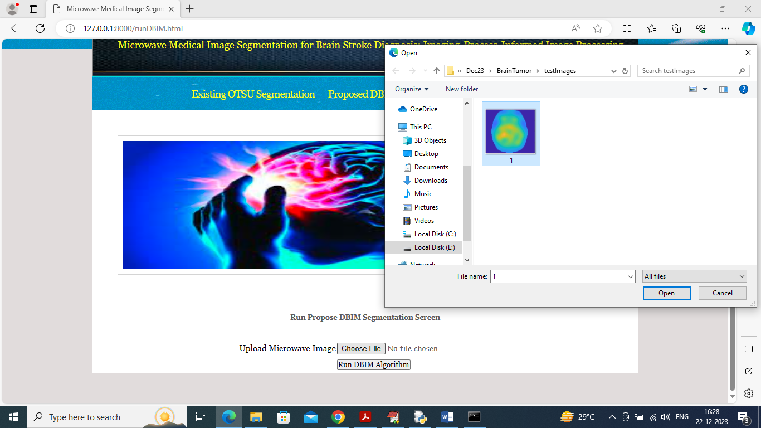

In above screen selecting and uploading ‘image’ and then click on ‘Run DBIM Algorithm’ button to get below output

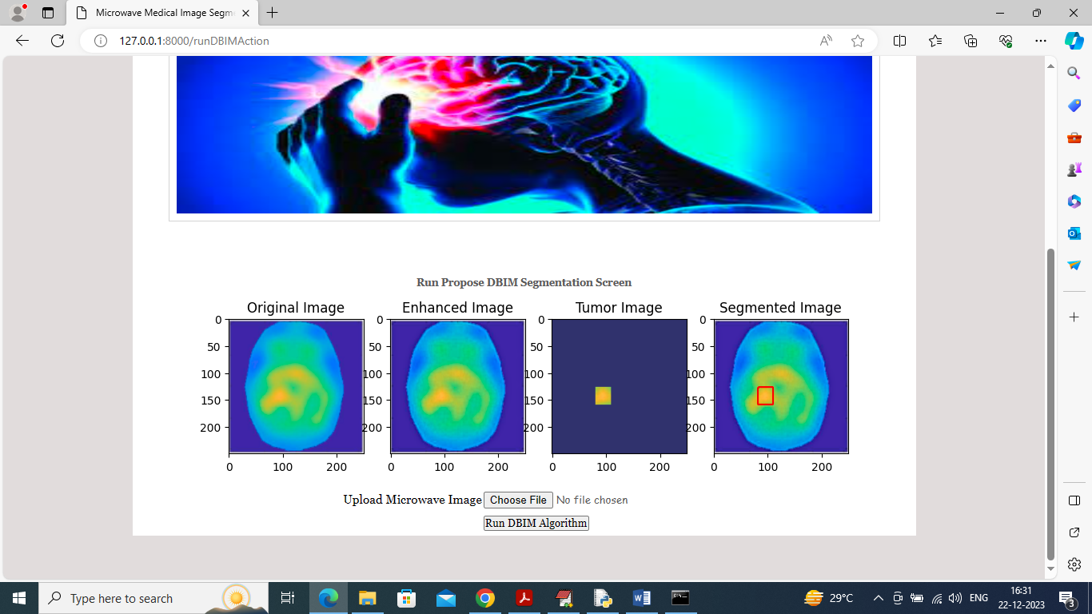

In above screen can see DBIM segmentation output where first image is the original image and second image is the enhanced image and 3rd image is the tumor detected image and 4th image contains segmented part of tumor image. Segmented part is showing in red colour box. Second image look little brighter compare to original image.

From above output we can see propose DBIM tumor segmentation is more accurate than existing OTSU technique