Mailbox Detection and Ownership Assignment
Single-class detector, parcel-frontage geometry and register cross-check
Belgium address-to-mailbox pipeline | Design and demo report
Input and output: GPKG and KML | Data: CadGIS parcels, Street View, BeSt / CadGIS register
Date: 12 October 2026
Status: design and illustrations. The method has not yet been run on real parcel and Street View data. Boxes and boundaries in the example images were placed by hand on screenshots to illustrate the idea, and the geometry examples use hypothetical coordinates.

1. Summary
For each address in a GPKG or KML file, the pipeline reports whether the house is valid and how many mailboxes it has, and writes the result back to GPKG and KML. The central difficulty is attached houses: the detector also finds the neighbours' mailboxes, and house numbers are often missing, so ownership cannot rely on reading numbers.

Design decisions
Decision | Reason
The detector has one class: mailbox | Detections of doors, gates or other objects can be invented. Fewer classes means fewer places for the detector to be wrong.
Ownership comes from geometry only | The cadastral parcel or building gives the target frontage. A mailbox's position along that frontage decides whose it is.
No OCR for ownership | House numbers are often absent. A readable number can only add confidence.
Banks are built in code | Mailboxes that are close together on the ground form a bank. The detector does not need a separate bank class.
The register cross-checks the count | The BeSt / CadGIS classifier gives an independent count. Differences go to review.
House existence comes from data | The image can say "no mailbox found", not "no house". Existence uses the building footprint and BeSt status.

What to expect. Without door anchoring, a mailbox within about a metre of a boundary cannot be settled by one panorama. Those cases rely on a second panorama, the register count or review. The share of such cases on narrow frontages has to be measured on real data.

2. The problem in images

2.1 Example A: a row of houses
The target is the red-brick house with the white door in the middle. The detector returns three mailboxes: M1 in front of the left neighbour, M2 at the target and M3 on the right neighbour's wall. Counting all of them gives three instead of one.
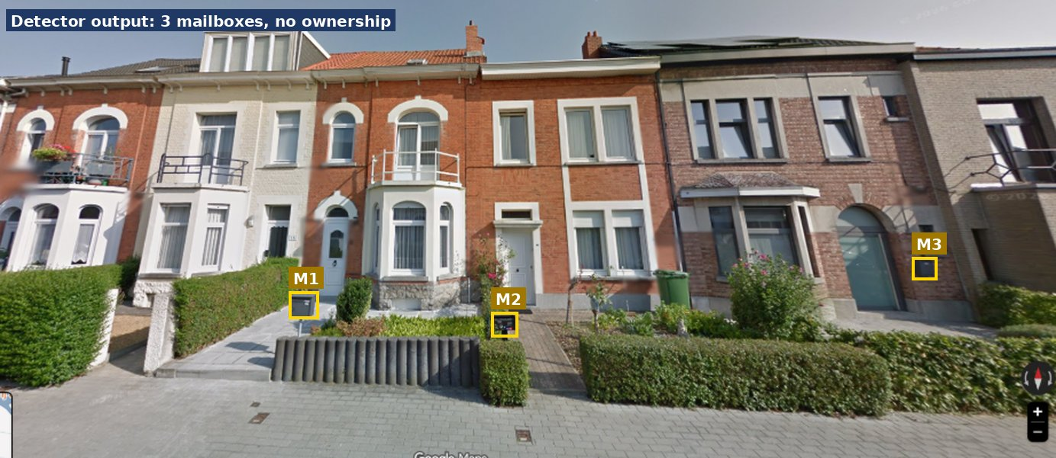
Figure 1. Detector output on a row of houses: three mailboxes, no ownership information.

2.2 Example B: Itterbeeksebaan 226C (MDU)
The target building has a bank of three mailbox slots at its entrance, and the left neighbour has a separate mailbox. A plain count gives four; the correct answer for the target is three.
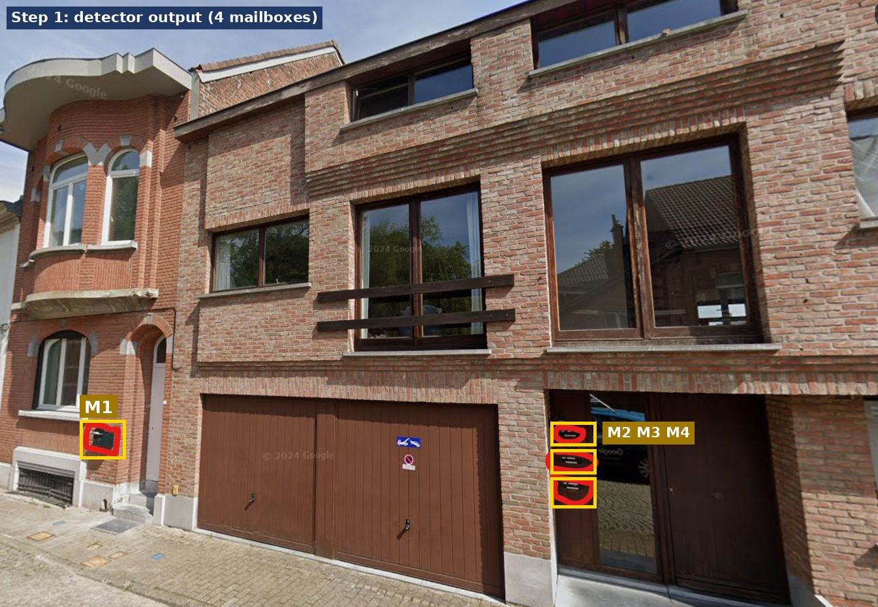
Figure 2. Detector output at 226C: four mailboxes, only the three at the right entrance belong to the target.

3. Pipeline: six agents
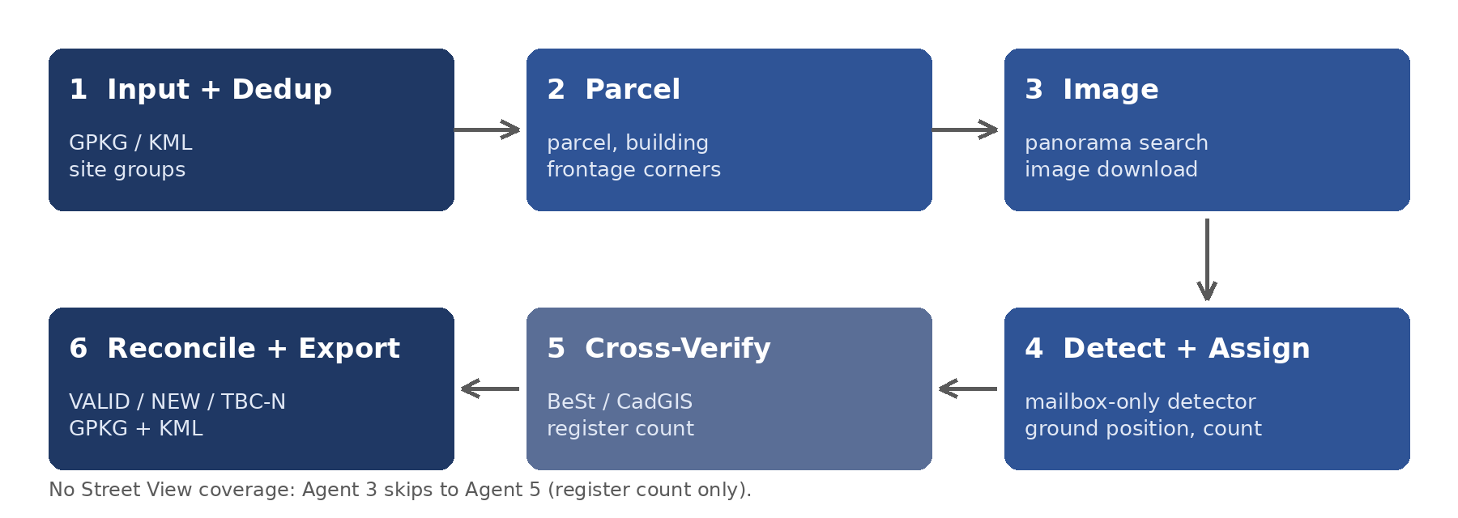
Figure 3. The six agents from input to export.
# | Agent | What it does | Output
1 | Input + Dedup | Reads GPKG or KML, normalises fields, reprojects to EPSG:31370. Groups 1A/1B/1C into one site using a text key (postcode, street, base number) plus a spatial check. | Site list and mapping to member addresses
2 | Parcel | Finds the parcel and building footprint, extracts the street-facing edge and its two corners, flags shared parcels. | site.json
3 | Image | Queries the Metadata API (free) with fallbacks, scores panoramas, picks the best 3 to 5, sets heading and FOV from the corners, downloads, saves metadata. | Images, images.json, or NO_STREETVIEW
4 | Detect + Assign | Runs the single-class mailbox detector, checks plausibility, places each mailbox on the ground, assigns it to target or neighbour, fuses views, builds banks. | Mailbox list, count, confidence
5 | Cross-Verify | Compares with the BeSt / CadGIS classifier; supplies the count when images cannot. | Final count, source, flags
6 | Reconcile + Export | Writes each site result to every member address, sets VALID / NEW / TBC-N, builds the review queue. | GPKG and KML

- One image set per site. Duplicate addresses share the same downloads.
- Check the Metadata API before downloading. Without coverage, the image API can return a placeholder that looks like zero mailboxes.
- Save what is needed to reprocess. pano_id, position, date, heading, fov, pitch, image width and file path for every image.
- Every agent writes a status, so one failed site can be retried without rerunning the rest.

4. Geometry: finding the frontage
Every pixel column of a Street View image corresponds to a direction from the camera. The target's frontage covers a known set of directions, so a detection can be placed against it.
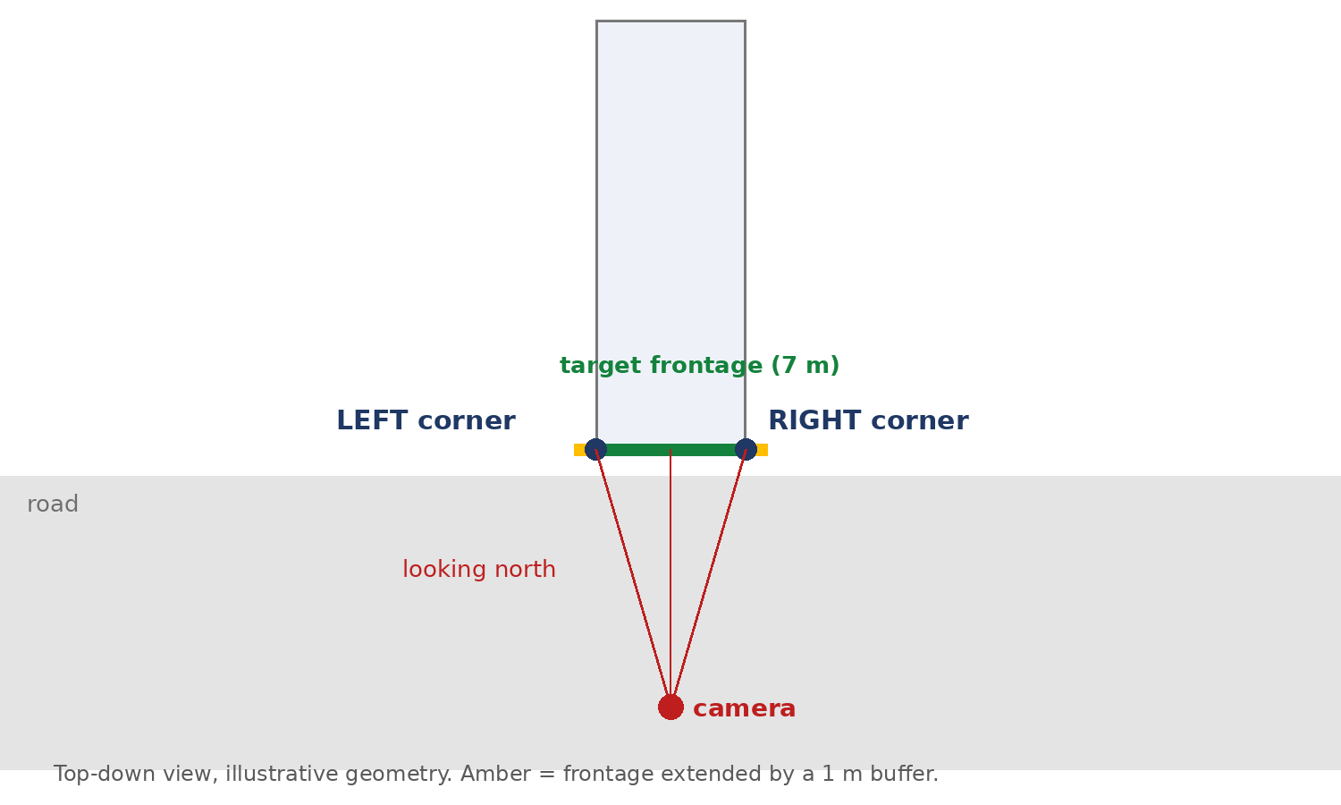
Figure 4. Top-down view: camera, left and right frontage corners, and the buffer (amber). Illustrative geometry.

4.1 Steps
- Find the parcel containing the address point (X, Y), or use the building footprint by building_id. The X/Y system is assumed to be EPSG:31370 and must be confirmed.
- Pick the street-facing edge. Split the polygon into edges, ignore edges under about 1.5 m, and take the edge nearest the camera or road. Its endpoints are P and Q, and M is the midpoint.
- Decide left and right. With d = M - camera, compute cross(C) = d.x * (C.y - cam.y) - d.y * (C.x - cam.x). The endpoint with the larger value is the left corner. This is recomputed for every panorama.
- Choose the buffer b in metres (about 1 m to start).
The address record itself holds only one point and no polygon (wkt_geom is NULL), so the corners always come from the parcel or building layer, never from the record.

4.2 Buffer size
The buffer absorbs camera position error and parcel offset. Independent errors combine as b = sqrt(e_pano^2 + e_parcel^2); the error values must be measured on your data. A camera 2 m off sideways moves the projected corners by about 112 px at 12 m (1345 px image, 90 degree FOV), more than a 1 m buffer covers, which is why a second panorama matters on narrow frontages.

5. Mailbox detection

5.1 One class only
The detector outputs boxes for a single class, mailbox, with a score. A wall-mounted box, a post-mounted box and each slot of a bank are all "mailbox". There are no door, gate, bank or number-plate classes. The model can be a trained detector (such as RF-DETR) or a prompted vision-language model such as Qwen; either must be measured on labelled images before it is trusted.

5.2 Reducing false mailboxes
- Single-class training on your own labels, with the confidence threshold chosen from a precision-recall curve.
- Hard negatives in the training set: electricity and gas meter boxes, intercom panels, doorbells, small signs and letter slots. These are the likely false positives on Belgian streets.
- Several angles and panoramas. Drop single-view, low-score detections.
- Non-maximum suppression and a minimum size, so one mailbox is not counted twice.
- Optional crop check. A yes/no question on a small cropped image to a second model.

5.3 Plausibility checks from geometry
After the ray in section 6.1 gives the distance t to the frontage, two quantities can be estimated for every box:
width_m = box_width_px * t / f
height_m = cam_height + t * tan(pitch + atan((H/2 - y_center) / f))

Reject boxes whose width or height is implausible for a mailbox. Starting values such as 0.1 to 0.6 m wide and 0.5 to 2.0 m high are only a first guess; the camera height (about 2.5 m for car imagery, to be verified) and the ranges must be tuned on labelled data. The width estimate is least accurate in oblique views.

6. Assigning a mailbox to a house

6.1 Ground position along the frontage
For each accepted box, convert its centre column to a bearing from the camera, cast a ray, and intersect it with the frontage line from the left corner to the right corner. The intersection gives s, the position along the frontage in metres. This also works for oblique views, where pixel-column ranges are less exact.
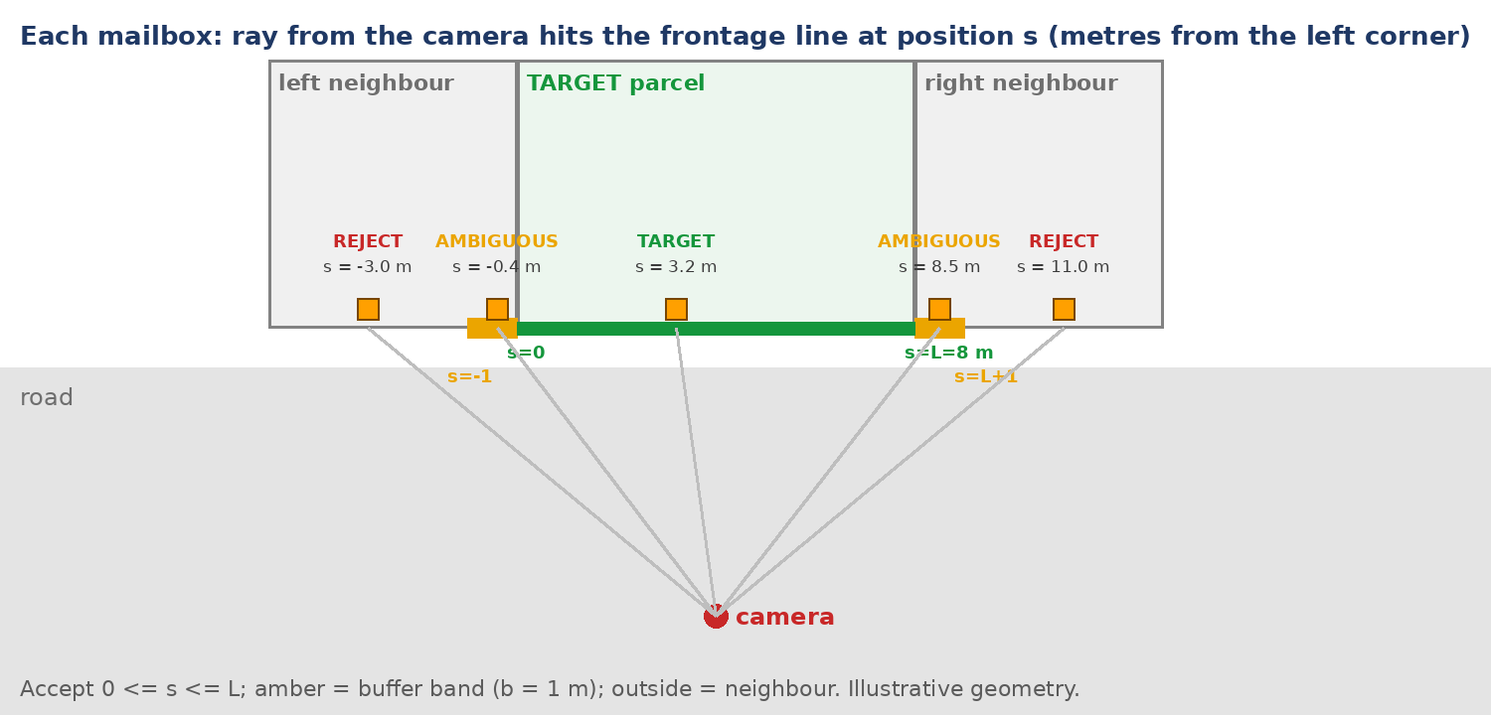
Figure 5. Rays from the camera hit the frontage line at s. Accept 0 <= s <= L, amber is the buffer band, outside is the neighbour.

6.2 Decision rules
Condition | Result
0 <= s <= L, seen in 2 or more panoramas that agree | TARGET, High confidence
0 <= s <= L, one panorama, good score | TARGET, Medium confidence
s in the buffer band at either end (-b to 0, or L to L+b) | AMBIGUOUS: second panorama, register count or review
s outside -b to L+b | NEIGHBOUR: not counted
Views disagree on the ground position | AMBIGUOUS

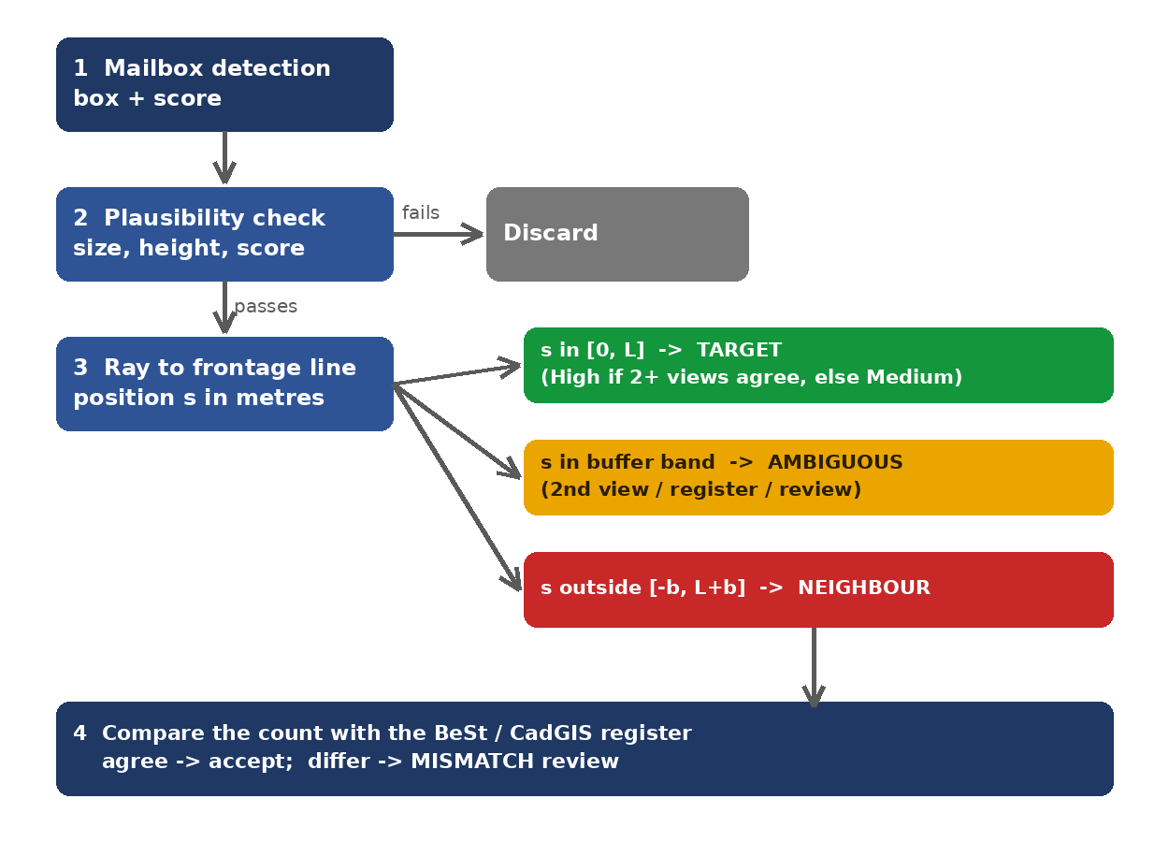
Figure 6. Decision flow for each detected mailbox.

6.3 Two panoramas resolve boundary cases
Rays from two camera positions intersect at the mailbox's ground position. That point is tested against the target parcel plus the buffer. A single ray cannot tell depth, so a mailbox just inside or outside the boundary stays ambiguous until a second view is available.
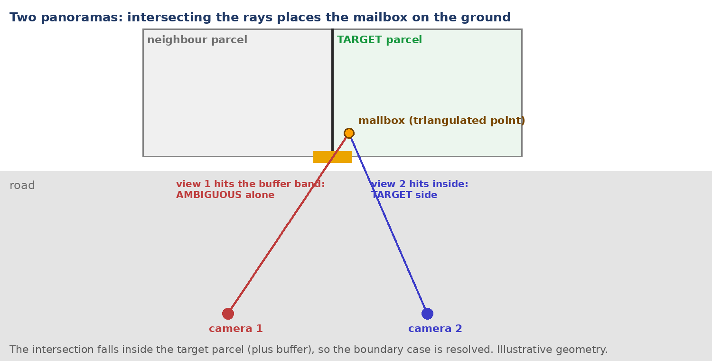
Figure 7. A boundary mailbox: view 1 alone is ambiguous, the intersection with view 2 lies inside the target parcel.

6.4 Banks and counts
Accepted mailboxes that lie within a short ground distance of each other (about 1 to 2 m to start) form a bank. For an MDU the count is the size of the bank, and slots are not tied to individual apartments. The count is then compared with the register in section 9.

7. Worked examples

7.1 Example A: row of houses
The target frontage range (green) is projected into the image, with a buffer (amber) at each end. M2 lies inside and is kept; M1 (left neighbour) and M3 (right neighbour) lie outside and are rejected. The range here was placed by eye; in the pipeline it comes from the parcel.
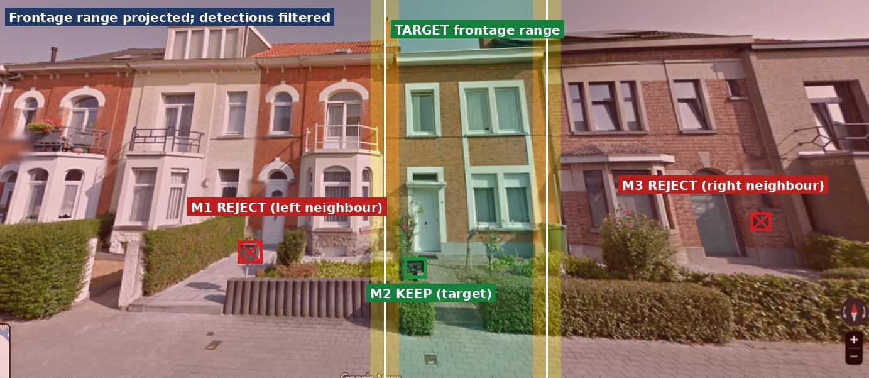
Figure 8. Row of houses: range projected, M2 kept, M1 and M3 rejected.
Item | Position | Test | Decision
M1 | Left of range | Outside range plus buffer | NEIGHBOUR
M2 | Inside range | Inside range | TARGET
M3 | Right of range | Outside range plus buffer | NEIGHBOUR

7.2 Example B: Itterbeeksebaan 226C
Red marks the neighbour, green the target frontage and amber the buffer around the boundary (estimated at about x = 265 px on this screenshot).
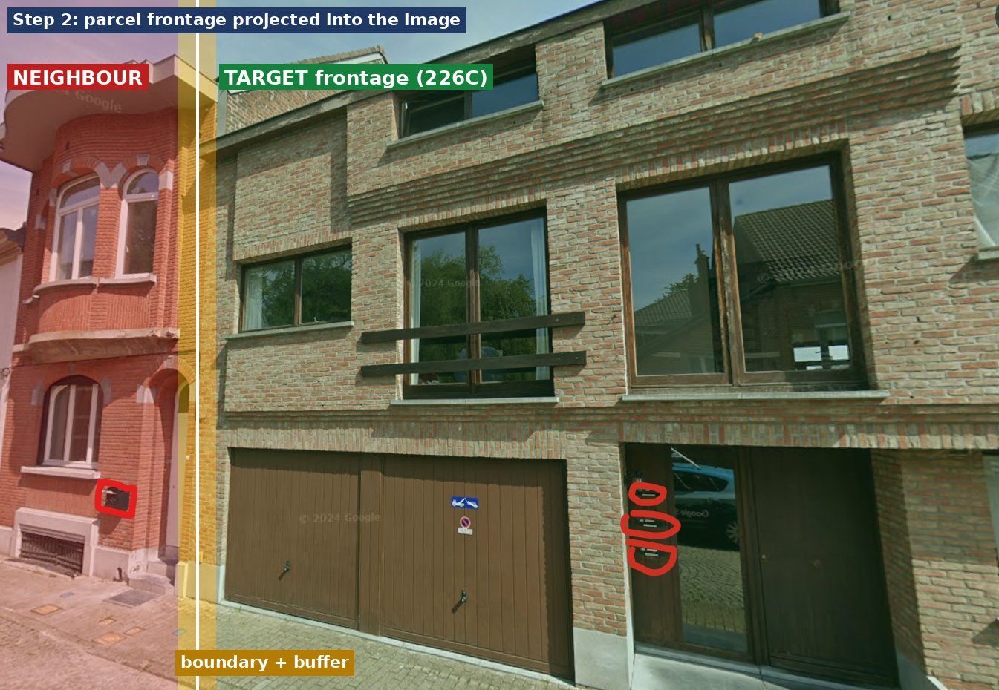
Figure 9. Frontage projected into the 226C image: neighbour (red), target (green), buffer (amber).
M1 is outside the range and is rejected. M2 to M4 are inside and are kept as a bank of three.
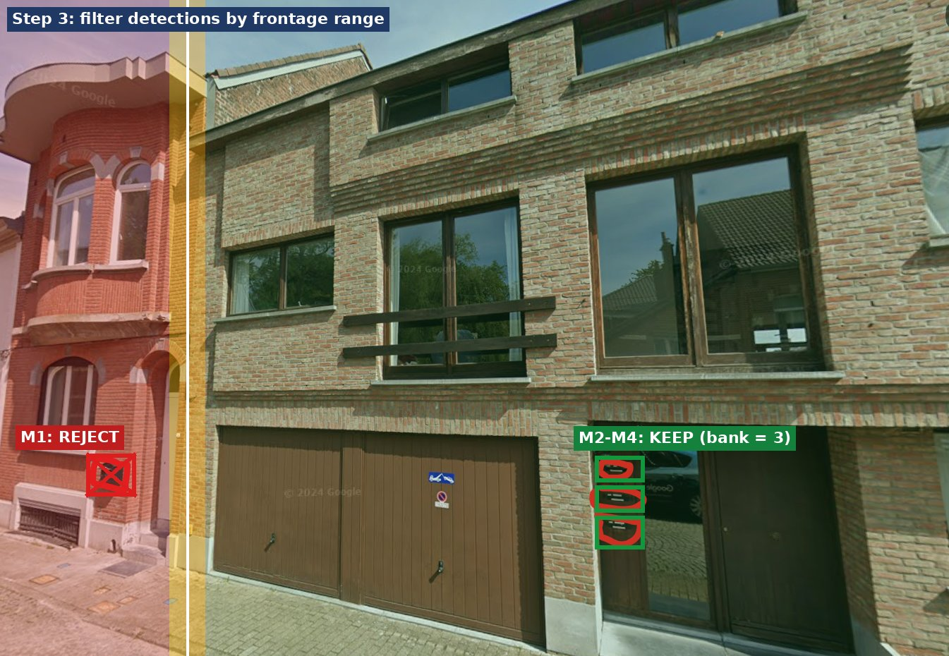
Figure 10. M1 rejected, M2-M4 kept as a bank of 3.
For review images only, everything outside the target range can be blurred. The decision itself comes from the geometry, because a hard mask can cut off a real mailbox if the boundary is slightly off.
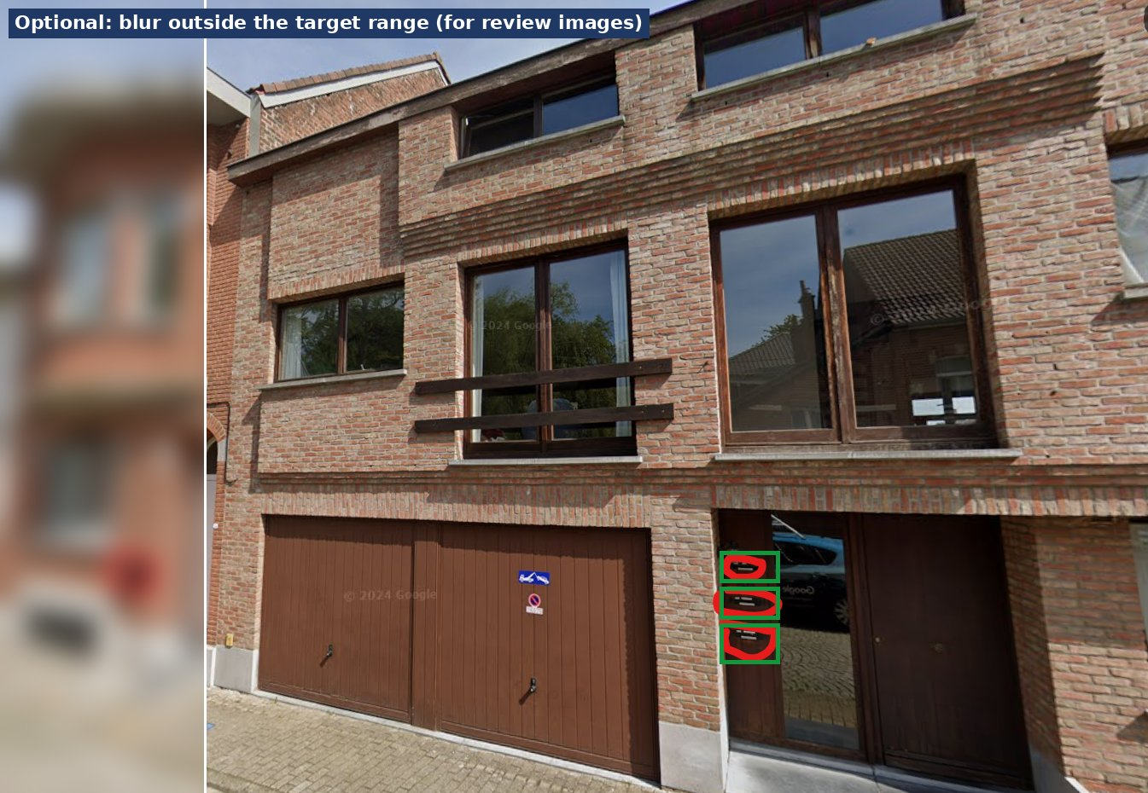
Figure 11. Optional review image with the neighbour blurred.
Item | Centre column | Test | Decision
M1 | ~155 px | Outside range (boundary ~265) | NEIGHBOUR
M2-M4 | ~880 px | Inside range | TARGET (bank of 3)

Check before relying on this example. The suffix C suggests other entrances (226A, 226B) may share this facade. The three slots belong to 226C only if that entrance is inside the 226C parcel; confirm with the building footprint (building_id 20419191). The coordinates and HASLength (0 in the record) should also be confirmed with the data owner.

8. Property types
The same method applies to every setting, but the line used as the frontage changes. With a single-class detector there are no door anchors, so the frontage line carries the decision.
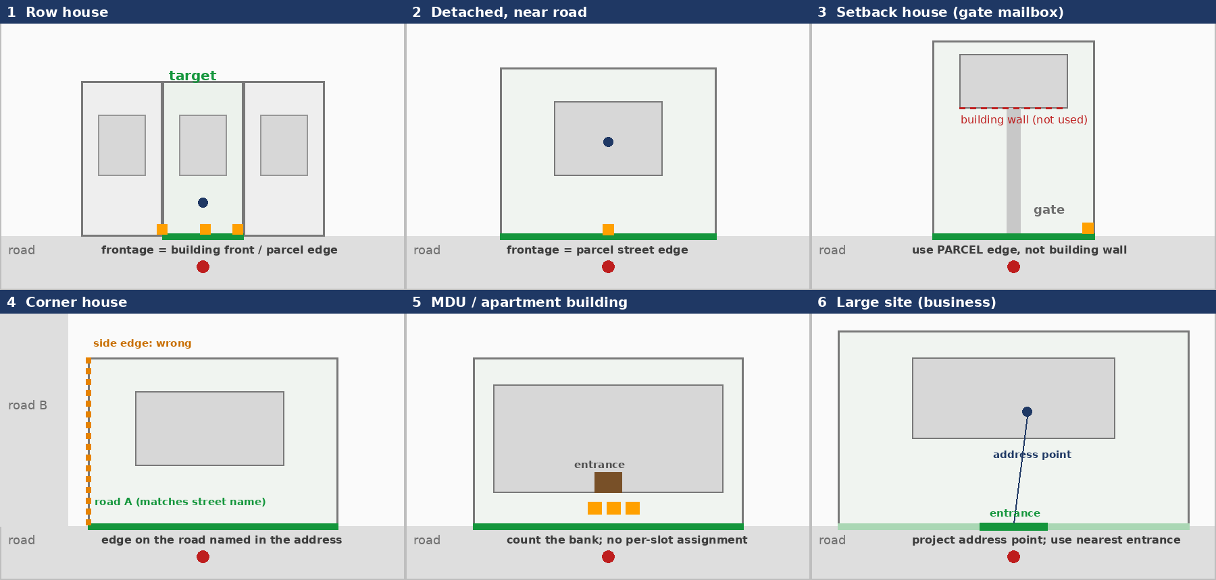
Figure 12. Frontage rule for six property types (green = frontage used, orange = mailbox, blue dot = address point).
Type | Frontage to use | Main risk | Extra check
Row house | Building front or parcel street edge | Neighbour mailbox near the boundary | Second panorama, register count
Detached, near road | Parcel street edge | Low | Register count
Setback / gate mailbox | Parcel street edge, not the building wall | Building far behind the line | Mailbox expected near the parcel edge
Corner house | Edge on the road named in the address | Choosing the side edge | Street name, road layer, 2 panoramas
MDU | Entrance range | Many mailboxes in one bank | Count the bank; compare with register
Large business site | Entrance near the address point | Very wide parcel | Project the address point; nearest entrance

A first step should classify each site (row, detached, setback, corner, MDU, large site) from the geometry and aansluit_type, then apply the matching rule. These categories and their thresholds have not been tested on real data.

9. Fallbacks, cross-check and outputs

9.1 No parcel for the address
# | Method | Flag | Confidence
1 | Nearest parcel within about 15 m that also overlaps the building | NEAREST_PARCEL | Medium
2 | Building footprint (by building_id or nearest within about 10 m); use its street-facing wall | BUILDING_ONLY | Medium
3 | Neighbouring address points: split the frontage halfway between adjacent points | NEIGHBOUR_SPLIT | Medium
4 | Fixed width (about 3 m each side) around the point, perpendicular to the camera line | POINT_ONLY | Low
5 | Nothing usable | NO_GEOMETRY | None

9.2 No Street View
Widen the search (radius 30, 60, 120 m, and points in front of the house and along the street). If nothing is found, set NO_STREETVIEW, skip the image steps and use the register count with a NO_IMAGERY flag. This status is separate from "zero mailboxes found".

9.3 House existence
Existence comes from data: the building footprint for the building_id and the BeSt status (CURRENT). If the image shows no mailbox, the result is a review case, not proof that the house is missing, because a mailbox can be inside a porch or hidden by a hedge or car.

9.4 Cross-check with the BeSt / CadGIS classifier
Vision result | Action
N found, register gives the same N | Accept; High confidence.
0 found, register gives a count | Use the register count; flag FROM_REGISTER; lower confidence.
N found, register gives a different count | Flag MISMATCH and send to review.
NO_STREETVIEW | Use the register count; flag NO_IMAGERY.
N found, register UNKNOWN | Accept vision; Medium confidence.

9.5 Status and output
Status | Meaning
VALID | Mailbox found and matches an input address.
NEW | Mailbox found with no matching input address; a new record is linked to the same site.
TBC / N | No mailbox and no register count, or the building cannot be confirmed.

Confidence levels are High, Medium, Low and Ambiguous. Output files: a GPKG with layers addresses_result, new_mailboxes and review_queue, and a KML with one style per status (VALID green, NEW blue, TBC/N orange, MISMATCH red) and the image path in each description. The original input columns are kept, and these are added: site_id, status, vision_count, register_count, final_count, count_source, confidence, flags, pano_ids and image_paths.

10. Limits, validation and plan

10.1 Limits and assumptions
- The method has not been run on real data; figures use hand-placed boxes and a hand-estimated boundary.
- Camera position error (a few metres) and parcel offset limit accuracy on narrow frontages, and there are no door anchors to help.
- A mailbox set back from the frontage line shifts the estimated s; a second view reduces this.
- The detector may still produce false or missed mailboxes; plausibility checks, several views and the register reduce but do not remove this.
- Thresholds (buffer, size and height ranges, bank distance, scores) are starting values.
- Terms of use for storing and processing Street View images at scale should be checked.

10.2 Validation
- Hand-label a sample of addresses, with emphasis on row houses, corner houses, setback houses and MDUs.
- Measure: correct assignment rate, neighbour leak rate, miss rate, false-mailbox rate, share of NO_STREETVIEW and share of Ambiguous.
- Compare blur-then-detect with detect-then-filter and keep whichever gives fewer wrong assignments.
- Tune the buffer and thresholds against the errors found, separately for each property type.

10.3 Implementation phases
Phase | Work
1: no API key | Ingest GPKG/KML, dedup, parcel and building matching, frontage corners, parcel overlay images, geometry tests on a synthetic row-house scene.
2: with API key | Panorama search and download, single-class detection, ground-position assignment, bank building, register cross-check, export.
3: validation | Hand-labelled sample, error measurement, threshold tuning, review queue workflow.

11. Suggested demo script
- Figures 1-2: "The detector finds every mailbox, but it cannot tell whose they are. In attached houses it also returns the neighbours'."
- Figure 3: "The work is split into six agents, from input to GPKG and KML export."
- Figure 4: "From the cadastre we take the target's frontage, with a small buffer for position error."
- Figures 5-6: "Each mailbox is placed on the frontage line. Inside the green range it is the target's, outside it is a neighbour's, and the amber band is flagged."
- Figure 7: "A second panorama resolves boundary cases by intersecting rays."
- Figures 8-11: "On real screenshots, the neighbours' mailboxes are rejected and the bank of three is kept."
- Figure 12: "The same approach adapts to detached, setback, corner, MDU and large sites."
- Close: "The detector only finds mailboxes, so there are no invented doors or gates. The register cross-check and a hand-labelled validation set show how reliable it is."

Appendix: geometry code
Handle 0/360 degree wrap-around when bearings straddle north. The ray function was checked on simple cases (camera at the origin, frontage 12 m ahead, an oblique camera); it has not been tested on real data.
import math
from shapely.geometry import Point, LineString

def street_edge(parcel, cam):
pts = list(parcel.exterior.coords)
edges = [(pts[i], pts[i+1]) for i in range(len(pts)-1)]
edges = [e for e in edges if math.dist(*e) > 1.5]
return min(edges, key=lambda e: LineString(e).distance(Point(cam)))

def left_right(P, Q, cam):
M = ((P[0]+Q[0])/2, (P[1]+Q[1])/2)
dx, dy = M[0]-cam[0], M[1]-cam[1]
cross = lambda C: dx*(C[1]-cam[1]) - dy*(C[0]-cam[0])
return (P, Q) if cross(P) > cross(Q) else (Q, P) # (left, right)

def col_to_bearing(x, heading, fov, W):
f = (W/2) / math.tan(math.radians(fov/2))
return (heading + math.degrees(math.atan((x - W/2) / f))) % 360

def ray_hit_frontage(cam, theta_deg, A, B):
"""Return (distance t along the ray, position s in metres from A) or None."""
ux, uy = math.sin(math.radians(theta_deg)), math.cos(math.radians(theta_deg))
vx, vy = B[0]-A[0], B[1]-A[1]
wx, wy = A[0]-cam[0], A[1]-cam[1]
det = vx*uy - ux*vy
if abs(det) < 1e-9:
return None
t = (vx*wy - vy*wx) / det
r = (ux*wy - uy*wx) / det
if t <= 0:
return None
return t, r * math.hypot(vx, vy)

def classify_s(s, L, b=1.0):
if 0 <= s <= L:
return "TARGET"
if -b <= s < 0 or L < s <= L + b:
return "AMBIGUOUS"
return "NEIGHBOUR"

def plausible(box, t, f, W, H, pitch_deg, cam_h=2.5,
wr=(0.1, 0.6), hr=(0.5, 2.0)): # starting values, tune on data
width_m = (box.x2 - box.x1) * t / f
yc = (box.y1 + box.y2) / 2
elev = math.radians(pitch_deg) + math.atan((H/2 - yc) / f)
height_m = cam_h + t * math.tan(elev)
return wr[0] <= width_m <= wr[1] and hr[0] <= height_m <= hr[1]

def build_banks(points, max_gap=1.5):
"""Greedy clustering of ground points (x, y) into banks."""
banks = []
for p in points:
for bank in banks:
if any(math.dist(p, q) <= max_gap for q in bank):
bank.append(p); break
else:
banks.append([p])
return banks

