

Name:Ch. Venkata sai mohith
Reg no:1925260287
Course:UBA0705-computer networks
Faculty:Dr.kumaran.G

ASSIGNMENT 2 – CO2

Q1. Spot the Invalid Addresses (NAT, Packet Switching)

1.1 Address analysis
Method: block size = 256 − (interesting octet of the mask); network = address rounded down to the block; broadcast = next network − 1; usable hosts = network+1 to broadcast−1.
Device | Network | Broadcast | Usable range | Verdict
Admission PC 172.16.45.200/20 (mask 255.255.240.0, block 16 in 3rd octet) | 172.16.32.0 | 172.16.47.255 | 172.16.32.1 – 172.16.47.254 | Valid host. Gateway 172.16.32.1 is in the same subnet.
Lab printer 10.0.15.255/21 (mask 255.255.248.0, block 8) | 10.0.8.0 | 10.0.15.255 | 10.0.8.1 – 10.0.15.254 | INVALID – trap 1: the address is the subnet's broadcast address.
X-ray server 192.168.4.0/23 (mask 255.255.254.0, block 2) | 192.168.4.0 | 192.168.5.255 | 192.168.4.1 – 192.168.5.254 | INVALID – trap 2: the address is the network address.
Clinic router 203.0.113.10/29 (mask 255.255.255.248, block 8) | 203.0.113.8 | 203.0.113.15 | 203.0.113.9 – .14 (6 hosts) | Valid host.

Fix: give the printer e.g. 10.0.8.50 and the X-ray server e.g. 192.168.4.10, keeping the same gateways.

1.2 NAT with Port Address Translation
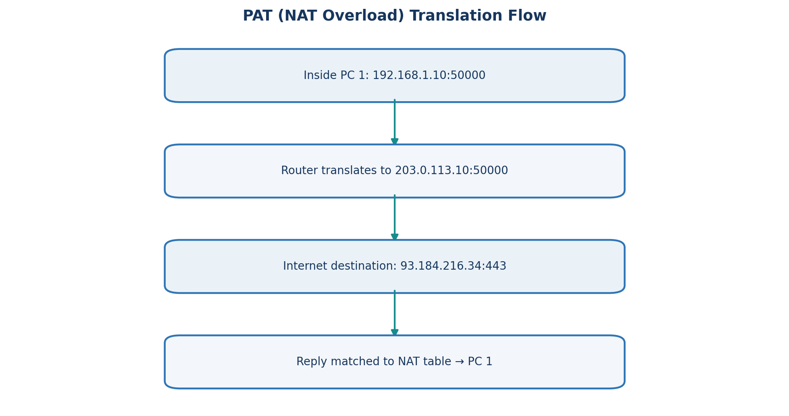
Figure 1. PAT translation example based on the assignment's NAT table.
The clinic's 18 devices share one public address. The router keeps a table keyed on the full connection (inside address, port, destination), and rewrites the source port when two inside hosts choose the same one.
Inside local | Inside global | Destination | Note
192.168.1.10:50000 | 203.0.113.10:50000 | 93.184.216.34:443 | PC1 keeps port 50000
192.168.1.11:50000 | 203.0.113.10:50001 | 93.184.216.34:443 | PC2's port is rewritten to 50001

Replies arriving at 203.0.113.10:50000 or :50001 are matched against the table and translated back to the correct PC, so both can use source port 50000 at the same time.

1.3 Datagram switching vs virtual circuits
- Datagram (IP): every packet carries the destination address and is routed independently. Routes or queue lengths can differ between packets, so packets of one file can arrive out of order; the receiver (TCP) reorders them. No set-up delay and it survives router failure by re-routing.
- Virtual circuit: a path is set up first and all packets follow it using a short circuit identifier, so order is preserved and per-packet overhead is small. The cost is set-up delay, state in every switch, and the circuit breaks if a switch on the path fails.

1.4 Alternative: public /27 instead of NAT behind a /29
Measure | NAT behind /29 | Public /27
Addresses | 8 (6 usable) | 32 (30 usable)
Needed for 18 devices + router | 1 public address | 19 addresses, 11 spare
Cost | Low | Higher (more addresses leased)
Exposure | Inside hosts hidden; inbound blocked by default | Every device reachable from the internet; firewall required
Application problems | Breaks inbound servers, end-to-end IPsec, FTP/SIP without helpers, port clashes | None of these NAT problems; true end-to-end connectivity

Q2. Subnet a Campus That Keeps Growing (VLSM, Summarisation)

2.1 Equal-size subnets
The largest LAN (Labs, 100 hosts) needs at least a /25 (126 hosts). A /25 gives only 2 subnets from the /24, but four networks are needed. Using /26 (4 subnets of 62 hosts) gives four networks, but Labs (100 hosts) cannot fit.
Subnet | Prefix / mask | First – Last host | Broadcast | Fits?
192.168.10.0 | /26 255.255.255.192 | 10.1 – 10.62 | 10.63 | Labs needs 100 – no
192.168.10.64 | /26 | 10.65 – 10.126 | 10.127 | Staff (50) yes
192.168.10.128 | /26 | 10.129 – 10.190 | 10.191 | Library (25) yes, 37 wasted
192.168.10.192 | /26 | 10.193 – 10.254 | 10.255 | WAN (2) yes, 60 wasted

Conclusion: equal-size subnetting cannot serve this campus; it either fails Labs or wastes most of the space.

2.2 VLSM (largest first)
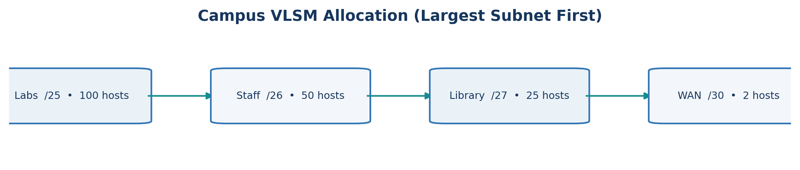
Figure 2. VLSM allocation sequence; subnet sizes follow the largest-first method.
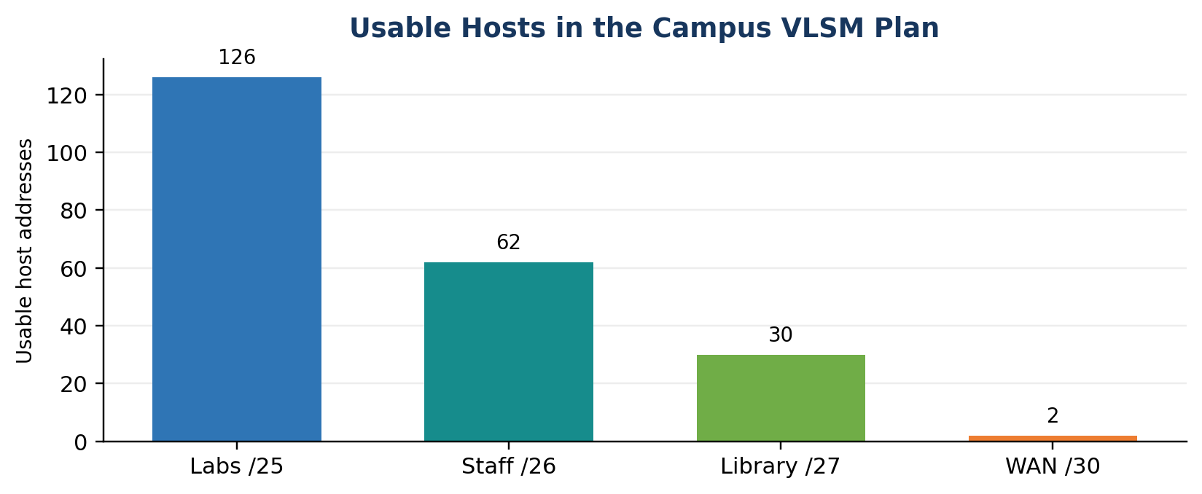
Figure 9. Usable host capacity of each allocated subnet.
LAN | Hosts | Block | Network/prefix | Mask | First – Last host | Broadcast
Labs | 100 | 128 | 192.168.10.0/25 | 255.255.255.128 | .1 – .126 | .127
Staff | 50 | 64 | 192.168.10.128/26 | 255.255.255.192 | .129 – .190 | .191
Library | 25 | 32 | 192.168.10.192/27 | 255.255.255.224 | .193 – .222 | .223
WAN | 2 | 4 | 192.168.10.224/30 | 255.255.255.252 | .225 – .226 | .227

Next free address: 192.168.10.228. Used 228 of 256 addresses.

2.3 Hostel trap (60 hosts)
A 60-host LAN needs 62 usable addresses, so a /26 (64 addresses). Only 192.168.10.228 – .255 (28 addresses) remain, and the largest aligned block there is a /28 (14 hosts). The hostel does not fit. In fact total demand is 128+64+64+32+4 = 292, which exceeds 256, so no arrangement of the /24 can hold it.
Smallest change without renumbering: enlarge the address space to 192.168.10.0/23 and place the hostel at 192.168.11.0/26 (hosts .11.1 – .11.62, broadcast .11.63). Existing subnets keep their addresses.

2.4 Route summarisation
172.16.8.0/24, 9.0/24, 10.0/24 and 11.0/24 differ only in the third octet values 8–11 (00001000 – 00001011). The first 22 bits are common, so the summary is 172.16.8.0/22.
If 172.16.12.0/24 is added and summarised as 172.16.8.0/21, the summary covers third octets 8–15. The router then advertises 172.16.13.0 – 15.255 which do not belong to the campus: traffic for those networks is attracted to this router and dropped (black-holed) or looped, and other sites can no longer be reached by their own more specific routes. Correct approach: keep 172.16.8.0/22 and advertise 172.16.12.0/24 separately, or summarise as /21 only when all 8 blocks are really in use.

2.5 Python VLSM program
import ipaddress, math
base = ipaddress.ip_network("192.168.10.0/24")

def alloc(reqs, nxt):
out = []
for name, h in sorted(reqs.items(), key=lambda x: -x[1]):
size = 1 << math.ceil(math.log2(h + 2))
if nxt % size:
nxt += size - nxt % size # align to block size
if nxt + size - 1 > int(base.broadcast_address):
print(name, "DOES NOT FIT"); continue
n = ipaddress.ip_network((nxt, 32 - int(math.log2(size))))
assert n.subnet_of(base) and not any(n.overlaps(o) for o in out)
out.append(n)
print(f"{name:8}{str(n):20}/{n.prefixlen} {n[1]} - {n[-2]} bc {n.broadcast_address}")
nxt += size
return nxt

nxt = alloc({"Labs":100,"Staff":50,"Library":25,"WAN":2}, int(base.network_address))
print("Next free:", ipaddress.ip_address(nxt))
alloc({"Hostel":60}, nxt) # prints: Hostel DOES NOT FIT

Expected output: the four subnets of table 2.2, 'Next free: 192.168.10.228' and 'Hostel DOES NOT FIT'. Every subnet passes the ipaddress checks (inside the /24, no overlap).

2.6 Alternative: smallest first
Allocating WAN (.0/30), then Library placed back-to-back at .4 gives a /27 that starts at .4. That is not a valid /27 (it must start at a multiple of 32) and it overlaps the .0/27 boundary. Aligning it to .32 repairs this but wastes .4 – .31 (28 addresses), exactly the space the hostel needs. Largest-first works because every block size divides the running offset, so blocks are always aligned and no gaps appear.

Q3. Which Way Will the Packet Go? (Static Routing)

3.1 Longest-prefix match
Destination | Matching routes | Chosen route | Next hop
10.1.2.200 | /8, /16, /24, /25 | 10.1.2.128/25 | 192.0.2.13
10.1.2.100 | /8, /16, /24 | 10.1.2.0/24 | 192.0.2.9
10.1.9.9 | /8, /16 | 10.1.0.0/16 | 192.0.2.5
10.7.7.7 | /8 | 10.0.0.0/8 | 192.0.2.1
8.8.8.8 | default only | 0.0.0.0/0 | 198.51.100.1

Rule: the router picks the matching route with the longest prefix length (most specific). Administrative distance and metric only decide between routes of the same prefix from different sources.

3.2 Configuration – R1
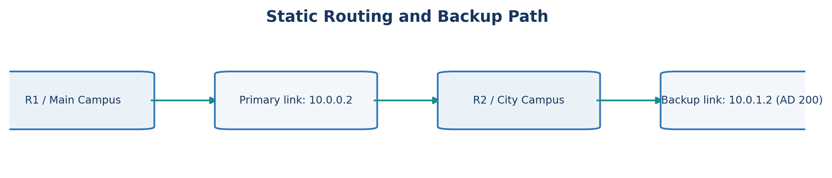
Figure 3. Primary and floating-backup static routing paths between the campuses.
hostname R1
interface g0/0
ip address 192.168.10.1 255.255.255.0
no shutdown
interface s0/0/0
ip address 10.0.0.1 255.255.255.252
clock rate 64000
no shutdown
interface g0/1
ip address 10.0.1.1 255.255.255.252
no shutdown
ip route 192.168.20.0 255.255.255.0 10.0.0.2
ip route 192.168.20.0 255.255.255.0 10.0.1.2 200 ! floating backup

Configuration – R2
hostname R2
interface g0/0
ip address 192.168.20.1 255.255.255.0
no shutdown
interface s0/0/0
ip address 10.0.0.2 255.255.255.252
no shutdown
interface g0/1
ip address 10.0.1.2 255.255.255.252
no shutdown
ip route 192.168.10.0 255.255.255.0 10.0.0.1
ip route 192.168.10.0 255.255.255.0 10.0.1.1 200 ! floating backup

3.3 Verification and expected results
- show ip route on R1 lists: S 192.168.20.0/24 [1/0] via 10.0.0.2. A main-campus PC pings a city-campus PC successfully.
- Floating static route: the AD-200 route is not installed while the AD-1 route exists. After shutting s0/0/0 the table shows S 192.168.20.0/24 [200/0] via 10.0.1.2 and pings continue over the backup link (at most a few lost packets).
- Removing the clock rate on the DCE end leaves the serial interface up, line protocol down. The connected route and the static route via 10.0.0.2 are removed from the routing table and the ping fails, because a serial link needs a clock from the DCE end.

3.4 Alternative: OSPF instead of static routes
Campuses | Static (config lines) | OSPF (config lines)
2 | 2 routes in total (1 per router) | about 6 (router ospf, 2 network lines per router)
5 | about 20 (4 routes per router) | about 15 (about 3 per router)

Static route effort grows quadratically with the number of campuses; OSPF effort is constant per router. Recovery: a floating static route switches within seconds only when the local interface goes down and cannot detect a remote failure without tracking. OSPF detects loss by the dead interval (40 s by default, sub-second with fast hellos) and then re-runs SPF, adapting to any failure automatically.

Q4. Distance-Vector Routing and Count to Infinity

4.1 Converged distance table
From \ To | A | B | C | D | E
A | 0 | 2 | 5 | 6 | 10
B | 2 | 0 | 3 | 4 | 8
C | 5 | 3 | 0 | 1 | 5
D | 6 | 4 | 1 | 0 | 4
E | 10 | 8 | 5 | 4 | 0

4.2 Round by round (changes)
Round | Updates
0 | Direct links only: A{B2,C7}, B{A2,C3,D8}, C{A7,B3,D1}, D{B8,C1,E4}, E{D4}; everything else 99
1 | A→D 8; B→D 4, B→E 12; C→A 5, C→E 5; D→A 8, D→B 4; E→B 12, E→C 5
2 | A→C 5, A→D 6, A→E 12; B→E 8; D→A 6; E→A 12, E→B 8
3 | A→E 10; E→A 10
4 | No change – converged. Three rounds of change, the fourth confirms stability.

A's best route to C is not the direct link: A→B→C costs 2 + 3 = 5, which is less than the direct cost 7.

4.3 Count to infinity (X–Y–Z, cost 1 each)
Y–Z fails. Before Y can announce the failure it hears X's vector, which still says Z = 2 (via Y). Y wrongly adopts Z = 3 via X.
Round | Y's distance to Z | X's distance to Z
Before failure | 1 | 2
Failure | ∞ (then 3 via X) | 2
1 | 3 | 4
2 | 5 | 4
3 | 5 | 6
4 | 7 | 6
… | keeps rising | keeps rising until RIP's limit of 16

Split horizon: X does not advertise Z back to Y because it learned Z from Y, so Y has no false route and marks Z unreachable. Poison reverse: X advertises Z with metric ∞ to Y. Y marks Z unreachable at once and the loop is broken in one or two rounds instead of about fourteen update intervals (about 7 minutes at RIP's 30 s timer).

4.4 RIP in Packet Tracer
router rip
version 2
no auto-summary
network 192.168.10.0
network 10.0.0.0
! test: show ip route -> R 192.168.20.0/24 [120/1]
! shut a link, then: show ip route and debug ip rip

4.5 Python program (Bellman-Ford exchange)
INF = 99
N = "ABCDE"
L = {("A","B"):2,("A","C"):7,("B","C"):3,("B","D"):8,("C","D"):1,("D","E"):4}

def run(L):
c = {}
for (u, v), w in L.items():
c[u, v] = c[v, u] = w
dv = {n: {m: 0 if n == m else c.get((n, m), INF) for m in N} for n in N}
rounds = 0
while True:
old = {n: dict(dv[n]) for n in N}
changed = False
for n in N:
for m in N:
if n == m: continue
best = min([old[n][m]] + [c[n, k] + old[k][m] for k in N
if (n, k) in c and c[n, k] < INF])
best = min(best, INF)
if best != dv[n][m]:
dv[n][m] = best; changed = True
if not changed: break
rounds += 1
print("rounds:", rounds)
for n in N: print(n, dv[n])

run(L)
L[("C", "D")] = 99 # link C-D fails
run(L)

4.6 After C–D fails
From \ To | A | B | C | D | E
A | 0 | 2 | 5 | 10 | 14
B | 2 | 0 | 3 | 8 | 12
C | 5 | 3 | 0 | 11 | 15
D | 10 | 8 | 11 | 0 | 4
E | 14 | 12 | 15 | 4 | 0

Every longest path is three hops, so the tables stabilise after about three rounds of change (confirm the exact number by running the program).

4.7 Alternative: link-state routing
Measure | Distance-vector | Link-state
Messages after C–D fails | Each router sends its vector to every neighbour each round: 10 messages per round × 3–4 rounds ≈ 30–40 | C and D flood one LSA each over the 5 remaining links ≈ 10–12 messages
Time to correct routes | 3–4 rounds (update intervals) | One flood across the network diameter plus a local SPF
Loop risk | Count to infinity | Transient loops only

Q5. Why Does OSPF Treat 1 Gbps and 10 Gbps the Same?

5.1 Cost with the default reference bandwidth (100 Mbps)
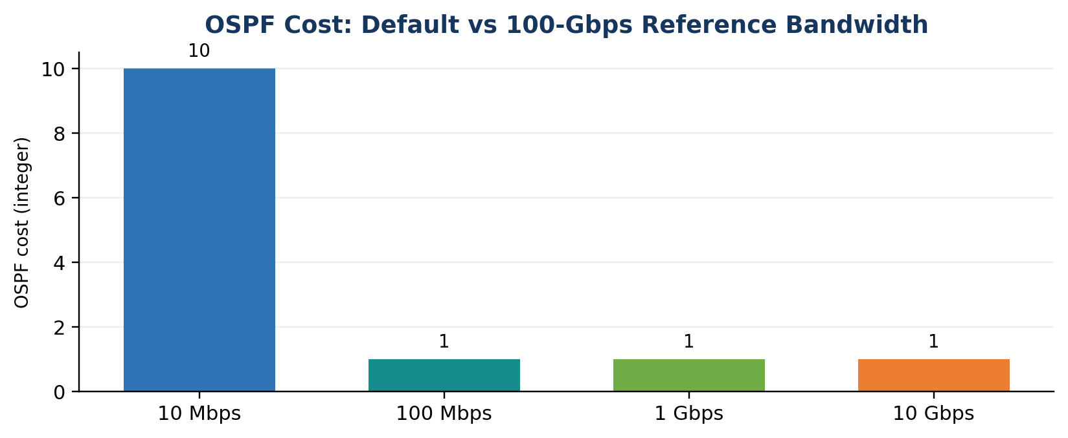
Figure 4. OSPF costs calculated using the default 100-Mbps reference bandwidth.
Link | 10 Mbps | 100 Mbps | 1 Gbps | 10 Gbps
Formula 100/BW | 10 | 1 | 0.1 | 0.01
OSPF cost | 10 | 1 | 1 | 1

Costs are integers with a minimum of 1, so 100 Mbps, 1 Gbps and 10 Gbps links all cost 1. The 1 Gbps and 10 Gbps paths tie (or the shorter-hop slow path wins), so traffic stays on the 1 Gbps path.

5.2 New reference bandwidth: 100 Gbps (100000 Mbps)
Link | 10 Mbps | 100 Mbps | 1 Gbps | 10 Gbps
OSPF cost | 10000 | 1000 | 100 | 10

5.3 Dijkstra from R1 on a six-router network
Links (cost): R1–R2 10G (10), R2–R4 10G (10), R1–R3 1G (100), R3–R4 1G (100), R4–R5 10G (10), R5–R6 10G (10), R3–R6 100M (1000).
Step | Router fixed | Tentative distances
1 | R1 = 0 | R2 = 10, R3 = 100
2 | R2 = 10 | R4 = 20
3 | R4 = 20 | R5 = 30; R3 via R4 = 120 (keep 100)
4 | R5 = 30 | R6 = 40
5 | R6 = 40 | R3 via R6 = 1040 (keep 100)
6 | R3 = 100 | done

Shortest-path tree from R1: R2 (10), R4 (20), R5 (30), R6 (40) along the 10G chain, and R3 (100) directly. With the old costs every link costs 1, so R1 would reach R6 in two hops through R3 and the 100 Mbps R3–R6 link instead of the 10G chain.

5.4 Packet Tracer configuration
router ospf 1
router-id 1.1.1.1
auto-cost reference-bandwidth 100000 ! same value on every router
network 10.0.12.0 0.0.0.3 area 0
network 10.0.13.0 0.0.0.3 area 0
interface g0/0
bandwidth 10000000 ! 10G link (kbps) in the simulator
! check: show ip ospf interface brief show ip route ospf

Expected: costs of 10 and 100 on the 10G and 1G links, and show ip route selects the 10G path.

5.5 One area or several?
For a state-wide ISP with many routers, use multiple areas: area 0 as the backbone between cities and one area per region. Benefits: smaller link-state databases, fewer and cheaper SPF runs, flooding limited to the area, and route summarisation at area border routers. Costs: more design complexity, possible sub-optimal inter-area paths, and the backbone must stay contiguous. A single area would be acceptable only for a small network (tens of routers).

5.6 Alternative: EIGRP or IS-IS
EIGRP metric = 256 × (10^7 / minimum bandwidth in kbps + total delay in tens of microseconds). Assuming one link of 10 µs delay (1 unit):
Path | Bandwidth term | Delay term | Metric
1 Gbps | 10^7/10^6 = 10 | 1 | 256 × 11 = 2816
10 Gbps | 10^7/10^7 = 1 | 1 | 256 × 2 = 512

EIGRP gives the two paths different metrics (10G preferred) without changing any reference value. IS-IS defaults to a metric of 10 on every interface, so it has the same problem as OSPF and needs manual metrics. Classic EIGRP flattens speeds above 10 Gbps and is Cisco-oriented. Decision: EIGRP avoids the problem in a Cisco-only network; for a multi-vendor ISP, OSPF with a 100 Gbps reference bandwidth is the standard choice.

Q6. IPv6, ICMP, Multicast and SDN in a Smart City

6.1 IPv6 address
2001:0db8:0000:0000:0000:ff00:0042:8329 → remove leading zeros and compress the longest run of zero groups once: 2001:db8::ff00:42:8329.

6.2 EUI-64 for MAC 00:1A:2B:3C:4D:5E
- Split the MAC: 00:1A:2B | 3C:4D:5E and insert FF:FE in the middle: 00:1A:2B:FF:FE:3C:4D:5E.
- Flip the universal/local bit (bit 7 of the first byte): 00 (00000000) becomes 02 (00000010).
- Interface identifier: 021A:2BFF:FE3C:4D5E (link-local address fe80::21a:2bff:fe3c:4d5e).

6.3 Traceroute and ICMP Time Exceeded
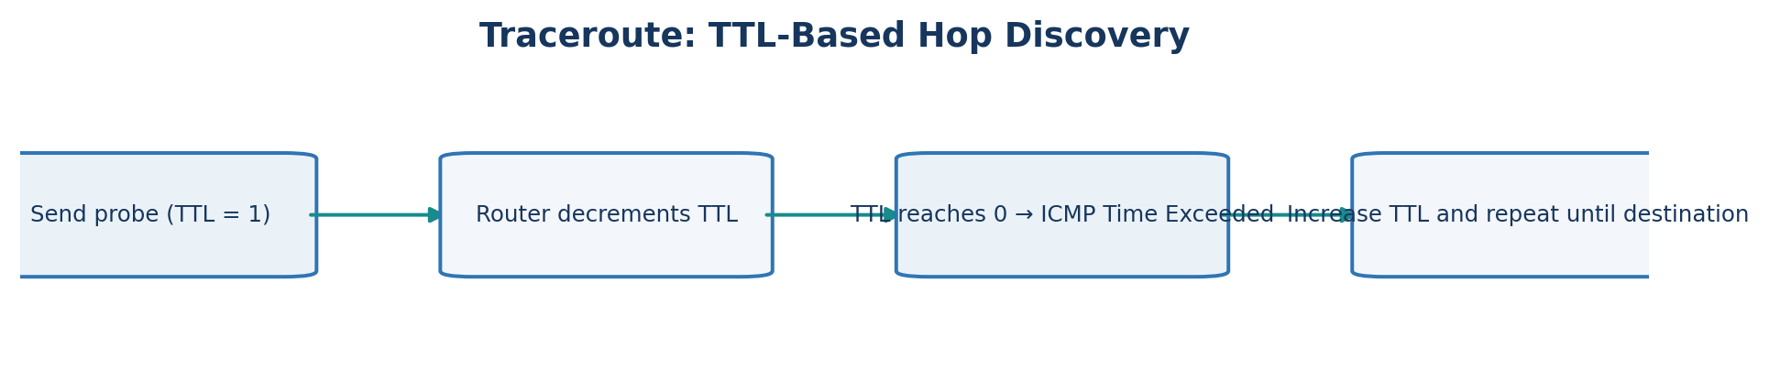
Figure 5. TTL progression and ICMP Time Exceeded response.
Traceroute sends probes with TTL = 1, 2, 3 … Each router decrements the TTL; the router that makes it 0 discards the packet and returns an ICMP Time Exceeded message (type 11, code 0) from its own address, revealing that hop. The round-trip time of each reply is recorded (usually three probes per TTL). When the probe finally reaches the destination, it answers with an echo reply or port unreachable, and the trace ends.

6.4 Multicast
The IPv4 multicast MAC is 01:00:5E followed by the lower 23 bits of the group address. For 239.1.2.3 the lower bits give 01:02:03, so the MAC is 01:00:5E:01:02:03 (32 groups share each MAC because 5 bits are dropped).
The camera sends a single stream to the group address. Control rooms join the group with IGMP, and the multicast routing protocol (e.g. PIM) builds a distribution tree. Routers copy the stream only where the tree branches, so each link carries it once and the camera never duplicates it.

6.5 OpenFlow and SDN decision
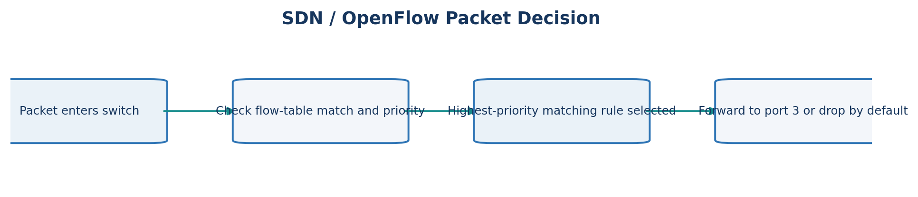
Figure 6. Simplified OpenFlow rule-matching decision sequence.
Packet | Matching rules | Result
HTTP to 10.5.1.1 | priority 200 (dst 10.5.0.0/16) and priority 100 (TCP 80) | Highest priority wins: forwarded to port 3 (not sent to the controller)
SSH to 10.6.1.1 | only the priority-0 default | Dropped

Decision: SDN is worth adopting for the smart city, in a phased pilot. It enables central, programmable route and policy changes across thousands of devices. Risks are the controller as a single point of failure (use clustered controllers), packet-in latency to the controller, and a larger security target.

6.6 Alternative: IPv6 transition options
Approach | Advantage | Drawback
Native IPv6 only | Simplest long term, 2 million sensors easily addressed | Cannot reach IPv4-only services without translation
Dual-stack | No tunnel overhead, works with both worlds | Two protocols to configure, secure and monitor
6in4 tunnel | Quick over an IPv4 core | Adds 20 bytes: a 100-byte packet becomes 120 bytes (20% overhead), plus MTU and tunnel endpoints to manage

Recommendation: start with dual-stack in the core, use native IPv6 for new sensors, and use tunnels only for temporary IPv6 islands.

Q7. Design Challenge – Find the Weak Point, Redesign and Validate
Selected network: the college campus addressing plan from Q2.

A. Identify the limitation (2 marks)
The VLSM plan uses 228 of the 256 addresses in 192.168.10.0/24. When the 60-host hostel is added it needs a /26, but only 28 addresses remain, in aligned blocks no larger than a /28 (14 hosts). Total demand is 292 addresses, more than the /24 holds. The cause is the addressing design itself: a single, tightly packed /24 with no growth reserve and no room for a block-aligned addition. More routers or switches would not help.

B. Design objective (2 marks)
- Accommodate the hostel and 50% growth in every LAN with no renumbering of existing subnets.
- Keep the core routing table to one summary route for the campus.
- Keep at least 40% of the allocated block unassigned as reserve.

C. Revised network (4 marks)
Replace the /24 with 10.20.0.0/22 (1024 addresses), still allocated largest first, with each LAN sized for 50% growth.
LAN | Planned hosts | Subnet | Mask | Usable hosts
Labs | 150 | 10.20.0.0/24 | 255.255.255.0 | 254
Staff | 75 | 10.20.1.0/25 | 255.255.255.128 | 126
Hostel | 90 | 10.20.1.128/25 | 255.255.255.128 | 126
Library | 38 | 10.20.2.0/26 | 255.255.255.192 | 62
WAN link | 2 | 10.20.2.64/30 | 255.255.255.252 | 2
Reserve | – | 10.20.2.68 – 10.20.3.255 | – | about 444 addresses

Topology: core router with five interfaces (Labs, Staff, Hostel, Library, WAN) towards the college router, advertising a single summary 10.20.0.0/22.
Trade-offs: one-time renumbering effort; a larger broadcast domain for Labs (/24 instead of /25); a bigger block of address space committed.

D. Prediction (1 mark)
The hostel subnet will be assigned and reachable without touching other subnets; about 43% of the block (444 of 1024) stays free; and the core needs 1 summary prefix instead of 5 separate prefixes.

E. Implement and validate (2 marks)
Test (same on both versions) | Original 192.168.10.0/24 | Redesign 10.20.0.0/22
Assign hostel subnet (60 hosts) | Fails – no aligned /26 free | Succeeds – 10.20.1.128/25
Ping hostel ↔ Labs, Staff, Library | Not possible | Succeeds
Prefixes in core routing table | 5 (4 LANs + WAN) | 1 summary (10.20.0.0/22)
Free addresses after change | 28 (fragmented) | about 444 (contiguous)

Capture show ip route and ping output on the two Packet Tracer files and keep them in the Q7 folder of the GitHub repository.

F. Defend the final design (2 marks)
The objective is met: the hostel fits, growth is covered, the reserve exceeds 40% and the core carries a single summary route. The costs are the renumbering effort, a larger Labs broadcast domain and 1024 addresses committed instead of 256. The original design is still preferable for a small, stable campus that will not grow, where renumbering has no benefit and the tight plan is adequate.

Submission Checklist
- GitHub repository CSA07-<RegisterNumber>-Assignment2: one folder per task (Q1–Q7), README with OS, Python and Packet Tracer versions, run steps and results.
- At least one commit per task; do not upload everything on the last day.
- Python programs for Q2 and Q4 with output shown; Packet Tracer .pkt files with screenshots for Q2, Q3, Q4, Q5 and Q7.
- Address tables, routing tables, ping and traceroute outputs (Q1–Q3, Q7); show ip route before and after link failures (Q3, Q4, Q5).
Visual note: All diagrams and bar graphs are based on the addressing plans, routing examples, and numerical values already presented in this assignment. They are explanatory visuals, not additional experimental measurements.

