

Name:Ch. Venkata sai mohith
Reg no:1925260287
Course:UBA0705-computer networks
Faculty:Dr.kumaran.G

ASSIGNMENT 3 – CO3

TASK 1 – WHICH SOCKET GETS THE SEGMENT?

1.1 Socket demultiplexing
Arriving segment | Destination socket / action | Reason
TCP 49.37.2.8:50001 → server:443 | Established TCP socket (203.0.113.5:443 ↔ 49.37.2.8:50001) | The four-tuple (source IP, source port, destination IP, destination port) matches exactly.
TCP 117.96.4.2:50000 → server:443 | Established TCP socket (203.0.113.5:443 ↔ 117.96.4.2:50000) | The remote IP distinguishes this connection from another using source port 50000.
TCP SYN 106.51.7.7:41000 → server:443 | TCP listening socket on 203.0.113.5:443 | No established connection matches; the listener accepts the new connection and creates a new socket after the handshake.
UDP 49.37.2.8:50000 → server:5004 | UDP socket 203.0.113.5:5004 | The UDP socket is bound to destination port 5004; with one shared socket, application code must inspect sender address if it needs to distinguish viewers.

Two TCP connections may use the same client source port because TCP demultiplexes established connections using the complete four-tuple. UDP commonly delivers datagrams to a socket selected by the local destination address and port. A single UDP socket can receive datagrams from many clients, but the application must use each datagram’s source address/port to identify the viewer.

1.2 Header overhead for a 100-byte score update
Protocol | IPv4 header | Transport header | Total headers | Header / payload | Headers / total packet
UDP over IPv4 | 20 B | 8 B | 28 B | 28/100 = 28% | 28/128 = 21.875%
TCP over IPv4 | 20 B | 20 B | 40 B | 40/100 = 40% | 40/140 = 28.57%

The “overhead percentage” depends on the denominator. This answer states both common definitions: header bytes as a percentage of payload, and header bytes as a percentage of the complete IP packet.

1.3 Protocol choice for the sports app
- Live score updates: TCP/HTTPS is suitable when every update must arrive reliably and in order. For very frequent replaceable score snapshots, UDP can be used if the application tolerates occasional loss and sends fresh updates.
- Ball-by-ball commentary: TCP is preferred because missing or reordered text can change the meaning; reliable delivery is more important than saving a few header bytes.
- Live video: UDP-based RTP/WebRTC is generally preferred because late packets are less useful than timely packets. The decoder can conceal some loss; congestion control and adaptive bitrate are still required.

1.4 Python socket demonstration
The following single-machine example starts a UDP echo-style ACK server and a TCP byte-counting server. Run the server first, then run clients. The TCP server reads until the client closes the connection.
# server.py
import socket
import threading

def udp_server():
s = socket.socket(socket.AF_INET, socket.SOCK_DGRAM)
s.bind(("127.0.0.1", 5004))
print("UDP server on 5004")
while True:
data, addr = s.recvfrom(65535)
s.sendto(b"ACK:" + data, addr)

def handle_tcp(conn, addr):
total = 0
while True:
chunk = conn.recv(4096)
if not chunk:
break
total += len(chunk)
print(f"{addr}: received {total} bytes")
conn.close()

def tcp_server():
s = socket.socket(socket.AF_INET, socket.SOCK_STREAM)
s.setsockopt(socket.SOL_SOCKET, socket.SO_REUSEADDR, 1)
s.bind(("127.0.0.1", 5005))
s.listen()
print("TCP server on 5005")
while True:
conn, addr = s.accept()
threading.Thread(target=handle_tcp, args=(conn, addr), daemon=True).start()

threading.Thread(target=udp_server, daemon=True).start()
tcp_server()

# client.py — send to UDP server and send 100,000 bytes to TCP server
import socket

u = socket.socket(socket.AF_INET, socket.SOCK_DGRAM)
for message in (b"score A", b"score B", b"score C"):
u.sendto(message, ("127.0.0.1", 5004))
print(u.recvfrom(2048)[0].decode())
u.close()

t = socket.create_connection(("127.0.0.1", 5005))
t.sendall(b"X" * 100_000)
t.shutdown(socket.SHUT_WR)
t.close()

1.5 Capture and loss investigation
- In Wireshark, select the loopback interface and filter with: udp.port == 5004 or tcp.port == 5005.
- For TCP, identify SYN, SYN-ACK and ACK; inspect sequence and acknowledgement numbers. For UDP, inspect source/destination ports and the 8-byte UDP header.
- On Linux, apply controlled loss to a test interface with sudo tc qdisc add dev <interface> root netem loss 1%, then repeat for 5% and 10%. Remove it with sudo tc qdisc del dev <interface> root. Use an isolated test environment and replace <interface> with the correct interface.
- List sockets using ss -tunap. Record actual packet counts and application-level delivered messages for each loss rate.

Alternative concept: sending video over TCP
At 500 packets/s and 2% loss, expected lost packets per minute = 500 × 60 × 0.02 = 600. With a 60 ms RTT, a TCP retransmission can cause at least one RTT of delay, so a simple upper-level estimate is 600 × 0.06 = 36 seconds of aggregate freeze exposure per minute if every loss independently caused a 60 ms freeze. This is not necessarily 36 seconds of distinct wall-clock freezing: losses may overlap, and modern TCP recovery behavior depends on congestion window, ACKs and retransmission timing. UDP-based real-time media avoids transport-level head-of-line waiting, although lost video data can still visibly degrade the picture.
Conclusion: “UDP is unreliable, so never use it” is incorrect. UDP deliberately leaves reliability, ordering and retransmission to the application. It is useful for time-sensitive media where a late retransmission may be worse than a small amount of loss. TCP is preferable when complete, ordered delivery is essential.
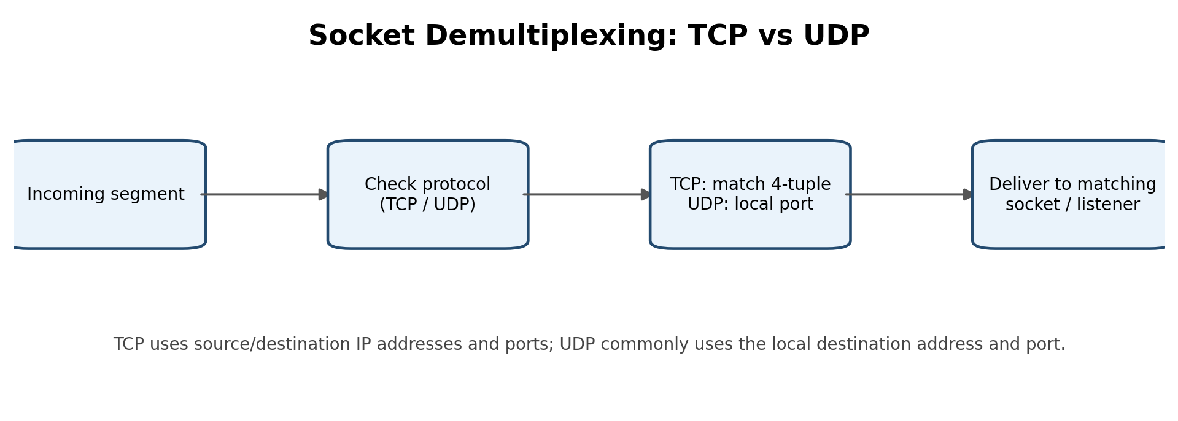
Figure 1: Socket demultiplexing overview.

TASK 2 – READ THE CONGESTION WINDOW

2.1 Interpret the given trace
Round trip | cwnd (segments) | Interpretation
1–5 | 1, 2, 4, 8, 16 | Slow start: approximately doubles each RTT.
6–8 | 17, 18, 19 | Congestion avoidance: increases about one segment per RTT.
9 | 9 | Window approximately halves after a loss, consistent with Reno fast retransmit/fast recovery.
10–14 | 10, 11, 12, 13, 14 | Congestion avoidance after recovery.
15 | 1 | Timeout-style response: sender restarts at one segment, consistent with Tahoe behavior on timeout.
16–17 | 2, 4 | Slow start after restart.

ssthresh at the start is 16 segments (given in the code task). At the first loss, the previous congestion-avoidance window is about 18–19 segments; halving gives approximately 9 segments. At the second loss, cwnd is 14, so the new threshold is approximately 7 segments (half of 14). Exact implementation details can differ by one segment depending on whether the loss is detected before or after the round-trip sample.
The drop from about 19 to 9 is characteristic of a fast-recovery response rather than a timeout reset. The drop from 14 to 1 indicates a timeout/Tahoe-style restart. Therefore the trace is not a pure textbook Reno or pure textbook Tahoe trace: the first event resembles Reno fast recovery, while the second resembles a timeout response.

2.2 Throughput at round trip 7
At RTT 7, cwnd = 18 segments. Segment size = 1,460 bytes; RTT = 40 ms = 0.04 s.
Throughput ≈ (cwnd × segment size × 8) / RTT = (18 × 1,460 × 8) / 0.04 = 5,256,000 bit/s ≈ 5.256 Mbps.

2.3 Why AIMD tends toward fairness
Additive increase gives each competing flow a similar absolute increase in congestion window. Multiplicative decrease reduces each flow’s window by a similar proportion when congestion occurs. A flow with a larger share therefore loses more in absolute terms, while a smaller flow loses less. Repeated cycles tend to move competing flows toward a fair share, assuming similar RTTs, congestion signals and bottleneck conditions. Different RTTs and different loss behavior can prevent perfect fairness.

2.4 Python simulation of Tahoe and Reno
# congestion.py — simplified teaching model, not a full TCP implementation
def simulate(kind):
cwnd = 1.0
ssthresh = 16.0
trace, total = [], 0.0
for rtt in range(1, 21):
# Count the window sent in this RTT (rounded to whole segments)
sent = max(1, int(cwnd))
trace.append(sent)
total += sent

if rtt in (8, 14): # loss detected at end of this RTT
ssthresh = max(2.0, cwnd / 2)
if kind == "Tahoe":
cwnd = 1.0
else: # simplified Reno fast recovery
cwnd = ssthresh
elif cwnd < ssthresh:
cwnd = min(ssthresh, cwnd * 2)
else:
cwnd += 1.0
return trace, int(total)

for name in ("Tahoe", "Reno"):
trace, total = simulate(name)
print(name, "trace:", trace)
print(name, "segments sent:", total)

This deliberately simplified model treats both specified losses as fast-detected events for Reno and as window resets for Tahoe. A real TCP implementation needs ACK-level state, duplicate-ACK counting, retransmission timers, fast-recovery exit rules and a precise definition of whether the listed RTT is before or after loss detection. Use this model for the requested conceptual comparison, not as a packet-accurate TCP stack.

2.5 Reno versus BBR under 1% random loss
Reno interprets packet loss as a congestion signal and reduces cwnd, even when loss is random rather than caused by a full queue. Its throughput can therefore fall unnecessarily. BBR estimates bottleneck bandwidth and minimum RTT and controls its sending rate using those estimates; it can maintain a higher rate under non-congestion random loss, provided the path and implementation support it. BBR is not immune to loss and can still experience retransmissions or application degradation.
For a hostel server, BBR is attractive on high-bandwidth, variable-delay paths where loss is not a reliable congestion signal. CUBIC is widely deployed and often performs well on conventional loss-based paths. The final choice should be based on measurements of throughput, RTT/queueing delay, retransmissions and fairness with other traffic.
- Experimental evidence to collect: run two simultaneous iperf3 flows; inspect ss -ti; repeat with controlled loss/delay using tc netem; plot each flow’s throughput and RTT.
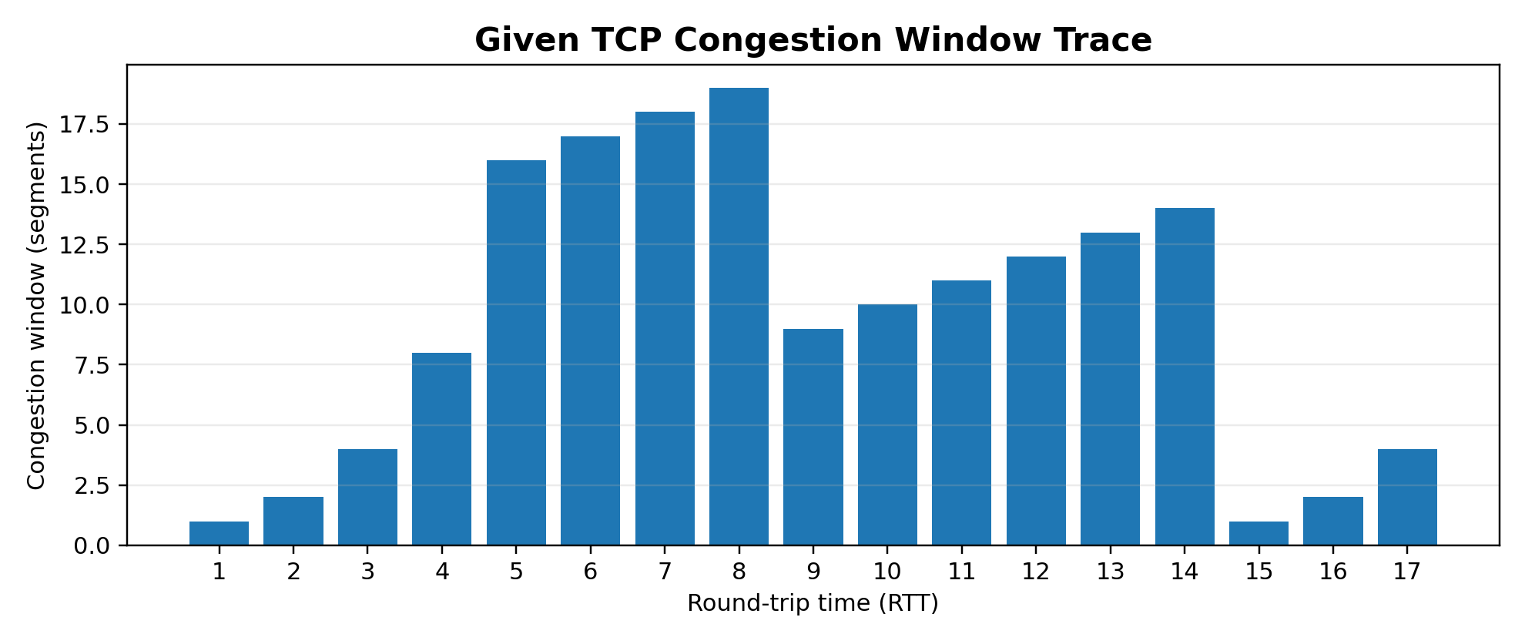
Figure 2: Congestion-window values from the given RTT trace.

TASK 3 – WHY DOES THE HOME PAGE TAKE 8 SECONDS?

3.1 Page-load calculations
There is one HTML file plus 80 small objects, RTT = 50 ms, and transmission time is negligible. Assume all objects are on the same origin and count a TCP handshake as one RTT and each HTTP request/response as one RTT.
HTTP arrangement | RTT calculation | Estimated load time
Non-persistent, one connection at a time | 81 objects × (1 RTT TCP setup + 1 RTT request/response) = 162 RTT | 162 × 50 ms = 8,100 ms = 8.1 s
Persistent HTTP/1.1, no pipelining | 1 RTT TCP setup + 81 sequential request/response RTTs = 82 RTT | 4,100 ms = 4.1 s
Persistent HTTP/1.1 with pipelining | 1 RTT setup + 1 RTT for HTML + 1 RTT for pipelined objects = 3 RTT | 150 ms
Six parallel non-persistent connections | HTML 2 RTT = 100 ms; 80 objects in ceil(80/6)=14 batches × 2 RTT = 1,400 ms | 1,500 ms = 1.5 s

The first result explains the “about 8 seconds” symptom: a new TCP connection for every object incurs repeated handshake and request RTT costs. Browser connection scheduling, server limits, DNS, TLS and object dependencies can change real measurements.

3.2 HTTP/2 versus HTTP/3
HTTP/2 multiplexes many streams over one TCP connection. If one TCP segment is lost, TCP withholds later bytes until the missing bytes are retransmitted and received in order. That transport-level head-of-line blocking can temporarily stall all HTTP/2 streams. HTTP/3 uses QUIC over UDP and independent QUIC streams; loss affecting one stream generally does not block delivery on unrelated streams, although congestion control still applies to the connection.

3.3 Cache headers and second visit
- Cache-Control: max-age=3600 allows a browser to reuse a fresh response for one hour without contacting the server. If all 80 objects and the HTML are fresh, the second visit can avoid their network request/response RTTs; the saved time can approach the first-visit load time (about 8.1 s in the sequential non-persistent model), excluding navigation and local processing.
- ETag gives a version identifier. When a cached object becomes stale, the browser sends If-None-Match; the server can reply 304 Not Modified. This avoids retransmitting the body but still costs a validation round trip per request, unless requests are combined or parallelized.

3.4 Engineering ranking
1. Enable effective caching with Cache-Control for static assets and ETag validation for content that changes. This can make repeat visits dramatically faster.
2. Use HTTP/3 where supported, or HTTP/2 otherwise, to multiplex resources and reduce repeated connection setup; HTTP/3 also reduces cross-stream head-of-line blocking.
3. Reduce object count and critical-path dependencies by bundling/minifying assets where appropriate, compressing responses and prioritizing critical resources.

Alternative concept: combine 80 objects into 8 bundles
There are now 9 resources including the HTML. Non-persistent sequential HTTP: 9 × 2 RTT × 50 ms = 900 ms. Persistent HTTP/1.1 without pipelining: 1 RTT setup + 9 request/response RTTs = 10 RTT × 50 ms = 500 ms. Compared with the original 8.1 s and 4.1 s estimates, bundling removes many sequential round trips. HTTP/2 can also fetch independent objects over one connection without requiring bundling, while retaining independent resource caching.
Experimental checklist: use browser developer tools to record protocol (h1/h2/h3), number of connections, first-visit and repeat-visit load times; repeat with 0, 50 and 200 ms added delay. Do not enter invented measurements in the report.
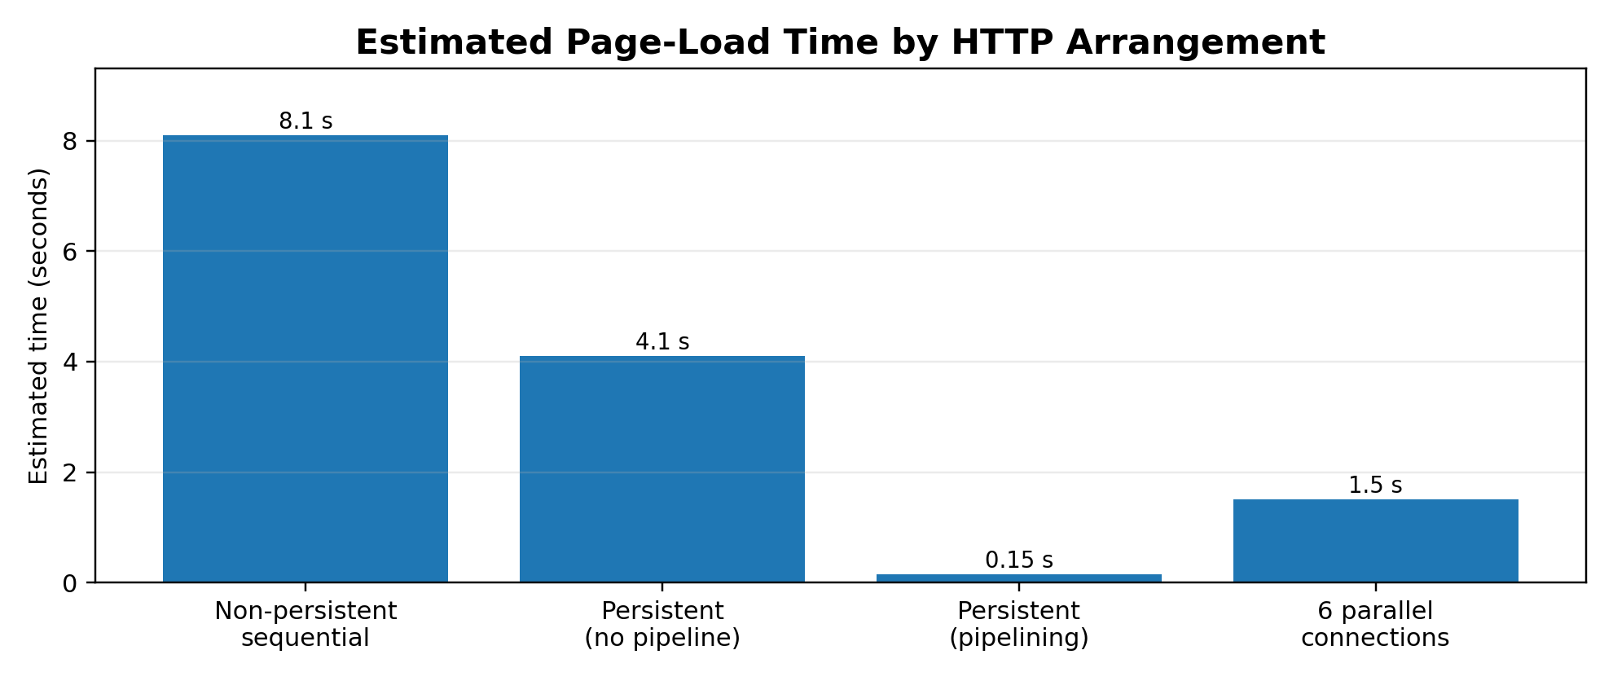
Figure 3: Comparison of the calculated HTTP page-load times.

TASK 4 – HOW MANY QUERIES REACH THE UNIVERSITY’S DNS SERVER?

4.1 Queries per hour per resolver
Assume one resolver has to refresh the relevant authoritative answer once per TTL and receives enough client requests to keep the cache useful. Queries/hour = 3,600 seconds ÷ TTL.
TTL | Calculation | Authoritative refresh queries per hour per resolver
300 s | 3,600 / 300 | 12
30 s | 3,600 / 30 | 120

If there is approximately one independent resolver in each of 40 cities, the corresponding illustrative totals are 40 × 12 = 480 queries/hour for TTL 300 s, and 40 × 120 = 4,800 queries/hour for TTL 30 s. Actual numbers depend on resolver count, cache behavior, record types, query demand, negative caching and refresh policies. The 150,000 students do not each directly query the authoritative server because their provider resolvers cache answers.

4.2 Recursive and iterative resolution
A phone normally sends a recursive query to its configured recursive resolver: it asks the resolver to return the final answer. The resolver performs iterative lookups, following referrals in order: a root server refers it to the .in TLD; the .in server refers it to .ac.in; the relevant authoritative server for simats.ac.in returns the requested record. The resolver caches the answer for its TTL and returns it to the phone.

4.3 DNS record types
Record | Purpose
A | Maps a host name to an IPv4 address.
AAAA | Maps a host name to an IPv6 address.
CNAME | Aliases one name to another canonical name.
MX | Identifies mail exchangers for the domain.
NS | Identifies authoritative name servers for a zone.
TXT | Stores text data, commonly used for SPF, domain verification and related policies.

DNS usually uses UDP for small, low-overhead queries and responses. It can use TCP for zone transfers and responses that are too large or truncated over UDP; modern DNS may also use EDNS(0) to support larger UDP messages. TCP is also used when a response indicates truncation (TC bit) and the client retries.

4.4 Long-TTL risk
A very long TTL reduces authoritative query load but can leave old IP addresses cached after a migration. If the result server moves during result day, some users may continue contacting the old address until their cached entries expire. A practical plan is to lower TTL well before a planned migration, wait out the previous TTL, move the service, verify, and then raise TTL again.

4.5 Iterative DNS cache simulation
# dns_sim.py — simplified referral walk with a TTL cache
import time

zones = {
"root": {"in.": "tld-in", "com.": "tld-com"},
"tld-in": {"ac.in.": "ns-ac"},
"tld-com": {"example.com.": "ns-example"},
"ns-ac": {"simats.ac.in.": "ns-simats"},
"ns-simats": {"results.simats.ac.in.": "10.20.30.40"},
"ns-example": {"www.example.com.": "93.184.216.34"},
}
TTL = 300
cache = {}

def resolve(name):
now = time.time()
if name in cache and cache[name][1] > now:
return cache[name][0], 0
server, queries = "root", 0
while True:
queries += 1
answer = zones[server].get(name)
if answer is not None and server in ("ns-simats", "ns-example"):
cache[name] = (answer, now + TTL)
return answer, queries
# choose the longest matching referral suffix
referrals = [(suffix, target) for suffix, target in zones[server].items()
if name.endswith(suffix)]
if not referrals:
raise LookupError(f"No referral for {name} at {server}")
_, server = max(referrals, key=lambda item: len(item[0]))

for host in ("results.simats.ac.in.", "www.example.com.",
"results.simats.ac.in."):
answer, count = resolve(host)
print(host, "=>", answer, "| queries:", count)

With the simulated referral chain, the first results.simats.ac.in lookup takes four queries (root, .in, .ac.in, authoritative answer); www.example.com takes three (root, .com, authoritative answer). The third lookup is served from the resolver cache and sends zero queries. Cache entries expire after TTL seconds. This is a teaching model; real DNS referrals and glue records are more detailed.

4.6 CDN / anycast alternative
With a CDN and anycast DNS, the student’s resolver is directed to a nearby or appropriate CDN edge. If the authoritative zone is hosted by the CDN provider, refresh queries for CDN-managed records generally reach the provider’s authoritative infrastructure rather than the university’s own server. The university may still receive control-plane, origin or health-check traffic, but it need not answer every student lookup. Nearby edges can reduce lookup and content-delivery latency for distant cities. Exact query counts cannot be calculated without the CDN’s DNS architecture, TTLs and resolver population.
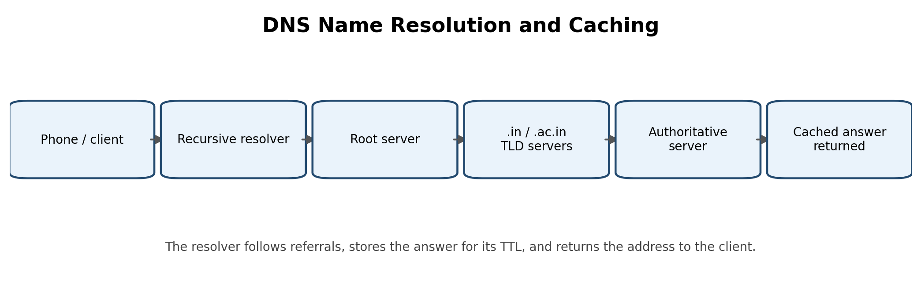
Figure 4: Recursive DNS resolution and cache flow.

TASK 5 – WHEN WILL THE VIDEO CALL FREEZE?

5.1 M/M/1 calculations
Service rate μ = 1,000 packets/s. Utilisation ρ = λ/μ; average number in system L = ρ/(1−ρ); average time in system W = 1/(μ−λ).
Arrival rate λ (packets/s) | Utilisation ρ | Average packets L | Average delay W
500 | 0.50 | 1.00 | 2.00 ms
800 | 0.80 | 4.00 | 5.00 ms
900 | 0.90 | 9.00 | 10.00 ms
950 | 0.95 | 19.00 | 20.00 ms
990 | 0.99 | 99.00 | 100.00 ms
1000 | 1.00 | Unbounded | Unbounded / unstable

The average delay first exceeds 20 ms when λ is greater than 950 packets/s. At λ = 950, W = 1/(1000−950) = 0.02 s = 20 ms exactly. For example, at λ = 960, W = 1/40 = 25 ms.

5.2 Why the “ten times” statement needs clarification
Using the stated M/M/1 average system-time formula W = 1/(μ−λ): at 450 packets/s, W = 1/550 = 1.818 ms; at 900 packets/s, W = 1/100 = 10 ms. This is a 5.5× increase, not tenfold. If “delay” means queueing wait only, Wq = λ/[μ(μ−λ)]: at 450, Wq = 1.636 ms; at 900, Wq = 9 ms, a 5.5× increase. Thus the assignment’s “ten” claim does not follow exactly from the supplied M/M/1 formulas and values; it may be an approximate statement or may assume a different baseline.

5.3 Token bucket burst duration
Bucket size = 1 MB = 8 megabits. Backup sends at 10 Mbps while the permitted long-term rate is 2 Mbps. Excess drain rate = 10−2 = 8 Mbps. Burst duration = 8 Mb ÷ 8 Mb/s = 1 second. After the one-second burst, the sender must average no more than 2 Mbps (subject to token refill and packetization).

5.4 DiffServ policy
- Live voice/video: EF (Expedited Forwarding) for low-delay, low-jitter treatment, with strict admission control and policing so EF traffic cannot starve other classes.
- Patient/business-critical interactive data and important backups: AF classes with appropriate drop precedence and shaping; backups should be lower priority than interactive traffic.
- Ordinary web browsing and non-urgent background transfers: Best Effort.

5.5 Faster link versus QoS
A faster link can reduce utilisation for all traffic, but it costs more and may still be congested during peaks. QoS can protect real-time video from bulk backup traffic on the existing link by shaping backups and scheduling media packets first. For this office scenario, configure QoS and a token bucket first, then upgrade the link if measurements show sustained demand remains near capacity.

5.6 Python M/M/1 calculator
mu = 1000 # packets per second
for lam in (500, 800, 900, 950, 990, 1000):
rho = lam / mu
if lam >= mu:
print(lam, "rho =", rho, "queue grows without limit")
else:
L = rho / (1 - rho)
W = 1 / (mu - lam)
print(lam, "rho =", round(rho, 3),
"L =", round(L, 2),
"W_ms =", round(W * 1000, 2))

# Capacity for W < 10 ms at arrival rate 1500 packets/s:
# 1/(mu - 1500) < 0.010 => mu > 1600 packets/s
print("Required service rate: strictly greater than 1600 packets/s")

Alternative concept: double the link
With μ = 2,000 packets/s and λ = 1,800 packets/s, ρ = 0.9 and W = 1/(2,000−1,800) = 0.005 s = 5 ms. The queue is stable, but the link is still highly utilised. On the original 1,000-packet/s link, strict priority can protect video from backup packets, but an exact video delay cannot be calculated without the video arrival rate, packet sizes, burstiness and scheduling details. Under strict priority, video delay depends mainly on the video class itself; backup traffic receives only leftover capacity.
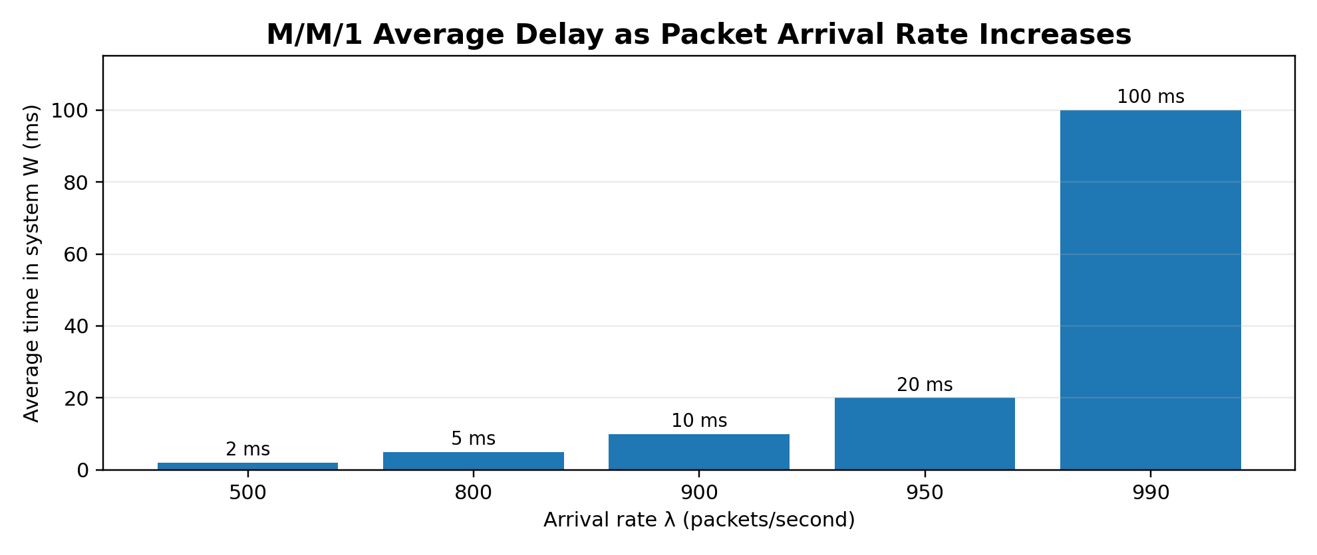
Figure 5: M/M/1 delay values calculated in Q5.

TASK 6 – COUNT THE ROUND TRIPS BEFORE THE FIRST BYTE

6.1 Connection setup time
RTT = 100 ms. The estimates below assume a full handshake, no packet loss, no DNS lookup time and no extra application processing.
Method | Round trips before request data | Time
TCP + TLS 1.2 | TCP 1 RTT + TLS 1.2 full handshake about 2 RTT | 3 RTT = 300 ms
TCP + TLS 1.3 | TCP 1 RTT + TLS 1.3 handshake about 1 RTT | 2 RTT = 200 ms
QUIC, first connection | QUIC transport and TLS 1.3 handshake combined, about 1 RTT | 1 RTT = 100 ms
QUIC 0-RTT resumption | Client can send eligible early application data immediately | 0 RTT ≈ 0 ms before sending; server acceptance/response still takes network time

The exact number of RTTs can vary with resumption, certificate and key-exchange choices, server configuration and whether the measurement is “first request sent” or “first response byte received.” The table answers the question’s request-send timing.

6.2 0-RTT replay risk
Early data in TLS 1.3/QUIC 0-RTT may be replayed by an attacker because the server cannot always distinguish a retransmitted early-data flight from a malicious replay. Do not send non-idempotent or state-changing operations as 0-RTT: money transfers, payments, account changes, order submission or one-time actions. Safe candidates are carefully designed idempotent reads, subject to application and server policy.

6.3 Connection migration
QUIC uses connection IDs in addition to the network address/port tuple. If a phone moves from Wi-Fi to 5G and its IP address changes, QUIC can validate the new path and continue the logical connection using the connection ID. A conventional TCP connection is identified by its endpoint tuple; a changed source IP/port normally breaks that connection, requiring a new TCP connection and TLS session (unless the application has its own recovery mechanism).

6.4 Firewall blocking and fallback
Some enterprise firewalls block or restrict UDP, including UDP port 443 used by QUIC, because of policy, inspection limitations or operational concerns. The application should attempt HTTP/3/QUIC and fall back to HTTPS over TCP with TLS 1.3 (typically HTTP/2) when QUIC is blocked or fails.

6.5 Mid-transfer Wi-Fi to 5G comparison
Transport | What happens after IP/port changes? | Approximate setup penalty at 100 ms RTT
TCP + TLS 1.3 | Existing TCP connection usually breaks; establish TCP and perform/resume TLS before continuing at application level. | About 2 RTT = 200 ms for a new TCP + TLS 1.3 setup, excluding recovery/application time.
QUIC | Connection ID can preserve the connection; path validation is required. No full new transport/TLS handshake in the normal migration case. | Path validation adds a network exchange; exact penalty depends on implementation and path validation. It is not safely fixed to one universal RTT.

Banking recommendation: use QUIC where supported because it reduces setup delay and handles network migration well. Retain a secure TCP/TLS 1.3 fallback. Never put transfers or other state-changing banking operations into 0-RTT early data.
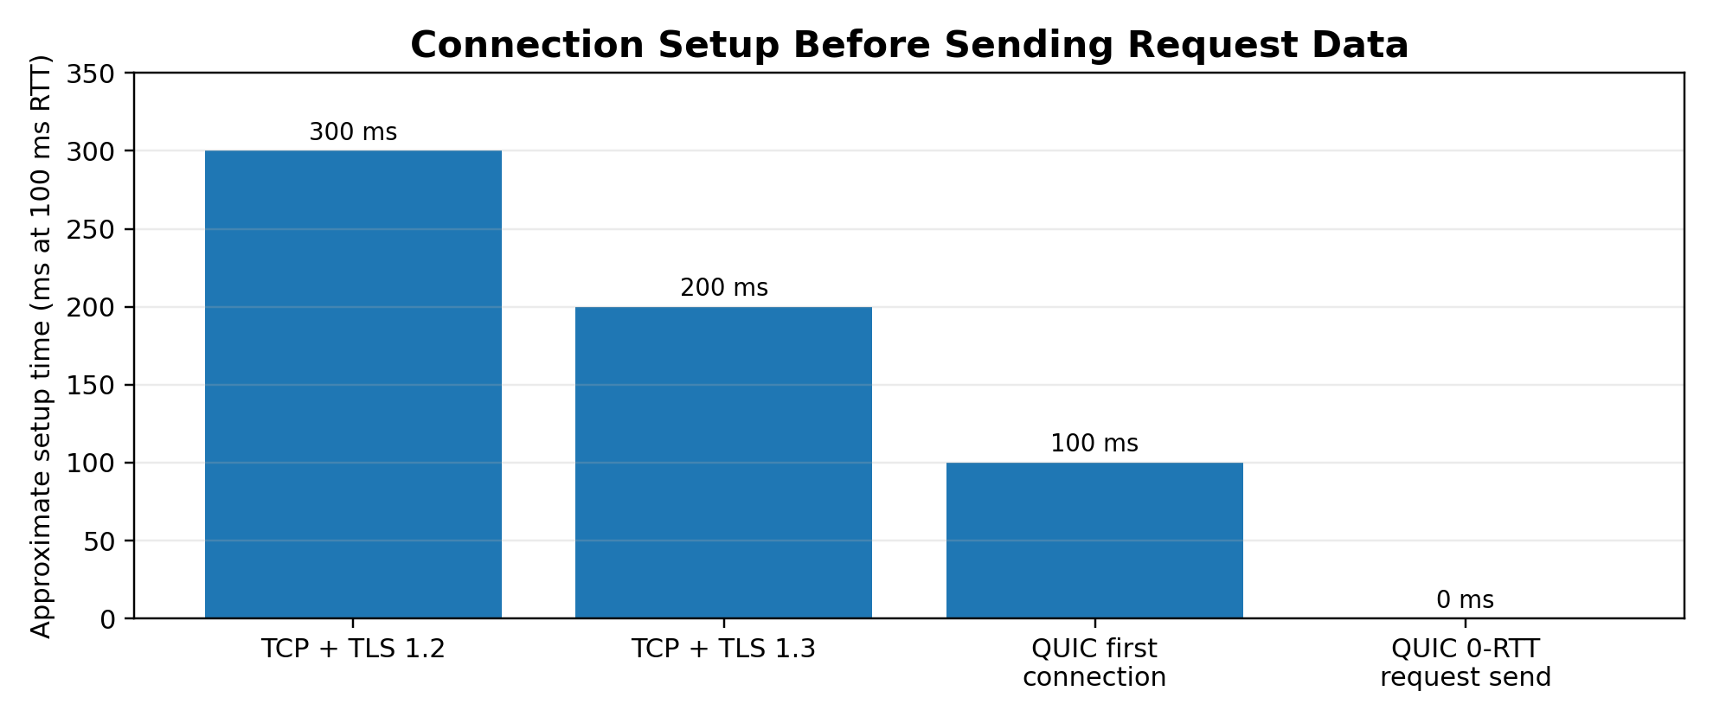
Figure 6: Approximate setup times at an RTT of 100 ms.

TASK 7 – CHOOSE THE PROTOCOLS FROM FIRST PRINCIPLES

Stage 1 – Interpret the requirements
Traffic | Delay / loss needs | Ordering and reliability | Security
Live video consultation | Very low delay and jitter; tolerate limited packet loss; adapt bitrate on 100–300 ms RTT and up to 5% loss. | Timely media is more important than retransmitting every late packet. | Encrypt media; authenticate participants; protect session signalling.
Patient records and X-ray images | Correct delivery is essential; transfer can tolerate more delay than live video. | Reliable, complete, ordered transfer with integrity checking. | Strong authentication, encryption, access control, audit and retention controls.
Chat | Low interactive delay; occasional loss must be recovered. | Reliable ordered messages are desirable. | Encrypt and authenticate; preserve confidentiality and integrity.
Hospital service lookup | Small request/response; should be fast and reliable. | DNS caching and reliable HTTPS response. | Use trusted DNS configuration where possible and HTTPS/TLS for service data.

Measurable design targets (proposed engineering targets, not supplied measurements): video should aim for one-way media latency below about 150 ms where the path permits, jitter below 30 ms, and adaptive recovery under 5% loss; record transfers must pass an end-to-end integrity check with zero undetected corruption; chat messages must be delivered once and in order at the application layer; service lookup should normally complete within a small number of RTTs and use cached DNS answers.

Stage 2 – Compare candidate protocols
Traffic | Recommended protocol stack | Reason
Live video | UDP media transport (e.g. RTP/WebRTC) with congestion control; secure media; QUIC/HTTP/3 for signalling where suitable. | Avoids transport-level head-of-line blocking; permits timely playout and loss concealment.
Records / X-rays | HTTPS over HTTP/3 (QUIC + TLS 1.3) or HTTP/2 over TCP + TLS 1.3. | Reliable delivery, encryption, stream multiplexing and resumable application-level transfer.
Chat | WebSocket over HTTPS/TCP or a reliable QUIC stream over HTTP/3. | Reliable ordered messages; QUIC can reduce setup and support migration.
Service lookup | DNS A/AAAA with suitable TTL; HTTPS for the actual service directory. | Caching reduces repeated lookup load; TLS protects application data.

TCP throughput limit for 64 KB window at 300 ms RTT
Assume 64 KB = 64 × 1024 = 65,536 bytes. Window-limited throughput = window size × 8 ÷ RTT = 65,536 × 8 ÷ 0.3 = 1,747,627 bit/s ≈ 1.75 Mbps. If the assignment intended decimal 64,000 bytes, the result is 1.71 Mbps. This is the approximate maximum rate imposed by that receive/congestion window and RTT, before protocol overhead and other limitations.
Implication for X-rays: large images may take significant time over a high-latency link if the TCP window is limited to 64 KiB. Use window scaling and an appropriately sized window, parallel/resumable transfer where safe, compression where appropriate, and integrity verification. At 1.75 Mbps, a 10 MB file would require roughly 10 × 8 Mb / 1.75 Mbps ≈ 45.7 seconds in ideal conditions.

DNS and QoS configuration
- DNS: publish A and AAAA records for service endpoints, NS records for authoritative delegation, CNAME only where appropriate, MX for mail, and TXT for SPF/domain verification. Use redundant authoritative DNS and a moderate TTL (for example, 300 seconds during normal operation; reduce it in advance of a planned migration). Use recursive resolvers with caching and monitor response time.
- QoS: EF for admitted real-time audio/video; AF classes for important interactive records and chat; Best Effort for ordinary browsing and background traffic. Shape backups and large non-urgent transfers so they do not fill the access-link queue.

Stage 3 – Implement and verify
The following compact socket examples demonstrate a reliable file transfer and a chat message exchange over TCP. Run the server and client on two terminals. For a real project, add authentication, TLS, file-size limits, safe filenames, timeouts and error handling.
# tcp_server.py — simple file receiver and chat echo service
import socket

HOST, PORT = "0.0.0.0", 6000
with socket.socket() as server:
server.setsockopt(socket.SOL_SOCKET, socket.SO_REUSEADDR, 1)
server.bind((HOST, PORT))
server.listen(5)
print("Waiting for client...")
conn, addr = server.accept()
with conn:
print("Connected:", addr)
mode = conn.recv(16).decode().strip()
if mode == "FILE":
size = int(conn.recv(32).decode().strip())
received = 0
with open("received.bin", "wb") as f:
while received < size:
block = conn.recv(min(4096, size - received))
if not block:
break
f.write(block)
received += len(block)
conn.sendall(f"RECEIVED {received}".encode())
else:
while True:
msg = conn.recv(4096)
if not msg:
break
print("Client:", msg.decode(errors="replace"))
conn.sendall(b"ACK:" + msg)

# tcp_client.py — choose FILE or CHAT mode
import socket
HOST, PORT = "127.0.0.1", 6000

with socket.create_connection((HOST, PORT)) as s:
mode = input("Enter FILE or CHAT: ").strip().upper()
s.sendall(mode.encode().ljust(16))
if mode == "FILE":
data = open("sample.bin", "rb").read()
s.sendall(str(len(data)).encode().ljust(32))
s.sendall(data)
s.shutdown(socket.SHUT_WR)
print(s.recv(128).decode())
else:
while True:
msg = input("Message (blank to quit): ")
if not msg:
break
s.sendall(msg.encode())
print(s.recv(4096).decode())

Note: TCP is a byte stream, not a message protocol. The example’s simple fixed-width headers are suitable only as a classroom demonstration; a production implementation should use a robust framing method (for example, fixed-size length prefixes and read-exactly loops).

Verification plan
1. Run the file and chat examples on a local network; verify file size and a cryptographic hash (for example SHA-256) at both ends.
2. Apply delay and loss with tc netem in an isolated Linux test environment: test 100 ms, 200 ms and 300 ms delay, and 1% and 5% loss.
3. Measure file transfer time, effective throughput, chat round-trip latency, message delivery and video quality metrics using an appropriate media test.
4. Compare TCP-based transfer with QUIC/HTTP/3 if a QUIC-capable test server/client is available. Record the software versions and exact test configuration.

Stage 4 – Defend the design
The design separates traffic according to its needs. Real-time video uses a congestion-controlled UDP media path to avoid waiting for retransmission of stale media. Records and X-rays use reliable encrypted streams and integrity checks. Chat uses reliable ordered delivery. DNS caching limits repeated lookups, while QoS protects interactive media from backups. These choices should be validated with measurements under the specified 100–300 ms RTT and up to 5% loss; do not present predicted values as measured results.
If links are upgraded to 5G, RTT and loss may improve and throughput may rise, reducing transfer time and buffering. The architecture should still retain adaptive bitrate, congestion control, encryption, reliable file transfer, DNS redundancy and QoS because radio conditions and congestion can still vary.

Alternative concept: evaluate a commercial video-consultation vendor
- What end-to-end latency and jitter does the vendor guarantee under 100–300 ms RTT and 5% packet loss? Ask for independently measured results, not only laboratory claims.
- How does the service handle loss: forward error correction, retransmission, adaptive bitrate, packet-loss concealment and congestion control? Request quality measurements at multiple loss rates.
- Where are media and patient records processed and stored? Are they encrypted in transit and at rest? Who controls encryption keys?
- Does the vendor support strong identity verification, role-based access, audit logs, data residency, retention/deletion controls and incident notification?
- Can the hospital export records and logs, integrate with existing systems, and continue safely during vendor outages?
Choose the vendor only after a pilot using rural 4G-like conditions demonstrates acceptable latency, call quality, security controls, privacy compliance, availability, support and total cost. Require a written service-level agreement and a data-processing agreement.
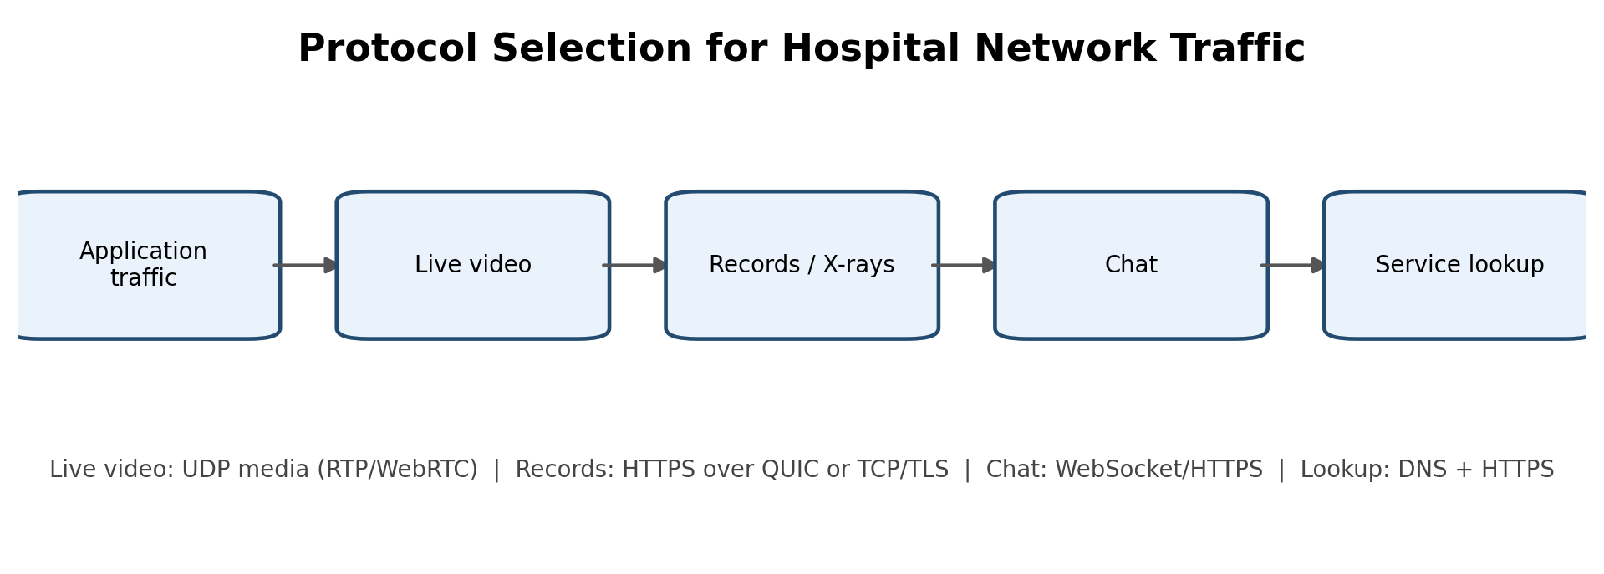
Figure 7: Protocol selection overview for the hospital network.

CONCLUSION
TCP provides reliable ordered byte-stream delivery and is appropriate for files, records, chat and conventional web transactions. UDP is useful for real-time media when timeliness is more important than retransmitting every lost packet. HTTP/2 improves resource multiplexing but remains subject to TCP head-of-line blocking; HTTP/3 uses QUIC streams to reduce cross-stream blocking and improve connection migration. DNS caching reduces authoritative-server load, while TTL must balance efficiency and agility. QoS, shaping and sound queue management protect latency-sensitive traffic.

