

Name:Ch. Venkata sai mohith
Reg no:1925260287
Course:UBA0705-computer networks
Faculty:Dr.kumaran.G

ASSIGNMENT 4 – CO4

TASK 1 – WHY DOES THE WHOLE OFFICE STOP?

1.1 Explain each complaint
Complaint | Cause and explanation
Moving a desk disconnects everyone | The original network is a bus: all computers share one coaxial backbone. Moving or disturbing the cable, a loose T-connector, or a missing terminator can interrupt the entire segment.
Server file takes a minute at month-end | All users contend for the same shared bandwidth. A hub repeats traffic to every port and operates half-duplex; collisions and retransmissions reduce useful throughput. The server at the far end also shares the same segment.
Internet stops when router restarts | The single home router is the only gateway to the internet. Restarting it removes the office's only route out, even though the local LAN could otherwise continue operating.
Additional weakness 1 | A bus has a single point of cable failure; troubleshooting a fault can affect all users.
Additional weakness 2 | Broadcasts and collisions are not isolated per desk; performance degrades as the number of active computers increases.
Additional weakness 3 | A home router may lack business-grade firewall rules, VLAN support, logging, throughput and redundancy. The design also has limited room for growth.

1.2 Redesigned extended-star topology
Assumption for comparison: the old coaxial segment is a 10 Mbps shared Ethernet segment. The redesigned access links are 1 Gbps full-duplex switched Ethernet. The actual original speed was not specified in the question, so the before figure is an explicit baseline assumption.

Logical topology
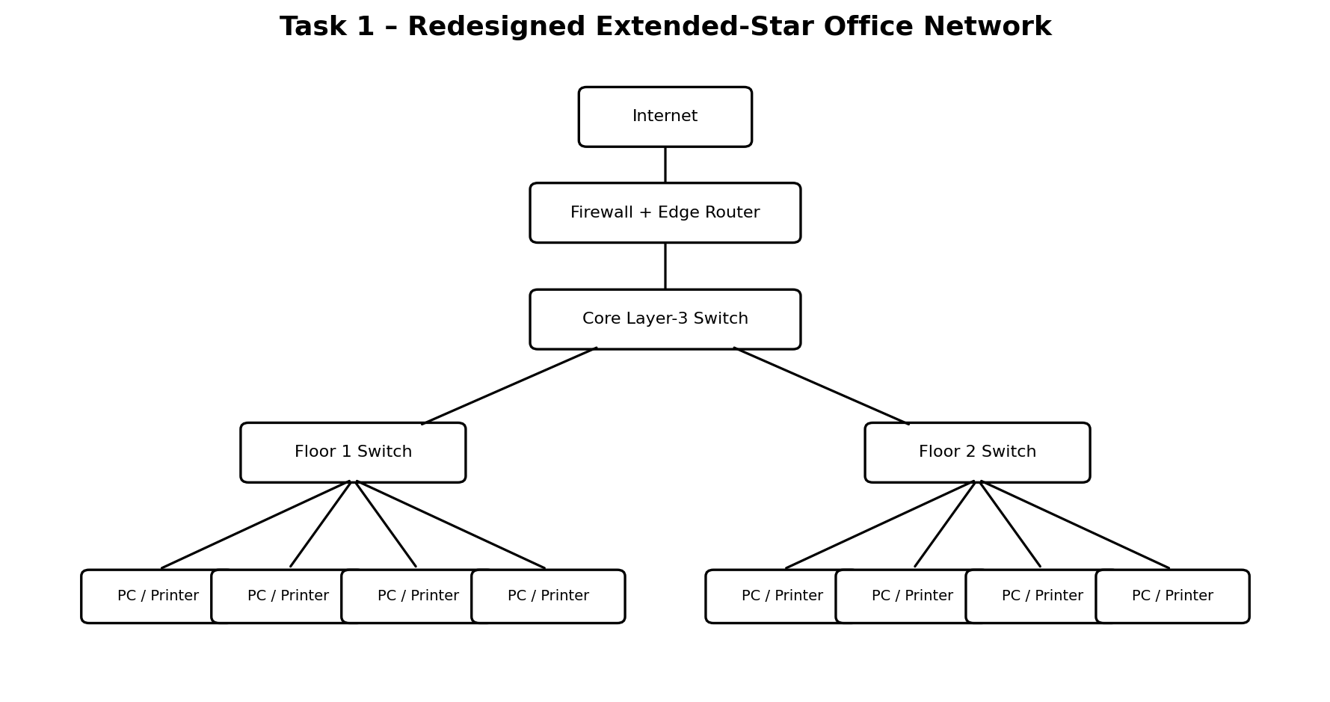
Figure 1: Extended-star office network with central core and floor switches.
Internet
|
Business Firewall
|
Edge Router / WAN
|
Core L3 Switch
/ \
Floor 1 switch Floor 2 switch
/ | | \ / | | \
PCs PCs Server Printer PCs ... PCs

Physical topology
Telecom room / rack:
[ISP handoff]—[Router]—[Firewall]—[Core switch]
| |
Cat6 home-runs Cat6 home-runs
| |
Floor 1 switch Floor 2 switch
| | | ... | | | ...
desk outlets desk outlets

Use a star cable run from each floor switch to every workstation outlet.
Use fibre or a suitable high-speed backbone between floor switches and the core
when distance or bandwidth requires it. Label and test every cable.

Bandwidth calculation
Design | Shared / access capacity | Per-computer planning figure
Old bus (assumed 10 Mbps) | 10 Mbps shared by 30 computers | 10 ÷ 30 = 0.333 Mbps average share under equal simultaneous use
New switched star | Each PC has a dedicated 1 Gbps full-duplex switch port | Up to 1,000 Mbps per PC link; actual throughput is limited by server, uplink and application
Wi-Fi 6 alternative (assumption) | One AP has 600 Mbps usable aggregate throughput shared by 30 active users | 600 ÷ 30 = 20 Mbps per user average

The 1 Gbps access-port figure is not a guarantee that the server can deliver 1 Gbps to all 30 users simultaneously. The core/server uplinks must be sized accordingly. For example, a 10 Gbps server connection offers a theoretical aggregate 333 Mbps per user if all 30 transfer equally at once.

1.3 Defence (under 100 words)
Replacing the bus with an extended star removes the shared coaxial backbone and confines a desk-cable fault to that desk or switch port. Managed switches provide dedicated full-duplex links, greatly reducing collisions and improving file-transfer performance. Structured Cat6 cabling makes moves and troubleshooting easier. A business firewall and router provide controlled internet access and security policies. A second WAN link or redundant edge equipment can reduce the single-router outage risk. For month-end file transfers, switched wired Ethernet is preferable to one shared wireless access point.

Alternative concept: all-wireless Wi-Fi 6
Under the stated planning assumptions, one AP with 600 Mbps usable aggregate throughput shared by 30 active users gives about 20 Mbps per user. The wired star gives each computer a 1 Gbps dedicated access link (subject to uplink/server limits). Wi-Fi 6 is convenient for mobile devices and avoids desk cabling, but contention, interference and shared airtime make it less predictable for large month-end file transfers. Recommended: wired star for desktops and server access, with Wi-Fi 6 for mobile users.

TASK 2 – HOW MANY LINKS CAN THE HOSPITAL AFFORD?
Assumptions: there are five building nodes and the patient-record data centre is treated as a separate central node for star calculations. For the bus comparison, the five buildings attach to one shared backbone; the equivalent graph is a chain of four cable segments. Fibre costs ₹60,000 per run and each fibre endpoint consumes one switch port costing ₹18,000. Costs below include both fibre runs and endpoint ports; they exclude switches, racks, optics and installation.

2.1 Links, ports and cost
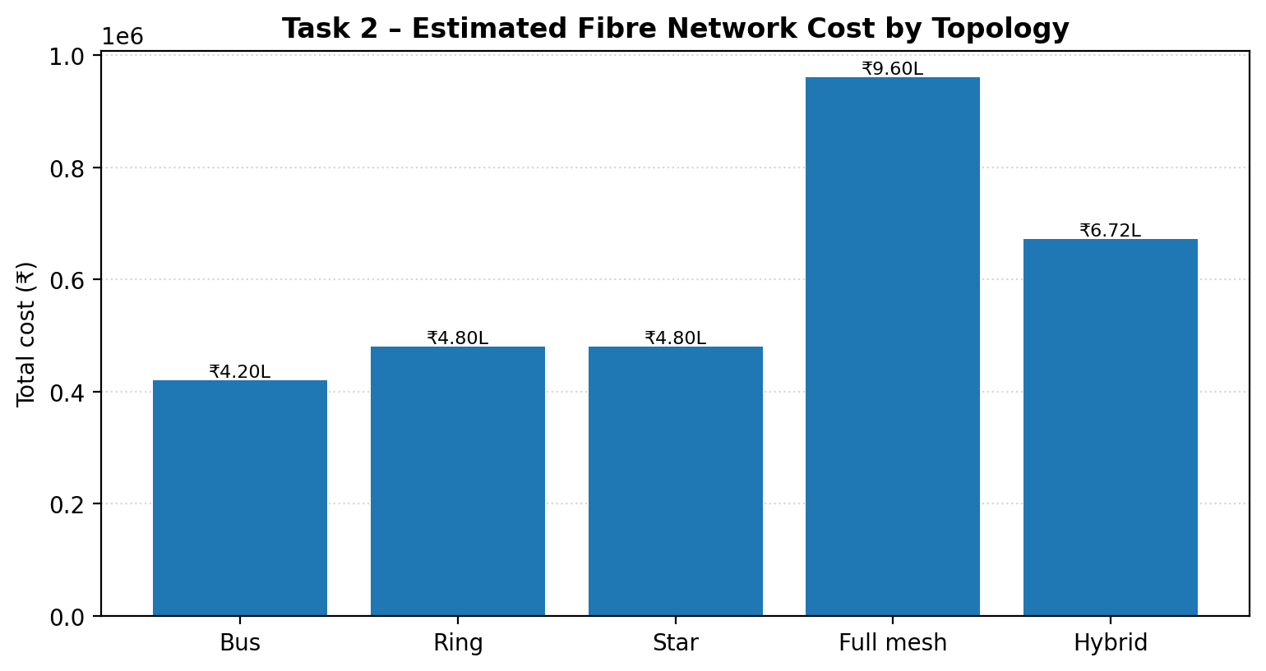
Figure 2: Comparison of estimated fibre costs for the four topologies and proposed hybrid design.
Topology | Fibre runs / links | Fibre endpoint ports | Fibre cost | Port cost | Total
Bus (5 buildings on backbone) | 4 backbone segments (assumed) | 10 attachment/end ports (assumed) | ₹2,40,000 | ₹1,80,000 | ₹4,20,000
Ring (5 buildings) | 5 | 10 | ₹3,00,000 | ₹1,80,000 | ₹4,80,000
Star (5 buildings to DC) | 5 | 10 | ₹3,00,000 | ₹1,80,000 | ₹4,80,000
Full mesh (5 buildings) | 5×4÷2 = 10 | 20 | ₹6,00,000 | ₹3,60,000 | ₹9,60,000

Formula: total cost = (number of fibre runs × ₹60,000) + (number of endpoint ports × ₹18,000). A point-to-point link uses two endpoint ports. For a shared bus, the number of physical attachment ports depends on the chosen tap/aggregation equipment; 10 is used as a simple five-node endpoint-equivalent estimate.

2.2 Single-cable failure analysis
Topology | Effect of one cable cut | Critical-node requirement
Bus | A cut in the shared backbone can isolate buildings on one side of the break. | Fails; a single break can disconnect emergency or theatres.
Ring | One cut opens the ring but the remaining path connects all five nodes. | Survives one cut, assuming switches support ring/alternate-path recovery.
Star | Cutting a building's own link isolates that building; other buildings remain connected. | Fails if the emergency or theatre link is cut.
Full mesh | One cut removes one direct path; alternate paths remain between nodes. | Survives one cut for both critical buildings.

2.3 Cheapest design meeting the critical rule
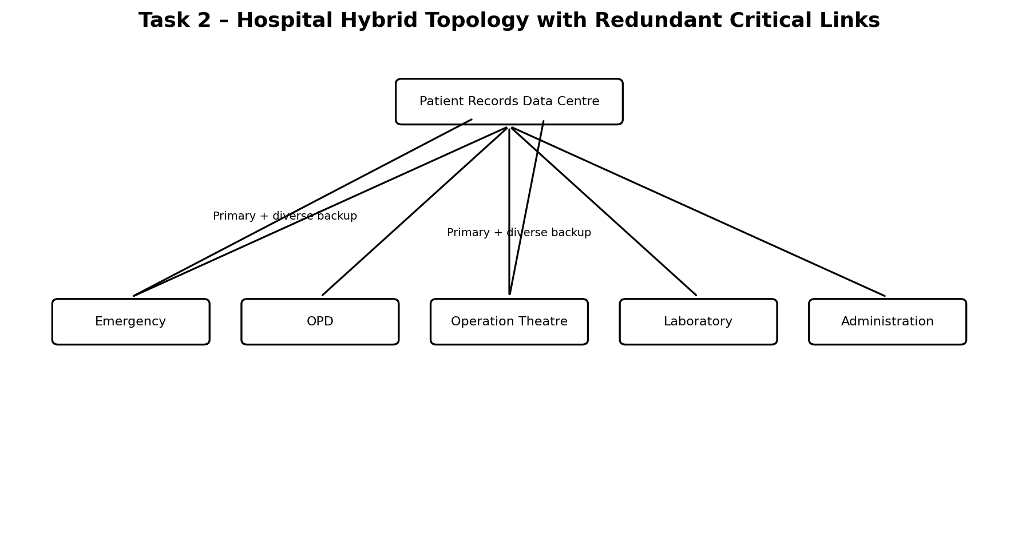
Figure 3: Hospital hybrid topology; emergency and operation theatre have diverse backup paths.
Use a hybrid: star connectivity for all five buildings, with a second physically diverse fibre path from the data centre to the emergency block and a second diverse path to the operation-theatre block. Non-critical buildings retain one link. This creates seven links in total (five primary links + two additional critical links).
[Data Centre / Patient Records]
/ | | | \
/ | | | \
[Emergency] [OPD] [OT] [Lab] [Admin]
|| ||
second diverse second diverse
fibre path fibre path
Calculation | Value
Primary star links | 5
Extra links for emergency and OT | 2
Total fibre runs | 5 + 2 = 7
Endpoint ports | 7 × 2 = 14
Fibre cost | 7 × ₹60,000 = ₹4,20,000
Port cost | 14 × ₹18,000 = ₹2,52,000
Total hybrid cost | ₹4,20,000 + ₹2,52,000 = ₹6,72,000

A single cable cut on either critical building's primary or secondary path leaves its other path available. The two paths must use separate ducts/routes and separate switch interfaces; otherwise a common physical fault could defeat the redundancy. This is cheaper than a full mesh (₹9,60,000 under the same assumptions).

2.4 Python 3 program: topology comparison
from collections import deque
from itertools import combinations

def make_links(kind, n):
# n office/building nodes are numbered 0..n-1.
if kind == "bus": # chain representation of a shared backbone
return [(i, i + 1) for i in range(n - 1)], n
if kind == "ring":
return [(i, (i + 1) % n) for i in range(n)], n
if kind == "star": # node n is the central hub
return [(i, n) for i in range(n)], n + 1
if kind == "full_mesh":
return list(combinations(range(n), 2)), n
raise ValueError("Unknown topology")

def all_reached(node_count, links, failed=None):
adj = [[] for _ in range(node_count)]
for index, (u, v) in enumerate(links):
if index == failed:
continue
adj[u].append(v)
adj[v].append(u)
seen = {0}
q = deque([0])
while q:
u = q.popleft()
for v in adj[u]:
if v not in seen:
seen.add(v)
q.append(v)
return len(seen) == node_count

def analyse(kind, n):
links, nodes = make_links(kind, n)
degrees = [0] * nodes
for u, v in links:
degrees[u] += 1
degrees[v] += 1
survived = sum(
all_reached(nodes, links, failed=i)
for i in range(len(links))
)
return len(links), max(degrees), survived

for n in (6, 20):
print(f"n = {n}")
for kind in ("bus", "ring", "star", "full_mesh"):
links, max_ports, failures_survived = analyse(kind, n)
print(kind, "links =", links,
"max ports on one device =", max_ports,
"single-link failures survived =", failures_survived)

Expected program results
n | Topology | Links | Maximum ports on one device | Single-link failures survived
6 | Bus | 5 | 2 | 0
6 | Ring | 6 | 2 | 6
6 | Star | 6 | 6 | 0
6 | Full mesh | 15 | 5 | 15
20 | Bus | 19 | 2 | 0
20 | Ring | 20 | 2 | 20
20 | Star | 20 | 20 | 0
20 | Full mesh | 190 | 19 | 190

Growth comparison: full mesh links = n(n−1)/2, while star links = n. At n=6, full mesh needs 15 links versus 6 for star (2.5×). At n=20, it needs 190 versus 20 (9.5×).

Alternative concept: ring versus hybrid
A five-node ring has 5 fibre runs, 10 endpoint ports and an estimated total of ₹4,80,000. It survives any one ring-link cut because traffic can travel the other way around the ring. Two distinct ring-link cuts can partition the ring if the cuts are on different places; in particular, two cuts can isolate a node or a section. The proposed hybrid uses 7 runs and costs ₹6,72,000, but provides two independent direct paths for each critical building. A ring is cheaper, but a two-link failure can disconnect a critical building; the hybrid is selected because it directly protects emergency and theatres against any one link cut. The hybrid's protection also assumes physically diverse routes.

TASK 3 – DEVICES, MEDIA AND CABLING

3.1 Check every cable run
TIA/EIA-568 structured copper channel guidance is 100 m maximum: normally 90 m permanent horizontal link plus up to 10 m total patch cords. The assignment asks to identify both limits.
Run | Length | Standard check | Recommended medium / action
Consulting rooms | 35–80 m | Within 90 m permanent-link and 100 m channel limits, if the stated length is the complete permanent run. | Cat6 UTP is suitable; certify each run.
Pharmacy | 96 m | Exceeds 90 m permanent-link limit if this is the fixed cable run, but is below the 100 m channel maximum. It leaves only 4 m for all patch cords. | Move the telecom outlet/switch closer or use fibre; do not design a 96 m permanent link.
Waiting-hall APs | 60 m | Within both limits. | Cat6 UTP is suitable; use PoE switch ports if the AP supports PoE.
Main-building link | 420 m | Far beyond 100 m copper Ethernet channel limit. | Use fibre. Multimode may suit a short campus/building backbone with compatible optics; single-mode is preferred for longer distance, future capacity and campus backbone flexibility.

Cat6A is not a solution for a 420 m Ethernet run: copper Ethernet channel reach remains typically 100 m. For 420 m, use a fibre link with transceivers selected for the required speed and distance.

Mixed T568A/T568B cable
Terminating one end as T568A and the other as T568B creates a crossover cable (transmit and receive pairs are crossed). It is not automatically a faulty cable: older unlike-device connections sometimes required crossover wiring. Modern switches and network interfaces commonly support Auto-MDIX and can adapt automatically. However, use the same standard at both ends (A-A or B-B) for normal structured horizontal cabling, and test for correct pair order, split pairs, continuity and performance.

3.2 Device selection and network domains
Device | Use in this hospital design | Domain impact
Layer-2 managed switch | Connect PCs, printers, CCTV and APs inside each block; assign access VLANs. | Each switch port is its own collision domain; VLANs define separate broadcast domains.
Layer-3 switch | Core/distribution routing between approved VLANs and fast building aggregation. | Routes between VLANs; each VLAN remains a separate broadcast domain.
Router | Connect hospital network to WAN/branch clinics and ISP services. | Routes between IP networks; separates broadcast domains.
Firewall | Protect internet edge and control traffic between trusted, guest and sensitive networks. | Applies security policy; not a replacement for VLAN segmentation.
Wireless access point | Connect staff, guest and approved medical wireless devices. | Wireless clients share radio airtime; map SSIDs to separate VLANs.
Hub | Not recommended for new deployment. | All hub ports share one collision domain and one bandwidth pool.

Domain count for the proposed outpatient block (explicit example): assume one managed access switch with VLAN 10 (staff), VLAN 20 (CCTV) and VLAN 30 (guest), plus 24 wired access ports. There are 24 collision domains (one per switch port) for wired Ethernet. There are 3 broadcast domains (one per VLAN). Each additional VLAN creates another broadcast domain; routed interfaces separate them.

3.3 Bill of materials – outpatient block
Assumptions for a practical estimate: 12 consulting-room outlets, 2 pharmacy outlets, 4 AP outlets, 2 printer/administrative outlets and 4 spare ports = 24 access ports. Distances are assumed to be 12 × 55 m average, 2 × 96 m pharmacy, 4 × 60 m AP and 2 × 40 m admin/printer. Replace these planning values with measured cable routes.
Item | Base quantity / calculation | Order quantity including 10% spare where applicable
Cat6 horizontal cable | 12×55 + 2×96 + 4×60 + 2×40 = 1,052 m | 1,052×1.10 = 1,157.2 m; order about 1,160 m
24-port managed PoE switch | 1 unit; 24 access ports (confirm PoE budget) | 1 unit
Fibre uplink module / SFP | 2 endpoints for fibre uplink | 2 compatible modules, plus 1 spare recommended
Cat6 keystone jacks | 24 outlets | 27 (24×1.10 rounded up)
Faceplates / back boxes | 24 | 27
Patch panels | 1 × 24-port | 1
Patch cords | 24 desk + 24 rack-side assumed | 53 of each type if 10% spare is applied
RJ45 plugs | Field-terminated cords only; prefer factory patch cords | As required by cable kit; add 10%
Rack and accessories | 1 wall/floor rack, cable manager, PDU, earthing | 1 set
Cable labels and test | 24 labelled links | 1 label set and certification report for all links

For the 420 m backbone, provide a separate fibre bill of materials: outdoor-rated fibre cable sized for route and spare cores, two compatible optical transceivers, termination panels/ODF, pigtails, patch cords, splice/termination work and surge/earthing practices appropriate to the installation.

3.4 T568B colour order
Pin | T568B conductor
1 | White / Orange
2 | Orange
3 | White / Green
4 | Blue
5 | White / Blue
6 | Green
7 | White / Brown
8 | Brown

Practical test: terminate both ends to T568B, use a cable tester to confirm pins 1–8 map straight through with no opens, shorts, reversals or split pairs. In Packet Tracer, choose the appropriate copper straight-through cable for PC-to-switch and verify link status.

Alternative concept: 420 m multimode fibre versus Cat6A plus intermediate switch
Factor | Multimode fibre | Cat6A + switch halfway
Distance | A suitable multimode optic can support 420 m only if its rated reach at the chosen speed is at least 420 m; check the optic standard (some 10G multimode types have shorter reach). | Each copper Ethernet segment is limited to 100 m. One midpoint switch creates two segments of about 210 m each, still too long. At least four copper segments and three intermediate switches are needed for 420 m, with route lengths planned below 100 m.
Equipment / power | Fibre cable, two optical transceivers and termination hardware; no powered intermediate repeater required. | At least three intermediate switches, cabinets, power, UPS and environmental protection; more equipment and maintenance.
Lightning / EMI | Dielectric fibre is immune to electromagnetic interference and does not conduct lightning between buildings (metallic armour needs proper bonding/grounding). | Copper can conduct surges between buildings; additional isolation, grounding and surge protection are required.
Decision | Preferred campus backbone, but confirm the chosen optic's reach. | Less suitable over 420 m because it adds powered intermediate sites and complexity.

A 420 m single-mode fibre link is the safer default where the exact speed/optics are not specified. Multimode is acceptable only after checking the transceiver reach at the intended Ethernet rate.

TASK 4 – SHARED MEDIA, WLANs AND WANs BY THE NUMBERS

4.1 Multiple access calculations
Protocol | Maximum normalized throughput | Calculation
Pure ALOHA | 1/(2e) = 0.184 = 18.4% | Maximum occurs at offered load G = 0.5.
Slotted ALOHA | 1/e = 0.368 = 36.8% | Maximum occurs at G = 1.

For a 10 Mbps channel, the corresponding theoretical peak throughputs are 1.84 Mbps (pure ALOHA) and 3.68 Mbps (slotted ALOHA).

CSMA/CD minimum frame size
Given cable length L = 2,500 m, propagation speed v = 2×10⁸ m/s and data rate R = 10 Mbps:
One-way propagation delay = L / v
= 2,500 / (2 × 10^8)
= 12.5 microseconds

Round-trip propagation delay = 2 × 12.5 = 25 microseconds
Minimum frame bits = R × round-trip delay
= 10,000,000 × 25 × 10^-6
= 250 bits = 31.25 bytes
This is the idealized minimum from the supplied distance and speed. Real Ethernet includes repeaters and other timing allowances; classic Ethernet's standard minimum frame is 64 bytes (512 bit-times), which is larger and provides the required collision-detection slot time. Switched full-duplex Ethernet has a dedicated transmit and receive path per link, so collisions do not occur and CSMA/CD is disabled. Wi-Fi is a shared radio medium in which a station cannot reliably detect a collision while transmitting; it uses CSMA/CA (listen, wait/backoff and acknowledgements) to reduce collisions.

4.2 Wireless LAN plan for 300 phones
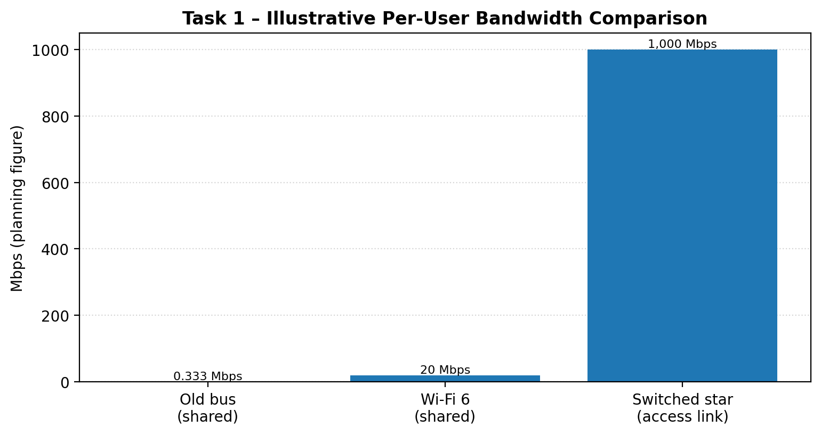
Figure 4: Illustrative per-user planning bandwidth; values depend on shared load and uplink limits.
Planning assumption: design for about 50 concurrently active phones per AP, then validate by a site survey and throughput test. Required AP count = 300 ÷ 50 = 6 access points. This is a capacity estimate, not a universal Wi-Fi client limit; real capacity depends on applications, channel width, interference and AP model.
Band | Channel plan | Deployment
2.4 GHz | Use non-overlapping channels 1, 6 and 11; repeat only with sufficient physical separation. | Six APs: AP1 ch1, AP2 ch6, AP3 ch11, AP4 ch1, AP5 ch6, AP6 ch11. Place same-channel APs apart and use 20 MHz channel width.
5 GHz | Use distinct non-overlapping channels where locally permitted, e.g. 36, 40, 44, 48, 149 and 153 (check local regulatory availability and DFS rules). | Assign one channel per AP where possible; use 20/40 MHz width in dense areas to improve reuse.

Wi-Fi 6 improvements: OFDMA divides a channel into resource units so an AP can serve multiple clients efficiently in the same scheduling interval; MU-MIMO allows simultaneous multi-user transmissions in supported directions/bands; BSS colouring helps devices distinguish their own network from overlapping neighbouring BSSs and improves spatial reuse. Bluetooth is suitable for low-power, short-range peripherals such as approved sensors, tags and selected medical accessories. It is not suitable as the primary high-throughput network for imaging, real-time video, large data transfers or critical devices that require guaranteed latency/reliability; clinical devices must be approved and managed by the hospital.

4.3 Backbone and WAN

ATM cell overhead
ATM cell size = 5-byte header + 48-byte payload = 53 bytes
Header overhead = 5 / 53 × 100 = 9.43% of transmitted cell
Payload efficiency = 48 / 53 × 100 = 90.57%
Ethernet has a 14-byte header and 4-byte FCS (18 bytes of frame overhead) with a 1,500-byte payload: 18/(1500+18) = 1.19% frame overhead, or 1500/1518 = 98.81% payload efficiency. This comparison excludes Ethernet preamble, inter-frame gap and physical-layer encoding; it compares the Ethernet frame header/FCS with the ATM cell header.
Technology | Virtual-circuit / forwarding identifier
Frame Relay | DLCI (Data-Link Connection Identifier) identifies a virtual circuit on a local Frame Relay interface.
ATM | VPI/VCI (Virtual Path Identifier / Virtual Channel Identifier) identifies the virtual path/channel.
MPLS | A label in the MPLS shim header identifies the forwarding-equivalence class/path at each hop; labels can be swapped by routers.

MPLS versus internet VPN for three branch clinics
Criterion | MPLS | Internet VPN
Bandwidth / delay | Provider-managed service can offer committed bandwidth and defined performance objectives under the SLA; not automatically unlimited or delay-free. | Uses public internet paths; bandwidth and delay vary with ISP congestion and routing.
Video consultation | QoS classes can prioritize voice/video traffic within the provider-managed network if configured end-to-end. | QoS may be applied inside the clinic, but public internet providers may not honour end-to-end priority.
Security | Private routed WAN service; encryption may still be required depending on policy and provider design. | IPsec encryption provides confidentiality and authentication over public internet.
Cost | Usually higher recurring cost and service lead time. | Usually lower cost; requires reliable broadband at each clinic and VPN-capable firewalls.

Recommendation: for a budget-limited three-clinic network, begin with site-to-site IPsec VPN over two independent business broadband links where possible. Add QoS at clinic routers and prioritize consultation traffic. Choose MPLS if the hospital's service-level requirement demands provider-backed bandwidth, predictable delay and managed QoS, and the higher monthly charge is justified. The exact bandwidth, delay and monthly prices are not supplied in the assignment, so they must be obtained from provider quotations rather than invented.
Alternative analysis: VPN offers lower cost but variable internet delay; MPLS can provide a contractual performance target and managed traffic classes. For example, the hospital should compare actual provider SLAs for committed rate, latency, jitter, packet loss, uptime and restoration time. Accept the MPLS premium only if the SLA measurably protects clinical video/voice quality and the cost fits the operating budget.

TASK 5 – SEPARATE THE GUESTS FROM THE OFFICE

5.1 VLAN design and access-switch configuration
VLAN | Name | Ports | Purpose
10 | OFFICE | Fa0/1–Fa0/12 | Staff computers and office devices
20 | CCTV | Fa0/13–Fa0/20 | Camera network and recording devices
30 | GUEST-WIFI | Fa0/21–Fa0/24 | Guest wireless access

An 802.1Q tag adds 4 bytes to an Ethernet frame. The tag carries VLAN and priority information. The trunk between SW-Admin and the core carries only VLANs 10, 20 and 30.

Cisco IOS configuration – SW-Admin
enable
configure terminal
hostname SW-Admin

vlan 10
name OFFICE
vlan 20
name CCTV
vlan 30
name GUEST-WIFI
exit

interface range fastEthernet0/1-12
switchport mode access
switchport access vlan 10
spanning-tree portfast
exit

interface range fastEthernet0/13-20
switchport mode access
switchport access vlan 20
spanning-tree portfast
exit

interface range fastEthernet0/21-24
switchport mode access
switchport access vlan 30
spanning-tree portfast
exit

interface gigabitEthernet0/1
switchport mode trunk
switchport trunk allowed vlan 10,20,30
no shutdown
exit
end
write memory

show vlan brief
show interfaces trunk

5.2 Inter-VLAN routing and guest restriction
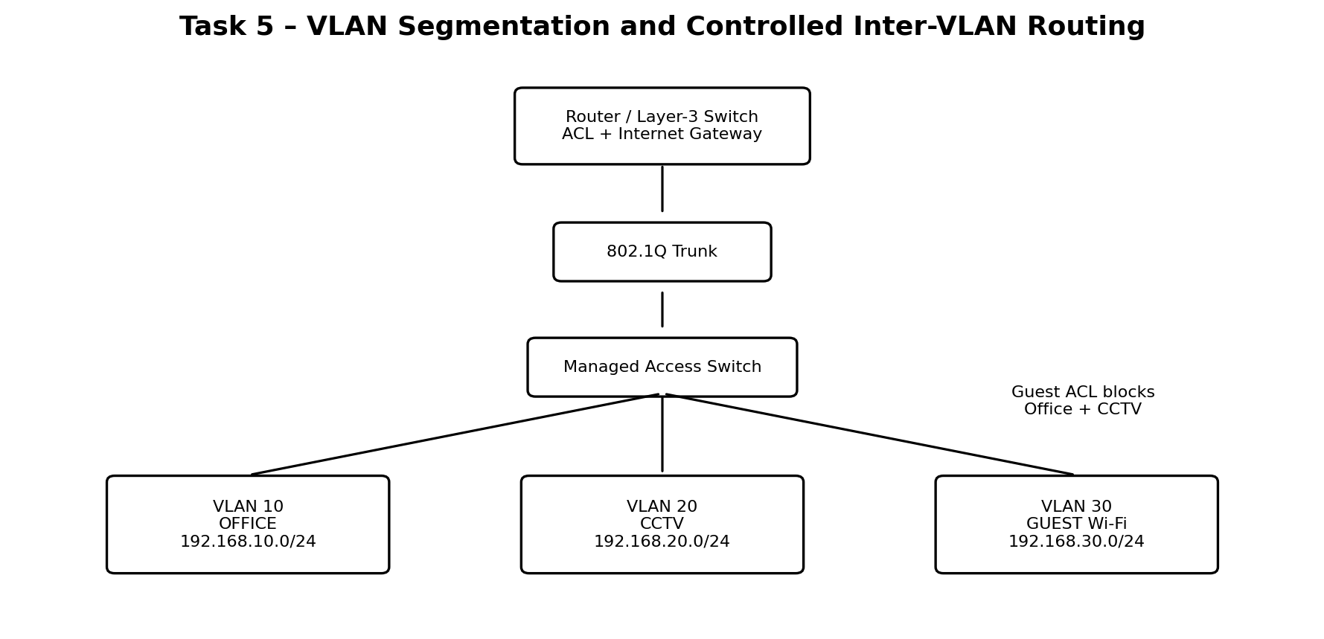
Figure 5: VLAN segmentation; guest traffic is filtered by an ACL before reaching internal networks.
Example addressing plan: VLAN 10 = 192.168.10.0/24, VLAN 20 = 192.168.20.0/24, VLAN 30 = 192.168.30.0/24. Default gateways are .1 in each subnet. Router-on-a-stick uses one trunk interface with 802.1Q subinterfaces. Apply an inbound ACL on the guest subinterface to deny private office/CCTV networks and permit other destinations (internet). In production, also block other internal/private ranges and allow DNS/DHCP services deliberately.

Router-on-a-stick example
enable
configure terminal
interface gigabitEthernet0/0
no shutdown
exit

interface gigabitEthernet0/0.10
encapsulation dot1Q 10
ip address 192.168.10.1 255.255.255.0
exit
interface gigabitEthernet0/0.20
encapsulation dot1Q 20
ip address 192.168.20.1 255.255.255.0
exit
interface gigabitEthernet0/0.30
encapsulation dot1Q 30
ip address 192.168.30.1 255.255.255.0
ip access-group GUEST-IN in
exit

ip access-list extended GUEST-IN
deny ip 192.168.30.0 0.0.0.255 192.168.10.0 0.0.0.255
deny ip 192.168.30.0 0.0.0.255 192.168.20.0 0.0.0.255
permit ip 192.168.30.0 0.0.0.255 any
end
write memory
The router's physical interface connected to the switch must be configured as an 802.1Q trunk on the switch side and carry VLANs 10, 20 and 30. Add DHCP pools and a default route/NAT toward the internet as required by the Packet Tracer topology. The example ACL blocks guest-to-office and guest-to-CCTV traffic; a production ACL should also deny all other internal address ranges.

5.3 Verification and broadcast domains
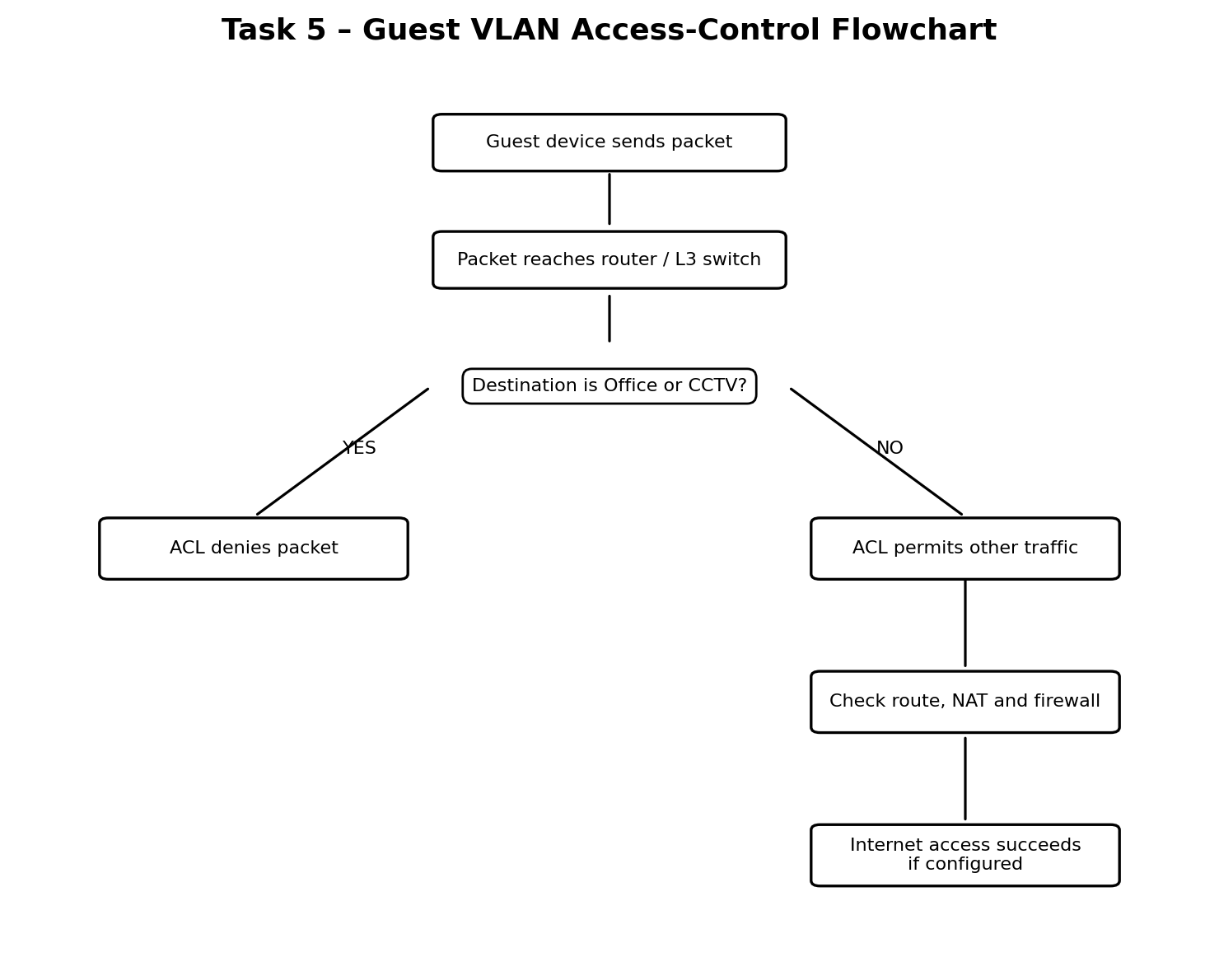
Figure 6: Flowchart for checking whether guest traffic is denied or permitted.
Test | Expected result
Guest PC (VLAN 30) → Office PC (VLAN 10) before inter-VLAN routing | Fails: different VLANs are isolated at Layer 2.
Guest PC → Office PC after routing and ACL | Fails: ACL explicitly denies guest-to-office traffic.
Guest PC → CCTV PC | Fails: ACL explicitly denies guest-to-CCTV traffic.
Guest PC → permitted internet address | Succeeds if default route, NAT and firewall policy are configured.
Office PC → approved internal services | Succeeds according to routing and security policy.

Broadcast-domain count: before segmentation, the common unsegmented LAN is 1 broadcast domain. After configuring VLANs 10, 20 and 30, there are 3 broadcast domains. Each VLAN has its own broadcast traffic; the router/L3 switch routes between them only when permitted.

Verification commands
SW-Admin# show vlan brief
SW-Admin# show interfaces trunk
SW-Admin# show interfaces fa0/1 switchport
Router# show ip interface brief
Router# show access-lists
Router# show ip route

Alternative concept: separate physical guest switch and internet
Factor | Guest VLAN on shared managed switch | Separate physical guest switch + ISP
Equipment cost | Usually lower; uses existing switch ports and one shared infrastructure. | Higher; extra switch, cabling, ISP circuit and firewall/router capacity.
Isolation | Logical separation with 802.1Q, ACLs and firewall rules; depends on correct configuration. | Stronger physical separation if there is no shared Layer-2 path and the guest ISP is independent.
Management | Centralized VLAN, policy and monitoring; requires competent configuration. | More hardware and contracts, but guest faults/traffic are more isolated.
When physical separation is worth it | Normal campus guest access when managed switches and firewalls are correctly configured. | High-risk environments, regulatory requirements, untrusted devices, or where guest traffic must not share critical infrastructure.

Recommendation: VLAN segmentation is the cost-effective default. Use a physically separate guest network when policy, threat model or compliance requires stronger isolation, and ensure it truly has independent switching and internet egress.

TASK 6 – DESIGN CHALLENGE: CAMPUS NETWORK FOR A NEW UNIVERSITY
This is a proposed reference design because the assignment provides no exact floor plans, user counts by building, application traffic profiles, switch prices or ISP bandwidth. The figures below are planning assumptions to make the design testable; validate them through a campus survey and procurement quotes.

Stage 1 – Interpret requirements
Building / group | Planning population / devices | Peak traffic estimate and requirement
Academic block | 1,000 students/staff; 500 wired endpoints plus Wi-Fi clients | Assume 1.5 Gbps peak aggregate; wired and wireless coverage in all teaching spaces.
Laboratories | 600 computers | Assume 5 Mbps busy-hour average per computer = 3,000 Mbps (3 Gbps) aggregate peak.
Library | 400 concurrent users; 100 wired endpoints | Assume 1 Gbps peak aggregate; dense Wi-Fi and quiet-study coverage.
Hostels | 3,000 students; up to 3,000 concurrent personal devices at peak | Assume 1 Mbps busy-hour average = 3 Gbps aggregate; high-density Wi-Fi per floor/wing.
Auditorium | 500 people; AV and production devices | Assume 1 Gbps peak aggregate; dedicated AV wired connections and high-density wireless.
Data centre | Servers, storage, security and management systems | Assume 10 Gbps minimum server/core connectivity, scalable to 25/40 Gbps.

Testable requirements: (1) each building has wired and Wi-Fi coverage; (2) student, staff, guest and CCTV traffic are isolated into separate VLANs; (3) emergency/core services remain reachable after one core-link failure; (4) two independent ISP connections are available; (5) core and building uplinks are monitored for utilization and packet loss; (6) the design can add users and access points for ten years without replacing the entire backbone.

Stage 2 – Hierarchical hybrid topology
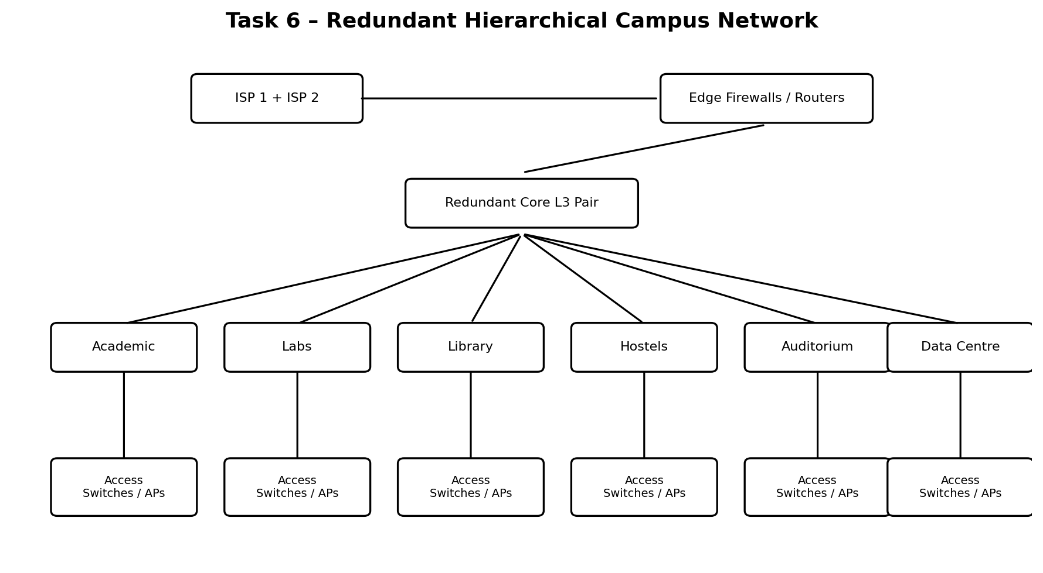
Figure 8: Redundant hierarchical campus network with dual ISP edge and core pair.
ISP-1 ISP-2
| |
[Edge FW/Router A] [Edge FW/Router B]
\ /
\ /
+-----------------------------+
| Redundant Core L3 Pair |
| Core-1 ===== Core-2 |
+-----------------------------+
|| || || ||
Fibre Fibre Fibre Fibre
|| || || ||
[Academic] [Labs] [Library] [Hostels]
| | | |
Access Access Access Access
switches switches switches switches
| | | |
PCs/APs 600 PCs PCs/APs Wi-Fi APs

Auditorium and Data Centre connect redundantly
to both core switches using diverse fibre paths.
Topology choices: star from each building distribution switch to its access switches; redundant partial-mesh fibre links between the two core switches and critical building distribution switches; hierarchical core–distribution–access architecture. The core is not a single switch. Use link aggregation where supported and spanning-tree/routing designs that prevent loops while allowing failover.

Stage 3 – Devices, media, VLANs and WAN
Component | Recommended choice
Core | Two Layer-3 core switches with redundant power, high-speed 25/40/100G-capable uplinks as justified by growth.
Distribution | Two distribution switches per large/critical building or a redundant pair; Layer-3 routing to core.
Access | Managed 48-port PoE+ switches for APs, IP phones and CCTV; non-PoE switches for computer labs where suitable.
Backbone | Single-mode fibre between buildings; diverse ducts/routes for critical links. Multimode only for short in-building links where cost/reach fit.
Horizontal cabling | Cat6/Cat6A structured cabling within 90 m permanent-link limit; certified patch panels and outlets.
Wireless | Wi-Fi 6/6E-capable managed APs, centrally managed; RF survey, channel/power planning and separate SSIDs mapped to VLANs.
Security | Next-generation firewall pair, ACLs, 802.1X for staff, guest captive portal, CCTV restrictions and network access control.
WAN | Two independent ISPs terminating on redundant edge firewalls/routers; automatic failover and policy-based routing.

VLAN and IP address plan
VLAN | Network | Purpose
10 | 10.10.10.0/22 | Staff and faculty
20 | 10.10.20.0/21 | Students and laboratories
30 | 10.10.30.0/22 | Guest Wi-Fi
40 | 10.10.40.0/23 | CCTV and physical security
50 | 10.10.50.0/24 | Servers and data centre
60 | 10.10.60.0/24 | Network management
70 | 10.10.70.0/24 | Voice / AV systems

Use gateway addresses such as the first usable address in each subnet, DHCP scopes for client VLANs, reserved/static addresses for infrastructure and servers, and ACLs/firewall rules to restrict inter-VLAN access. The subnet sizes are initial estimates; perform a host-count and growth review before deployment.

Stage 4 – Bandwidth, oversubscription and bill of materials
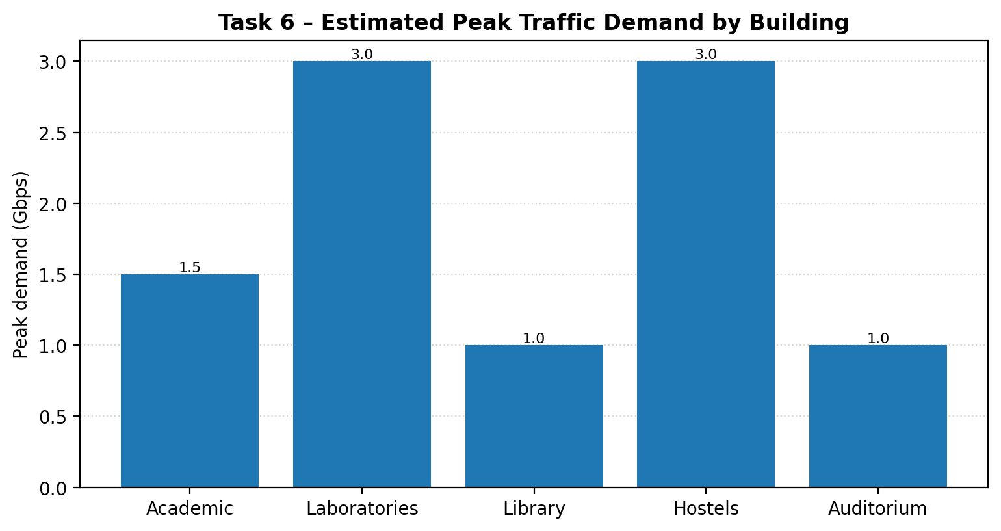
Figure 7: Estimated peak demand by campus building based on the assignment's stated planning assumptions.
Illustrative uplink sizing: assume two 10 Gbps uplinks from each building distribution layer to the core (20 Gbps aggregate capacity when both are active). For normal traffic, use the peak estimates below. The oversubscription ratio is access-side peak demand ÷ available uplink capacity.
Building | Estimated peak demand | Uplink capacity | Oversubscription
Academic | 1.5 Gbps | 2 × 10 Gbps = 20 Gbps | 1.5/20 = 0.075:1 (1:13.3)
Laboratories | 3.0 Gbps | 2 × 10 Gbps = 20 Gbps | 3/20 = 0.15:1 (1:6.7)
Library | 1.0 Gbps | 2 × 10 Gbps = 20 Gbps | 1/20 = 0.05:1 (1:20)
Hostels | 3.0 Gbps | 2 × 10 Gbps = 20 Gbps | 3/20 = 0.15:1 (1:6.7)
Auditorium | 1.0 Gbps | 2 × 10 Gbps = 20 Gbps | 1/20 = 0.05:1 (1:20)

These ratios are below 1:1 on the stated aggregate assumptions. If one 10 Gbps link fails, remaining capacity is 10 Gbps; laboratory and hostel peak assumptions remain below that, but combined traffic from all buildings requires a properly sized core and internet edge. The university should validate busy-hour concurrency and avoid treating the theoretical access-port sum as actual traffic.
Bill of materials – planning estimate | Quantity / note
Layer-3 core switches | 2 redundant units
Building distribution switches | At least 2 per large/critical building; final count from floor plan and port survey
48-port managed access switches | Laboratory: at least 600/48 = 12.5 → 13 switches, plus spare capacity; other buildings sized after outlet/AP counts
Wireless access points | Initial estimate: 6 buildings × 10 APs = 60 APs for planning only; replace with RF survey and client-density calculation
Single-mode fibre backbone | Two diverse fibre paths to core for data centre, labs and other critical buildings; length from route survey + 10% slack
Cat6/Cat6A horizontal cable | One home-run per wired outlet/AP; length per measured route, plus 10% spare
Firewall / edge routers | 2 firewalls or HA pair, 2 ISP handoffs, redundant edge routing
Racks, patch panels, UPS, PDU | At each telecom room and data centre; size to switch count and power/heat
Optics and fibre termination | Matched SFP/SFP+/SFP28 modules, ODFs, pigtails, patch cords and testing

Stage 5 – Packet Tracer simulation and demonstration
Build a reduced Packet Tracer model with two core multilayer switches, two building distribution/access switches (for example Labs and Academic), one router/firewall representation and two ISP/cloud links. Create VLANs 10, 20, 30 and 40; configure 802.1Q trunks and inter-VLAN routing; apply ACLs to block guest access to staff and CCTV; configure default routes toward the simulated internet.
- Connectivity test: ping between permitted staff and server endpoints; confirm gateway reachability.
- VLAN isolation test: guest PC must fail to ping staff and CCTV PCs; permitted internet test should succeed when NAT/default routing is configured.
- Redundancy test: shut down one core-to-building link (or one core switch uplink) and verify that the alternate path maintains connectivity. Capture before/after ping and show interface outputs.
- Save the .pkt file and screenshots; Packet Tracer simulation evidence must be generated by the student in the installed application.

Alternative concept: collapsed core
A collapsed core combines core and distribution functions. It can save a pair of distribution switches or a separate distribution layer in a small campus. However, if the single collapsed-core switch fails, all buildings whose gateways/uplinks depend on it can lose inter-VLAN routing and campus connectivity. In this university, the laboratories (600 computers), hostels (3,000 students), data centre and internet edge are critical; a single collapsed core creates a large failure domain.
Comparison | Separate redundant core/distribution | Single collapsed core
Initial equipment | More switches, optics and rack/power cost. | Fewer switches and lower initial cost.
Failure impact | A single core switch/link failure can be handled by the redundant peer/path if configured correctly. | One core failure can disconnect the whole campus or a large portion of it.
Scalability | Clear growth boundaries and easier capacity upgrades. | Can become a bottleneck as buildings, APs and traffic grow.
Ten-year judgement | Recommended for this 40-acre campus and critical services. | Not recommended as a single device; a redundant collapsed-core pair could be considered only after detailed capacity/failure analysis.

The exact number of devices saved depends on the final building distribution design. Do not claim a fixed saving without a port and floor-plan survey. The cost saving is not worth a single point of failure for the stated campus. If budget requires a collapsed architecture, deploy a redundant pair, diverse uplinks and tested failover rather than one switch.

CONCLUSION
The office should move from a shared bus to a switched extended star. The hospital should use a hybrid topology with redundant paths specifically for emergency and operation theatres, while selecting fibre for long inter-building distances. Managed switches, VLANs, ACLs, Wi-Fi 6 and a protected WAN provide segmentation and scalable access. The campus design uses a redundant hierarchical core, fibre backbone, structured copper access, separate VLANs, dual ISPs and tested failover. Calculations and assumptions are shown so the designs can be checked and adjusted using Packet Tracer and actual site measurements.

