
Name:Ch. Venkata sai mohith
Reg no:1925260287
Course:UBA0705-computer networks
Faculty:Dr.kumaran.G

ASSIGNMENT 5 – CO5

TASK A1 – WHERE DOES THE DELAY COME FROM?

A1.1 – Break Down the Delay
Given: packet size = 1,500 bytes = 12,000 bits; distance = 2,000 km = 2,000,000 m; link rate = 100 Mbps; 3 routers, each with 0.5 ms queuing and 0.1 ms processing. Assume propagation speed in the fibre is 2 × 10⁸ m/s and that the packet is transmitted once on the stated bottleneck link.
Delay component | Formula and working | Result
Transmission | L/R = 12,000 bits / 100,000,000 bit/s | 0.00012 s = 0.12 ms
Propagation | d/v = 2,000,000 m / (2 × 10⁸ m/s) | 0.010 s = 10 ms
Queuing | 3 × 0.5 ms | 1.50 ms
Processing | 3 × 0.1 ms | 0.30 ms
Total | 0.12 + 10 + 1.50 + 0.30 | 11.92 ms

Propagation delay (10 ms) dominates. Increasing link capacity from 100 Mbps to 1 Gbps reduces transmission delay from 0.12 ms to 0.012 ms, saving only 0.108 ms. It does not reduce propagation, queuing or processing delay. Therefore, a 1 Gbps upgrade alone gives only a small improvement for this path; congestion control and router processing also matter.

A1.2 – Bandwidth–Delay Product
BDP = bandwidth × RTT = 1 × 10⁹ bit/s × 0.080 s = 80,000,000 bits = 10,000,000 bytes ≈ 10 MB (decimal). A 64 KiB TCP window holds only 65,536 bytes = 524,288 bits.
Maximum throughput = window / RTT = 524,288 bits / 0.080 s = 6,553,600 bit/s ≈ 6.55 Mbps. The window is much smaller than the 10 MB BDP, so the sender cannot keep enough data in flight to fill the 1 Gbps link. A window near 10 MB (or suitable TCP window scaling) is required, ignoring other protocol limits.

. End-to-end delay breakdown
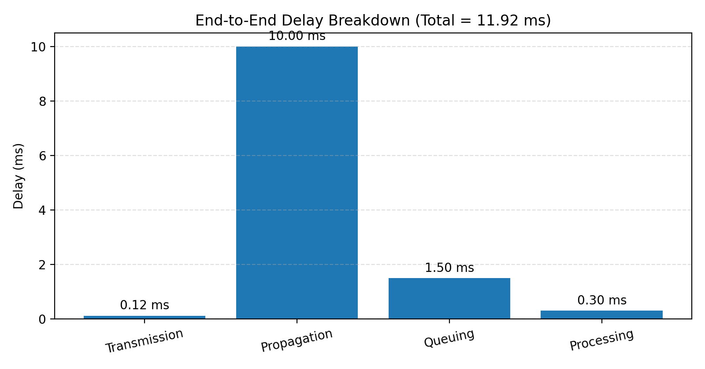
Propagation delay (10 ms) is the largest component of the calculated 11.92 ms total

A1.3 – Set the Targets and Tools
Application | Suggested target | Measurement tools
Live video | One-way delay <150 ms; jitter <30 ms; loss <1%; throughput ≥2 Mbps per stream (assumption) | Wireshark/RTP, ping, iperf3; SNMP for utilisation
Voice / VoIP | Delay <150 ms; jitter <30 ms; loss <1%; about 80 kbps per G.711 call per direction | Wireshark RTP analysis, ping, iperf3
Recorded video | Throughput ≥5 Mbps for smooth HD playback; low sustained loss; buffering can tolerate more delay (assumption) | iperf3, HTTP developer tools, SNMP
E-mail | Reliable delivery; low loss; delay of seconds is generally acceptable (assumption) | Wireshark, ping, SMTP/IMAP logs
File downloads | Sustained throughput ≥80% of available access-link rate (assumption); retransmissions/loss low | iperf3, Wireshark, SNMP

Active measurement injects test traffic (for example ping, traceroute and iperf3) and measures the response. Passive measurement observes existing traffic and counters (Wireshark capture and SNMP). Active tests can measure a path even when no user traffic exists, but add test load. Passive monitoring reflects real application traffic but cannot measure an unused path and may not reveal a problem until users generate traffic.
Alternative concept – passive-only monitoring: it can obtain observed throughput, packet sizes, packet loss/retransmissions (where visible), traffic volume/utilisation and packet timing/jitter for captured flows. It cannot reliably obtain unloaded path RTT, route behaviour, or available capacity without test traffic. Problems may be noticed only after users start a session or congestion occurs; active probes can detect degradation earlier.

TASK A2 – FOLLOW THE APPLICATION PROTOCOLS

A2.1 – E-mail
Example SMTP exchange (addresses are illustrative):
S: 220 mail.example.edu ESMTP ready\nC: EHLO student.example.edu\nS: 250-mail.example.edu; 250-SIZE 25000000; 250 OK\nC: MAIL FROM:<student@example.edu>\nS: 250 2.1.0 Sender accepted\nC: RCPT TO:<teacher@example.edu>\nS: 250 2.1.5 Recipient accepted\nC: DATA\nS: 354 Start mail input; end with <CRLF>.<CRLF>\nC: Subject: Assignment\nC: Please find my assignment attached.\nC: .\nS: 250 2.0.0 Message queued\nC: QUIT\nS: 221 2.0.0 Bye
POP3 configured to delete after download removes messages from the server after one device retrieves them. The phone may download and delete a message, leaving the laptop and lab PC without the same mailbox state; read/unread status and folders are not synchronised. IMAP keeps messages on the server and synchronises folders, flags and message state across all devices.

A2.2 – File Transfer and Monitoring
Active FTP uses a control connection (normally TCP 21) and asks the server to open a data connection back to the client. A firewall/NAT may block this incoming connection. Passive FTP instead has the client initiate both control and data connections to a server-advertised port, so it usually passes outbound-only firewall rules. SFTP (over SSH, normally TCP 22) encrypts authentication and data and uses one connection; HTTPS also encrypts transfer and is commonly easier to permit through firewalls.
SNMP GET: an SNMP manager sends a GET request for an interface counter OID such as ifInOctets for interface 1; the agent returns the counter value. SNMP TRAP: when a router detects an event such as linkDown, it sends an unsolicited trap notification to the manager.

A2.3 – DNS and HTTP
In browser developer tools, inspect DNS lookup time, initial connection time, TLS negotiation time, waiting/TTFB, content download time and total request duration. High DNS time indicates name-resolution delay; high connection/TLS time indicates connection setup overhead; high TTFB points to server or network waiting; high content download time points to large content or low throughput.
Alternative concept – illustrative mailbox estimate: assume 50 messages average 20 KB each and webmail loads 50 message bodies, while an IMAP client initially downloads 50 headers of 1 KB each and fetches only the 2 opened bodies. Webmail transfers about 50 × 20 KB = 1,000 KB (plus page assets); IMAP initially transfers 50 KB + 2 × 20 KB = 90 KB (plus protocol overhead). If all 50 bodies are opened, IMAP eventually transfers about the same message-body volume. HTTPS webmail is usually simpler to secure centrally because access is through a browser and one HTTPS endpoint; IMAP can also be secured using TLS but requires correct client configuration.

Figure 2. 4 GB package distribution comparison
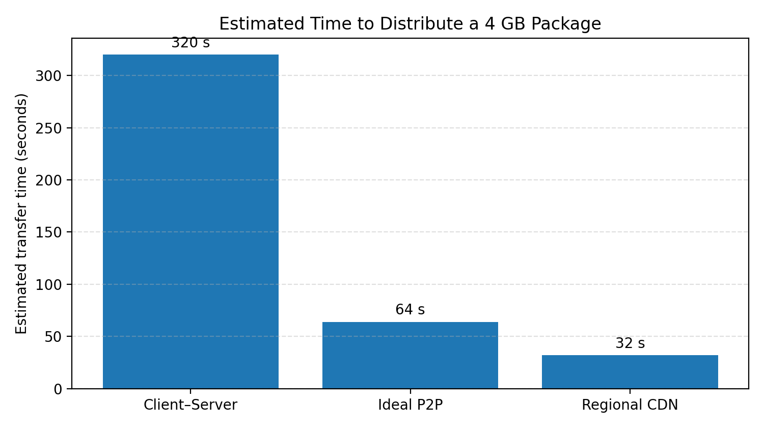
The estimates are 320 s for client–server, 64 s for ideal P2P and 32 s for regional CDN delivery

TASK A3 – PEER-TO-PEER, VoIP AND OVERLAYS BY THE NUMBERS

A3.1 – Distribute a 4 GB Package
Assume 1 GB = 10⁹ bytes and all 20 centres download concurrently. Package size = 4 × 10⁹ × 8 = 32 × 10⁹ bits.
Client–server: server upload is the bottleneck at 100 Mbps. Time = 32 × 10⁹ / 100 × 10⁶ = 320 s = 5 min 20 s. Each centre’s 50 Mbps download capacity is not the limiting factor when the server has only 100 Mbps total upload.
Peer-to-peer: ideal aggregate upload capacity = original server 100 Mbps + 20 centres × 20 Mbps = 500 Mbps. Ideal lower-bound time = 32 × 10⁹ / 500 × 10⁶ = 64 s. The aggregate download capacity is 20 × 50 = 1,000 Mbps, so upload is the limiting aggregate rate. Real P2P time will be longer due to initial seeding, peer discovery, protocol overhead, uneven peer availability and the fact that a centre cannot upload pieces it has not yet received. P2P may not win when peers are offline, upload is restricted, security/licensing requires central control, or the swarm is small.

A3.2 – The Real Cost of a Voice Call
Packet interval = 20 ms = 0.020 s, so packets per second = 1 / 0.020 = 50. G.711 payload per packet = 64,000 bit/s × 0.020 s = 1,280 bits = 160 bytes. Add 40 bytes IP/UDP/RTP header: total = 200 bytes per packet.
Bandwidth per direction = 200 bytes × 8 × 50 = 80,000 bit/s = 80 kbps. On a 2 Mbps link, theoretical call count = 2,000 / 80 = 25 calls per direction. In practice, reserve capacity for link-layer overhead, signalling and other traffic, so support fewer than 25 calls. SIP establishes, modifies and terminates sessions; RTP carries the real-time audio/video media packets.

A3.3 – Overlay Networks
An overlay is a logical network built on top of the underlying Internet. A CDN places cached content at distributed edge servers and directs users to a nearby copy; it reduces long-distance delivery time and origin-server load for recorded lectures and course packages. A VPN creates encrypted logical tunnels between users/sites; it protects traffic over untrusted networks and securely connects regional centres, but does not by itself solve Internet congestion or reduce physical propagation distance.
Alternative concept – CDN: with a 1 Gbps edge server in each of the 20 regions, each region can receive its own 4 GB copy at 1 Gbps. Ideal per-region transfer time = 32 × 10⁹ / 1 × 10⁹ = 32 s. All regions can transfer concurrently, assuming the CDN has pre-positioned or can supply the package independently at each edge. This is faster than the ideal P2P estimate of 64 s and client–server 320 s. CDN costs more through provider/egress and storage fees, but offers managed capacity and predictable regional delivery. P2P can be cheaper and resilient when peers are active, but performance varies with peer availability.

Figure 3. TCP window and bandwidth–delay product
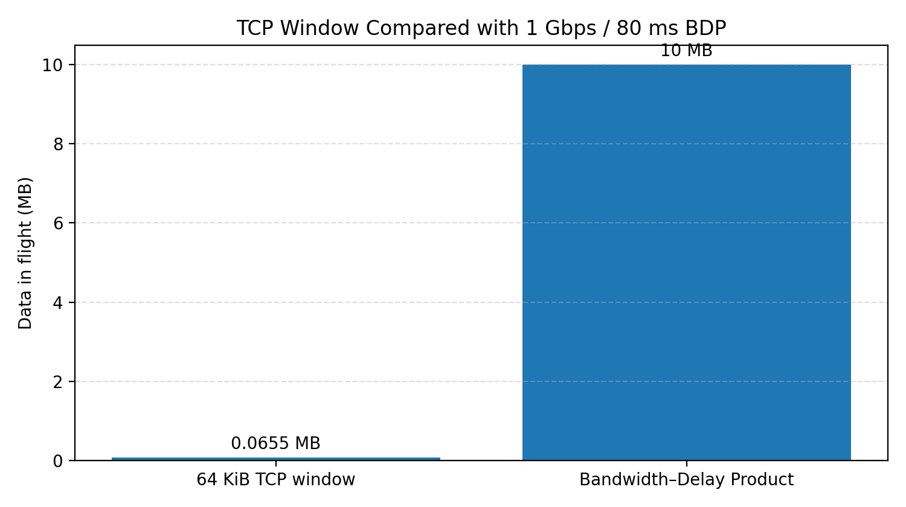
The 64 KiB window is much smaller than the approximately 10 MB BDP for the stated 1 Gbps, 80 ms path.

TASK A4 – FIND THE HOLE IN THE FIREWALL

A4.1 – SSL/TLS
A valid TLS certificate binds a domain name to a public key and is signed by a trusted certificate authority; it helps the client authenticate the server (subject to certificate validation). The TLS handshake negotiates protocol version and cipher suite, authenticates the server, establishes shared session keys and provides integrity/confidentiality. On café Wi-Fi, an ordinary network attacker can generally see IP addresses, connection timing, traffic volume and often the destination hostname through DNS or other metadata. The attacker cannot read or alter HTTPS application content without detection if TLS is correctly validated; a fake certificate or compromised endpoint changes this assumption.

A4.2 – Read the Rule Set
Original order: allow TCP any → 443; allow TCP any → 22; deny TCP any → 22; allow TCP 10.1.0.0/16 → 22; allow UDP any → 53; deny all.
Rule 4 (allow SSH from 10.1.0.0/16) can never take effect because rule 2 already allows all TCP traffic to port 22. Rule 3 (deny TCP port 22) is also shadowed by rule 2. The security hole is that SSH port 22 is open to every source, not just the trusted 10.1.0.0/16 network.
Correct order | Action / match
1 | Allow TCP destination port 443 from any source
2 | Allow TCP destination port 22 from source 10.1.0.0/16
3 | Deny TCP destination port 22 from any source
4 | Allow UDP destination port 53 from any source
5 | Deny all remaining traffic

Stateless firewall: evaluates each packet independently using fields such as source, destination, protocol and port; it does not remember connection state. Stateful firewall: tracks connection state and permits valid return traffic for established sessions. Application-layer proxy firewall: terminates/proxies application sessions and can inspect application content and commands, providing deeper control at higher processing cost and possible latency.
Python 3 stateless-filter program (first matching rule wins; source prefix is matched as a string as specified in the assignment):
rules = [\n ("allow", "tcp", 443, ""),\n ("allow", "tcp", 22, "10.1."),\n ("deny", "tcp", 22, ""),\n ("allow", "udp", 53, ""),\n]\n\ndef decide(proto, port, src):\n for action, rule_proto, rule_port, prefix in rules:\n if (proto == rule_proto and\n (rule_port == "any" or port == rule_port) and\n (prefix == "" or src.startswith(prefix))):\n return action\n return "deny"\n\ntests = [\n ("tcp", 443, "49.37.2.8"),\n ("tcp", 22, "10.1.4.20"),\n ("tcp", 22, "49.37.2.8"),\n ("udp", 53, "10.1.4.20"),\n ("tcp", 80, "49.37.2.8"),\n ("icmp", None, "49.37.2.8"),\n]\nfor test in tests:\n print(test, "->", decide(*test))
Test packet | Decision (correct order)
TCP 443 from 49.37.2.8 | ALLOW
TCP 22 from 10.1.4.20 | ALLOW
TCP 22 from 49.37.2.8 | DENY
UDP 53 from 10.1.4.20 | ALLOW
TCP 80 from 49.37.2.8 | DENY (default)
ICMP from 49.37.2.8 | DENY (default)

If rules 2 and 3 are swapped, the general deny for TCP/22 is evaluated before the trusted-subnet allow. Both TCP/22 test packets are then denied; the trusted administrator is locked out. The other four test decisions remain unchanged.
Alternative concept – a cloud WAF can stop application-layer attacks such as SQL injection and cross-site scripting, which a basic packet filter cannot recognise from ports and IP addresses alone. It may add a small processing/network delay (provider- and configuration-dependent; measure it rather than assume a fixed value). Because the company hosts a public learning website and has suffered an outage, a managed WAF is justified alongside—not instead of—a correctly configured network firewall.

Figure 4. Illustrative network topology
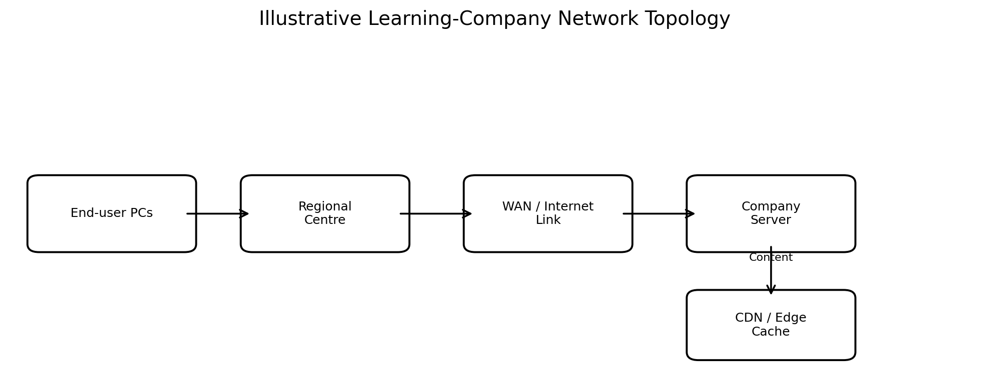
This conceptual layout represents end-user PCs, a regional centre, WAN/Internet connectivity and company-side services.

TASK A5 – HOW EASY IS IT TO TAKE THE SITE DOWN?

A5.1 – Size the Attack
The half-open connection queue holds 1,024 entries and each remains for 60 s. At steady state, rate required to fill it = 1,024 / 60 = 17.07 SYN packets/s, assuming each SYN occupies one queue entry for the full 60 s and no entries expire earlier.
SYN cookies avoid storing full connection state when the SYN arrives. The server encodes necessary state in the SYN-ACK sequence number and allocates connection state only after receiving a valid ACK, reducing exhaustion of the half-open queue. DNS amplification is hard to block at the victim because responses are much larger than spoofed requests and arrive from many legitimate open resolvers; the victim may be saturated before it can filter the traffic.

A5.2 – Plan the Protection
Attack / threat | Recommended protection | Reason
SYN flood | SYN cookies + connection rate limiting; upstream scrubbing for large floods | Cookies protect the half-open queue; rate limits reduce bursts; scrubbing absorbs traffic before the access link.
DNS amplification | Upstream DDoS scrubbing, provider filtering and CDN/Anycast distribution | Large distributed response volume is best filtered/absorbed upstream; victim-only filtering may be too late.
HTTP request flood | WAF, per-client/application rate limits and CDN caching | Controls abusive request rates and serves cacheable content at the edge.

Alternative concept – four times server capacity: if queue capacity scales linearly from 1,024 to 4 × 1,024 = 4,096 half-open entries, the ideal rate to fill it over 60 s becomes 4,096 / 60 = 68.27 SYN/s. This is only four times the original threshold, not a robust defence: an attacker can increase the rate, and the network link or application may fail before the larger queue helps. Layered protection is more realistic.

Firewall packet-filtering flowchart
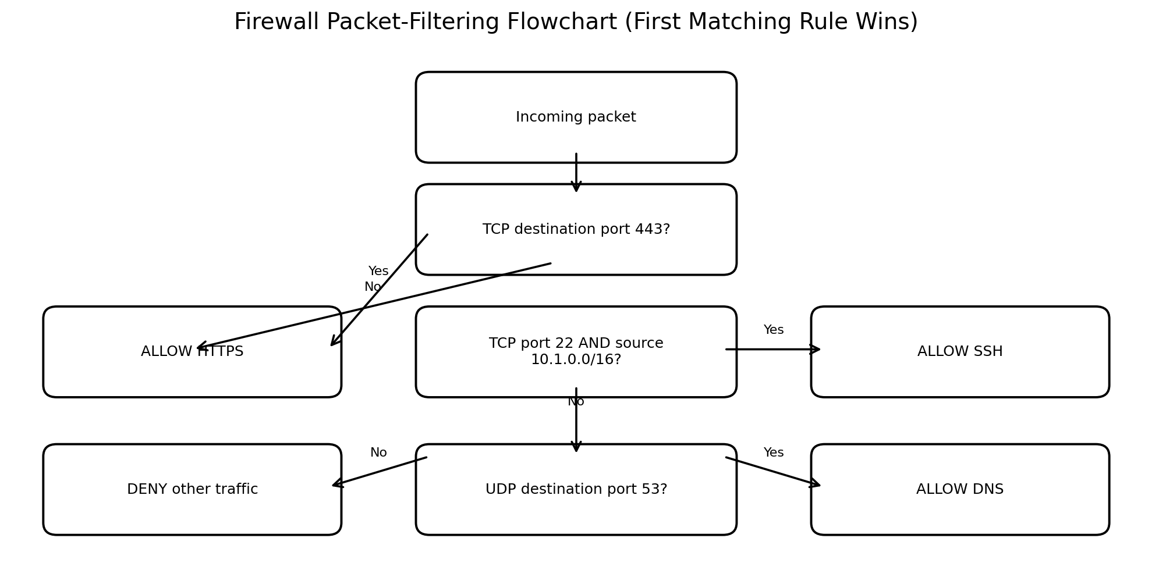
The intended order allows HTTPS, permits SSH only from 10.1.0.0/16, allows required DNS, and denies remaining traffic.

PART B – IMPLEMENTATION & EXPERIMENTAL INVESTIGATION
Important: The assignment asks for the student’s own ping, traceroute, iperf3, Wireshark, Packet Tracer/NS-3 and tc netem evidence. Those measurements cannot be truthfully generated from the PDF alone. The commands, calculation program and sample analysis below provide a reproducible method. Replace all illustrative values with your own command outputs and screenshots before submission.

TASK B1 – MEASURE A REAL NETWORK

B1.1 – Delay and Path
Run the following at morning, afternoon and evening for three destinations at different distances. Save the full terminal output. Example destinations may be a nearby university server, a national public server and an overseas server; choose hosts that respond to ICMP.
ping -c 20 <hostname>\ntraceroute <hostname> # Linux/macOS\ntracert <hostname> # Windows
Record minimum/average/maximum RTT, standard deviation, packet loss and hop sequence in a table. Jitter can be estimated as the mean absolute difference between consecutive RTT samples (state this definition). Compare minimum RTT with the theoretical propagation lower bound 2d/v; the actual route distance is usually longer than straight-line distance.
Destination / time | Min RTT (ms) | Avg RTT (ms) | Max RTT (ms) | Loss (%) | Jitter (ms) | Notes
Near / morning | Fill from ping | Fill | Fill | Fill | Calculate | Own result
National / morning | Fill from ping | Fill | Fill | Fill | Calculate | Own result
Overseas / morning | Fill from ping | Fill | Fill | Fill | Calculate | Own result
Repeat for afternoon and evening

B1.2 – Throughput
# On machine A (server):
iperf3 -s
# On machine B (client), TCP:
iperf3 -c <A-IP> -t 30
# UDP test at a chosen offered rate:
iperf3 -c <A-IP> -u -b 10M -t 30
# Repeat over wired and Wi-Fi; reverse direction if needed:
iperf3 -c <A-IP> -R -t 30
Record sender/receiver throughput, retransmissions (TCP), UDP jitter and lost/total datagrams. Keep test duration, offered UDP rate, interface type and machine details constant when comparing wired and wireless.
Link / direction | Protocol | Throughput | Retransmits or loss | Jitter | Interpretation
Wired A→B | TCP | Your iperf3 result | Your result | — | Compare with link speed
Wired A→B | UDP | Your iperf3 result | Your result | Your result | Compare with offered rate
Wi-Fi A→B | TCP | Your result | Your result | — | Compare with wired
Wi-Fi A→B | UDP | Your result | Your result | Your result | Compare with wired

B1.3 – Analyse a Capture
Capture an authorised voice/video call in Wireshark. Use Telephony → RTP → RTP Streams → Analyze, where RTP is present. Record packet count, sequence gaps, timestamps, jitter and bitrate. The supplied trace is analysed below; it is an assignment dataset, not a real capture from your computer.
Python 3 program to calculate loss, average one-way delay, jitter and throughput:
trace = [
(1, 0, 42, 1200), (2, 20, 61, 1200), (3, 40, 85, 1200),
(4, 60, None, 1200), (5, 80, 119, 1200), (6, 100, 146, 1200),
(7, 120, 158, 1200), (8, 140, 190, 1200),
(9, 160, None, 1200), (10, 180, 222, 1200)
]
sent = len(trace)
received = [x for x in trace if x[2] is not None]
lost = sent - len(received)
loss_pct = lost / sent * 100
delays = [rx - tx for _, tx, rx, size in received]
avg_delay = sum(delays) / len(delays)
jitter = sum(abs(delays[i] - delays[i-1])
for i in range(1, len(delays))) / (len(delays)-1)
total_bits = sum(x[3] * 8 for x in received)
duration_s = (max(x[2] for x in received) -
min(x[1] for x in trace)) / 1000
throughput_kbps = total_bits / duration_s / 1000
print("Loss %:", loss_pct)
print("Average one-way delay ms:", avg_delay)
print("Jitter ms:", jitter)
print("Throughput kbps:", throughput_kbps)
Metric | Calculation | Result
Packet loss | 2 lost / 10 sent × 100 | 20%
One-way delay | Mean of 42, 41, 45, 39, 46, 38, 50, 42 ms | 42.875 ms
Jitter | Mean absolute consecutive delay difference: (1+4+6+7+8+12+8)/7 | 6.57 ms
Throughput | 8 received × 1,200 bytes × 8 / 0.222 s | 345.95 kbps

Correction note: the consecutive absolute differences are 1, 4, 6, 7, 8, 12 and 8 ms; their sum is 46 ms, so jitter = 46/7 = 6.57 ms.
VoIP threshold check: delay 42.875 ms <150 ms and jitter 6.57 ms <30 ms, but loss 20% is not <1%; therefore the original trace is NOT acceptable. If the two lost packets are removed from the trace, loss becomes 0%, while the received-packet delay and jitter remain 42.875 ms and 6.57 ms. The resulting trace meets all three stated thresholds. Removing lost packets is a what-if calculation, not a real network fix.

B1.4 – Compare with Your Targets
Compare each measured result from B1.1–B1.3 with the A1.3 targets. State pass/fail and explain any mismatch. Do not mark a target as achieved unless your own measurement supports it.
Application | Target | Your measured value | Pass / fail and explanation
VoIP | Delay <150 ms; jitter <30 ms; loss <1% | Fill from capture | Fill
Live video | Use A1.3 target | Fill | Fill
Recorded video | Use A1.3 target | Fill | Fill
E-mail / downloads | Use A1.3 target | Fill | Fill

Alternative concept – one-way delay versus half RTT: suppose a measured RTT is 100 ms, with 80 ms on the slow upload path and 20 ms on the return path. Half RTT estimates 50 ms, but actual forward one-way delay is 80 ms (or 20 ms in the reverse direction). Thus halving RTT can be wrong by 30 ms when paths are asymmetric. Synchronized endpoint clocks can measure one-way delay directly, but clock offset must be controlled.

TASK B2 – SIMULATE UNDER VARYING CONDITIONS
Build a topology with a learning-company server, Internet/WAN link, one regional centre and end-user PCs. In Packet Tracer, use Simulation mode and traffic generators/complex PDUs; in NS-3, configure point-to-point links, queueing and application flows. Vary bandwidth, propagation delay and number of users. Add a large TCP download while a UDP voice-like flow runs, then repeat with voice priority.
Run | Link rate | One-way link delay | Users / background load | Voice priority | Expected observation (not measured data)
1 – Baseline | 100 Mbps | 10 ms | 10; no bulk download | No | Lowest congestion; establish baseline
2 – Lower capacity | 10 Mbps | 10 ms | 10 | No | Lower throughput; queueing may increase
3 – Longer path | 100 Mbps | 80 ms | 10 | No | Higher end-to-end delay; TCP throughput sensitive to RTT
4 – More users | 10 Mbps | 10 ms | 50 | No | More contention and possible packet loss
5 – Bulk download | 10 Mbps | 10 ms | 20 + bulk TCP | No | Voice packets may queue behind download
6 – QoS | 10 Mbps | 10 ms | 20 + bulk TCP | Yes | Voice delay/jitter should improve; download throughput may reduce

For each run, record simulator configuration, throughput, average/max delay, jitter, packet loss and queue utilisation. The table gives qualitative expectations only; enter the actual simulator results in a separate results table and attach the .pkt or NS-3 script and screenshots.
Alternative concept – compare Packet Tracer and NS-3: Packet Tracer is easier for visual topology construction and learning Cisco device configuration, but offers less detailed packet-level modelling. NS-3 supports programmable, repeatable experiments and detailed protocol/queue models, but requires more coding and configuration. Run one identical scenario in both and compare measured throughput, delay and loss rather than assuming the tools will produce identical values.

TASK B3 – PERFORMANCE UNDER STRESS AND ATTACK
Run tc netem only on a machine/interface in your isolated lab, and remove the impairment after each test. Do not run flood tests against public websites or shared networks.

B3.1 – Delay and Loss
# Add impairment to a lab interface (replace eth0):
sudo tc qdisc add dev eth0 root netem delay 50ms loss 1%
# Change the qdisc between test cases:
sudo tc qdisc change dev eth0 root netem delay 150ms loss 5%
sudo tc qdisc change dev eth0 root netem delay 300ms loss 10%
# Remove impairment:
sudo tc qdisc del dev eth0 root
Test all nine combinations: delay 50/150/300 ms × loss 1/5/10%. Measure TCP throughput with iperf3 and voice delay/jitter/loss using a controlled lab stream. Include a table of actual measurements; greater delay and loss are expected to reduce TCP throughput and worsen real-time quality.
Delay | Loss | TCP throughput | Voice delay | Voice jitter | Voice loss
50 ms | 1% | Measure | Measure | Measure | Measure
50 ms | 5% | Measure | Measure | Measure | Measure
50 ms | 10% | Measure | Measure | Measure | Measure
150 ms | 1% | Measure | Measure | Measure | Measure
150 ms | 5% | Measure | Measure | Measure | Measure
150 ms | 10% | Measure | Measure | Measure | Measure
300 ms | 1% | Measure | Measure | Measure | Measure
300 ms | 5% | Measure | Measure | Measure | Measure
300 ms | 10% | Measure | Measure | Measure | Measure

B3.2 – Window Size
Use a controlled long-delay test link. Compare a small TCP window with a window large enough to cover the BDP. For the A1.2 link, BDP is about 10 MB; a 64 KiB window limits throughput to about 6.55 Mbps at 80 ms RTT. A window near 10 MB can theoretically fill the 1 Gbps path, subject to congestion control, socket limits and actual network conditions.

B3.3 – Firewall and Flood
Apply the corrected rule order from A4.2 using an isolated test machine. Verify that TCP/443 is reachable, TCP/22 is reachable only from 10.1.0.0/16, UDP/53 is allowed if required, and other traffic is denied. For a safe load test, use a bounded request generator against your own local test server in a disconnected/isolated lab. Record request rate, response time, errors and CPU/network utilisation with and without rate limiting. Never flood a real website or shared network.

B3.4 – Trade-Off
Choose settings from the measured results: prioritise low delay/jitter and very low loss for voice; provide sufficient sustained throughput for recorded video and downloads; keep e-mail reliable. Strict-priority DiffServ EF can give voice very low delay, but if unlimited it can starve other traffic. Weighted fair queuing shares capacity more fairly but may give voice slightly higher delay. A practical choice is bounded/controlled EF priority for voice plus fair queuing for other classes.
Alternative concept: compare strict-priority EF and weighted fair queuing using the same offered voice and download loads. Record voice delay/jitter/loss and download throughput for each. Select the policy that meets voice thresholds without unacceptably starving downloads; do not claim a measured winner without the experiment.

TASK B4 – FINAL ENGINEERING DECISION

B4.1 – Predict the Effect
Use your own B1 and B2 results to estimate the effect of twice as many users. If the aggregate offered traffic doubles while capacity stays constant, utilisation rises and queues, delay, jitter and loss are likely to increase. Students on another continent will generally have a longer propagation path and higher RTT. Quantify the prediction using measured baseline RTT and the simulated doubled-load result; do not invent a precise value.

B4.2 – Check the Security
Repeat the normal-traffic tests at the simulated doubled load. Confirm that HTTPS (TCP/443), authorised SSH administration, required DNS and established return traffic still work, while unauthorised SSH and unneeded ports remain blocked. Verify that rate limits protect the service without rejecting legitimate peak-hour users. Record allowed/blocked test counts and response times.

B4.3 – Recommend
Recommended engineering plan: deploy a CDN for recorded lectures and large course packages; add regional servers or edge caches for students on other continents; implement QoS with controlled priority for voice/video; increase WAN and Internet capacity based on measured peak utilisation; enable SYN cookies, upstream DDoS scrubbing, application rate limits and a WAF; and continuously monitor delay, jitter, loss, throughput and utilisation using SNMP and packet analysis.
Evidence-based justification: the calculations show propagation contributes 10 ms of the 11.92 ms A1.1 delay, so bandwidth upgrades alone cannot remove long-distance latency. A1.2 shows a 64 KiB window limits a 1 Gbps/80 ms path to about 6.55 Mbps. A3 estimates package delivery at 320 s client–server, 64 s ideal P2P and 32 s with 1 Gbps regional CDN edges. A3.2 estimates 80 kbps per G.711 call per direction. A5 estimates 17.07 SYN/s can fill the stated 1,024-entry half-open queue, demonstrating why capacity alone is not enough. Combine these design estimates with your actual B1–B3 measurements before final submission.
Alternative concept – regional servers: measure RTT from India to the overseas student location and from that location to a proposed regional server. Estimated improvement in one-way delay is approximately (old RTT − new RTT)/2 only if the forward and reverse paths are reasonably symmetric. If, for example, the measured RTT falls from 240 ms to 60 ms, the approximate one-way improvement is (240−60)/2 = 90 ms. This example is illustrative; use your measured RTTs. Regional servers can materially improve live-class responsiveness, but require content synchronisation, extra infrastructure, security and operational cost. The improvement is justified where the measured latency reduction enables the live-class quality target.

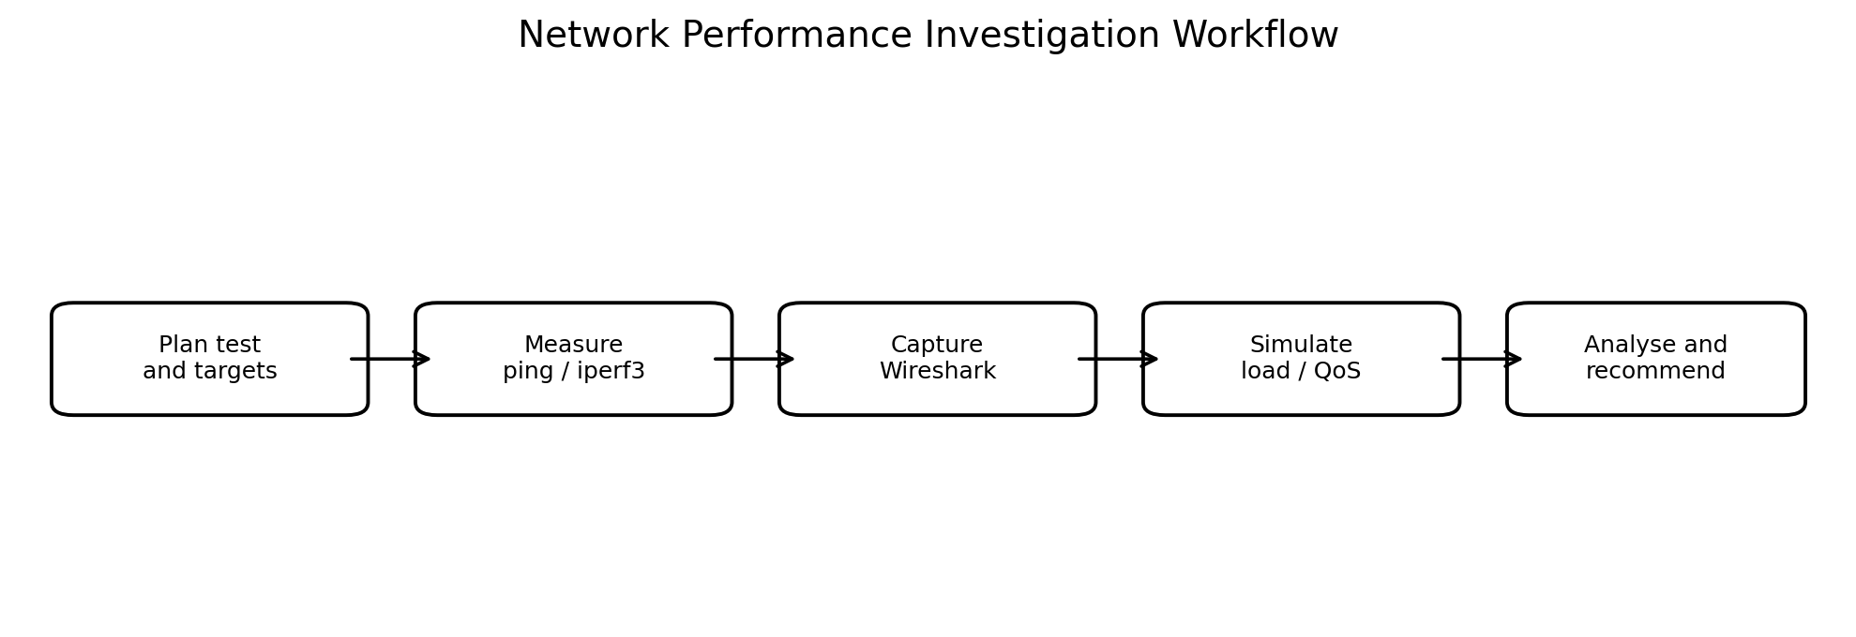
Use the workflow to organise measurement, packet capture, simulation and evidence-based recommendations.

CONCLUSION
Network performance must be evaluated using multiple metrics rather than bandwidth alone. Propagation delay, TCP window size, queueing, packet loss and application protocol overhead all affect user experience. CDN distribution, peer-to-peer delivery and regional servers can reduce origin load and distance; QoS protects real-time voice/video; and TLS, correctly ordered firewalls, SYN cookies, rate limiting and upstream DDoS protection improve security. The final design should be validated using the student’s own measurements and simulator evidence.

