

Name:Ch. Venkata sai mohith
Reg no:1925260287
Course:UBA0705-computer networks
Faculty:Dr.kumaran.G

ASSIGNMENT 1 – CO1

1. Task 1 – Size the Traffic Before Choosing Anything (4 marks)

1.1 Given data
Source | Quantity | Traffic
Robot controllers | 40 | 200-byte command every 2 ms each
Vibration sensors | 600 | 50 bytes per second each
CCTV cameras | 24 | 4 Mbps each, continuous
Office users | 150 | 2 Mbps each at peak, 10 % active at a time

1.2 Model and hand calculation
Every source is converted to bits per second with rate = number × bytes × 8 ÷ period. The office load uses the active fraction: 150 × 2 Mbps × 0.10.
Source | Working | Mbps / line | Share
Robot controllers | 40 × 200 B × 8 ÷ 0.002 s = 32,000,000 bit/s | 32.00 | 20.2 %
Vibration sensors | 600 × 50 B × 8 ÷ 1 s = 240,000 bit/s | 0.24 | 0.2 %
CCTV cameras | 24 × 4 Mbps | 96.00 | 60.7 %
Office users | 150 × 2 Mbps × 0.10 | 30.00 | 19.0 %
One line total | 32 + 0.24 + 96 + 30 | 158.24 | 100 %
Plant (8 lines) | 8 × 158.24 | 1,265.92 | –

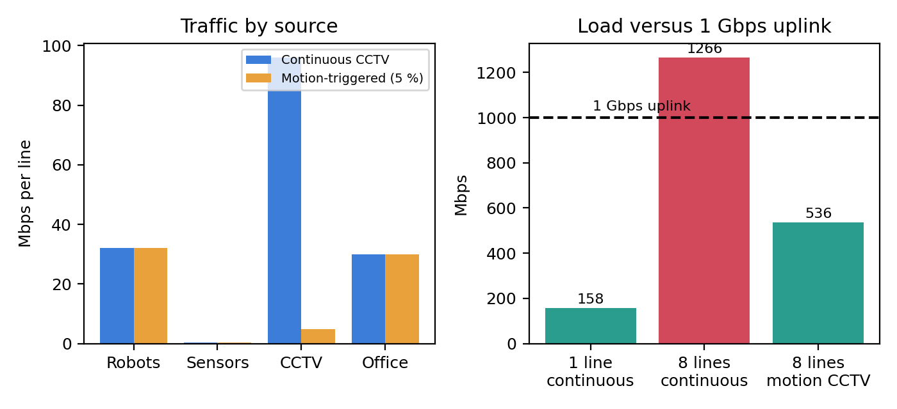
Figure 1.1 – Traffic by source (left) and load against a 1 Gbps uplink (right)

1.3 Answers to the questions
(a) Total traffic. One line carries 158.24 Mbps; eight lines carry 1,265.92 Mbps (≈ 1.27 Gbps). Counting the 38 bytes of Ethernet overhead on each robot command (238 B instead of 200 B) the robot figure becomes 38.08 Mbps, so the line total is about 164 Mbps.
(b) Most data versus strictest delay. The CCTV cameras send the most data (96 Mbps, 60.7 %). The robot controllers have the strictest delay requirement (10 ms). They are not the same source: the heaviest traffic is the most delay-tolerant, and the lightest critical traffic is the most delay-sensitive. This is why a design based only on bandwidth is wrong.
(c) Is one 1 Gbps uplink enough? For one line, yes: 158.24 Mbps is only 15.8 % of 1 Gbps. For the plant, no: 1,265.92 Mbps is 126.6 % of the link. Even if the 150 office users are shared by the whole plant instead of repeated per line (sensitivity check of assumption A1), the load is 8 × 128.24 + 30 = 1,055.92 Mbps, still 105.6 %. A link running above 100 % must queue or drop.
Effect of CCTV sharing the robots’ queue. At one line the queue is harmless: a 1,500-byte frame takes 12 µs at 1 Gbps and even a simultaneous burst from all 24 cameras takes only 288 µs. At plant level the excess is 265.9 Mbps; a 1 MB FIFO buffer fills in 1 MB × 8 ÷ 265.9 Mbps = 30.1 ms. A full 1 MB buffer adds 1 MB × 8 ÷ 1 Gbps = 8 ms of waiting to every frame, and a 2 MB buffer adds 16 ms – already beyond the robots’ 10 ms deadline. After that the switch drops frames. Robot commands queue behind video, so they are delayed or lost. The remedy is separate priority queues (802.1p/DSCP), not only a faster link.

1.4 Ranking by harm of a 100 ms delay
Rank | Traffic | Effect of 100 ms | Reason
1 (worst) | Robot commands | 10 × the 10 ms deadline; 50 commands (100 ms ÷ 2 ms) arrive stale | Machines move on old instructions: collisions, scrap, emergency stops
2 | Vibration sensors | 10 % of the 1 s reporting period | Trend analysis unaffected, but a trip or alarm arrives late
3 | CCTV | Hidden by a 100–500 ms play-out buffer | Live view slightly late; recording not damaged
4 (least) | Office ERP / e-mail | Below human perception for transactions | People notice delay only above about 150–400 ms

and the heaviest source is now the robot controllers (32 Mbps), almost equal to the office (30 Mbps). The trade-off: clips are bursty, so during an incident several cameras start together (24 × 4 = 96 Mbps per line again), local storage is needed, and live viewing is lost. Priority queueing is still required.
Decision (Task 1). A 1 Gbps uplink is acceptable for one line but not for eight (126.6 %). Use a 10 Gbps uplink (12.7 % loaded), place robot traffic in a strict-priority queue, and consider motion-triggered recording to cut CCTV traffic by 95 %.

2. Task 2 – Count the Domains in the Contractor’s Drawing (3 marks)

2.1 Given and model
The drawing has three hubs with 8 PCs each; the three hubs connect to one 24-port switch; the switch connects to router interface G0/0; router interface G0/1 connects to a second switch with 12 IP phones. Rules: a hub repeats bits to all ports, so everything joined by hubs is one collision domain; every switch port is its own collision domain; a router interface ends a broadcast domain.
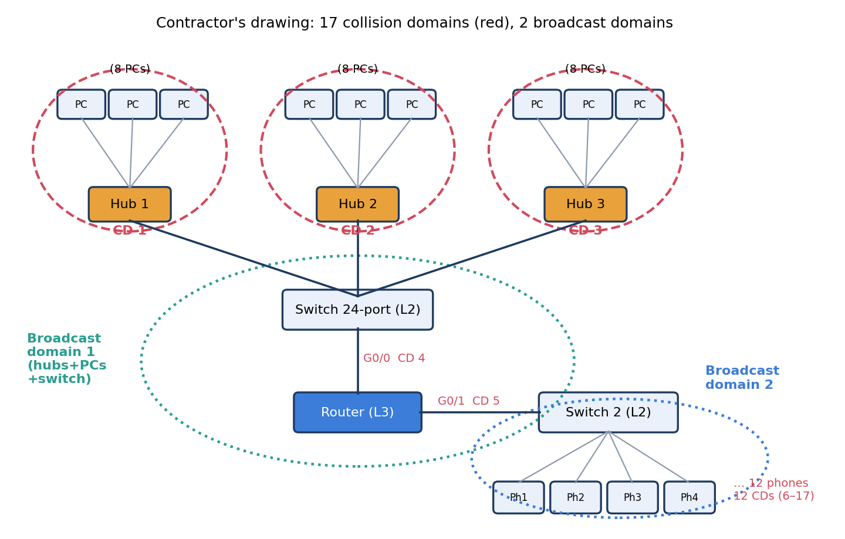
Figure 2.1 – Marked drawing: collision domains (red dashed) and broadcast domains (dotted)

2.2 Domain count
Collision domain | Members | Count
Hub 1, 2, 3 segments | 8 PCs + hub + the uplink to the 24-port switch (each hub is one shared wire) | 3
Switch to router G0/0 | One point-to-point link | 1
Router G0/1 to Switch 2 | One point-to-point link | 1
Switch 2 to each IP phone | 12 separate switch ports | 12
Total collision domains | 3 + 1 + 1 + 12 | 17

Broadcast domains = 2. Hubs and the 24-port switch do not stop broadcasts, so the 24 PCs and the G0/0 side form broadcast domain 1; the router blocks broadcasts, so Switch 2 and its 12 phones on G0/1 form broadcast domain 2. The program in Code 2 reproduces both counts with a union-find model of the drawing.

2.3 OSI layer of each device
Device | OSI layer | What it looks at | Domain effect
Hub | 1 Physical | Electrical signal only | Joins everything into one collision and one broadcast domain
Switch | 2 Data link | Destination MAC address | Splits collision domains per port; keeps one broadcast domain
Router | 3 Network | Destination IP address | Splits both collision and broadcast domains
IP phone / PC | 1–7 (end host) | All layers | Source and sink of data

Why a hub cannot stop collisions. A hub has no memory and does not read frames; it copies every incoming bit to all other ports. Two PCs that transmit at the same time therefore corrupt each other’s signal on the whole segment, and CSMA/CD must detect and repeat the transmission. A switch buffers a complete frame, reads the destination MAC address and forwards it only to one port, so frames from different ports no longer share a wire.

2.4 Point-to-point and multipoint connections
Connection | Type | Reason
Switch – router G0/0 and router G0/1 – Switch 2 | Point-to-point | Exactly two devices share the link
Switch 2 – each IP phone | Point-to-point | Dedicated switch port
Hub – 24-port switch uplink | Point-to-point cable, but shared logically | The wire has two ends, yet the hub merges it into a shared segment
PCs on a hub | Multipoint (shared medium) | Eight stations and the uplink share one collision domain

2.5 Standards and standards bodies
Technology | Standard | Body | What it defines
Ethernet | IEEE 802.3 | IEEE | Frame format, CSMA/CD, copper and fibre PHYs
Wi-Fi | IEEE 802.11 (Wi-Fi 6 = 802.11ax) | IEEE; certified by the Wi-Fi Alliance | Wireless MAC and PHY
IPv4 | RFC 791 | IETF | Datagram format and addressing
OSI model | ISO/IEC 7498 | ISO | Seven-layer reference model
5G | 3GPP Release 15 onward; IMT-2020 | 3GPP; ITU | Radio access, core network, eMBB/URLLC/mMTC

Why buy only standard-compliant equipment. Standards guarantee that devices from different vendors interoperate, so the plant is not locked to one supplier; they allow spare parts and later expansion to five plants; certified products have been tested for interference and safety; and security fixes and protocol updates arrive for everyone. Non-standard devices can fail silently when a new line is added.
R1# show ip interface brief

2.6 Alternative concept – replace the hubs by three unmanaged switches
With switches, every link is its own collision domain: 3 × (8 PC links + 1 uplink) = 27, plus 1 + 1 + 12 = 41 collision domains (verified by the program). The broadcast domains stay at 2.
Effect | Fixed by switches? | Explanation
Collisions on PC segments | Yes | Each port is a dedicated full-duplex link; CSMA/CD is no longer needed
Bandwidth per PC | Yes | 100 Mbps or 1 Gbps per port instead of a shared 100 Mbps for 8 PCs
Broadcast storms and ARP traffic | No | All 24 PCs still share one broadcast domain
Security and segmentation | No | Unmanaged switches have no VLANs, ACLs, port security or QoS
Robot priority | No | No 802.1p queues; video can still delay commands

Decision (Task 2). 17 collision domains and 2 broadcast domains in the drawing. Replace the hubs by managed switches (41 collision domains) and add VLANs so that robots, sensors, CCTV and office are separate broadcast domains.

3. Task 3 – Read a Captured Frame Layer by Layer (4 marks)

3.1 The capture
Captured robot command
Ethernet II Dst: 00:1d:9c:c7:b0:41 Src: 3c:52:82:4e:11:07 Type: 0x0800
IPv4 Src: 10.10.1.25 Dst: 10.10.9.4 TTL: 61 Protocol: 6 (TCP)
TCP Src Port: 51522 Dst Port: 502 (Modbus) Seq: 1201 Ack: 88 Len: 12
Data 12 bytes (Modbus write-register command)

3.2 Layer and protocol data unit
Capture line | OSI layer | PDU | Meaning of the fields
Ethernet II | 2 Data link | Frame | Source and destination MAC; type 0x0800 means IPv4 follows; FCS at the end
IPv4 | 3 Network | Packet | 10.10.1.25 to 10.10.9.4; TTL 61; protocol 6 means TCP
TCP | 4 Transport | Segment | Port 51522 (client, random) to port 502 (Modbus server); Seq 1201, Ack 88, 12 bytes
Modbus data | 7 Application | Data / message | Write-register command; layers 5 and 6 add no header in Modbus/TCP
Bits on the cable | 1 Physical | Bit | Preamble, line coding, signal

Note on the MAC addresses. The destination MAC 00:1d:9c:c7:b0:41 is the next hop (the default gateway), not the server, because 10.10.9.4 is in another subnet. The IP addresses stay the same end to end; the MAC addresses change at every router.

3.3 Routers crossed
The controller starts with TTL 64 and each router subtracts 1. The captured TTL is 61, so the packet crossed 64 − 61 = 3 routers.

3.4 Bytes on the wire and overhead
Item | Robot command | Camera packet
Application data | 12 B | 1,400 B
TCP header | 20 B | 20 B
IPv4 header | 20 B | 20 B
Ethernet header | 14 B | 14 B
FCS | 4 B | 4 B
Frame total | 70 B (above the 64 B minimum, no padding) | 1,458 B
Overhead (58 B) | 58 ÷ 70 = 82.86 % | 58 ÷ 1,458 = 3.98 %
With preamble + gap (+20 B) | 90 B; useful data is 13.3 % | 1,478 B; useful data is 94.7 %

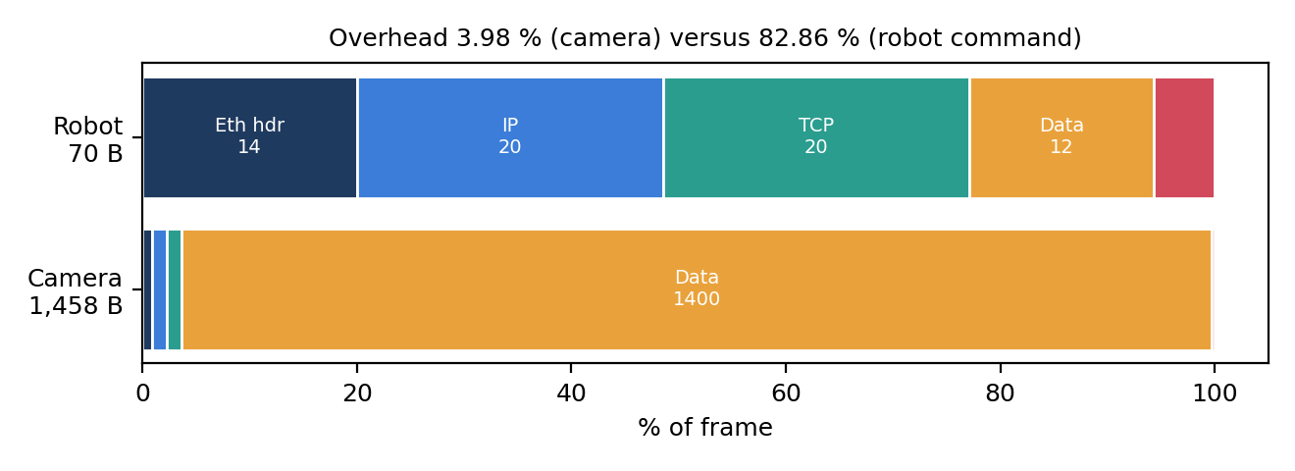
Figure 3.1 – Composition of a robot command frame and a camera frame
Meaning for small commands. For a 12-byte command, 83 out of every 100 bytes are headers; for a camera packet only 4 are. A link’s bit rate therefore says little about how many robot commands it can carry; plan capacity with frames per second, and avoid adding more headers (tunnels, extra VLAN tags) to control traffic. Task 1 uses payload sizes; with 238 B on the wire the robot load is 38.08 Mbps.

3.5 Which layer handles which fault
Fault | Layer | What happens
(a) Wrong MAC address | 2 Data link | The NIC or switch does not accept or forward the frame; ARP cannot resolve the address
(b) TTL reaches 0 | 3 Network | The router discards the packet and returns ICMP Time Exceeded
(c) Destination port closed | 4 Transport | The host answers with a TCP RST (or ICMP port unreachable for UDP)

3.6 TCP/IP model mapped onto the seven OSI layers
TCP/IP layer | OSI layers | Examples in this capture
Application | 7, 6, 5 | Modbus
Transport | 4 | TCP
Internet | 3 | IPv4, ICMP
Network access (link) | 2, 1 | Ethernet II, cable

camera packet: data=1400 B frame=1458 B overhead=58 B = 3.98 % (+20 B preamble/IFG -> 1478 B on the wire)
raw-Ethernet frame: nominal 30 B, padded to 64 B ; saved nominal=40 B, real=6 B
TCP/IP: 138,889 commands/s on 100 Mbps (frame 70 B + 20 B preamble/IFG)
raw L2: 148,810 commands/s on 100 Mbps (frame 64 B + 20 B preamble/IFG)

3.7 Alternative concept – raw Ethernet (EtherType 0x8892), no IP and no TCP
Without IP and TCP the frame is 14 + 12 + 4 = 30 bytes, so 40 bytes are saved on paper. But Ethernet requires at least 64 bytes, so the frame is padded to 64 B and the real saving is only 6 bytes (70 B → 64 B). On a 100 Mbps link, counting preamble and gap, the capacity rises from 100 Mbps ÷ (90 B × 8) = 138,889 to 100 Mbps ÷ (84 B × 8) = 148,810 commands per second (+7.1 %).
What is lost by giving up IP: routing (a raw Layer-2 frame cannot cross a router, so it can never reach the head office or another subnet); TCP’s ordering, acknowledgement and retransmission (the application must handle loss); IP-based firewalls, access lists and addressing; and remote diagnostics with ping and traceroute. Raw Ethernet is acceptable inside one robot cell, not across the plant.
Decision (Task 3). Control traffic is dominated by headers (82.86 %), so protect it by priority and not by bigger links. Use raw Layer-2 industrial protocols only inside a cell; keep IP between cells and towards the head office.

4. Task 4 – Choose a Medium for Each Run (There Is a Trap) (4 marks)

4.1 Medium for each run
Run | Length | Copper limit (100 m) | Chosen medium | Deciding reason
(a) Robot cell next to arc welders | 85 m | Within | Cat6A S/FTP (shielded, grounded) | Welding EMI; shield restores SNR; inside 100 m; PoE possible
(b) Office floor to shop-floor switch | 140 m | Exceeds | Multimode fibre (OM4) | The trap: only 140 m, but beyond 100 m; fibre is also immune to welder noise and to ground-potential differences
(c) Shop floor to data centre | 550 m | Exceeds | Single-mode fibre (OS2) | Multimode 10 GBASE-SR reaches only 300–400 m; single-mode gives 10 G headroom (10GBASE-LR 10 km)
(d) Plant to head office | 400 km | Exceeds | Leased line / carrier optical (WDM) over single-mode fibre | Fibre loses about 0.2 dB/km: 400 km = 80 dB, so amplifiers every 80 km are needed; only a carrier can provide them

Which run cannot use copper Ethernet at all? Runs (b), (c) and (d) all exceed the 100 m limit. Run (d) is obvious, but the run that catches careless designers is (b): 140 m looks like ordinary office cabling, yet a 100BASE-TX/1000BASE-T channel stops at 100 m because signal attenuation and the round-trip timing and crosstalk budget are specified for that length.

4.2 Shannon capacity
Shannon’s law: C = B log₂(1 + SNR), with SNR as a ratio (SNR = 10^(dB/10)).
Case | B | SNR | Working | Capacity
Cable, quiet | 250 MHz | 40 dB = 10,000 | 250×10⁶ × log₂(10,001) = 250×10⁶ × 13.288 | 3.322 Gbps
Cable near welders | 250 MHz | 15 dB = 31.62 | 250×10⁶ × log₂(32.62) = 250×10⁶ × 5.027 | 1.257 Gbps
Same, with 6 dB margin | 250 MHz | 9 dB = 7.94 | 250×10⁶ × log₂(8.94) = 250×10⁶ × 3.162 | 790 Mbps

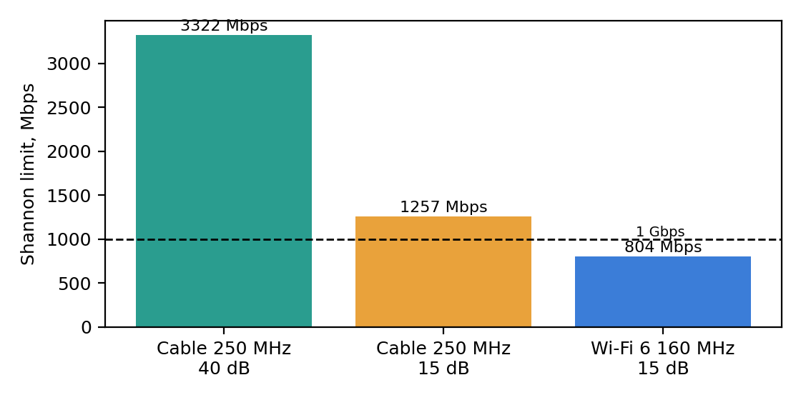
Figure 4.1 – Shannon limits for the cable and for Wi-Fi 6
Meaning for the robot cell. Noise cuts the theoretical capacity by 62.2 % (3.322 → 1.257 Gbps). The limit is still above 1 Gbps, but once a realistic 6 dB margin is applied it falls to 790 Mbps, below the 1 Gbps port speed. Unshielded cable would therefore suffer errors, CRC drops and retransmissions, which add delay that a 10 ms control loop cannot afford. Shielding (S/FTP) recovers SNR instead of buying speed. The robot cell needs only 32 Mbps per line, so the point is reliability and latency, not bandwidth.
Why the measured speed is always below the Shannon limit. Shannon is an upper bound for ideal coding and Gaussian noise. Real links use finite modulation and error-correcting codes that sit 1–3 dB from the bound, keep a safety margin, suffer crosstalk and impulse noise (welders), and spend capacity on preamble, headers, gaps and retransmissions.

4.3 Telephone line: SNR needed for 56 kbps
C = B log₂(1 + SNR) gives 56,000 = 3,100 × log₂(1 + SNR), so log₂(1 + SNR) = 18.065 and SNR = 2^18.065 − 1 = 274,132, that is 10 log₁₀(274,132) = 54.4 dB. Real analogue telephone lines reach only about 30–38 dB, so a 56 kbps rate is not realistic over a purely analogue path; the 56k modems worked only because one end was digital and the rate was limited by the 8 kHz sampling of the network, not by Shannon alone.

4.4 Alternative concept – Wi-Fi 6 for the robot cell
With 160 MHz at 15 dB the limit is 160×10⁶ × 5.027 = 804 Mbps, far above the 32 Mbps needed, so capacity is not the problem. Timing is. Wi-Fi 6 uses CSMA/CA with random back-off, so the delay of a single command is not bounded; welding noise raises retransmissions; and any hand-over costs tens to hundreds of milliseconds (Task 5). Wi-Fi 6 features such as OFDMA and Target Wake Time reduce but do not remove contention. A wireless link is acceptable for monitoring but not for 10 ms safety-relevant robot commands in a fixed cell, where a shielded cable is cheaper and deterministic.
Decision (Task 4). (a) Cat6A S/FTP, (b) multimode fibre OM4, (c) single-mode fibre OS2, (d) leased line over carrier single-mode fibre. Run (b) is the trap. Noise reduces the cable limit from 3.322 to 1.257 Gbps, so the robot cell must be shielded and kept on cable.

5. Task 5 – Wi-Fi 6 or 5G for Moving Equipment? (4 marks)

5.1 Given data and model
An AGV moves at 2 m/s along a 1.2 km route, so one trip takes 1,200 ÷ 2 = 600 s. Wi-Fi access points are 30 m apart (hand-over 150 ms); a 5G cell covers 300 m (hand-over 20 ms). Commands have a 10 ms deadline. Number of cells = route ÷ spacing; hand-overs = cells − 1 (the AGV starts inside the first cell); unreachable time = hand-overs × hand-over time.
Quantity | Wi-Fi 6 (150 ms) | Wi-Fi 6 + 802.11r (assume 30 ms) | Private 5G (20 ms)
Cells on the route | 1,200 ÷ 30 = 40 | 40 | 1,200 ÷ 300 = 4
Hand-overs per trip | 39 | 39 | 3
Unreachable time per trip | 39 × 0.150 = 5.85 s | 39 × 0.030 = 1.17 s | 3 × 0.020 = 0.06 s
Share of the 600 s trip | 0.975 % | 0.195 % | 0.010 %
Commands missed (÷ 10 ms) | 585 | 117 | 6
Distance travelled blind per hand-over | 2 × 0.150 = 0.30 m | 0.06 m | 0.04 m
Time between hand-overs | 15 s | 15 s | 150 s

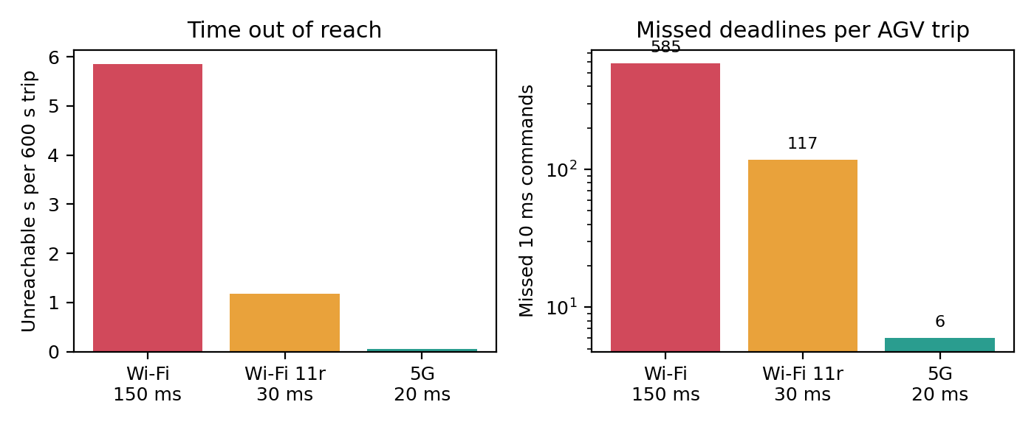
Figure 5.1 – Time out of reach and missed 10 ms commands per AGV trip
Every Wi-Fi hand-over silences the AGV for 15 command periods and lets it travel 0.30 m without instructions; 5G reduces that to two periods and 4 cm. Even 5G is not perfect: 3 hand-overs still lose about 6 commands per trip unless the radio keeps two links at once (dual connectivity, Task 12).

5.2 Which 5G service type does each traffic need?
Traffic | 5G service | Why
AGV control and status | URLLC (ultra-reliable low-latency) | 10 ms deadline, almost no loss; small packets every 10 ms
CCTV cameras | eMBB (enhanced mobile broadband) | High, steady bit rate (96 Mbps per line), delay-tolerant
Vibration / temperature sensors | mMTC (massive machine-type communication) | Many devices, tiny messages (50 B/s), long battery life

5.3 Where Bluetooth, Zigbee or LoRa beat Wi-Fi and 5G
Technology | Best use in the plant | Reason
Bluetooth Low Energy | Tool tags, handheld scanners, operator badges, short-range pairing (up to about 10–30 m) | Very low power and cost, no infrastructure needed for pairing
Zigbee (IEEE 802.15.4) | Mesh of battery sensors, lighting and valve status inside crowded machine areas | Low data rate (250 kbps), self-healing mesh, years on a battery
LoRa / LoRaWAN | Slow sensors spread over kilometres (tank levels, yard gates, outbuildings) | Range of kilometres, a few kbps, very long battery life

5.4 Could Wi-Fi 6 with fast roaming (802.11r) meet the deadline?
802.11r (fast BSS transition) removes the full re-authentication and typically brings the hand-over to about 20–50 ms. That is better but still above 10 ms: even at 30 ms an AGV misses 117 command slots per trip. It could meet the deadline only if the hand-over were below 10 ms, which cannot be guaranteed. What remains risky: the client, not the network, decides when to roam; contention and random back-off make delay unbounded; 2.4/5 GHz interference and welder noise raise retransmissions; many AGVs roaming at once load the controller; and scanning for the next AP can leave gaps. Fast roaming is a useful improvement for slow or non-critical vehicles, not a guarantee.

5.5 Alternative concept – LoRaWAN for the 600 sensors
The sensors generate 600 × 50 B × 8 = 240,000 bit/s = 240 kbps. One gateway offers about 5 kbps, so demand is 48 times the capacity and one gateway can serve only 5,000 ÷ 400 = 12 sensors at 50 B/s (about 50 gateways would be needed, and LoRa duty-cycle limits make it worse). LoRa is therefore unsuitable for 50-byte-per-second vibration sensors.
If a sensor sends 50 bytes once a minute (6.67 bit/s) one gateway serves 5,000 ÷ 6.67 = 750 sensors. Decision: the 600 vibration sensors (high rate, may trigger protection) stay on Wi-Fi 6 or wired Ethernet; slow temperature, level and environment sensors (one reading per minute or slower) can move to LoRaWAN, which frees Wi-Fi airtime and battery.
Decision (Task 5). Use private 5G for AGVs: 3 hand-overs and 0.06 s of silence per trip against 39 hand-overs and 5.85 s for Wi-Fi. Map AGVs → URLLC, cameras → eMBB, sensors → mMTC; keep Bluetooth, Zigbee and LoRa for low-rate niches.

6. Task 6 – Interpret an Ethernet Port Report (4 marks)

6.1 The report
Interface report of the slow shop-floor PC
Speed: 100Mb/s Duplex: Half Auto-negotiation: off
Link detected: yes rx_errors: 2381 late_collisions: 412 crc_errors: 1907

6.2 What the counters mean
Counter | Meaning | Share of rx_errors
crc_errors 1,907 | The frame check sequence (CRC-32) of a received frame did not match: the frame was damaged by noise or cut short by a collision | 80.1 %
late_collisions 412 | A collision detected after the first 512 bit times (64 bytes). On a correct half-duplex link collisions occur only inside that window, so a late collision means the other end is not following CSMA/CD (or the cable is too long) | 17.3 %
other errors | Runts, alignment and so on | 2.6 % (62)

What the combination suggests. Late collisions plus many CRC errors on a link that shows “link detected” is the classic signature of a duplex mismatch: one end is half-duplex (waits and detects collisions), the other transmits full duplex whenever it likes. The full-duplex side never defers, so frames hit the half-duplex side in the middle of its own transmission, producing late collisions and damaged frames.

6.3 Likely cause and the configuration change
The PC has auto-negotiation switched off and is forced to 100 Mb/s half duplex, while the gigabit switch port is set to auto and runs full duplex. (When one end is forced and the other negotiates, the negotiating end can see the speed but cannot learn the duplex, so the two ends easily end up different. Confirm the switch end with the switch’s port-status command.) Gigabit Ethernet in fact requires auto-negotiation (IEEE 802.3ab), so forcing is wrong for 1000BASE-T.
Get-NetAdapter | Format-List Name, LinkSpeed, FullDuplex

Check after the fix | Expected value
Speed / Duplex / Auto-negotiation | 1000 Mb/s, Full, on
late_collisions | 0 and not rising (full duplex has no collisions)
crc_errors | Stops rising; any remaining errors point to the cable or noise

6.4 Addresses
01:00:5e:0a:01:02 – the least-significant bit of the first byte (0x01) is 1, so it is a group (multicast) address, not a single device. The prefix 01:00:5e is reserved for IPv4 multicast; the last 23 bits (0a:01:02) map to 224.10.1.2 (32 different multicast groups share each such MAC address).
3c:52:82:4e:11:07 – the first three bytes 3c:52:82 are the OUI (Organisationally Unique Identifier) assigned by the IEEE to the interface manufacturer; the last three bytes (4e:11:07) are the serial number chosen by that manufacturer. Bit 0 of 0x3c is 0, so it is a unicast address; bit 1 is 0, so it is globally administered. The vendor name can be looked up in the IEEE OUI registry.

6.5 Would jumbo frames (9,000 bytes) help the CCTV storage server?
MTU | TCP payload | Bytes on wire | Efficiency | Frame time at 1 Gbps | Frames per GB
1,500 | 1,460 | 1,538 | 94.9 % | 12.3 µs | 684,932
9,000 | 8,960 | 9,038 | 99.1 % | 72.3 µs | 111,607

Yes, for the storage server. Large sequential video writes use 6 times fewer frames, which cuts interrupts and CPU load and raises efficiency from 94.9 % to 99.1 %. What must also change: every device on the path (NICs, switch ports, any VLAN or trunk) must be set to an MTU of 9,000 (for example ip link set eth0 mtu 9000 on Linux and a jumbo-frame setting on the switch), otherwise frames are dropped or fragmented. Jumbo frames must stay inside one Layer-2 domain, because routers and WAN links normally use 1,500. Limit them to the storage VLAN: a 72 µs frame in front of a robot command would add delay, and CRC-32 protects very long frames less well.

6.6 Alternative concept – ring of industrial switches versus star
Property | Ring with fast ring recovery | Star of switches
Recovery after one cable cut | 10–500 ms depending on the protocol (MRP default 200 ms, faster profiles 30 or 10 ms; RSTP 1–5 s) | No recovery until the cable is repaired (minutes to hours); with dual uplinks and RSTP about 1–5 s
Devices that lose connection | None permanently; traffic crossing the cut is interrupted only during recovery | All devices behind the cut link (one device if an access cable, a whole cell if an uplink)
Cable and cost | One ring cable between neighbours, fewer long runs | A home run to the centre for each switch; more cable
Effect on 10 ms robot commands | A 200 ms recovery loses about 20 commands; 10 ms profiles lose about 1 | Cut device is offline for the whole repair time
Hardware | Needs ring-aware (managed) switches | Any managed switch

Decision (Task 6). The PC suffers a duplex mismatch: turn auto-negotiation on at both ends (verify 1000 Mb/s Full and zero late collisions). Use jumbo frames only on the CCTV storage VLAN. For the shop floor prefer a ring with fast recovery (30 ms or better) or redundant uplinks, because a plain star has no resilience.

7. Task 7 – Will the Receiver Notice the Error? (4 marks)

7.1 CRC of the data 1101011011 with generator 1011 (x³ + x + 1)
The generator has 4 bits, so r = 3 zeros are appended: 1101011011000. The division is modulo-2 (XOR); at every step the divisor is XORed under the leading 1 and the leading bit disappears.
Hand division, reproduced by Task07/longdiv.py
dividend 1101011011000
XOR @0 1011
0110011011000
XOR @1 1011
0011111011000
XOR @2 1011
0001001011000
XOR @3 1011
0000010011000
XOR @5 1011
0000000101000
XOR @7 1011
0000000000100
remainder 100

The remainder is 100, so the transmitted frame is 1101011011100 (data + CRC).

7.2 Is the received frame 1101011011101 accepted?
The receiver divides the whole received word by 1011. A correct frame leaves remainder 000. Here the last bit differs from the transmitted frame (101 instead of 100), and the program gives remainder 001, so the frame is rejected. A hand check: the received word equals the correct word XOR 0000000000001, and x⁰ = 1 is not divisible by x³ + x + 1, so the remainder is 001.

7.3 Burst errors and an undetectable pattern
- Longest burst certain to be detected: a CRC with r check bits detects every burst of length ≤ r. Here r = 3, so every burst up to 3 bits is detected. A burst of 4 bits escapes with probability 2^-(r-1) = 1/4, and longer bursts with probability 2^-r = 1/8.
- An error pattern it cannot detect: any error that is itself a multiple of the generator. The simplest is E = 1011 (x³ + x + 1): added to a frame, for example as 0000000001011, it leaves remainder 000 (verified by the program). The pattern is a 4-bit burst equal to the generator.
- Other undetected patterns: two single-bit errors exactly 7 bits apart (x⁷ + 1 is divisible by x³ + x + 1, because the generator is primitive of period 7); and the 3-bit odd-weight error 110001 (x⁵ + x⁴ + 1 = (x³ + x + 1)(x² + x + 1)). The generator does not contain the factor (x + 1), so it does not catch all odd-weight errors.

7.4 Two-dimensional parity
A 4 × 4 block of data with even parity on every row and column (the corner bit is the parity of the parity row):
 | c1 | c2 | c3 | c4 | Row parity
r1 | 1 | 0 | 1 | 1 | 1
r2 | 0 | 1 | 1 | 0 | 0
r3 | 1 | 1 | 0 | 0 | 0
r4 | 0 | 0 | 1 | 1 | 0
Column parity | 0 | 0 | 1 | 0 | 1

A 4-bit error pattern that two-dimensional parity misses: flip the four corners of a rectangle, for example (r1,c1), (r1,c2), (r2,c1), (r2,c2). Each affected row and each affected column now contains two flipped bits, so every parity is unchanged and the receiver sees nothing (the program confirms “passes parity check: True”). A single flipped bit, by contrast, is both detected and located by the intersection of the failing row and column.

7.5 Internet checksum of 4500, 0073, 0000, 4000 (hex)
Step | Value
Add the four words | 4500 + 0073 = 4573; 4573 + 0000 = 4573; 4573 + 4000 = 8573 (no carry out of 16 bits)
One’s complement of the sum | FFFF − 8573 = 7A8C
Check at the receiver | 8573 + 7A8C = FFFF, whose complement is 0000, so the data is accepted

7.6 Alternative concept – even-parity bit versus CRC-3
A single even-parity bit detects every error that changes an odd number of bits and misses every even number. CRC-3 (1011) detects all bursts up to 3 bits and all 2-bit errors in frames of up to 7 bits, but misses every error pattern that is a multiple of 1011 (odd or even weight). Patterns below are 13-bit error vectors (1 = flipped bit):
Error pattern | Bits flipped | Even parity | CRC-3 (1011) | Remainder
0000000000101 | 2 bits, 2 apart | Missed (even count) | Detected | 101
0000010000001 | 2 bits, 7 apart | Missed | Missed (x⁷ + 1 multiple of G) | 000
0000000001001 | 2 bits, 3 apart | Missed | Detected | 010
0000000001111 | 4 bits | Missed (even count) | Detected | 100
0000000001011 | 3 bits (pattern = G) | Detected (odd count) | Missed | 000
0000000110001 | 3 bits (x⁵ + x⁴ + 1) | Detected (odd count) | Missed | 000

Result. Parity misses all 2-bit and 4-bit patterns, so it is far weaker against bursts, which welders cause. CRC-3 catches every 2-bit pattern in a short frame and every 4-bit pattern except the generator itself, yet it is not stronger in every case: the odd-weight multiples of 1011 (three flipped bits above) are caught by parity but not by CRC-3. Real Ethernet uses the 32-bit CRC, with a far smaller undetected probability (about 2⁻³²) and detects all bursts up to 32 bits.
Decision (Task 7). CRC = 100; 1101011011101 is rejected; checksum = 0x7A8C. Use CRC-32 (Ethernet FCS) rather than parity on the noisy shop floor, accepting that no code detects every error.

8. Task 8 – Correct the Error or Ask Again? (3 marks)

8.1 Hamming check bits for a 16-bit word
Rule: 2^r ≥ m + r + 1, with m = 16. For r = 4: 16 ≥ 21 is false; for r = 5: 32 ≥ 22 is true. So 5 check bits are needed and the codeword has 21 bits. Overhead = 5 ÷ 16 = 31.25 % of the data (5 ÷ 21 = 23.8 % of the codeword).

8.2 Minimum Hamming distance of {00000, 01011, 10101, 11110}
Pair | XOR | Distance
00000 – 01011 | 01011 | 3
00000 – 10101 | 10101 | 3
00000 – 11110 | 11110 | 4
01011 – 10101 | 11110 | 4
01011 – 11110 | 10101 | 3
10101 – 11110 | 01011 | 3

The minimum distance is d = 3. A code detects d − 1 = 2 errors and corrects ⌊(d − 1)/2⌋ = 1 error.

8.3 Hamming(7,4): the word 0110011 arrives as 0110111
Bit positions 1–7 hold p1 p2 d1 p4 d2 d3 d4. Parity bit p1 covers positions 1, 3, 5, 7; p2 covers 2, 3, 6, 7; p4 covers 4, 5, 6, 7.
Position | 1 | 2 | 3 | 4 | 5 | 6 | 7
Sent 0110011 | 0 | 1 | 1 | 0 | 0 | 1 | 1
Received 0110111 | 0 | 1 | 1 | 0 | 1 | 1 | 1

Check | Positions | Received bits | Parity | Syndrome bit
c1 | 1, 3, 5, 7 | 0, 1, 1, 1 | odd (1) | 1
c2 | 2, 3, 6, 7 | 1, 1, 1, 1 | even (0) | 0
c4 | 4, 5, 6, 7 | 0, 1, 1, 1 | odd (1) | 1

Syndrome c4 c2 c1 = 101 = 5, so bit 5 is wrong. Flipping it gives the corrected codeword 0110011. The data bits (positions 3, 5, 6, 7) are 1 0 1 1, i.e. data 1011.

8.4 Two flipped bits make Hamming “correct” the wrong bit
Take 0110011 and flip bits 3 and 5: it arrives as 0100111. Syndrome: c1 (positions 1, 3, 5, 7: 0, 0, 1, 1) = 0; c2 (2, 3, 6, 7: 1, 0, 1, 1) = 1; c4 (4, 5, 6, 7: 0, 1, 1, 1) = 1. The syndrome c4 c2 c1 = 110 = 6 (equal to 3 XOR 5 = 011 XOR 101 = 110), so the decoder flips bit 6 and outputs 0100101, which differs from the sent word 0110011 in bits 3, 5 and 6. The decoded data is 0101 instead of 1011. A single-error-correcting code treats every non-zero syndrome as a single error, so a double error is mis-corrected and undetected; adding one overall parity bit (SEC-DED, as in ECC memory) would flag it.

8.5 FEC or ARQ for the noisy radio link?
Retransmission costs 40 ms (more than the 10 ms of a control loop and a large multiple of the sensor’s own air time), and a noisy radio link makes retransmissions frequent. Forward error correction costs extra bits (5 per 16-bit reading) but no waiting. Therefore FEC suits this link; ARQ suits clean links (wired LAN) where errors are rare and the round trip is short. Video streaming and 5G use FEC because retransmitting would arrive after the play-out or slot deadline, radio errors are frequent, and one-way or broadcast streams have no feedback path; 5G also adds HARQ (retransmission combined with FEC) for the rest.

8.6 Alternative concept – calculation at a bit-error rate of 1 in 1,000
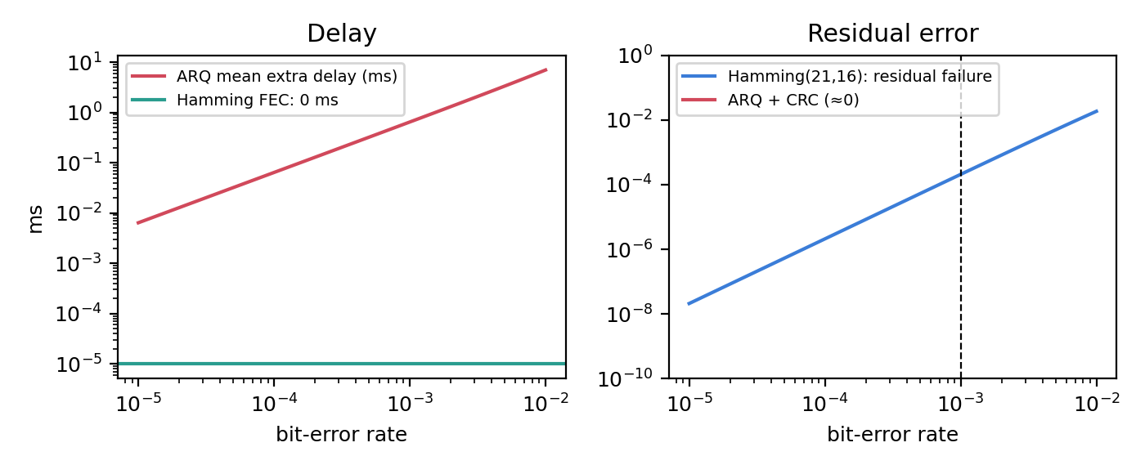
Figure 8.1 – ARQ mean extra delay and Hamming residual failure against bit-error rate
Quantity | Retransmission (ARQ, error detected) | Hamming(21,16) correction (FEC)
P(frame in error) | 1 − 0.999^16 = 0.01588 | ≥ 2 errors in 21 bits = 2.07 × 10⁻⁴ (residual failure)
Bits sent per reading | 16 × 1/(1 − 0.01588) = 16.26 | 21
Mean extra delay | 40 ms × 0.01614 = 0.645 ms (40 ms for each retransmitted reading) | 0 ms (decoding takes microseconds)
Worst-case delay | 40 ms or more (repeats on consecutive errors) | 0 ms
Weakness | Needs a reliable return path and a CRC | Two or more errors in 21 bits (about 1 reading in 4,800) are mis-corrected or missed

ARQ wins on bandwidth (16.26 versus 21 bits) and on correctness (a CRC catches nearly all errors), but it has a delay tail of 40 ms. FEC wins on bounded delay. For a sensor whose reading can be late by 40 ms and where overall accuracy matters, ARQ with a CRC is acceptable; for the noisy radio link in the task, where the retransmission time is long compared with the reading interval and the deadline, FEC (preferably SEC-DED or a stronger code with a CRC) is the better choice.
Decision (Task 8). 5 check bits (31.25 %); minimum distance 3 (detects 2, corrects 1); 0110111 is corrected to 0110011 (data 1011). Use FEC on the noisy radio link and ARQ on wired links; remember that a double error defeats plain Hamming.

9. Task 9 – How Big Must the Window Be? (4 marks)

9.1 Timing and the ratio a
Link: 400 km fibre, 1 Gbps, 1,500-byte frames (12,000 bits), signal speed 2 × 10⁸ m/s.
Quantity | Formula | Working | Result
Transmission time Tt | frame bits ÷ rate | 12,000 ÷ 10⁹ | 12 µs
Propagation time Tp | distance ÷ speed | 400,000 ÷ 2 × 10⁸ | 2 ms (one way)
Ratio a | Tp ÷ Tt | 2,000 µs ÷ 12 µs | 166.67

9.2 Stop-and-wait utilisation
The sender transmits one frame (Tt) and then waits a whole round trip (2 Tp) for the acknowledgement: U = Tt ÷ (Tt + 2Tp) = 1 ÷ (1 + 2a) = 1 ÷ 334.33 = 0.00299 = 0.299 %. On a 1,000 Mbps link that is 2.99 Mbps. The fibre sits idle 99.7 % of the time.

9.3 Smallest window and sequence-number bits
To keep the pipe full the sender must send until the first acknowledgement returns: W = 1 + 2a = 334.33, rounded up to 335 frames.
Protocol | Window rule | Bits needed for W = 335 | Why
Go-Back-N | W ≤ 2^k − 1 | 2^k ≥ 336, so k = 9 (512 numbers) | One number must remain to tell a new frame from a repeat
Selective Repeat | W ≤ 2^(k−1) | 2^(k−1) ≥ 335, so k = 10 (1,024 numbers) | Sender and receiver windows must not overlap

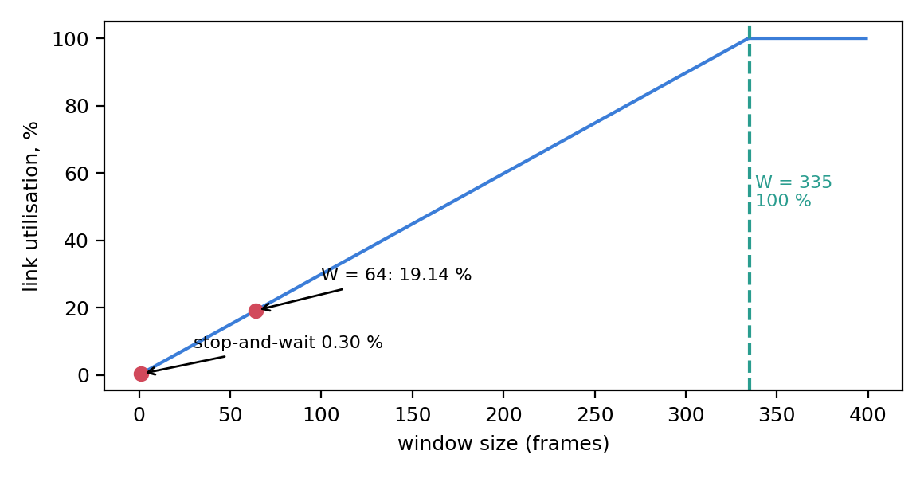
Figure 9.1 – Utilisation against window size (a = 166.67)

9.4 Which ARQ protocol resends fewer frames after one loss?
Selective Repeat resends only the lost frame (1 frame). Go-Back-N resends the lost frame and every frame sent after it, up to 335 frames. The price paid by Selective Repeat is at the receiver: it must buffer out-of-order frames, up to 335 × 1,500 B = 502.5 kB, keep a separate acknowledgement and timer for each frame, and run a more complex algorithm. A Go-Back-N receiver keeps only one frame.

9.5 How HDLC and PPP mark the start and end of a frame
Protocol | Flag | Method of keeping the flag out of the data | Example
HDLC (bit-oriented) | 01111110 (0x7E) at both ends | Bit stuffing: after five consecutive 1s the sender inserts a 0; the receiver removes it | Data 0111110 is sent as 01111100
PPP (byte-oriented) | 0x7E at both ends | Byte stuffing: 0x7E in the data is sent as 0x7D 0x5E, and 0x7D as 0x7D 0x5D | Data 7E becomes 7D 5E

An HDLC frame is Flag | Address | Control | Data | FCS | Flag; a PPP frame is Flag 7E | Address FF | Control 03 | Protocol | Data | FCS | Flag 7E. The FCS (CRC-16 or CRC-32) detects errors, so framing and error detection together give a reliable Layer-2 link.

9.6 Satellite link: window for 100 % utilisation
36,000 km, 10 Mbps, 12,000-bit frames, 2 × 10⁸ m/s: Tt = 12,000 ÷ 10⁷ = 1.2 ms; Tp = 36 × 10⁶ ÷ 2 × 10⁸ = 180 ms; a = 180 ÷ 1.2 = 150; W = 1 + 2a = 301 frames. A satellite needs a window nearly as large as the 400 km fibre link although the bit rate is 100 times lower, because the distance is 90 times longer.

9.7 Alternative concept – Selective Repeat with a window of 64
Quantity | Window 335 (calculated) | Window 64
Utilisation | 100 % | 64 ÷ 334.33 = 19.14 %
Throughput on 1 Gbps | 1,000 Mbps | 191.4 Mbps
Receiver buffer | 335 × 1,500 B = 502.5 kB | 64 × 1,500 B = 96 kB
Sequence-number bits (SR) | 10 | 7 (2^6 = 64 ≤ 2^(k−1))

A window of 64 saves memory but throws away 80.9 % of the link. Memory is cheap compared with an idle 1 Gbps leased line, so the larger window is justified.
Decision (Task 9). Use Selective Repeat (TCP with selective acknowledgements and window scaling) with a window of 335 frames (about 0.5 MB, 10-bit sequence numbers). Go-Back-N would resend up to 335 frames after each loss. Stop-and-wait would give only 2.99 Mbps.

10. Task 10 – Find Where the Delay Comes From (4 marks)
6 10.200.0.10 12.6 ms 12.4 ms 12.9 ms

10.2 Propagation delay check
Propagation over 400 km of fibre: 400,000 m ÷ 2 × 10⁸ m/s = 2.0 ms one way, 4.0 ms round trip. Traceroute times are round-trip times, and the final hop shows 12.6 ms. So propagation explains 4.0 ÷ 12.6 = 31.7 %; the other 8.6 ms is processing, queueing, serialisation and a fibre route that is longer than the straight 400 km (carrier routes are commonly 20–50 % longer, which would add another 0.8–2 ms RTT).

10.3 Reading the traceroute
Hop | Median RTT | Increment | Reading
1 10.10.1.1 | 0.6 ms | +0.6 | Plant gateway on the local LAN
2 100.64.0.1 | 3.1 ms | +2.5 | Address in 100.64.0.0/10 (RFC 6598): the ISP uses carrier-grade NAT, so the plant has no public address
3 172.31.4.9 | 4.2 ms | +1.1 | ISP aggregation; one probe at 38.2 ms is an isolated spike
4 103.21.8.17 | 11.8 ms | +7.6 | The long-haul leg: largest increase
5 * * * | – | – | No reply; not a fault (see below)
6 10.200.0.10 | 12.6 ms | +0.8 | Head-office server

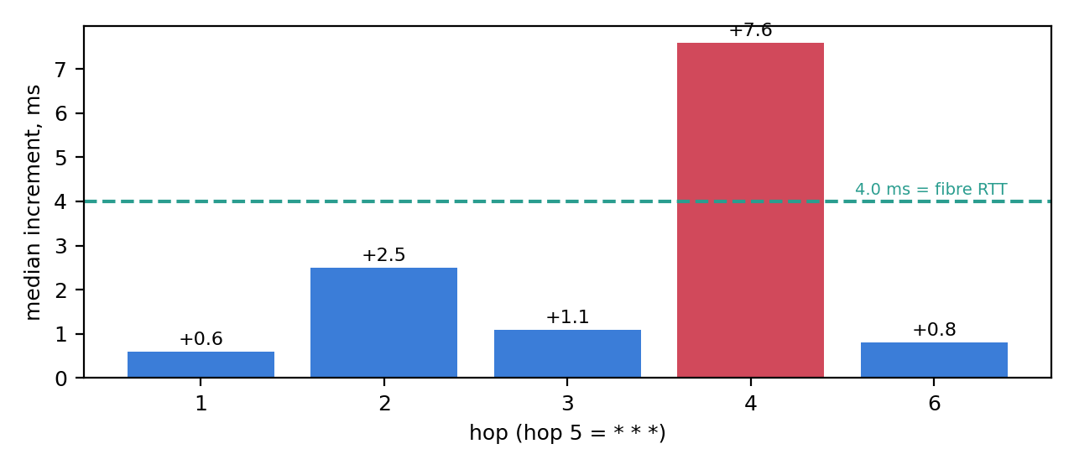
Figure 10.1 – Median delay added at each hop; hop 4 carries the long-haul link
Why hop 3 shows a single 38.2 ms value. Traceroute asks every router to generate an ICMP “time exceeded” message. Generating it is a low-priority job for the router’s control processor, which can be busy for a moment, and replies are often rate-limited. Only one of the three probes was delayed, the next hop (4) again shows 11.5–12.1 ms, and the later hops do not carry the spike. The data path was not slow, so this is not a fault.
Why hop 5 shows only stars. That router forwards the packets (hop 6 answers with 12.6 ms) but does not answer TTL-expired probes, because ICMP is filtered by a firewall or rate-limited by policy. It is not a fault. A real fault would show stars from a hop onward with no reply at the destination.
Which hop adds the most delay? Hop 4, with +7.6 ms (60 % of the total 12.6 ms). It is the WAN leg that contains the 4 ms of fibre propagation plus about 3.6 ms of equipment and route detour. Hop 2 is next with +2.5 ms. The 12.6 ms is acceptable for ERP and production data but would never meet a 10 ms one-way control deadline, so control traffic must stay inside the plant. At 1 Gbps the bandwidth-delay product is 1 Gbps × 12.6 ms = 1.575 MB, which sets the TCP window needed on this path.

10.4 Own measurement procedure (ping, traceroute, Wireshark)
The program Task10/measure.py runs ping and traceroute (tracert on Windows) against any host and saves the outputs. The Wireshark capture is taken at the same time, and the headers are identified layer by layer:
Commands
ping -c 20 <host> (Windows: ping -n 20 <host>)
traceroute <host> (Windows: tracert <host>)
# Wireshark display filters
icmp # ping request/reply and time-exceeded replies
ip.ttl <= 3 # first probes of the traceroute
frame contains "time exceeded"

Layer | Header seen for a ping | Fields to read | Header seen for traceroute (UDP)
2 Data link | Ethernet II | Src/Dst MAC, type 0x0800 | Ethernet II
3 Network | IPv4 | Src/Dst IP, TTL, protocol 1 (ICMP) | IPv4, TTL 1, 2, 3 …, protocol 17
4 Transport | none (ICMP sits on IP) | ICMP type 8 request / type 0 reply, id, sequence | UDP, destination port 33434 and up; replies are ICMP type 11

Target | Hops | Min RTT (ms) | Avg RTT (ms) | Max RTT (ms) | Loss (%) | Largest hop increment

10.5 Alternative concept – continuous monitoring versus occasional tests
Problem seen in the traceroute | SNMP counters + NetFlow (continuous) | Occasional ping / traceroute
Hop 3 spike (38.2 ms, one probe) | SNMP averages over 1–5 min and hides a single packet; NetFlow shows flows, not one probe. Not detected (correctly: it is not a fault) | Found only if run at that moment; repeated tests show it is a one-off
Hop 5 silent (* * *) | SNMP shows the router is up and its interfaces forward traffic; NetFlow shows flows crossing it. Confirms no fault | Shows the star but cannot tell silent from broken without the end-to-end result
High delay, 12.6 ms against 4 ms ideal, hop 4 +7.6 ms | Interface utilisation, queue drops and flow latency appear within one poll (30–60 s) and show whether congestion causes it | Detects only when someone runs it (minutes to hours); locates the hop but not the cause
Gradual overload (1.27 Gbps offered to 1 Gbps) | Detected early by utilisation trends and drop counters | Missed until users complain
Cost and effort | Collector, storage, licences, 30–60 s polling load | Free, no setup, but manual

Decision (Task 10). The 400 km fibre explains 4.0 ms of the 12.6 ms round trip (31.7 %). Hop 4 adds the most (+7.6 ms). Hop 3’s spike and hop 5’s stars are normal ICMP behaviour, not faults. Run both: SNMP + NetFlow for continuous trends and scheduled probes (every minute) for end-to-end delay, and request a public address or leased line because hop 2 reveals carrier-grade NAT.

11. Task 11 – Defend the Network Design (4 marks)

11.1 Recommended design
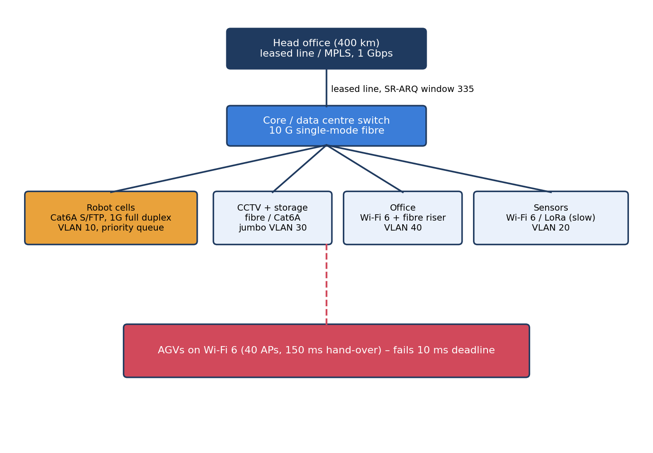
Figure 11.1 – Recommended wired-backbone design with Wi-Fi 6 (before 5G and AGVs)
Area | Medium | Wireless | Ethernet settings | Number that justifies it
Robot cells (a) | Cat6A S/FTP, 85 m | None | 1000BASE-T, auto-negotiation on, full duplex, VLAN 10, strict-priority queue | Shannon 1.257 Gbps at 15 dB; 32 Mbps load (T1, T4); robots most delay-sensitive
Office floor (b) | OM4 fibre riser, 140 m | Wi-Fi 6 access points | VLAN 40, DSCP marking, port security | 140 m > 100 m copper limit; office 30 Mbps per line (T1)
Shop floor to DC (c) | OS2 single-mode, 550 m | None | 10 G, trunk with 802.1Q, jumbo only on CCTV VLAN 30 | Plant 1,265.92 Mbps = 126.6 % of 1 G, 12.7 % of 10 G (T1)
CCTV | Cat6A / fibre to the storage server | None | VLAN 30, MTU 9000 end to end | 96 Mbps per line; jumbo gives 99.1 % efficiency (T6)
Sensors | Wired where fixed | Wi-Fi 6 for 600 vibration sensors; LoRa for slow sensors | VLAN 20 | 240 kbps needs 48 LoRa gateways (T5)
Plant to head office (d) | Leased line over carrier fibre, 1 Gbps | None | Router with QoS and VPN | RTT 12.6 ms, BDP 1.575 MB (T10)

11.2 Error control and flow control for each link
Link | Error control | Flow control | Calculation
Robot cell, 85 m, 1 Gbps | Ethernet CRC-32 detects; TCP/Modbus retransmits (LAN round trip is far below 10 ms) | Window of 2 frames | Tt = 238 B × 8 ÷ 10⁹ = 1.90 µs; Tp = 85 ÷ 2×10⁸ = 0.425 µs; a = 0.223; W = 1 + 2a = 1.45, so 2
Noisy radio sensors | FEC (Hamming with an overall parity bit) because ARQ costs 40 ms | Stop-and-wait is enough: one 50-byte reading per second | 5 check bits (31.25 %); 0 ms versus 0.645 ms mean and 40 ms worst case (T8)
Head-office WAN, 400 km | CRC-32 at Layer 2 and selective retransmission | Selective Repeat, window 335, 10-bit sequence numbers | a = 166.67; stop-and-wait would give 2.99 Mbps; GBN would resend up to 335 frames (T9)
AGV radio | 5G LDPC / polar codes with HARQ (FEC + retransmission) | 5G scheduler; dual connectivity | 6 missed slots per trip without, 0 with dual connectivity (T5, T12)

11.3 The two biggest remaining risks
- Single WAN path and carrier dependence. One leased line with 12.6 ms RTT, a carrier-grade-NAT hop and hop 4 adding 7.6 ms is a single point of failure for production data. Mitigation: a second path from another carrier (or a backup VPN) with automatic fail-over and the monitoring of Task 10.
- Wireless determinism and electrical noise. Wi-Fi 6 for sensors and offices shares the air with welders; its delay is unbounded, and a noise burst lowers SNR from 40 dB to 15 dB (capacity 3.322 → 1.257 Gbps). Mitigation: keep all robots on shielded cable, dedicate channels, and move the vehicles to 5G (Task 12).

11.4 Does the design still work for five plants?
Yes, with changes at three points. (1) Inside a plant nothing changes: 1,500 devices need at least 1,500 ÷ 254 = 6 “/24” VLANs, so keep the VLAN design instead of one broadcast domain. (2) Under assumption A10, each plant sends about 8 × 30 + 8 × 0.24 + 8 × 96 × 0.05 = 280 Mbps to the head office (28 % of a 1 Gbps line), so a 1 Gbps leased line per plant works, and the head office needs 1.40 Gbps in total, i.e. a 10 G aggregation. (3) Each WAN link keeps the window of 335 and needs the same monitoring. Local traffic (1,266 Mbps per plant, 6.33 Gbps in total) never leaves the plants.

11.5 Alternative concept – the whole plant on private 5G
Traffic (Task 1 numbers, 8 lines) | Load | Carry on 5G? | Reason
AGVs (mobile) | 4.24 Mbps each (T12) | Yes (URLLC) | Moving; only 3 hand-overs, 0.06 s per trip
Sensors (mMTC) | 1.92 Mbps | Yes | Many small devices, long battery life, easy coverage
Robot controllers | 256 Mbps | No (stay on cable) | Fixed cells, deterministic wired link is cheaper; URLLC reliability depends on RF quality near welders
CCTV | 768 Mbps | No | Exceeds the assumed 150 Mbps uplink 5.1 times
Office | 240 Mbps | No (Wi-Fi 6 / wired) | High volume, delay-tolerant, cheaper on Wi-Fi 6
Backbone and WAN | 1,266 Mbps | No | Needs fibre capacity; 5G is only the access network

Split: 5G carries about 2 Mbps of sensors plus 212 Mbps of AGV traffic (14 Mbps if the cameras are motion-triggered); cable carries more than 1.2 Gbps. A whole-plant 5G network would need about 5 times the planned uplink and would put the safety-critical robots in an RF environment next to welders.
Decision (Task 11). Recommend: S/FTP for robots, fibre for office riser, data centre and WAN access, Wi-Fi 6 for offices and sensors, 10 G backbone with VLANs and priority queues, Selective Repeat with window 335 on the WAN, FEC on noisy radio. The two risks are the single WAN path and wireless determinism near welders. The design scales to five plants with 1 Gbps per plant and a 10 G head-office aggregation.

12. Task 12 – Day-4 Design Challenge: Re-evaluate and Adapt the Design (8 marks)
Changed requirement: a private 5G network is added on the shop floor and 50 AGVs must move parts between lines and never miss a command. Options: RETAIN, MODIFY or REDESIGN the original solution of Task 11.

A. Impact analysis (2 marks)
New AGV traffic (assumption A9). Per AGV: command 200 B × 8 ÷ 10 ms = 0.16 Mbps; status 100 B × 8 ÷ 10 ms = 0.08 Mbps; on-board camera 4 Mbps. Total 4.24 Mbps per AGV, 212 Mbps for 50 AGVs.
Quantity | Original (Task 1) | With 50 AGVs | Change
Plant traffic | 1,265.92 Mbps | 1,477.92 Mbps | +212 Mbps (+16.7 %)
Load on 1 Gbps uplink | 126.6 % | 147.8 % | Already overloaded; worse
Load on 10 Gbps uplink | 12.7 % | 14.8 % | Comfortable
With motion-triggered CCTV (Task 1 alternative) | 536.32 Mbps | 748.32 Mbps | 74.8 % of 1 Gbps
5G uplink demand (AGV status + cameras) | – | 50 × 4.08 = 204 Mbps streaming; 14 Mbps with motion-triggered cameras | Budget 150 Mbps: streaming cameras exceed it

Design element | Affected? | How
Media (Task 4) | Yes | Fibre is needed from the data centre to the 5G radio units; PoE and fibre drops at four cells; the 10 G backbone is confirmed
Wireless choice (Task 5) | Yes | AGVs leave Wi-Fi 6 for private 5G (URLLC for control, eMBB for cameras); Wi-Fi 6 stays for offices and sensors
Error control (Tasks 7, 8) | Yes | Radio errors for AGVs are handled by 5G FEC and HARQ; wired links keep CRC-32 and ARQ
Flow control (Task 9) | No | WAN window of 335 unchanged; AGV traffic stays on site
Ethernet settings (Task 6) | Partly | New VLAN 50 for the 5G core and radio units; auto-negotiation unchanged

B. Test the original design with 50 moving AGVs (2 marks)
The original design serves moving vehicles with Wi-Fi 6 (40 access points, 39 hand-overs per trip, 150 ms each, Task 5). Evaluated for the fleet:
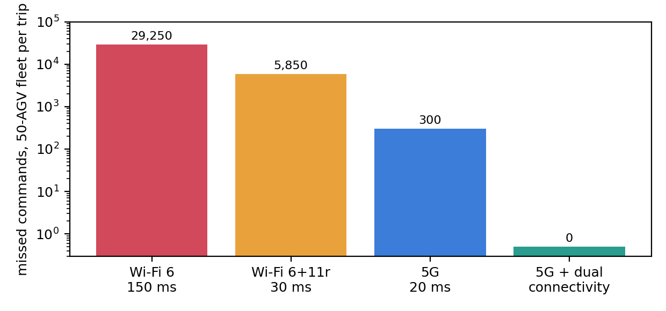
Figure 12.1 – Missed commands per trip for the 50-AGV fleet (log scale)
Option | Silent time per AGV per trip | Missed commands per AGV | Missed, 50 AGVs | AGVs unreachable on average
Original: Wi-Fi 6, 150 ms | 39 × 0.150 = 5.85 s (0.975 %) | 585 | 29,250 | 0.49
Wi-Fi 6 + 802.11r, 30 ms | 1.17 s (0.195 %) | 117 | 5,850 | 0.10
Private 5G, 20 ms | 3 × 0.020 = 0.06 s (0.010 %) | 6 | 300 | 0.01
Private 5G + dual connectivity (0 ms) | 0 s | 0 | 0 | 0

Result of the test. The original design fails the “never miss a command” requirement: each AGV loses 585 commands per trip and, on average, half an AGV in the fleet is unreachable at any moment (50 × 5.85 ÷ 600 = 0.49). Each hand-over leaves an AGV blind for 0.30 m of travel. Even fast roaming leaves 117 missed slots. In addition, 50 AGVs add 212 Mbps to the shared airtime and uplink (147.8 % of 1 Gbps without a 10 G backbone).

C. Adaptation or redesign (2 marks)
Chosen action: MODIFY. Keep the parts of the original design that still pass the tests and replace only the part that fails (AGV connectivity).
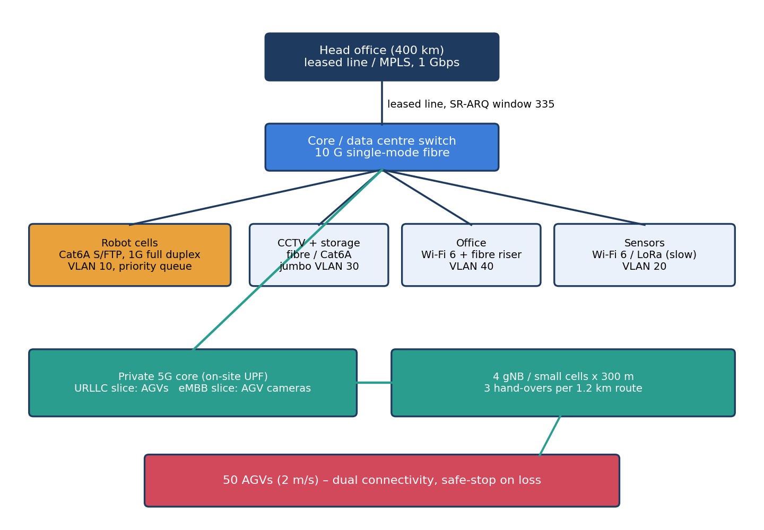
Figure 12.2 – Revised design: wired backbone retained, private 5G added for the AGVs
Part | Action | Reason from earlier tasks
Robot cells (Cat6A S/FTP) | Retain | Fixed machines; shielded cable gives deterministic delay (T4); 32 Mbps
Fibre backbone 10 G, VLANs, priority queues | Retain (add VLAN 50 for 5G) | Load 14.8 % of 10 G with AGVs (A)
Offices and sensors on Wi-Fi 6 | Retain | Delay-tolerant; 240 kbps sensors and 30 Mbps office
AGVs | Replace Wi-Fi with private 5G: URLLC for commands, eMBB for cameras (separate slices) | 3 hand-overs and 0.06 s against 39 and 5.85 s (T5)
5G coverage | 4 small cells of 300 m on the 1.2 km route, fibre fronthaul, on-site core with a local user-plane function | Keeps latency local; 12–13 AGVs per cell
Reliability | Dual connectivity and duplicated commands; AGV stops safely if two missed slots occur | Brings missed commands from 6 to 0 per trip
AGV cameras | Motion-triggered clips | Cuts uplink from 204 to 14 Mbps (budget 150)
Monitoring | SNMP and NetFlow extended to the 5G core and radio units; ping probes every minute | T10 comparison

Code 12 – Task12/task12.py

D. Evidence-based defence (2 marks)
Criterion | RETAIN (no change) | MODIFY (add 5G for AGVs) | REDESIGN (all private 5G)
AGV commands missed per trip | 585 (fleet 29,250) | 6, or 0 with dual connectivity | 6, or 0 with dual connectivity
Plant traffic and uplink | 1,477.92 Mbps; 147.8 % of 1 G | 1,477.92 Mbps on 10 G (14.8 %) | Same, but 5G access would carry CCTV 768 Mbps against a 150 Mbps uplink
Robot cells near welders | Wired, deterministic | Wired, deterministic | Radio next to arc welding: SNR risk (T4)
Security and manageability | Familiar | Two systems (wired, 5G) with clear boundaries | Single system but new skills everywhere
Cost and effort | Lowest now; failures later | 5G core, 4 small cells, spectrum or licence, training | Highest; replaces working cable
Meets “never miss a command” | No | Yes | Yes
Risk | Safety and production loss | Hand-over and core outage: mitigated by redundancy | Single technology failure domain

Trade-offs accepted. The company pays for a private 5G core, four small cells, spectrum or a licence and engineer training, and must manage two technologies. In return it reduces AGV silent time by 99 % (5.85 s → 0.06 s per trip), cuts missed commands from 585 to at most 6 per AGV, and protects the 14.8 % headroom of the 10 G backbone. Redesigning everything onto 5G would add cost and put the 768 Mbps CCTV load (5.1 times the uplink budget) and the welder-adjacent robots on radio without any gain in safety.
Final decision (Task 12). MODIFY. Keep the wired fibre backbone, shielded robot cables, VLANs and Wi-Fi 6 for offices and sensors. Add private 5G with URLLC for AGV commands and eMBB for AGV cameras, four 300 m cells and dual connectivity. This takes missed commands from 585 per AGV per trip to 6 (0 with dual connectivity), and keeps the plant at 14.8 % of a 10 G backbone.

