
POSTGRADUATE PROJECT | 7001SOM
________________________________________________________________
FairNest UK
Business Feasibility of an Evidence-Led Accommodation
Decision Platform for International Students
Coventry Pilot
Student: Venkata Saranya Manthina
Student ID: 15987220
Programme: International Business Management
Assessment: Business Plan + Artefact
Artefact: FairNest UK Decision Engine
Submission period: September 2026
Coventry University

Table of Contents
Executive Summary 2
1. Introduction 2
2. Critical Literature Review and Conceptual Framework 3
2.1 Information asymmetry, signals and trust 3
2.2 Accommodation search and the limits of more information 4
2.3 Current scholarly debate: supply, affordability and financialisation 4
2.4 Accommodation as home, wellbeing and heterogeneous preference 4
2.5 Two-sided platform economics and the trust conflict 5
2.6 Responsible choice architecture 5
2.7 Conceptual framework 5
3. Research Methodology 6
3.1 Research philosophy and design 6
3.2 Secondary-data strategy, inclusion and evidence hierarchy 6
3.3 Data extraction and competitor audit 6
3.4 Analytical procedure 7
3.5 Artefact logic and testing 7
3.6 Reliability, validity, ethics and limitations 7
4. Findings: Market, Customer, Competitor and Regulatory Analysis 8
4.1 Market context: large market, local abundance 8
4.2 Affordability is multidimensional 8
4.3 Contract comprehension and 2026 reform 8
4.4 Competitor analysis: a residual rather than absolute gap 9
4.5 Evidence provenance as product design 9
4.6 Segments and positioning 9
5. Business Model, Operations, Marketing and Sales 10
5.1 Value proposition and service design 10
5.2 Revenue architecture 11
5.3 Segmentation, positioning and go-to-market strategy 11
5.4 Operations and data supply chain 11
5.5 Legal, ethical and data governance 12
5.6 Partnerships 12
5.7 Financial logic 12
6. Implementation Plan 13
7. Evaluation, Financial Feasibility and Risk 14
7.1 Feasibility assessment 14
7.2 Risk register, controls and residual risk 15
7.3 Performance framework 15
7.4 Artefact evaluation against requirements 15
8. Artefact Design and Evidence Traceability 16
9. Conclusion and Recommendations 17
References 19
Appendices 21
Appendix A. Coventry prototype listing extract 21
Appendix B. Fit Score logic 21
Appendix C. Governance rules embedded in the artefact 21
Appendix D. Artefact screenshots 22
Appendix E. Supporting artefact files 23

Executive Summary
FairNest UK is a proposed evidence-led accommodation decision platform for international students choosing housing in the United Kingdom. The opportunity is a decision-quality problem rather than a shortage of listing websites: providers use different price units, payment schedules, contract forms and verification signals. The Coventry pilot illustrates the consequence. A Coventry University postgraduate en-suite at The Cycle Works is £154 per week and £7,700 for 50 weeks, yet the September 2026 international booking schedule requires about £2,657 on acceptance. FairNest therefore separates headline rent from total contract cost and known booking cash.
Secondary research shows a large but changing market. HESA recorded 2,863,180 UK higher-education students in 2024/25, while international enrolment fell 6% and international postgraduate-taught entrants fell 10%. Coventry-Warwick's 2023/24 student-to-bed ratio was 1.62:1 against a nationally observed 2.12:1 reference, indicating relative PBSA oversupply. The proposition is therefore based on comparability and evidence quality, not continuing demand growth or housing scarcity.
The functional Coventry Decision Engine uses public secondary data to compare cost, booking cash, commute, agreement context and evidence completeness, with adjustable user preferences and source links. It includes bounded 2026 legal prompts without offering legal advice. The commercial model keeps core comparison and safety information free while testing provider subscriptions and optional planning tools. Year 1 remains funding-negative in all modelled scenarios, so FairNest is assessed as conditionally feasible only as a controlled, capital-light pilot.

1. Introduction
For international students, accommodation is often a major pre-arrival commitment made before the local housing market is fully understood. A weekly rent does not capture contract length, bills, deposits or licence fees, guarantor rules, payment timing, transport, cancellation conditions or provider credibility. UKCISA (2026a) distinguishes university housing, private halls and private rentals because their practical and contractual features differ. The problem is therefore not a lack of listings, but the difficulty of converting fragmented information into a financially realistic and trustworthy decision.
The market is commercially relevant but should not be framed as automatic growth. HESA (2026) recorded 2.863 million UK higher-education students in 2024/25, while international enrolment fell 6% and international postgraduate-taught entrants fell 10%. FairNest is therefore justified by the value and complexity of each accommodation decision, not by an assumption of continuously rising international demand.
The proposition is illustrated by the gap between visible price and decision-relevant cash. Coventry University lists a 2026/27 postgraduate en-suite at The Cycle Works at £154 per week, or £7,700 over 50 weeks (Coventry University, 2026a). For September 2026 international bookings, the £90 advance licence fee and first third of rent are due on acceptance (Coventry University, 2026b), creating known booking cash of about £2,656.67. FairNest is designed to make both measures visible.
Coventry is selected as a demanding pilot market. Coventry City Council (2024) reported a Coventry-Warwick demand pool of 41,835 students and 25,590 PBSA beds in 2023/24. PBSA supply had grown 71% over five years against 13% demand-pool growth, producing a 1.62:1 student-to-bed ratio versus the study's nationally observed 2.12:1 reference. Knight Frank (2026) later reported another 3,600 PBSA beds under construction. The opportunity is therefore comparison quality in a relatively well-supplied market, not a scarcity narrative.
The business is defined as an independent decision-support layer rather than a letting agent, landlord, legal-advice service or conventional listing marketplace. The aim is to evaluate the commercial, operational and responsible-business feasibility of FairNest UK as a platform that standardises total contract cost, known move-in cash, contractual context, commute and source provenance for international students choosing Coventry accommodation.
The study addresses four questions: which decision and information problems international students face; which standardised cost and verification signals matter; where existing platforms and university guidance leave residual gaps; and which legal, ethical and data controls should govern a pilot. The objectives are to profile the decision context, audit current channels, specify a comparison framework, build and test a secondary-data artefact, and assess feasibility. The scope is a Coventry proof of concept using public data retrieved to 16 September 2026; it does not claim national validation or observed willingness to pay.
Table 1. Research questions, evidence focus and design implications
Research question | Evidence focus | Business / artefact implication
RQ1: decision challenges and information gaps | OfS, UKCISA and academic housing evidence | Prioritise cash, contract, commute and evidence fields
RQ2: meaningful cost and verification signals | Provider prices/payment terms and trust/signalling literature | Separate weekly, total and upfront cost; expose provenance
RQ3: current-channel gaps | Competitor feature audit | Position around a residual integration gap rather than absence of competitors
RQ4: legal, ethical and data safeguards | GOV.UK 2026 reforms, ICO and UKCISA | Classify agreement context; no individual legal advice; minimise personal data
Source: Author's synthesis of Office for Students (2026), UKCISA (2026a), Coventry University (2026a, 2026b), MHCLG (2026a, 2026b) and ICO (2026a, 2026b).

Figure 1. Coventry-Warwick student-to-bed ratio compared with the nationally observed reference.
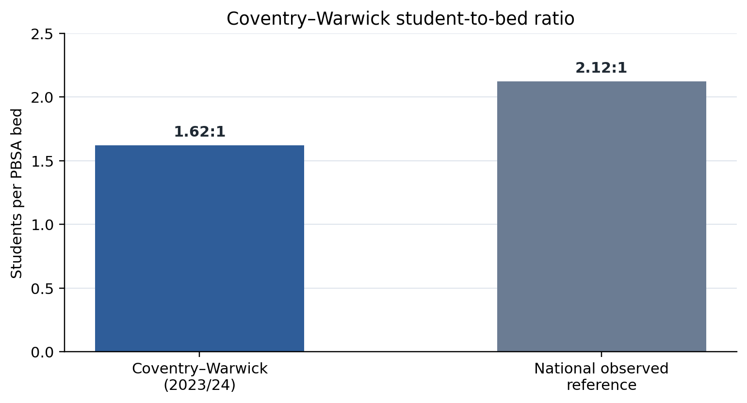
Source: Coventry City Council (2024).

2. Critical Literature Review and Conceptual Framework

2.1 Information asymmetry, signals and trust
FairNest addresses information asymmetry, but a generic claim that 'trust matters' is insufficient. Mavlanova, Benbunan-Fich and Koufaris (2012) show that online buyers rely on signals when seller quality cannot be directly inspected; their pharmacy context limits direct transfer to housing, but the distinction between verifiable and weak signals remains useful. For FairNest, a first-party page naming room, year, contract length and price is more decision-useful than an unattributed badge or promotional 'from' price.
Kim, Ferrin and Rao (2008) likewise show that trust and perceived risk shape online purchase decisions. General e-commerce evidence cannot prove that a FairNest badge would increase bookings, but it supports a narrower design principle: where users cannot inspect a service before payment, the interface should explain why a field is believed rather than merely label it 'verified'. This underpins source URLs, check dates and missing-data warnings.

2.2 Accommodation search and the limits of more information
UK-specific evidence supports the importance of displayed property attributes. Oladiran et al. (2023) found that tangible and intangible PBSA attributes affect online attractiveness, but this does not justify displaying every possible feature. FairNest therefore prioritises decision fields with financial or contractual consequences: recurring price, contract total, booking cash, commute, bills, agreement context and evidence completeness.
The evidence rules out a novelty claim based on comparison alone. Student.com already compares price, transit, room attributes, bills, facilities, security and rules (Student.com, 2026), while University Living provides filters and booking-policy information. FairNest's residual proposition is therefore cross-provider cost normalisation, agreement-aware prompts, provenance, visible missing data and user-controlled ranking.

2.3 Current scholarly debate: supply, affordability and financialisation
Recent scholarship challenges a simple supply-led interpretation of student housing. Kallin (2024), analysing student housing precarity in Edinburgh, questions whether additional PBSA can resolve an affordability crisis when new supply remains inaccessible to constrained budgets. Hunter and Makin (2025) likewise show that PBSA expansion is embedded in planning, investment and studentification. The debate is therefore not simply about bed numbers, but whether the price, form and governance of supply meet students' needs.
A related regulatory debate concerns students as a distinct housing population. Hubbard and Morris (2026) show how planning and housing regulation in England and Wales can shape where and how students live. For FairNest, this means provider type cannot be treated as a proxy for suitability: halls, PBSA and private rentals operate under different contractual contexts, while students differ in budget, household form and support needs.
These arguments sit in tension with the investment case for PBSA, which emphasises professionally managed stock and scale. Professional management may improve consistency without guaranteeing affordability, inclusion or contractual understanding. FairNest therefore compares total contract cost, known booking cash, agreement context, commute and evidence quality rather than privileging any tenure category.

2.4 Accommodation as home, wellbeing and heterogeneous preference
A purely financial tool would still be incomplete. Hoolachan, Preece and Moore's (2026) interviews with 45 students across three Scottish catchments show that student accommodation is experienced as “home” and shaped by shared living, the material environment and social inclusion. This supports giving users control over room type and location rather than assuming that minimum cost is universally optimal.
Recent international-student studies add a wellbeing dimension, although their Australian settings require caution. Corney et al. (2024), using a survey of 375 international students plus 19 focus-group participants, report that location, safety and shared accommodation can affect wellbeing and connectedness. Hastings et al. (2024) link housing insecurity, unaffordability and condition, amplified by financial stress, with anxiety about studies. These studies support mechanisms, not UK prevalence estimates.
The 2026 Office for Students research provides a current English counterpoint. Among more than 1,200 first-year students, 87% were satisfied overall, 69% said accommodation cost strongly influenced institution choice and 15% reported difficulty covering cost; 54% of West Midlands respondents considered accommodation good value. Although 93% described key contract terms as clear, some could not identify basic contractual details, including who the contract was with (Office for Students, 2026). The relevant issue is therefore comprehension, not merely access to terms.

2.5 Two-sided platform economics and the trust conflict
FairNest potentially connects students, providers and later universities. Rochet and Tirole (2003) show that two-sided platforms must attract both sides: without student traffic providers have little reason to pay, while without useful inventory students have little reason to return. A narrow Coventry pilot therefore reduces the cost of solving the coordination problem.
Provider revenue can fund a free student service but can also undermine perceived independence if payment affects ranking. Freeman's (1984) stakeholder perspective is useful because FairNest affects students, sponsors, providers, universities and advice bodies. The design response is governance: paid placement should be labelled, visually separated and excluded from the Fit Score; basic safety and evidence information remains free. Provider monetisation is acceptable only while decision logic remains auditable.

2.6 Responsible choice architecture
The interface can simplify or manipulate. FairNest uses salience only for material distinctions, such as headline rent versus move-in cash, and avoids unverifiable scarcity messages. Missing data is labelled rather than silently imputed as favourable. Unknown upfront cash receives a neutral-low prototype score instead of being treated as zero.
The Fit Score is a weighted preference function rather than a safety, quality or legal-compliance certificate. Users control weights for recurring cost, booking cash, commute and evidence completeness; protected characteristics are excluded. Changing priorities can therefore change ranking, making trade-offs explicit rather than producing a universal 'best' property.

2.7 Conceptual framework
The literature therefore supports four connected design layers: source provenance to reduce information asymmetry; separate measures of headline rent, total contract cost and booking cash; agreement classification before legal prompts; and user-controlled preferences. FairNest's differentiation lies in integrating these layers transparently rather than relying on any single novel feature.
Table 2. Critical literature synthesis and implications for FairNest design
Analytical lens | What the evidence supports | What it does not justify | FairNest response
Information asymmetry | Verifiable signals can reduce uncertainty | A generic "verified" badge as proof of safety | Source links, check dates and visible missing data
Online accommodation search | Displayed tangible/intangible attributes affect attractiveness | Adding every possible attribute | Prioritised comparable decision fields
Student experience | Housing choice includes belonging, location and shared-living trade-offs | Reducing "best" to lowest rent | User-controlled preferences
Two-sided platforms | Both student demand and provider participation matter | Pay-to-rank as a sustainable strategy | Free student core; provider-funded model independent of organic ranking
PBSA supply, affordability and regulation | Supply growth can coexist with affordability pressure and regulatory exclusion | Assuming professionally managed or additional PBSA automatically resolves student housing problems | Compare cost, contract context and evidence quality without privileging tenure type
Source: Author's synthesis of peer-reviewed studies cited in Sections 2.1-2.5, including Mavlanova et al. (2012), Oladiran et al. (2023), Kallin (2024), Hunter and Makin (2025), and Hubbard and Morris (2026).

Figure 2. Conceptual decision architecture derived from the literature and 2026 regulatory context.
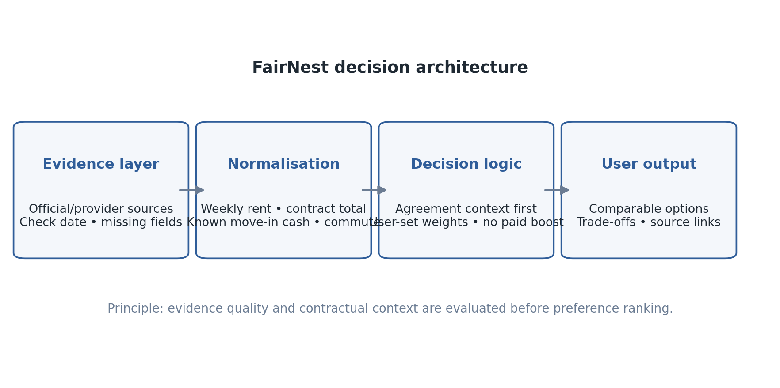
Source: Developed for this study from Sections 2 and 4.3.

3. Research Methodology

3.1 Research philosophy and design
The study adopts a pragmatic secondary-data feasibility design because the problem is applied rather than purely explanatory. It combines official statistics, regulation, peer-reviewed scholarship, first-party provider data and competitor interfaces according to their relevance to the research questions. It does not estimate causal effects or population demand. The UK regulatory system provides macro context, Coventry-Warwick defines the pilot market, provider pages supply decision fields and competitor interfaces provide the service benchmark.
The study sits under Coventry University's 7001SOM low-risk block approval P192092. No participants or personal datasets are used. Ethical controls therefore focus on accurate public-data representation, non-deceptive design, legal-boundary wording and data minimisation. The artefact is a non-transactional prototype rather than a live booking service.

3.2 Secondary-data strategy, inclusion and evidence hierarchy
Sources were prioritised in four tiers: official/regulatory and first-party institutional evidence; peer-reviewed scholarship; specialist market intelligence; and current commercial platforms used for competitor analysis. Commercial sources were not treated as substitutes for regulation or scholarship. Mutable market claims use recent material where possible, while older works are retained only for foundational constructs such as two-sided markets and online trust. Non-UK studies are used for mechanisms rather than UK prevalence claims.

3.3 Data extraction and competitor audit
The Coventry dataset records provider and room type, weekly rent, contract length and total, known booking cash, walk time, bills, agreement context, source URL and check date. Official 2026/27 Coventry University data populate university halls; selected iQ Weaver Place rooms represent private PBSA; and a University Living 'from' price is retained as an intentionally incomplete aggregator case. The dataset is a prototype sample, not a census.
Derived values use only explicit source rules. Contract total is weekly rent multiplied by published weeks where required. For Coventry University's September 2026 international schedule, known booking cash is the £90 licence fee plus one-third of annual rent. For iQ, the £125 booking fee is shown but not treated as the full pre-arrival liability because later payment obligations are not fully established on the extracted room page.
The competitor audit assesses Student.com, University Living, Rightmove, Student SpareRoom, Coventry University, UKCISA and UCAS using the same criteria: comparison capability, cost detail, location, contract guidance, trust signals, provenance, tenancy context and booking-cash normalisation. Recording existing strengths as well as gaps reduces confirmation bias.

3.4 Analytical procedure
Analysis proceeded in four stages. Official and scholarly sources were first coded into recurring themes: affordability, contract comprehension, trust, location, wellbeing, regulation and platform governance. Coventry accommodation records were then normalised so weekly price, contract total and known booking cash were not treated as interchangeable. A structured competitor matrix applied the same criteria to each channel, and scenario analysis separated sourced market facts from managerial assumptions. This produced a traceable chain from evidence to finding, business decision and artefact requirement.

3.5 Artefact logic and testing
The Decision Engine uses four component scores: recurring-cost fit, move-in-cash fit, commute fit and evidence completeness. The first three respond to user-set limits. Evidence completeness is a prototype traceability indicator based on the specificity and coverage of price, contract, payment, bills, location and provider-source information. It is not a probability that a property is safe. The overall Fit Score is the weighted mean after user weights are normalised.
Testing is deterministic rather than participant-based: budgets and weights are changed to verify logical reordering; unknown payment data cannot appear as £0; incomplete “from” listings remain visibly incomplete; legal prompts distinguish assured private tenancies from halls/PBSA; and arithmetic is checked against source data. Requirements traceability links each interface element to a finding or governance requirement.

3.6 Reliability, validity, ethics and limitations
Triangulation improves credibility but does not remove population differences or source incentives. HESA establishes market scale, OfS supplies English student-experience evidence, local council research supplies Coventry structure, and providers supply current product fields. Commercial pages change frequently, so each live field has a check date and needs revalidation before payment.
The main limitation is absence of primary behavioural and willingness-to-pay evidence. Subscription prices, conversion rates and operating costs in the financial model are managerial assumptions, not survey findings. The feasibility conclusion is therefore conditional and implementation uses evidence gates before scale. This is preferable to presenting unobserved validation as fact.
Validity is strengthened by using the most authoritative source available for each claim and retaining evidence that constrains the business case, including weaker international recruitment and Coventry's relative PBSA oversupply. Reliability is supported by a documented data schema, evidence-check dates, reproducible calculations and a source register. Ethically, the study remains low risk: no participants or personal data are used, and the prototype avoids individual legal advice, protected-characteristic ranking and undisclosed paid influence.
Table 3. Evidence hierarchy used in the feasibility study
Tier | Evidence type | Examples | Purpose
1 | Official, regulatory and institutional | HESA; OfS; GOV.UK; ICO; UKCISA; Coventry Council/University | Mutable facts, legal rules and first-party prices
2 | Peer-reviewed research | Oladiran et al.; Hoolachan et al.; Corney et al.; Hastings et al. | Theoretical mechanisms and critical interpretation
3 | Specialist market intelligence | Cushman & Wakefield; Knight Frank | Current investment and supply context, used with triangulation
4 | Live commercial platforms | Student.com; University Living; SpareRoom; Rightmove | Competitor capability and current interface evidence
Source: Developed for this study.

4. Findings: Market, Customer, Competitor and Regulatory Analysis

4.1 Market context: large market, local abundance
Two simplistic narratives are rejected. International-student demand is not guaranteed to grow: HESA (2026) reports a 6% fall in international enrolment and a 10% fall in international postgraduate-taught entrants in 2024/25. Coventry is also not a straightforward shortage market: its PBSA supply grew faster than its demand pool and its 1.62:1 student-to-bed ratio was below the nationally observed 2.12:1 benchmark (Coventry City Council, 2024). Knight Frank (2026) reports a further 3,600 PBSA beds under construction.
This changes the opportunity. FairNest should not sell a scarcity story. In a relatively well-supplied city, more options increase the need to interpret combinations of room, provider, price, contract and payment. The stronger proposition is a decision layer across existing supply.

4.2 Affordability is multidimensional
OfS evidence shows why price matters without making it the only criterion. Sixty-nine per cent of first-year respondents said accommodation cost strongly influenced institution choice; 15% struggled to cover the cost; and 54% of West Midlands respondents considered accommodation good value (Office for Students, 2026). These figures are not specific estimates for Coventry international postgraduates, but they support cost salience.
The Coventry dataset confirms that price measures answer different questions. In 2026/27, The Cycle Works en-suite is £154 per week (£7,700 total), while Bishop Gate and Godiva Place en-suites are £162 (£8,100 total) (Coventry University, 2026a). September international bookings require the £90 licence fee plus one-third of rent, producing booking-cash requirements of about £2,656.67 and £2,790. A student can therefore meet a weekly budget while failing an upfront-cash constraint.
The product implication is to decompose affordability. “Cheap”, “affordable” and “low upfront cost” are not equivalent, so FairNest displays the raw measures before any preference score.

4.3 Contract comprehension and 2026 reform
From 1 May 2026, most existing private assured shorthold tenancies in England became assured periodic tenancies and new assured private tenancies became rolling. For applicable tenancies, rent cannot be requested before the agreement is signed, holding deposits are capped at one week's rent and tenancy deposits are normally capped at five weeks below £50,000 annual rent (MHCLG, 2026a; 2026b). These rules cannot be applied indiscriminately to halls or qualifying PBSA, so FairNest classifies agreement context before displaying prompts.
Applying these rules to all student accommodation would itself be misleading. Government guidance states that different rules apply to halls, and the implementation roadmap provides an assured-tenancy-system exemption for qualifying private PBSA complying with approved student housing codes (MHCLG, 2025; 2026a). FairNest therefore classifies agreement context before displaying rule-based prompts.
OfS (2026) found that 93% of students said key terms were clear while some still misunderstood who their contract was with. The implication is commercial as well as legal: supplying contract text is not equivalent to comprehension. FairNest's role is to structure and signpost, not to provide individual legal advice.

4.4 Competitor analysis: a residual rather than absolute gap
The competitor audit narrows the market gap. Student.com already offers detailed comparison; University Living provides broad inventory and policy badges; Rightmove combines search with renting guidance; Student SpareRoom uses anti-scam controls; Coventry University provides strong first-party data for its own halls; and UKCISA and UCAS provide specialist guidance and budgeting. FairNest therefore does not claim to be the first comparison service. Its residual proposition is the combination of cross-provider normalisation, booking-cash visibility, agreement-aware prompts, source provenance, missing-data treatment and user-controlled ranking.
FairNest therefore should not claim to be the first comparison service. The residual opportunity is that the reviewed services do not visibly combine cross-provider comparison, normalised move-in cash, agreement-aware prompts, source-level provenance/freshness, explicit missing-data treatment, user-controlled ranking and a sponsor summary in one independent interface. This narrower position is supported more directly by the reviewed evidence.
Substitution risk remains high. A large marketplace could replicate interface features rapidly. The defensible capability must therefore be operational: maintain source-linked data, classify context consistently, publish transparent rules and build institutional trust. Software features alone are unlikely to provide a durable barrier to imitation.

4.5 Evidence provenance as product design
Trust is not treated as a binary badge. First-party Coventry University pages can support high evidence completeness because they identify academic year, room, price, contract length and payment schedule. An aggregator 'from' price may still aid discovery while lacking comparable contract or payment fields. FairNest retains such options but labels missing data rather than filling gaps with favourable assumptions.
This also creates a provider proposition. Providers are not asked merely to pay for visibility; they are asked to supply evidence-complete data. Better documentation can improve profile usefulness without buying ranking priority.

4.6 Segments and positioning
The initial user is an international student planning a Coventry move, particularly a postgraduate comparing options remotely, with parents/sponsors as secondary users. Supply-side customers are PBSA operators and landlords seeking qualified international enquiries. Universities and student unions are strategically attractive but later-stage partners because procurement and reputational review are slower.
The resulting launch message is precise: compare what you will pay, when you will pay it, what agreement you are entering, and where each fact came from. It is more credible than “find the cheapest verified room”.
Table 4. Key market evidence and critical interpretation
Evidence | Observed result | Interpretation for FairNest
HESA 2024/25 | 2,863,180 HE students; international enrolment -6%; international PGT entrants -10% | Large addressable context, but no automatic-growth assumption
OfS 2026 | 69% said cost strongly influenced institution choice; 15% reported cost difficulty; West Midlands 54% good value | Cost is salient, but the sample covers first-year students in England rather than international postgraduates specifically
Coventry PBSA study | 41,835 demand pool; 25,590 PBSA beds; SBR 1.62:1 vs 2.12:1 observed national reference | The local problem is not simply undersupply; comparison quality matters
Knight Frank 2026 | 3,600 PBSA beds reported under construction in Coventry | Supply intensity and competition may increase further
Source: HESA (2026); Office for Students (2026); Coventry City Council (2024); Knight Frank (2026).

Figure 3. Headline weekly rent and known booking cash for selected Coventry University 2026/27 postgraduate options.
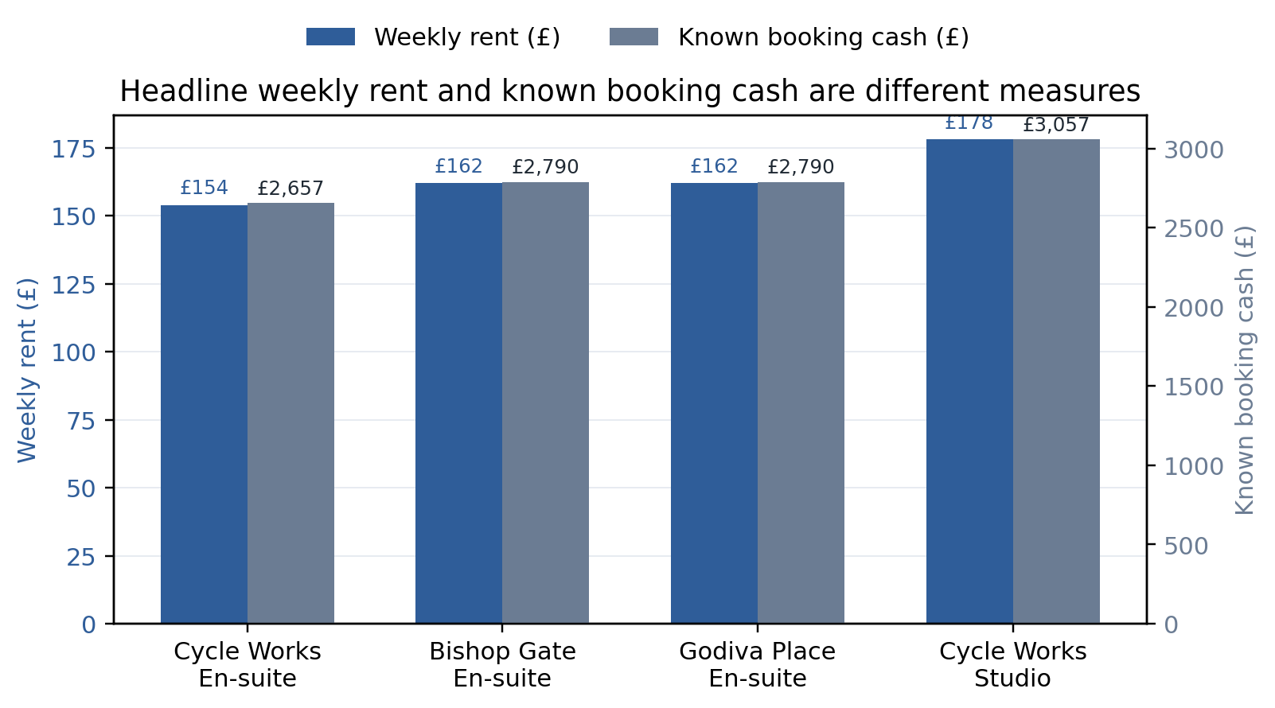
Source: Derived from Coventry University (2026a, 2026b).
Table 5. Competitor capability audit and residual market gap
Channel | Established capability | Residual issue relevant to FairNest
Student.com | Detailed cross-property comparison of price, transit, bills and room/facility fields | No visible cross-regime move-in-cash/provenance layer in the reviewed comparison
University Living | Broad inventory, booking-policy badges and international-student focus | Dynamic "from" prices can still require room, contract and payment normalisation
Rightmove | Large rental search plus current international-student renting guidance | Guidance and property comparison remain separate decision tasks
Student SpareRoom | Large classified marketplace with anti-scam controls | Not every advertiser is reference-checked; users still interpret trust/payment evidence
Coventry University | Strong first-party fees, bills, location and payment data for its own halls | Does not compare university halls with independent PBSA/private alternatives
UKCISA / UCAS | Specialist guidance and budgeting support | Not a property-level cross-provider decision engine
Source: Competitor audit using the sources cited in Section 4.4.

5. Business Model, Operations, Marketing and Sales

5.1 Value proposition and service design
FairNest is a freemium decision-support service. The free student layer includes comparable cost fields, source links, evidence status and safety/legal signposting. Charging for basic safety information could create ethical and adoption concerns. Optional student revenue therefore comes from convenience features such as exportable planning packs, saved shortlists and sponsor-ready summaries.
Users set a weekly budget, maximum move-in cash, commute threshold and room preference, then adjust weights for recurring cost, upfront cash, commute and evidence completeness. Raw fields remain visible beside the Fit Score. The interface therefore supports decision-making without pretending that one accommodation option is universally best.

5.2 Revenue architecture
The provider side is expected to fund most of the service. The Year-1 model tests a £29 monthly single verified-profile fee and a £149 Provider Pro account covering multiple listings and basic enquiry analytics. A £7.99 one-off student planning/export product is also modelled. These are managerial assumptions, not observed willingness-to-pay. Institutional licences are excluded from core Year-1 revenue because university procurement requires evidence and due diligence.
The structure responds to the two-sided platform problem identified by Rochet and Tirole (2003): students receive enough free value to build demand while providers pay for structured presence and lead-management utility. Payment cannot buy decision priority. Any later sponsored placement should be labelled, visually separated and contribute zero weight to the Fit Score.

5.3 Segmentation, positioning and go-to-market strategy
Segmentation is based on decision context rather than nationality stereotypes. The primary launch segment is pre-arrival international students comparing Coventry accommodation remotely; parents or sponsors are secondary decision influencers, while PBSA operators and landlords form the paying supply side. The positioning is deliberately narrow: FairNest is an evidence-led comparison layer that explains what a student will pay, when payment is due, which contractual context applies and where each material fact came from.
Marketing should begin with high-intent educational content rather than broad paid acquisition. Pre-arrival content can answer questions such as “How much cash do I need before booking?”, “What is the difference between weekly rent and contract total?” and “Does the 2026 rent-in-advance rule apply to halls?”. Each item leads to the free comparison tool. The trigger is practical relevance, not fear-based scam messaging.
Student acquisition should focus on Coventry international societies, course/intake communities, student-support channels and search-led content. Social media supports discovery, but the conversion destination should be the source-linked dashboard. Provider sales should be account-based: a small set of Coventry operators can be shown sample evidence-complete profiles. The pitch is to reduce repetitive pre-booking questions and improve international-student comparability, not to “pay to rank”.

5.4 Operations and data supply chain
The critical process is information governance. A provider profile moves through source capture, field extraction, first-party verification, publication with a check date, scheduled reconfirmation, and expiry/removal if material fields cannot be refreshed. Price, availability and payment terms require shorter freshness windows than facilities. User corrections create a review queue rather than automatically changing verified fields.
A lean pilot team can include a project lead, part-time verification assistant, contract technical support and periodic legal/data-protection review. The key resource is a maintainable evidence schema. Automating extraction before that schema is proven would scale errors rather than value.
Quality metrics are percentage of listings rechecked on time, percentage of material fields with first-party sources, correction turnaround, expired listings and complaints per 100 enquiries. These are more useful at pilot stage than raw page views.

5.5 Legal, ethical and data governance
Three boundaries are explicit. FairNest is decision support, not legal advice; evidence completeness is not a safety certificate; and commercial status does not determine ranking. Users needing personal interpretation are directed to official sources or qualified advice.
ICO guidance requires a valid lawful basis and data minimisation: information should be adequate, relevant and limited to what is necessary (ICO, 2026a; 2026b). The pilot can work without collecting nationality, ethnicity, religion or other protected-characteristic data. Provider access to enquiry data should be limited to fields required to respond, with retention rules documented before live launch.

5.6 Partnerships
Universities and student unions should initially be trust/support partners rather than sales targets. FairNest should offer transparent source rules, a correction process and an explicit statement that official institutional information overrides the prototype if a discrepancy arises. Provider relationships should be governed symmetrically through update requirements and dispute/correction routes. Existing accreditation schemes should be referenced where verifiable rather than replaced by an invented FairNest certification.

5.7 Financial logic
Because no primary willingness-to-pay data were collected, the financial model is used as a scenario test rather than a forecast. The £5,900 launch allowance covers prototype hardening, legal/data review, initial verification and contingency, while monthly operating cost is modelled to rise from £1,200 to £1,450 as verification and support activity increases. The £29 single-profile, £149 Provider Pro and £7.99 export prices are managerial test assumptions, not observed market prices. Founder salary, corporation tax, VAT and financing costs are excluded, so the model represents an initial feasibility boundary rather than a full investment appraisal.
In the base scenario, Year 1 ends with 20 single paid listings, six Provider Pro accounts and 110 one-off premium exports. These assumptions generate approximately £10,071 of revenue against £21,800 of launch and operating cost, leaving an £11,729 funding requirement. By Month 12, recurring provider revenue is about £1,474 against £1,450 monthly operating cost, leaving only £24 of recurring headroom; including two one-off exports, total Month-12 revenue is about £1,490. The conservative and upside scenarios remain Year-1 cash-negative, with funding gaps of approximately £16,734 and £5,534 respectively (Table 7).
The result therefore does not demonstrate profitability; it defines the conditions under which a pilot can be tested. Verification and data-governance capacity must be funded before recurring revenue matures, and the narrow Month-12 headroom could be removed by costs excluded from the model. Consistent with staged experimentation (Ries, 2011), funding should therefore be released against evidence gates such as provider uptake, verification cost and renewal rather than committed to national scale at launch.
Table 6. Pilot business model
Element | Pilot design
Customer segments | International students; parents/sponsors; Coventry PBSA/landlords; later universities/student unions
Value proposition | Source-transparent comparison of total cost, known move-in cash, contract context and commute
Free core | Comparison, evidence links, missing-data warnings and safety/legal signposting
Revenue assumptions | £29 single profile; £149 Provider Pro; £7.99 planning/export - unvalidated managerial assumptions
Channels | Search-led educational content, international student communities and provider account-based outreach
Key capability | Repeatable evidence verification and refresh rather than proprietary inventory
Governance | Paid status excluded from organic Fit Score; no protected-characteristic ranking
Source: Developed for this study from Section 4 and Rochet and Tirole (2003).

Table 7. Year-1 scenario economics
Scenario | End single listings | End Pro accounts | Premium exports | Year-1 revenue | Total cost | Funding gap
Conservative | 15 | 2 | 40 | £5,066 | £21,800 | £16,734
Base | 20 | 6 | 110 | £10,071 | £21,800 | £11,729
Upside | 30 | 10 | 220 | £16,266 | £21,800 | £5,534
Source: FairNest managerial financial model. Commercial assumptions are illustrative and require live validation.

Figure 4. Scenario revenue versus combined Year-1 launch and operating cost.
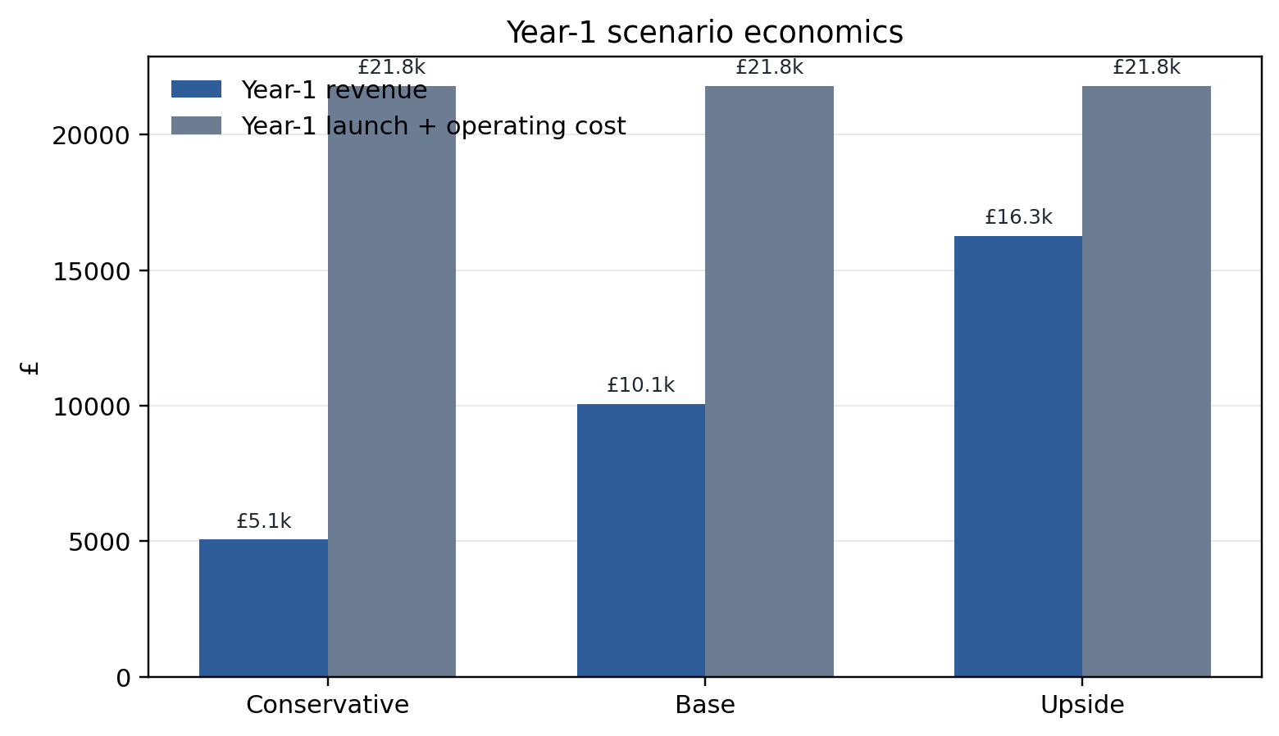
Source: FairNest managerial financial model; commercial assumptions require live validation.

6. Implementation Plan
FairNest should be implemented through evidence gates rather than a six-month 'build then launch' sequence. The sequencing follows the logic of iterative experimentation associated with lean start-up practice (Ries, 2011), but modifies it for a housing decision service where inaccurate data can create material consumer harm. Data quality, source traceability and legal-context controls are therefore tested before market-demand assumptions. The proposed Year-1 roadmap has four phases.
Phase 1, weeks 1-6, converts the current prototype into a controlled pilot specification. The data schema, evidence-completeness framework, agreement categories, disclaimer wording, correction process and privacy notice are frozen. Twenty to thirty Coventry accommodation options are then populated from first-party sources. The gate is data quality: at least 90% of published material fields should have a first-party source and every option must show a check date. If this cannot be maintained manually in one city, national scaling is not credible.
Phase 2, weeks 7-12, tests operational reliability rather than demand. The team runs weekly price-change checks, deliberately removes or alters source data in a test environment, validates expiry logic and completes contract-classification test cases. The artefact is also checked across mobile and desktop layouts. The gate is control performance: no missing price/payment value may silently default to a favourable score, and private-tenancy rules must not be automatically applied to university halls.
Phase 3, months 4-6, is a small live-market validation subject to any further ethics and commercial approvals required for live-market testing. The objective is not mass acquisition. It is to establish whether providers will supply structured data, whether students repeatedly use comparison outputs, and which questions generate support requests. Core pilot metrics are source freshness, returning users, shortlist creation, provider enquiry conversion, correction rate and provider renewal intent. Price testing should be treated as experimentation rather than validation of the £29/£149 assumptions.
Phase 4, months 7-12, is conditional expansion. If the Coventry evidence gates are passed, inventory can expand within the city and one adjacent university market can be prepared. University/student-union partnership discussions can begin using actual pilot evidence. If provider participation is weak but student use is strong, FairNest can remain an independent public-data decision tool and test institutional funding. If student use is weak despite high data quality, the business should stop or pivot rather than subsidise a marketplace without demand.
The implementation logic therefore protects against escalation of commitment. Success is defined as learning whether a repeatable evidence-governance process creates enough user and provider value to justify scale. Scale itself is not a Year-1 success criterion.
Table 8. Evidence-gated implementation roadmap
Phase | Timing | Primary output | Go/no-go evidence gate
1. Controlled specification | Weeks 1-6 | Data schema, 20-30 source-linked options and governance rules | At least 90% of material fields sourced; all records dated
2. Reliability test | Weeks 7-12 | Expiry, correction, classification and device tests | No favourable silent imputation; regime logic passes test cases
3. Live validation* | Months 4-6 | Observed use, provider onboarding and price tests | Evidence of repeat use plus feasible verification cost
4. Conditional expansion | Months 7-12 | More Coventry inventory and adjacent-city preparation | Acceptable provider retention and evidence-adjusted contribution margin
Source: Developed for this study from Sections 3-7.

* Live validation is a future commercial/research stage and is not claimed as completed in the current secondary-data study.

7. Evaluation, Financial Feasibility and Risk

7.1 Feasibility assessment
Market feasibility is plausible but not proven. The need for accommodation information is obvious; the need for FairNest specifically is narrower. OfS evidence supports cost and contract-comprehension challenges, while the competitor audit confirms that substantial comparison functionality already exists. The market case therefore depends on the residual combination of source provenance, move-in cash, contract context and explainable ranking. That is a testable differentiation, not a monopoly claim.
Technical feasibility is strong at pilot scale because the artefact uses conventional web filtering, calculation and content management. Operational feasibility is harder: accommodation data must be refreshed continuously, making verification labour and provider data quality the likely scale constraints. The pilot should therefore measure verification cost per evidence-complete listing and average refresh time.
Financial feasibility is conditional. The base case reaches about £1,474 provider MRR in Month 12 against £1,450 monthly operating cost, only £24 of recurring headroom before founder salary, tax, VAT, financing or unexpected verification work. Year 1 remains about £11.7k funding-negative. A tightly capped pilot could therefore test whether recurring provider revenue covers verification cost, but funding should be released by milestone rather than committed to national rollout.

7.2 Risk register, controls and residual risk
The highest-impact risk is decision harm from stale, incomplete or misclassified information. A wrong rent can distort budgeting and a wrong agreement classification can surface an inapplicable legal rule. Controls are visible check dates, field-level sources, uncertainty labels and expiry rules; where legal form is uncertain, the interface should state 'classification required' rather than infer it from provider brand.
A second risk is ranking bias if paying providers appear favoured. The control is a published scoring formula, user-controlled weights and zero influence of paid status on the organic Fit Score, supported by audit logs for scoring-rule changes.
Third, the business faces substitution and imitation. Student.com already has sophisticated comparison functionality and large marketplaces own substantially more inventory. FairNest cannot defend itself by adding another filter. Its defensible capability must be evidence governance, contract-context logic and institutional trust. If a large competitor implements these features credibly, FairNest may be more viable as a B2B decision module or university-facing toolkit than as a standalone consumer brand.
Fourth, demand and policy are volatile. International postgraduate recruitment weakened in 2024/25, while PBSA supply in Coventry has expanded rapidly. This makes fixed national forecasts unreliable. City-level deployment and low fixed cost reduce exposure. Provider revenue assumptions should be reviewed each intake rather than extrapolated linearly.
Fifth, data protection and discrimination risks arise if the product evolves into personalised matching. Collecting nationality or protected characteristics to “improve recommendations” would create unnecessary exposure and could enable discriminatory outcomes. The prototype demonstrates that useful comparison can be produced without those variables. Data minimisation is therefore both a compliance control and a product-design constraint.

7.3 Performance framework
A balanced pilot scorecard combines commercial, operational and consumer outcomes. Commercial measures include active providers, renewals, qualified enquiries and recurring revenue; operational measures include refresh compliance, verification hours and correction turnaround; consumer measures include repeat comparison, shortlist/export use and source-link engagement. An unvalidated 'confidence improvement' metric is excluded because no before/after primary study was conducted.
The main scale gate is evidence-adjusted contribution margin: provider revenue minus the verification and support cost required to keep information trustworthy. Growth is not scalable if verification cost rises faster than revenue, and traffic without shortlist or source engagement may indicate interest rather than decision utility.

7.4 Artefact evaluation against requirements
The prototype satisfies the principal functional requirements identified by the business case. It displays multiple provider types; separates weekly rent, contract total and known move-in cash; allows user-controlled weights; exposes missing data; shows source URLs and a 16 September 2026 check date; distinguishes university halls, private PBSA and assured private-tenancy contexts; and generates a parent/sponsor decision summary. A comparison modal supports side-by-side review of up to three shortlisted options.
The prototype also demonstrates deliberate failure behaviour. The University Living “from” price remains visible because aggregators are realistic discovery channels, but missing contract length and payment data are not inferred. The interface reduces the evidence score and labels the gaps. This tests an important operational condition because a live service will inevitably encounter incomplete information.
The Fit Score is transparent but should remain subordinate to raw fields. It can help order options, yet it is sensitive to user thresholds and the pre-scored evidence measure. It should never be represented as an objective quality score. A production version should formalise evidence completeness into a documented field-level framework, version the scoring formula, and provide an option to sort by any raw field without scoring.
Overall, the artefact adds value because it embodies the business logic rather than merely illustrating it. It exposes the central research finding—that comparable decisions require normalisation and provenance—and converts legal and ethical constraints into interface controls.
Table 9. Pilot risk register
Risk | Likelihood | Impact | Control / trigger
Stale or incorrect listing data | High | High | Check dates, expiry, source links and correction queue; remove stale material fields
Agreement misclassification | Medium | High | Classification first; "verify agreement type" state; official signposting
Paid-ranking trust conflict | Medium | High | Paid placement separated; zero Fit-Score effect; scoring rule published
Weak provider willingness to pay | High | Medium | Manual price tests; cap acquisition spend; test B2B/institutional alternatives
Large-platform imitation | Medium | High | Compete on evidence operations and partnership trust rather than dashboard features alone
International demand volatility | Medium | Medium | City-by-city cost base; refresh forecasts by intake
Data-protection creep | Medium | High | Minimise profile data; no protected-characteristic ranking; retention controls
Source: Developed for this study from Sections 4-7.

8. Artefact Design and Evidence Traceability
The FairNest UK Decision Engine is the professional artefact accompanying the business plan. The standalone HTML prototype is supported by the evidence and financial workbook. Its architecture is 'evidence first, ranking second': public sources populate a normalised record, contractual context determines relevant prompts and user preferences then order options. This avoids false precision from scoring poorly sourced or misclassified data.
The Discover & Compare screen uses progressive disclosure. Users set budget, booking-cash and commute thresholds, select room/provider types and adjust four preference weights while raw values remain visible beside the score. The interface makes material cash differences salient but avoids scarcity cues or countdowns, prioritising comprehension over conversion pressure.
The Contract & Legal Check tab converts 2026 regulatory changes into bounded prompts. It does not assume one legal regime for all student accommodation and explicitly avoids legal advice. Assured periodic tenancy rules, deposit caps, halls exclusions and PBSA classification are separated, responding to both the Renters' Rights reforms and OfS evidence of contract misunderstanding.
The Evidence Provenance tab treats uncertainty as visible product information. Each sample option has an evidence-completeness indicator, source link, check date and contextual note. Lower-quality evidence is not hidden simply because it makes the interface less tidy. The Parent/Sponsor Summary converts the current highest preference fit into a small checklist of questions to complete before money is transferred.
Traceability is maintained in the supporting workbook: the listing dataset stores prototype records; the competitor audit supports the residual-gap claim; the legal/governance sheet maps rules to controls; the evidence register records sources and limitations; and the financial sheets separate assumptions from sourced metrics. This gives the artefact an auditable evidence trail rather than a static mock-up.
Figure 5. FairNest UK Decision Engine - Discover & Compare screen.
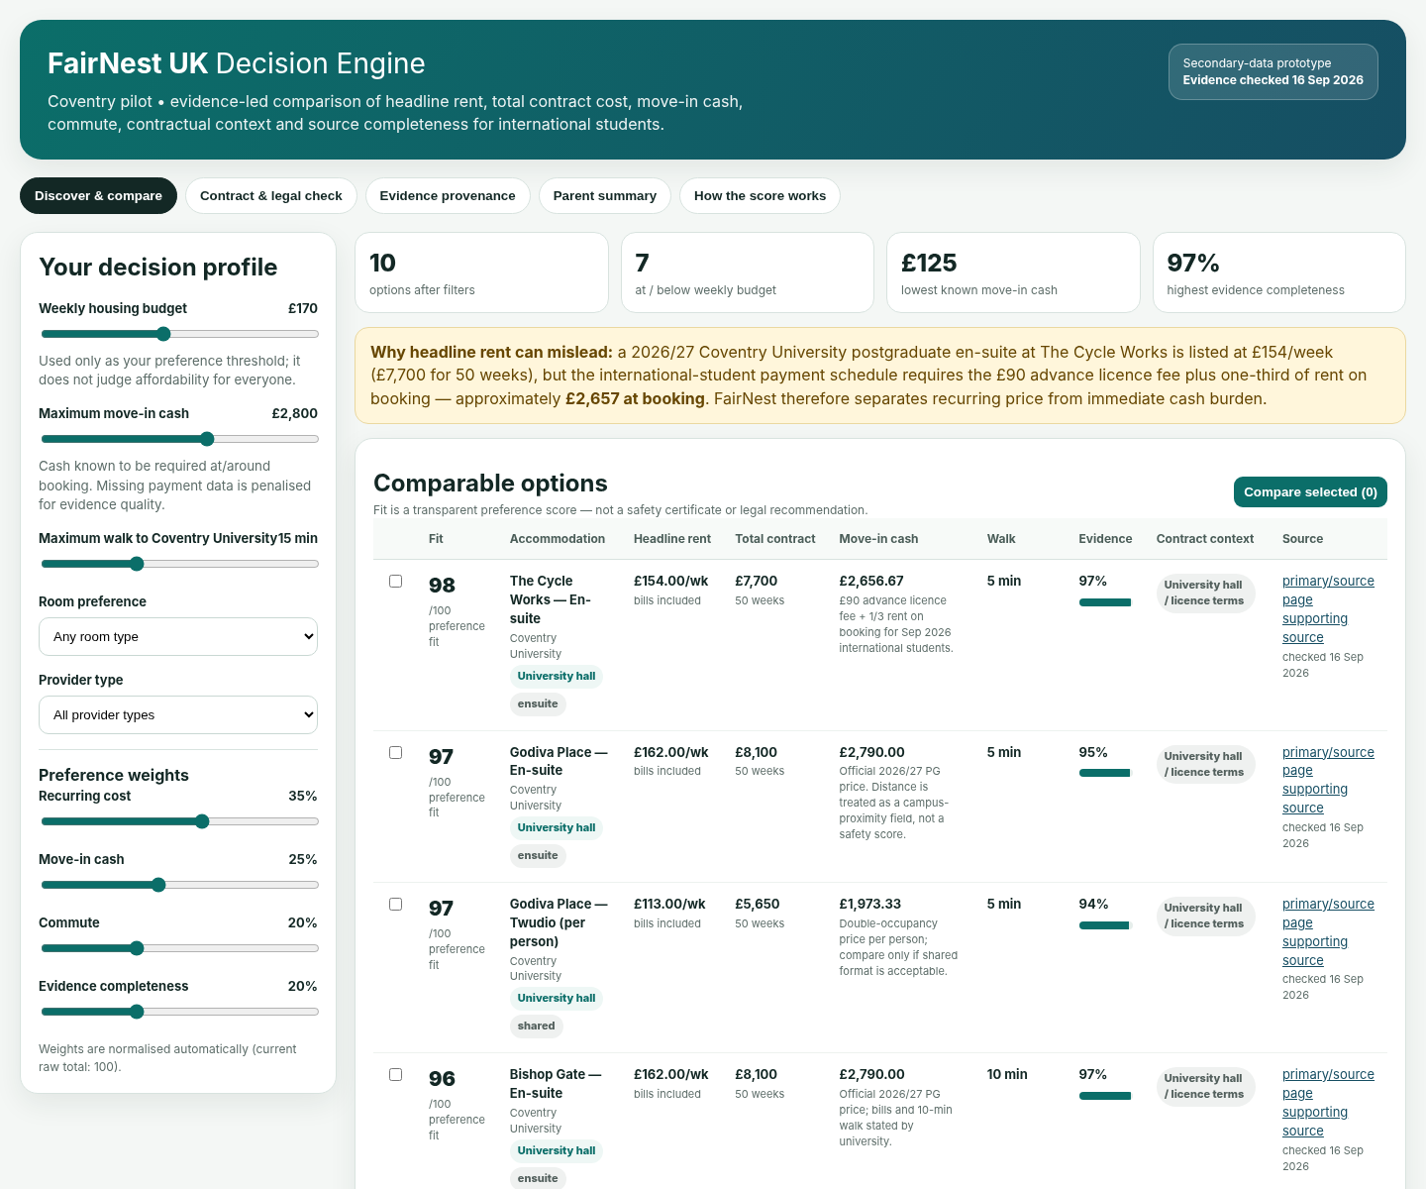
Source: FairNest UK Decision Engine; evidence checked 16 September 2026.
Table 10. Requirements traceability from evidence to artefact
Requirement | Evidence basis | Artefact implementation | Acceptance condition
Separate visible price measures | Coventry University fees/payment schedule; OfS cost salience | Weekly rent, contract total and known move-in cash shown separately | No weekly-rent-only affordability conclusion
Explain uncertainty | Signalling/trust literature and dynamic listings | Evidence indicator, source URL, check date and missing-data labels | Unknown payment is never displayed as £0
Respect legal context | Renters' Rights reforms and halls/PBSA distinctions | Contract & Legal Check tab and classification warning | Private-tenancy rules are not automatically applied to halls
Avoid opaque ranking | Preference diversity and governance risk | User-controlled weights and formula explanation | Paid status and protected characteristics excluded
Support sponsor decision | International pre-arrival context | Parent/Sponsor Summary | Payment and evidence questions surfaced before transfer
Source: Developed for this study from the preceding analysis.

9. Conclusion and Recommendations
FairNest UK is feasible as a controlled Coventry decision-support pilot, but the evidence does not justify describing it as a proven national marketplace. The strongest opportunity is narrower and more defensible: international students must compare accommodation across inconsistent cost, payment, contractual and evidential formats, while existing services solve different parts of that problem. Coventry's relative PBSA oversupply strengthens this logic because the pilot is not dependent on a shortage narrative; abundant supply increases the value of transparent comparison.
The project contributes a practical framework that separates headline rent, total contract cost and move-in cash; classifies agreement context before applying legal prompts; exposes source provenance and missing data; and keeps ranking user-controlled. The functional artefact demonstrates that these principles can be converted into an operational product.
Three recommendations follow. First, launch only after the evidence-completeness framework, correction workflow and legal-boundary wording are independently reviewed. Second, keep free safety/comparison information structurally separate from monetisation and prevent paid status from influencing the Fit Score. Third, use the Coventry pilot to obtain evidence not available within the present secondary-research design: observed student use, provider willingness to pay, data-refresh cost and retention. Expansion should occur only if the evidence-adjusted contribution margin and trust controls remain acceptable. Expansion should therefore remain evidence-gated rather than assumption-led.

References
Corney, T., du Plessis, K., Woods, B., Lou, C., Dewhurst, A., & Mawren, D. (2024). 'If you are feeling alone and you are not feeling safe, it impacts everything': A mixed-methods exploration of international students' accommodation, subjective wellbeing and mental health help-seeking. BMC Public Health, 24, 1262. https://doi.org/10.1186/s12889-024-18691-8
Coventry City Council. (2024). Purpose-built student accommodation market study 2024. https://www.coventry.gov.uk/downloads/file/44031/purpose-built-student-accommodation-market-study-2024
Coventry University. (2026a). Accommodation fees 2026/27. Retrieved September 16, 2026, from https://www.coventry.ac.uk/life-on-campus/accommodation/applying/accommodation-fees/
Coventry University. (2026b). Ways to pay for student accommodation. Retrieved September 16, 2026, from https://www.coventry.ac.uk/life-on-campus/accommodation/applying/ways-to-pay/
Cushman & Wakefield. (2025). UK student accommodation report 2025. https://www.cushmanwakefield.com/en/united-kingdom/insights/uk-student-accommodation-report
Freeman, R. E. (1984). Strategic management: A stakeholder approach. Pitman.
Hastings, C., Overgaard, C., Wilson, S., Ramia, G., Morris, A., & Mitchell, E. (2024). Crowded house: Accommodation precarity and self-reported academic performance of international students. Compare: A Journal of Comparative and International Education, 54(7), 1190-1209. https://doi.org/10.1080/03057925.2023.2184199
HESA. (2026, January 27). UK higher education student numbers fall for second year in a row. https://www.hesa.ac.uk/news/27-01-2026/uk-he-student-numbers-fall-second-year-in-a-row
Hoolachan, J., Preece, J., & Moore, T. (2026). Student accommodation in Scotland: Home, emotions and diverse experiences. Housing, Theory and Society. Advance online publication. https://doi.org/10.1080/14036096.2026.2622948
Hubbard, P., & Morris, C. (2026). Young, educated and excluded? Regulating student accommodation in England & Wales. Urban Geography. Advance online publication. https://doi.org/10.1080/02723638.2026.2623129
Hunter, C., & Makin, C. (2025). Shaping the 'studenthood': Purpose-built student accommodation and planning law. Journal of Social Welfare and Family Law, 47(4), 479-500. https://doi.org/10.1080/09649069.2025.2569180
iQ Student Accommodation. (2026). Bronze En Suite Plus, Weaver Place, Coventry. Retrieved September 16, 2026, from https://www.iqstudentaccommodation.com/coventry/weaver-place/bronze-en-suite-plus
Information Commissioner's Office. (2026a). A guide to lawful basis. https://ico.org.uk/for-organisations/uk-gdpr-guidance-and-resources/lawful-basis/a-guide-to-lawful-basis/
Information Commissioner's Office. (2026b). Principle (c): Data minimisation. https://ico.org.uk/for-organisations/uk-gdpr-guidance-and-resources/data-protection-principles/a-guide-to-the-data-protection-principles/data-minimisation/
Kallin, H. (2024). Victims of studentification? Variegated student experiences of housing precarity and homelessness in Edinburgh. Scottish Geographical Journal. https://doi.org/10.1080/14702541.2024.2372623
Kim, D. J., Ferrin, D. L., & Rao, H. R. (2008). A trust-based consumer decision-making model in electronic commerce: The role of trust, perceived risk, and their antecedents. Decision Support Systems, 44(2), 544-564. https://doi.org/10.1016/j.dss.2007.07.001
Knight Frank. (2026, February 16). UK student market update - Q4 2025: Investors committed £4.3 billion to the PBSA market in 2025. https://www.knightfrank.co.uk/research/article/2026/2/investors-committed-4.3-billion-to-the-pbsa-market-in-2025-up-10-year-on-year
Mavlanova, T., Benbunan-Fich, R., & Koufaris, M. (2012). Signaling theory and information asymmetry in online commerce. Information & Management, 49(5), 240-247. https://doi.org/10.1016/j.im.2012.05.004
Ministry of Housing, Communities and Local Government. (2025). Implementing the Renters' Rights Act 2025: Our roadmap for reforming the private rented sector. https://www.gov.uk/government/publications/renters-rights-act-2025-implementation-roadmap/implementing-the-renters-rights-act-2025-our-roadmap-for-reforming-the-private-rented-sector
Ministry of Housing, Communities and Local Government. (2026a). Renters' Rights Act overview for tenants. https://www.gov.uk/guidance/renters-rights-act-overview-for-tenants
Ministry of Housing, Communities and Local Government. (2026b). Fees you can charge as part of a tenancy. https://www.gov.uk/guidance/fees-you-can-charge-as-part-of-a-tenancy
Office for Students. (2026, June 10). OfS research finds over eight in ten students are satisfied with their accommodation. https://www.officeforstudents.org.uk/news-blog-and-events/press-and-media/ofs-research-finds-over-eight-in-ten-students-are-satisfied-with-their-accommodation/
Oladiran, O., Sunmoni, A., Ajayi, S., Guo, J., & Abbas, M. A. (2023). What property attributes are important to UK university students in their online accommodation search? Journal of European Real Estate Research, 16(1), 130-151. https://doi.org/10.1108/JERER-03-2021-0019
Ries, E. (2011). The lean startup: How today's entrepreneurs use continuous innovation to create radically successful businesses. Crown Business.
Rightmove. (2026). Accommodation information for international students. Retrieved September 16, 2026, from https://www.rightmove.co.uk/guides/renter/student-property/international-students/
Rochet, J.-C., & Tirole, J. (2003). Platform competition in two-sided markets. Journal of the European Economic Association, 1(4), 990-1029. https://doi.org/10.1162/154247603322493212
Student.com. (2026). Property comparison. Retrieved September 16, 2026, from https://www.student.com/compare
Student SpareRoom. (2026). Safety tips for room seekers. Retrieved September 16, 2026, from https://student.spareroom.co.uk/content/student-advice/safety-tips-student/
UCAS. (2026). Budget calculator. Retrieved September 16, 2026, from https://www.ucas.com/money-and-student-life/money/budgeting/budget-calculator
UK Council for International Student Affairs. (2026a). Accommodation for international students. https://www.ukcisa.org.uk/student-advice/life-in-the-uk/accommodation/
University Living. (2026). Student accommodation in Coventry. Retrieved September 16, 2026, from https://www.universityliving.com/united-kingdom/city/coventry

Appendices

Appendix A. Coventry prototype listing extract
Table A1. Coventry prototype listing extract
Option | Provider type | Weekly | Contract total | Known booking cash | Walk | Evidence
The Cycle Works - En-suite | University hall | £154 | £7,700 | £2,656.67 | 5 min | 97%
The Cycle Works - Standard studio | University hall | £178 | £8,900 | £3,056.67 | 5 min | 97%
Bishop Gate - En-suite | University hall | £162 | £8,100 | £2,790.00 | 10 min | 97%
Godiva Place - En-suite | University hall | £162 | £8,100 | £2,790.00 | 5 min | 95%
Godiva Place - Double-occupancy option (per person) | University hall | £113 | £5,650 | £1,973.33 | 5 min | 94%
iQ Weaver Place - Bronze En Suite Plus | Private PBSA | £138 | £7,038 | £125 booking fee* | 6 min | 89%
University Living - Queens Park House "from" example | Aggregator | £86.40 | Missing | Not normalised | Missing | 52%
Source: Coventry University (2026a, 2026b); iQ (2026); University Living (2026).

* The iQ booking fee is credited to rent and is not treated as the full eventual pre-arrival liability. The evidence percentage is a prototype traceability indicator, not a safety probability.

Appendix B. Fit Score logic
• Recurring-cost fit = min(100, weekly budget / weekly rent × 100).
• Move-in-cash fit = min(100, cash limit / known move-in cash × 100); unknown payment data receives a neutral-low prototype value rather than zero.
• Commute fit decreases with distance relative to the user's selected walk threshold; unknown distance receives a neutral-low value.
• Evidence completeness is a pre-scored traceability measure based on specificity and coverage of price, contract, payment, bills, location and source information.
• Overall Fit = Σ(component score × user weight) / Σ(user weights). It is a preference-fit measure only; it is not a safety, legal-compliance or quality certificate.

Appendix C. Governance rules embedded in the artefact
Table C1. Governance controls embedded in the artefact
Control | Prototype behaviour | Rationale
Agreement classification | Halls, PBSA and assured private tenancy are displayed separately | Avoids applying private-tenancy rules to the wrong agreement
Missing data | Shown as "missing/not normalised", not inferred as zero | Prevents incomplete evidence from appearing artificially attractive
Paid status | Not part of scoring logic | Reduces provider-bias conflict
Protected characteristics | Not collected for ranking | Supports data minimisation and non-discrimination
Legal advice boundary | Official prompts/links only; no individual legal conclusion | Reduces risk of misleading advice
Freshness | Source link plus evidence-check date | Accommodation data is dynamic
Source: Developed from MHCLG and ICO guidance cited in the report.

Appendix D. Artefact screenshots
Figure D1. Contract & Legal Check screen.
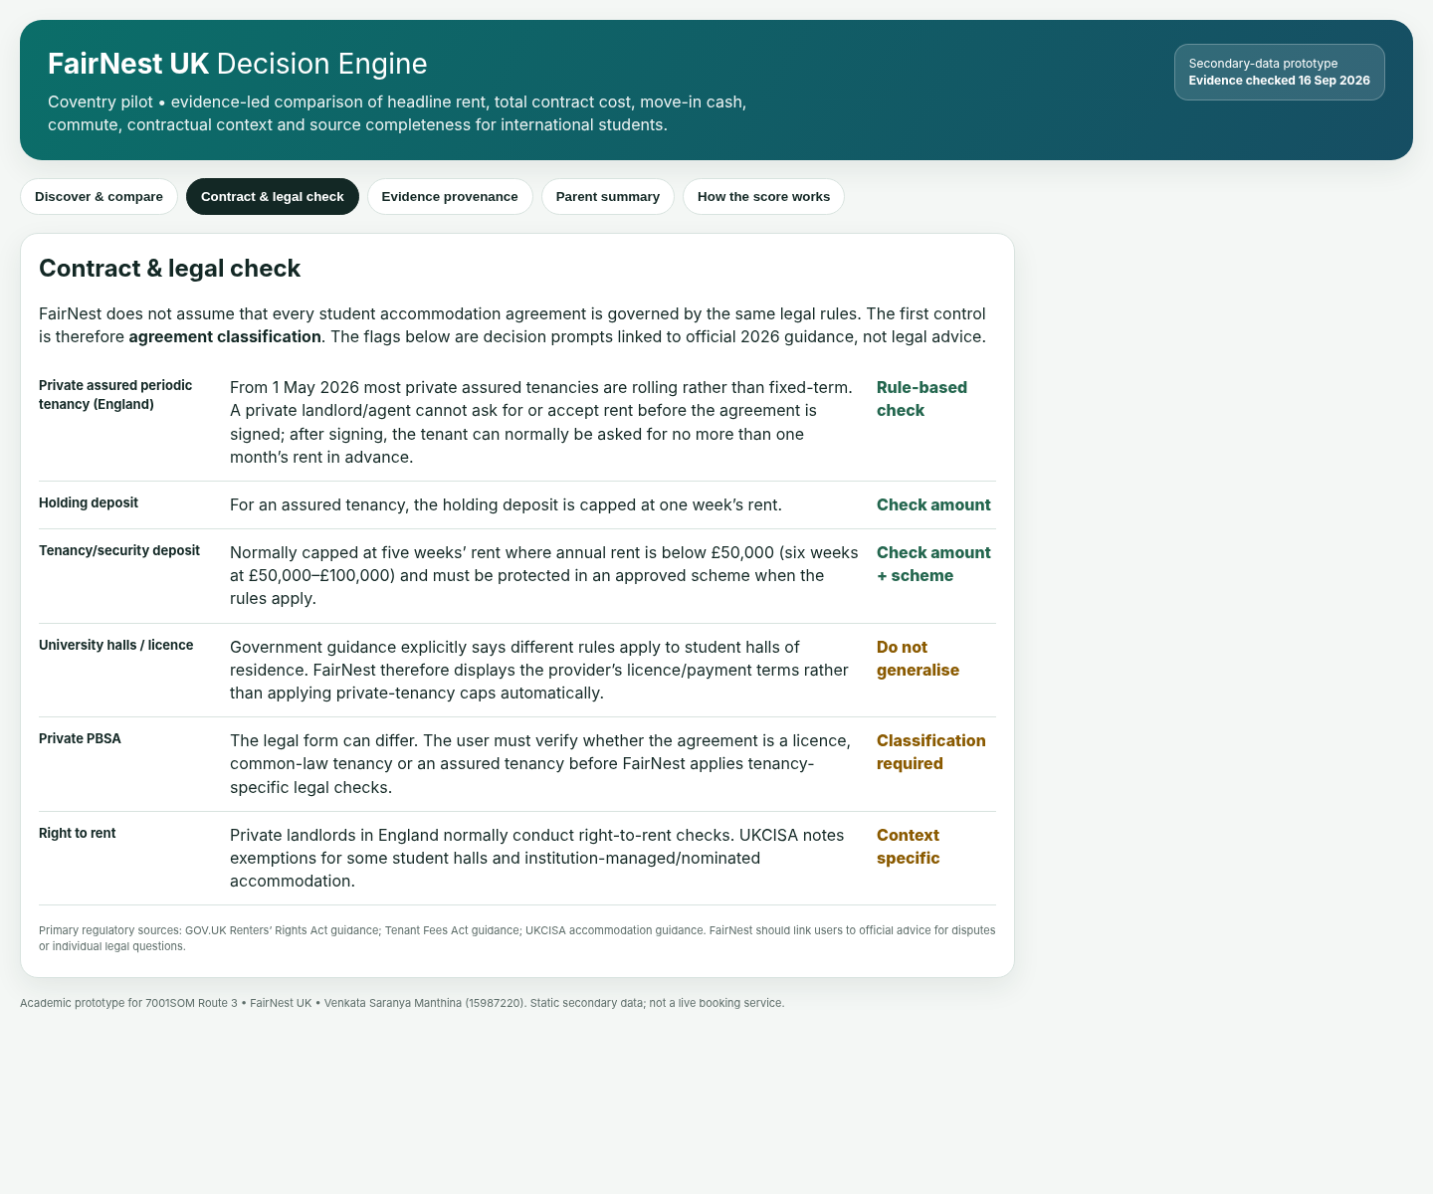
Source: FairNest UK Decision Engine.
Figure D2. Evidence Provenance screen.
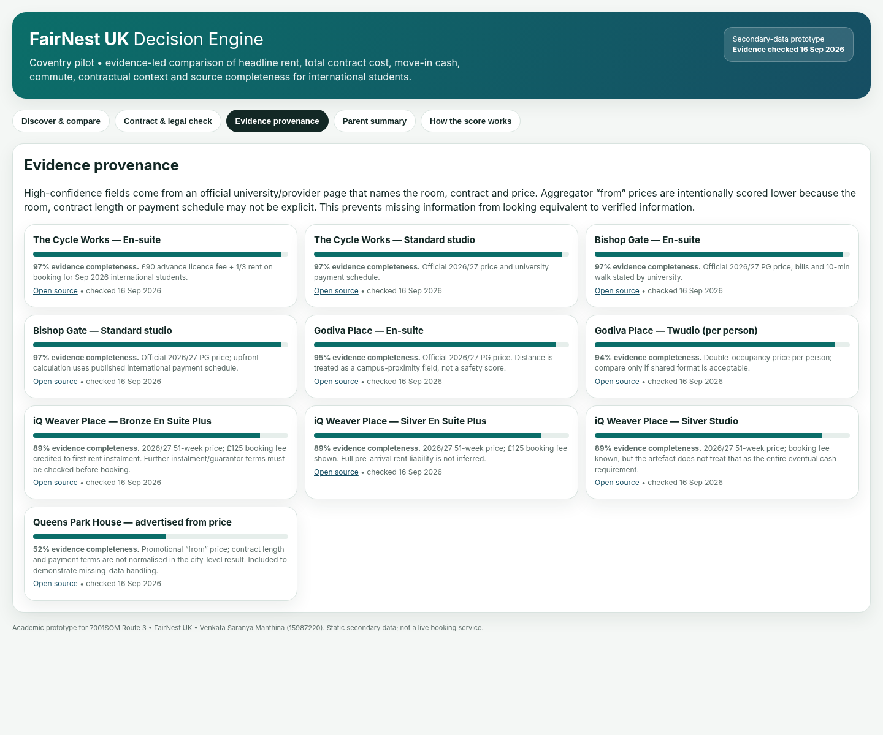
Source: FairNest UK Decision Engine.

Appendix E. Supporting artefact files
Functional artefact: FairNest_Decision_Engine.html
Evidence and financial model: FairNest_Evidence_and_Financial_Model.xlsx

