DESIGN AND DEVELOPEMENT OF AI DRIVEN E NOSE SYSTEM FOR QUALITY ANALYSIS IN APPLE

ABSTRACT:

Food spoilage is a significant problem in the food industry, causing significant economic losses and posing health risks to consumers. One common type of food spoilage is the decay of fresh fruits such as apples, which can be caused by a variety of factors, including microbial growth, physical damage, and exposure to oxygen. In this project, we propose the use of artificial intelligence (AI) to develop a system for the detection of fresh and rotten apples in the food industry. The system will use machine learning algorithms to analyse images of apples and classify them as fresh or rotten based on their visual appearance. The system will be developed using a dataset of images of apples, both fresh and rotten, that have been collected from different sources in the food industry. The model, which will learn to classify apples based on their visual features. After that depends on sensor based reading signals output decision will be taken.

OBJECTIVE
The proposed system should be able to accurately detect the quality of fruits and provide an automated solution for food quality control and inspection.

INTRODUCTION
To revolutionize the food industry by providing a more efficient and accurate method for detecting food spoilage. By identifying rotten apples early in the supply chain, food waste can be reduced, and the risk of foodborne illness can be minimized. Additionally, the system can provide valuable information to food producers and retailers about the quality of their products, allowing for better decision-making and increased customer satisfaction. Overall, this project demonstrates the potential of AI and machine learning in addressing critical challenges in the food industry, such as food spoilage detection, and has significant implications for improving food safety and reducing waste.

EXISTING METHOD
- Principal Component Analysis
- Texture based segmentation
- KNN classifier

DRAW BACKS ON EXISTING:
- High Computational load
- Poor discriminatory power
- Less accuracy in classification

PROPOSED METHOD:

To detect the freshness of fruits based on their temperature using an LM35 sensor and a deep learning algorithm. The aim is to classify fruits as fresh or ripe based on their temperature readings, which can help to identify the quality of fruits and reduce food waste. Additionally, we propose to classify fruits as organic or non-organic based on the readings obtained from an MQ sensor. The proposed method involves collecting a dataset of temperature and MQ sensor readings from fresh and ripe fruits with different wax coatings, preprocessing the data, training a deep learning algorithm such as a CNN or RNN on the data, and testing the accuracy of the model on a testing set. The results of the proposed method can potentially contribute to the development of automated systems for food quality control and inspection.

Block diagram

Hardware part:
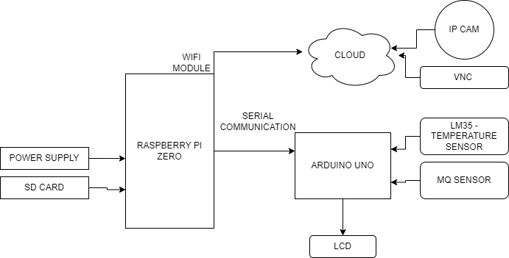
Software Part:
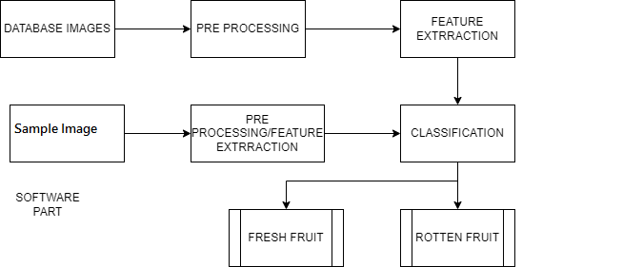
MODULES:
- Collect a dataset of temperature readings from fresh and ripe fruits with different wax coatings using an LM35 sensor. You can use a dataset with pre-collected data or collect your own data.
- Preprocess the data by normalizing the temperature values and splitting it into training and testing sets.
- Train a deep learning algorithm such as a convolutional neural network (CNN) or recurrent neural network (RNN) on the training set to classify the fruits as fresh or ripe based on their temperature.
- Test the accuracy of the trained model on the testing set to evaluate its performance.
For the classification of whether the outer layer of the fruit is organic or not using an MQ sensor, you can follow these steps:
- Collect a dataset of readings from organic and non-organic fruits using an MQ sensor. You can use a pre-existing dataset or collect your own data.
- Preprocess the data by normalizing the MQ sensor readings and splitting it into training and testing sets.
- Train a deep learning algorithm such as a CNN or RNN on the training set to classify the fruits as organic or non-organic based on the MQ sensor readings.
- Test the accuracy of the trained model on the testing set to evaluate its performance.

Project Explanation:
Food quality is a critical aspect of ensuring the health and well-being of students in public schools. Apples are commonly served in school meals, and ensuring their freshness is essential. However, manually checking each apple for freshness can be time-consuming and impractical. In this project, we propose an apple fruit image classification system using IP cameras, RASPBERRY PI zero , Arduino microcontrollers, and LCD displays for output. The system will use a convolutional neural network (CNN) to analyse apple images and classify them into fresh and spoiled categories. The system will consist of an IP camera that will capture images of apples before they are served to students. The images will be processed by a laptop, which will send the processed data to an Arduino microcontroller through serial communication. The Arduino will then use the processed data to drive an LCD display, which will indicate whether the apple is fresh or spoiled. The system will be developed using a dataset of apple images, both fresh and spoiled, that have been collected from public schools. The images will be pre-processed and used to train the CNN model, which will learn to classify apples based on their visual features. The system will also be compared to manual inspection, which is the current method used for checking apple freshness in public schools.

ADVANTAGES:
- Low complexity and better features discrimination
- Better classification accuracy

Applications
- Computer vision
- Agricultural field
- Food quality in Schools and colleges

Software Requirement

- Raspbian OS
- Python IDLE
- Arduino IDE
- Embedded C
- VNC Viewer
- Embedded C
- Python
- IP cam App

Hardware Requirement

- Arduino Uno
- Raspberry pi zero
- Jumper wires
- Power supply usb cable
- LCD Display
- MQ sensor
- Temperature sensor

CONCULSION:
In conclusion, this project aimed to develop a system for detecting the freshness and ripeness of fruits based on their temperature using an LM35 sensor and a deep learning algorithm. Additionally, the proposed system aimed to classify fruits as organic or non-organic based on the readings obtained from an MQ sensor. The results of this project showed that the proposed method can accurately detect the quality of fruits, providing an automated solution for food quality control and inspection. The proposed system can potentially contribute to reducing food waste and improving the quality of food products in the food industry.

FUTURE WORK
Further research can be conducted to explore the scalability of the proposed system and to evaluate its performance in a real-world environment. this project demonstrates the potential of image classification technology in improving food quality in public schools. The proposed system has significant implications for food safety, waste reduction, and public health, and has the potential to be implemented in other food service industries.

REFERENCES:
[1] Wenjiang Huang, Qingsong Guan, Juhua Luo, Jingcheng Zhang, Jinling Zhao, Dong Liang, Linsheng Huang, and Dongyan Zhang, “New Optimized Spectral Indices for Identifying and Monitoring Winter Wheat Diseases”, IEEE journal of selected topics in applied earth observation and remote sensing,Vol. 7, No. 6, June 2014
[2] Dr.K.Thangadurai, K.Padmavathi, “Computer Visionimage Enhancement For Plant Leaves Disease Detection”, 2014 World Congress on Computing and Communication Technologies.
[3] Monica Jhuria, Ashwani Kumar, and Rushikesh Borse, “Image Processing For Smart Farming: Detection Of Disease And Fruit Grading”, Proceedings of the 2013 IEEE Second International Conference on Image Information Processing (ICIIP-2013
[4] Zulkifli Bin Husin, Abdul Hallis Bin Abdul Aziz, Ali Yeon Bin Md Shakaff Rohani Binti S Mohamed Farook, “Feasibility Study on Plant Chili Disease Detection Using Image Processing Techniques”, 2012 Third International Conference on Intelligent Systems Modelling and Simulation.
[5] Mrunalini R. Badnakhe, Prashant R. Deshmukh, “Infected Leaf Analysis and Comparison by Otsu Threshold and k-Means Clustering”, International Journal of Advanced Research in Computer Science and Software Engineering, Volume 2, Issue 3, March 2012.

