import pandas as pd import numpy as np
RD_Spend Administration Marketing_Spend State
Profit
0
0
0
0
0
import matplotlib.pyplot as plt import seaborn as sns
from sklearn.linear_model import LinearRegression from sklearn.metrics import r2_score
df = pd.read_csv("profit_analysis project dataset.csv") df.head()
RD_Spend Administration Marketing_Spend State Profit
0 165349.20 136897.80 471784.10 New York 192261.83
1 162597.70 151377.59 443898.53 California 191792.06
2 153441.51 101145.55 407934.54 Florida 191050.39
3 144372.41 118671.85 383199.62 New York 182901.99
4 142107.34 91391.77 366168.42 Florida 166187.94

df.info()
<class 'pandas.core.frame.DataFrame'> RangeIndex: 50 entries, 0 to 49
Data columns (total 5 columns):
# | Column | Non-Null Count | Dtype
0 | RD_Spend | 50 non-null | float64
1 | Administration | 50 non-null | float64
2 | Marketing_Spend | 50 non-null | float64
3 State 50 non-null object
4 Profit 50 non-null float64 dtypes: float64(4), object(1)
memory usage: 2.1+ KB df.isnull().sum()

dtype: int64 df.describe()
 | RD_Spend | Administration | Marketing_Spend | Profit
count | 50.000000 | 50.000000 | 50.000000 | 50.000000
mean | 73721.615600 | 121344.639600 | 211025.097800 | 112012.639200
std | 45902.256482 | 28017.802755 | 122290.310726 | 40306.180338
min | 0.000000 | 51283.140000 | 0.000000 | 14681.400000

 | 25% | 39936.370000 | 103730.875000 | 129300.132500 | 90138.902500
 | 50% | 73051.080000 | 122699.795000 | 212716.240000 | 107978.190000
 | 75% | 101602.800000 | 144842.180000 | 299469.085000 | 139765.977500
 | max | 165349.200000 | 182645.560000 | 471784.100000 | 192261.830000
df.corr(numeric_only=True)
plt.figure(figsize=(8,6))
sns.heatmap(
df.corr(numeric_only=True), annot=True
)
plt.title("Correlation Heatmap") plt.show()

 | RD_Spend | Administration | Marketing_Spend | Profit
RD_Spend | 1.000000 | 0.241955 | 0.724248 | 0.972900
Administration | 0.241955 | 1.000000 | -0.032154 | 0.200717
Marketing_Spend | 0.724248 | -0.032154 | 1.000000 | 0.747766
Profit | 0.972900 | 0.200717 | 0.747766 | 1.000000

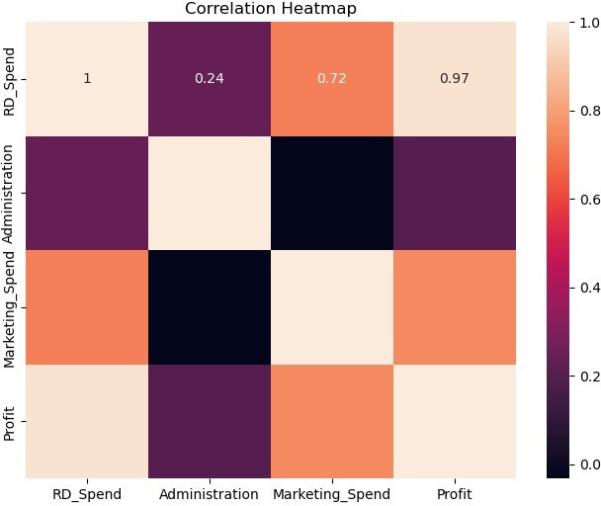
print(df.columns)
Index(['RD_Spend', 'Administration', 'Marketing_Spend', 'State', 'Profit'], dtype='object')
df.columns = df.columns.str.strip() print(df.columns)
Index(['RD_Spend', 'Administration', 'Marketing_Spend', 'State',
'Profit'], dtype='object')
for col in df.columns: print(repr(col))
'RD_Spend' 'Administration' 'Marketing_Spend' 'State'
'Profit'

plt.figure(figsize=(8,5))
plt.scatter(
df['RD_Spend'],
df['Profit']
)
plt.xlabel('RD Spend') plt.ylabel('Profit') plt.title('RD Spend vs Profit')
plt.show()
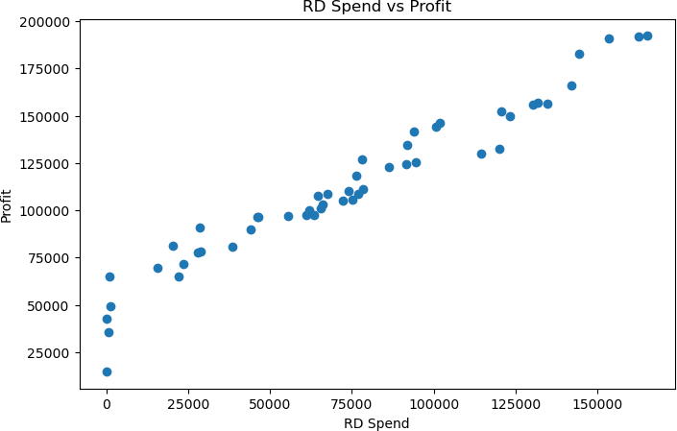
plt.figure(figsize=(8,5))
plt.scatter(
df['Marketing_Spend'], df['Profit']
)
plt.xlabel('Marketing Spend') plt.ylabel('Profit') plt.title('Marketing Spend vs Profit')
plt.show()

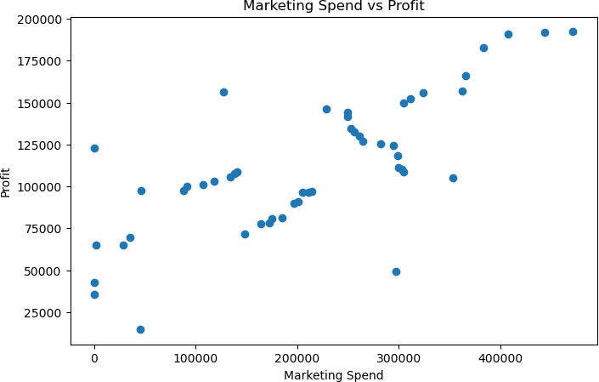
X = df[
[
'RD_Spend', 'Administration', 'Marketing_Spend'
]
]
y = df['Profit']
from sklearn.linear_model import LinearRegression model = LinearRegression()
model.fit(X, y) LinearRegression()
new_data = pd.DataFrame({ 'RD_Spend':[21892.92,23940.93],
'Administration':[81910.77,96489.63], 'Marketing_Spend':[164270.7,137001.1]
})
prediction = model.predict(new_data)

print(prediction) [70037.90476543 70554.57255993]

