
DEPARTMENT OF ELECTRONICS AND
COMMUNICATIONS ENGINEERING
Academic Year 2025-26 (ODD)
PROJECT SYNOPSIS
OF
“Accident Detection and Emergency Alert
System”
Submitted From :
SL NO. | NAME | USN NO.
1 | GAGANDEEP NS | 1BY24EC052
2 | KARTHIK P KUMAR | 1BY24EC073
3 | K VENKATA SATHVIK | 1BY24EC074
4 | A VENKATA MOUNISH | 1BY24EC015
5 | V NANDA KISHORE NAIK | 1BY24EC180
Submitted To
: Dr. DEEPA N Reddy
Social Connect and Responsibilities
[DEPARTMENT OF ELECTRONICS
AND COMMUNICATION ENGINEERING]

INTRODUCTION
Road accidents have become a significant cause of injuries and
fatalities worldwide, particularly on highways and rural roads where emergency response may be delayed. Rapid detection of accidents and immediate notification to relevant authorities can significantly reduce response time and save lives.
The Accident Detection and Emergency Alert System is designed to address this challenge by continuously monitoring a vehicle’s motion using sensors such as accelerometers, gyroscopes, and GPS modules. When an abnormal event, such as a collision or sudden tilt, is detected, the system triggers an alert to both the driver and emergency services.
This project not only focuses on real-time accident detection but also emphasizes social responsibility, aiming to minimize fatalities and ensure timely medical assistance. The system is adaptable to multiple vehicle types, including cars, bikes, and lorries, making it a versatile solution for road safety.


The Accident Detection and Emergency Alert System is designed to address this challenge by continuously monitoring a vehicle’s motion using sensors such as accelerometers, gyroscopes, and GPS modules. When an abnormal event, such as a collision or sudden tilt, is detected, the system triggers an alert to both the driver and emergency services

PROBLEM STATEMENT :
Road accidents are unpredictable and can happen anytime, anywhere.
Highways, rural roads, and less-populated areas are particularly dangerous because emergency help may take too long to arrive. Even a few minutes’ delay can turn minor injuries into life-threatening situations.
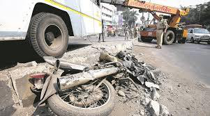


OBJECTIVES:

- Another important objective is to provide instant communication with emergency services and designated contacts, reducing response time and potentially saving lives.
- The system is designed to be compatible with multiple vehicle types, including cars, bikes, and lorries, making it practical for real-world applications.
- Beyond technology, the project emphasizes road safety and social responsibility, aiming to reduce fatalities and promote safer driving practices across diverse road environment
METHODOLOGY:
- The Accident Detection and Emergency Alert System monitors vehicles in real-time using sensors like accelerometers, gyroscopes, and GPS.
- These sensors track the vehicle’s motion, tilt, and speed to detect sudden collisions, rollovers, or abnormal movements.
- When an accident is detected, the system alerts the driver and
automatically notifies emergency contacts and nearby services with the vehicle’s location and accident details. This reduces response time and ensures help reaches quickly.
BLOCK DIAGRAM:
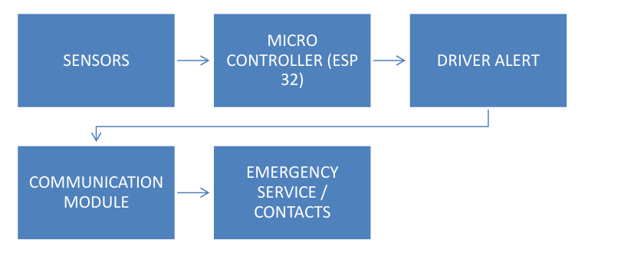

SYSTEM DESGIN:
The Accident Detection and Emergency Alert System consists of four main components: sensors, microcontroller, communication module, and alert/feedback mechanism.
1. Sensors: Accelerometers and gyroscopes detect sudden collisions, tilts, or rollovers, while the GPS module tracks vehicle location in real-time.
2. Microcontroller: Processes sensor data using threshold-based logic to determine whether an accident has occurred.
3. Communication Module: GSM or IoT module sends accident alerts with location details to emergency services and designated contacts.
4. Alert/Feedback Mechanism: Provides a buzzer or LED notification to the driver, allowing confirmation to reduce false alarms, and logs accident data for analysis.

Advantages / Expected Outcomes:
- By providing accurate accident detection and minimizing false alarms, the system increases reliability and trustworthiness for drivers across multiple vehicle types, including cars, bikes, and lorries.
- The system promotes road safety and social responsibility by encouraging safer driving habits and ensuring timely intervention during emergencies.
- It also allows logging of accident data for analysis, helping improve road conditions and future accident prevention.

CONCLUSION:
- The Accident Detection and Emergency Alert System is a practical solution to improve road safety and reduce fatalities caused by vehicle accidents. Accidents often happen suddenly, and delayed emergency response can result in severe injuries or loss of life.

- This system provides real-time monitoring of vehicles and immediately notifies emergency services and designated contacts, ensuring faster assistance.

- Beyond technology, the system emphasizes social responsibility, aiming to save lives, reduce trauma, and promote safer driving practices. Logging accident data allows for analysis to improve road safety and driver awareness.

- In summary, this project combines innovation, practicality, and social responsibility. It demonstrates how technology can make roads safer, save lives, and promote awareness, providing a reliable and life-saving solution for modern transportation.

