Smart Lockbox System
Consolidated Review 1 + Review 2 + Review 3 Report
Name: - Venkata Sriram Topalli
Reg No: - 23BCE0441

1. Executive Summary
The Smart Lockbox project is an IoT-based access control system that combines an ESP32 microcontroller, Firebase Realtime Database, a web application, an ultrasonic sensor, a servo motor, and an active buzzer. The system forms a closed-loop cyber-physical workflow: the web interface writes commands to Firebase, the ESP32 reads them, executes the physical action, and writes sensor-derived status back to the database.
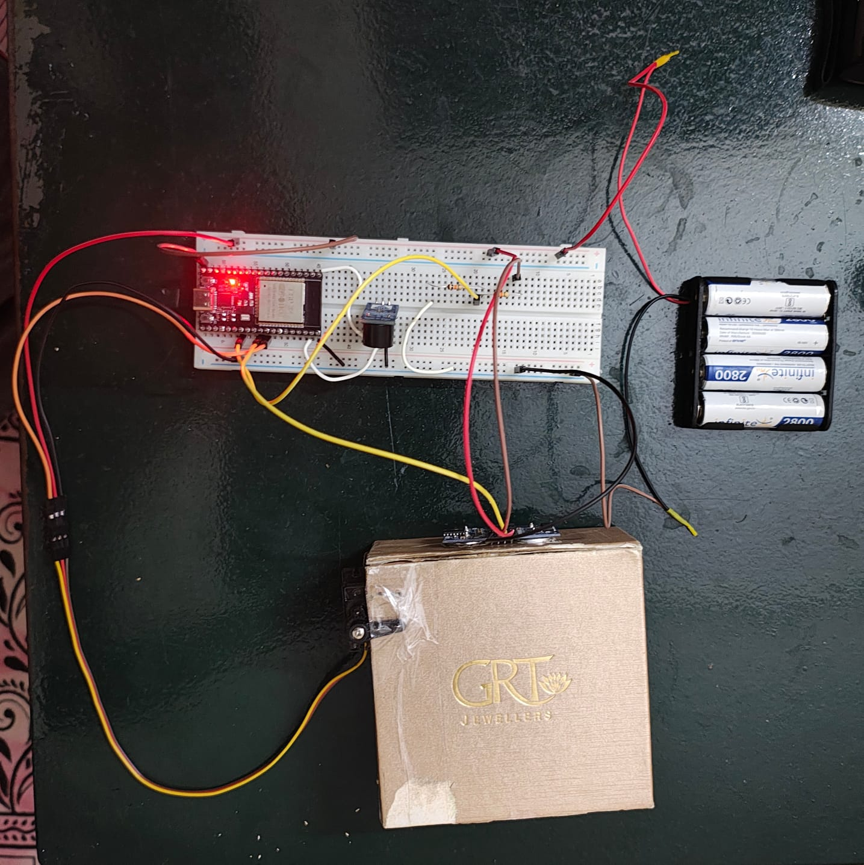
The consolidated report presents the project as a complete solution across architecture, data handling, algorithm design, execution layers, user interface, real-time synchronization, calibration, test cases, performance metrics, prototype validation, and comparison with commercial alternatives.

Figure 1: Complete smart lockbox prototype assembled for demonstration

2. Project Overview and Scope
The Smart Lockbox System is an Internet of Things (IoT) based access-control solution designed to securely store and manage physical keys. The system integrates embedded hardware, cloud infrastructure, and a web-based user interface to enable controlled and monitored access to a physical asset.
The ESP32 functions as the main controller and communicates with Firebase Realtime Database to synchronize the hardware state with the web application. This enables the system to act as a cyber-physical loop in which user actions become database events, database events trigger physical actions, and physical feedback is reported back to the user interface.
Scope Type | Key Points
Functional scope | Remote lock/unlock, key presence detection, buzzer alerts, role-based workflows
Technical scope | ESP32 control, Firebase communication, Wi-Fi connectivity, event-driven firmware
Performance scope | Fast response, stable sensing, reliable communication, efficient resource use
Application scope | Real-estate access, rental services, shared facilities, secure storage
Limitations | Requires Wi-Fi, sensor calibration matters, power optimization can be improved

3. Dataset and Database

3.1 Dataset
The project does not depend on a fixed offline dataset. Instead, it generates a real-time operational dataset from live user interaction, sensor readings, and internal system events. The dataset is therefore dynamic, event-driven, and time-dependent.
Data Type | Examples | Source | Purpose
Control data | LOCKED, UNLOCKED, WARNING_1_MIN | Web application | Controls the lockbox
Sensor data | Distance, key present / absent | HC-SR04 ultrasonic sensor | Detects the key state
System state data | Lock state, operating mode | ESP32 logic | Maintains system status
Event data | Unlock, return, alert events | ESP32 and web app | Supports logging and validation

Firebase Path | Direction | Meaning | Example Value
/state | Read | Lock command from web app | LOCKED / UNLOCKED
/buzzer/pattern | Read | Alert trigger pattern | WARNING_1_MIN
/keyPresent | Write | Ultrasonic key status | true / false
/lockbox | Read/Write | Main device state container | JSON object
/requests | Website-side | Request history records | JSON object

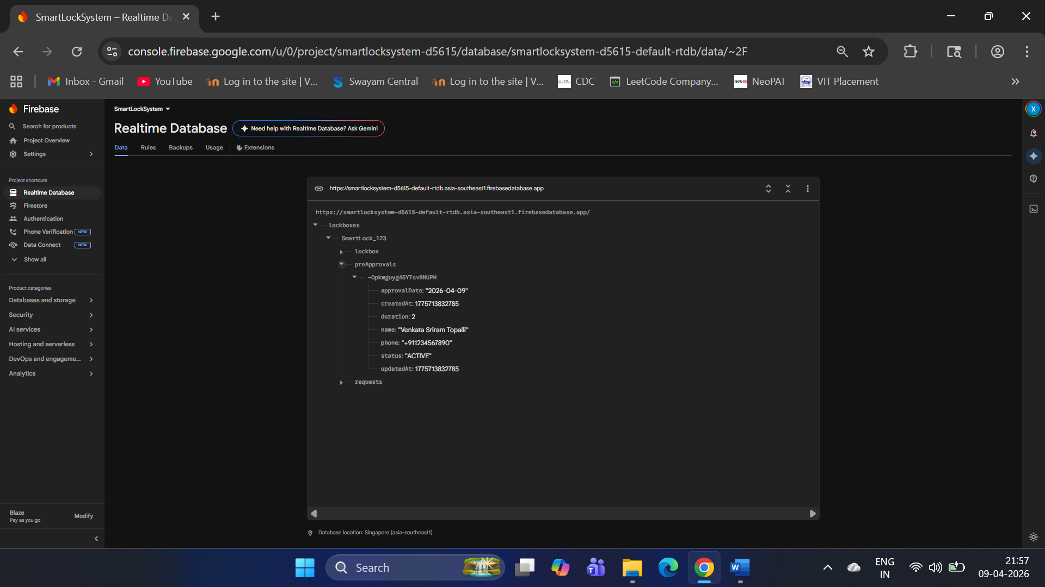
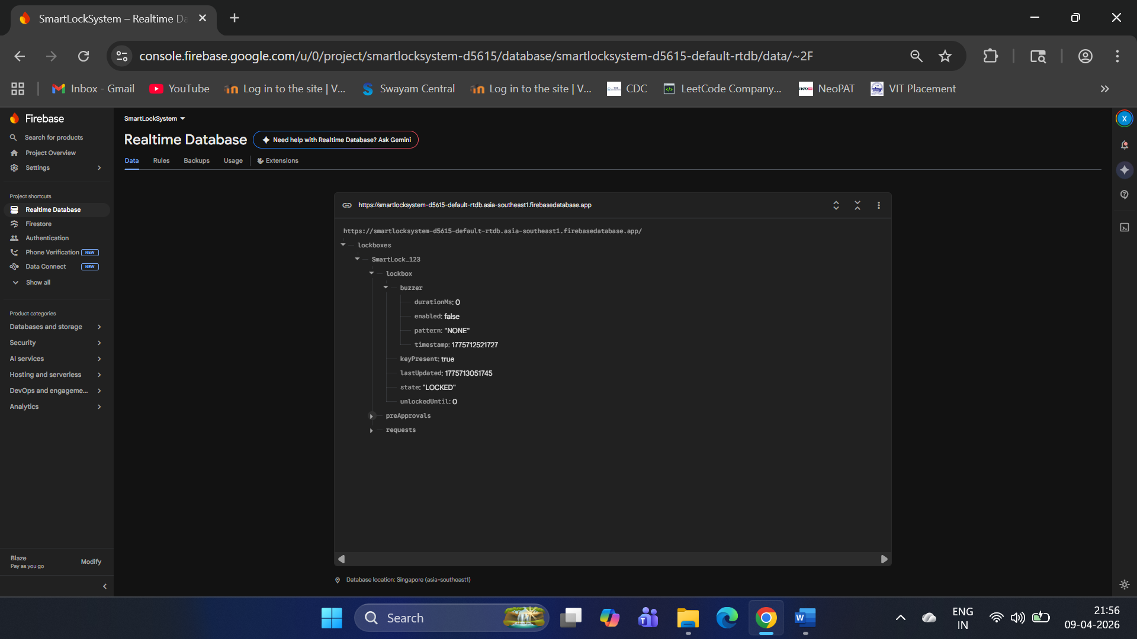
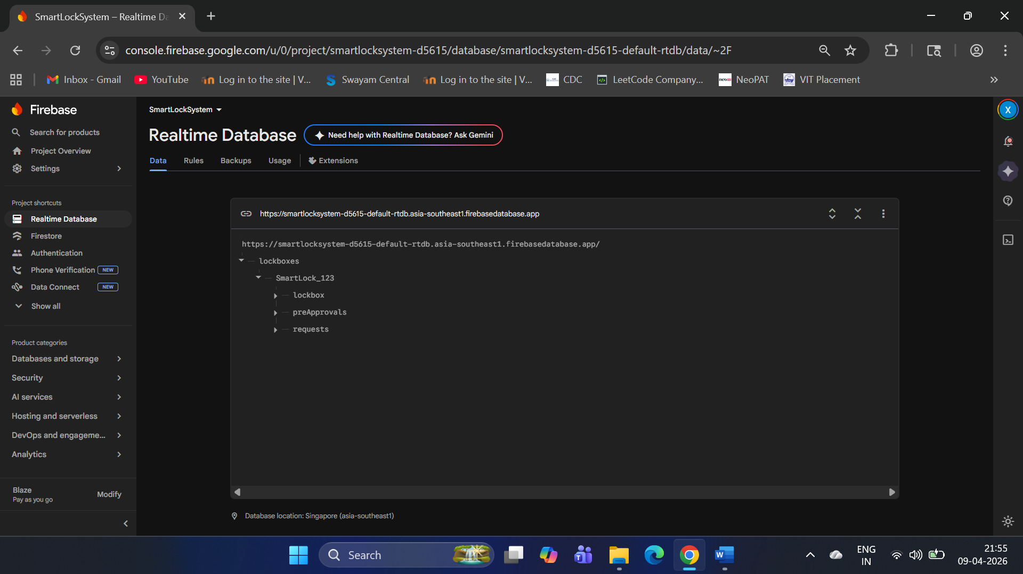
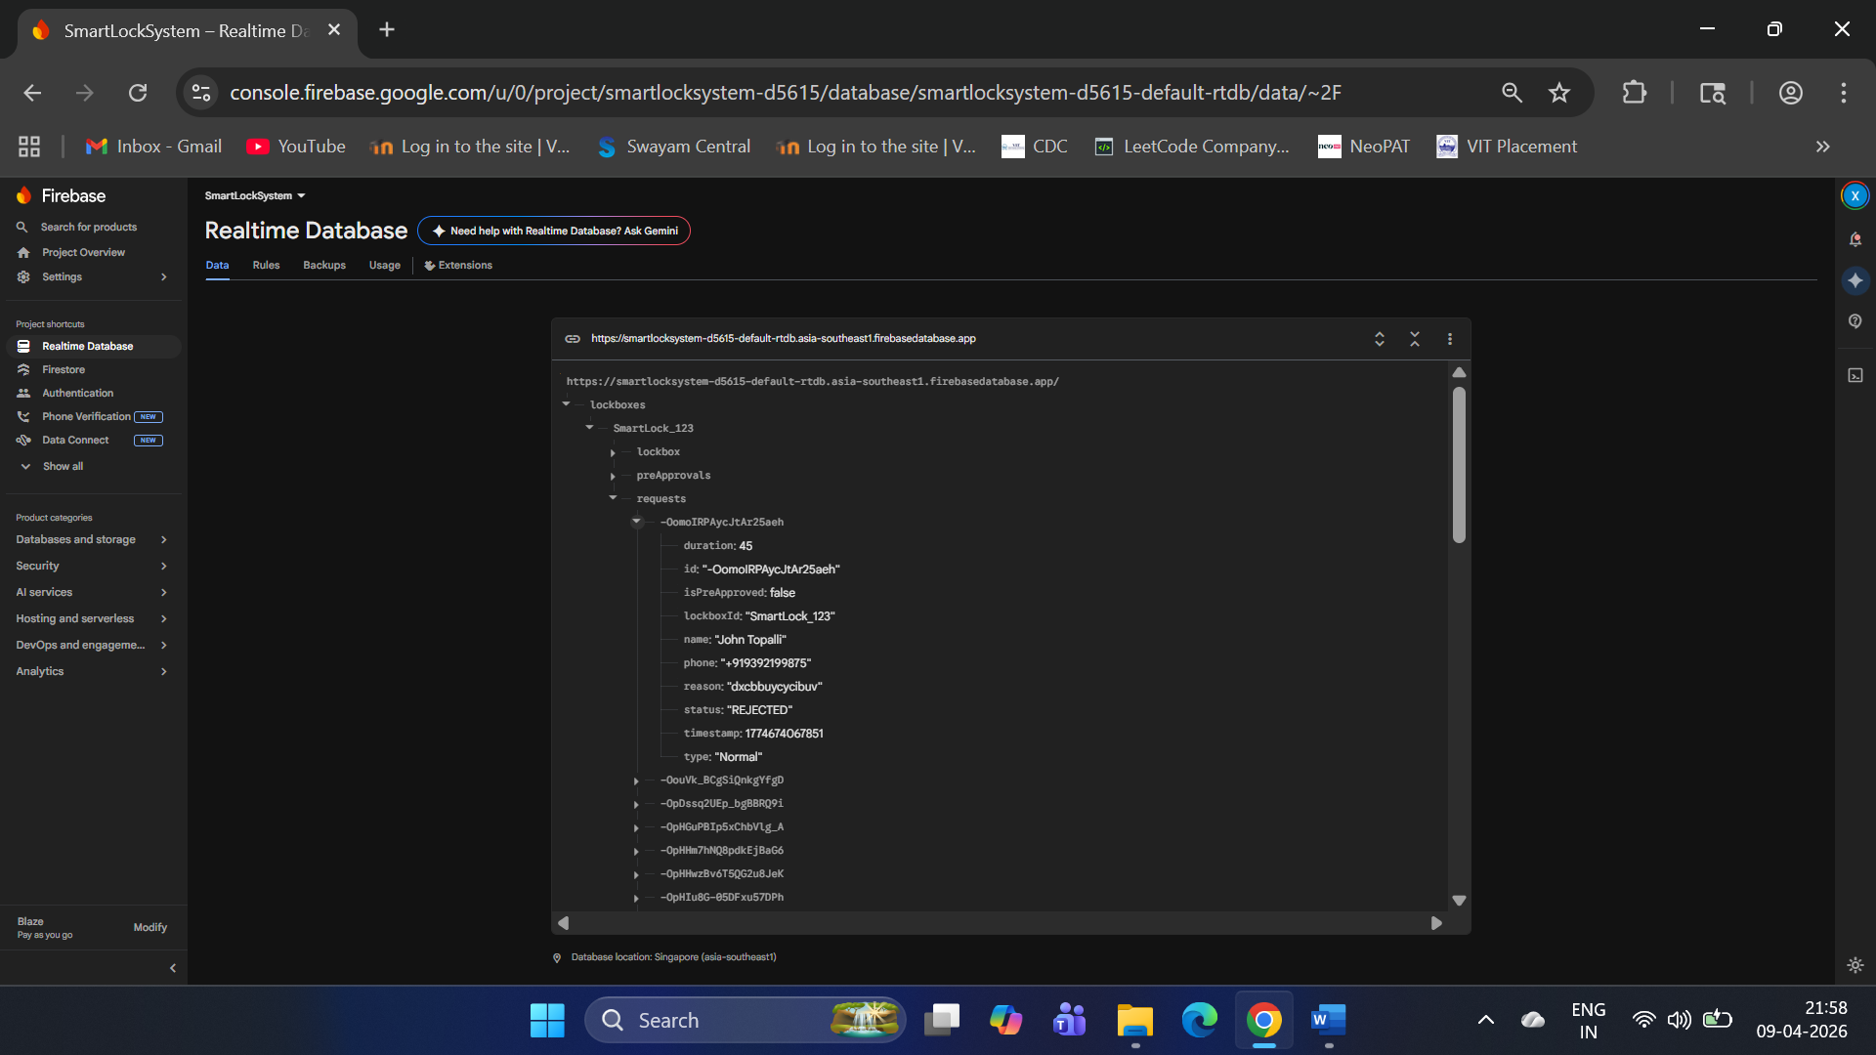
Figure 2: Different nodes in Firebase Realtime Database

3.2 Database
The system uses Firebase Realtime Database, a cloud-hosted NoSQL database that stores information in a JSON tree format. Its real-time synchronization and low-latency update model make it suitable for a reactive embedded system.
• Real-time synchronization
• Low-latency updates
• Cloud-based access
• Automatic propagation of changes
The database is organized hierarchically as follows:
lockboxes/
SmartLock_123/
lockbox/
state: "LOCKED" / "UNLOCKED"
keyPresent: true / false
buzzer/
pattern: "NONE" / "WARNING_1_MIN" / "KEY_NOT_RETURNED"
The ESP32 reads the state and buzzer pattern from Firebase, while the sensor-derived key status is written back to the same database so the website can display the live physical state.

4. Algorithm Description
The Smart Lockbox algorithm is event-driven, state-based, and divided between communication and hardware execution. The ESP32 listens to Firebase updates, converts relevant changes into command flags, and then the hardware loop performs the physical actions.
Task | Responsibility | Output
Core 0 / Network task | Reads Firebase stream and converts updates into flags | cmdOpenBox, cmdCloseBox, cmdStartBuzzer
Core 1 / Hardware task | Executes servo, buzzer, and sensor logic | Physical lock/unlock, alerts, key detection

The algorithm operates in four main stages:
1. Connect – establish Wi-Fi and Firebase connection
2. Listen – monitor Firebase for incoming updates
3. Act – execute servo, buzzer, and sensor-related actions
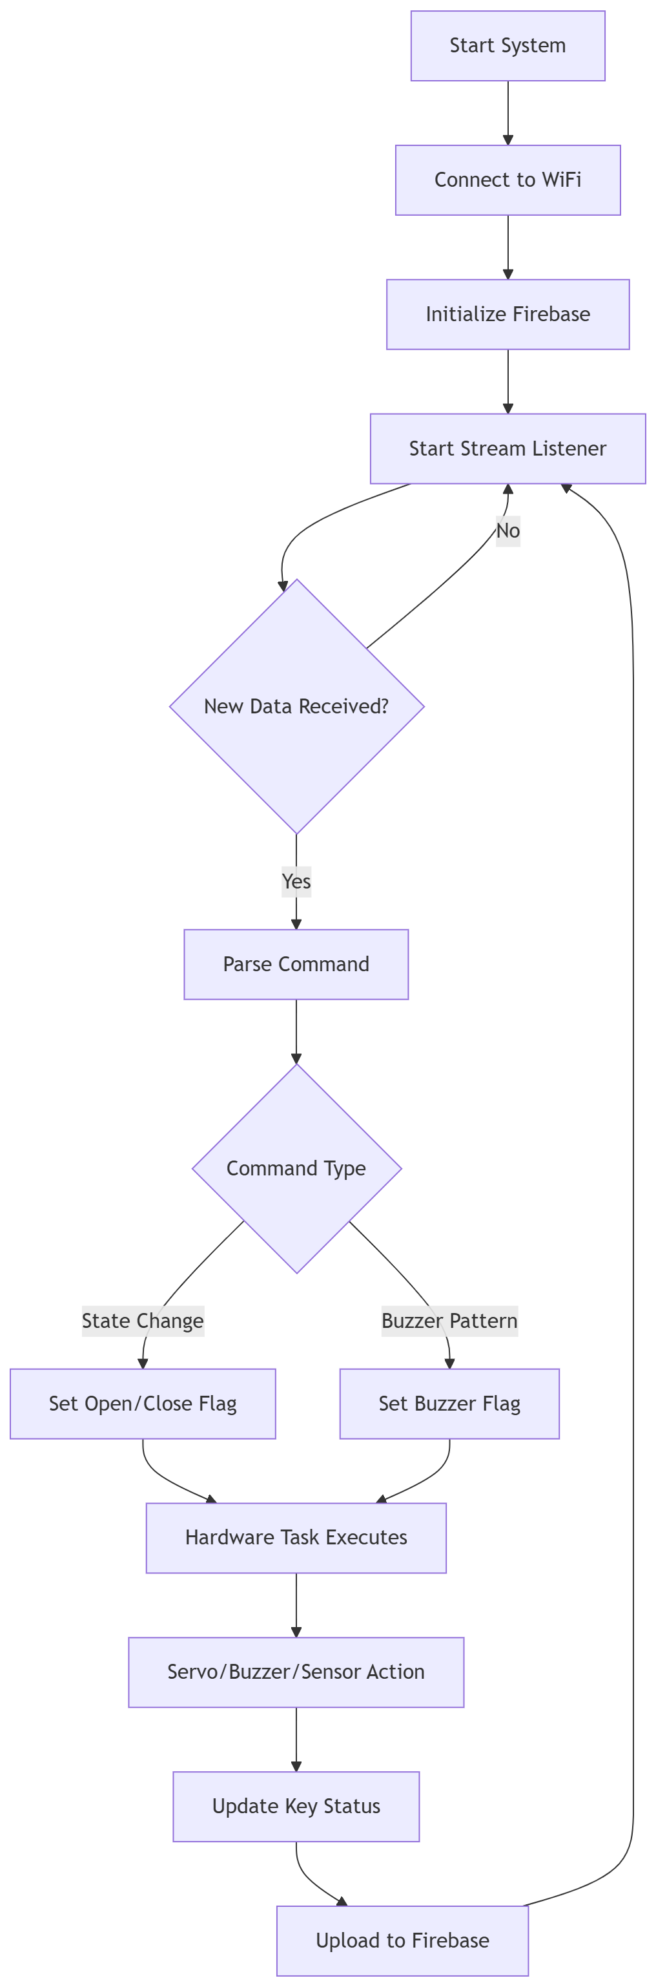
4. Report – upload key-state updates back to Firebase

Figure 3: High-level algorithm flow
Command processing is handled by the network task, which listens to Firebase stream updates.
• Read updated data from Firebase stream
• Identify the data path (/state, /buzzer/pattern)
• Convert data into internal command flags
• Avoid duplicate triggers using lastBuzzerPattern
Servo, buzzer, and sensor logic are executed locally on the ESP32.
• Servo moves only when the lock state changes
• Buzzer runs for a fixed duration with non-blocking toggling
• Ultrasonic sensor is read only during unlocked state
• Key changes are accepted only after a 1-second stability window
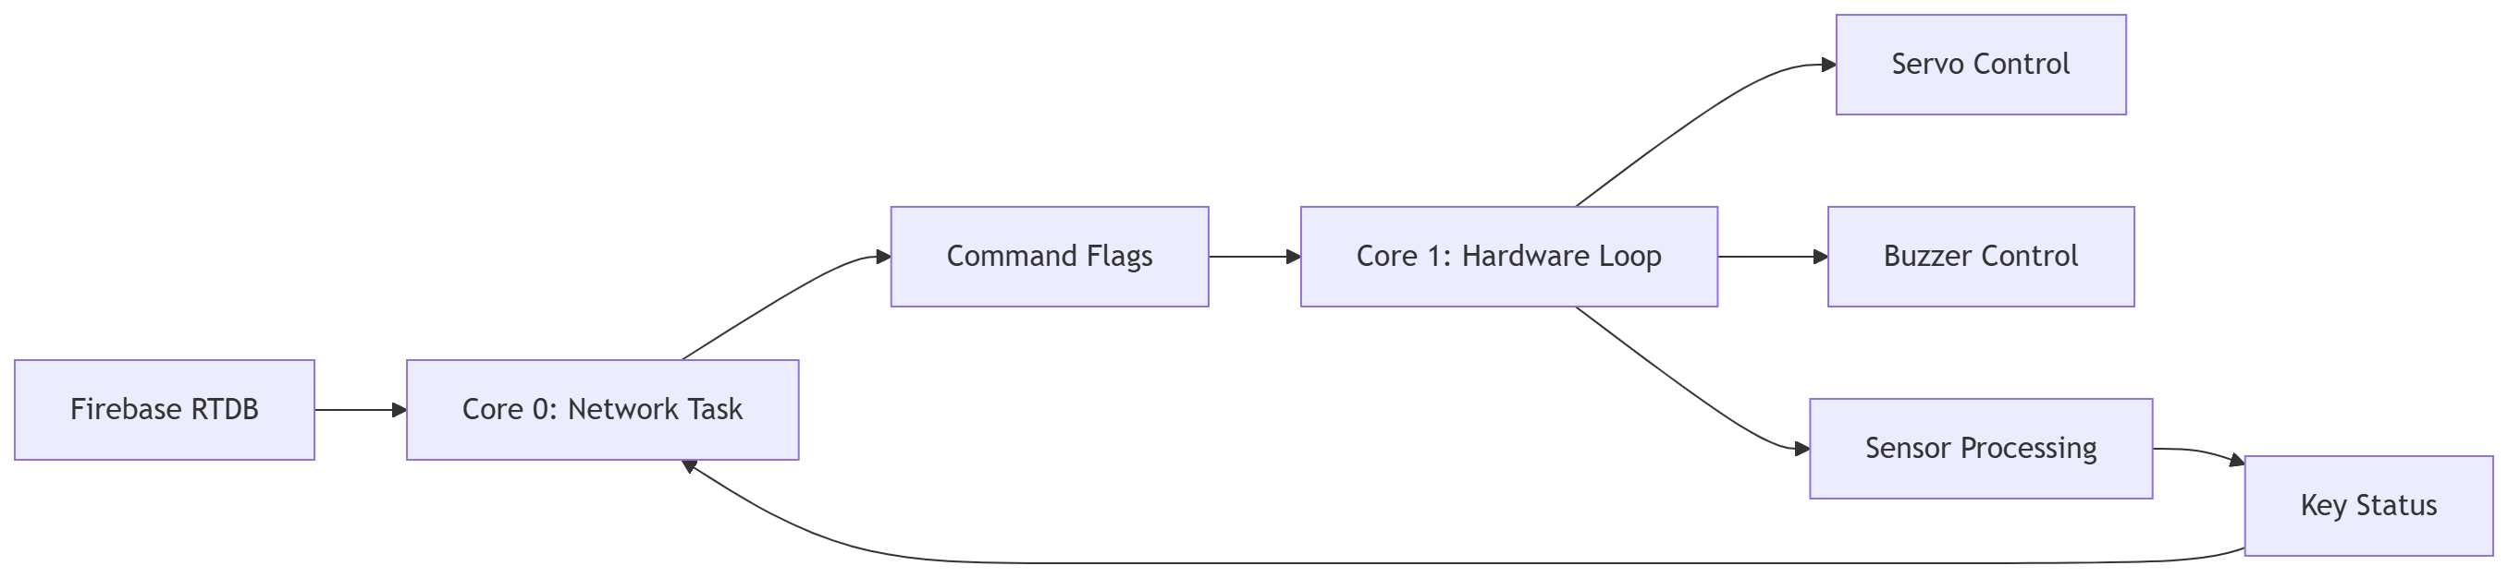
Figure 4: Dual-core execution diagram
The full source code is stored in the GitHub repository. In this report, the algorithmic behavior is emphasized rather than reproducing the entire code listing.

5. Execution of the Algorithm: Edge, Fog, and Cloud
The Smart Lockbox system executes across three layers. The cloud layer manages the web interface and access workflow, the fog layer acts as the synchronization bridge through Firebase Realtime Database, and the edge layer performs the physical operations on the ESP32 and peripherals.
Layer | Where it runs | What it does | Why it matters
Cloud | Web application and backend logic | Login, dashboard updates, logs, access requests | Enables remote control and monitoring
Fog | Firebase Realtime Database | Shared state storage between web app and ESP32 | Synchronizes commands and sensor feedback
Edge | ESP32 and peripherals | Servo motion, buzzer timing, ultrasonic sensing | Provides immediate physical response

Execution description:
• Cloud execution handles user interaction, authentication, and status display.
• Fog execution appears in Firebase, which temporarily stores commands and sensor feedback.
• Edge execution happens in the ESP32 sketch, where time-sensitive physical actions are performed locally.
[Figure 5: System-level flow from user to web app, Firebase RTDB, and ESP32 edge device]
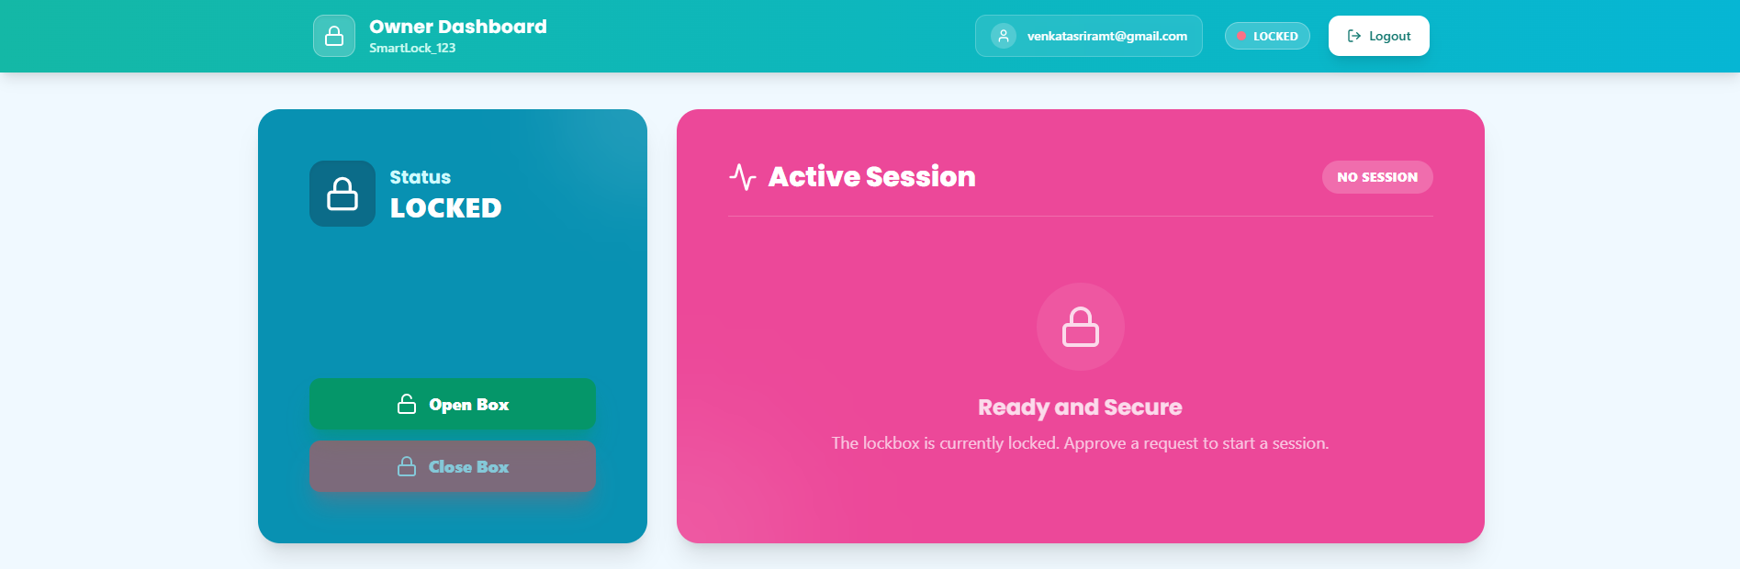
[Figure 6: Owner Dashboard showing the active session and the open and close buttons]

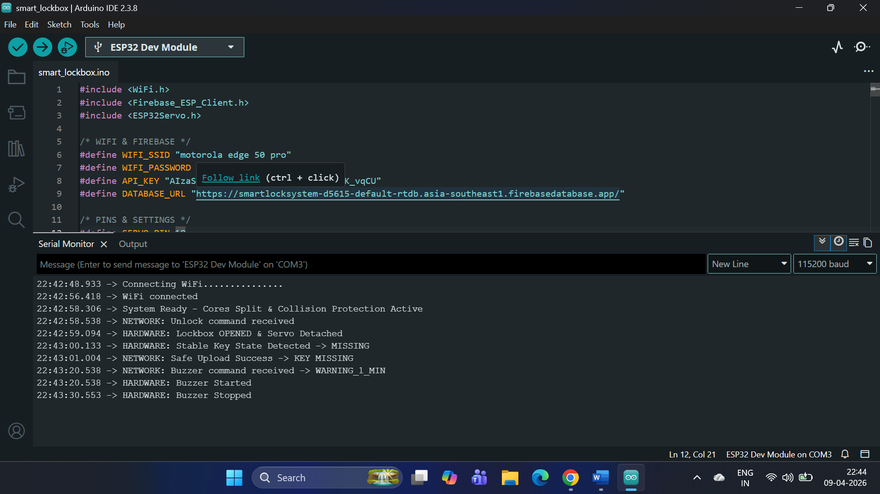
Figure 7: Logs from ESP32 showing booting (connecting to wifi) and working off servo, ultrasonic sensor and buzzer

6. User Interface
The user interface is divided into owner and guest workflows so that each user sees only the actions relevant to them. The design focuses on clarity, real-time feedback, and simple state transitions.
UI Module | Main Purpose | Key Functions
Owner Dashboard | Property management and supervision | Manage properties, grant access, view request history, monitor alerts
Guest Dashboard | Visit execution and access handling | View assigned property, unlock box, track visit status, complete visit
Status Panel | Live system feedback | Locked, unlocked, key present, key missing, buzzer active

Owner interface:
• Manage properties and lockbox entries
• Grant access for a specific user and time
• View request history and access logs
• Monitor buzzer alerts and lock state in real time
Guest interface:
• Login and verification
• View assigned property
• Unlock the lockbox
• Check visit status
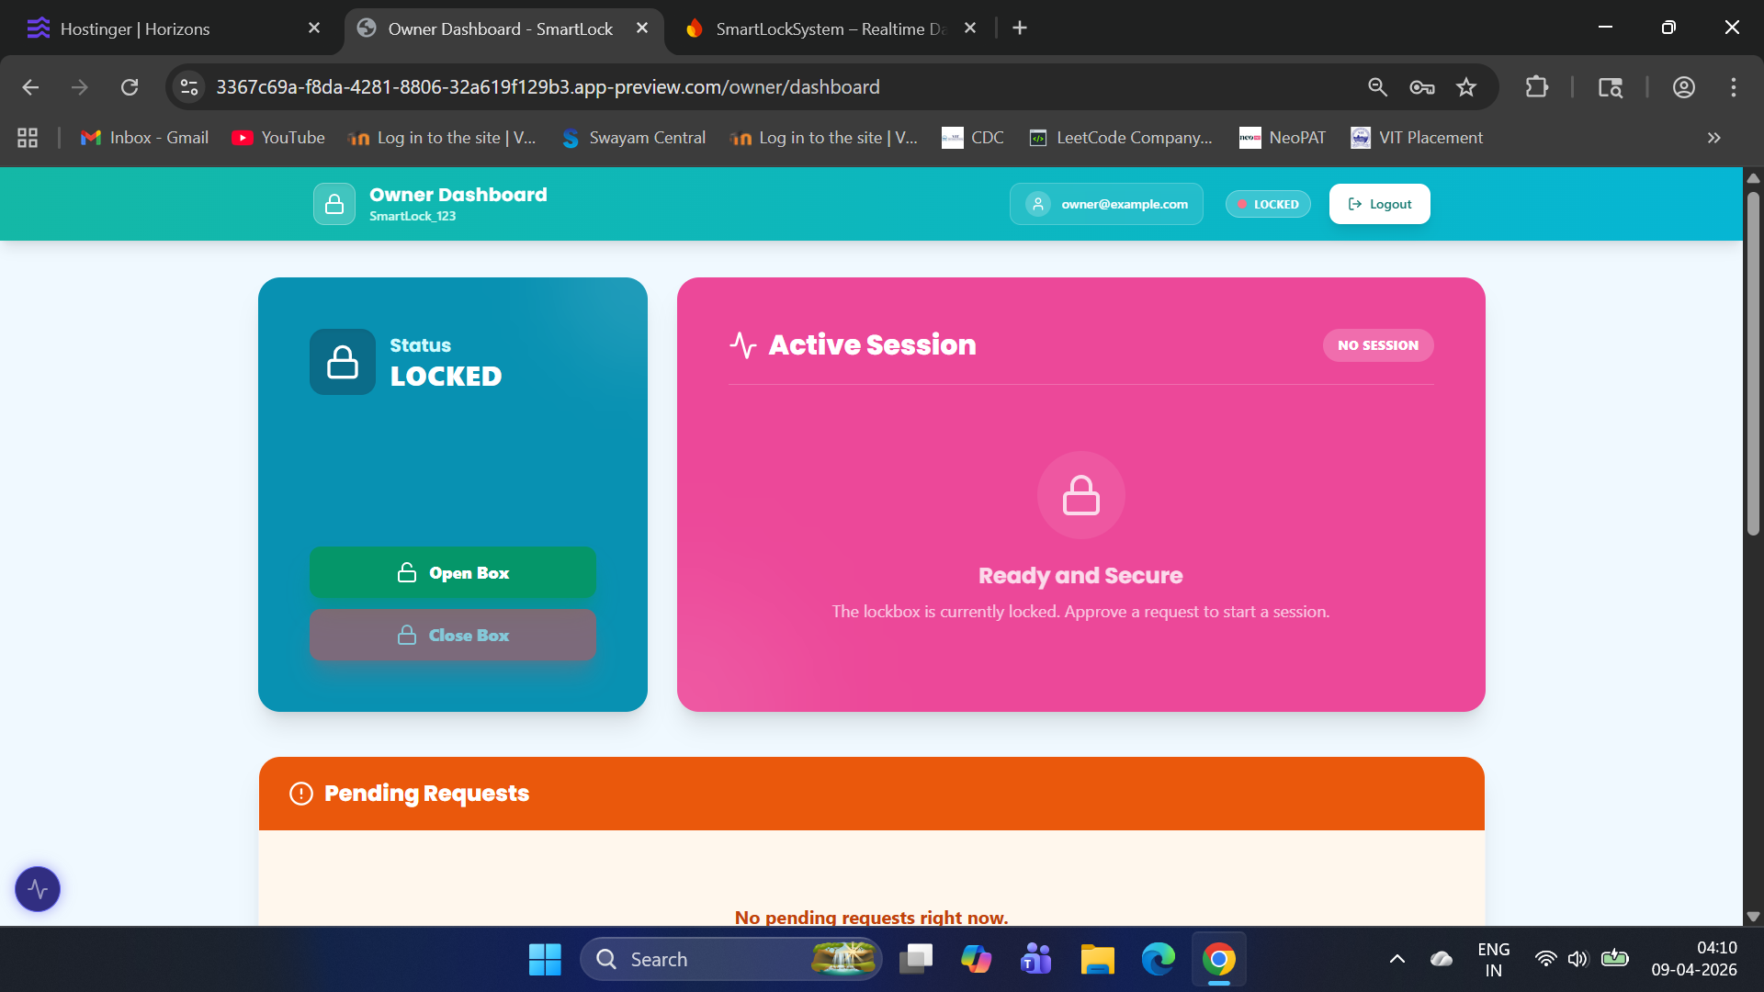
• Finish visits after returning the key
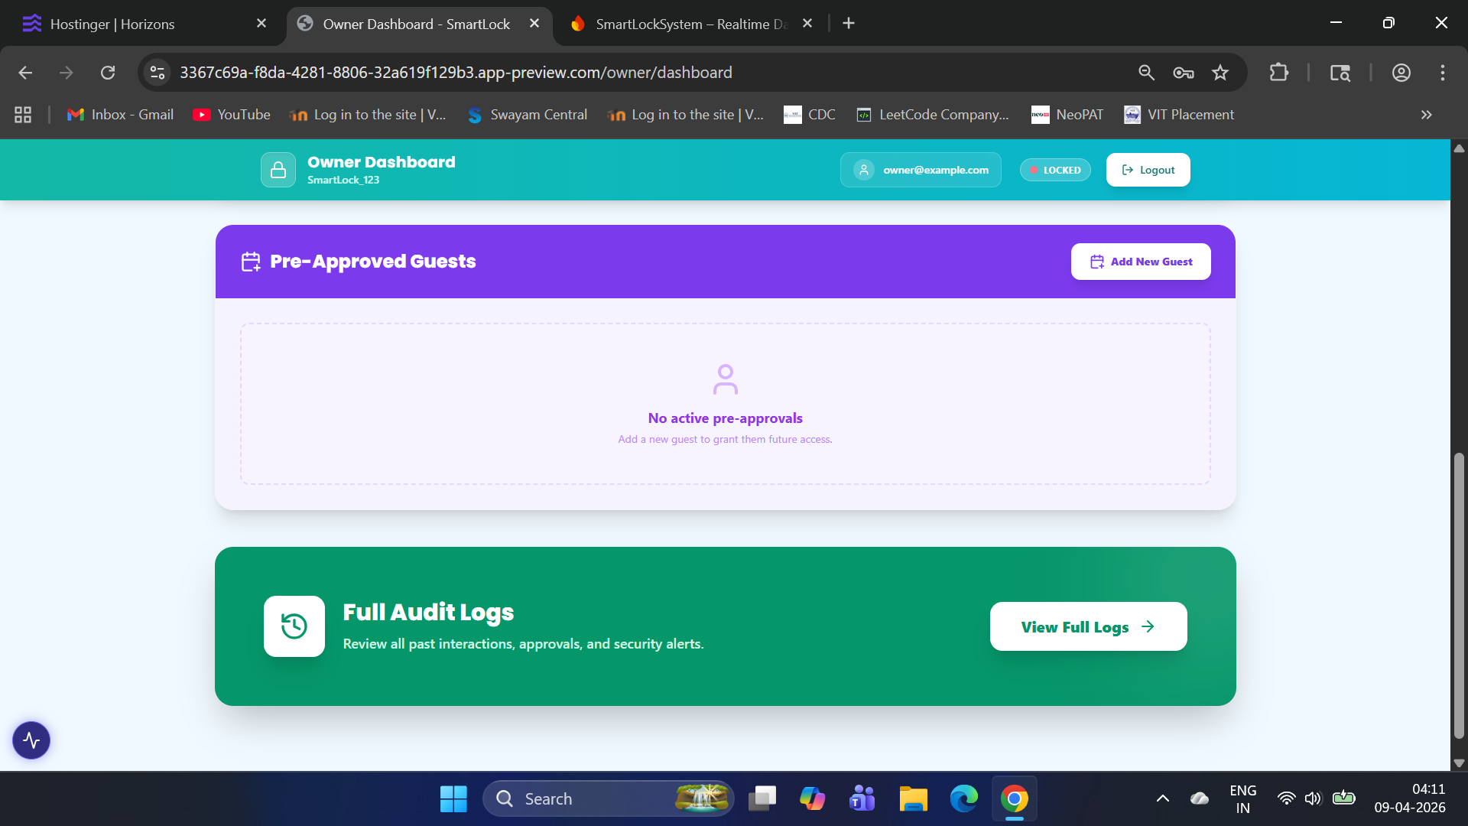
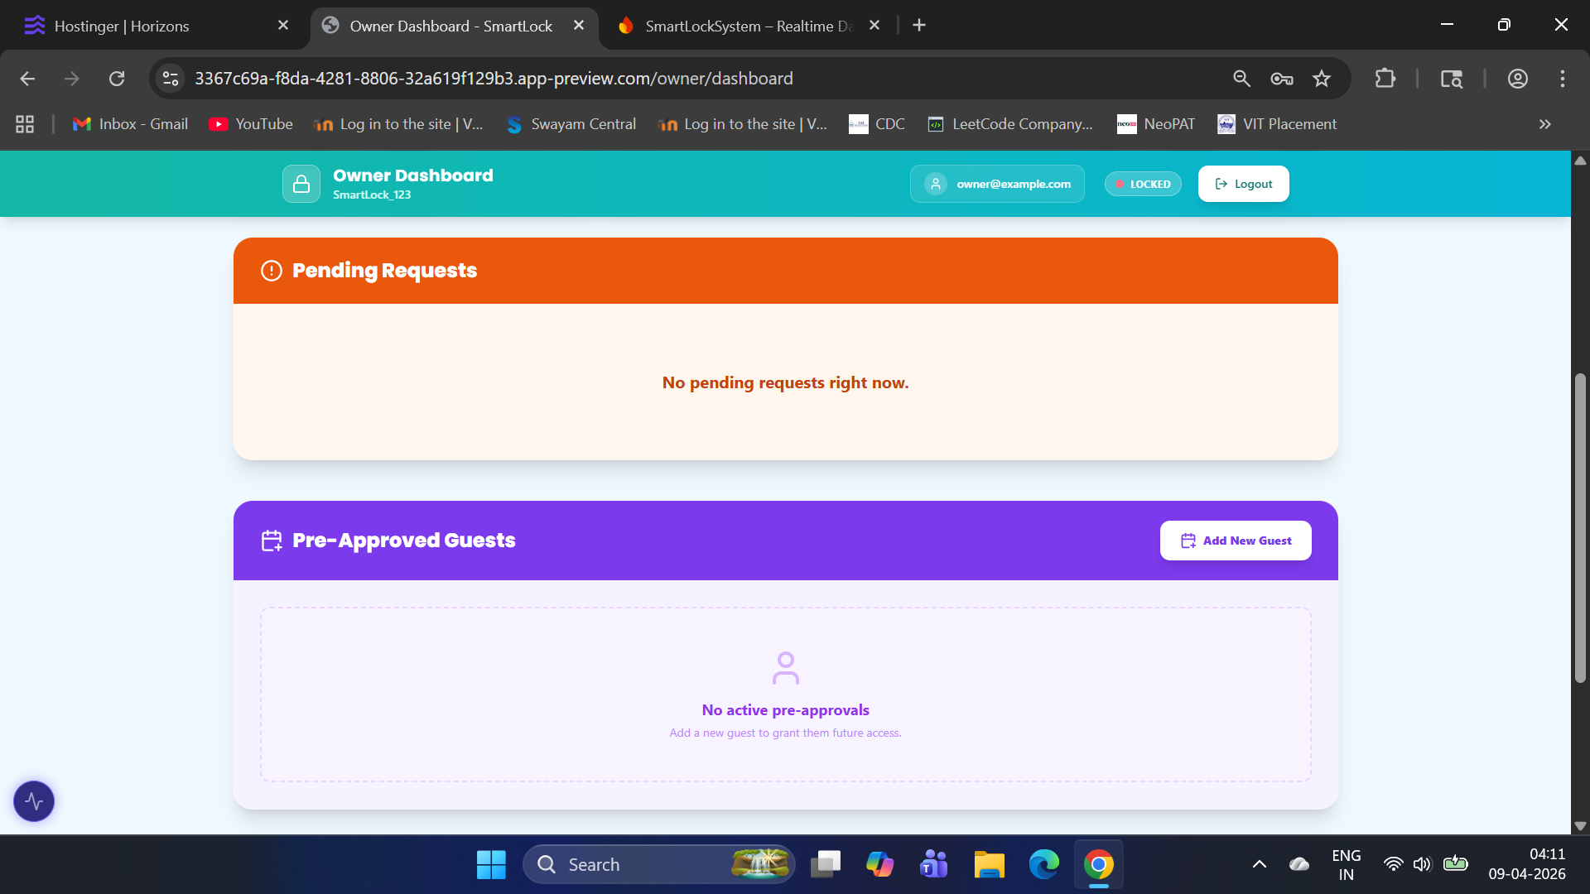
Figure 8: Owner Dashboard
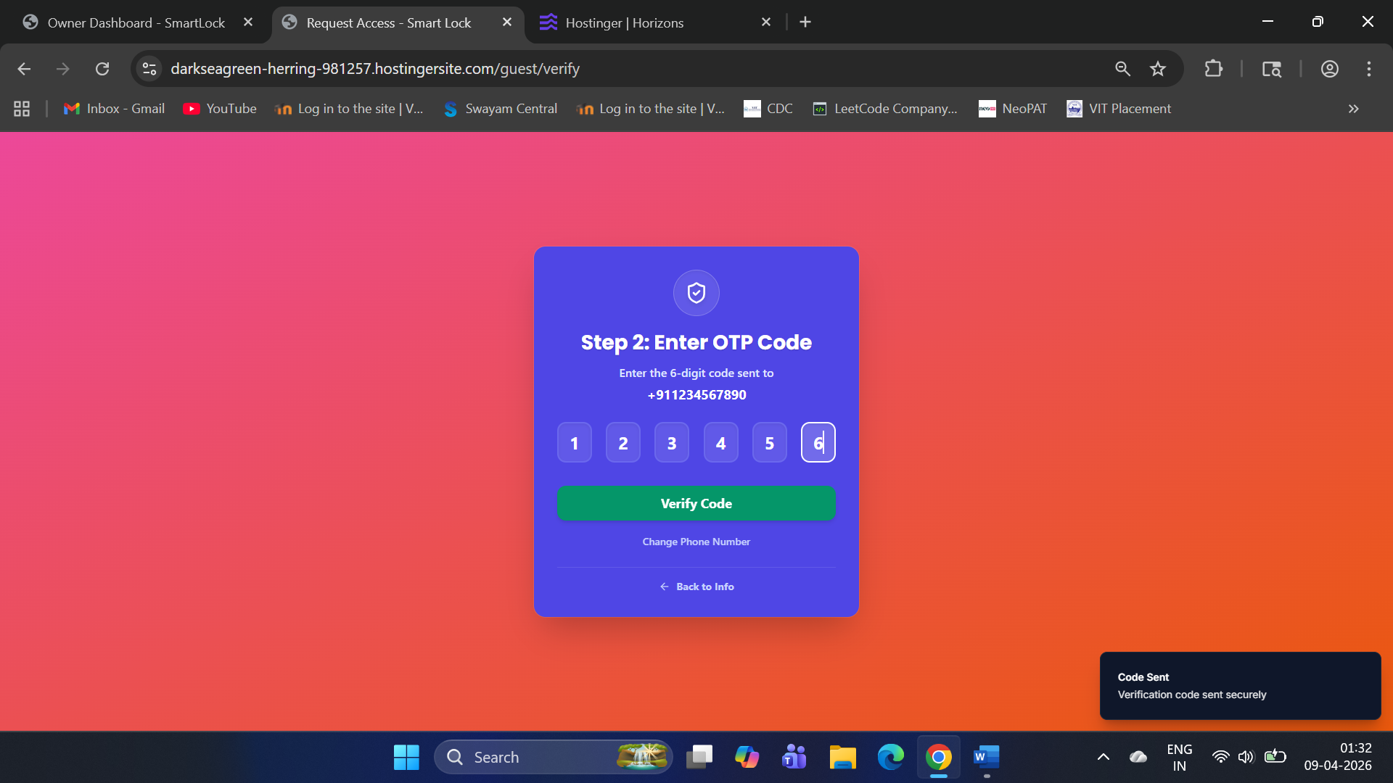
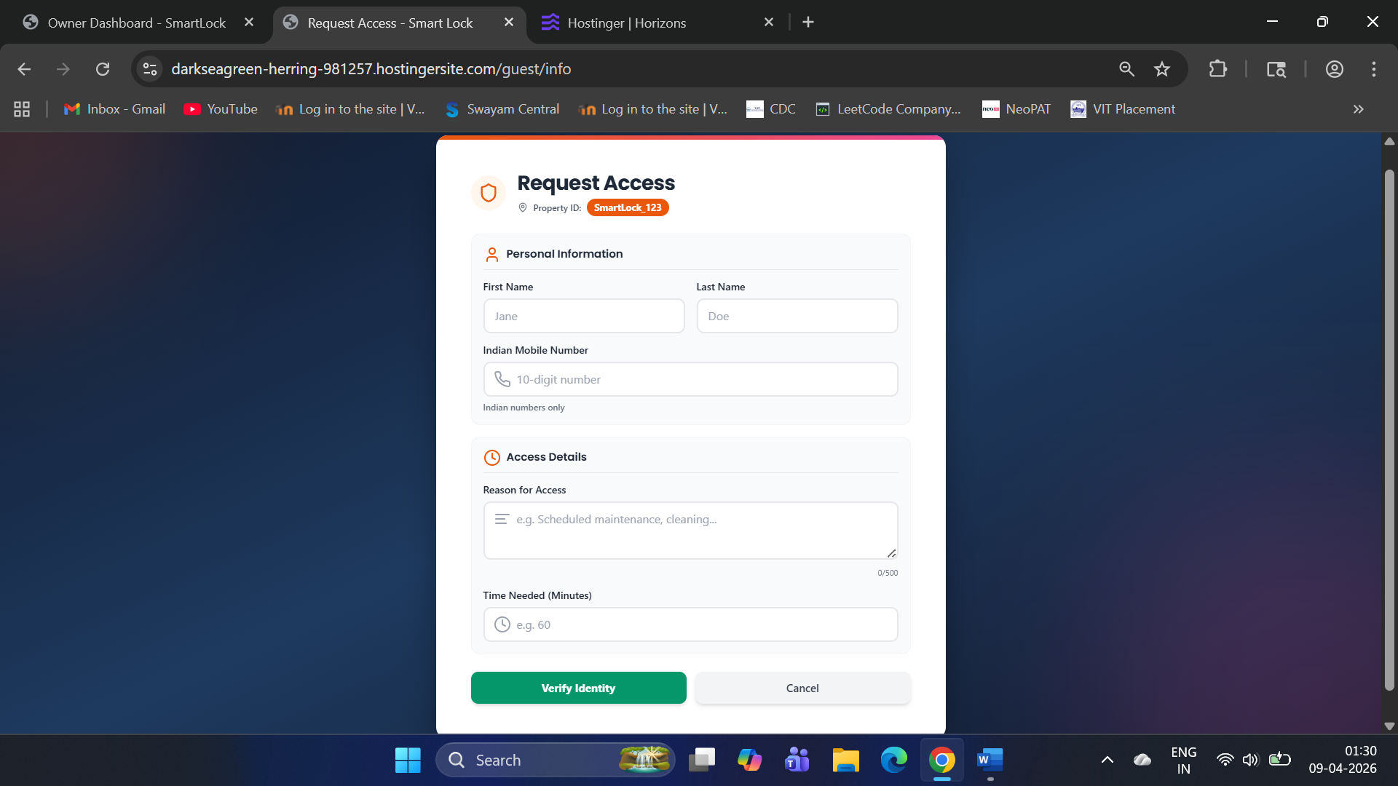
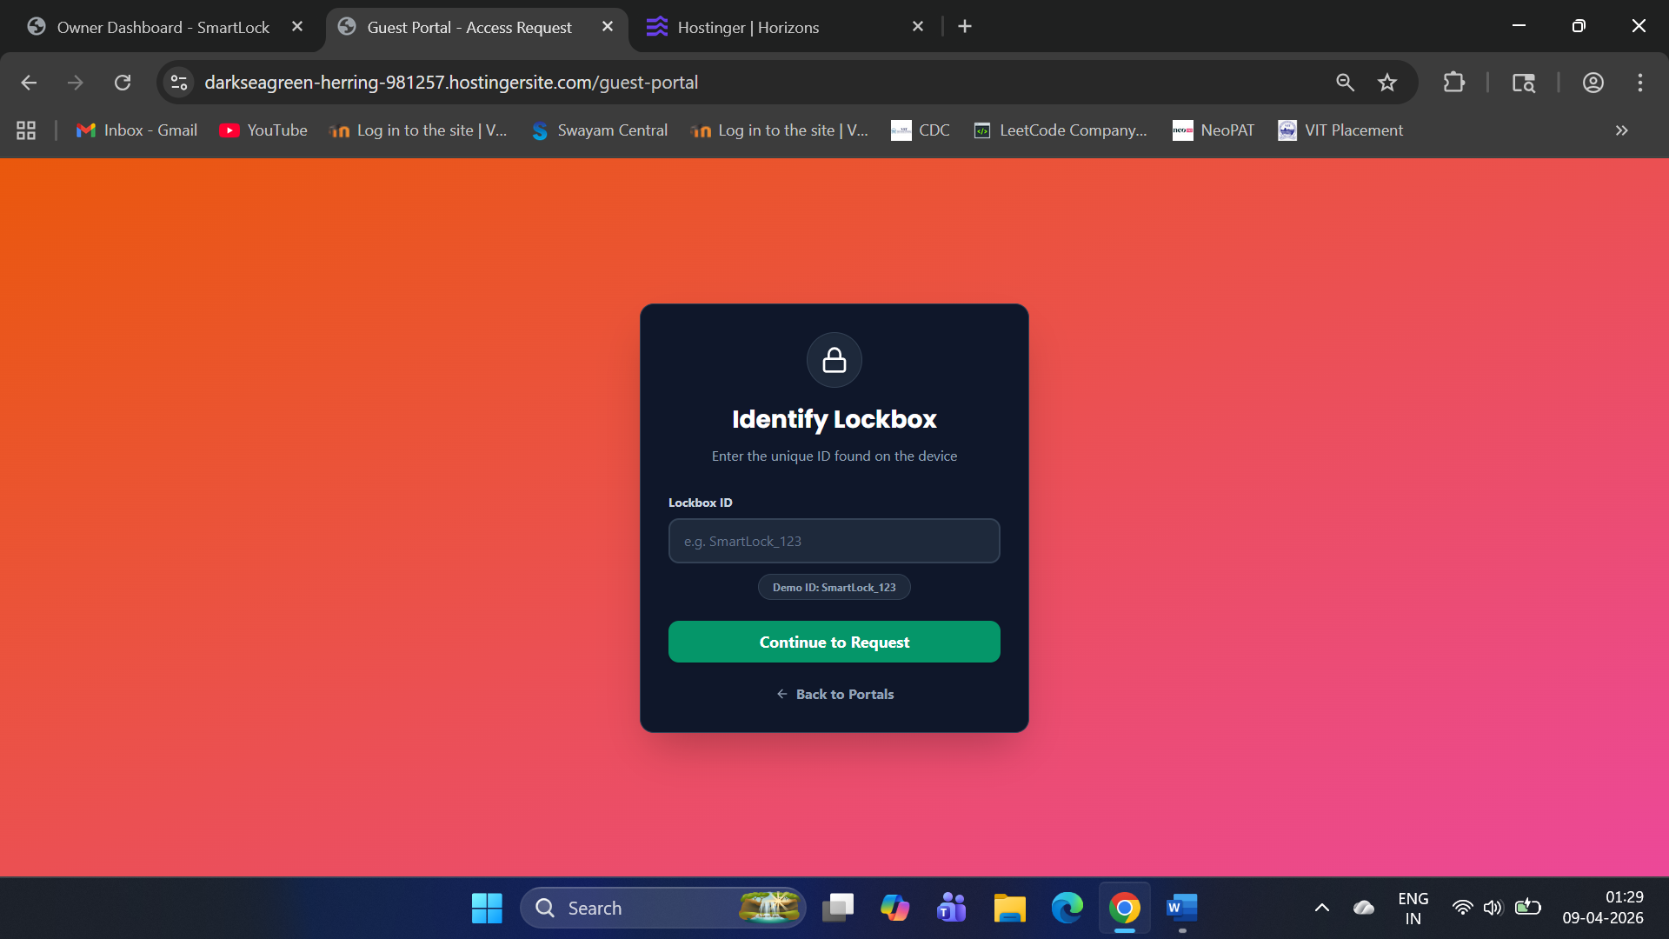
Figure 9: Guest sending a normal request workflow (entering lockbox id, filling guest details, and OTP verification)

7. Real-Time Data Handling
The Smart Lockbox system is a real-time reactive system. Instead of repeatedly polling the database, the ESP32 uses the Firebase stream API to listen for changes as they occur. This reduces delay, lowers network overhead, and improves responsiveness.
Event | Source | Action Taken | Real-Time Benefit
Lock state change | Firebase | Servo opens or closes the box | Immediate access response
Buzzer pattern update | Firebase | Starts timed alert sequence | Fast warning delivery
Key presence change | Ultrasonic sensor | Uploads updated key status | Accurate physical synchronization
Stable distance detected | ESP32 logic | Confirms key present/missing | Reduces false readings

The real-time data flow is straightforward:
• The web app updates Firebase with a new command.
• Firebase stream immediately detects the change.
• The ESP32 executes the corresponding physical action.
• Sensor results are written back to Firebase and shown in the UI.

The system uses four important real-time mechanisms:
1. Stream-based listening
2. Change-based uploading of keyPresent
3. Pattern-based buzzer control
4. Stable sensor validation



[Figure 10: Firebase stream update received by ESP32 in Serial Monitor]

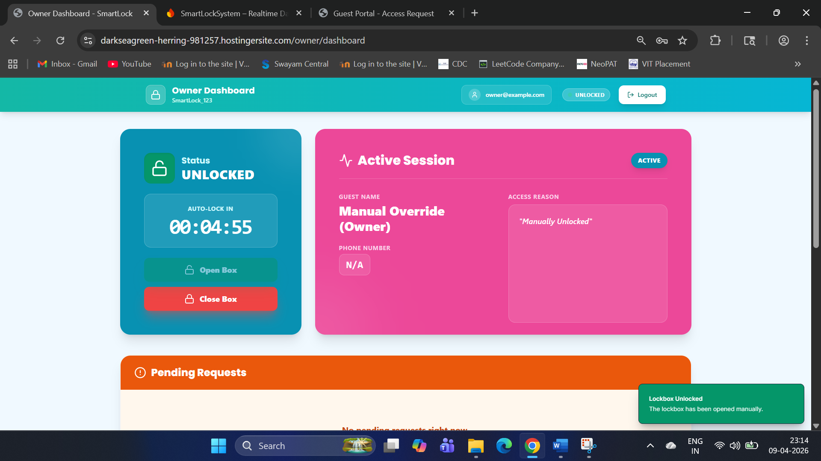
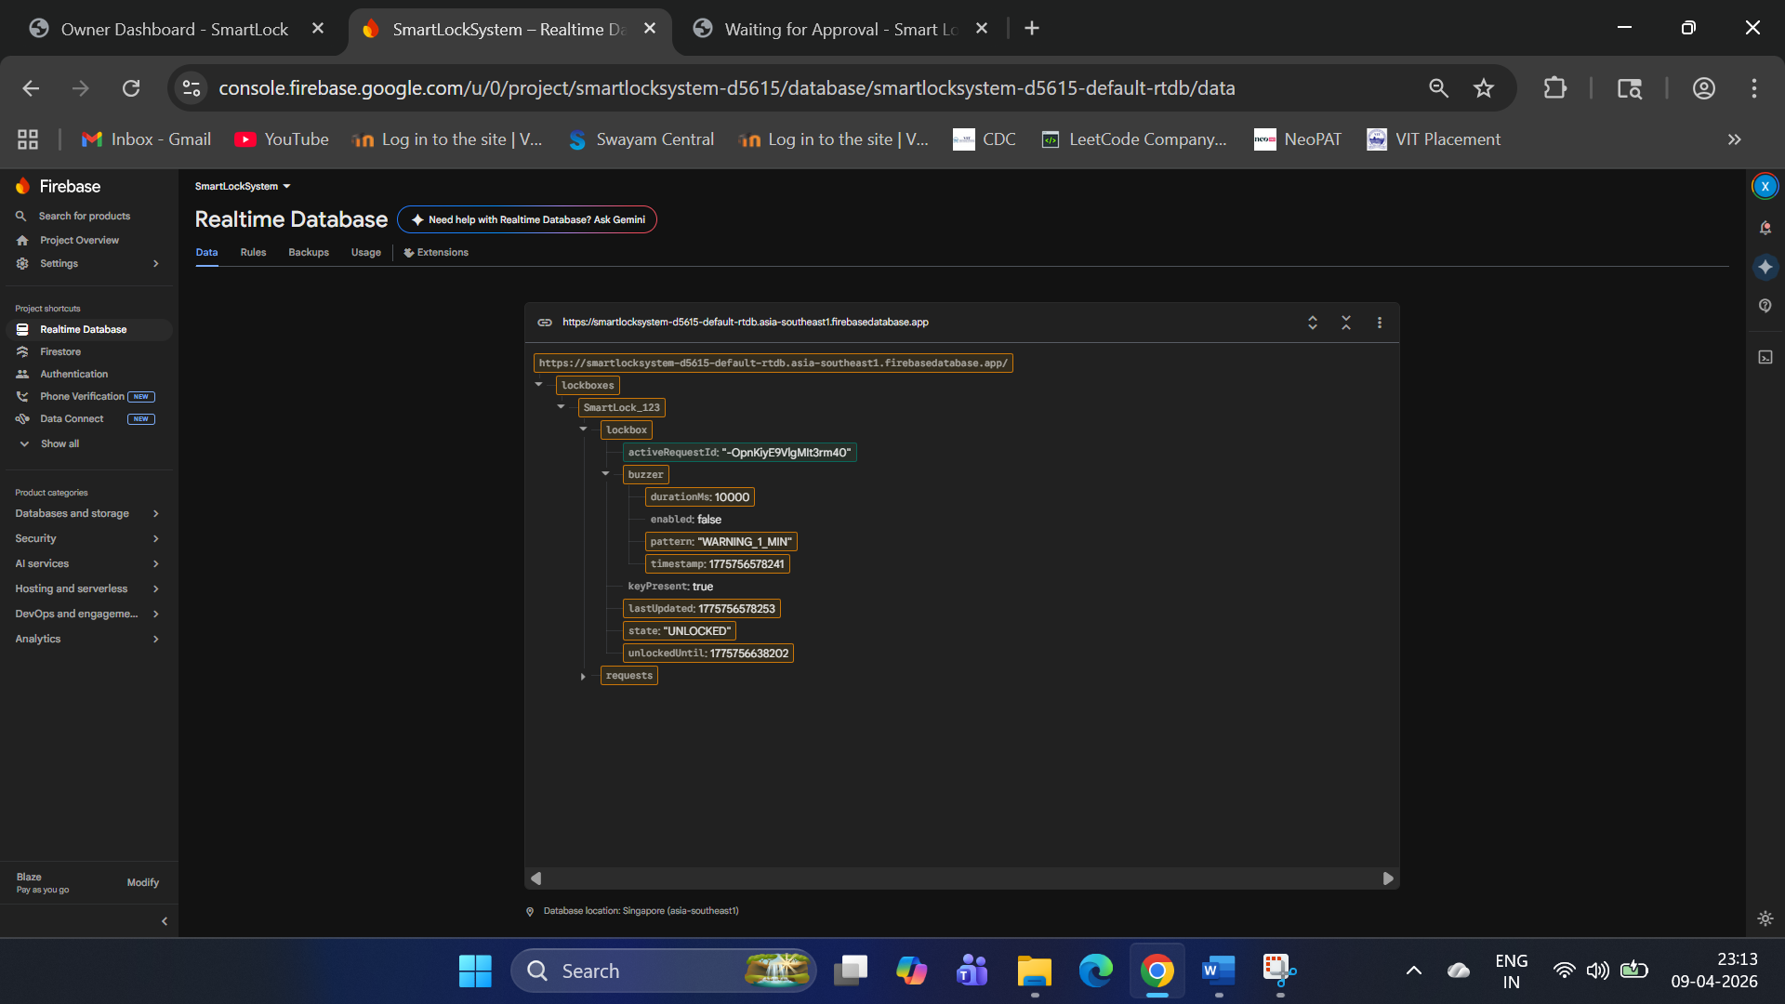
[Figure 11: Lock state changing from LOCKED to UNLOCKED in the web UI]

[Figure 12: Firebase database showing updated state, keyPresent, and buzzer/pattern]

8. Sensor Calibration and Validation
The Smart Lockbox uses an HC-SR04 ultrasonic sensor to determine whether the key is present inside the box. Because ultrasonic readings vary with mounting position, object shape, and reflection angle, the sensor is calibrated using the empty-box condition as the reference threshold.
In the current firmware, the empty range is set between 7.0 cm and 8.5 cm. Readings inside this range are treated as key missing; readings outside are treated as key present. A stable reading is required before a new state is accepted and uploaded to Firebase.
Stage | Method | Purpose | Outcome
Empty-box baseline | Measure distance without the key | Find the normal vacant-slot range | Set EMPTY_LOW and EMPTY_HIGH
Occupied-box baseline | Place the key in its normal position | Confirm presence detection | Validate true-positive reading
Stability test | Repeat readings over time | Check consistency | Use debounce and 1-second confirmation window
Functional validation | Remove and reinsert the key | Verify state transitions | Update keyPresent only after stable change

Calibration logic:
• If the measured distance is inside the empty range, the slot is considered empty.
• If the measured distance is outside the empty range, the slot is considered occupied.
• A stable reading is required before changing the database value.
Validation method:
1. Keep the box empty and observe the baseline readings.
2. Place the key back in the holder and verify the occupied reading.
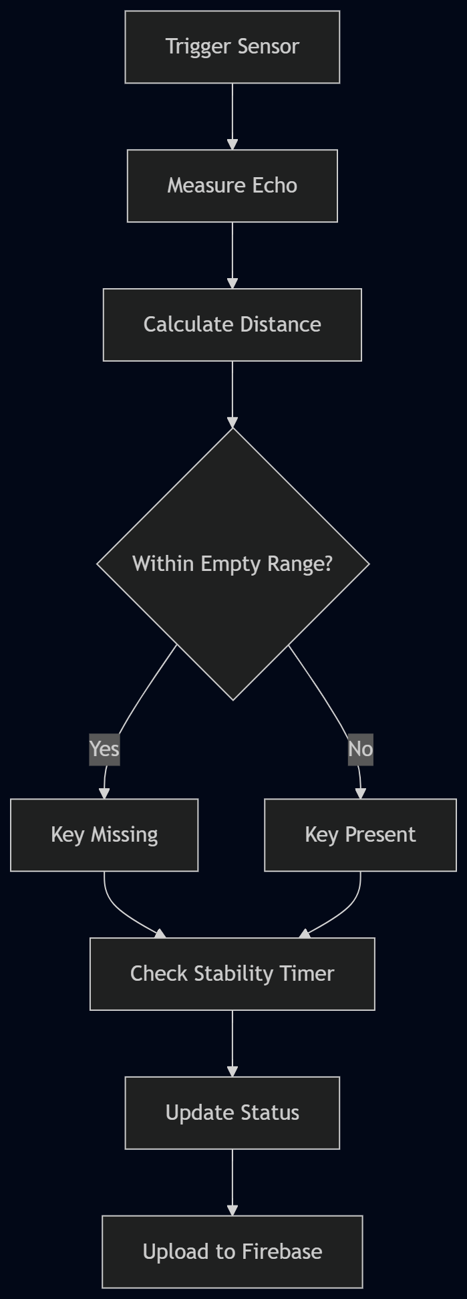
3. Remove the key again and confirm that the database changes only after stability.

[Figure 13: Sensor validation flow]
Condition | Expected Reading | System Interpretation | Database Action
Slot empty | 7.0–8.5 cm | Key missing | Upload keyPresent = false
Key in place | Outside empty range | Key present | Upload keyPresent = true
Reading fluctuates | Varies slightly | Ignore until stable | No immediate update
State change confirmed | Stable for 1 second | Valid transition | Write new value to Firebase

9. Test Cases
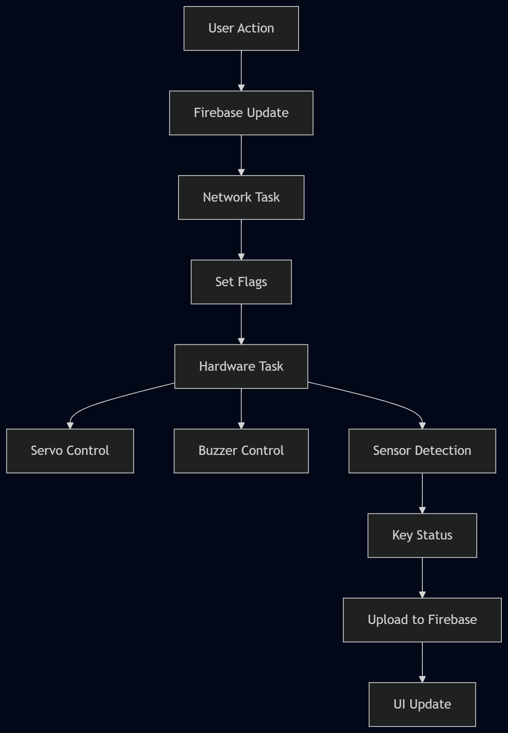
The following test cases cover the main functional behavior of the prototype and validate the lock/unlock workflow, buzzer behavior, and key detection logic.
Test Case | Input | Expected Result | Observed in Code | Status
TC1 | UNLOCKED command | Servo opens, system becomes active | cmdOpenBox flag is set | Pass
TC2 | LOCKED command | Servo closes and detaches | cmdCloseBox flag is set | Pass
TC3 | WARNING_1_MIN pattern | Buzzer beeps for 10 seconds | Timed beep sequence starts | Pass
TC4 | Key removed while unlocked | keyPresent becomes false | Distance crosses empty threshold | Pass
TC5 | Key returned after absence | keyPresent becomes true | Stable reading uploads after debounce | Pass
TC6 | Repeated same alert | Alert should not restart | lastBuzzerPattern blocks duplicate triggers | Pass

[Figure 14: Functional flow for command, sensor, and buzzer validation]

10. Metrics and Evaluation
The system is evaluated using execution time, response time, memory usage, power consumption, communication reliability, and sensor accuracy. Because the project is embedded and real-time in nature, response time and detection accuracy are the most important metrics.
Metric | Measurement Method | Formula / Basis | Why it Matters | Current Observation
Execution time | Measure delay from command reception to servo action | Command-to-actuation latency | Shows time efficiency | Reduced by flag-based execution and short loop delay
Space efficiency | Estimate RAM and flash usage | Code size and variable footprint | Shows resource efficiency | Small state set; library-based abstraction
Power efficiency | Measure current in idle and active mode | Idle current vs active current | Important for battery life | Servo detached after motion; sleep optimization possible
Response time | Time from Firebase update to hardware response | Firebase update → physical action delay | Shows real-time behaviour | Stream-based updates reduce delay
Communication efficiency | Count successful, lost, or repeated updates | PDR, packet loss, duplicate avoidance | Shows network reliability | Retry and state comparison reduce repeats
Sensor accuracy | Compare ultrasonic result with manual key check | Correct detections / total tests | Ensures reliable key detection | Calibration range already defined in firmware

Estimated performance ranges (prototype-level observations):
Metric | Typical / Estimated Value
State-change delay | ~100–300 ms
Sensor distance band | 7.0–8.5 cm
Alert duration | ~10 seconds
Update frequency | ~100–150 ms cycle

11. Qualitative and Quantitative Measures
Qualitative measures focus on usability, clarity, and real-world behavior.
Aspect | Description | Observation
User clarity | UI clearly shows lock and key status | Users can easily understand system state
Operational simplicity | Minimal steps to unlock and complete visit | Smooth owner and guest workflows
Physical behavior | Servo and sensor reflect real actions | Lockbox behaves predictably
Alert visibility | Buzzer and UI alerts are noticeable | Alerts are clear and timely

Quantitative measures focus on measurable system performance.
Metric | What is Measured | Typical / Estimated Value
State-change delay | UI command → hardware action | ~100–300 ms
Sensor distance band | Empty range calibration | 7.0–8.5 cm
Alert duration | Buzzer active time | ~10 seconds
Update frequency | Sensor and database updates | ~100–150 ms cycle

12. Hardware Prototype and Working Model
The hardware prototype is organized as a closed-loop embedded system made up of four main subsystems: the controller, sensor, actuator, and alert unit. Together, these parts allow the Smart Lockbox to receive remote commands, physically unlock or lock the box, detect whether the key has been returned, and notify the user through sound and database updates.
Subsystem | Role | Working Behavior
ESP32 Controller | Main control unit | Connects to Wi-Fi, reads Firebase, executes logic
Servo Motor | Lock actuator | Opens and closes the box on command
Ultrasonic Sensor | Key detection unit | Detects key presence only during unlocked state
Buzzer | Alert unit | Produces timed warning pattern
Firebase Database | Communication layer | Stores lock state, key status, and buzzer commands

Working model sequence:
1. ESP32 boots and establishes Wi-Fi connection.
2. Firebase is initialized and the stream listener starts.
3. Servo is initialized in the locked position.
4. When an UNLOCKED command arrives, the servo opens the box.
5. During the unlocked period, the ultrasonic sensor monitors key presence.
6. If the key is removed or returned, the system waits for stability before updating Firebase.
7. If an alert pattern is received, the buzzer sounds for the defined duration.
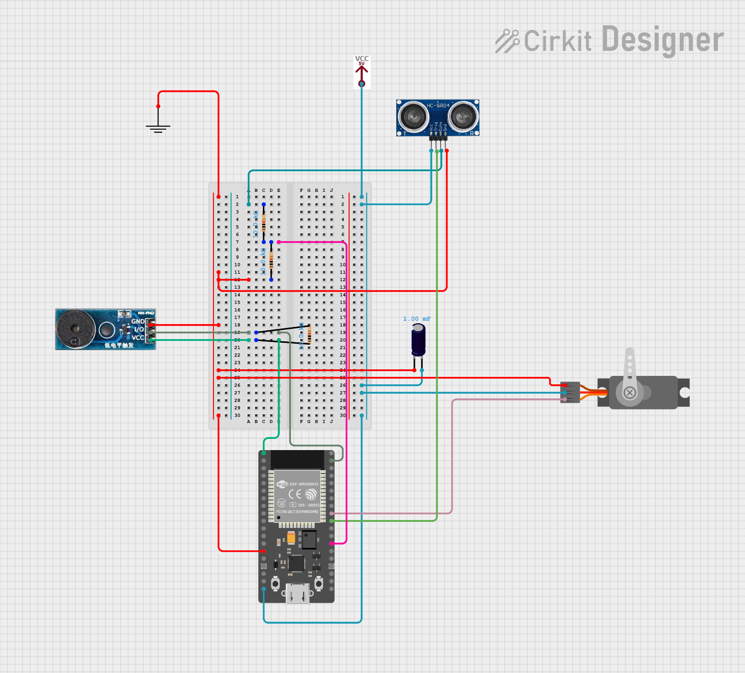
8. After the action completes, the system returns to monitoring mode.

[Figure 15: Full circuit diagram showing ESP32, servo, ultrasonic sensor, and buzzer]

12.1 Wiring Details

12.1.1 Electrolytic Capacitor
- Negative (-) Pin: Connected to GND (common ground).
- Positive (+) Pin: Connected to VCC 5V and ESP32 5V pin.

12.1.2 Buzzer Module
- GND Pin: Connected to GND (common ground).
- Vcc Pin: Connected to ESP32 3.3V pin.
- I/O Pin: Connected to ESP32 GPIO 23 (VSPI MOSI) through a 10k Ohm resistor.

12.1.3 Servo
- GND Pin: Connected to GND (common ground).
- VCC Pin: Connected to VCC 5V.
- PWM Pin: Connected to ESP32 GPIO 18 (VSPI CLK).

12.1.4 Sensor - Ultrasonic HC-SR04
- Trig Pin: Connected to ESP32 GPIO 5 (VSPI CS).
- Echo Pin: Connected to ESP32 GPIO 4 through a 10k Ohm resistor.
- GND Pin: Connected to GND (common ground).
- VCC Pin: Connected to VCC 5V.

12.1.5 VCC 5V
- VCC Pin: Provides 5V power to the circuit.

12.1.6 ESP32 38-PIN
- GND Pin: Connected to GND (common ground).
- 5V Pin: Connected to VCC 5V.
- 3.3V Pin: Connected to Buzzer Module Vcc pin.
- GPIO 23 (VSPI MOSI): Connected to Buzzer Module I/O pin through a 10k Ohm resistor.
- GPIO 18 (VSPI CLK): Connected to Servo PWM pin.
- GPIO 5 (VSPI CS): Connected to Sensor Trig pin.
- GPIO 4: Connected to Sensor Echo pin through a 10k Ohm resistor.

12.1.7 GND
- GND Pin: Common ground connection for all components.

12.1.8 Resistors (10k Ohms)
- Resistor 1: Connected between Buzzer Module I/O pin and ESP32 GPIO 23.
- Resistor 2: Connected between Sensor Echo pin and ESP32 GPIO 4.
- Resistor 3: Used in the ground network.

13. Comparative Analysis with Existing Solutions
The proposed lockbox can be compared against commercial alternatives in terms of cost, connectivity, offline behavior, key monitoring, auditability, and customization. The comparison highlights the main differentiator of the student-built prototype: low cost and full control over both code and user interface.
Aspect | Your Smart Lockbox (ESP32 + Firebase) | Master Lock Smart Lockbox | Igloohome Smart Lockbox
Cost | Medium-cost prototype | High / premium branded product | High / premium smart solution
Connectivity | Wi-Fi + Firebase real-time sync | Bluetooth + proprietary app | Bluetooth + offline PIN system
Cloud integration | Open Firebase backend | Closed ecosystem | Partial cloud + offline hybrid
Offline capability | Limited / future scope | Limited | Strong via algoPIN
Key monitoring | Ultrasonic-based key detection | Not typically available | Not typically available
Audit logs | Possible via Firebase | Limited to vendor ecosystem | Advanced time-based access logs
Customization | Fully customizable | Very limited | Limited to vendor-defined features
Main advantage | Low cost + full control | Reliable hardware | Works without internet
Main limitation | Prototype-level robustness | Expensive and less flexible | Expensive and closed system

The comparison indicates that the prototype fills an important gap between affordability and functionality. Commercial solutions are polished, but the student-built system provides stronger customizability and the unique feature of key-return monitoring.
Cost: -
ESP32 WROOM 32 - ₹634.00
4 Ni-MH Batteries with charger - ₹855.00
3 10 kΩ resistors - ₹10.00
Breadboard - ₹59.00
Wires and jumper cables - ₹ 107.00
Ultrasonic Sensor - ₹ 75.00
Battery pack holder - ₹ 40.00
TowerPro MG90S Micro Servo (180° rotation) - ₹ 150.00
ADIY Active Buzzer Module - ₹ 20.00
1000µF Capacitor - ₹ 20.00
Website Development - ₹ 9490.98
Firebase - ₹ 20.00

Total Cost: - ₹ 11480.98

14. Conclusion
The Smart Lockbox project demonstrates a complete embedded-to-cloud control loop. The ESP32, ultrasonic sensor, servo motor, buzzer, Wi-Fi link, and Firebase database work together to deliver a practical access-management system. The most important strengths of the implementation are the real-time synchronization architecture, the state-based firmware, and the key-return monitoring concept.
The combined manuscript brings together the earlier review work into one coherent document that can be used for submission, presentation, and final evaluation. The most important future improvement area is power optimization, especially if the design is later moved toward a battery-first commercial version.

Diagrams
System flow
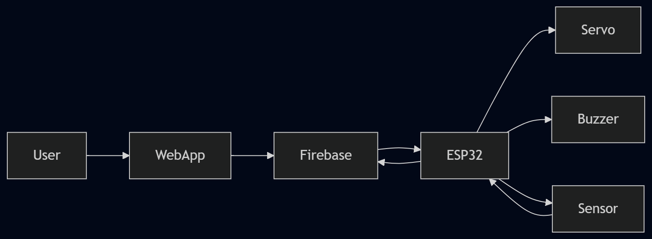
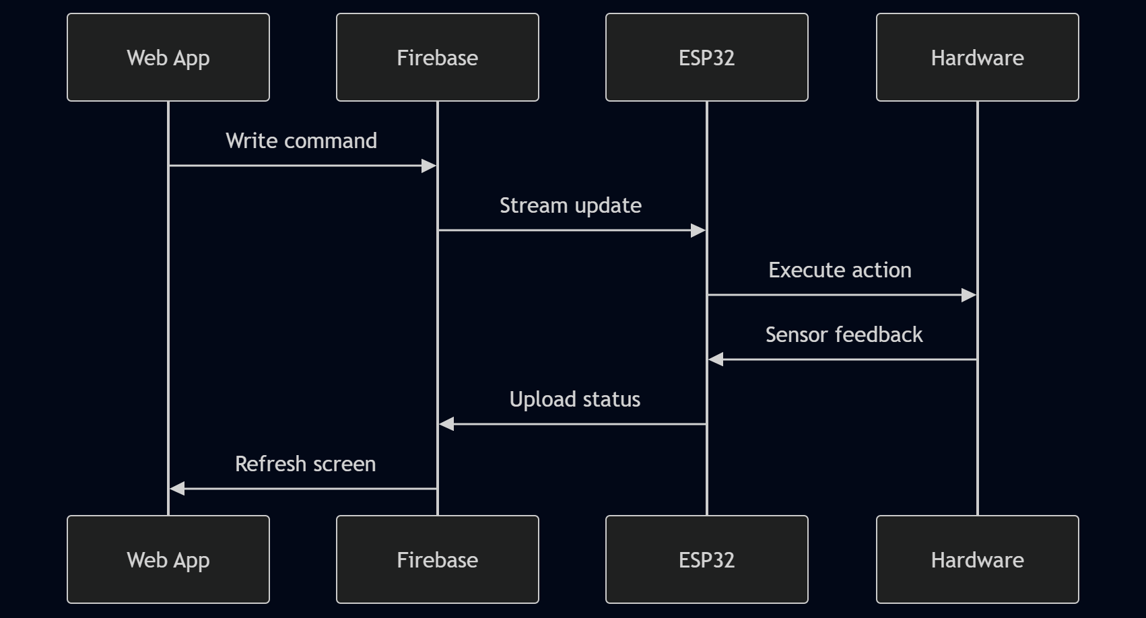
Timing
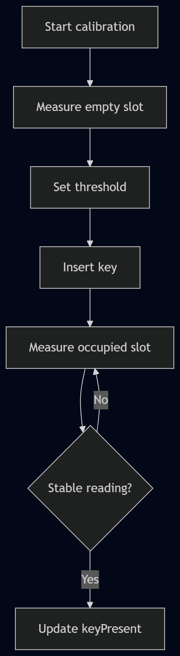
Calibration

Github Link: - https://github.com/venkatasriramt-spec/smart-lockbox
Video Link: - https://drive.google.com/file/d/1E9RE_bLEjM_qFtxsSgggLJNm_ikXJtsr/view?usp=sharing

