**GUI for Fitness Calculator**

END-TERM REPORT

**BACHELOR OF TECHNOLOGY**

**in**

**COMPUTER SCIENCE AND ENGINEERING**

By:

|  |  |  |  |
| --- | --- | --- | --- |
| *S.no.* | *Name* | *Roll No.* | *Registration no.* |
| *1.* | *T.Mallikarjuna* | *50* | *11910404* |
| *2.* | *G.venkata subba rao* | *08* | *11905331* |
| *3.* | *B.Satya* | *19* | *11903226* |

**Courses Code: INT213**

**School of Computer Science and Engineering**

Lovely Professional University

Phagwara, Punjab (India)

**Chapter #1**

**INTRODUCTION :**

**CONTENTS** :

* INTRODUCTION
* PROBLEM DEFINATION
* OBJECTIVE
* GOAL
* NEED OF SYSTEM

Abstract :

Vehicle parking management system maintains a good record of vehicle check in and check out time both two wheelers and four wheelers can be managed by system .vehicle parking management system that enables the time management and control of vehicles by using parking number the system that will track the entry and exit of vehicles maintain a list of vehicle with the parking lot and determine the parking and it will also determine the history of a specific vehicle.

Introduction :

vehicle parking management system is a web based technology that will manage the records of the incoming and outgoing vehicles in a parking house it's easy for admin to retrieve the data if the vehicle has been wasted through number we can get the data vehicle parking management system is an automatic system which delivers data processing in very high speed in systematic manner.

**Problem Defination** :

In present all vehicle parking work done on paper the whole year vehicle parking record is stored in register Srikanth generate reports as per our requirements because it's take more time to calculate the vehicle parking report.

Disadvantages of present system :

* **Non user friendly** : The present system not user friendly because data is not store in structured and proper format.
* **Manual control** :all report characterizations is done manually so there is a chance of error.
* **lots of paperwork :** vehicle records maintained in the register so lots of paper required for storing details.
* **Time consuming**

**Need of the system :**

There is always a need of system that will provide a way to a effectively control records and track vehicle parking traffic.

Thus ,there is a big need of developing vehicle parking management system is to computerized the traditional way of parking management and other need of developing this application is to generate the report automatically.

**E-R DIAGRAMS OF THE SYSTEM :**

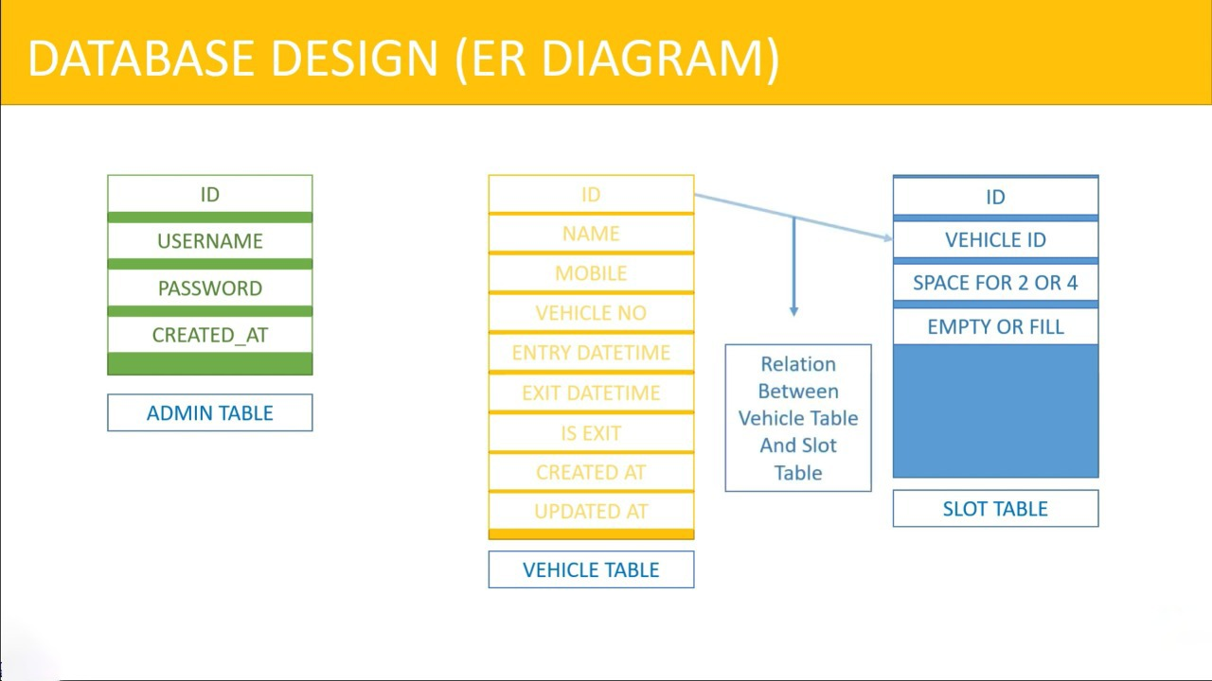

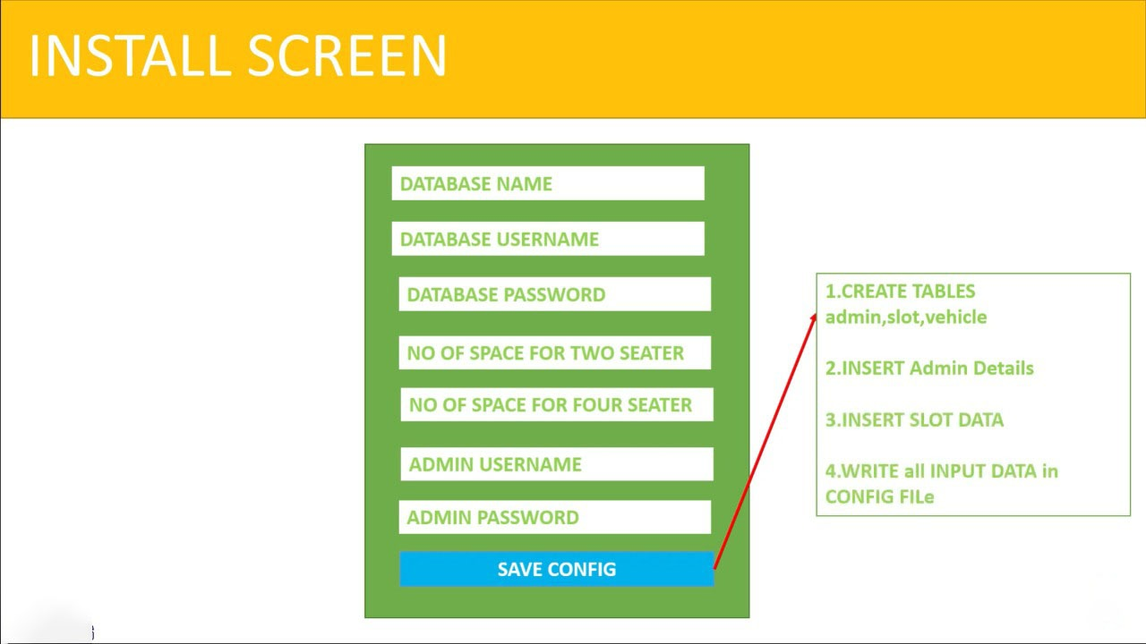

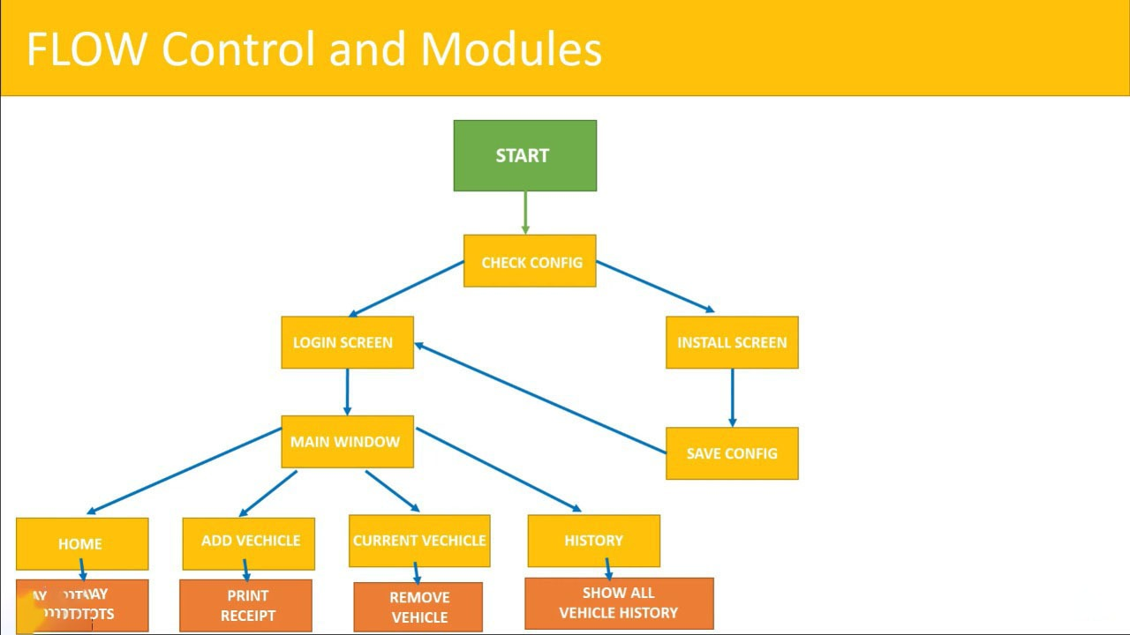

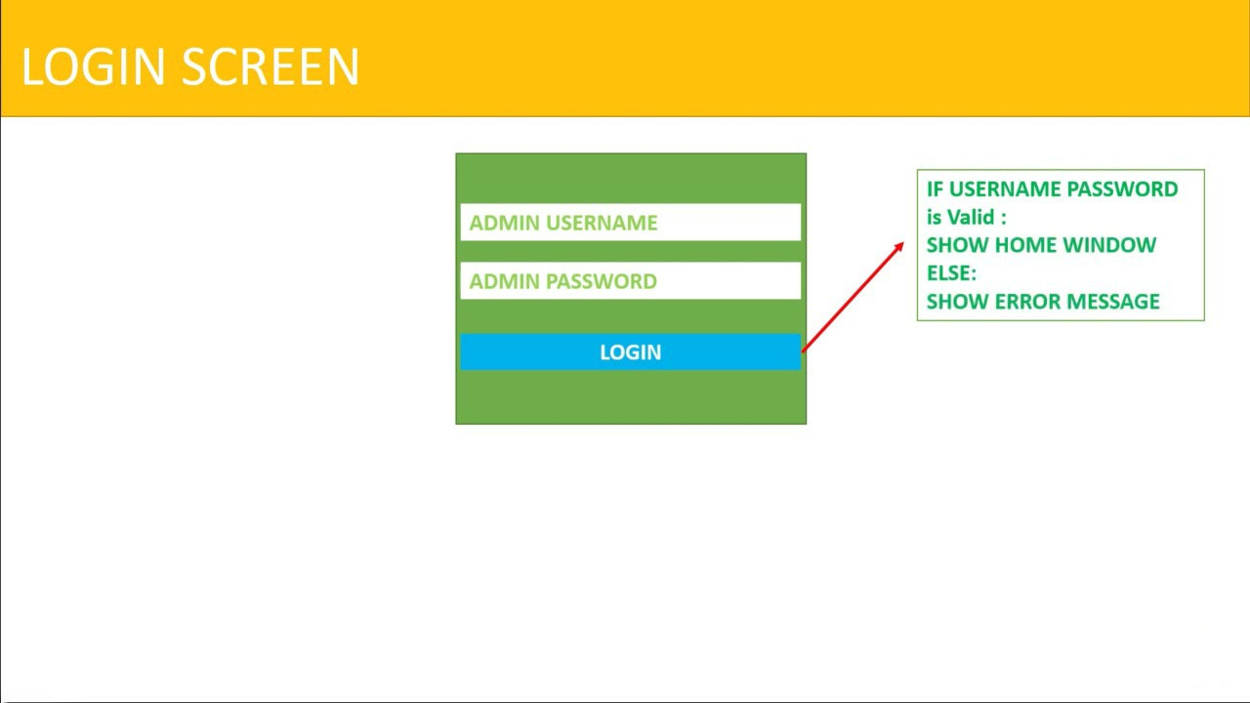

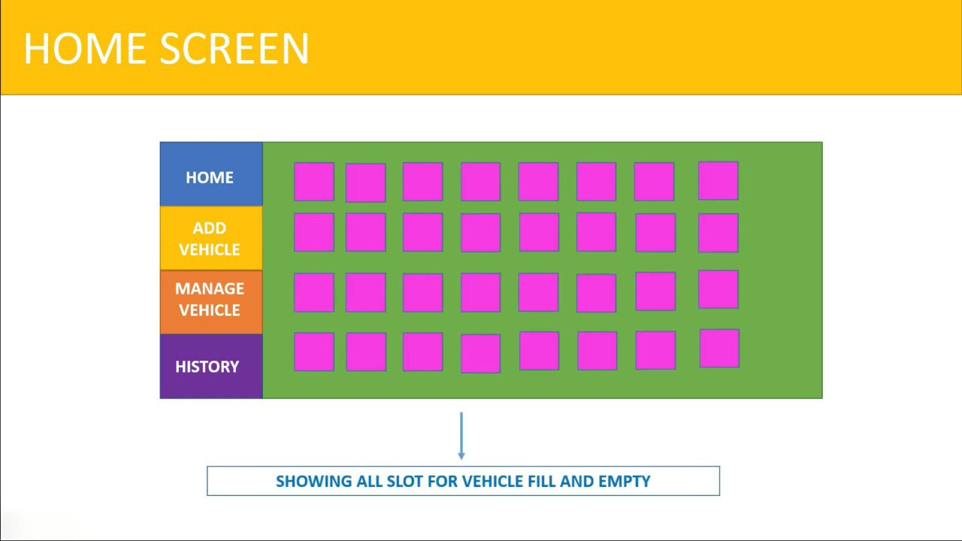

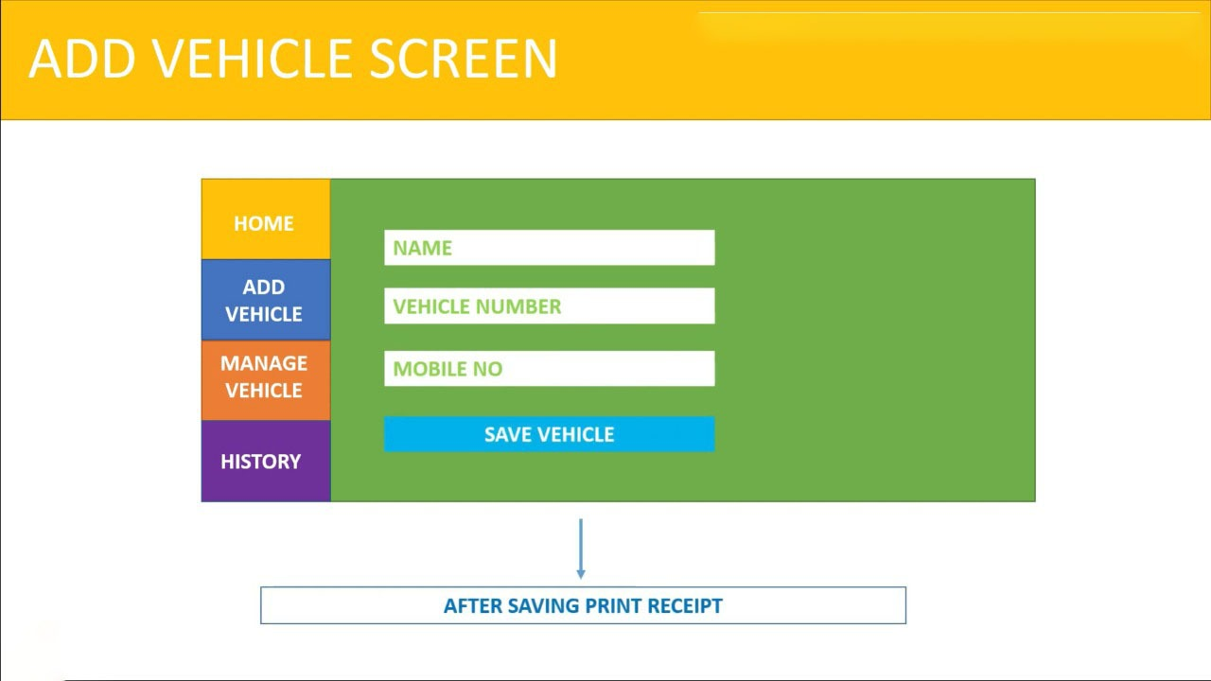

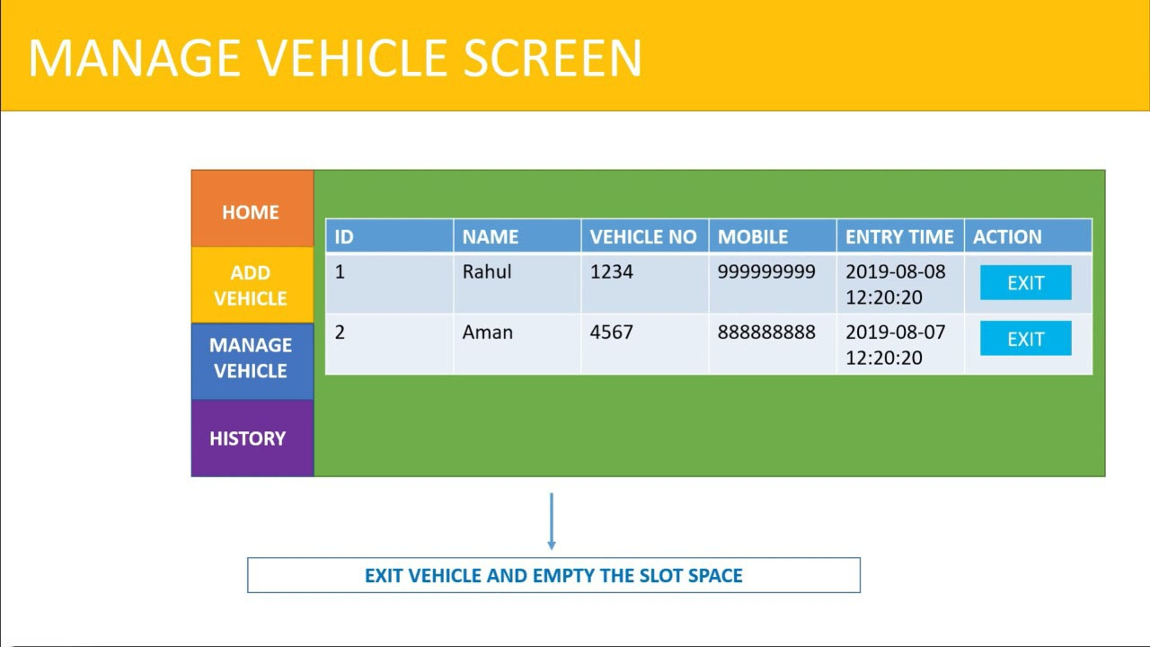

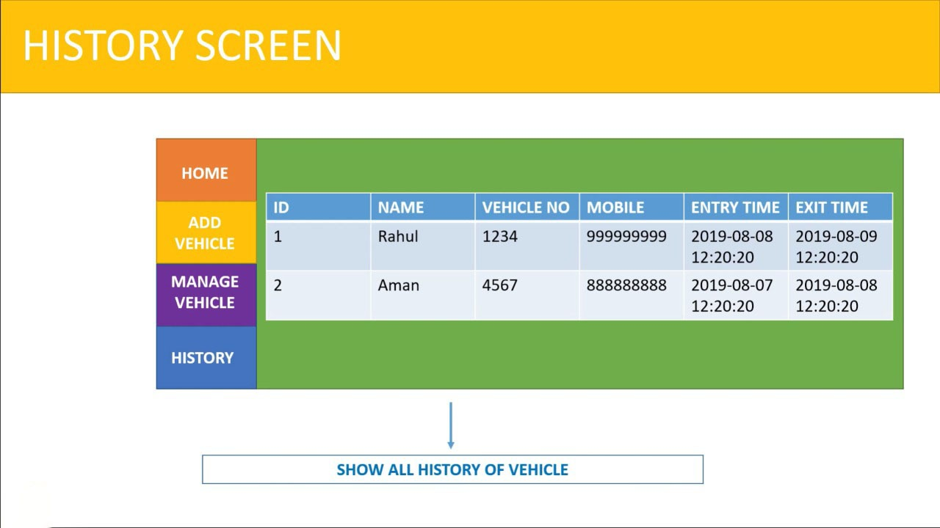

**USE CASE DIAGRAN OF SYSTEM** :

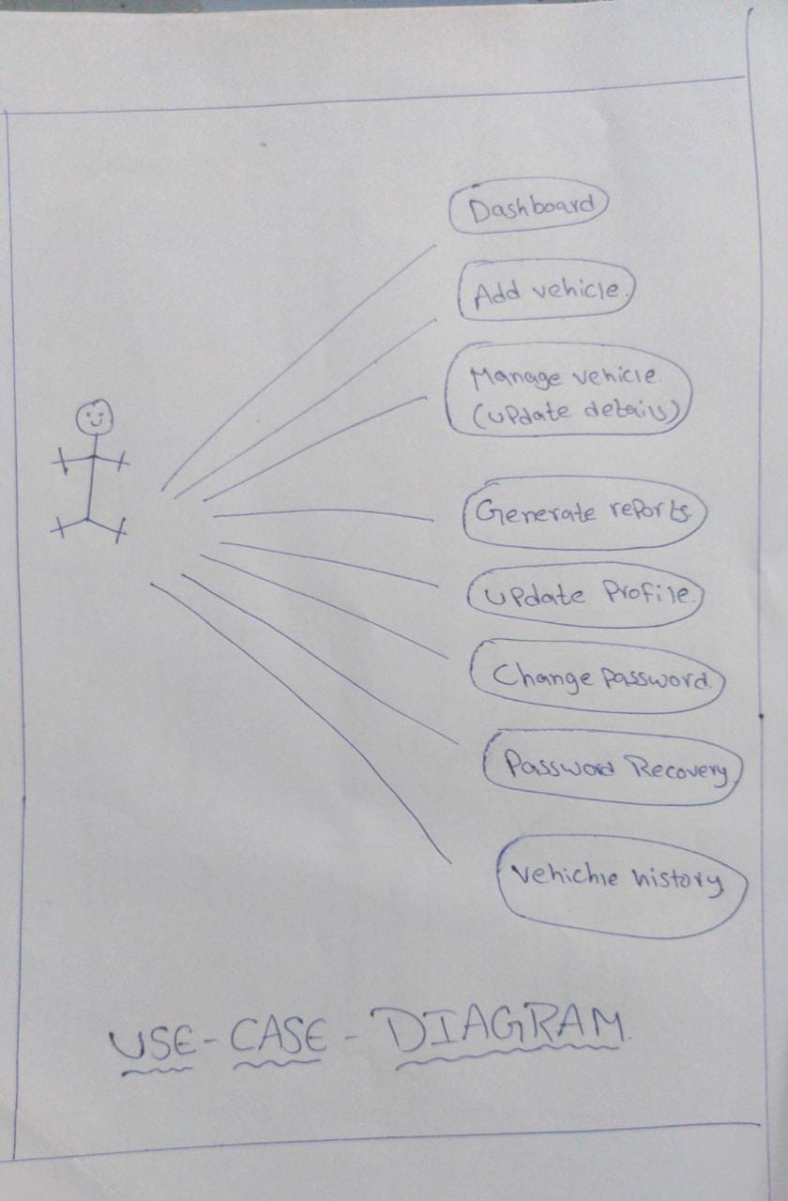

**DATA FLOW DIAGRAM (DFD)** :

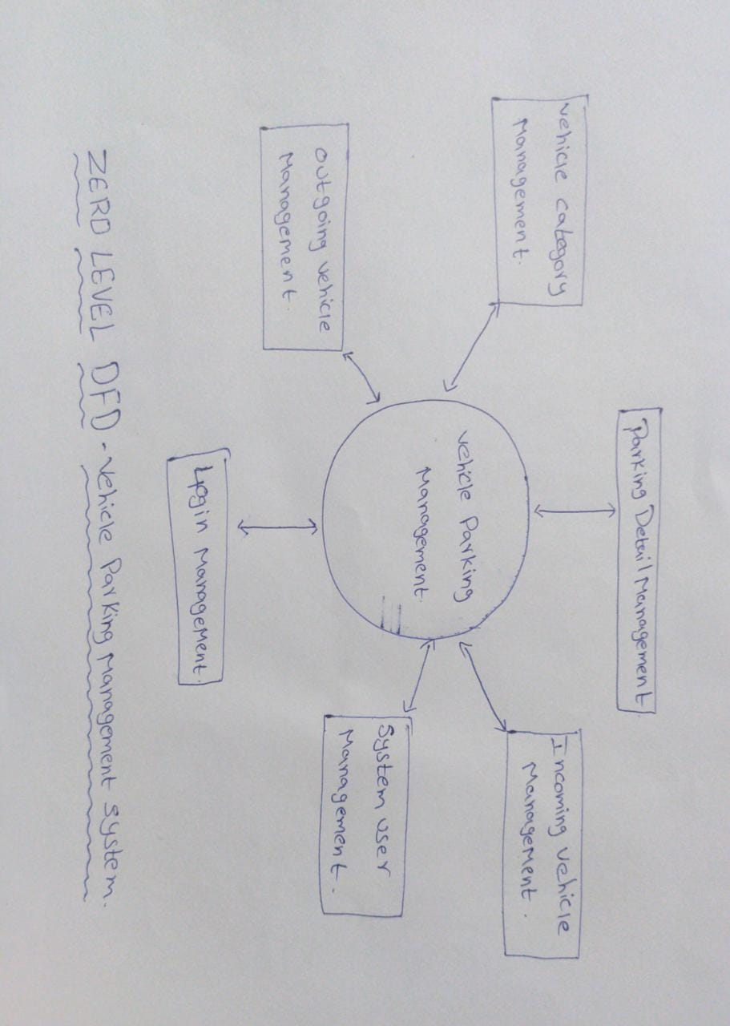

**RESULT(output screen)** :

