PROBLEM_STATEMENT

# TASK-2:

[**http://zero.webappsecurity.com/**](http://zero.webappsecurity.com/) We have set up a real life-like web application in the form of an online bank portal.

Your task is to test this website and find all possible vulnerabilities and loopholes in it. To do so you can use the automatic vulnerabilities scanner “Netsparker” which was taught to you in the session of Automatic Vulnerability Scanner.

If you want you can download it using this link:

https://drive.google.com/drive/folders/193Ha6QVU9Joh-rhhOvH78HrTNO1OgaMx?usp =sharing You have to find 3 critical vulnerabilities. No matter if they are taught to you or not. Now just choose any 1 amongst that 3 and write a report in your own language.

If you are using Netsparker you can use the report already generated by software but make sure you do not have to copy it. You have to then submit the report generated by you.

# SOLUTION:

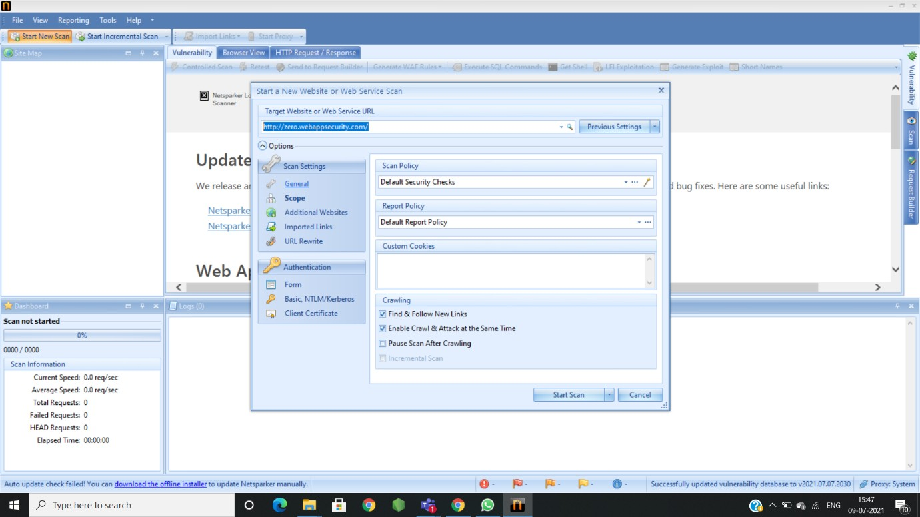

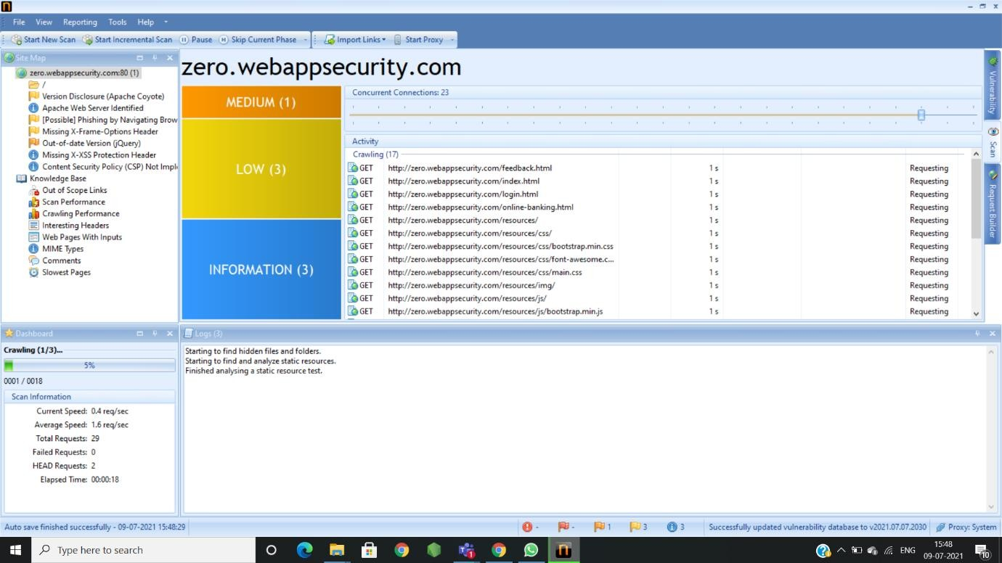

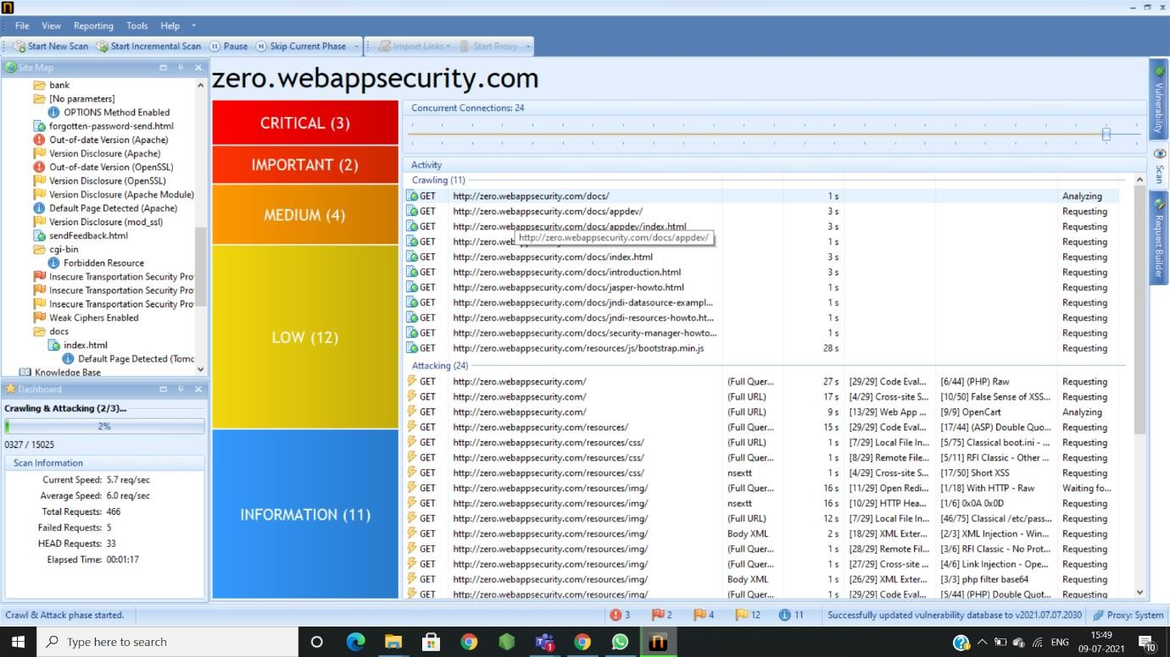

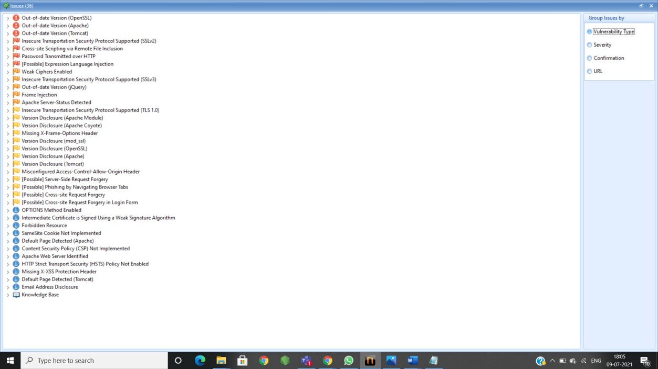

REPORT GENERATED BY NETSPARKER:

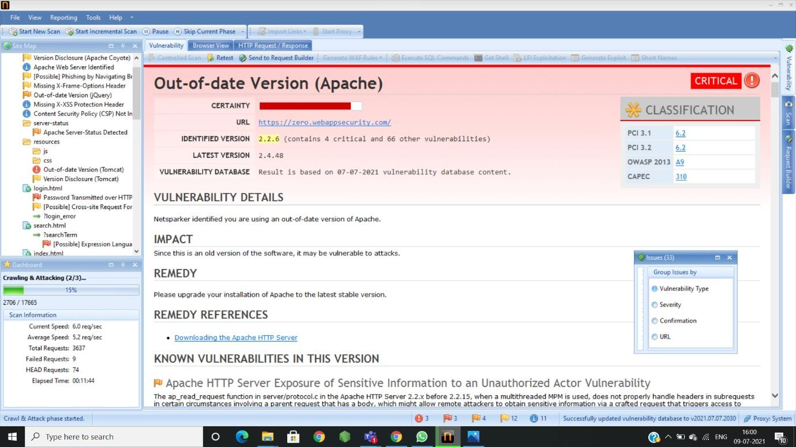

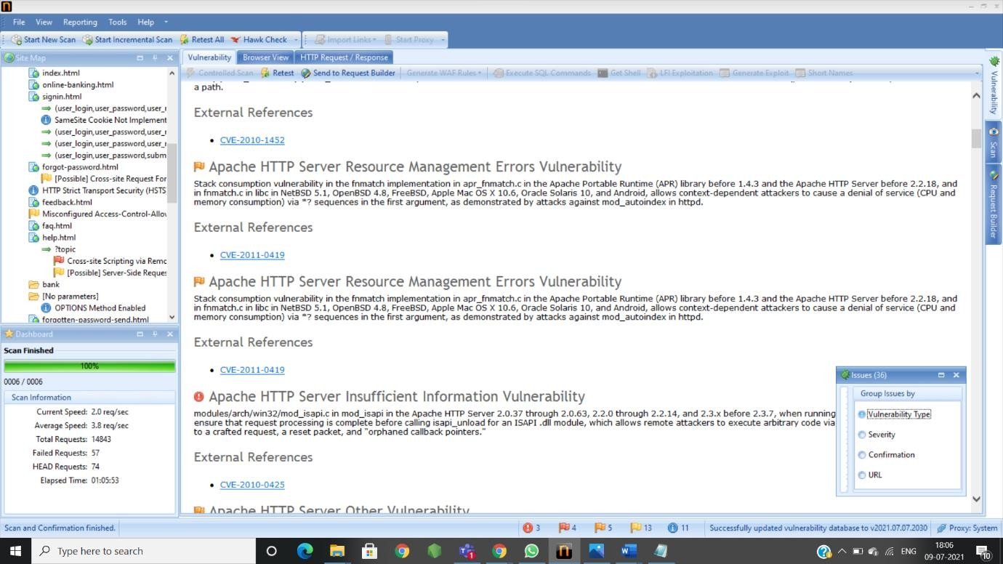

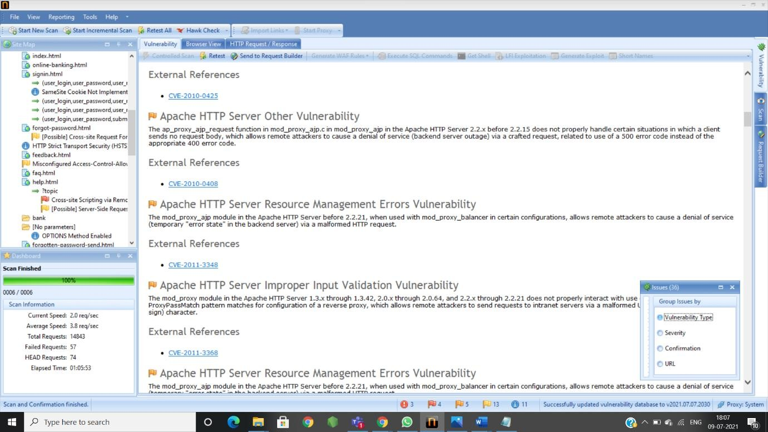

MY REPORT:

TITLE: Out-Of-Date Version(Apache) DOMAIN- <https://zero.webappsecurity.com/>

VULNERABILITY DETAILS:You are using out of date version of apache.

IMPACT:-may be vulnerable to attacks because of its OLD ersion(VERSION-2.2.6)

* your systems/devices will be more vulnerable to random ware attacks, malware and data breaches.
* Some times it might be the back door for your systems/devices/servers for hackers .
* Hackers can steal yours user details because of its vulnerability.
* This might be the back door for the hackers.

REMEDY:-found that latest version:2.4.48