**List of Hospitals and their Patients**

1. **List of Hospitals: -**

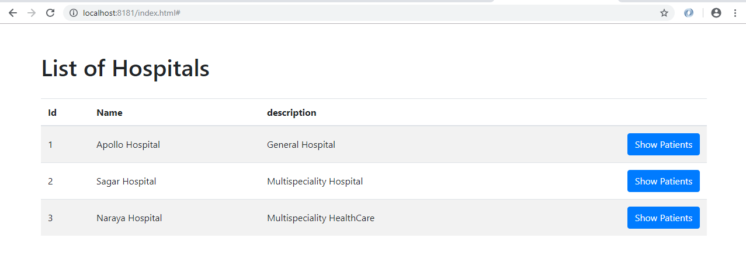

1. **List of Patients: -**

when user click on Show Patients

