

# School of Computing

**SRM IST, Kattankulathur – 603 203**

**Course Code: 18CSC206J**

**Course Name: Software Engineering and Project Management**

|  |  |
| --- | --- |
| **Experiment No** | 13 |
| **Title of Experiment** | Provide the details of Architecture Design/Framework/Implementation |
| **Name of the candidate** | VENKAT ADITYA VELLANKI |
| **Team Members** | PARAS PAL, M.V. MANISH |
| **Register Numbers** | RA2111003011799,RA2111003011818,RA2111003011818 |
| **Date of Experiment** |  |

**Mark Split Up**

|  |  |  |  |
| --- | --- | --- | --- |
| **S. No** | **Description** | **Maximum Mark** | **Mark Obtained** |
| 1 | Exercise | 5 |  |
| 2 | Viva | 5 |  |
| **Total** | | **10** |  |

# Staff Signature with date

## Aim

To provide the details of architectural design/framework/implementation

## Team Members:

|  |  |  |  |
| --- | --- | --- | --- |
| **S No** | **Register No** | **Name** | **Role** |
| **1** | PARAS PAL | RA2111003011818 | **Rep/Member** |
| **2** | VENKAT ADITYA VELLANKI | RA2111003011799 | **Member** |
| **3** | M.V.MANISH | RA2111003011819 | **Member** |

**ARCHITECTURAL DESIGN**

A mix of SOA and microservices.

This microservice based system has many advantages.

1. One is that if PVR system has some issue it will affect only PVR microservice and not others.
2. Failure of one microservice will have no effect on other microservices.
3. The system is extensible. In future suppose we want to handle live events we can follow the same approach of reusing or creating a new microservice template.

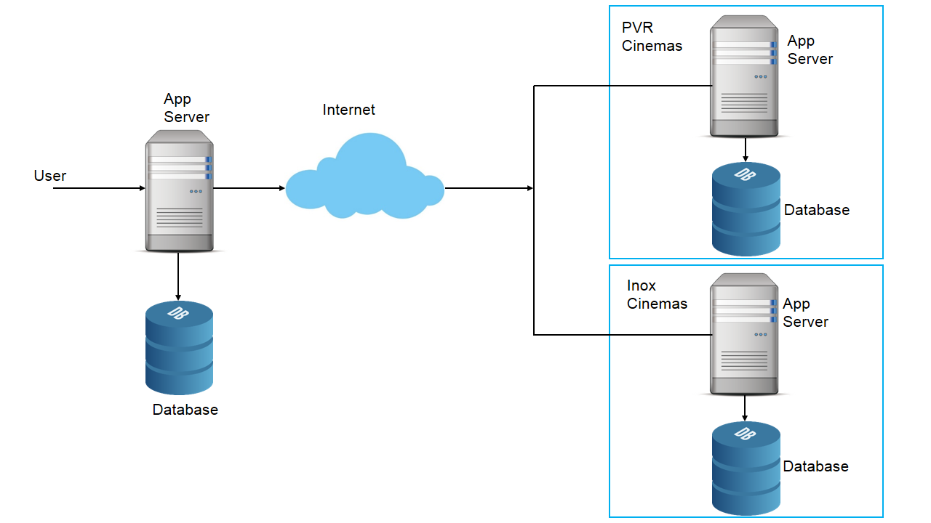

MOVIE TICKET BOOKING SYSTEM DESIGN

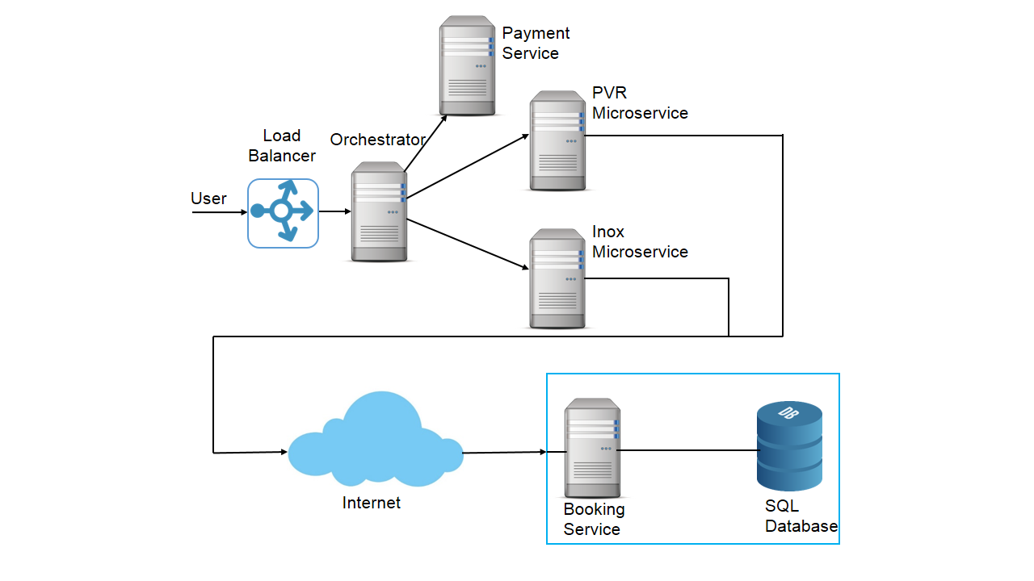

ADDING MICROSERVICE FOR BOOKING

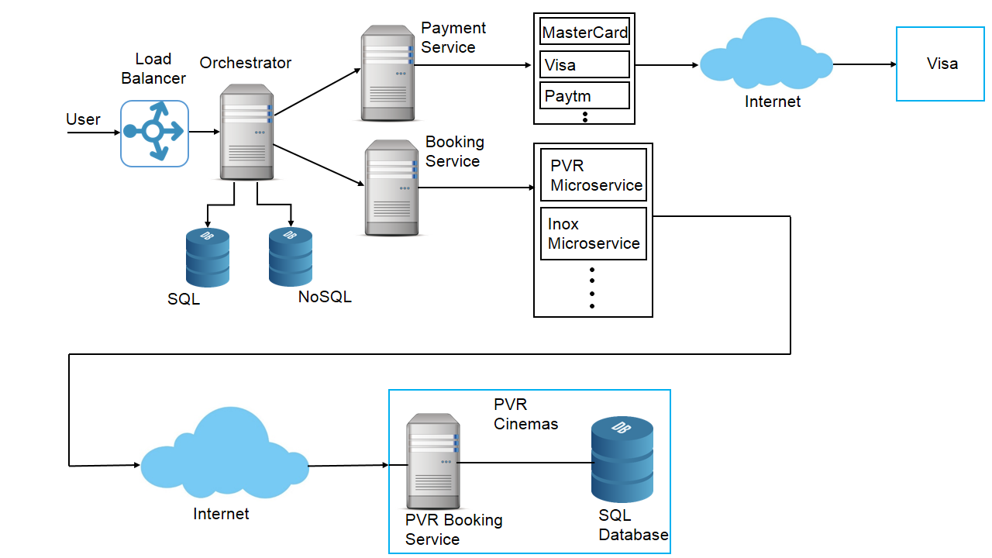

ADDING MICROSERVICE FOR PAYMENT

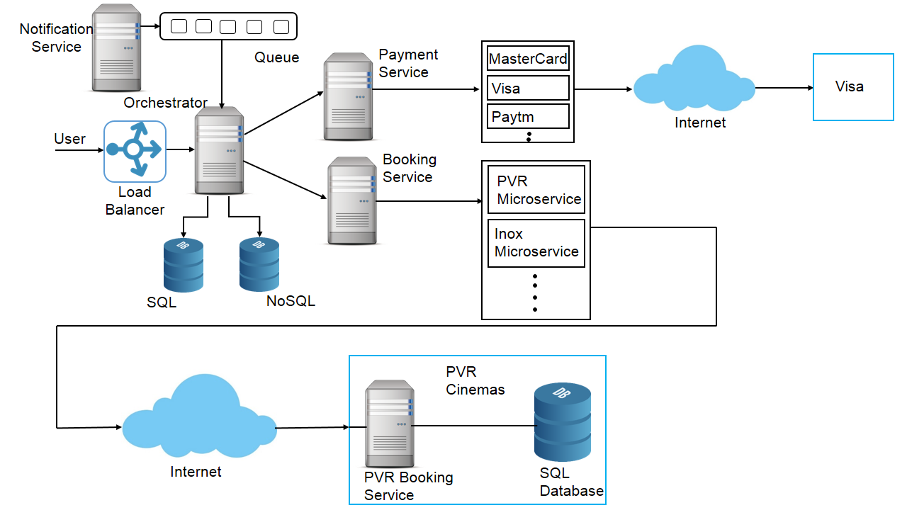

ADDING NOTIFICATION SERVICE

##### Scaling the design

Let us revisit our non-functional requirements

1. The system should always be available  
   We can use no single point of failure principle and create replicas so in the event of failure of one component other can take over. This will much easier since we have microservices which can restart themselves or create new instances in the event of failures.
2. The system should be responsive. The user experience should be smooth. We have a queue and a notification service which runs asynchronously from the main process to improve the performance. We have also added caching for performance reasons.

**IMPLEMENTATION WITH CODING:**

**HTML CODE MOVIE:**

<html>

<head>

<title>CINEPO</title>

<link rel="stylesheet" type="text/css" href="CSS/myStyle.css">

<link rel="stylesheet" href="https://cdnjs.cloudflare.com/ajax/libs/font-awesome/4.7.0/css/font-awesome.min.css">

<script type="text/javascript" src="js/jsFile.js"></script>

<script name="javascript">

var sign = window.prompt('Are you feeling lucky??', 'sure');

if (sign.toLowerCase() == "sure") {

alert("Wow! I'm happy for you!");

}

</script>

</head>

<body id="foodBody">

<div class="announcement">

<p class="announcement-message">WE'RE BACK. DUE TO PANDEMIC SOME THEATRES HAVE CHANGED TIMINGS. PLEASE CONTACT US IF YOU HAVE ANY QUESTIONS. </p>

</div>

<div>

<ul class="Navbar">

<li class="logo"><a id="logoText" href="index.html"><span class="logoColr2"></span>CINEPO </a></li>

<li class="logo"><input type="text" id="search" placeholder="Search for Movies, Events and Sports."></li>

<li class="dropdown">

<!-- <select class="dropdown">

<option value="English">ENGLISH</option>

<option value="French">FRENCH</option>

</select> -->

</li>

<li><a href="signup.html" >SIGNUP</a></li>

<li><a href="Login.html" >LOG IN</a></li>

<li><a href="contact.html">CONTACT</a> </li>

<li><a href="about.html">ABOUT US</a> </li>

<li><a href="index.html" >HOME</a>

</ul>

</div>

<div>

<ul id="secondaryNavbar">

<li class="secondaryNavbar"><a id="logoText" href="movies.html" class="active">Movies</a></li>

<li class="secondaryNavbar"><a id="logoText" href="events.html">Events</a></li>

<li class="secondaryNavbar"><a id="logoText" href="food.html" >Food & Drink</a></li>

<li class="secondaryNavbar"><a id="logoText" href="quote.html">Get-a-Quote</a></li>

<li class="secondaryNavbar"><a id="logoText" href="offers.html">Giftcards</a></li>

</ul>

</div>

<div id="foodContainer">

<table id="foodTable">

<tr>

<td colspan="2" id="foodHead"><h2>Movies</h2></td>

</tr>

</table>

<table id="moviesTable">

<tr class="moviesTr">

<td class="moviesTd">

<a href="payment.html" class="moviesLinkList"><img src="Assets/beauty.jpg" width="100%"></a>

</td>

<td class="moviesTd">

<a href="payment.html" class="moviesLinkList"><img src="Assets/jaws.jpg" width="100%"></a>

</td>

<td class="moviesTd">

<a href="payment.html" class="moviesLinkList"><img src="Assets/bohemian.jpg" width="100%"></a>

</td>

<td class="moviesTd">

<a href="payment.html" class="moviesLinkList"><img src="Assets/invisibleman.jpg" width="100%"></a>

</td>

<td class="moviesTd">

<a href="payment.html" class="moviesLinkList"><img src="Assets/jurassic.jpg" width="100%"></a>

</td>

</tr>

<tr>

<td class="moviesTdText">

<a href="payment.html" class="moviesLinkList">Beauty And The Beast</a>

</td>

<td class="moviesTdText">

<a href="payment.html" class="moviesLinkList">Jaws</a>

</td>

<td class="moviesTdText">

<a href="payment.html" class="moviesLinkList">Bohemian Rhapsody</a>

</td>

<td class="moviesTdText">

<a href="payment.html" class="moviesLinkList">The Invisible Man</a>

</td>

<td class="moviesTdText">

<a href="payment.html" class="moviesLinkList">Jurassic Park</a>

</td>

</tr>

<tr>

<td class="moviesTd">

<a href="payment.html" class="moviesLinkList"><img src="Assets/ironman.jpg" width="100%"></a>

</td>

<td class="moviesTd">

<a href="payment.html" class="moviesLinkList"><img src="Assets/bloodshot.jpg" width="100%"></a>

</td>

<td class="moviesTd">

<a href="payment.html" class="moviesLinkList"><img src="Assets/sonic.jpg" width="100%"></a>

</td>

<td class="moviesTd">

<a href="payment.html" class="moviesLinkList"><img src="Assets/sing.jpg" width="100%"></a>

</td>

<td class="moviesTd">

<a href="payment.html" class="moviesLinkList"><img src="Assets/spy.jpg" width="100%"></a>

</td>

</tr>

<tr>

<td class="moviesTdText">

<a href="payment.html" class="moviesLinkList">Iron Man</a>

</td>

<td class="moviesTdText">

<a href="payment.html" class="moviesLinkList">Bloodshot</a>

</td>

<td class="moviesTdText">

<a href="payment.html" class="moviesLinkList">Sonic The Hedgehog</a>

</td>

<td class="moviesTdText">

<a href="payment.html" class="moviesLinkList">Sing</a>

</td>

<td class="moviesTdText">

<a href="payment.html" class="moviesLinkList">The spy</a>

</td>

</tr>

<tr>

<td class="moviesTd">

<a href="payment.html" class="moviesLinkList"><img src="Assets/pets.jpg" width="100%"></a>

</td>

<td class="moviesTd">

<a href="payment.html" class="moviesLinkList"><img src="Assets/jumanji.jpg" width="100%"></a>

</td>

<td class="moviesTd">

<a href="payment.html" class="moviesLinkList"><img src="Assets/badboys.jpg" width="100%"></a>

</td>

<td class="moviesTd">

<a href="payment.html" class="moviesLinkList"><img src="Assets/unhinged.jpg" width="100%"></a>

</td>

<td class="moviesTd">

<a href="payment.html" class="moviesLinkList"><img src="Assets/tenet.jpg" width="100%"></a>

</td>

</tr>

<tr>

<td class="moviesTdText">

<a href="payment.html" class="moviesLinkList">The Secret Life Of Pets</a>

</td>

<td class="moviesTdText">

<a href="payment.html" class="moviesLinkList">Jumanji: The Next Level</a>

</td>

<td class="moviesTdText">

<a href="payment.html" class="moviesLinkList">Bad Boys For Life</a>

</td>

<td class="moviesTdText">

<a href="payment.html" class="moviesLinkList">Unhinged</a>

</td>

<td class="moviesTdText">

<a href="payment.html" class="moviesLinkList">Tenet</a>

</td>

</tr>

<tr>

<td class="moviesTd">

<a href="payment.html" class="moviesLinkList"><img src="Assets/mulan.jpg" width="100%"></a>

</td>

<td class="moviesTd">

<a href="payment.html" class="moviesLinkList"><img src="Assets/pulp.jpg" width="100%"></a>

</td>

<td class="moviesTd">

<a href="payment.html" class="moviesLinkList"><img src="Assets/birdsofprey.jpg" width="100%"></a>

</td>

<td class="moviesTd">

<a href="payment.html" class="moviesLinkList"><img src="Assets/1917.jpg" width="100%"></a>

</td>

<td class="moviesTd">

<a href="payment.html" class="moviesLinkList"><img src="Assets/blackwidow.jpg" width="100%"></a>

</td>

</tr>

<tr>

<td class="moviesTdText">

<a href="payment.html" class="moviesLinkList">Mulan</a>

</td>

<td class="moviesTdText">

<a href="payment.html" class="moviesLinkList">Pulp Fiction</a>

</td>

<td class="moviesTdText">

<a href="payment.html" class="moviesLinkList">Harley Quinn:Birds Of Prey</a>

</td>

<td class="moviesTdText">

<a href="payment.html" class="moviesLinkList">1917</a>

</td>

<td class="moviesTdText">

<a href="payment.html" class="moviesLinkList">The Gentlemen</a>

</td>

</tr>

</table>

<table id="foodTable">

<tr>

<td colspan="2" id="foodHead">

<button class="active" >1</button>&nbsp;&nbsp;&nbsp;

<button class="moviesButton">2</button>&nbsp;&nbsp;&nbsp;

<button class="moviesButton">3</button>&nbsp;&nbsp;&nbsp;

<button class="moviesButton">4</button>&nbsp;&nbsp;&nbsp;

<button class="moviesButton">5</button>&nbsp;&nbsp;&nbsp;

</td>

</tr>

</table>

</div>

<footer class="footer">

<div class="footer-message"><span id="footerText">List your Show </span>

Got a show, event, activity or a great experience? Partner with us & get listed on BookMyShow

<a href="contact.html"><button id="buttonFooter">Contact today!</button></a>

</div>

<div="horizontal">

<hr>

</div>

</footer>

<table>

<tr>

<th>Navigate</th>

<th>Help</th>

<th>Top Movies and Events</th>

<th>Newsletter</th>

</tr>

<tr>

<td><a href="index.html" class="footerLinks">Home</a></td>

<td><a href="#search" class="footerLinks">Search</a></td>

<td><a href="movies.html" class="footerLinks">Avengers</a></td>

<td rowspan="2">Get updates, news and specials before anyone else.</td>

</tr>

<tr>

<td><a href="signup.html" class="footerLinks">Signup</a></td>

<td><a href="quote.html" class="footerLinks">Get-a-Quote</a></td>

<td><a href="movies.html" class="footerLinks">Chal mera putt 2</a></td>

</tr>

<tr>

<td><a href="login.html" class="footerLinks">Log In</a></td>

<td><a href="contact.html" class="footerLinks">Help</a></td>

<td><a href="movies.html" class="footerLinks">Bloodshot</a></td>

<td rowspan="2" >

<input type="email" placeholder="Type you email here.." id="emailFooter">

<span><button class="emailFooter">Subscribe</button></span>

</td>

</tr>

<tr>

<td><a href="about.html" class="footerLinks">About</a></td>

<td><a href="conditions.html" class="footerLinks">Terms & Conditions</a></td>

<td><a href="movies.html" class="footerLinks">Scoob!</a></td>

</tr>

<tr>

<td><a href="movies.html" class="footerLinks">Movies</a></td>

<td> </td>

<td><a href="movies.html" class="footerLinks">The invisible man</a></td>

</tr>

<tr>

<td> <a href="contact.html" class="footerLinks">Contact</a></td>

<td> </td>

<td><a href="movies.html" class="footerLinks">Underwater</a></td>

</tr>

</table>

<div class="footer">

<hr>

</div>

<table>

<tr>

<th> <p class="footer">Copyright &copy; 2020 All Rights Reserved by BookMyShow</p></th>

<th>

<a href="https://www.facebook.com/navandeep.singh.73" class="fa fa-facebook"></a>

<a href="https://twitter.com/explore" class="fa fa-twitter"></a>

<a href="https://www.instagram.com/navan.rana/" class="fa fa-instagram"></a>

<a href="mailto:navandeep0511@gmail.com" class="fa fa-google"></a>

<a href="https://www.youtube.com/channel/UChzUn-zq1V6KnQHSe24okFg?view_as=subscriber" class="fa fa-youtube"></a>

</th>

</tr>

</table>

</body>

</html>

**CSS CODE:**

@import url('https://fonts.googleapis.com/css2?family=Joan&display=swap');

* {

margin: 0;

padding: 0;

box-sizing: border-box;

font-family: 'Joan', serif;

}

a {

text-decoration: none;

color: #adadad;

}

.btn {

display: inline-block;

padding: .5rem 1rem;

background-color: #cd8c38;

border-radius: 2rem;

color: #1e1f26;

transition: .3s;

}

.btn:hover {

background-color: #92601f;

}

.btn-l {

width: 100%;

text-align: center;

}

body {

background-color: #1e1f26;

display: grid;

grid-template-columns: 1000px;

justify-content: space-evenly;

}

/* top bar */

.top-bar {

display: flex;

align-items: center;

justify-content: space-between;

padding: 1.5rem 1rem;

}

.left-content,

.right-content {

display: flex;

align-items: center;

}

.title {

margin-right: 3rem;

color: #cd8c38;

}

.navigation {

display: flex;

list-style: none;

}

.navigation li {

margin-right: 1rem;

}

.navigation li a:hover {

color: #cd8c38;

}

.active {

color: #cd8c38;

}

.filter,

.cart,

.help,

.menu {

position: relative;

width: 20px;

height: 20px;

}

.filter,

.cart,

.help {

margin-right: 1rem;

}

.menu {

margin-left: .8rem;

}

.filter,

.menu {

display: none;

}

.profile-img-box {

position: relative;

height: 30px;

width: 30px;

border-radius: 50%;

overflow: hidden;

}

img {

position: absolute;

top: 0;

left: 0;

width: 100%;

height: 100%;

object-fit: cover;

}

/* main container */

.main-container {

color: #adadad;

display: grid;

grid-template-columns: 1fr 3fr;

gap: 2rem;

}

/* sidebar */

.sidebar {

background: linear-gradient(45deg, rgba(255, 255, 255, .05), rgba(205, 140, 56, .15));

backdrop-filter: blur(5px);

height: fit-content;

border-radius: 1rem;

padding: 2rem 2.5rem;

}

.sidebar-groups {

margin-bottom: 1rem;

}

.sg-title {

margin-bottom: .5rem;

color: #fff;

}

input {

margin-bottom: .6rem;

}

input[type=checkbox]:checked {

accent-color: #cd8c38;

}

input[type=radio]:checked {

accent-color: #cd8c38;

}

label {

margin-left: .5rem;

}

/* movies container */

.upcoming-img-box {

position: relative;

height: 300px;

width: 100%;

border-radius: 1rem;

overflow: hidden;

margin-bottom: 1.5rem;

}

.upcoming-title {

position: absolute;

top: 2rem;

left: 2rem;

color: #cd8c38;

background-color: #1e1f26;

padding: .5rem 1rem;

border-radius: 2rem;

border: 1px solid #cd8c38;

font-weight: 500;

}

.buttons {

position: absolute;

bottom: 2rem;

left: 2rem;

}

.btn-alt {

background-color: #1e1f26;

color: #cd8c38;

border: 1px solid #cd8c38;

margin-left: 1rem;

}

.btn-alt:hover {

color: #1e1f26;

background-color: #cd8c38;

}

/* current movies */

.movies-container {

padding-bottom: 2rem;

}

.current-movies {

display: grid;

grid-template-columns: repeat(3, 1fr);

gap: 1.5rem;

}

.current-movie {

background: linear-gradient(45deg, rgba(255, 255, 255, .05), rgba(205, 140, 56, .15));

padding: 1rem;

border-radius: .5rem;

}

.cm-img-box {

position: relative;

height: 150px;

width: auto;

margin-bottom: 1rem;

border-radius: .5rem;

overflow: hidden;

}

.movie-title {

color: #fff;

margin-bottom: .2rem;

}

.booking {

display: flex;

align-items: center;

justify-content: space-between;

margin-top: 1rem;

}

.price {

color: #cd8c38;

}

SELECTOR ENGIENE MODULE CODE:

const NODE_TEXT = 3

const SelectorEngine = {

find(selector, element = document.documentElement) {

return [].concat(...Element.prototype.querySelectorAll.call(element, selector))

},

findOne(selector, element = document.documentElement) {

return Element.prototype.querySelector.call(element, selector)

},

children(element, selector) {

return [].concat(...element.children)

.filter(child => child.matches(selector))

},

parents(element, selector) {

const parents = []

let ancestor = element.parentNode

while (ancestor && ancestor.nodeType === Node.ELEMENT_NODE && ancestor.nodeType !== NODE_TEXT) {

if (ancestor.matches(selector)) {

parents.push(ancestor)

}

ancestor = ancestor.parentNode

}

return parents

},

prev(element, selector) {

let previous = element.previousElementSibling

while (previous) {

if (previous.matches(selector)) {

return [previous]

}

previous = previous.previousElementSibling

}

return []

},

next(element, selector) {

let next = element.nextElementSibling

while (next) {

if (next.matches(selector)) {

return [next]

}

next = next.nextElementSibling

}

return []

}

}

export default SelectorEngine

**EVENT HANDLER MODUL CODE :**

import { getjQuery } from '../util/index'

const namespaceRegex = /[^.]*(?=\..*)\.|.*/

const stripNameRegex = /\..*/

const stripUidRegex = /::\d+$/

const eventRegistry = {}

let uidEvent = 1

const customEvents = {

mouseenter: 'mouseover',

mouseleave: 'mouseout'

}

const nativeEvents = new Set([

'click',

'dblclick',

'mouseup',

'mousedown',

'contextmenu',

'mousewheel',

'DOMMouseScroll',

'mouseover',

'mouseout',

'mousemove',

'selectstart',

'selectend',

'keydown',

'keypress',

'keyup',

'orientationchange',

'touchstart',

'touchmove',

'touchend',

'touchcancel',

'pointerdown',

'pointermove',

'pointerup',

'pointerleave',

'pointercancel',

'gesturestart',

'gesturechange',

'gestureend',

'focus',

'blur',

'change',

'reset',

'select',

'submit',

'focusin',

'focusout',

'load',

'unload',

'beforeunload',

'resize',

'move',

'DOMContentLoaded',

'readystatechange',

'error',

'abort',

'scroll'

])

function getUidEvent(element, uid) {

return (uid && `${uid}::${uidEvent++}`) || element.uidEvent || uidEvent++

}

function getEvent(element) {

const uid = getUidEvent(element)

element.uidEvent = uid

eventRegistry[uid] = eventRegistry[uid] || {}

return eventRegistry[uid]

}

function bootstrapHandler(element, fn) {

return function handler(event) {

event.delegateTarget = element

if (handler.oneOff) {

EventHandler.off(element, event.type, fn)

}

return fn.apply(element, [event])

}

}

function bootstrapDelegationHandler(element, selector, fn) {

return function handler(event) {

const domElements = element.querySelectorAll(selector)

for (let { target } = event; target && target !== this; target = target.parentNode) {

for (let i = domElements.length; i--;) {

if (domElements[i] === target) {

event.delegateTarget = target

if (handler.oneOff) {

// eslint-disable-next-line unicorn/consistent-destructuring

EventHandler.off(element, event.type, fn)

}

return fn.apply(target, [event])

}

}

}

// To please ESLint

return null

}

}

function findHandler(events, handler, delegationSelector = null) {

const uidEventList = Object.keys(events)

for (let i = 0, len = uidEventList.length; i < len; i++) {

const event = events[uidEventList[i]]

if (event.originalHandler === handler && event.delegationSelector === delegationSelector) {

return event

}

}

return null

}

function normalizeParams(originalTypeEvent, handler, delegationFn) {

const delegation = typeof handler === 'string'

const originalHandler = delegation ? delegationFn : handler

// allow to get the native events from namespaced events ('click.bs.button' --> 'click')

let typeEvent = originalTypeEvent.replace(stripNameRegex, '')

const custom = customEvents[typeEvent]

if (custom) {

typeEvent = custom

}

const isNative = nativeEvents.has(typeEvent)

if (!isNative) {

typeEvent = originalTypeEvent

}

return [delegation, originalHandler, typeEvent]

}

function addHandler(element, originalTypeEvent, handler, delegationFn, oneOff) {

if (typeof originalTypeEvent !== 'string' || !element) {

return

}

if (!handler) {

handler = delegationFn

delegationFn = null

}

const [delegation, originalHandler, typeEvent] = normalizeParams(originalTypeEvent, handler, delegationFn)

const events = getEvent(element)

const handlers = events[typeEvent] || (events[typeEvent] = {})

const previousFn = findHandler(handlers, originalHandler, delegation ? handler : null)

if (previousFn) {

previousFn.oneOff = previousFn.oneOff && oneOff

return

}

const uid = getUidEvent(originalHandler, originalTypeEvent.replace(namespaceRegex, ''))

const fn = delegation ?

bootstrapDelegationHandler(element, handler, delegationFn) :

bootstrapHandler(element, handler)

fn.delegationSelector = delegation ? handler : null

fn.originalHandler = originalHandler

fn.oneOff = oneOff

fn.uidEvent = uid

handlers[uid] = fn

element.addEventListener(typeEvent, fn, delegation)

}

function removeHandler(element, events, typeEvent, handler, delegationSelector) {

const fn = findHandler(events[typeEvent], handler, delegationSelector)

if (!fn) {

return

}

element.removeEventListener(typeEvent, fn, Boolean(delegationSelector))

delete events[typeEvent][fn.uidEvent]

}

function removeNamespacedHandlers(element, events, typeEvent, namespace) {

const storeElementEvent = events[typeEvent] || {}

Object.keys(storeElementEvent).forEach(handlerKey => {

if (handlerKey.includes(namespace)) {

const event = storeElementEvent[handlerKey]

removeHandler(element, events, typeEvent, event.originalHandler, event.delegationSelector)

}

})

}

const EventHandler = {

on(element, event, handler, delegationFn) {

addHandler(element, event, handler, delegationFn, false)

},

one(element, event, handler, delegationFn) {

addHandler(element, event, handler, delegationFn, true)

},

off(element, originalTypeEvent, handler, delegationFn) {

if (typeof originalTypeEvent !== 'string' || !element) {

return

}

const [delegation, originalHandler, typeEvent] = normalizeParams(originalTypeEvent, handler, delegationFn)

const inNamespace = typeEvent !== originalTypeEvent

const events = getEvent(element)

const isNamespace = originalTypeEvent.startsWith('.')

if (typeof originalHandler !== 'undefined') {

// Simplest case: handler is passed, remove that listener ONLY.

if (!events || !events[typeEvent]) {

return

}

removeHandler(element, events, typeEvent, originalHandler, delegation ? handler : null)

return

}

if (isNamespace) {

Object.keys(events).forEach(elementEvent => {

removeNamespacedHandlers(element, events, elementEvent, originalTypeEvent.slice(1))

})

}

const storeElementEvent = events[typeEvent] || {}

Object.keys(storeElementEvent).forEach(keyHandlers => {

const handlerKey = keyHandlers.replace(stripUidRegex, '')

if (!inNamespace || originalTypeEvent.includes(handlerKey)) {

const event = storeElementEvent[keyHandlers]

removeHandler(element, events, typeEvent, event.originalHandler, event.delegationSelector)

}

})

},

trigger(element, event, args) {

if (typeof event !== 'string' || !element) {

return null

}

const $ = getjQuery()

const typeEvent = event.replace(stripNameRegex, '')

const inNamespace = event !== typeEvent

const isNative = nativeEvents.has(typeEvent)

let jQueryEvent

let bubbles = true

let nativeDispatch = true

let defaultPrevented = false

let evt = null

if (inNamespace && $) {

jQueryEvent = $.Event(event, args)

$(element).trigger(jQueryEvent)

bubbles = !jQueryEvent.isPropagationStopped()

nativeDispatch = !jQueryEvent.isImmediatePropagationStopped()

defaultPrevented = jQueryEvent.isDefaultPrevented()

}

if (isNative) {

evt = document.createEvent('HTMLEvents')

evt.initEvent(typeEvent, bubbles, true)

} else {

evt = new CustomEvent(event, {

bubbles,

cancelable: true

})

}

// merge custom information in our event

if (typeof args !== 'undefined') {

Object.keys(args).forEach(key => {

Object.defineProperty(evt, key, {

get() {

return args[key]

}

})

})

}

if (defaultPrevented) {

evt.preventDefault()

}

if (nativeDispatch) {

element.dispatchEvent(evt)

}

if (evt.defaultPrevented && typeof jQueryEvent !== 'undefined') {

jQueryEvent.preventDefault()

}

return evt

}

}

export default EventHandler

**LOGIN MODULE CODE:**

<html>

<head>

<title>Book My Show</title>

<link rel="stylesheet" type="text/css" href="CSS/myStyle.css">

<link rel="stylesheet" href="https://cdnjs.cloudflare.com/ajax/libs/font-awesome/4.7.0/css/font-awesome.min.css">

<script type="text/javascript" src="js/jsFile.js"></script>

<script language="javascript">

function lossUnsaved(){

window.addEventListener("beforeunload", function (e) {

var confirmationMessage = 'It looks like you have been editing something. '

+ 'If you leave before saving, your changes will be lost.';

(e || window.event).returnValue = confirmationMessage; //Gecko + IE

return confirmationMessage; //Gecko + Webkit, Safari, Chrome etc.

});

}

</script>

</head>

<body>

<div class="announcement">

<p class="announcement-message">WE'RE BACK. DUE TO PANDEMIC SOME THEATRES HAVE CHANGED TIMINGS. PLEASE CONTACT US IF YOU HAVE ANY QUESTIONS. </p>

</div>

<div>

<ul class="Navbar">

<li class="logo"><a id="logoText" href="index.html">Book<span class="logoColr2">My</span>Show </a></li>

<li class="logo"><input type="text" id="search" placeholder="Search for Movies, Events and Sports."></li>

<li class="dropdown">

<!-- <select class="dropdown">

<option value="English">ENGLISH</option>

<option value="French">FRENCH</option>

</select> -->

</li>

<li><a href="signup.html" >SIGNUP</a></li>

<li><a href="Login.html" class="active" >LOG IN</a></li>

<li><a href="contact.html">CONTACT</a> </li>

<li><a href="about.html">ABOUT US</a> </li>

<li><a href="index.html" >HOME</a>

</ul>

</div>

<div>

<ul id="secondaryNavbar">

<li class="secondaryNavbar"><a id="logoText" href="movies.html">Movies</a></li>

<li class="secondaryNavbar"><a id="logoText" href="events.html">Events</a></li>

<li class="secondaryNavbar"><a id="logoText" href="food.html">Food & Drink</a></li>

<li class="secondaryNavbar"><a id="logoText" href="quote.html">Get-a-Quote</a></li>

<li class="secondaryNavbar"><a id="logoText" href="offers.html">Giftcards</a></li>

</ul>

</div>

<table id="loginTable">

<tr>

<td class="loginTd">

<img src="Assets/login.jpg" width="100%" style="float:left">

</td>

<td class="loginTd">

<h1>Customer Login</h1>

<input class="textLogin" type="email" placeholder="Email Address" required onclick="lossUnsaved()">

<br>

<input class="textLogin" type="password" placeholder="Password" required onclick="lossUnsaved()">

<br>

<a href="movies.html"><Button class="buttonLogin">SIGN IN</Button> </a>

<a href="signup.html"><Button class="buttonLogin">JOIN NOW!</Button></a>

</td>

</tr>

</table>

<footer class="footer">

<div class="footer-message"><span id="footerText">List your Show </span>

Got a show, event, activity or a great experience? Partner with us & get listed on BookMyShow

<a href="contact.html"><button id="buttonFooter">Contact today!</button></a>

</div>

<div="horizontal">

<hr>

</div>

</footer>

<table>

<tr>

<th>Navigate</th>

<th>Help</th>

<th>Top Movies and Events</th>

<th>Newsletter</th>

</tr>

<tr>

<td><a href="index.html" class="footerLinks">Home</a></td>

<td><a href="#search" class="footerLinks">Search</a></td>

<td><a href="movies.html" class="footerLinks">Avengers</a></td>

<td rowspan="2">Get updates, news and specials before anyone else.</td>

</tr>

<tr>

<td><a href="signup.html" class="footerLinks">Signup</a></td>

<td><a href="quote.html" class="footerLinks">Get-a-Quote</a></td>

<td><a href="movies.html" class="footerLinks">Chal mera putt 2</a></td>

</tr>

<tr>

<td><a href="login.html" class="footerLinks">Log In</a></td>

<td><a href="contact.html" class="footerLinks">Help</a></td>

<td><a href="movies.html" class="footerLinks">Bloodshot</a></td>

<td rowspan="2" >

<input type="email" placeholder="Type you email here.." id="emailFooter">

<span><button class="emailFooter">Subscribe</button></span>

</td>

</tr>

<tr>

<td><a href="about.html" class="footerLinks">About</a></td>

<td><a href="conditions.html" class="footerLinks">Terms & Conditions</a></td>

<td><a href="movies.html" class="footerLinks">Scoob!</a></td>

</tr>

<tr>

<td><a href="movies.html" class="footerLinks">Movies</a></td>

<td> </td>

<td><a href="movies.html" class="footerLinks">The invisible man</a></td>

</tr>

<tr>

<td> <a href="contact.html" class="footerLinks">Contact</a></td>

<td> </td>

<td><a href="movies.html" class="footerLinks">Underwater</a></td>

</tr>

</table>

<div class="footer">

<hr>

</div>

<table>

<tr>

<th> <p class="footer">Copyright &copy; 2020 All Rights Reserved by BookMyShow</p></th>

<th>

<a href="https://www.facebook.com/navandeep.singh.73" class="fa fa-facebook"></a>

<a href="https://twitter.com/explore" class="fa fa-twitter"></a>

<a href="https://www.instagram.com/navan.rana/" class="fa fa-instagram"></a>

<a href="mailto:navandeep0511@gmail.com" class="fa fa-google"></a>

<a href="https://www.youtube.com/channel/UChzUn-zq1V6KnQHSe24okFg?view_as=subscriber" class="fa fa-youtube"></a>

</th>

</tr>

</table>

</body>

</html>

PAYMENT MODULE CODE:

<html>

<head>

<title>Book My Show</title>

<link rel="stylesheet" type="text/css" href="CSS/myStyle.css">

<link rel="stylesheet" href="https://cdnjs.cloudflare.com/ajax/libs/font-awesome/4.7.0/css/font-awesome.min.css">

<script type="text/javascript" src="js/jsFile.js"></script>

<script language="javascript">

function ok(){

var a=(prompt("enter yes to confirm"))

var b="yes"

if(a==b){

alert("Thank you, you booking have been confirmed. Have a great day ahead.")

}

}

function lossUnsaved(){

window.addEventListener("beforeunload", function (e) {

var confirmationMessage = 'It looks like you have been editing something. '

+ 'If you leave before saving, your changes will be lost.';

(e || window.event).returnValue = confirmationMessage; //Gecko + IE

return confirmationMessage; //Gecko + Webkit, Safari, Chrome etc.

});

}

</script>

</head>

<body id="paymentBody">

<div class="announcement">

<p class="announcement-message">WE'RE BACK. DUE TO PANDEMIC SOME THEATRES HAVE CHANGED TIMINGS. PLEASE CONTACT US IF YOU HAVE ANY QUESTIONS. </p>

</div>

<div>

<ul class="Navbar">

<li class="logo"><a id="logoText" href="index.html">Book<span class="logoColr2">My</span>Show </a></li>

<li class="logo"><input type="text" id="search" placeholder="Search for Movies, Events and Sports."></li>

<li class="dropdown">

<!-- <select class="dropdown">

<option value="English">ENGLISH</option>

<option value="French">FRENCH</option>

</select> -->

</li>

<li><a href="signup.html" >SIGNUP</a></li>

<li><a href="Login.html" class="active" >LOG IN</a></li>

<li><a href="contact.html">CONTACT</a> </li>

<li><a href="about.html">ABOUT US</a> </li>

<li><a href="index.html" >HOME</a>

</ul>

</div>

<div>

<ul id="secondaryNavbar">

<li class="secondaryNavbar"><a id="logoText" href="movies.html">Movies</a></li>

<li class="secondaryNavbar"><a id="logoText" href="events.html">Events</a></li>

<li class="secondaryNavbar"><a id="logoText" href="food.html">Food & Drink</a></li>

<li class="secondaryNavbar"><a id="logoText" href="quote.html">Get-a-Quote</a></li>

<li class="secondaryNavbar"><a id="logoText" href="offers.html">Giftcards</a></li>

</ul>

</div>

<div id="paymentContainer">

<table id="paymentTable">

<tr>

<td class="paymentTd">

<img src="assets/bloodshot.jpg" width="317px" height="470">

<img src="assets/bloodshot2.jpg" width="317px" height="470">

</td>

<td class="paymentTd1">

<h2 id="paymentHead">Bloodshot</h2>

<p>MARCH 13, 2020 <span class="paymentSpan">Length: </span> 1h 50m</p><br>

<span class="paymentSpan">Action, Fantasy</span><br>

<br>

<p>IMDb: 5.7/10</p>

<br>

<button id="paymentButton"><a href="https://www.youtube.com/watch?v=vOUVVDWdXbo"><span id="buttonTextPayment">Trailer</span></a></button>

</td>

</tr>

</table>

<div class="about3">

<h1>Synopsis</h1>

</div>

<div class="about3">

<p>Based on the bestselling comic book, Vin Diesel stars as Ray Garrison, a soldier recently killed in action and brought back to life as the superhero

Bloodshot by the RST corporation. With an army of nanotechnology in his veins, he's an unstoppable force --stronger than ever and able to heal instantly.

But in controlling his body, the company has sway over his mind and memories, too. Now, Ray doesn't know what's real and what's not -- but he's on a mission

to find out.

</p>

</div>

<div class="about3">

<h1>Cast</h1>

</div>

<div class="about3">

<p>Michael Sheen, Vin Diesel, Eiza González, Sam Heughan, Toby Kebbell, Talulah Riley, Lamorne Morris, Guy Pearce, Jóhannes Haukur Jóhannesson,

Alex Hernandez, Siddharth Dhananjay, Tamer Burjaq, Clyde Berning, David Dukas, Charlie Bouguenon, Tyrel Meyer, Frans Steyn, David Davadoss,

Alex Anlos, Nic Rasenti, Ryan Michael Sin, Michael Kirch, Ryan Kruger, Austin Rose, Gary Naidoo, Hilton Sun, Jeremy Jess Boado</p>

</div>

<div class="about3">

<h1>Directors</h1>

</div>

<div class="about3">

<p>Dave Wilson, Dave Wilson</p>

</div>

<div class="about3">

<h1>Producers</h1>

</div>

<div class="about3">

<p>Neal H. Moritz, Toby Jaffe, Dinesh Shamdasani, Vin Diesel, Chris Cowles, Dione Wood, Dan Mintz, Yu Dong,

Jeffrey Chan, Matthew Vaughn, Louis G. Friedman, Rita Benson LeBlanc, Buddy Patrick, Steven Matzkin, Sarah Schroeder-Matzkin,

Matthew Rhodes, Jonathan Gray, Matthew Antoun, Mark Strome, Maurice Fadida, Jason Kothari</p>

</div>

<div class="about3">

<h1>Writers</h1>

</div>

<div class="about3">

<p>Jeff Wadlow, Eric Heisserer, Adam Cozad, Kevin Van Hook, Don Perlin</p>

</div>

<div class="about3">

<h1>Check out showtimes for this movie!</h1>

</div>

<div class="about3">

<span>Date:<input type="date" class="paymentInput" required onclick="lossUnsaved()"> At

<select class="paymentInput">

<option>Cinema StarCite Montreal</option>

<option>Cinema Saint John</option>

<option>Cinema StarCite Laval</option>

<option>Cinema Strawberry hills</option>

</select></span>

<br>

Time: <select class="paymentInput">

<option>2:00pm</option>

<option>4:00pm</option>

<option>6:30pm</option>

<option>9:30pm</option>

</select>

<br>

<br>

<button class="paymentInput2" onclick="ok()">Confirm Payment</button>

</div>

</div>

<footer class="footer">

<div class="footer-message"><span id="footerText">List your Show </span>

Got a show, event, activity or a great experience? Partner with us & get listed on BookMyShow

<a href="contact.html"><button id="buttonFooter">Contact today!</button></a>

</div>

<div="horizontal">

<hr>

</div>

</footer>

<table>

<tr>

<th>Navigate</th>

<th>Help</th>

<th>Top Movies and Events</th>

<th>Newsletter</th>

</tr>

<tr>

<td><a href="index.html" class="footerLinks">Home</a></td>

<td><a href="#search" class="footerLinks">Search</a></td>

<td><a href="movies.html" class="footerLinks">Avengers</a></td>

<td rowspan="2">Get updates, news and specials before anyone else.</td>

</tr>

<tr>

<td><a href="signup.html" class="footerLinks">Signup</a></td>

<td><a href="quote.html" class="footerLinks">Get-a-Quote</a></td>

<td><a href="movies.html" class="footerLinks">Chal mera putt 2</a></td>

</tr>

<tr>

<td><a href="login.html" class="footerLinks">Log In</a></td>

<td><a href="contact.html" class="footerLinks">Help</a></td>

<td><a href="movies.html" class="footerLinks">Bloodshot</a></td>

<td rowspan="2" >

<input type="email" placeholder="Type you email here.." id="emailFooter">

<span><button class="emailFooter">Subscribe</button></span>

</td>

</tr>

<tr>

<td><a href="about.html" class="footerLinks">About</a></td>

<td><a href="conditions.html" class="footerLinks">Terms & Conditions</a></td>

<td><a href="movies.html" class="footerLinks">Scoob!</a></td>

</tr>

<tr>

<td><a href="movies.html" class="footerLinks">Movies</a></td>

<td> </td>

<td><a href="movies.html" class="footerLinks">The invisible man</a></td>

</tr>

<tr>

<td> <a href="contact.html" class="footerLinks">Contact</a></td>

<td> </td>

<td><a href="movies.html" class="footerLinks">Underwater</a></td>

</tr>

</table>

<div class="footer">

<hr>

</div>

<table>

<tr>

<th> <p class="footer">Copyright &copy; 2020 All Rights Reserved by BookMyShow</p></th>

<th>

<a href="https://www.facebook.com/navandeep.singh.73" class="fa fa-facebook"></a>

<a href="https://twitter.com/explore" class="fa fa-twitter"></a>

<a href="https://www.instagram.com/navan.rana/" class="fa fa-instagram"></a>

<a href="mailto:navandeep0511@gmail.com" class="fa fa-google"></a>

<a href="https://www.youtube.com/channel/UChzUn-zq1V6KnQHSe24okFg?view_as=subscriber" class="fa fa-youtube"></a>

</th>

</tr>

</table>

</body>

</html>

**IMPLEMENTATION SCREENSHOT**

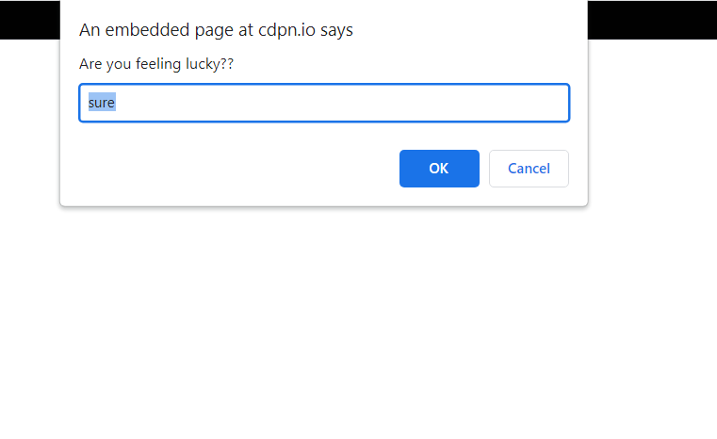

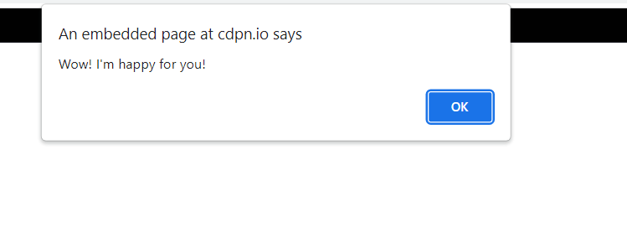

### Result:

Thus, the details of architectural design/framework/implementation along with the

### screenshots were provided.