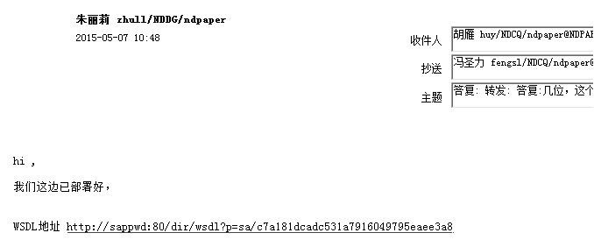

http://sappwd:80/dir/wsdl?=sa/c7a181dcadc531a7916049795eaee3a8

CQ_CARSYS

1234nm,.

