# Assignment-3

NAME: Boyina venkat

REG NO: 192110617

1. Write a C++ program to demonstrate the overloading of a unary operator.

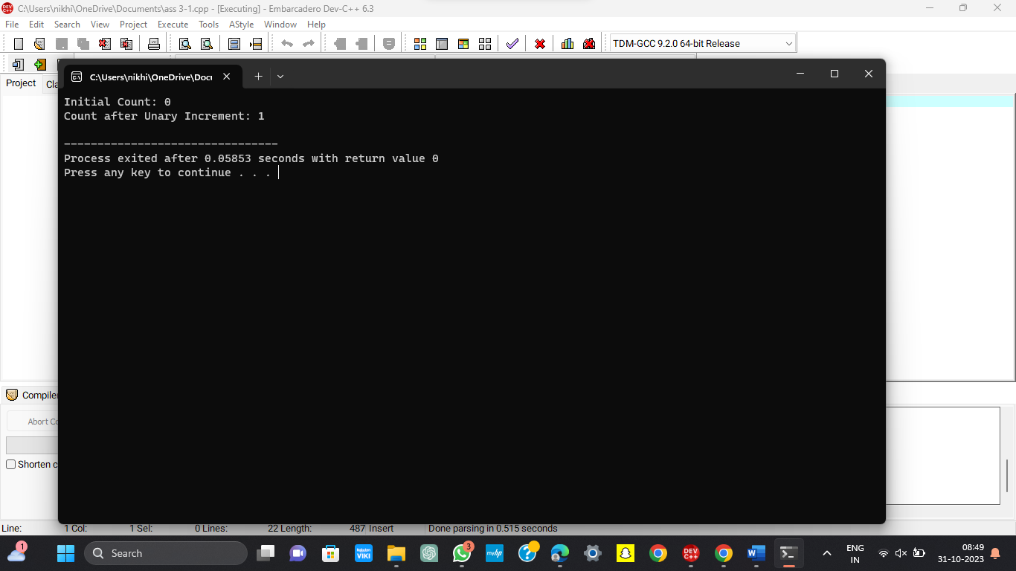

1. Write a C++ program to demonstrate the overloading of a binary operator.

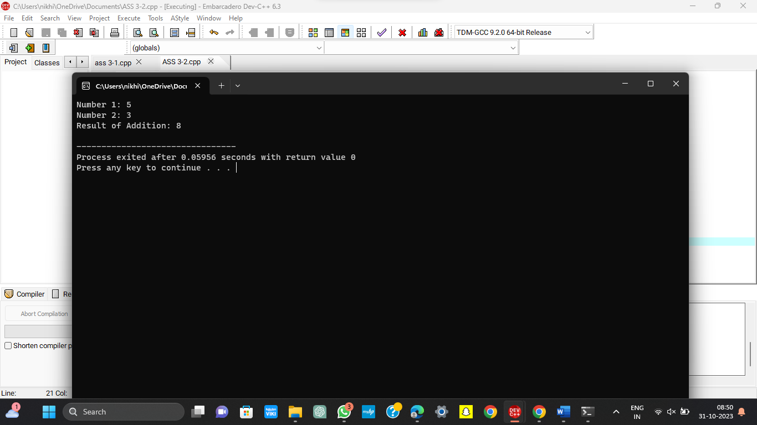

3. What is the output of the following code? #include<iostream.h>#include<string.h>

void main()

{

cout<<strlen(“Hello, World.\n”)<<”\n”;

}

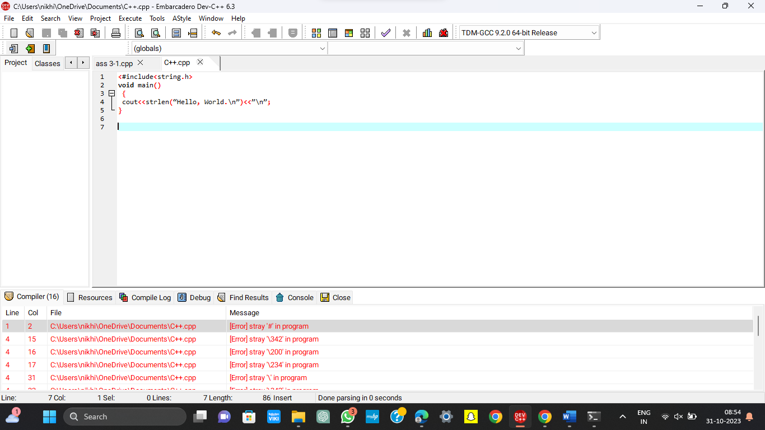

4. What is the output of the following code?

#include<iostream.h>

void main()

{

int a = 20;

int &n = a;

n=a++;

a=n++;

cout<<a <<”,”<<n<<endl; }

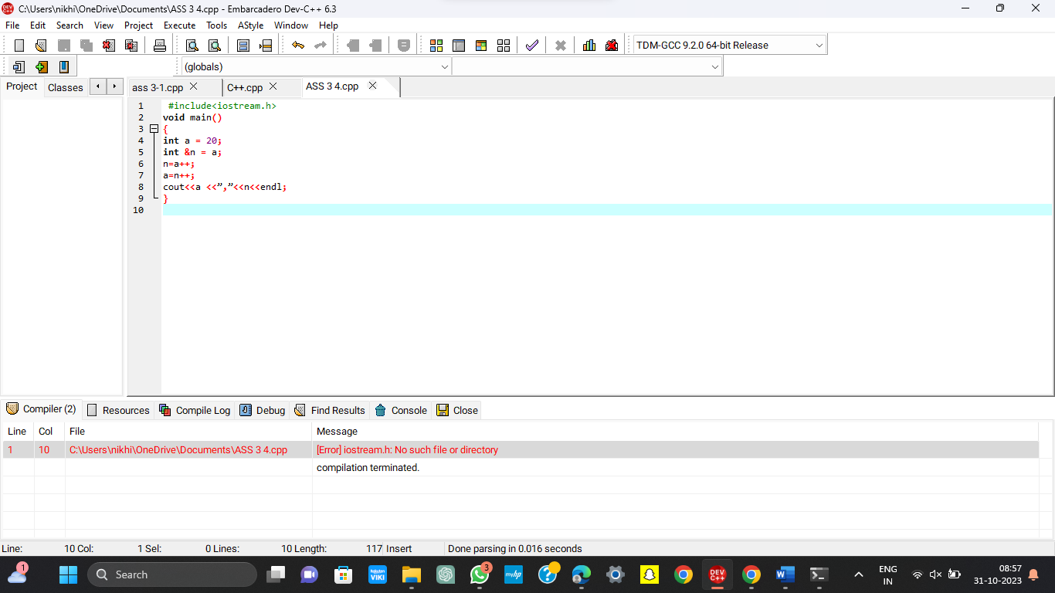

5. Write down a C++ program to implement function overloading.

