* github for desktop
* vs code
* command prompt
* pulling the code
* pushing the code
* switching the one branch
* see the list of branch
* merging the code ..
* commit the code .
* To clone the code
  + git clone https://github.com/venkatch669/ashokit-august-23.git

**VPN - virutal private network .**

* + based on uses of people, your speed of accessing the portal/app would be slow .
  + :late night:
    - VPN would be more faster bcz people uses the VPN very less ..
    - VPN is a software, it would be as below(cisco)

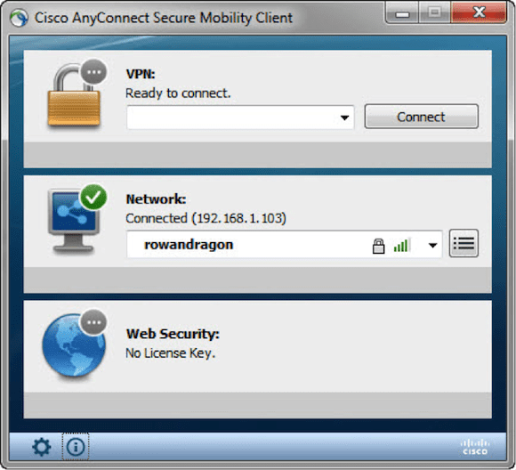

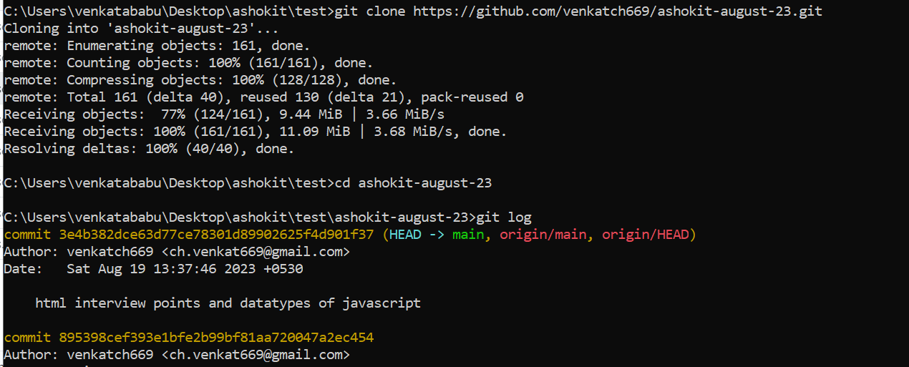

If you would like to exist from the log what you can **“wq”** so that if the log info to long you can exist easily

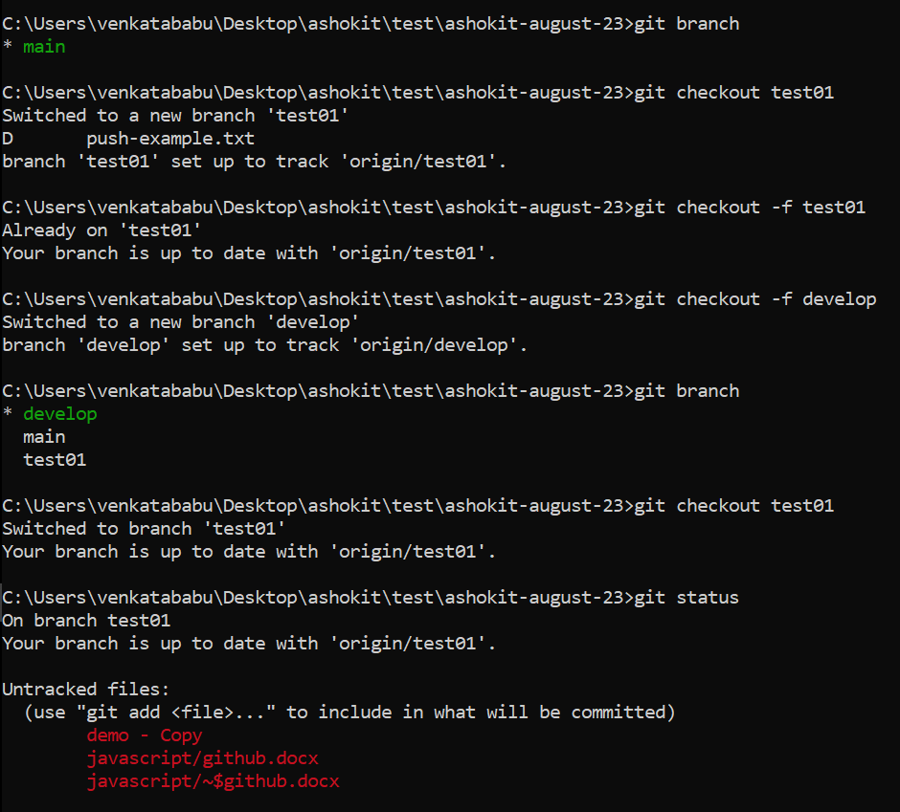

Git status: to see the list of changes of your local repo

Git add . : add all the changes into local folder using dot(.)

Git add <specific path > : if you would like add specific file or folder you can mention absolute path / relative path also

Git branch : to see the under which branch your

Git checkout -f <branchName>

Git commit -m “commit message” : you can commit you staged changes

Git push : move your local changes into remote

Git pull : take the remote changes into your local

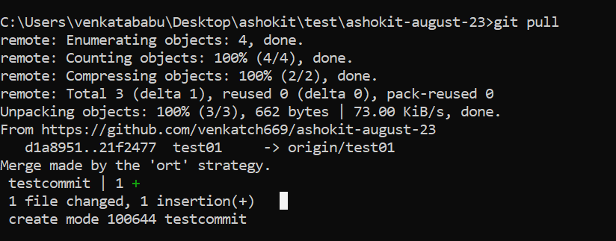

Git fetch : to get the list of branch from local

Git merge: merging/combining the changes of one branch another branch

