* github for desktop
* vs code
* command prompt
* pulling the code
* pushing the code
* switching the one branch
* see the list of branch
* merging the code ..
* commit the code .
* To clone the code
  + git clone https://github.com/venkatch669/ashokit-august-23.git

**VPN - virutal private network .**

* + based on uses of people, your speed of accessing the portal/app would be slow .
  + :late night:
    - VPN would be more faster bcz people uses the VPN very less ..
    - VPN is a software, it would be as below(cisco)

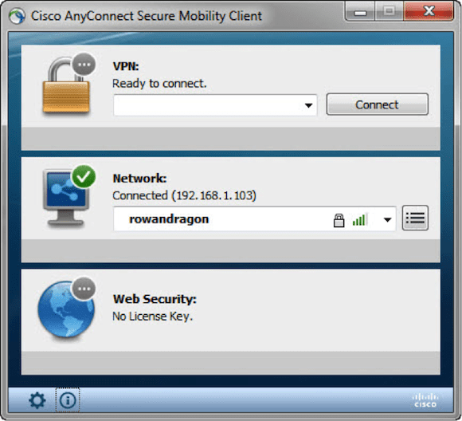

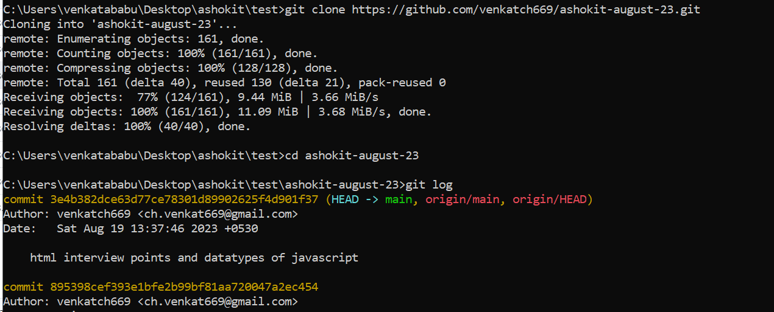

If you would like to exist from the log what you can **“wq”** so that if the log info to long you can exist easily