**Conceptual Model:**

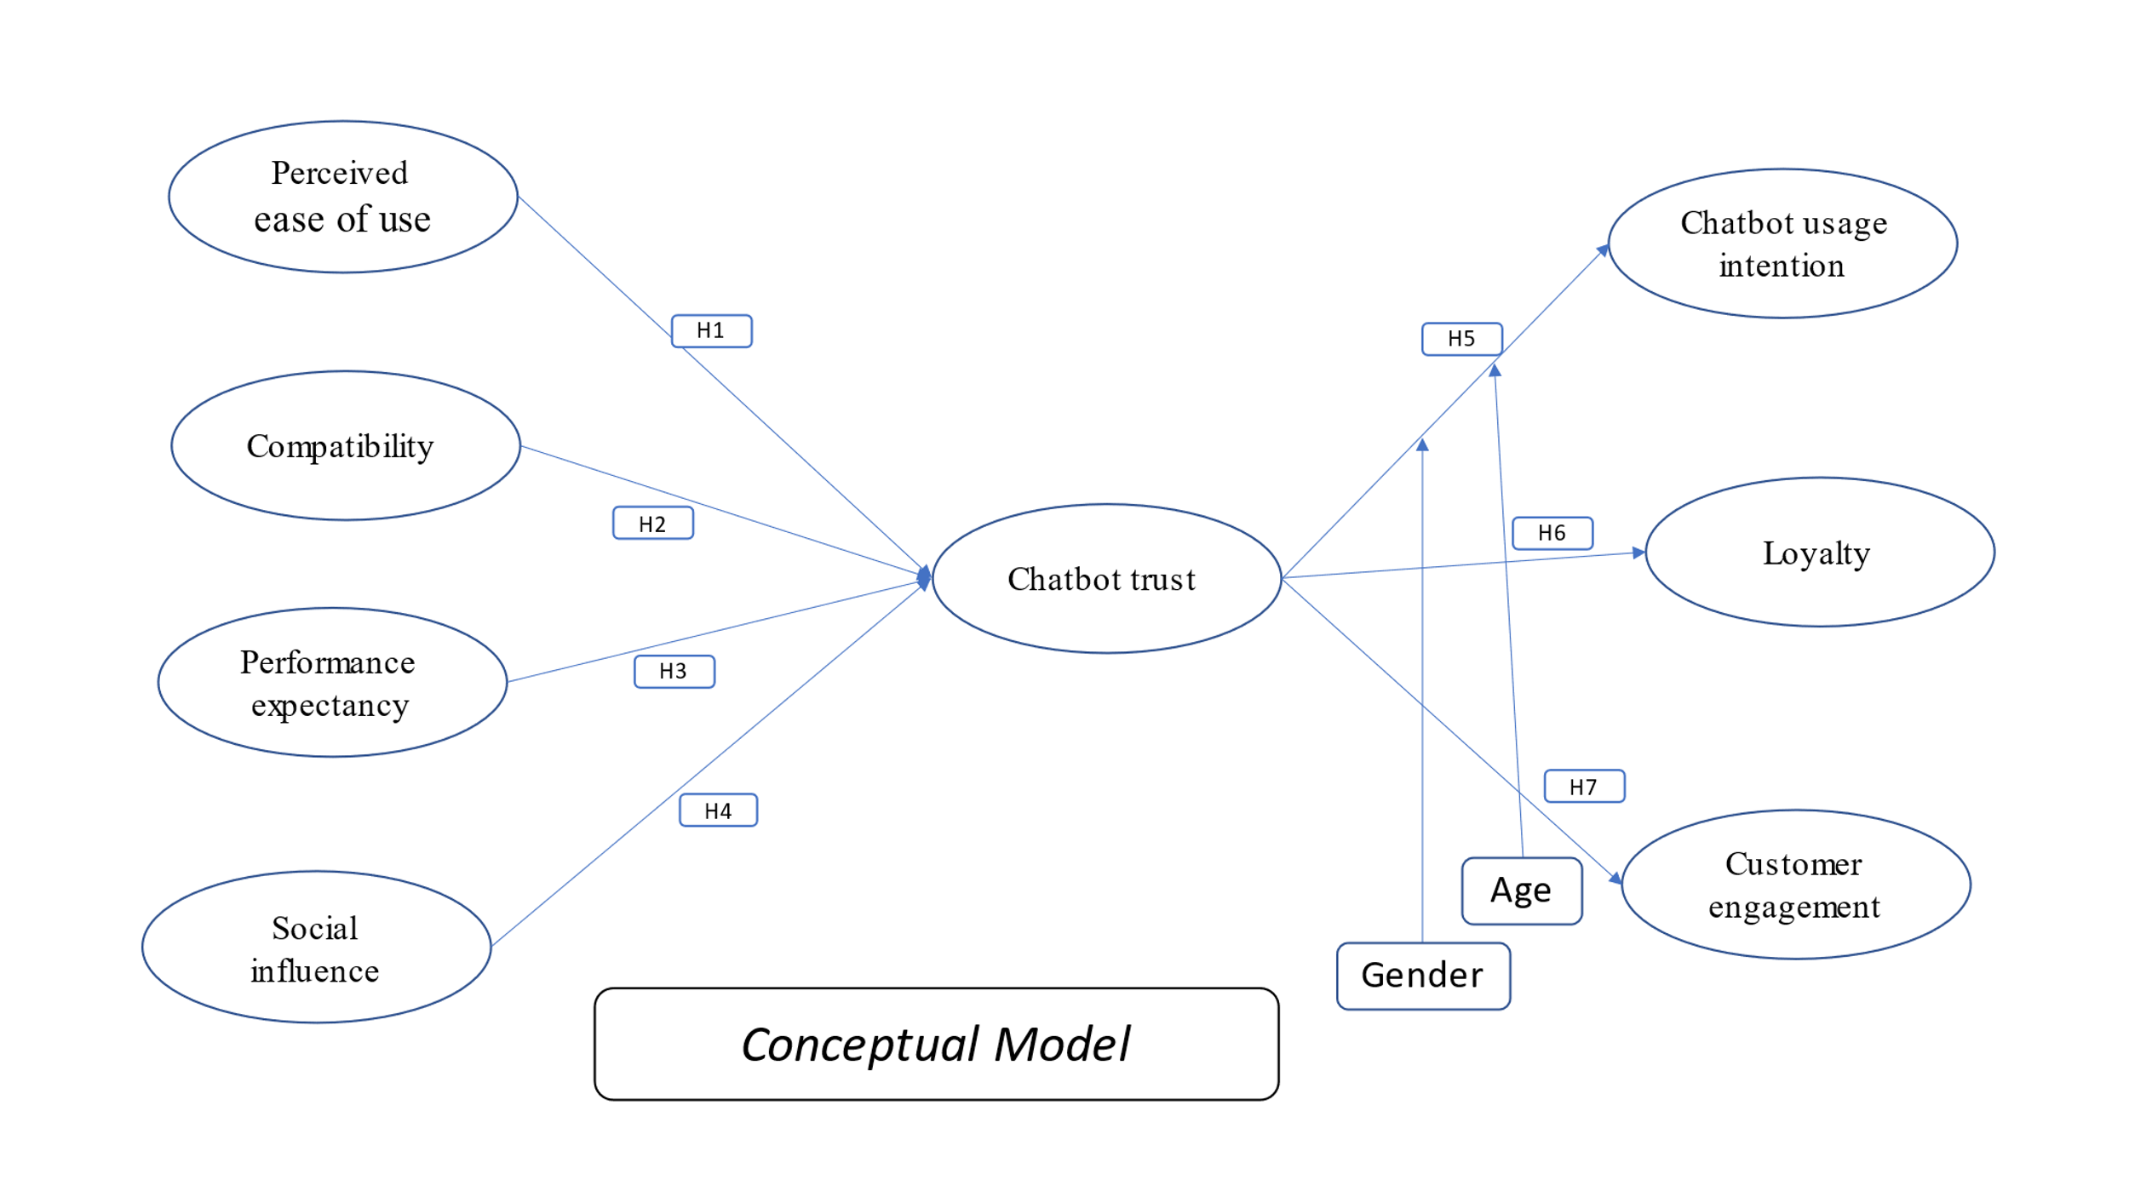

Fig-1

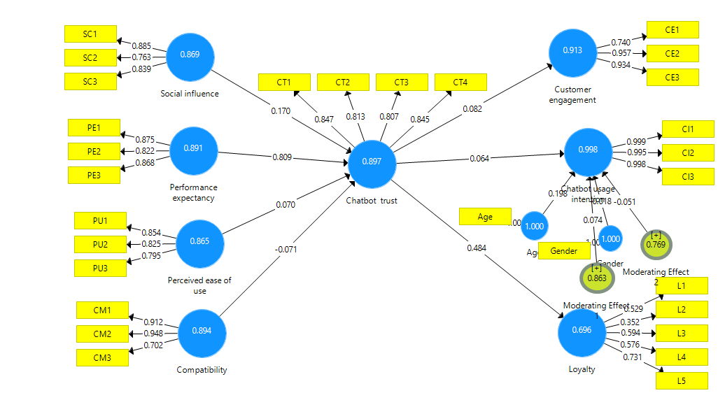**4.1 Measurement model result:**