Q1: **What is emmet**?

* Emmet is a set of plug-ins for text editors that allow for high-speed coding and editing. It is an add-on for your text editor. It allows you to type shortcuts that are then expanded into full pieces of code.

Example: html boilerplate code.

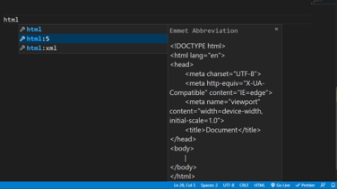

Q2: **What is the difference between Library and a framework**?

* Both frameworks and libraries are code written by someone else that is used to help solve common problems. For example, You decide to keep your code DRY (don’t repeat yourself) and write some reusable functions then that can be called a library.
* The technical difference between a framework and library lies in a term called **inversion of control**.
* When you use a library, you are in charge of the flow of the application. You are choosing when and where to call the library. When you use a framework, the framework is in charge of the flow. It provides some places for you to plug in your code, but it calls the code you plugged in as needed.

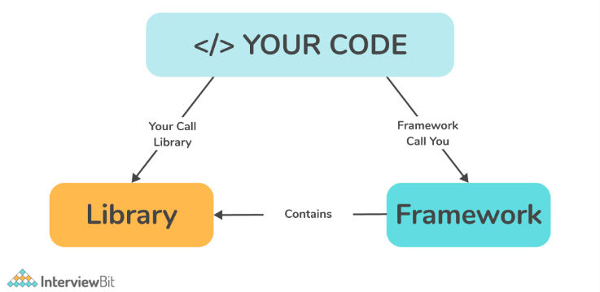

Q3: **What is CDN**? **Why do we use it**?

* CDN (content delivery network) is essentially a network of servers that distributes content from an “origin” server throughout the world by caching content close to where each end user is accessing the internet via a web-enabled device.
* Each CDN node (also called Edge Server) caches the static content of a site like the images, CSS/JS files and other structural components. The majority of an end-user’s page load time is spent on retrieving this content, and so it makes sense to provide these “building blocks” of a site in as many server nodes as possible, distributed throughout the world.
* When a user requests your site, the node closest in proximity to user will deliver the static content, ensuring the shortest distance for the data to travel (reduced latency), therefore providing the fastest site experience.

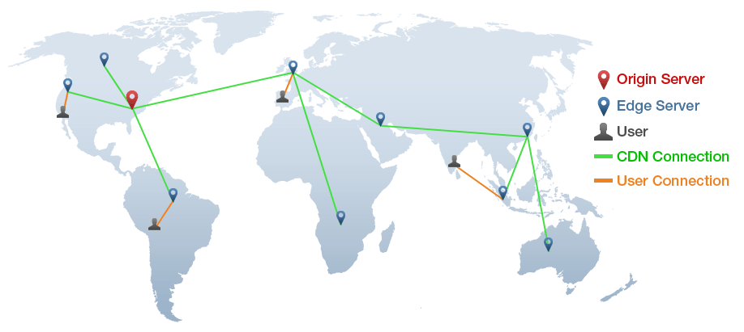 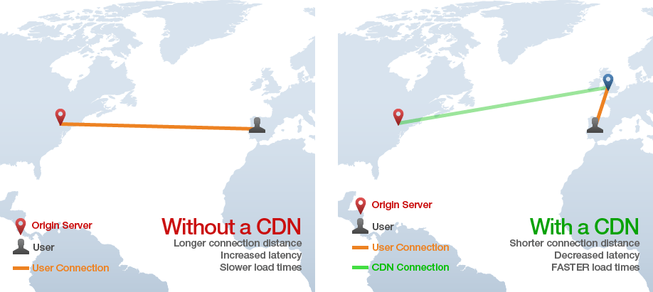

* CDNs can help protect a site by providing TLS and/or SSL certificates that ensure a high standard of authentication and encryption. In addition, CDNs can help protect your websites and apps through a Web Application Firewall (**WAF**) another reason for using a CDN is to improve your user’s experience in terms of speed.

Q4: **Why is React known as React**?

* **React** is named **React** because of its ability to react to changes in data. When the data in a **React** component changes, **React** will automatically re-render the component so that it reflects the new data. This makes it easy to create performant user interfaces that always look up-to-date.

Q5: **What is crossorigin in script tag**?

* The crossorigin attribute sets the mode of the request to an HTTP CORS Request. As web pages often make requests to load resources on other servers. Here is where CORS comes in.
* Example: A cross-origin requests for a resource (e.g. style sheets, iframes, images, fonts, or scripts) from another domain.

Q6: **What is diference between React and ReactDOM**?

* React is a JavaScript library for building User Interfaces and ReactDOM is the JavaScript library that allows React to interact with the DOM i.e actually render UI in the browser.

Q7: **What is difference between react.development.js and react.production.js files via CDN**?

* The development build is used - as the name suggests - for development reasons. You have Source Maps, debugging and often times hot reloading ability in those builds.
* The production build, on the other hand, runs in production mode which means this is the code running on your client's machine. The production build runs uglify and builds your source files into one or multiple minimized files. So, this makes rendering of file on end user's browser very quick and performance enhancing.

Q8: **What is async and defer**?

* Async allows your script to run as soon as it's loaded, without blocking other elements on the page. Defer means your script will only execute after the page has finished loading.