Assignment for Module 10
The assignment for Module 10 involves problems for schema conversion. Problems 1 to 4 involve the ERD in Figure 1.
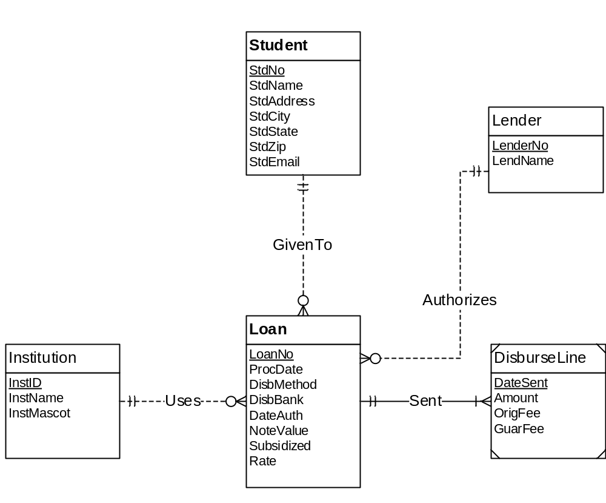
Figure 1: ERD for Problems 1 to 4
1. Requirements for Data Modeling Problems
- For the ERD in Figure 1, you should indicate the applications of the entity type rule. For each entity type rule application, you should identify the table name, primary key, and other columns. You do not need to write CREATE TABLE statements.
Answer:
Applying entity type rule on the above ERD,we can convert Entity types to the following tables:
Student(PRIMARY KEY(StdNo),StdName,StdAddress,StdCity,StdState,StdZip,StdEmail),
Lender(PRIMARY KEY(LenderNo),LenderName),
DisburseLine(PRIMARYKEY(DateSent),Amount,OrigFee,GuarFee),
Loan(PRIMARY KEY(LoanNo),ProcDate,DisbMethod, DisbBank,DateAuth,NoteValue,Subsidized,Date),
Institution(PRIMARY KEY(InstID),InstName,InstMascot).

- For the ERD in Figure 1, you should indicate applications of the 1-M relationship rule. For each 1-M relationship rule application, you should indicate the changes to the tables you listed in problem 1 including foreign key columns and NOT NULL constraints for foreign keys if necessary.
Answer:
- For the ‘uses’ relationship, a foreign key InstId can be introduced into Loan table.
- For the ‘sent’ relationship,a foreign key LoanNo can be introduced in DisburseLine table.
- For the ‘GivenTo’ relationship,a foreign key StdNo can be introduced into Loan table.
- For the ‘Authorizes’ relationship,a foreign key LenderNo can be introduced into Loan table.
The above changes can be summarized as:
Loan(FOREIGN KEY(InstId) references Institution Not Null,FOREIGN KEY(StdNo) references Student Not Null,FOREIGN KEY(LenderNo) references Lender Not Null),
DisburseLine(FOREIGN KEY(LoanNo) references Loan Not Null).
- For the ERD in Figure 1, you should indicate applications of the M-N relationship rule. For each M-N relationship rule application, you should list the table name, primary key, and other columns.
Answer:
There are no M-N relationships in Figure 1.

- For the ERD in Figure 1, you should indicate applications of the identifying relationship rule. For each identifying relationship rule application, you should indicate the changes to the tables you listed in problem 2.
Answer:
Applications of identifying relationship rule:
Lender(PRIMARY KEY(LenderNo,LoanNo));
Student(PRIMARY KEY(StudentNo,LoanNo));
Loan(PRIMARY KEY(LoanNo,InstId));
DisburseLine(PRIMARY KEY(DateSent,LoanNo));
- Convert the ERD shown in Figure 2 into tables. List the conversion rules used and table design. For each table, you should list the primary key, foreign keys, other columns, and NOT NULL constraints for foreign keys if necessary. You do not need to write CREATE TABLE statements.
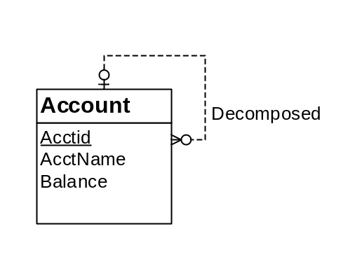
Figure 2: ERD for Conversion Problem 5
Answer:
Account(PRIMARY KEY(Acctid),superAcctid,AcctName,Balance)
FOREIGN KEY(superAcctid) references Account
superAcctid Not Null

- Convert the ERD shown in Figure 3 into tables. List the conversion rules used and table design. For each table, you should list the primary key, foreign keys, other columns, and NOT NULL constraints for foreign keys if necessary. You do not need to write CREATE TABLE statements.
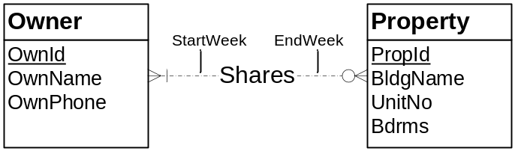

Figure 3: ERD for Conversion Problem 6

Answer:
Owner(PRIMARY KEY(OwnId),OwnName,OwnPhone)
Shares(OwnId,PropId,StartWeek,EndWeek)
FOREIGN KEY(OwnId) references Owner
FOREIGN KEY(PtopId) references Property
Property(PRIMARY KEY(PropId),BldnName,UnitNo,Bdrms)

