Employee table:

create table Employee
(EMPNO varchar(5) ,
EMPNAME varchar(20) not null,
DEPARTMENT varchar (15) not null,
EMAIL varchar(20) not null,
PHONE varchar(6) not null,
constraint pkEMPNO primary key(empno),
constraint unqEMPNAME unique(EMPNAME));
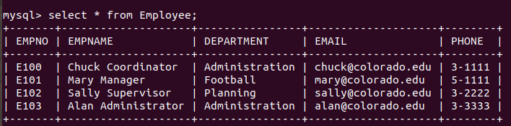
------------------------------------------------------------------------------------------------------------------------

RESOURCETBL:
create table RESOURCETBL
(RESNO varchar(4),
RESNAME varchar(15) not null,
rate integer not null,
constraint pkRESNO primary key(RESNO))
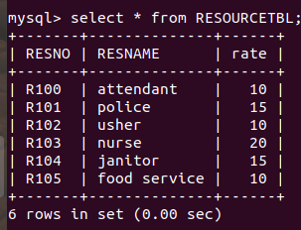

EVENTREQUEST:
create table EVENTREQUEST
(EVENTNO varchar(5),
DATEHELD date not null,
DATEREQ date not null,
CUSTNO varchar(5) not null,
FACNO varchar(5) not null,
DATEAUTH date,
STATUS varchar(8),
ESTCOST integer,
ESTAUDIENCE INTEGER,
BUDNO varchar(5),
constraint PKEno primary key(EVENTNO),
constraint fkEventRequestfacno foreign key(FACNO) references Facility(facno),
constraint fkEventRequestCustno foreign key(CUSTNO) references Customer(custno));
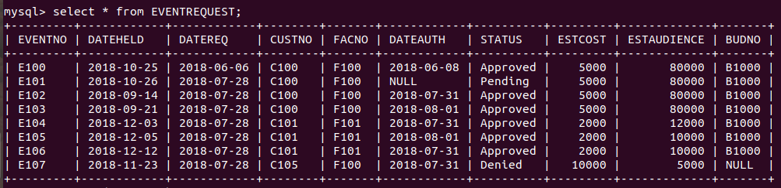
EVENTPLAN:
create table EVENTPLAN(
PLANNO varchar(4),
EVENTNO varchar(4) not null,
WORKDATE date not null,
NOTES varchar(25),
ACTIVITY varchar(10),
EMPNO varchar(4),
constraint pkplanno primary key(PLANNO),
constraint fkEventPlanEventNo foreign key(EVENTNO) references EVENTREQUEST(EVENTNO),
constraint fkEventplanEmpNo foreign key(EMPNO) references Employee(EMPNO));
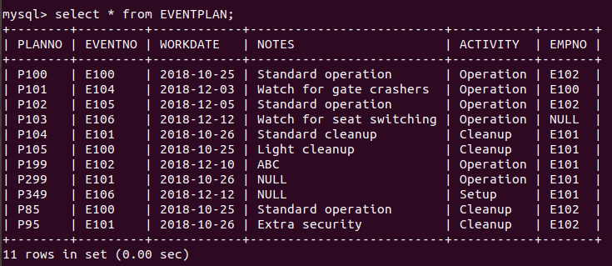

EVENTPLANLINE:
create table EVENTPLANLINE
(PLANNO varchar(4),
LINENO integer ,
TIMESTART date,
TIMEEND date,
NUMBERFLD integer,
LOCNO varchar(10),
RESNO varchar(4),
constraint fkEventplanlinePlanno foreign key(PLANNO) references EVENTPLAN(PLANNO),
constraint fkEPLLocno foreign key(LOCNO) references Location(locno));
