SakilaDB Assignment 1
1. Find out the PG-13 rated comedy movies. DO NOT use the film_list table.
Query:
select title from film inner join film_category on film.film_id=film_category.film_id inner join category on film_category.category_id=category.category_id where rating='PG-13' and category.name='Comedy';

Output:
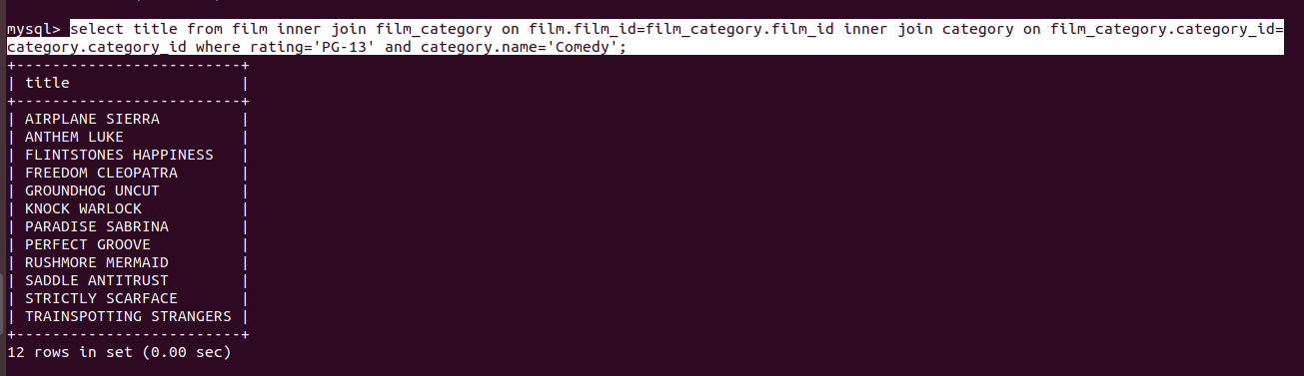
2. Find out the top 3 rented horror movies.
Query:
select film.title,count(inventory.film_id) as number_of_rentals
from rental inner join inventory on rental.inventory_id=inventory.inventory_id
inner join film_category on inventory.film_id=film_category.film_id
inner join category on film_category.category_id=category.category_id
inner join film on film_category.film_id=film.film_id
where category.name='Horror'
group by inventory.film_id
order by number_of_rentals
desc limit 3;

Output:
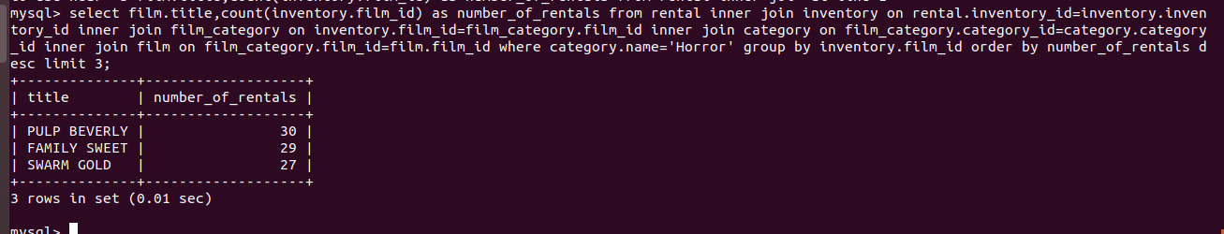

3. Find out the list of customers from India who have rented sports movies.
Query:
select distinct ID,customer_list.name
from customer_list inner join rental on customer_list.ID=rental.customer_id
inner join inventory on rental.inventory_id=inventory.inventory_id
inner join film_category on inventory.film_id=film_category.film_id
inner join category on film_category.category_id=category.category_id
where category.name='Sports' and customer_list.country='India';

Output:
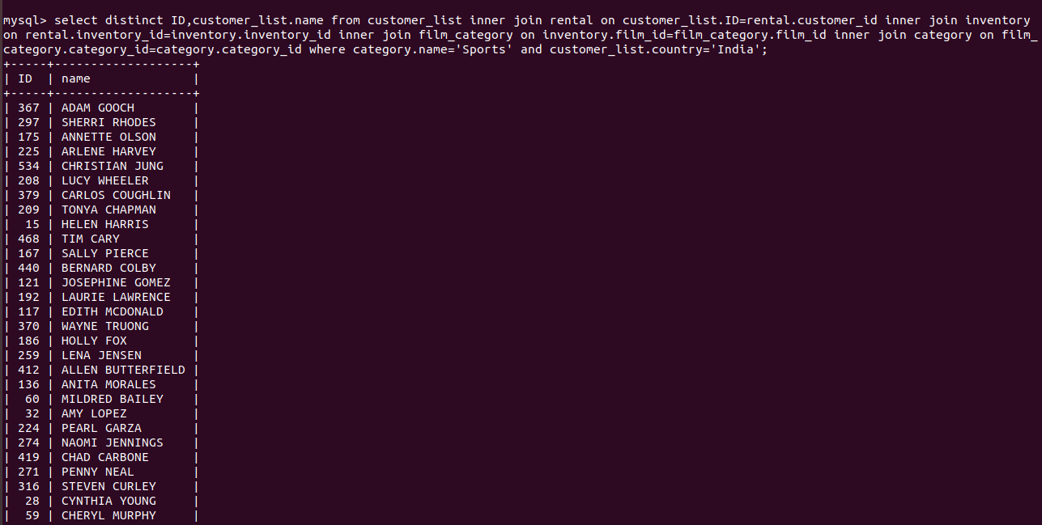

4. Find out the list of customers from Canada who have rented “NICK WAHLBERG” movies.
Query:
select distinct ID,customer_list.name
from customer_list inner join rental on customer_list.ID=rental.customer_id
inner join inventory on rental.inventory_id=inventory.inventory_id
inner join film_actor on inventory.film_id=film_actor.film_id
inner join actor on film_actor.actor_id=actor.actor_id
where actor.first_name='NICK' and actor.last_name='WAHLBERG' and customer_list.country='Canada';

Output:
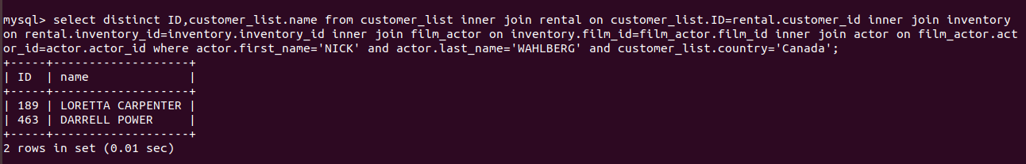
5. Find out the number of movies in which “SEAN WILLIAMS” acted.
Query:
select film_actor.actor_id,actor.first_name,actor.last_name,
count(film_id) as number_of_movies
from film_actor inner join actor on film_actor.actor_id=actor.actor_id
where actor.first_name='SEAN' and actor.last_name='WILLIAMS';

Output:


