Assignment for Module 7
The assignment for Module 7 provides practice using the Crow’s Foot notation. I encourage you to use the ER Assistant or Visual Paradigm to complete the problems in module 7. Module 7 contains software demonstrations for both the ER Assistant and Visual Paradigm.
1. Basic Crow’s Foot Notation Requirements
- Create an ERD containing the TestOrder and Specimen entity types and a 1-M relationship from Specimen to TestOrder. For each specimen collected, the database should record a unique SpecNo, SpecArea (vaginal, cervical, or endocervical), and SpecCollMethod (thin prep or sure path). A test order contains a TONo (primary key), TOTestName, TOTestType (HPV, CT/GC, CT, or GC), and TOTestResult (positive, negative, equivocal, or failure). A specimen does not have a test order until a delay, from hours to days. If a test order produces a failure, the specimen is given a new test order and tested again until a non-failure result is obtained. A test order is created for exactly one specimen.
Solution:
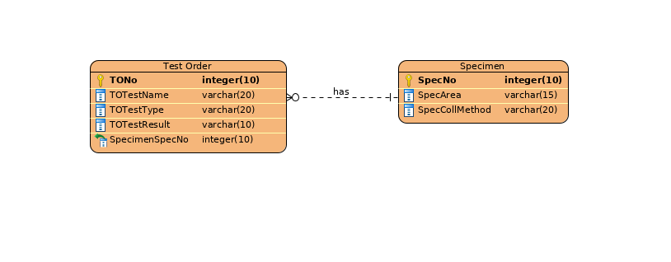
- Augment your ERD from problem 1 with the Supply entity type and an M-N relationship between TestOrder and Supply. Choose a name for the relationship based on your common knowledge of test orders and supplies. A test order can use a collection of supplies (0 or more) and a supply can be used on a collection of test orders (0 or more). The Supply entity type contains SuppNo (primary key), SuppName, SuppLotNo, and SuppQOH.
Solution:Visual paradigm automatically converts M-N relationships into its associate 1-M relationships(as shown in solution for problem 3).

- Use the M-N equivalence rule to transform the M-N relationship in Problem 2. You should choose appropriate names for the new relationships and entity type.
Solution:
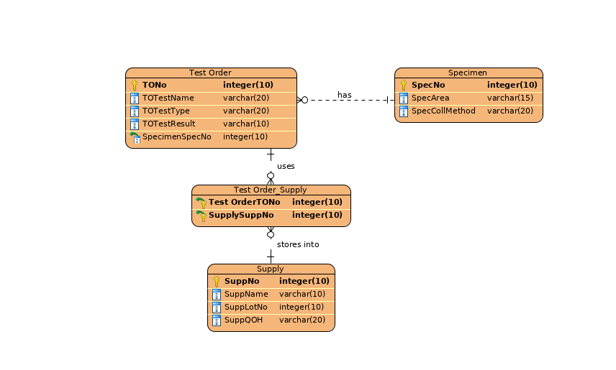
- For each consistency error in Figure 1, you should identify the consistency rule violated and suggest possible resolutions of the error. The ERD has generic names to help will concentrate on finding diagram errors rather than focusing on the meaning of the diagram

Figure 1: ERD for Problem 4

Solution:
1)Identifying relationship rule violation:
Rel6 has identifying relationship but it does not have an associated weak entity. This can be resolved by changing Rel6 from identifying relationship to regular relationship or by making Entity4 or Entity7 weak entity.
2)Redundant FK rule violation:
Entity 2 and Entity 1 have a redundant key called Attribute 4-1.This can be resolved by removing redundant key or renaming it if it is not a part of foreign key.
3)ID dependency cardinality rule violation:
Rel7 associates Entity 6(weak entity) to one or more Entity 7.This is a violation of cardinality rule because a weak entity’s cardinality to other entities should be only 1.This can be resolved by simply changing angular lines in Rel& to single perpendicular line.

