SakilaDB Assignment 2

1. Find out the number of documentaries with deleted scenes.

Query:
select count(title) as number_of_documentaries_with_deleted_scenes
from film
inner join film_category on film.film_id=film_category.film_id
inner join category on film_category.category_id=category.category_id
where special_features like '%Deleted Scenes%' and
category.name='Documentary';

Output:


2. Find out the number of sci-fi movies rented by the store managed by Jon Stephens.

Query:
select count(inventory.film_id)
from rental inner join inventory on rental.inventory_id=inventory.inventory_id
inner join film_category on inventory.film_id=film_category.film_id
inner join category on film_category.category_id=category.category_id
inner join store on inventory.store_id=store.store_id
inner join staff on store.manager_staff_id=staff.staff_id
where staff.first_name='Jon' and staff.last_name='Stephens'
and category.name='Sci-Fi';

Output:
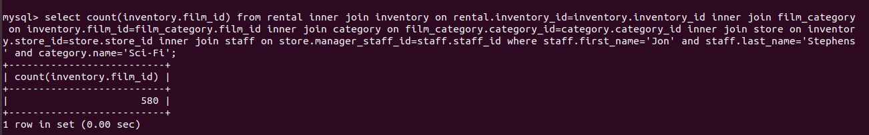

3. Find out the total sales from Animation movies.

Query:
select total_sales from sales_by_film_category where category='Animation';

Output:
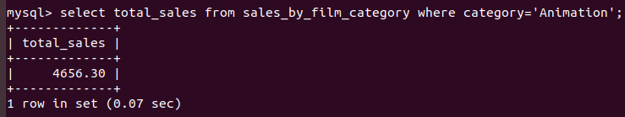

4. Find out the top 3 rented category of movies by “PATRICIA JOHNSON”.

Query:
select distinct category.name,count(inventory.film_id) as number_of_rentals
from rental inner join inventory on rental.inventory_id=inventory.inventory_id
inner join film_category on inventory.film_id=film_category.film_id
inner join category on film_category.category_id=category.category_id
inner join film on film_category.film_id=film.film_id
inner join customer on rental.customer_id=customer.customer_id
where customer.first_name='PATRICIA' and customer.last_name='JOHNSON' group by inventory.film_id order by number_of_rentals desc limit 3;

Output:
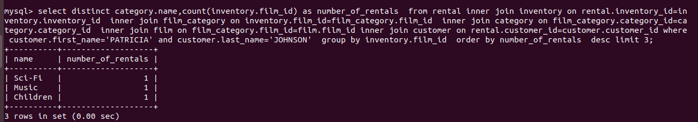

5. Find out the number of R rated movies rented by “SUSAN WILSON”.

Query:
select count(*) as number_of_R_rated_movies_rented_by_SUSAN_WILSON
from rental inner join inventory on rental.inventory_id=inventory.inventory_id
inner join film on inventory.film_id=film.film_id
inner join customer on rental.customer_id=customer.customer_id
where customer.first_name='SUSAN' and customer.last_name='WILSON' and film.rating='R';

Output:
