|  |  |
| --- | --- |
| 1 | Java Setup |
| 2 | Maven Setup |

|  |  |
| --- | --- |
| |  | | --- | | Note: Please view this image in “Web Layout” to see the complete image,  right side bottom of the word doc. | |

**JAVA Setup:**

Google search for jdk download. Click on the below java downloads link.

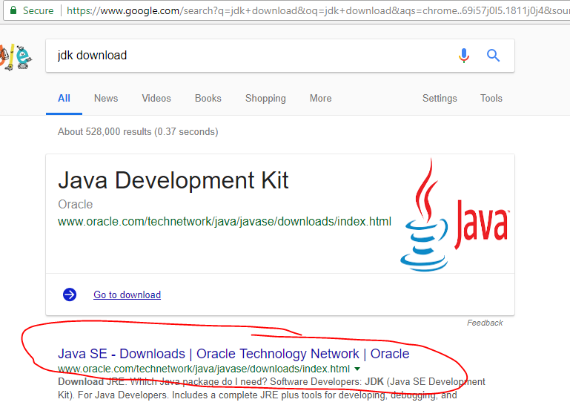

It will navigate to this URL, you can directly click on this URL:

<http://www.oracle.com/technetwork/java/javase/downloads/index.html>

Choose the version you want to install: Here, I am downloading JDK 1.8 171

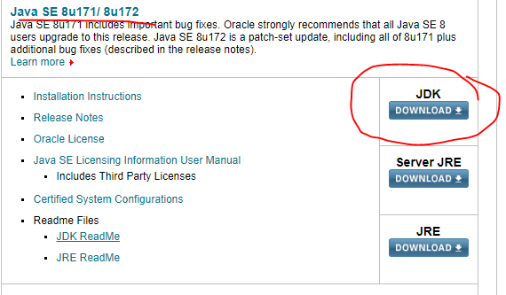

Click on Accept licence & choose the compatible package to your windows or linux OS.

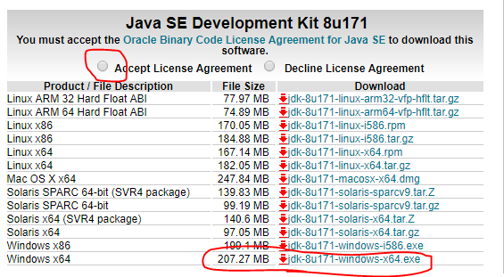

Downloading status:



Go to downloads and double click on the JDK exe file to proceed with installation:

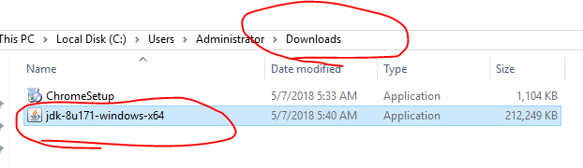

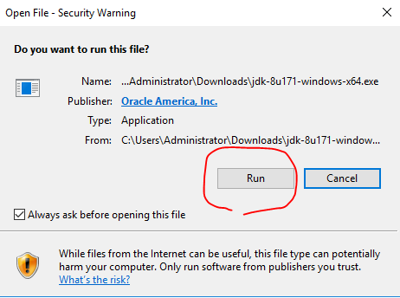

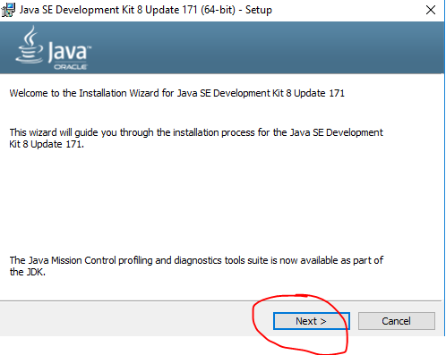

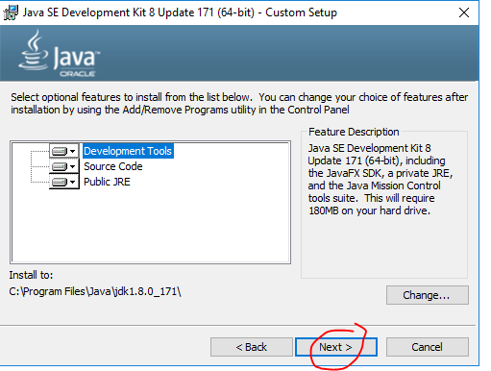

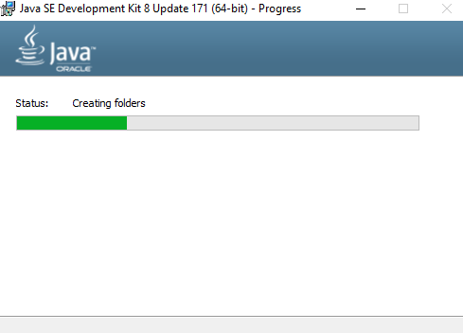

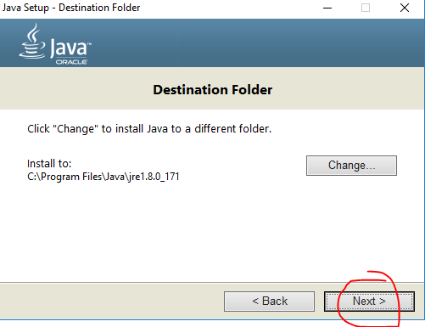

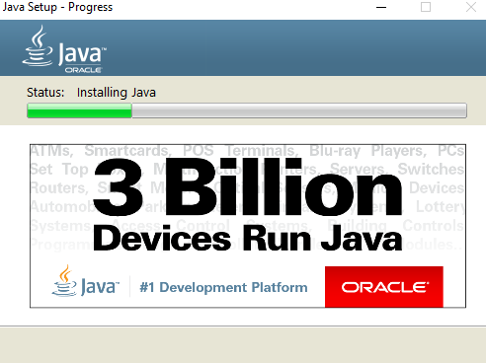

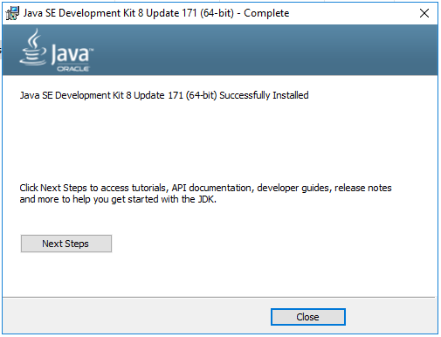

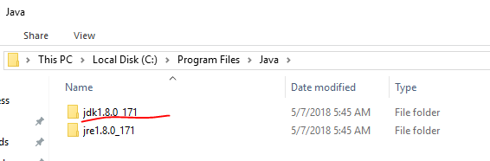



C:\Program Files\Java\jdk1.8.0_171\bin

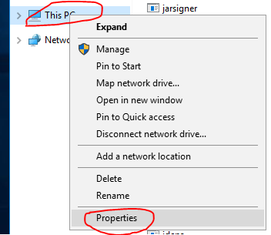

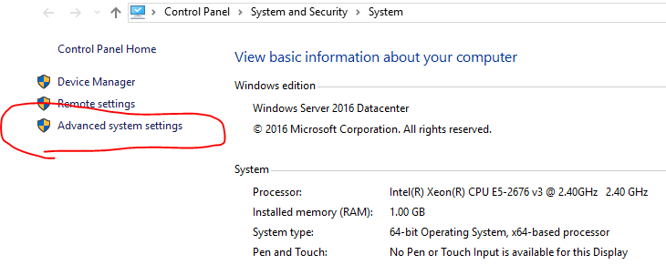

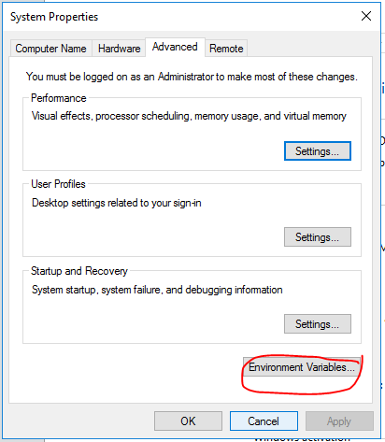

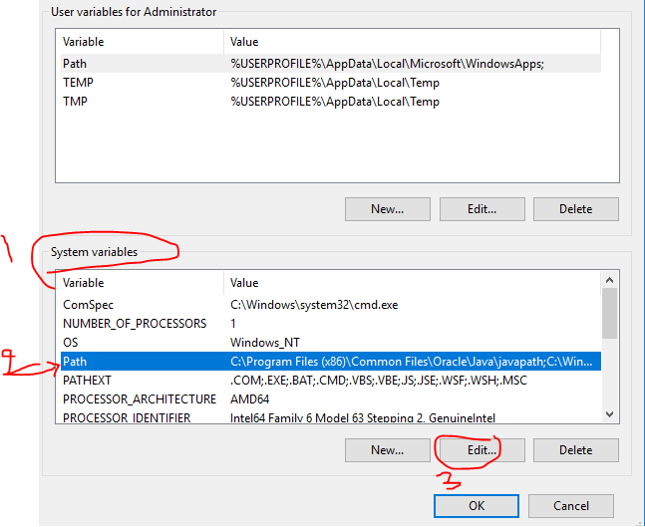

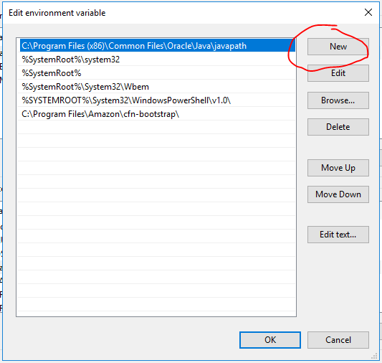

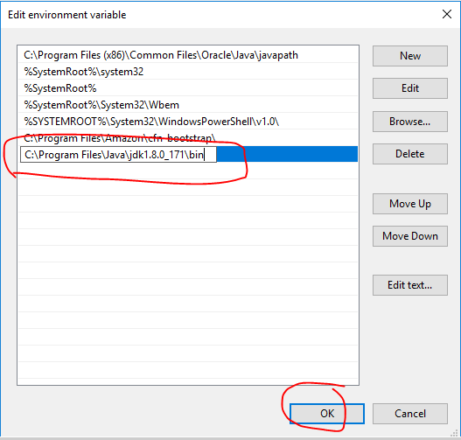

Create new system variable for JAVA_HOME: C:\Program Files\Java\jdk1.8.0_171 (without the bin folder)

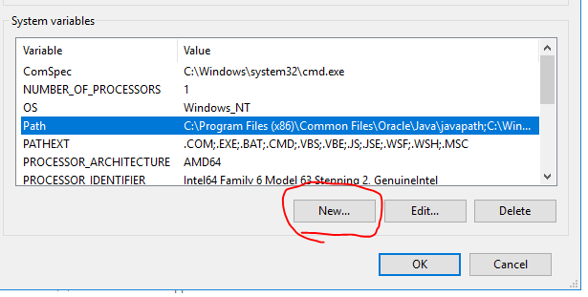

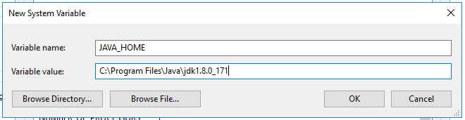

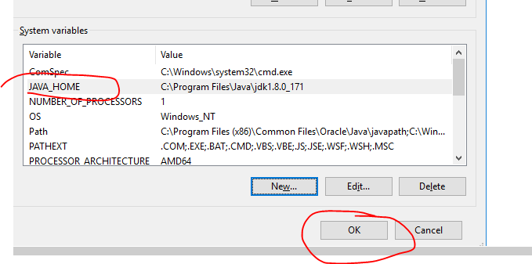

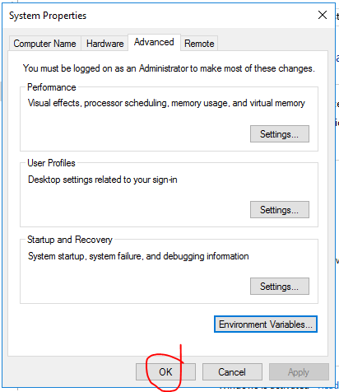

Check whether the java installed & setup properly or not:

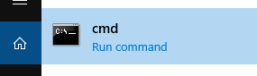

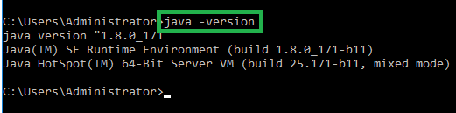

**Maven Setup:**

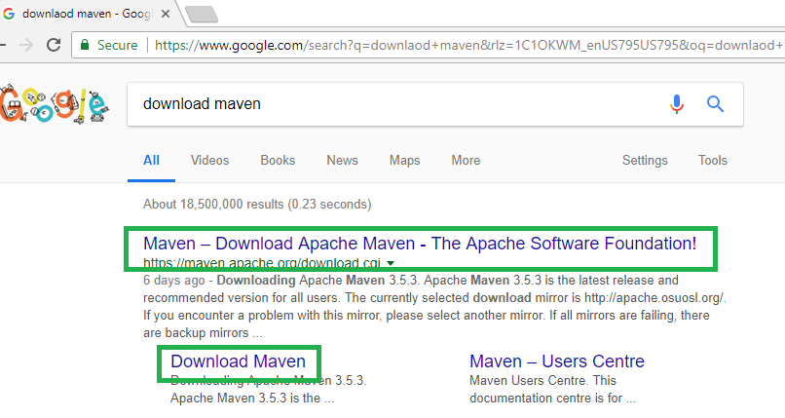

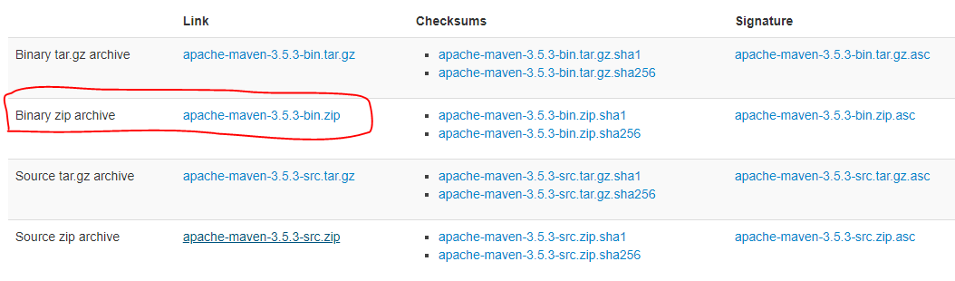



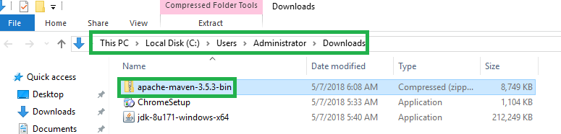

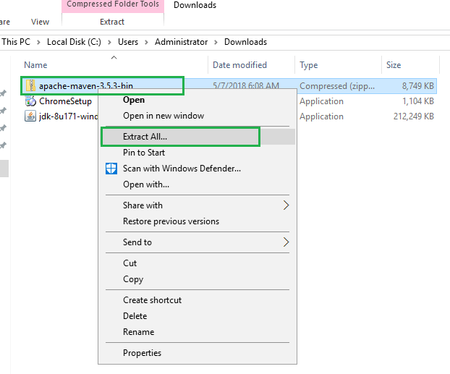

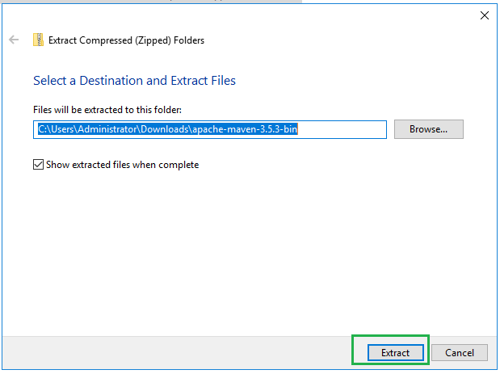

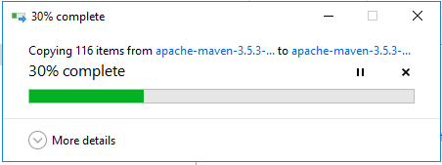

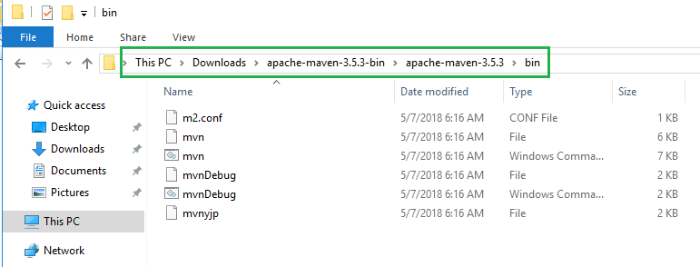

You can proceed with downloads maven path as shown above. Or you can keep the maven folder in any location in your system and then setup the path. Here, I am copying the maven to different folder.

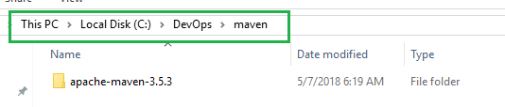

Now maven is here C:\DevOps\maven\apache-maven-3.5.3, we need to set the class path.

C:\DevOps\maven\apache-maven-3.5.3\bin

Repeat the above steps to setup the java path to system variables.

Right click on computer or This PC 🡪 Advanced system settings 🡪 Environment Variables 🡪 Edit the ‘path’ under the system variables 🡪 new 🡪 add the maven path as mentioned in below image.











