**Jenkins Pipeline Script**

**Scenario-1:**

* 1. Checkout the code from GitHub using Jenkins pipeline script.

|  |
| --- |
| Checkout the code: single stage |
| node {  stage('Checkout') {  //Checkout the code from a GitHub repository  git credentialsId: 'jenkinsGitHub', url: 'https://github.com/DIGITALAPPLICATION/WebApp.git'  }  } |

**Scenario-2:**

2.1. Checkout the code from GitHub.

2.2. Compile the source code and then package the compiled files.

|  |
| --- |
| Checkout the code + build: two stages |
| node{  stage('Checkout'){  //Checkout the code from a GitHub repository  git credentialsId: 'jenkinsGitHub', url: 'https://github.com/DIGITALAPPLICATION/WebApp.git'  }  stage('build'){  sh '"/root/apache-maven-3.5.3/bin/mvn" -V clean package'  }  } |

**Output**:

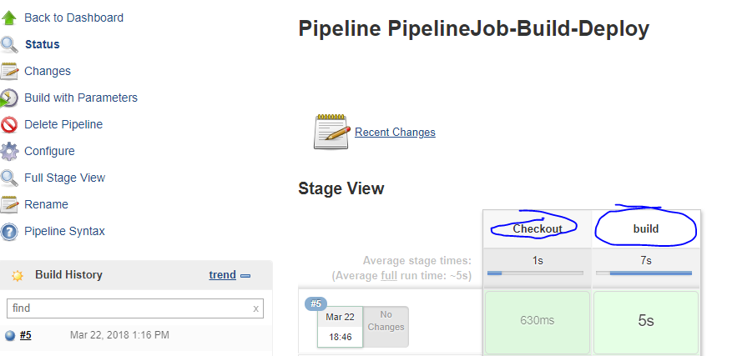

**Scenario-3:**

3.1. Checkout the code from GitHub.

3.2. Compile the original source code.

3.3. Compile the test source files and run those tests. (Original source code also will be compiled in this stage; sometimes we may get this type of Jenkins job configuration request from Dev team).

3.4. Package the compiled code and then deploy/stage the package to nexus. (In this phase 3.3 included, please refer maven lifecycle phases. If dev team don’t request separate stages, then 3.1 & 3.4 stages are enough).

|  |
| --- |
| Checkout the code + build + test +deploy to nexus: four stages |
| node{  stage('Checkout'){  //Checkout the code from a GitHub repository  git credentialsId: 'jenkinsGitHub', url: 'https://github.com/DIGITALAPPLICATION/WebApp.git'  }  stage('build'){  sh '"/root/apache-maven-3.5.3/bin/mvn" -V clean compile'  }  stage('test'){  sh '"/root/apache-maven-3.5.3/bin/mvn" -V clean test'  }  stage('deploy-to-nexus'){  sh '"/root/apache-maven-3.5.3/bin/mvn" -V clean deploy'  }  } |

Output:

4 stages executed successfully.

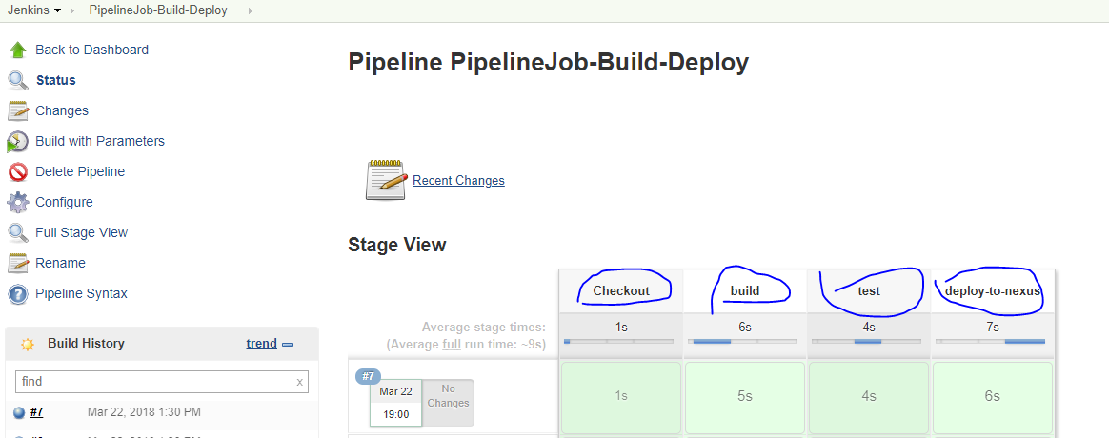

Deployed the package to nexus server.

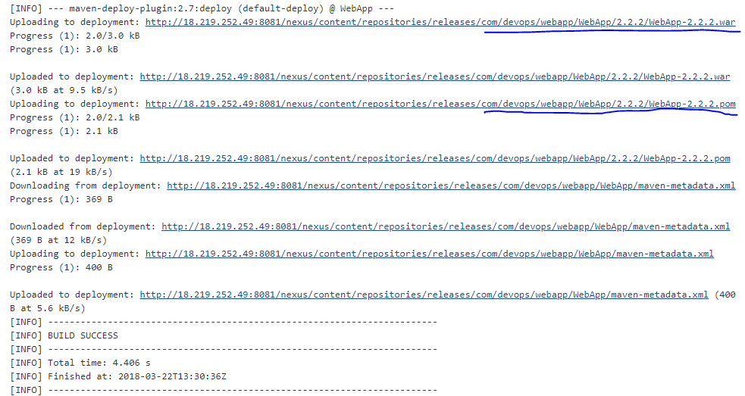

**Scenario-4:** 3.4. + deploy the same package to nexus.

|  |
| --- |
| Checkout the code + build + test +deploy to nexus + deploy to tomcat: five stages |
| node{  stage('Checkout'){  //Checkout the code from a GitHub repository  git credentialsId: 'jenkinsGitHub', url: 'https://github.com/DIGITALAPPLICATION/WebApp.git'  }  stage('build'){  sh '"/root/apache-maven-3.5.3/bin/mvn" -V clean compile'  }  stage('test'){  sh '"/root/apache-maven-3.5.3/bin/mvn" -V clean test'  }  stage('deploy-to-nexus'){  sh '"/root/apache-maven-3.5.3/bin/mvn" -V clean deploy'  }  stage('deploy-to-tomcat'){  sh '''  echo Deploy the war to tomcat server.  echo Step-1: Removing the existing package  rm -rf /root/tomcat7/webapps/WebApp-*.war  rm -rf /root/tomcat7/webapps/WebApp-*  echo Step-2: Staging the new package to tomcat server.  cp ${WORKSPACE}/target/*.war /root/tomcat7/webapps  '''  }  } |

All 5 stages executed successfully.

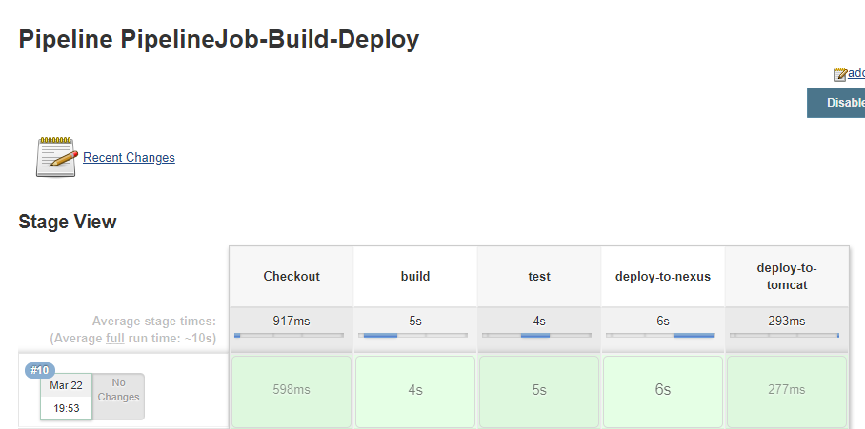

Copy the war package to tomcat server.

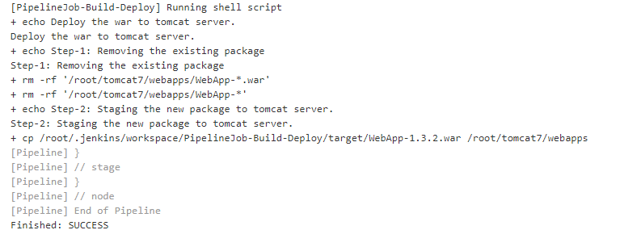

Output: Run the web application which is deployed on tomcat. Run the tomcat sever http://<ipaddress>:8080. Click on “manager webapp” to find the deployed artifacts/packages in this tomcat server.

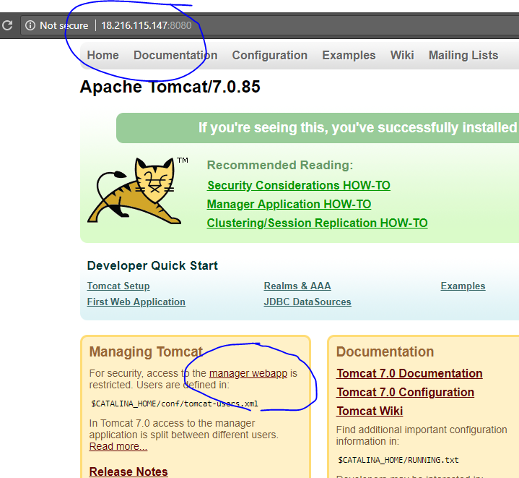

Click on the context root (our application name). It will display the default web page(see below image).

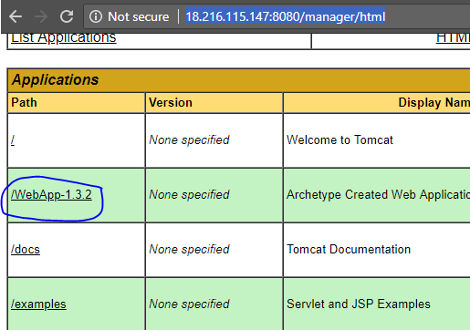

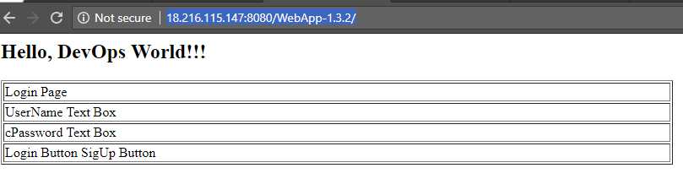

Remove unnecessary phases compile, test since these two goals are covered in **deploy** phase by default.

|  |
| --- |
| Checkout the code + build(compile+test+deploy the package to nexus) + deploy to tomcat: five stages |
| node{  stage('Checkout'){  //Checkout the code from a GitHub repository  git credentialsId: 'jenkinsGitHub', url: 'https://github.com/DIGITALAPPLICATION/WebApp.git'  }  stage(' build(compile+test+deploy the package to nexus) '){  sh '"/root/apache-maven-3.5.3/bin/mvn" -V clean deploy'  }  stage('deploy-to-tomcat'){  sh '''  echo Deploy the war to tomcat server.  echo Step-1: Removing the existing package  rm -rf /root/tomcat7/webapps/WebApp-*.war  rm -rf /root/tomcat7/webapps/WebApp-*  echo Step-2: Staging the new package to tomcat server.  cp ${WORKSPACE}/target/*.war /root/tomcat7/webapps  '''  }  } |

