Jenkins Job configuration for build and deploy the web project (i.e., java war package) to tomcat server which is in another instance.

|  |  |  |
| --- | --- | --- |
| Server1 | Server2 | Server3 |
| Java  Tomcat  Maven  Git  Jenkins  Ansible | Java  Tomcat | nexus |

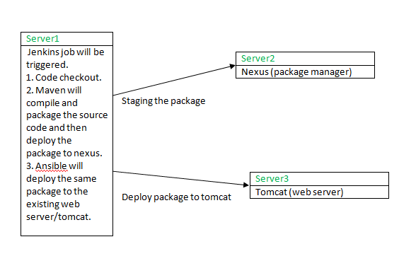

1. Code Checkout

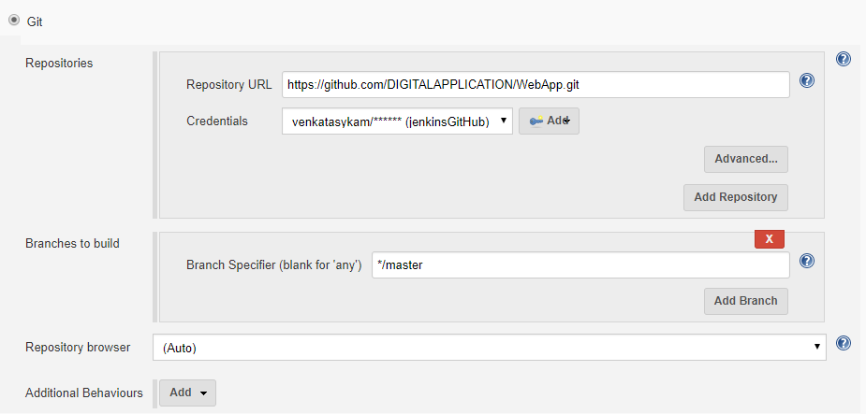

2. Build and deploy the package to nexus

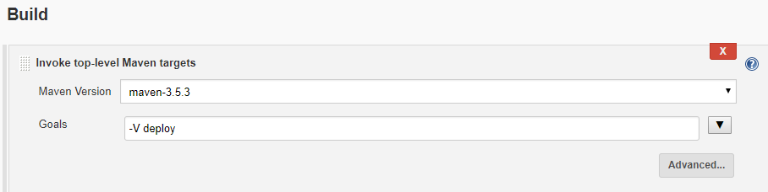

3. Deploy the war package to the target server using Ansible.

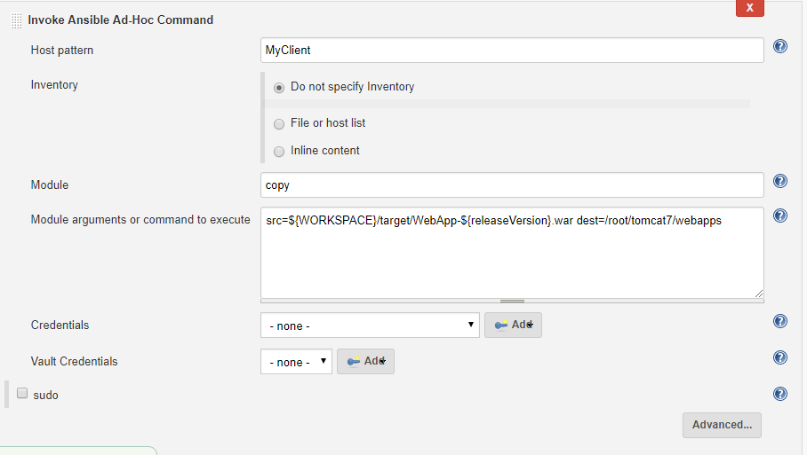

**Parameterized build**: passing the release version.

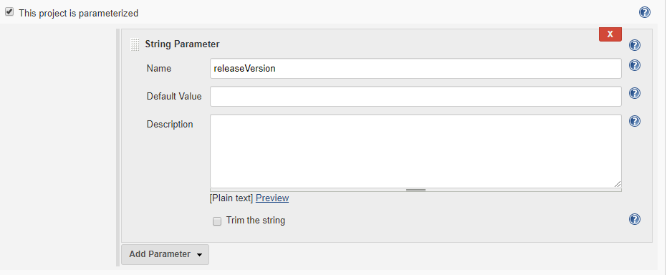

Output:

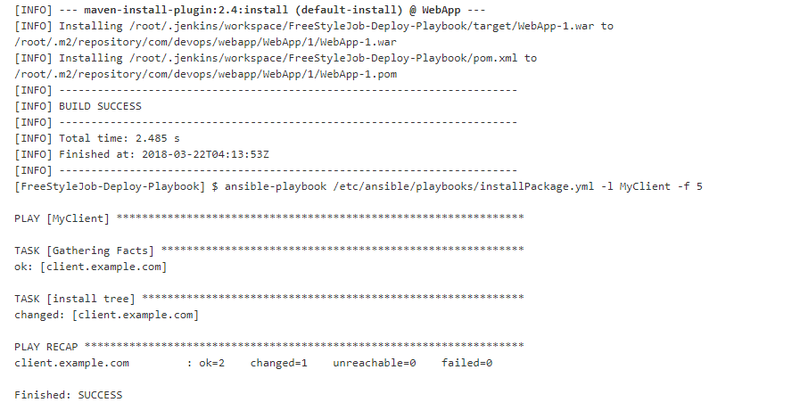

**Using Playbook**:

|  |
| --- |
| warDeployWithVariables.yml |
| - hosts: MyClient  tasks:  - name: Deploy WAR file  copy: src={{WORKSPACE}}/target/WebApp-{{releaseVersion}}.war dest=/root/tomcat7/webapps/ |

**Invoking the Ansible playbook**: playbook path, host details, extra vars, & additional parameters.

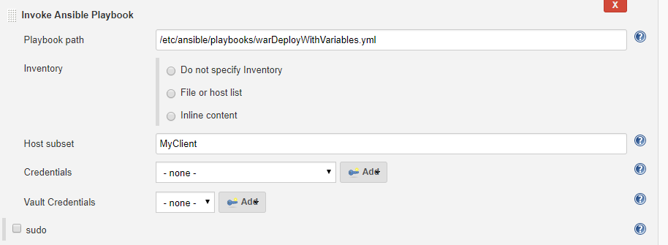

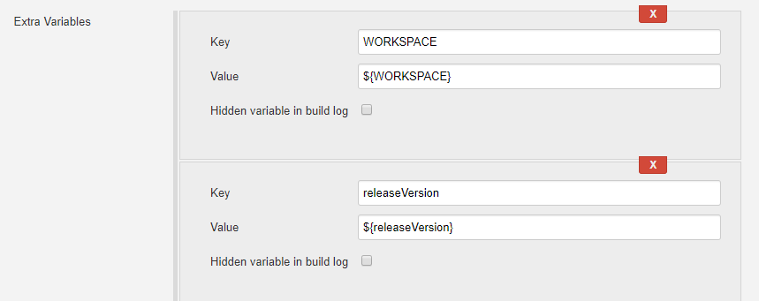



Output: Give -v at Additional parameters under advanced section.

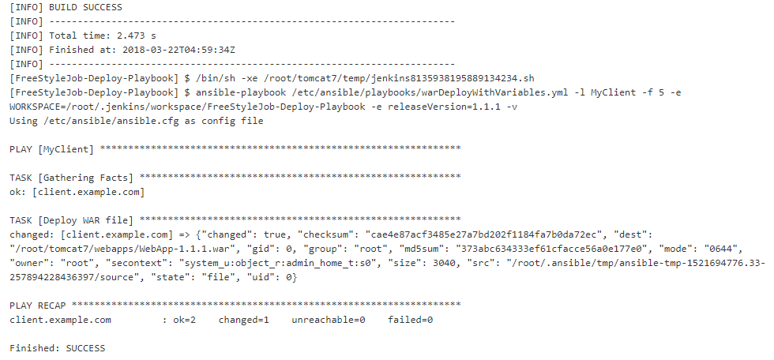

**Separate Deploy**: Download the artefact from nexus and deploy on nexus.

|  |
| --- |
| warDeploySeparetly.yml |
| - hosts: MyClient  tasks:  - name: Download WAR to server  get_url:  url: http://18.221.129.212:8081/nexus/content/repositories/releases/com/devops/webapp/{{artifactId}}/{{deployVersion}}/{{artifactId}}-{{deployVersion}}.{{package}}  dest: .  - name: Deploy WAR file  command: mv ./{{artifactId}}-{{deployVersion}}.{{package}} /root/tomcat7/webapps/ |
| 1. Passing the artefactId, version details to Jenkins job. 2. Downloading the artefact from nexus, and keeping it in current directory. i.e., Jenkins workspace. 3. And move the artefact from current location to tomcat server which is in another machine. |

**Passing the parameters**: artifactId, version & package.

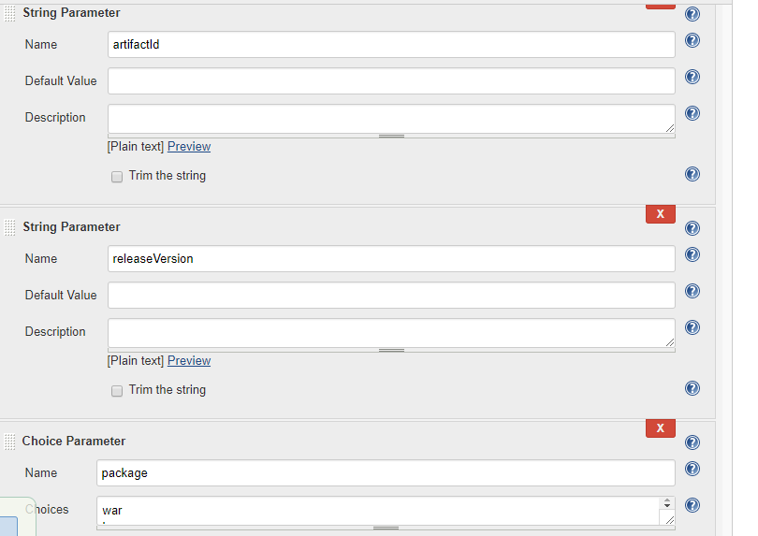

**Invoking the Ansible playbook**: playbook path, host details, extra vars, & additional parameters.

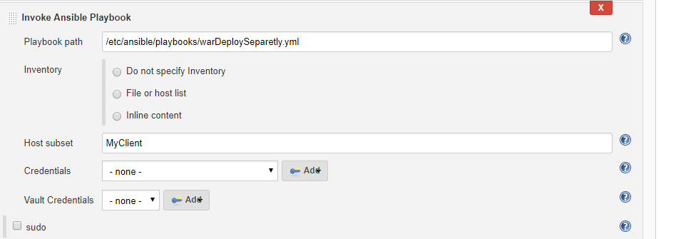

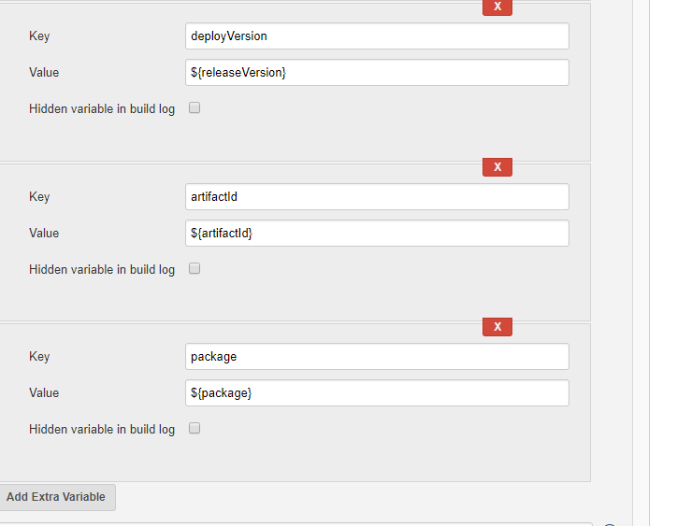

**Output**:

