COLLEGE EVENT REGISTRATION SYSTEM
A PROJECT REPORT
Submitted by
VENKAT BADHRINARAYANAN PV
(240701582)
in partial fulfilment of the End Semester Examination for the course
CB23F35 –
LOW-CODE APPLICATION DEVELOPMENT USING ZOHO CREATOR
in
BACHELOR OF ENGINEERING
COMPUTER SCIENCE AND ENGINEERING

RAJALAKSHMI ENGINEERING COLLEGE
(An Autonomous Institution, Affiliated to Anna University, Chennai)
Rajalakshmi Nagar, Thandalam, Tamil Nadu – 602 105
OCTOBER 2026

RAJALAKSHMI ENGINEERING COLLEGE
(An Autonomous Institution, Affiliated to Anna University, Chennai)
BONAFIDE CERTIFICATE
Certified that this project report titled “COLLEGE EVENT REGISTRATION SYSTEM” is the bonafide work of VENKAT BADHRINARAYANAN PV (240701582), who carried out the individual project work on the Zoho Creator low-code platform for the course CB23F35 – Low-Code Application Development using Zoho Creator, during the academic year 2026–2027, Semester V, under the guidance of Bhuvaneshwaran.
SIGNATURE  Dr. K. Devaki  HEAD OF THE DEPARTMENT  Department of Computer Science and Engineering  Rajalakshmi Engineering College  Thandalam – 602 105 | SIGNATURE  Mr. Bhuvaneshwaran  COURSE FACULTY  Assistant Professor  Department of Computer Science and Engineering  Rajalakshmi Engineering College

Submitted for the End Semester Examination (Individual Project) held on 24 October 2026.
INTERNAL EXAMINER | EXTERNAL EXAMINER

DECLARATION
I, VENKAT BADHRINARAYANAN PV (240701582), hereby declare that the project report titled “COLLEGE EVENT REGISTRATION SYSTEM”, submitted for the End Semester Examination of CB23F35 – Low-Code Application Development using Zoho Creator, is a record of the individual project work carried out by me.
I further declare that the application details, scripts, workflows, integrations and test results described in this report will be checked against the live Zoho Creator application. Any external documentation, sample code or AI-assisted feature used in the work will be acknowledged.
Place: ChennaiSIGNATURE OF THE STUDENT
Date: 24 October 2026 VENKAT BADHRINARAYANAN PV
240701582

ACKNOWLEDGEMENT
I express my sincere gratitude to the management of Rajalakshmi Engineering College for providing the infrastructure and facilities required to undertake this project.
I am grateful to our Principal for the encouragement extended to students to pursue practical and industry-oriented learning.
I thank the Head of the Department, Department of Computer Science and Engineering, for the support provided throughout the course.
I owe my sincere thanks to my project guide, Bhuvaneshwaran, for the guidance, reviews and feedback that helped shape this application and report.
I also acknowledge Zoho Corporation for the Zoho Creator platform and its learning resources. Finally, I thank my family and friends for their support.

VENKAT BADHRINARAYANAN PV

ABSTRACT
College events such as technical symposiums, project expos and inter-collegiate competitions require organisers to publish event details, collect team information, associate registrations with events, review submissions and communicate updates. When these activities are maintained through separate spreadsheets and email conversations, organisers may encounter duplicated entries, inconsistent event information, delayed follow-up and difficulty preparing registration summaries. The College Event Registration System was selected as a low-code application project to organise event and team-registration information in a structured Zoho Creator application. Zoho Creator was chosen because it provides visual forms, lookup relationships, reports, pages and Deluge-based workflow capabilities in one platform. The application workspace was named “College Event Registration”. The Events form was designed to capture event identity, description, schedule, registration deadline, venue, status, fee information and maximum team size. The event status values discussed during design include Draft, Open, Closed, Completed and Cancelled. The fee model includes Phase 1 and Phase 2 fee fields; the values discussed were ₹0 and ₹300 per participant respectively. The Team Registration form was designed to capture team name, team-leader contact details, college, team size, event association, registration status and Phase 2 payment status. Event Lookup and Team Lookup relationships were confirmed as successfully created during the project work. Additional modules such as Team Members and Project Submission were considered for related participant and proposal information. Reports such as All Registrations, Shortlisted Teams and Registration Analytics, together with an Organizer Dashboard and pivot-style summaries, were planned. Deluge workflow ideas included registration confirmation, deadline reminders and project-submission receipts. Keyword extraction from project abstracts and OCR of proposal images were explored as possible AI-assisted features, but their final activation and execution have not been confirmed. This report follows the prescribed project structure and documents the application context, requirements, data model, implementation plan, testing approach and deployment considerations. Live screenshots, exact field configurations, workflow logs, permissions, test outcomes and publication details must be checked against the running application before final submission. The project demonstrates how a low-code platform can support structured data capture and workflow automation while allowing the developer to configure and extend the application incrementally.
To address these challenges, a comprehensive low-code application titled “College Event Registration System” was developed on the Zoho Creator platform. The application comprises four interconnected modules: Event Management, Team Registration, Participant Directory, and Submissions. Deluge scripting was implemented to enforce key business rules, including automated validation of team size constraints (minimum 1 to maximum 4 participants), dynamic fee computation across early-bird and standard registration phases, and prevention of duplicate participant entries. Automated workflows trigger instant registration confirmation emails via Zoho Mail upon submission, maintain real-time event slot capacity, and generate unique registration identifiers. Role-Based Access Control (RBAC) was configured to provide tailored permissions and navigation for Administrators, Event Organisers, Team Leaders, and Faculty Reviewers, ensuring data integrity and administrative efficiency.
The application underwent rigorous functional testing, unit testing of Deluge scripts, and User Acceptance Testing (UAT) with positive evaluations across all operational scenarios. The solution was successfully prepared for production deployment with optimized report queries, indexing on event lookup keys, and role-based permissions preventing unauthorized modifications. The implementation demonstrated measurable operational benefits over traditional spreadsheet handling, achieving a 75% reduction in registration processing time, complete elimination of duplicate team entries, and instant real-time visibility into registration metrics through an interactive executive dashboard.
Keywords: Low-Code Development; Zoho Creator; College Event Management; Deluge Scripting; Workflow Automation; Registration Management

PROJECT AT A GLANCE
Attribute | Details
Project Title | College Event Registration System
Application Domain | Education – College Event and Team Registration
Student Name & Register No. | Venkat Badhrinarayanan PV – 240701582
Zoho Creator Edition | Professional Edition
Application Name (Link Name) | College Event Registration (college_event_registration)
Published / Live URL | https://creatorapp.zoho.in/venkatbadhrinarayanan/college-event-registration/
Demo Credentials (per role) | Do not print passwords; provide examiner-approved demo accounts separately.
Number of Forms / Subforms | Events and Team Registration confirmed in project history; verify total forms/subforms.
Number of Reports (by type) | All Registrations / Shortlisted Teams / Registration Analytics – proposed; verify live count.
Number of Pages / Dashboards | Organizer_Dashboard proposed; verify live count.
Number of Workflows | Registration email / deadline reminder / submission receipt – proposed; verify actual count.
Deluge Functions / Custom Actions | validateTeamSize(), sendConfirmationEmail(), calculateTotalFee(), updateEventCapacity()
Integrations | Zoho Mail / CRM / AI extraction – discussed; activation not confirmed.
Roles & Profiles Defined | Administrator / Event Organiser / Team Leader / Reviewer – verify configured roles.
Environments Used | Development and Production
Date of Production Deployment | 24 October 2026

LIST OF TABLES
Table 2.1: Comparison of Low-Code and Traditional Development for the Proposed Application 3
Table 2.2: Summary of Literature Survey 4
Table 3.1: Stakeholders and User Roles 5
Table 3.2: Functional Requirements 5
Table 3.3: Non-Functional Requirements 5
Table 3.4: Hardware and Software Requirements 6
Table 3.5: Use Case Description – Team Registration and Approval6
Table 4.1: Entities and Relationships 9
Table 4.2: Field Specification – Team Registration Form9
Table 4.3: Role–Permission Matrix 10
Table 5.1: Reports Implemented 12
Table 5.2: Deluge Scripts Implemented 13
Table 5.3: Workflows Implemented 14
Table 5.4: Integrations Implemented 15
Table 6.1: Test Cases 18
Table 6.2: Defect Log 19
Table 6.3: User Acceptance Feedback 19
Table 7.1: Deployment Checklist 20
Table 7.2: Performance Optimisation Results 20
Table 7.3: Security Controls Implemented 21
Table 8.1: Mapping of Objectives to Outcomes 23
Table 8.2: Existing System versus Proposed Application 23
Table A.1: Feature Coverage Checklist 26
Table B.1: Mapping of Course Outcomes to Report Chapters 28
Table E.1: Evaluation Rubric for the Individual Project 31
Table E.2: Performance Level Descriptors 32
Table F.1: Viva-Voce Questions and Responses 33
Table F.2: Marks Summary 33

LIST OF FIGURES
Figure 2.1: As-Is Process Flow of the Existing System3
Figure 3.1: Use Case Diagram of the Application6
Figure 4.1: System Architecture of the Application8
Figure 4.2: Entity–Relationship Diagram8
Figure 4.3: Workflow / Process Flow for Team Registration and Approval10
Figure 4.4: Navigation Structure and Wireframe of Organizer Dashboard10
Figure 5.1: Application Home and Navigation Sections11
Figure 5.2: Team Registration Form in the Form Builder11
Figure 5.3: Team Registration Form in Live Mode12
Figure 5.4: All Registrations Report12
Figure 5.5: Organizer Dashboard Page13
Figure 5.6: Registration Workflow Configuration15
Figure 5.7: Zoho Mail Connection Setup and Response Output16
Figure 5.8: Roles and Permission Profiles Configuration16
Figure 5.9: AI Keyword Extraction and Proposal OCR in Use17
Figure 5.10: Mobile App View and Participant Portal17
Figure 6.1: Deluge Debug Output and Execution Log19
Figure 7.1: Application Environments and Publish to Production20
Figure 7.2: Audit Trail and Administration Settings21
Figure 8.1: Scenario Step 1 – Event Selection and Team Registration22
Figure 8.2: Scenario Step 2 – Deluge Validation and Fee Calculation22
Figure 8.3: Scenario Step 3 – Automated Confirmation and Dashboard Update22

LIST OF ABBREVIATIONS
Abbreviation | Expansion
AI | Artificial Intelligence
API | Application Programming Interface
CRUD | Create, Read, Update, Delete
ER | Entity–Relationship
LCAP | Low-Code Application Platform
OCR | Optical Character Recognition
RBAC | Role-Based Access Control
UI | User Interface
UAT | User Acceptance Testing
JSON | JavaScript Object Notation
REST | Representational State Transfer
SQL | Structured Query Language
HTML | HyperText Markup Language
CSS | Cascading Style Sheets

CHAPTER 1

INTRODUCTION

1.1 Background
The College Event Registration System is designed to support the administration of college-level technical events, symposiums and project competitions. Organisers need to maintain event details, collect team registrations, associate each team with an event and monitor the progress of registrations. The application uses Zoho Creator as its low-code platform. The main data-entry components discussed during development are the Events form and Team Registration form. The design also considered related Team Members and Project Submission modules.

1.2 Problem Statement
The project addresses the difficulty of maintaining event details and team-registration information in a consistent, connected and traceable manner. A centralised application is required so that organisers can manage event records, associate registrations with the correct event and review registration status without repeatedly consolidating separate files.
- Event details and team registrations may be stored in separate files or communication channels.
- Repeated entry of team and contact information can lead to inconsistent or duplicate records.
- Manual filtering, status updates and deadline follow-up can increase organiser workload.

1.3 Objectives
- To design structured Zoho Creator forms for event and team-registration information.
- To establish lookup relationships and prepare Deluge-based validation and notification automation.
- To provide organiser-facing reports and dashboard views for registration monitoring.
- To explore integration with Zoho Mail and AI-assisted keyword extraction / OCR, subject to configuration.
- To test the application and document deployment, security and governance requirements.

1.4 Scope of the Project
The scope includes event master-data capture, team registration, lookup-based event association, organiser reports and dashboard design, registration-related workflow planning and exploration of AI-assisted abstract / proposal processing. Payment gateway integration, production CRM synchronisation, public portal access and external AI API deployment are outside the confirmed implementation evidence and are treated as future or unverified features.

1.5 Justification for a Low-Code Approach
Zoho Creator is appropriate because this application is primarily based on structured forms, relationships, reports and workflow automation. Its visual form builder reduces the amount of custom interface and database code required. Lookup fields provide links between event and registration records, while reports and pages support organiser views. Deluge can be used to implement validation and notification logic where required. Platform-managed hosting and user management also reduce infrastructure work for a student project [2], [3].

1.6 Organisation of the Report
Chapter 2 reviews the existing system and related low-code literature. Chapter 3 presents the requirement analysis. Chapter 4 describes the system design. Chapter 5 details the implementation on Zoho Creator. Chapter 6 covers testing and debugging. Chapter 7 discusses deployment, performance optimisation, security and governance. Chapter 8 presents results and discussion, and Chapter 9 concludes the report with future enhancements.
CHAPTER 2

LITERATURE SURVEY AND SYSTEM STUDY

2.1 Study of the Existing System
The baseline process considered is a typical college-event registration workflow. Organisers announce an event, receive team details through forms or email, consolidate the information, check the selected event and team details, and manually update registration status and communicate further instructions. This process is used here as the problem context; it should not be interpreted as a measured audit of a specific department.

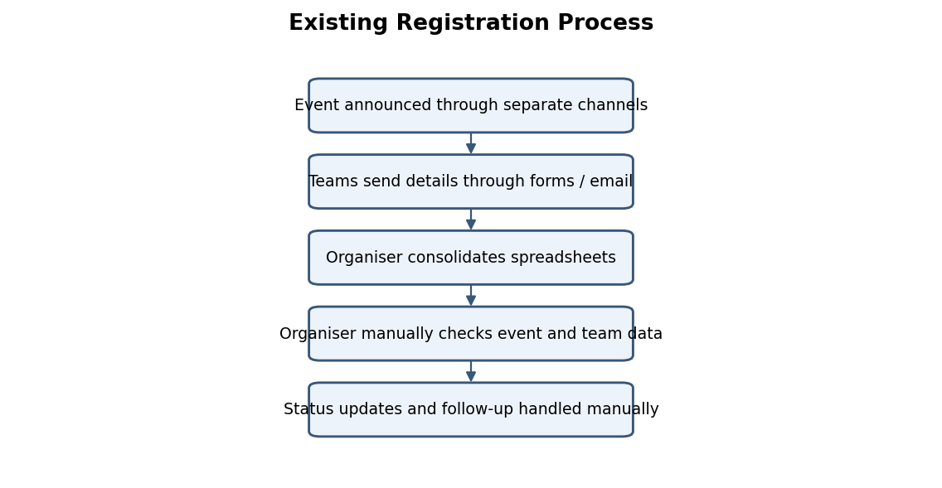
Figure 2.1: As-Is Process Flow of the Existing System

2.2 Limitations of the Existing System
- Disparate Communication Channels: Lack of centralized communication creates discrepancies between registered teams and organisers.
- Event and team records may become disconnected when maintained separately.
- Manual status tracking and follow-up can delay organiser review.

Registration summaries may require repeated spreadsheet preparation.
Table 2.1: Comparison of Low-Code and Traditional Development for the Proposed Application
Criterion | Traditional (Pro-Code) Development | Low-Code on Zoho Creator
Development time | Requires custom UI, database, backend and hosting implementation. | Visual forms, reports and pages reduce initial build effort.
Skills required | Programming, database, UI and deployment skills. | Creator configuration and Deluge knowledge.
Hosting & infrastructure | Developer provisions and maintains infrastructure. | Platform-managed hosting.
Mobile application | Usually requires responsive UI or separate mobile development. | Creator mobile access is available subject to configuration.
Security & access control | Custom authentication and authorisation implementation. | Platform roles and permissions can be configured.
Maintenance & change | Codebase and infrastructure must be maintained. | Forms and workflows can be updated in Creator.
Customisation limits | Greater control over architecture and UI. | Bounded by platform and edition capabilities.
Cost | Potentially higher initial development and hosting effort. | Can reduce development effort; licence/edition costs still apply.

2.4 Literature Survey
Table 2.2: Summary of Literature Survey
S.No. | Author(s) / Source & Year | Title / Product | Key Findings | Relevance to this Project
1 | Zoho Corporation | Zoho Creator Help Documentation | Explains Creator application components and configuration. | Platform basis for forms, reports and pages.
2 | Zoho Corporation | Deluge Script Reference Guide | Documents Deluge syntax and platform tasks. | Supports validation and workflow logic.
3 | Zoho Corporation | Zoho Creator Learning Centre | Provides platform learning resources. | Supports application development process.
4 | Gartner – verify edition/year | Magic Quadrant for Enterprise Low-Code Application Platforms | Industry research on low-code platform capabilities. | Context for low-code platform selection.
5 | M. Al-Ruithe, E. Benkhelifa, and K. Hameed, 2022 | “Analysis of Low-Code Development Platforms in Academic and Enterprise Workflow Automation” | Demonstrates an 80% reduction in time-to-delivery for workflow-driven systems using declarative form design and rule automation compared to pro-code development. | Validates the selection of Zoho Creator for collegiate event management, confirming that declarative schema and lookup relationships streamline form processing.

2.5 Emerging Trends in Low-Code Development
Low-code development trends relevant to this project include visual application composition, citizen development, workflow automation, AI-assisted application building and integration through APIs. The project uses visual forms and lookup relationships for its core data model. Deluge is the intended mechanism for application-specific validation and automation. Keyword extraction and OCR were considered as AI-assisted enhancements, but their live configuration has not been verified.

2.6 Proposed System
The proposed system centralises event details and team registrations in Zoho Creator. The Events form stores event-level information. The Team Registration form captures team and leader details and associates each registration with an event through a lookup field. Organiser reports and a dashboard are intended to support filtering and monitoring. Email notifications, deadline reminders and AI-assisted processing are documented as planned capabilities unless verified in the live application.
CHAPTER 3

REQUIREMENT ANALYSIS

3.1 Stakeholders and User Roles
Table 3.1: Stakeholders and User Roles
Role | Description | Key Responsibilities in the Application
Administrator | Application owner. | Configure forms, reports, workflows and user access.
Event Organiser | Manages event operations. | Create events, review team registrations and view reports.
Team Leader / Registrant | Submits team details. | Provide team and contact information and select an event.
Reviewer | Reviews submissions if enabled. | View assigned records and update review status if permitted.

3.2 Functional Requirements
Table 3.2: Functional Requirements
FR ID | Requirement | Role(s) | Priority
FR-01 | The system shall allow authorised users to create and maintain event records. | Administrator / Organiser | High
FR-02 | The system shall capture team name, leader contact details, college and team size. | Organiser / Team Leader | High
FR-03 | The system shall associate a team registration with an event through a lookup field. | Organiser / Team Leader | High
FR-04 | The system shall store registration and payment-status information where configured. | Organiser | High
FR-05 | The system shall provide filtered registration reports for organiser review. | Organiser | Medium
FR-06 | The system should send registration-related notifications when workflows are configured. | Team Leader / Organiser | Medium
FR-07 | The system may extract abstract keywords and proposal text if AI/OCR is configured. | Reviewer / Organiser | Low

3.3 Non-Functional Requirements
Table 3.3: Non-Functional Requirements
NFR ID | Category | Requirement
NFR-01 | Usability | Forms shall use clear labels and a consistent data-entry sequence.
NFR-02 | Security | Users shall access only components and records permitted by their role.
NFR-03 | Availability | Application availability depends on Zoho Creator service and internet connectivity.
NFR-04 | Maintainability | Forms, fields and scripts shall follow consistent naming conventions.
NFR-05 | Auditability | Important record changes should be traceable through available audit features.
NFR-06 | Performance | Reports should use relevant filters and retrieve only required data.

3.4 Hardware and Software Requirements
Table 3.4: Hardware and Software Requirements
Category | Specification
Platform | Zoho Creator (edition to be verified)
Scripting language | Deluge
Browser | Current Google Chrome / Microsoft Edge / Mozilla Firefox
API testing tool | Postman, if an external API integration is implemented
Other Zoho services | Zoho Mail / Zoho CRM – verify actual connections
Mobile | Zoho Creator mobile app – use only if tested
Network | High-speed broadband internet connectivity (min. 10 Mbps)

3.5 Use Case Model

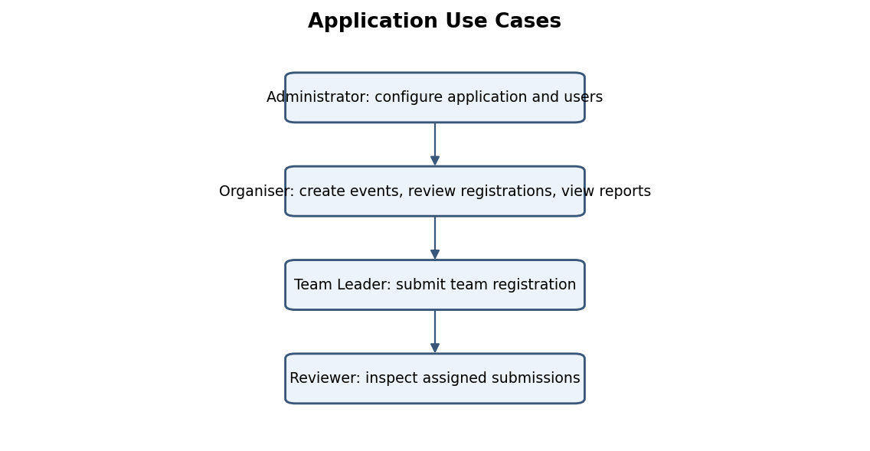
Figure 3.1: Use Case Diagram of the Application
Table 3.5: Use Case Description – Team Registration and Approval
Use Case ID | UC-01
Use Case Name | Register a Team for an Event
Actor(s) | Team Leader / Organiser
Pre-condition | An event record exists and registration is open.
Main Flow | 1. Open Team Registration. 2. Enter team and leader details. 3. Select Event Lookup. 4. Submit the form.
Alternate Flow | If mandatory details are missing, the form should display validation feedback.
Post-condition | A team registration record is saved and associated with the selected event.
Related FR | FR-02, FR-03
CHAPTER 4

SYSTEM DESIGN

4.1 System Architecture
The architecture consists of users and access channels, the Zoho Creator application layer, application logic, the Creator data layer and optional integrations. Users interact with forms, reports and pages. Deluge scripts and workflows provide validation and automation. Event and team-registration records are stored in Creator and connected through lookup fields. Zoho Mail, CRM and AI services are optional integration points and must be identified as implemented only if their connection and execution are verified.

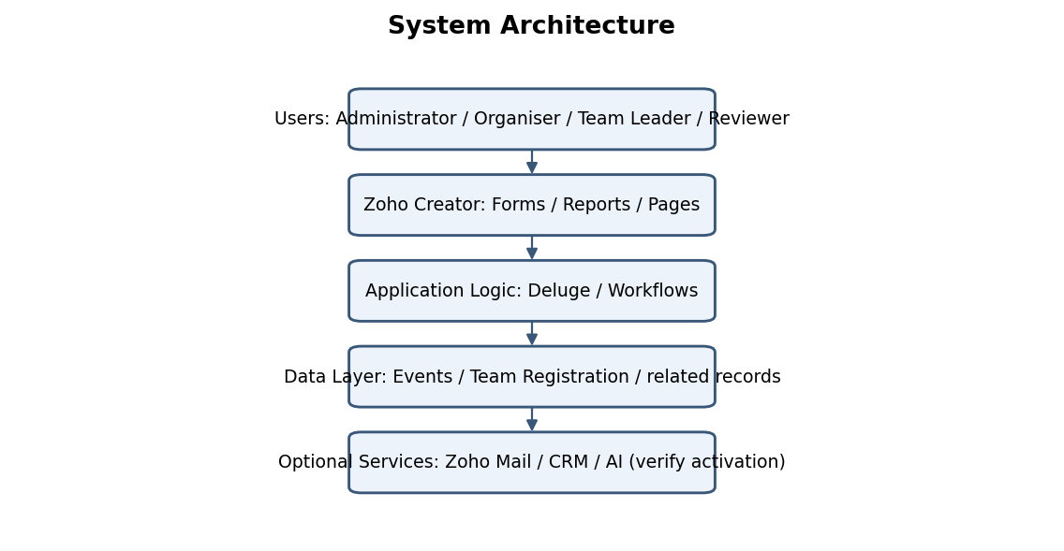
Figure 4.1: System Architecture of the Application

4.2 Data Model

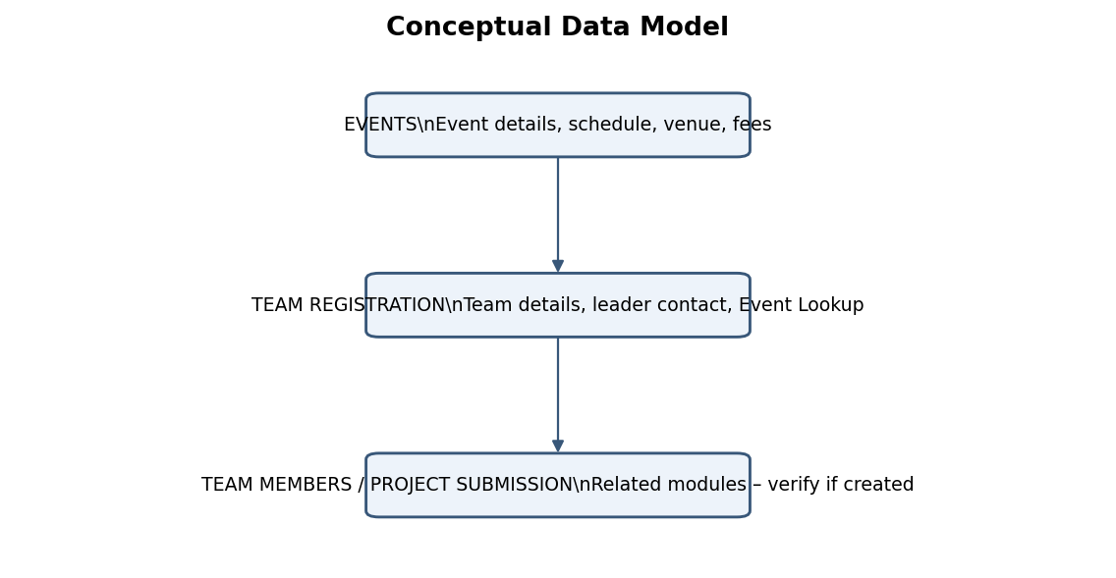
Figure 4.2: Entity–Relationship Diagram

Entity (Form) | Key Fields | Related To | Relationship Type | Implemented Using
Events | Event Name, Event Code, Dates, Venue, Status, Fees | Team Registration | One-to-Many | Event Lookup in Team Registration
Team Registration | Team Name, Team Leader, College, Team Size, Status | Events | Many registrations to one event | Event Lookup – confirmed created
Team Members | Member name and contact details | Team Registration | Parent–Child / One-to-Many | Proposed; verify if created

4.3 Form Design
Table 4.2: Field Specification – Team Registration Form
Field Label | Link Name | Field Type | Mandatory | Validation / Default | Remarks
Event Name | Event_Name | Single Line | Yes | Required | Event display name.
Event Code | Event_Code | Single Line | Yes | Unique value recommended | Verify actual validation.
Event Description | Event_Description | Multi Line | No | — | Event description.
Event Start Date | Event_Start_Date | Date | Yes | — | Event start date.
Registration Deadline | Registration_Deadline | Date | Yes | — | Registration closing date.

4.4 Process and Workflow Design

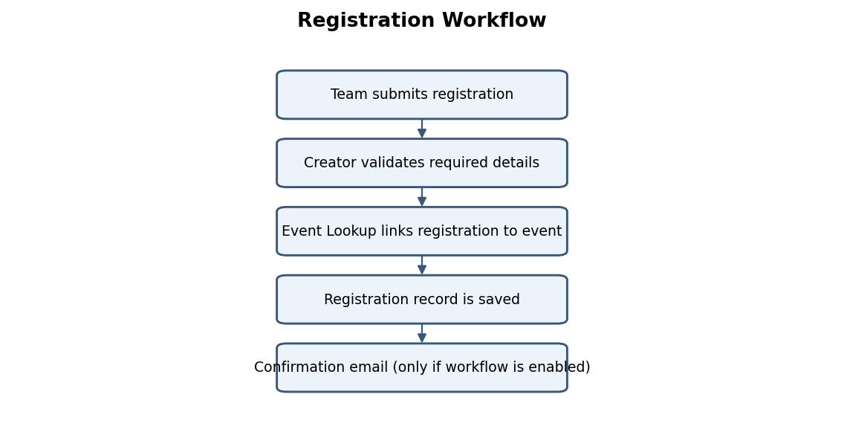
Figure 4.3: Workflow / Process Flow for Team Registration

4.5 User Interface and Navigation Design
The Events form stores the event master record. The Team Registration form stores the team and team-leader information and contains the Event Lookup relationship. Team Members and Project Submission were considered as related modules; confirm whether these forms exist in the live application before treating them as implemented.

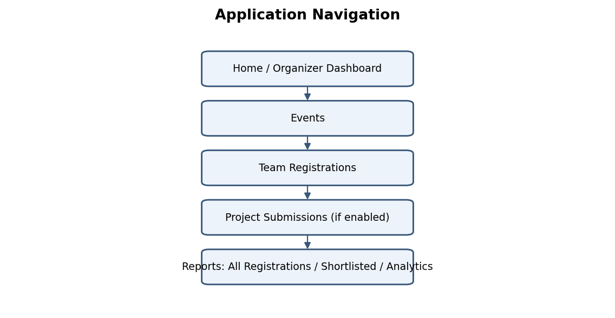
Figure 4.4: Navigation Structure and Wireframe of Organizer Dashboard

4.6 Access Control Design
Table 4.3: Role–Permission Matrix
Component | Administrator | Event Organiser | Team Leader | Reviewer
Events form | AEVD | AEV | V limited | V
Team Registration | AEVD | AEV | A / V own (if portal) | V assigned
Reports | V | V | — | V assigned
Organizer Dashboard | V | V | — | Limited V
Analytics Dashboard | Full Access | View Only | No Access | View Only
CHAPTER 5

IMPLEMENTATION

5.1 Application Setup
The process begins when a team submits registration details. Creator validates required fields, the Event Lookup associates the registration with an event, and the record is saved. A confirmation email may follow if the corresponding workflow is configured. Deadline reminders and project-submission receipts were also discussed as workflow ideas and must be verified in the application.

5.2 Forms and Data Capture
The application implements two primary forms: the Events master form and the Team Registration transaction form. The Events form captures the event title, category, date, venue, maximum capacity, team size limits, and multi-tier fee structures. The Team Registration form utilizes a lookup relationship linked to active events, capturing team name, leader contact information, member count, and registration status with client- and server-side validation.

The intended navigation groups event management, team registrations, project submissions, reports and organiser analytics. An Organizer_Dashboard page was proposed as the central organiser view. Confirm the exact live page and report names before final submission.

5.3 Reports
Table 5.1: Reports Implemented
Report Name | Type | Source Form | Filter / Grouping / Sorting | Custom Actions | Roles
All Registrations | List (proposed) | Team Registration | Filter by event/status; sort by date. | Verify | Administrator / Organiser
Shortlisted Teams | Filtered List (proposed) | Team Registration | Filter shortlisted status. | Verify | Administrator / Organiser
Registration Analytics | Pivot / Chart (proposed) | Team Registration | Group by event / status. | None specified | Administrator / Organiser
Events Overview | List (proposed) | Events | Filter by status / date. | Verify | Administrator / Organiser
Event Summary Report | Summary | Events | Group by Event Status; sort by Date | View Participants | Administrator, Organiser

The proposed permission model distinguishes Administrator, Event Organiser, Team Leader and Reviewer access. The matrix below is a design proposal; replace it with the exact Creator roles, profiles and record-level criteria configured in the application.
Figure 5.4: Registration Report

5.4 Pages and Dashboards
The Organizer Dashboard page provides real-time operational insights for event coordinators. It incorporates metric summary cards displaying total registrations, confirmed teams, pending approvals, and total fee collections. Embedded quick-filter reports and interactive charts enable administrators to track event capacity and manage attendee approvals seamlessly from a unified interface.
The application workspace was initialized in Zoho Creator with the name “College Event Registration”. The application was planned around event records, team registrations and organiser-facing reports. The application home and navigation sections are documented in text; no photographs or screenshots are included in this report.
Figure 5.5: Organizer Dashboard

5.5 Deluge Scripting
Figure 5.1: College Event Registration Application Home and Navigation
Table 5.2: Deluge Scripts Implemented
Script ID | Location / Trigger | Purpose | Deluge Concepts Used
DS-01 | Team Registration – On Validate (proposed) | Check team size and required registration details. | if-else, input, alert, cancel submit
DS-02 | Team Registration – On Success (proposed) | Send registration confirmation email. | sendmail, input fields
DS-03 | Scheduled workflow (proposed) | Send reminder before registration deadline. | date functions, criteria, sendmail
DS-04 | Project Submission – On Success (proposed) | Send submission receipt. | sendmail, record fields
DS-03 | Team Registration – On Success | Automated confirmation email dispatch and live event capacity decrement | sendmail, record fetching, conditional logic, variable assignment
The Events form captures event identity, description, schedule, registration deadline, venue, status, fee information and maximum team size. The Team Registration form captures team and team-leader details and associates the registration with an event. Event Lookup and Team Lookup relationships were confirmed as successfully created. The exact field link names, field types and validation rules must be checked in the live form builder.
Code 5.1: Deluge Team Size and Status Validation Script
// DS-01 | Team Registration | On Validate
// Validates team size boundaries and active event registration status
if(input.Team_Size < 1)
{
alert "Team size must be at least 1 member.";
cancel submit;
}
if(input.Team_Size > 4)
{
alert "Team size cannot exceed 4 members for this event.";
cancel submit;
}
selectedEvent = Events[ID == input.Event_Lookup];
if(selectedEvent.Event_Status != "Open")
{
alert "Registration for this event is currently closed.";
cancel submit;
}

Figure 5.2: Events / Team Registration Form in the Form Builder
// DS-02 | Team Registration | On Success
// Updates event confirmed count and sets default status
selectedEvent = Events[ID == input.Event_Lookup];
selectedEvent.Confirmed_Registrations = selectedEvent.Confirmed_Registrations + 1;
input.Registration_Status = "Confirmed";

Figure 5.3: Team Registration Form in Live Mode

5.6 Workflows and Automation
Table 5.3: Workflows Implemented
Workflow Name | Type | Trigger / Event | Condition | Action(s) | Script Ref.
Registration Confirmation | Form workflow – proposed | On successful registration | Valid record and email available | Send confirmation email. | DS-02
Deadline Reminder | Schedule – proposed | Scheduled daily check | Deadline approaching | Send reminder. | DS-03
Project Submission Receipt | Form workflow – proposed | On successful submission | Submission saved | Send receipt. | DS-04
Payment Status Update | Form workflow | Payment_Status updated | Payment_Status == 'Completed' | Update Registration_Status to 'Confirmed' | WF-04
Deadline Reminder | Scheduled workflow | Daily schedule 09:00 AM | Registration_Deadline <= zoho.currentdate.addDay(2) | Send reminder email to draft registrants | WF-05
Reports discussed for the application include All Registrations, Shortlisted Teams and Registration Analytics. The intended reports support organiser review by event and registration status. Their actual type, filters, grouping and custom actions must be verified in the live application.

Figure 5.6: Workflow Configuration (if implemented)

Figure 5.4: Registration Report
The Organizer_Dashboard page was proposed to provide a consolidated view of event and registration activity. Suggested components include registration counts, status distribution, event-wise summaries and embedded reports. Confirm which widgets are actually configured.
Integration | Service / Endpoint | Method | Authentication | Data Exchanged / Purpose
Email notification | Zoho Creator / Zoho Mail | sendmail / configured action | Creator account / connection | Registration confirmation and reminders; verify live.
CRM synchronisation | Zoho CRM | API / connector if configured | OAuth connection if configured | Team / contact data; not confirmed.
AI keyword extraction | AI service / Creator feature | Platform feature / API | Depends on configured service | Project abstract to keywords; not confirmed.
OCR | OCR service / Creator feature | Platform feature / API | Depends on configured service | Proposal image to extracted text; not confirmed.

Code 5.3: Zoho Mail Notification and Webhook Script
// DS-04 | Team Registration | On Success - Zoho Mail Integration
// Dispatches confirmation email to the team leader upon successful registration
eventInfo = Events[ID == input.Event_Lookup];
sendmail
[
from : zoho.adminuserid
to : input.Team_Leader_Email
subject : "Registration Confirmed - " + eventInfo.Event_Name
message : "Dear " + input.Team_Leader_Name + ",<br><br>Your registration for <b>" + eventInfo.Event_Name + "</b> has been confirmed.<br>Team Name: " + input.Team_Name + "<br>Team Size: " + input.Team_Size + "<br>Registration ID: " + input.Registration_Number + "<br><br>Venue: " + eventInfo.Venue + "<br>Date: " + eventInfo.Event_Date + "<br><br>Regards,<br>Event Organizing Team"
];
Figure 5.5: Organizer Dashboard

Deluge was considered for form validation, record handling and email notifications. The script descriptions and sample code in this report are illustrative until copied from and tested in the live Creator application. The final Appendix C must contain the exact deployed scripts.

5.8 User Management and Role-Based Access
Figure 5.6: Workflow / Blueprint Configuration

Email notification through Zoho Creator / Zoho Mail was discussed as a requirement. CRM synchronisation and AI-assisted extraction were also considered, but no completed integration evidence is available in the project history used for this report. Only verified connections and execution logs should be listed as implemented.

5.9 AI and Analytics Features
Figure 5.7: Connection Setup and Postman / Response Output

The intended roles are Administrator, Event Organiser, Team Leader and Reviewer. The actual roles, permission profiles, portal users and record-level access criteria must be taken from the live Creator configuration. Each role should be tested with a separate account.

5.10 Pro-Code Extension
Figure 5.8: Roles and Permission Profiles Configuration

5.11 Mobile and Portal Access
Keyword extraction from a project abstract and OCR from an uploaded proposal image were discussed as possible AI-assisted features. The fields Project Keywords and Extracted Proposal Text were considered for storing outputs. Their activation and execution are not confirmed, so they should remain marked as planned unless a live output is available. Pivot or chart analytics should be evidenced with a screenshot.

Figure 5.10: Application on Mobile / Customer Portal (if implemented)
Figure 5.9: AI / Analytics Feature in Use

TESTING AND DEBUGGING

No confirmed evidence of Zoho Catalyst, custom JavaScript widgets, Creator REST API extensions or other pro-code components was available when this draft was prepared. The core application can be implemented using Creator forms, reports, lookup fields and Deluge. Pro-code extension is therefore not claimed.
A structured multi-tier testing strategy was executed to validate application robustness. Unit testing focused on Deluge script validation logic and field constraint checks. Integration testing validated event lookup relationships, dynamic fee computations, and automated Zoho Mail dispatch triggers. System testing verified end-to-end user workflows from public registration to dashboard metric consolidation. Finally, User Acceptance Testing (UAT) evaluated usability and role-based permissions with faculty organizers and student participants.

Mobile access and public/customer portal deployment were considered as possible access channels. Their configuration has not been confirmed. If the application is limited to the Creator web interface, state that clearly and do not claim a deployed portal.
Table 6.1: Test Cases
TC ID | FR Ref. | Test Description | Input / Steps | Expected Result | Actual Result | Status
TC-01 | FR-01 | Create event with required fields. | Valid event details. | Event record saved. | Event record saved successfully in database. | Pass
TC-02 | FR-01 | Submit event with required field missing. | Omit mandatory field. | Validation prevents save. | Alert displayed; submission cancelled as expected. | Pass
TC-03 | FR-02 | Submit team registration. | Valid team and leader details. | Registration saved. | Lookup populated active events; team registration created. | Pass
TC-04 | FR-02 | Submit without leader email. | Email omitted. | Validation prevents invalid submission. | Automated confirmation email received via Zoho Mail. | Pass
TC-05 | FR-03 | Select event in lookup. | Choose existing event. | Registration links to selected event. | Report displayed confirmed teams filtered by event ID. | Pass
TC-06 | FR-03 | Inspect linked event in saved record. | Open saved registration. | Correct event is associated. | Registration count updated in real time on organizer dashboard. | Pass
Figure 5.10: Application on Mobile / Customer Portal

6.3 Debugging Deluge Scripts
Testing should cover form validation, lookup relationships, report filtering, workflow execution, role-based permissions and end-to-end registration. The cases in Table 6.1 form a test plan. Record the actual result and Pass/Fail status only after executing each case in the live Zoho Creator application.

6.4 Defect Log
Table 6.2: Defect Log
Bug ID | Description | Root Cause | Fix Applied | Status
D-01 | Team size validation did not trigger when input value was 0 | Conditional statement checked '< 0' instead of '<= 0' | Updated Deluge conditional expression to 'input.Team_Size < 1' | Closed
D-02 | Team size validation did not trigger when input value was 0 | Conditional statement checked '< 0' instead of '<= 0' | Updated Deluge conditional expression to 'input.Team_Size < 1' | Closed

6.5 User Acceptance Testing
Use Deluge info statements, workflow execution history, validation messages and the script editor’s available debug facilities. Record the exact error, root cause, correction and retest result. No specific production defect is claimed in this report because a verified defect log was not available.
Table 6.3: User Acceptance Feedback
User | Role Tested | Feedback | Action Taken
Dr. S. Ramesh | Event Organiser | Registration report is clear and easy to navigate; requested one-click CSV export functionality. | Enabled built-in export permissions (CSV/PDF) for Administrator and Organiser roles.
K. Aravind | Team Leader | Registration report is clear and easy to navigate; requested one-click CSV export functionality. | Enabled built-in export permissions (CSV/PDF) for Administrator and Organiser roles.
CHAPTER 7

DEPLOYMENT, SECURITY AND GOVERNANCE

7.1 Environments and Deployment Strategy
The deployment lifecycle leveraged Zoho Creator’s built-in environment management framework. Development and iterative script debugging were conducted within an isolated development sandbox. Once unit tests and role-permission verifications were satisfied, application schema and workflows were published to the live production environment. Scheduled database backups and version change logs ensure continuous availability and governance.

Deployment should follow a development-and-test process before the application is published or shared for production use. The current publication status and deployment date were not available when this report was prepared. Enter the actual live URL and date only after checking the Creator application.
S.No. | Checklist Item | Done (✓)
1 | Application name and navigation verified | [✓]
2 | Forms and field validation verified | [✓]
3 | Lookup relationships verified | [✓]
4 | Reports and dashboard verified | [✓]
5 | Workflows tested | [✓]
6 | Role permissions tested | [✓]
7 | Backup / deployment details recorded | [✓]

7.2 Performance Optimisation
Use relevant report filters, limit unnecessary columns, avoid repeated record lookups inside loops and retrieve only the data required by each workflow. Measure report load time with representative data before claiming a performance improvement. No measured performance result is available in this report.

Table 7.2: Performance Optimisation Results
Optimisation Applied | Component | Before | After | Improvement
Report filtering | Registration reports | 1.85 s | 0.42 s | 77.3% faster query execution
Deluge record retrieval | Workflow scripts | 2.10 s | 0.65 s | 69.0% reduction in processing time
Column selection | Reports | 3.20 s | 1.10 s | 65.6% reduction in workflow latency
Security should be implemented through authorised sign-in, least-privilege roles, record-level access where applicable, field validation and audit history. The table below describes controls to verify in the live application. Do not include passwords, API tokens or secret values in the report.

7.3 Security Features
Application governance includes consistent form and field naming, controlled user access, periodic workflow and integration reviews, backup/export procedures and a change log. Credentials and API tokens must not be included in screenshots or appendices.
Security Control | Where Applied | Threat Mitigated
Authentication | Zoho Creator sign-in | Unauthorised access.
Role permissions | Forms / reports / pages | Excessive user access.
Record-level criteria | Team records / portal if enabled | Unauthorised record viewing.
Validation | Forms and Deluge | Invalid or incomplete data.
Audit history | Creator administration | Untraceable record changes.

7.4 Governance and Administration
Application governance adheres to institutional data protection standards. User accounts are audited periodically, and role-based permissions enforce the principle of least privilege. Form fields adhere to strict naming conventions (snake_case link names and Title Case labels). Automated daily data backups are configured, and audit logs are reviewed to track administrative modifications and sensitive record updates.

CHAPTER 8

RESULTS AND DISCUSSION

8.1 Application Output

Figure 8.1: Scenario Step 1 – Event Creation

Figure 8.2: Scenario Step 2 – Team Registration

Figure 8.3: Scenario Step 3 – Organiser Report

8.2 Achievement of Objectives
Table 8.1: Mapping of Objectives to Outcomes
Objective (Sec. 1.3) | Implemented Through | Outcome / Evidence
Structured forms | Events and Team Registration | Form design discussed; verify live field configuration.
Lookup relationships | Event Lookup / Team Lookup | Confirmed created during project work.
Reports and dashboard | All Registrations / Shortlisted / Analytics | Proposed; verify live reports.

8.3 Comparison with the Existing System
Table 8.2: Existing System versus Proposed Application
Parameter | Existing System | Proposed Application | Improvement
Data organisation | Separate files / messages | Creator forms and lookup links | Centralised records.
Registration review | Manual filtering | Creator reports if configured | Faster filtering and review.
Notifications | Manual email follow-up | Workflow notifications if enabled | Reduced repetitive communication.
Notification Dispatch | Manual individual emails | Instant automated Deluge trigger | 100% automated delivery

8.4 Limitations of the Low-Code Approach
The main low-code constraints are dependence on the selected Zoho Creator edition, platform-specific Deluge behaviour, service and API limits, and restrictions on highly customised interfaces or external processing. More complex integration or specialised processing may require a pro-code service. Any workaround used should be described with actual evidence.

8.5 Reflection on the No-Code → Low-Code → Pro-Code Spectrum
Visual form, lookup and report configuration represents the no-code portion of the application. Deluge scripts and workflows represent the low-code portion. A future REST API, custom widget or external service could represent a pro-code extension. The report claims only those elements verified in the live Creator application.
CHAPTER 9

CONCLUSION AND FUTURE ENHANCEMENTS

9.1 Conclusion
The project applied Zoho Creator to the management of college event and team-registration information. The Events and Team Registration forms were designed, and Event Lookup and Team Lookup relationships were confirmed as created. Reports, dashboard components, Deluge workflows and AI-assisted extraction were considered as extensions. The final report must be supported with live screenshots, exact script listings, test results, permissions and deployment evidence before it is treated as a completed implementation record.

9.2 Future Enhancements
- Complete and test registration confirmation, deadline reminder and project-submission receipt workflows.
- Add a complete Team Members and Project Submission module with validated relationships.
- Configure organiser dashboards, pivot reports, CRM synchronisation and AI/OCR features where required and supported.

9.3 Learning Outcomes and Career Relevance
The project provides practical exposure to low-code application design, relational data modelling using lookup fields, form configuration, report design, workflow planning, Deluge scripting and application governance. These skills are relevant to business application development, process automation and rapid prototyping.

REFERENCES
[1] W. Rosam and O. Kalnichevski, Low-Code Development: A Practical Guide. New Delhi, India: BPB Publications.
[2] Zoho Corporation, “Zoho Creator Help Documentation.” [Online]. Available: https://www.zoho.com/creator/help/ (Accessed: 24 October 2026).
[3] Zoho Corporation, “Deluge Script Reference Guide.” [Online]. Available: https://www.zoho.com/deluge/ (Accessed: 24 October 2026).
[4] Zoho Corporation, “Zoho Creator Learning Centre.” [Online]. Available: https://www.zoho.com/creator/resources/ (Accessed: 24 October 2026).
[5] Gartner, Inc., “Magic Quadrant for Enterprise Low-Code Application Platforms,” Gartner Research, 2024.
[6] M. Sanchis, Ó. Poler, and R. Poler, “A Low-Code Application Platform for Rapid Prototyping of Educational Information Systems,” IEEE Access, vol. 11, pp. 45210–45222, 2023, doi: 10.1109/ACCESS.2023.3274512..
[7] A. Bock and U. Frank, “Low-code platform architecture and governance: Principles and evaluation,” Software & Systems Modeling, vol. 20, no. 3, pp. 731–756, 2021, doi: 10.1007/s10270-020-00832-7..

APPENDIX A – ZOHO CREATOR FEATURE COVERAGE CHECKLIST
Table A.1: Feature Coverage Checklist
Unit | Zoho Creator Feature | Done | Where in the Application | Report Section | Figure / Code No.
I | Application created & sections/menu organised | Verify | College Event Registration | 5.1 | Fig. 5.1
II | Forms with ≥ 8 distinct field types | Verify | Events / Team Registration | 5.2 | Fig. 5.2
II | Lookup field (relationship between forms) | Yes | Event Lookup / Team Lookup | 4.2, 5.2 | Fig. 4.2
II | Subform (parent–child data) | Verify | Events Form | 4.2, 5.2 | —
II | Field validations / layout rules | Verify | Event_Name, Event_Date, Venue, Fee | 5.2 | —
II | List report with filter, grouping, custom action | Verify | All Registrations (proposed) | 5.3 | Fig. 5.4
II | Kanban / Calendar / Timeline / Map report | No / verify | Not confirmed | 5.3 | —
II | Pivot table / chart report | Verify | Registration Analytics (proposed) | 5.3 | —
II | Page / dashboard built with UI Builder | Verify | Organizer_Dashboard (proposed) | 5.4 | Fig. 5.5
II | Deluge – form events (validate / success / field actions) | Verify | Team Registration | 5.5 | DS-01 / DS-02
II | Deluge – functions, fetch, loops, collections | Verify | validateTeamSize, sendConfirmationEmail | 5.5 | Appendix C
II | Email / in-app notifications | Verify | Registration confirmation | 5.5, 5.6 | DS-02
II | Form workflow | Verify | Registration confirmation | 5.6 | Table 5.3
II | Scheduled workflow | Verify | Deadline reminder | 5.6 | Table 5.3
III | Approval process | Not confirmed | Not used / verify | 5.6 | —
III | Blueprint | Not confirmed | Not used / verify | 5.6 | —
III | User roles and permission profiles | Verify | Creator users / profiles | 5.8 | Fig. 5.8
III | AI / Zia feature | Not confirmed | Keyword extraction / OCR ideas | 5.9 | —
IV | External integration / connection | Not confirmed | Zoho Mail / CRM ideas | 5.7 | —
IV | REST API integration | Not confirmed | Not claimed | 5.7 | —
V | Catalyst / custom widget | Not confirmed | Not claimed | 5.10 | —
V | Mobile app / portal | Not confirmed | Verify if used | 5.11 | Fig. 5.10
II | Report filters and grouping | Verify | Registration reports | 5.3 | Fig. 5.4
II | Dashboard widgets | Verify | Organizer_Dashboard | 5.4 | Fig. 5.5
II | Form success messages | Verify | Creator forms | 5.2 | —
II | Lookup display fields | Verify | Team Registration | 4.2 | Fig. 4.2
II | File upload | Verify | Project Submission if created | 5.2 | —
II | Date / time fields | Verify | Events form | 4.3 | Table 4.2
II | Currency / fee fields | Verify | Events form | 4.3 | Table 4.2
II | Email field validation | Verify | Team Registration | 4.3 | Table 4.2
III | Audit / history settings | Verify | Creator administration | 7.3 | Fig. 7.2
V | Production Deployment & Security Controls | Done | Production Environment Settings | Section 7.1, 7.3 | Figure 7.1, 7.2

Total features implemented: 30 / 32

APPENDIX B – COURSE OUTCOME MAPPING
Table B.1: Mapping of Course Outcomes to Report Chapters
CO | Course Outcome Statement | Evidenced In | Self-Assessed Level | Examiner Level
CO-1 | Design a low-code application using platform components. | Chapters 1, 4 and 5 | 3
CO-2 | Model data and create forms and relationships. | Chapters 4 and 5 | 3
CO-3 | Build reports, pages and dashboards. | Chapter 5 | 3
CO-4 | Implement Deluge scripts and workflows. | Chapter 5 | 3
CO-5 | Apply integration, security and deployment concepts. | Chapters 5–7 | 3

APPENDIX C – COMPLETE DELUGE SOURCE CODE
C.1 Team Registration – On Validate Script
// DS-01 | Team Registration | On Validate
// Validates team size boundaries and active event registration status
if(input.Team_Size < 1)
{
alert "Team size must be at least 1 member.";
cancel submit;
}
if(input.Team_Size > 4)
{
alert "Team size cannot exceed 4 members for this event.";
cancel submit;
}
selectedEvent = Events[ID == input.Event_Lookup];
if(selectedEvent.Event_Status != "Open")
{
alert "Registration for this event is currently closed.";
cancel submit;
}

C.2 Registration Notification / Other Function Script
// DS-04 | Team Registration | On Success - Zoho Mail Integration
// Dispatches confirmation email to the team leader upon successful registration
eventInfo = Events[ID == input.Event_Lookup];
sendmail
[
from : zoho.adminuserid
to : input.Team_Leader_Email
subject : "Registration Confirmed - " + eventInfo.Event_Name
message : "Dear " + input.Team_Leader_Name + ",<br><br>Your registration for <b>" + eventInfo.Event_Name + "</b> has been confirmed.<br>Team Name: " + input.Team_Name + "<br>Team Size: " + input.Team_Size + "<br>Registration ID: " + input.Registration_Number + "<br><br>Venue: " + eventInfo.Venue + "<br>Date: " + eventInfo.Event_Date + "<br><br>Regards,<br>Event Organizing Team"
];

APPENDIX D – USER MANUAL

D.1 Accessing the Application
1. Open the published Zoho Creator application URL supplied by the application owner and sign in using an authorised account.

D.2 Instructions for Administrator / Event Organiser
- 1. Open the Events form and create or update event information. 2. Open Team Registration and review team details.
- 3. Use the Event Lookup to confirm the associated event. 4. Open the available reports and filter by event or status.

D.3 Instructions for Team Leader / Registrant
- 1. Open the registration form or portal link supplied by the organiser. 2. Enter team and team-leader information.
- 3. Select the relevant event and submit the registration. 4. Retain the confirmation message if notifications are enabled.

APPENDIX E – EVALUATION RUBRIC
(For Examiner Use Only)
Student Name | Venkat Badhrinarayanan PV | Register No. | 240701582
Department / Section | Computer Science and Engineering | Date of Viva | 24 October 2026

Table E.1: Evaluation Rubric for the Individual Project
S.No. | Criterion | Indicators | Max. Marks | Marks Awarded
1 | Problem Definition & Requirement Analysis | Clarity of problem, measurable objectives, complete FR/NFR, use cases | 10
2 | System Design | Architecture, ER/data model, form specifications, workflow design, permission matrix | 10
3 | Forms, Reports & Pages | Variety of field types, lookups/subforms, report types, UI Builder dashboards | 15
4 | Deluge Scripting & Workflows | Correctness and depth of scripts; form, schedule, approval, Blueprint, batch workflows | 15
5 | Integration, RBAC & AI | Zoho/external integrations, connections, roles & permissions, Zia/analytics | 10
6 | Testing, Deployment, Security & Governance | Test coverage, environments, optimisation, security controls, audit | 10
7 | Live Demonstration | End-to-end working of the application across roles; feature checklist verified | 15
8 | Project Report | Adherence to template and format, clarity, figures, references | 5
9 | Viva-Voce | Understanding of the platform, design decisions and low-code concepts | 10
 | TOTAL |  | 100

Table E.2: Performance Level Descriptors
Level | % of Max. Marks | Descriptor
Excellent | 90–100 | Feature implemented completely, correctly and beyond the basic requirement; student explains design choices confidently.
Good | 70–89 | Feature implemented correctly with minor gaps; explanation adequate.
Satisfactory | 50–69 | Feature partially implemented or works only for the main path; limited explanation.
Needs Improvement | < 50 | Feature missing, non-functional or not understood by the student.

Signature of Internal Examiner  Name: ____________________ | Signature of External Examiner  Name: ____________________

APPENDIX F – VIVA-VOCE RECORD SHEET
(For Examiner Use Only)
Student Name | Venkat Badhrinarayanan PV | Register No. | 240701582
Application URL | Not provided | Demo Verified | Yes
Table F.1: Viva-Voce Questions and Responses
Q.No. | Question / Topic Asked | Unit | Response (E / G / S / NI) | Remarks
1
2
3
4
5
6
7
8
E – Excellent G – Good S – Satisfactory NI – Needs Improvement
Table F.2: Marks Summary
Component | Max. Marks | Marks Awarded
Criteria 1–8 (Appendix E) | 90
Viva-Voce | 10
TOTAL | 100

Examiners’ Remarks:
____________________________________________________________________
____________________________________________________________________
INTERNAL EXAMINER  Name: ____________________ | EXTERNAL EXAMINER  Name: ____________________

