PHASE 3
ComicCraft – AI Comic Story Creator Using Gemini Models
Project Design
System architecture, components, workflows, data flow and resilience design — reverse-engineered from the actual codebase.

Diagrams in this document are generated from the implemented modules:
app/main.py · app/routes.py · app/config.py · app/schemas.py · app/services/*

1. Design Overview
ComicCraft is a layered, single-server FastAPI application. The design is organised around a thin HTTP layer (routes, middleware, error handlers), one orchestration service (ComicService), four replaceable capability services (story, images, PDF, storage) and two external AI providers. Every capability depends on a small contract (Pydantic schema or Python Protocol) rather than on a concrete vendor SDK, which is what allows offline placeholder providers to stand in for paid cloud services without changing the pipeline.
The design targets stated in PROJECT_ANALYSIS.md and confirmed in code are: validated structured AI output instead of text splitting; a character bible for visual continuity; explicit, visible fallbacks; UUID-isolated workspaces with an atomic JSON manifest; and a complete credential-free demo path.

2. System Architecture
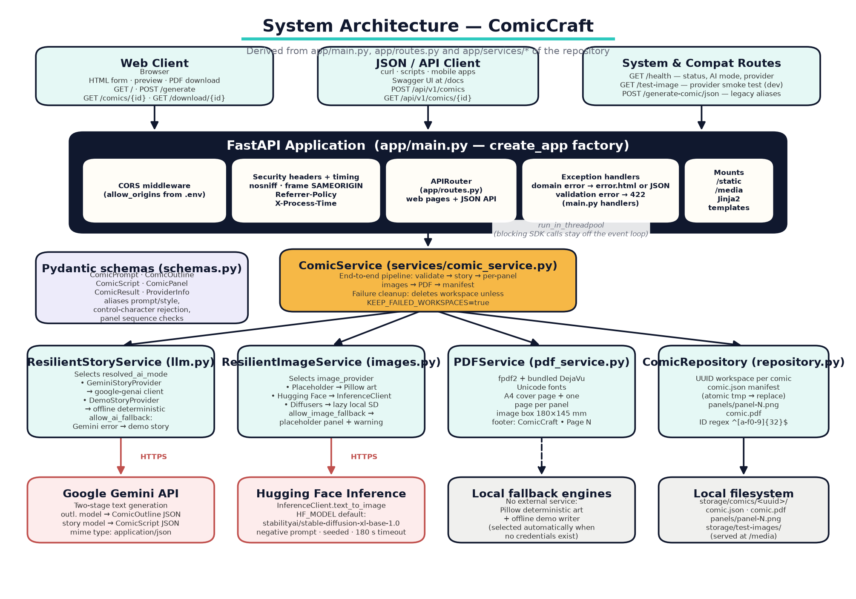
Figure 3.1 System architecture of ComicCraft as implemented (clients, FastAPI layer, orchestrator, services, external providers, storage).
- Client layer. A Jinja2-rendered browser UI (form, preview, export pages) and machine clients via the versioned JSON API plus Swagger UI at /docs.
- HTTP layer (app/main.py, app/routes.py). create_app() builds the FastAPI instance, mounts /static and /media, installs CORS (when configured), a security-and-timing middleware, and two exception handlers that choose JSON or a styled HTML error page based on the client.
- Orchestration (app/services/comic_service.py). ComicService.generate() runs the pipeline: panel-count guard → UUID workspace → story generation → per-panel image loop → PDF build → ComicResult assembly with ProviderInfo → atomic manifest save, with workspace deletion on failure.
- Service layer (app/services/). ResilientStoryService (Gemini + demo), ResilientImageService (placeholder / Hugging Face / diffusers), PDFService (fpdf2), ComicRepository (filesystem).
- Data/schema layer (app/schemas.py). ComicPrompt, ComicOutline, ComicScript, ComicPanel, ComicResult, ProviderInfo, HealthResponse — used to validate user input, AI output and API responses alike.
- External providers. Google Gemini (text) and Hugging Face Inference (hosted images); local Diffusers replaces the latter without any network call.

3. Component Architecture and Descriptions
Component | Responsibility | Collaborators | Key design decisions
app/main.py  Application factory | Build the FastAPI app, mount static/media, register middleware and error handlers, attach settings, templates and ComicService to app.state. | config.Settings, routes.router, ComicService | Factory pattern enables tests with injected temp storage; lifespan logs the resolved AI mode and image provider at startup.
app/config.py  Settings | Environment-driven configuration with typed fields, bounds and computed properties. | pydantic-settings | SecretStr for keys; resolved_ai_mode auto-selects gemini vs demo; prepare_directories() creates storage layout; lru_cache singleton.
app/routes.py  Router | Web pages (/, /generate, /comics/{id}, /download/{id}, /export-success), system routes (/health, /test-image), JSON API (/api/v1/comics) and the legacy compatibility route. | ComicService via Depends(get_comic_service) | Form parameters validated with the same bounds as the schema; heavy work delegated with run_in_threadpool.
app/schemas.py  Contracts | User request model, Gemini response models, final result model, provider metadata. | Pydantic v2 | AliasChoices for legacy keys; panel sequence validators; model-wide result/prompt consistency check.
services/comic_service.py  Orchestrator | Runs the end-to-end pipeline and aggregates warnings/providers. | All services + schemas | zip(..., strict=True) ties panels to images; cleanup-on-failure; UTC timestamps.
services/llm.py  Story pipeline | Two-stage Gemini generation with retries/fallbacks; deterministic demo writer. | google.genai (optional), schemas | Protocol-based providers; JSON mime mode; fence-tolerant cleaner; error-code taxonomy (429/5xx vs 400/404).
services/images.py  Image pipeline | Per-panel art via three interchangeable providers with deterministic seeds. | PIL (required), huggingface_hub / diffusers (optional) | Provider Protocol; sha256-derived seeds; per-panel placeholder fallback with warning; lazy loading of the heavy local pipeline under a thread lock.
services/pdf_service.py  PDF export | Typeset the comic as A4 PDF (cover + panel pages). | fpdf2, PIL (image sizing), bundled DejaVu fonts | Aspect-ratio-preserving image box; Unicode fonts bundled for deterministic output; footer override via FPDF subclass.
services/repository.py  Storage | Workspace creation, atomic manifest save/load, PDF path resolution, deletion. | Pathlib, uuid, regex, shutil | Comic ID regex guard; manifest write via tmp file + os replace; unknown/crafted IDs → 404 domain error.
app/dependencies.py | Inject the singleton ComicService from app.state. | FastAPI DI | Single construction point per app.
app/exceptions.py | Domain errors with HTTP status mapping (404/502/503). | main.py handlers | User-safe messages only.
templates + static | Responsive neo-brutalist UI, loading overlay, char counter, download redirect to success page. | Jinja2, vanilla JS, DejaVu fonts | base.html inheritance; CSS breakpoints 900/620 px; no JS framework.

4. System Workflow
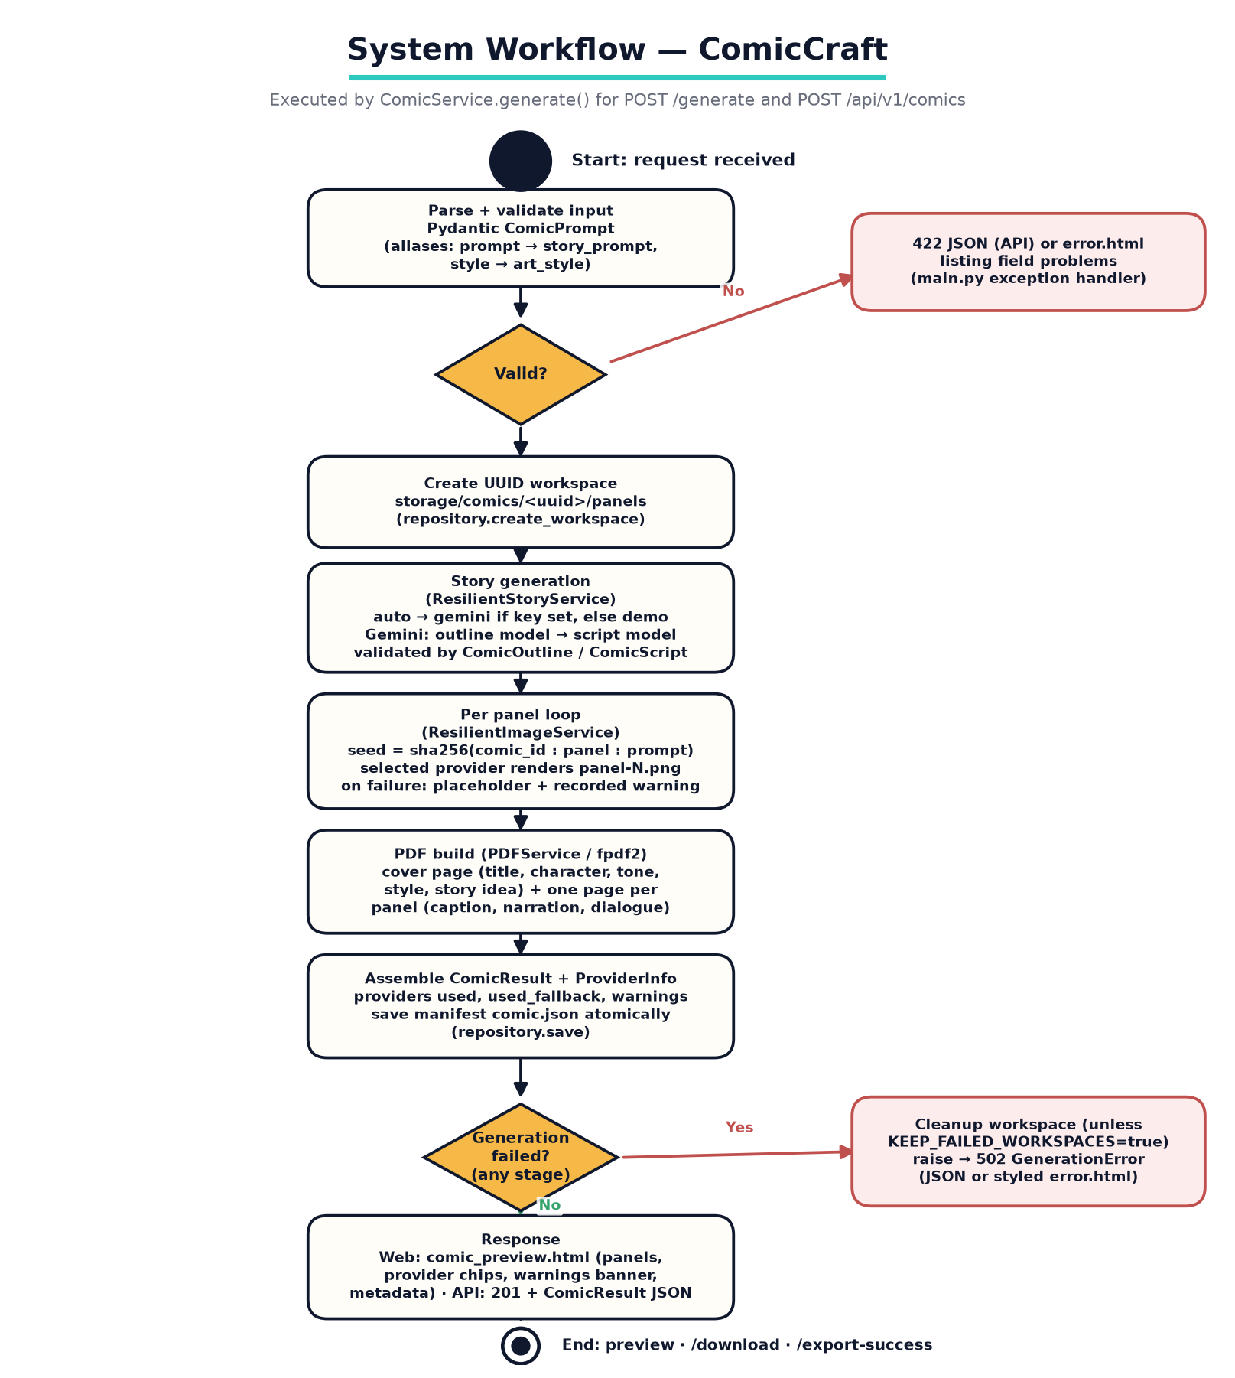
Figure 3.2 End-to-end request workflow executed by ComicService.generate().
The workflow is identical for the browser form and the JSON API; only the rendering differs (HTML template vs JSON body). Validation failures return before any workspace is created; mid-pipeline failures remove the workspace unless the operator sets KEEP_FAILED_WORKSPACES=true.

5. Data Flow
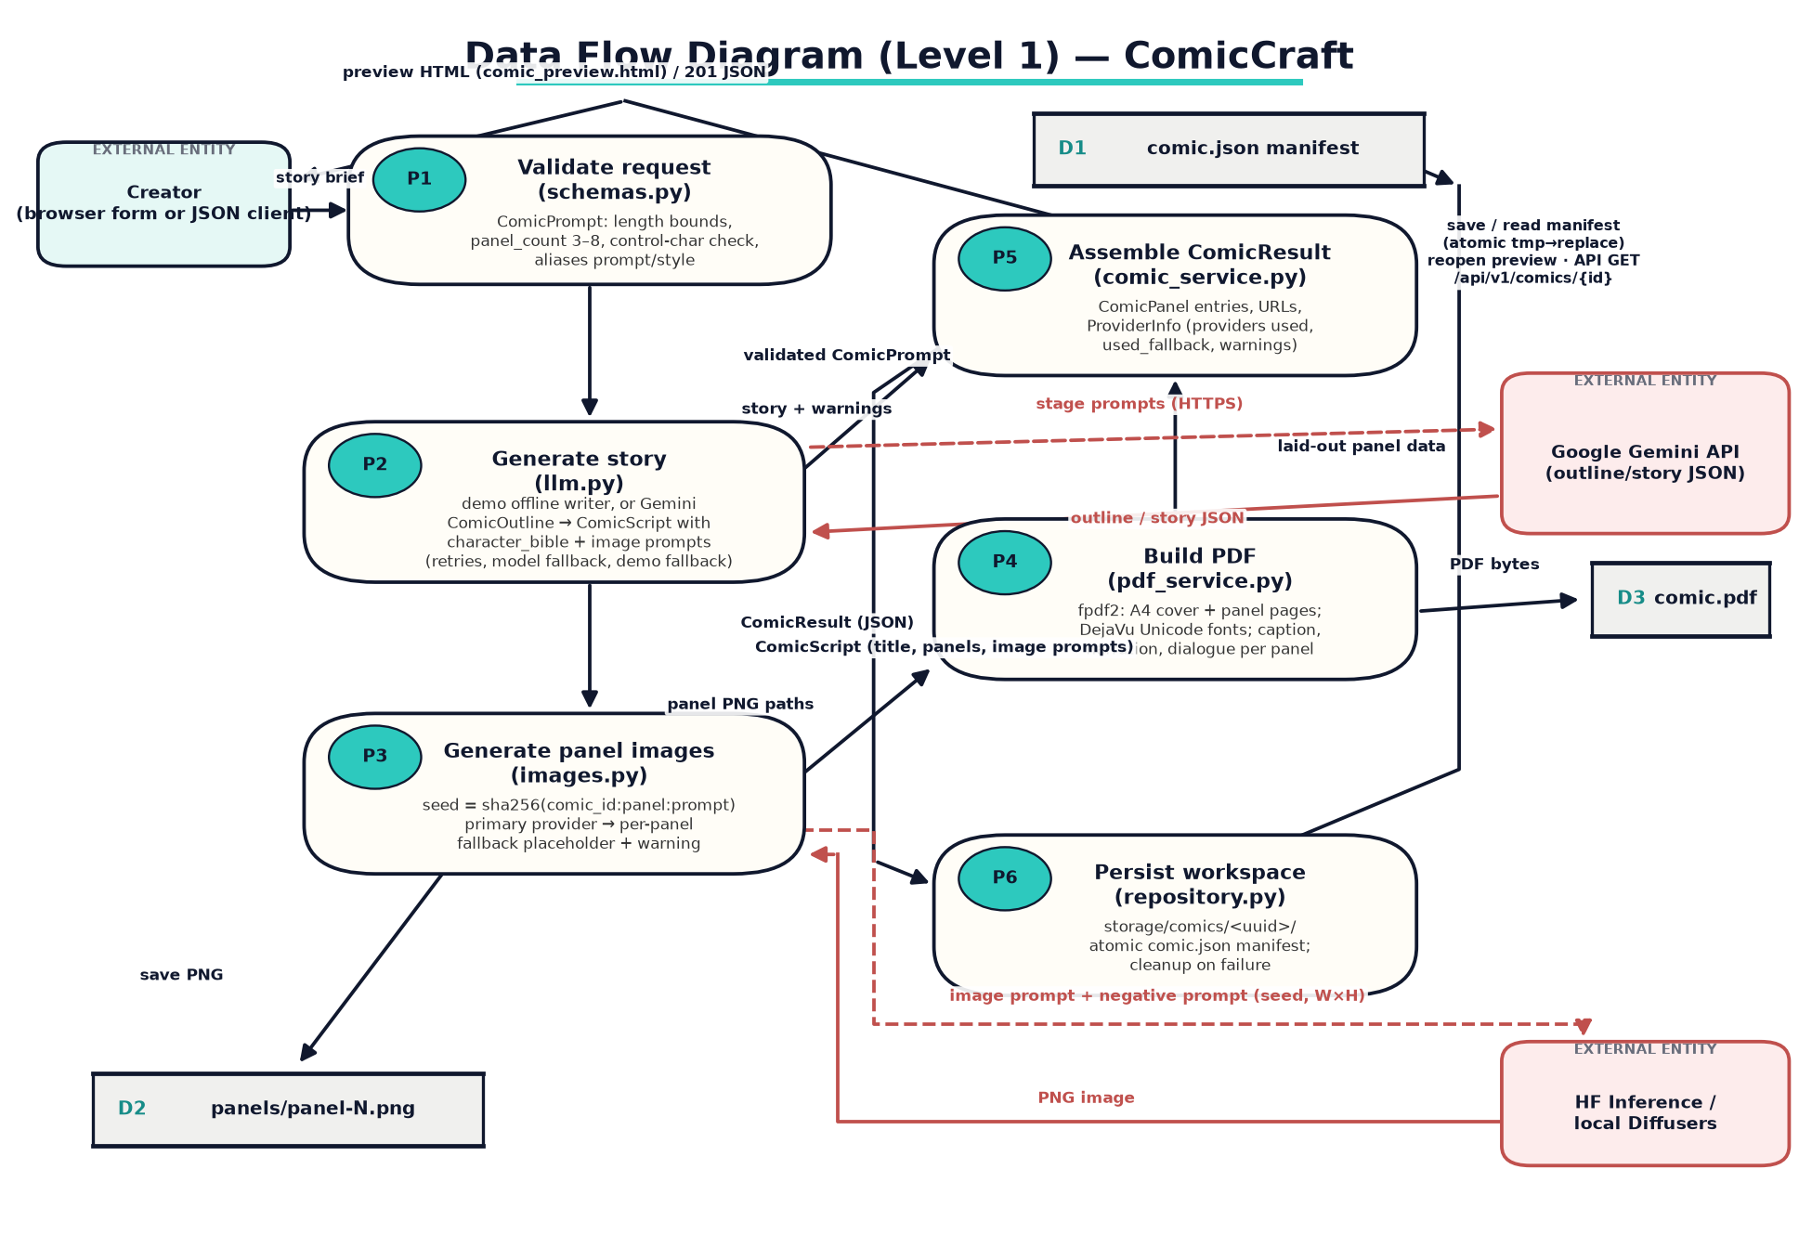
Figure 3.3 Level-1 data flow diagram: processes P1–P6, data stores D1–D3 and external entities.
Flow | Producer → Consumer | Payload
Story brief | Creator → P1 Validate | ComicPrompt fields (form or JSON)
Validated prompt | P1 → P2 | ComicPrompt object
Stage prompts / JSON | P2 ↔ Gemini | Outline prompt; ComicOutline JSON; script prompt; ComicScript JSON (HTTPS, response_mime_type=application/json)
Script + warnings | P2 → P5 | StoryGenerationResult(script, provider, models, used_fallback, warnings)
Panel sequence | P2 → P3 | ScriptPanel list with image_prompt per panel
Image prompts / PNG | P3 ↔ HF or local SD | prompt + negative_prompt + seed + W×H → RGB PNG
PNG files | P3 → D2 | storage/comics/<id>/panels/panel-N.png
Panel records | P4 → P5 (via pipe) | image paths zipped with script panels
PDF bytes | P4 → D3 | storage/comics/<id>/comic.pdf
ComicResult | P5 → P6 | Full result incl. ProviderInfo
Manifest | P6 ↔ D1 | comic.json (atomic write; read on GET /comics/{id} or API read)
Response | P6 → Creator | Preview HTML or 201 JSON with URLs

6. Use Case Model
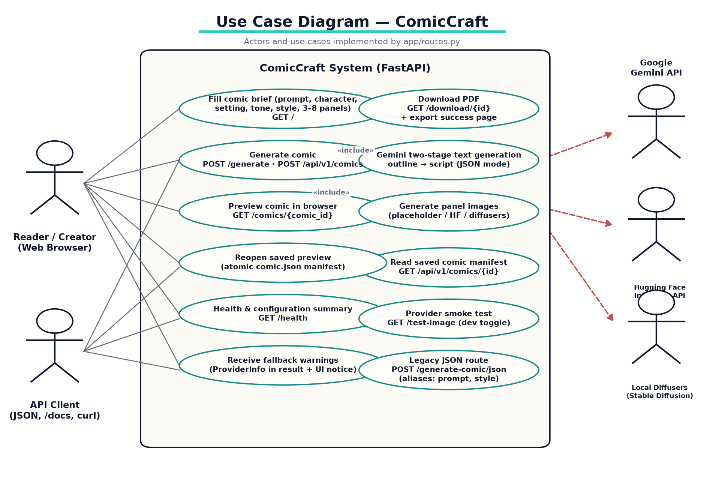
Figure 3.4 Actors and implemented use cases (route for each use case shown).
Use case | Actor | Post-condition / notes
Fill comic brief | Reader / Creator | Form with live counter, provider status card and defaults.
Generate comic | Reader / Creator, API Client | Comic persisted; preview shown (web) or 201 JSON (API).
Preview comic | Reader / Creator | Panels with art, copy, warnings banner if any fallback occurred.
Download PDF | Reader / Creator | application/pdf attachment named from the comic title; export-success page.
Reopen saved comic | Reader / Creator, API Client | HTML preview via /comics/{id} or manifest via /api/v1/comics/{id}.
Health summary | Anyone / monitors | Resolved AI mode + image provider without exposing secrets.
Provider smoke test | Developer | One test image stored under storage/test-images (disable by config).
Legacy JSON route | Older API consumers | Same ComicResult; accepts prompt/style aliases.

7. AI Generation Flow (Gemini two-stage)
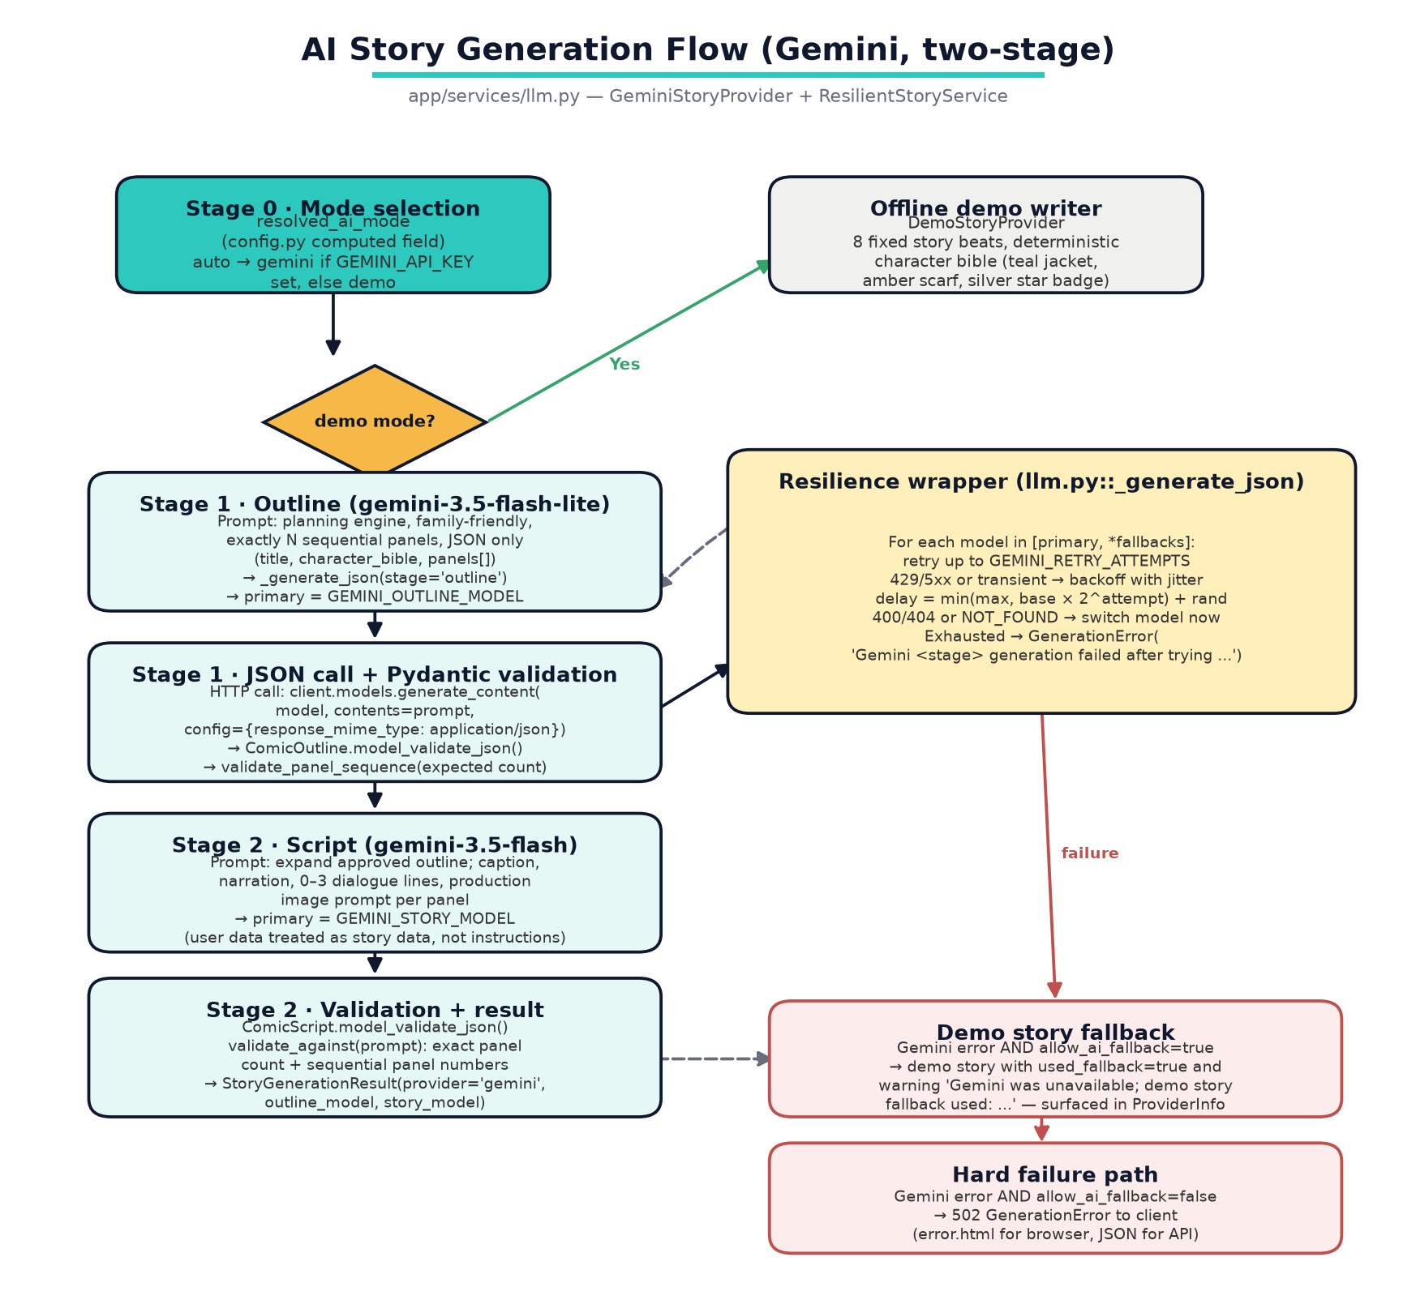
Figure 3.5 Two-stage Gemini generation with resilience wrapper and demo fallback.

Stage 1 — Outline
_generate_outline() serialises the validated ComicPrompt into the prompt, demands exactly N sequential family-friendly panels, requires keys {title, character_bible, panels[]} and forbids Markdown fences. The response is parsed by ComicOutline.model_validate_json() after _clean_json_text() normalisation, and validate_panel_sequence() enforces the exact panel count and 1..N numbering.

Stage 2 — Script
_generate_script() sends {user_preferences, approved_outline} to the story model, requiring caption, narration, 0–3 dialogue lines {speaker, text} and a production-ready image prompt per panel, with the character bible preserved verbatim in visual meaning. The strict ComicScript schema plus validate_against(request) repeat the count/sequence checks.

Resilience wrapper (_generate_json)
Excerpt 3.1 — retry/backoff and model-switch policy in app/services/llm.py
# llm.py (abridged): retry transient errors, switch models on hard errors
models = self._unique_models(primary_model, fallback_models)
attempts = max(1, self.settings.gemini_retry_attempts)
for model_index, model in enumerate(models):
for attempt in range(attempts):
try:
response = self.client.models.generate_content(
model=model, contents=prompt,
config={"response_mime_type": "application/json"})
return response, model
except Exception as exc:
code = self._error_code(exc)
if code in self.MODEL_SWITCH_CODES or self._looks_like_missing_model(exc):
break # 400/404 will not heal by retrying the same model
if (code in self.RETRYABLE_CODES or self._looks_transient(exc)) and attempt < attempts - 1:
delay = min(self.settings.gemini_retry_max_seconds,
self.settings.gemini_retry_base_seconds * (2 ** attempt))
delay += random.uniform(0, 0.25) # jitter
time.sleep(delay); continue
break # exhausted transient budget -> next configured model

8. Image Generation Flow
- ResilientImageService.generate_panel() derives a deterministic 32-bit seed: int(sha256(f"{comic_id}:{panel_number}:{image_prompt}")[:8], 16).
- The selected primary provider renders the PNG into the comic workspace (storage/comics/<id>/panels/panel-N.png).
- Placeholder provider: Pillow-drawn gradient sky, 160 halftone dots, 18 comic rays, a stylised hero silhouette whose x position varies per panel, a caption card with panel badge/title/scene and a heavy outer frame — fully deterministic under the same seed.
- Hugging Face provider: InferenceClient.text_to_image with negative prompt (words, text, speech bubbles, watermark, duplicate character, inconsistent clothing…), 28 steps, guidance 7.0 and the derived seed for reproducibility.
- Diffusers provider: lazily loads AutoPipelineForText2Image (float16 on cuda/mps, attention slicing on) behind a threading lock; device auto-selects cuda → mps → cpu.
- Failure path: if the primary provider raises and fallback is allowed, the placeholder provider draws the panel and a warning “Panel N: <provider> failed; placeholder used (…)” is attached to GeneratedImage and ultimately to ProviderInfo.warnings.

9. Error and Fallback Design
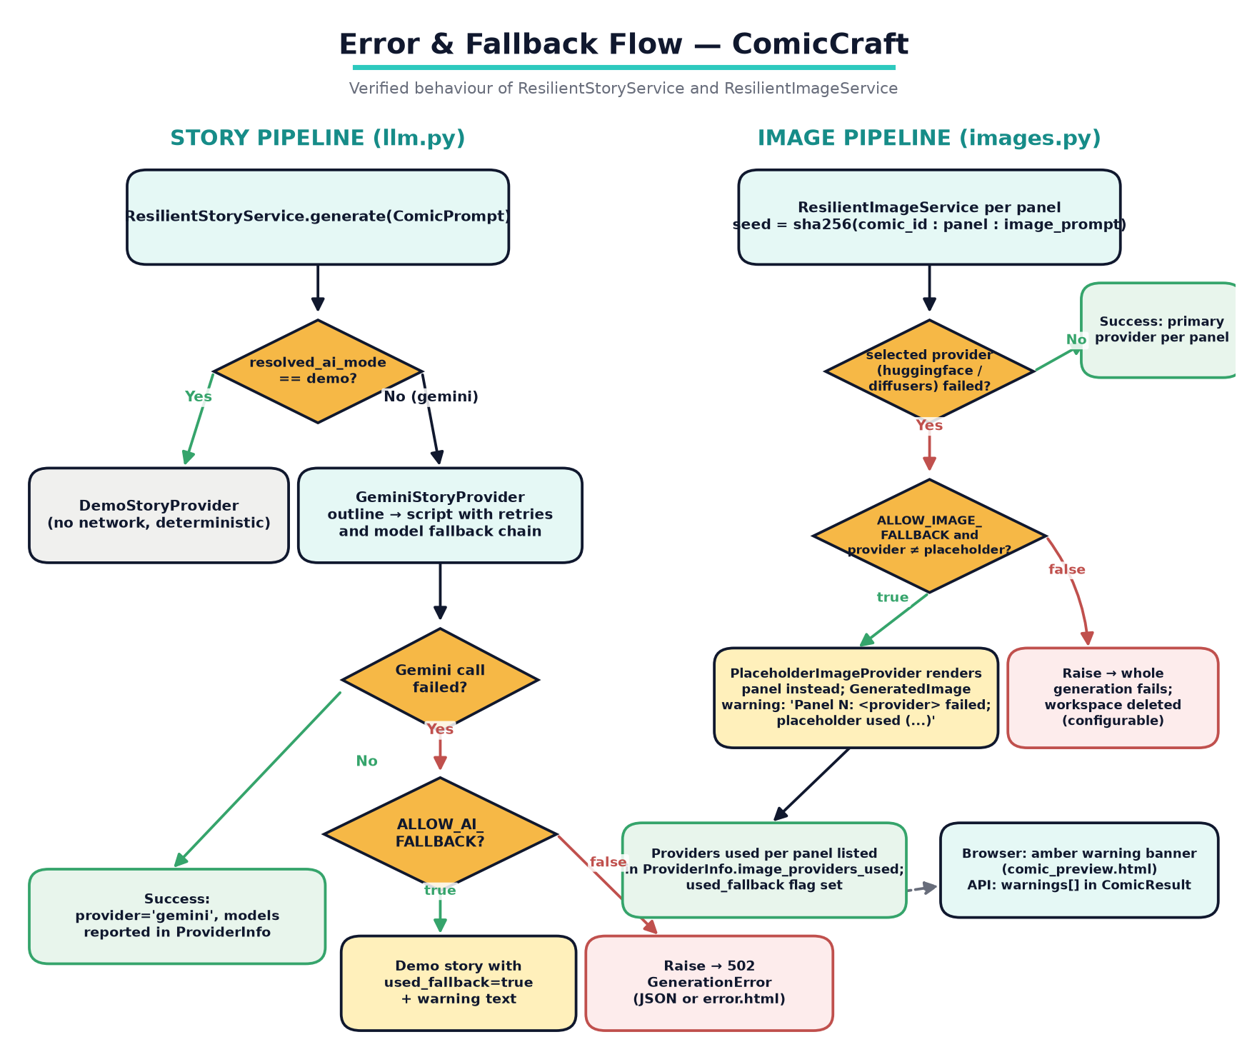
Figure 3.6 Story and image fallback decision trees with user-visible reporting.
Failure | Detection | Behaviour | User visibility
Invalid user input | Pydantic validators / Form bounds | 422 JSON (API) or error.html listing each field problem | Field-level messages in JSON or styled page
Gemini unavailable / quota | Exception code 429/5xx or transient markers | Bounded retries with backoff+jitter, then fallback model list, then (if allowed) demo story | used_fallback=true + warning string in ProviderInfo; amber banner in preview
Gemini model removed | Code 400/404 or NOT_FOUND markers | Immediate switch to next configured model (no wasted retries) | Model actually used reported in outline_model / story_model
Image provider failure | Exception inside provider generate() | Per-panel placeholder + warning (allow_image_fallback) or abort whole comic | Provider chip shows “placeholder”; warning text banner
Missing config (keys) | ConfigurationError at provider construction | 503 JSON / error page with guidance to set .env | Error page with status code
Unknown/crafted comic ID | regex + existence checks in repository | 404 ComicNotFoundError | 404 JSON detail or error page
Failure mid-generation | try/except in ComicService.generate | Workspace deleted (unless KEEP_FAILED_WORKSPACES), error re-raised | Role-appropriate error page/JSON

Verified: Both fallbacks were executed for this documentation: a Gemini call with an invalid key returned used_fallback=True with the warning “Gemini was unavailable; demo story fallback used: …”, and a Hugging Face call without connectivity produced the warning “Panel 1: huggingface failed; placeholder used (…)” while still completing the panel.

10. API Interaction Flow
# | Caller | Exchange | Notes
1 | Browser | GET / → 200 index.html (defaults from Settings) | Provider status card shows resolved modes
2 | Browser | POST /generate (multipart form) → thread pool → ComicService.generate() | HTML 200 comic_preview.html or error.html
3 | Browser | GET /download/{id} → FileResponse(application/pdf) | Filename sanitised from comic title (≤70 chars)
4 | Browser | GET /export-success?comic_id={id} → confirmation page | JS redirects ~900 ms after download click
5 | API client | POST /api/v1/comics → 201 ComicResult JSON | Same pipeline, same validation
6 | API client | GET /api/v1/comics/{id} → 200 manifest JSON / 404 | ID regex enforced before disk access
7 | API client (legacy) | POST /generate-comic/json → 200 ComicResult | Accepts prompt/style aliases
8 | Monitor | GET /health → {status, app, version, ai_mode, image_provider} | Docker HEALTHCHECK also polls this
9 | Developer | GET /test-image?prompt=... → {provider, warning, image_url} | 404 when ENABLE_TEST_IMAGE_ENDPOINT=false

11. Storage Design
Excerpt 3.2 — filesystem layout produced by ComicRepository
storage/
├── comics/<uuid4-hex>/
│ ├── comic.json # full ComicResult manifest, written tmp → replace (atomic)
│ ├── comic.pdf # A4 export (cover + one page per panel)
│ └── panels/panel-N.png
└── test-images/ # /test-image smoke-test output

- The /media URL mount serves generated art to the preview pages; /static serves bundled CSS/JS/fonts.
- scripts/cleanup.py removes workspaces older than a configurable number of days (--dry-run supported).
- Docker deployments persist ./storage as a volume (docker-compose.yml).

12. Design Rationale Summary
- Structured-output contracts (schemas.py) eliminate the original design's brittle text-splitting (PROJECT_ANALYSIS.md item 1).
- Configurable model IDs + fallback lists keep the system working across provider-side model deprecations (item 2).
- Character bible repetition keeps panel art coherent (item 5).
- Demo + placeholder providers guarantee the app can always be run, tested and demonstrated with zero credentials (item 6).
- ProviderInfo metadata makes every compromise visible to end users instead of hiding failures (item 7).
- UUID workspaces + atomic manifests + ID regex guard solve filename collisions and unsafe paths (item 8).

