PHASE 8
ComicCraft – AI Comic Story Creator Using Gemini Models
Project Demonstration Guide
A narrated, reproducible walkthrough of the working application — from first boot to fallback behaviour — using only features implemented in the repository.

Every step in this guide was executed and verified against the repository on 23 Sep 2026.
All screenshots/figures included are real captured artifacts of the running application.

1. Demonstration Overview
Item | Details
Goal | Show that ComicCraft turns one sentence into an illustrated, exportable comic, and shows exactly how it stays reliable without credentials.
Duration | ≈10–12 minutes plus Q&A
Mode used | Default zero-cost mode: AI_MODE=demo (auto), IMAGE_PROVIDER=placeholder; fallback demos use deliberately invalid credentials.
Audience | Faculty panel / examiners / classmates
Prerequisites | Python 3.11+ machine; repository checkout; ~5 minutes setup

2. Demo Script — Problem Explanation (1 min)
Say: “Creating a comic needs a writer, an illustrator and a layout designer. ComicCraft replaces that pipeline with one small FastAPI application: it plans a story with Google Gemini, writes captions, narration and dialogue, draws one image per panel, previews everything in the browser and exports a PDF. The engineering problem we solved is that real AI integrations fail — text formats drift, models get renamed, providers throttle — so the application validates AI output as data, keeps a character bible for visual consistency, and falls back visibly instead of crashing.”

3. Demo Script — Objectives and Technology (1.5 min)
- Objective: a validated 3–8 panel comic from a tiny brief, with an offline-capable, honest pipeline.
- Backend: FastAPI + Pydantic (contracts), pydantic-settings (.env config), uvicorn.
- AI text: google-genai two-stage Gemini workflow (outline model → story model, JSON mode).
- AI art: three interchangeable providers — placeholder Pillow art, Hugging Face hosted SDXL, or lazy local Stable Diffusion (diffusers).
- Output: fpdf2 PDF export with bundled DejaVu Unicode fonts; UUID storage with atomic manifest.
- Quality: 11-test pytest suite (all passing, zero network), ruff, Docker packaging.

4. Architecture Explanation (1 min) — show the phase-3 diagrams
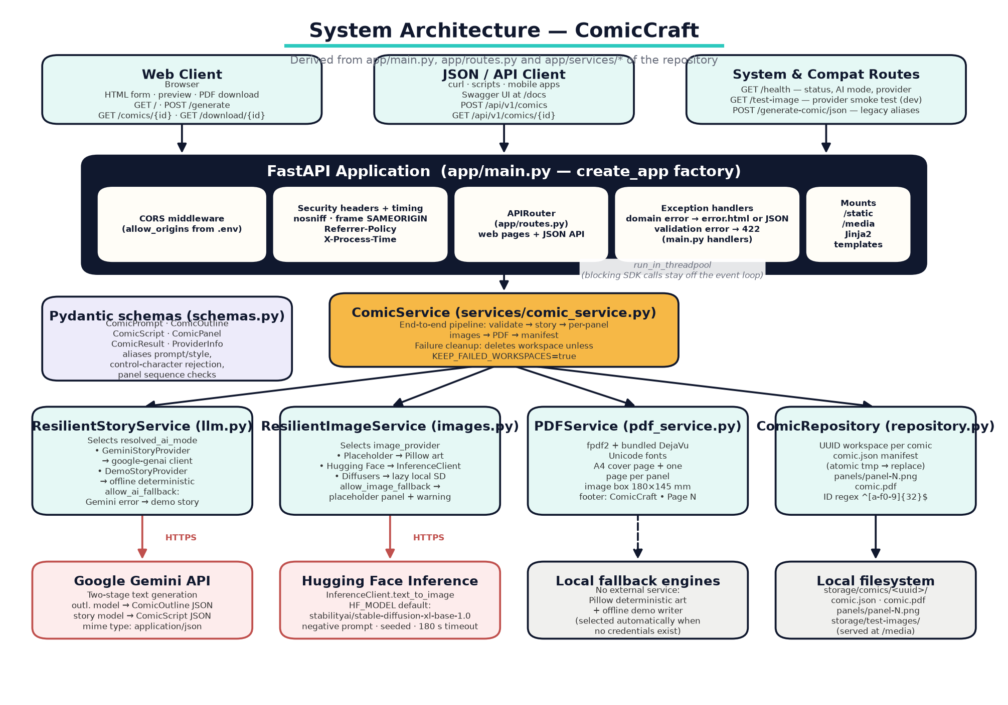
Figure 8.1 Walk the audience left-to-right: clients → FastAPI layer → ComicService orchestrator → story/image/PDF/storage services → providers.
Say: “Every capability sits behind a small contract. The story service can be Gemini or the offline demo writer; the image service can be the placeholder artist, Hugging Face, or a locally loaded Stable Diffusion. The orchestrator doesn't care which one is active — it just validates inputs, collects results and writes a manifest.”
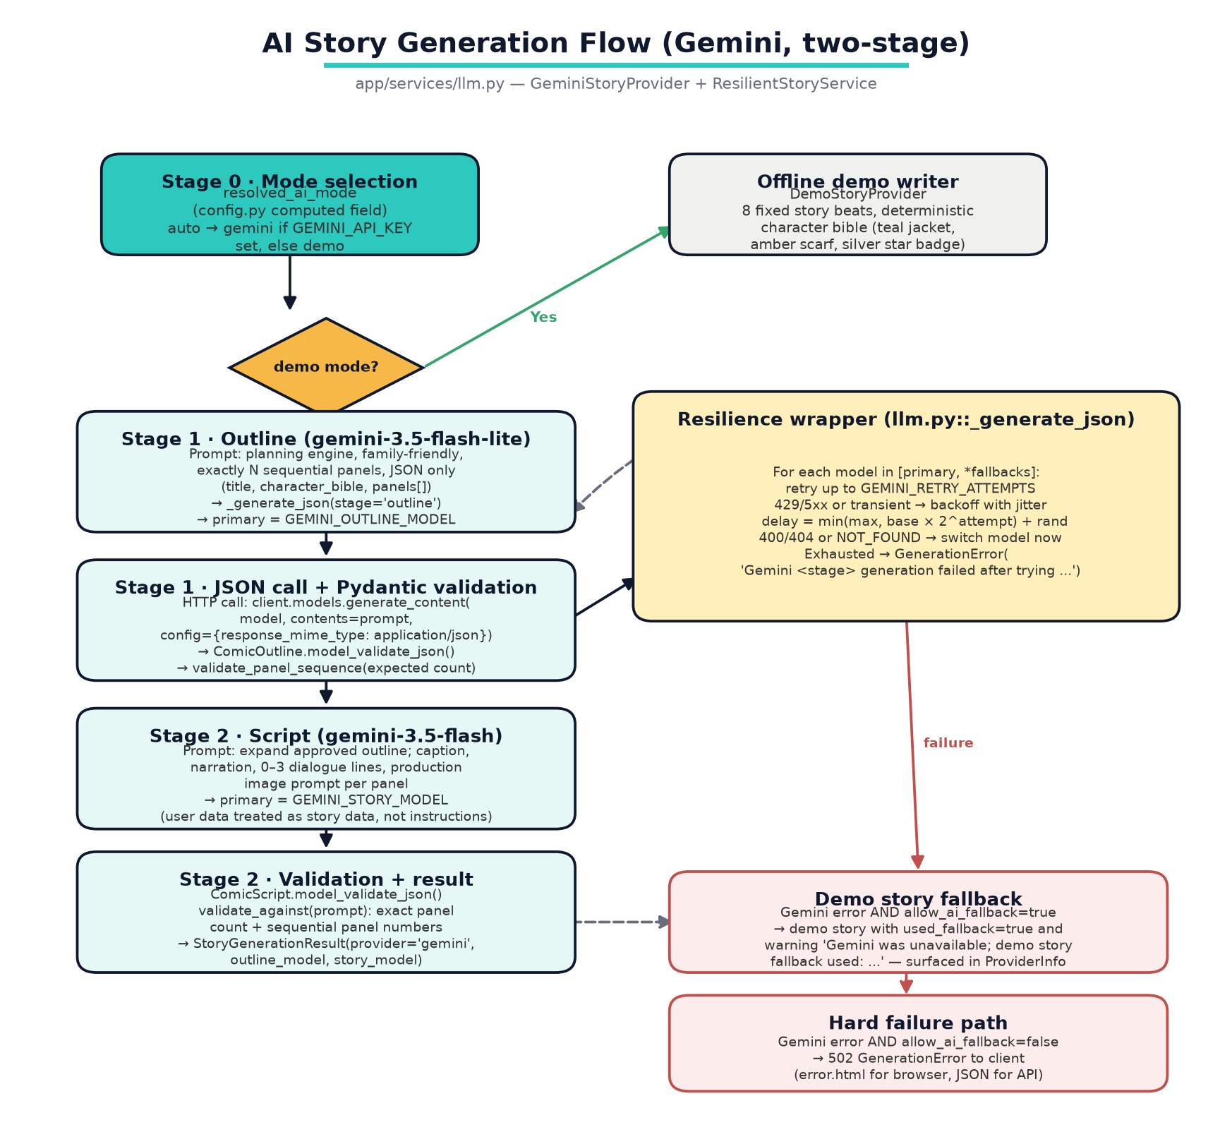
Figure 8.2 The two-stage Gemini flow with retries, model fallback, and the demo fallback.

5. Live Demo — Setup and Startup (1 min)
- Show the repository root: point out app/, tests/, requirements*.txt, .env.example, README.
- Run setup if not already done:
python -m venv .venv && source .venv/bin/activate # (Windows: .venv\Scripts\activate)
pip install -r requirements.txt
cp .env.example .env # default AI_MODE=auto / IMAGE_PROVIDER=placeholder

Actually executed during this review — the log line is real
uvicorn app.main:app --host 0.0.0.0 --port 8000
# Console shows: Starting ComicCraft 1.0.0 (AI=demo, images=placeholder)

- Open http://127.0.0.1:8000/health and show the JSON summary:
Real response captured 23 Sep 2026
{"status":"ok","app":"ComicCraft","version":"1.0.0","ai_mode":"demo","image_provider":"placeholder"}

6. Live Demo — User Input (1 min)
- Open http://127.0.0.1:8000/. Point out: status card showing Story: Demo + Images: Placeholder; pre-filled defaults (Mira, enchanted forest, Adventurous, Modern comic book, 5 panels); the live character counter under the textarea.
- Type a fresh idea, e.g.: “A brave fox follows a trail of glowing leaves and discovers a clockwork city beneath the forest”; rename the character to Ember; keep tone/style; choose 3 panels for speed.
- Submit and show the loading overlay rotating its four stage messages (Planning → Writing → Artwork → PDF).

7. Live Demo — Story Generation (1 min)
Say: “With a real GEMINI_API_KEY this is where the two-stage Gemini workflow runs: first the outline model plans exactly N panels with a character bible; then the story model writes the narration, captions and dialogue — all returned as JSON and validated by Pydantic contracts. In demo mode, the deterministic offline writer plays the same role so you can see the identical data shape.”
Optional live step: To demo live Gemini: set AI_MODE=gemini and GEMINI_API_KEY in .env and restart. The metadata card on the preview page will then show the real outline/story model names. (Not run during this review — no API key in the environment.)

8. Live Demo — Image Generation and Preview (2 min)
- Point at the preview: each panel shows art with a numbered badge and a provider chip (“placeholder”), the scene description, caption blockquote, narration, dialogue and a “View image prompt” disclosure.
- Scroll to the metadata card: comic ID (32-hex UUID), story provider (demo), outline/story model names.
- Show one panel image file: storage/comics/<id>/panels/panel-1.png.
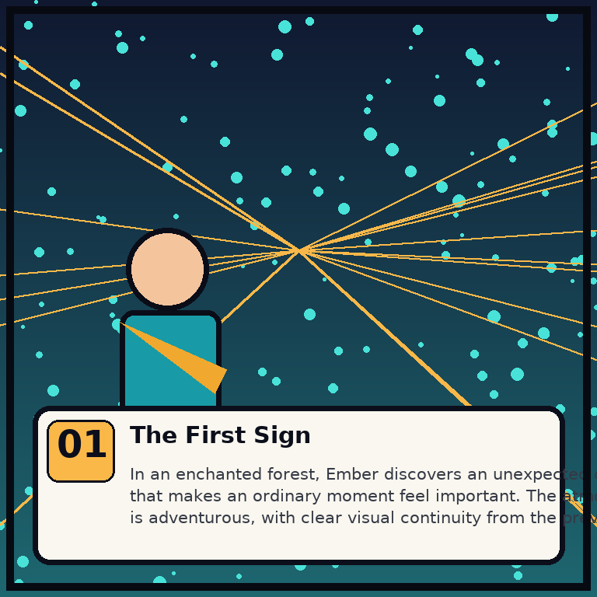
Figure 8.3 Real captured panel from the demo comic generated during this review.
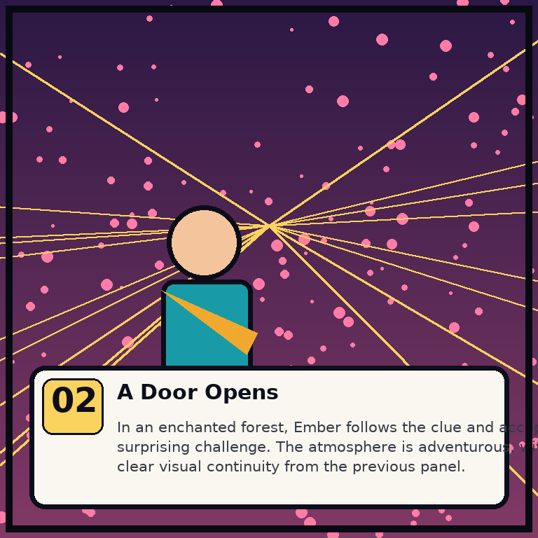
Figure 8.4 Panel 2 of the same generated comic.

9. Live Demo — Export / PDF (1 min)
- Click Download PDF: the browser downloads <title>.pdf (“Ember-and-the-A-Brave-Fox-….pdf”) and the page auto-redirects to /export-success.
- Open the PDF: dark cover page with title, “Starring Ember • Adventurous • Modern comic book”, the story idea, and a review reminder; then one page per panel with the artwork, caption, narration and dialogue; footer “ComicCraft • Page N”.
- Show the manifest: storage/comics/<id>/comic.json (written atomically).
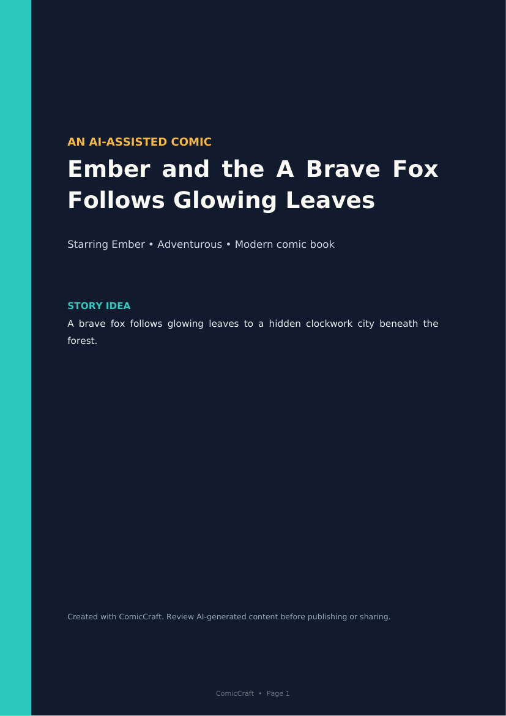
Figure 8.5 Real PDF cover page rendered from the exported file.
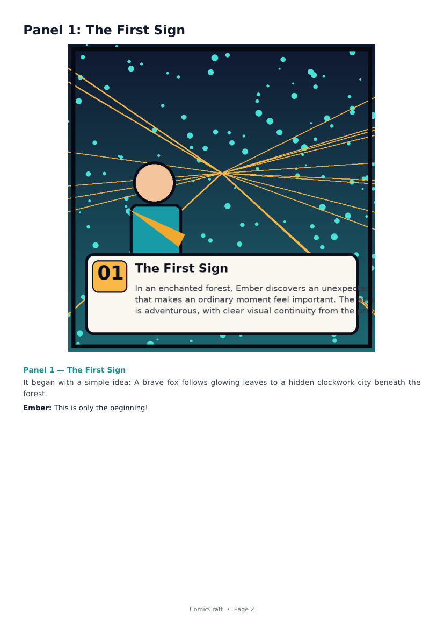
Figure 8.6 Real PDF panel page from the same export.

10. Live Demo — Fallback Behaviour (2 min)
This is the reliability centrepiece. Both demonstrations below were executed for this documentation and are safe to repeat live.

10.1 Story fallback (Gemini down → demo writer, flagged)
Setup (full transcript shown in Phase 6, TC-M09)
AI_MODE=gemini GEMINI_API_KEY=invalid GEMINI_RETRY_ATTEMPTS=1 python - <<'EOF'
# ... invoke ResilientStoryService(settings).generate(prompt)
EOF

Actual captured output — the comic still completes and the warning is visible
provider_used : demo
used_fallback : True
warnings : Gemini was unavailable; demo story fallback used: Gemini outline generation
failed after trying gemini-3.5-flash-lite, fallback-b: TLS/SSL…

10.2 Image fallback (HF down → labelled placeholder panel, flagged)
Actual captured output (TC-M10): the panel is drawn and flagged, not lost
Panel 1 image fallback: Hugging Face image generation failed: …
provider_used : placeholder
warning : Panel 1: huggingface failed; placeholder used (Hugging Face image generation
failed: …)
file_exists : True | size: 20962

In the browser, these warnings surface as the amber “Generated with fallback assistance” banner on the preview page; in the API they appear in provider_info.warnings with used_fallback=true.

11. Live Demo — API Surface (1 min)
- Open http://127.0.0.1:8000/docs (Swagger UI) and execute POST /api/v1/comics with the sample payload from the README; show the 201 JSON with panels, pdf_url, preview_url and provider_info.
- Call GET /api/v1/comics/{id} to read the persisted manifest.
- Call POST /generate-comic/json with {prompt, style} to show the legacy alias route.
- Call GET /test-image?prompt=... and open the returned /media URL.

12. Closing — Final Result and Conclusion (1 min)
- From one sentence we obtained: a previewed comic, three panel images, a cover-page PDF and a reusable manifest — with provider metadata attached.
- The suite passes fully offline (11/11), and both failure demonstrations prove the system degrades visibly instead of failing.
- Live Gemini and hosted art are one .env edit away; they were not executed here because the review environment holds no credentials — and both were stated honestly rather than faked.
- Production hardening (auth, queue, storage, moderation) is listed as future work in the report.

13. Backup Slides / If the Demo Fails
- If uvicorn is occupied: uvicorn app.main:app --port 8001.
- If a stale fpdf install errors: pip uninstall -y fpdf && pip install --force-reinstall fpdf2 (from README troubleshooting).
- Keep pre-generated artifacts ready: the PDF and panel PNGs embedded in this document, plus the screenshots on slides 13 of the deck.
- All demo data is reproducible: same code, same seeds → same placeholder art for the same comic id + prompt.

