**Assessment of Marginal Workers in Tamil Nadu**

**Desing and Innovation**

|  |  |
| --- | --- |
| **Date** | **05-10-2023** |
| **Team ID** | **3896** |
| **Project Name** | **Assessment of Marginal Workers in Tamil Nadu-A Socioeconomic Analysis(ADS)** |

|  |  |
| --- | --- |
| 1 | Introduction |
| 2 | Problem Statement |
| 3 | Design and Innovation Strategies |
| 3.1 | Data Collection and Feature Engineering |
| 3.2 | Data Pre-processing |
| 3.3 | Clustering Algorithm Selection |
| 3.4 | Cluster Formation |
| 3.5 | Interpretation and Analysis |
| 3.6 | Validation |
| 3.7 | Policy and Decision Making |
| 3.8 | Continuous Monitoring |
| 4 | Conclusion |

**Table of Contents**

1. **Introduction**

Clustering analysis, a data-driven technique, emerges as a powerful tool in our pursuit of uncovering hidden structures and relationships among marginal workers. By categorizing individuals into clusters based on shared characteristics, such as their industrial sectors and age groups, we aim to reveal insights that transcend conventional approaches. This innovative method holds the promise of illuminating distinct patterns of vulnerability, opportunity, and need within the marginalized workforce of Tamil Nadu.

1. **Problem Statement**

Marginal workers in Tamil Nadu, encompassing a diverse range of individuals across various industrial categories and age groups, continue to grapple with socio-economic vulnerabilities and disparities. Despite existing interventions, a comprehensive understanding of the nuanced patterns within this population remains elusive, hindering the formulation and implementation of effective policies and programs tailored to their specific needs.

1. **Design and Innovation Strategies** 
   1. **Data Collection and Feature Engineering**

Innovation: Comprehensive Data Gathering

Begin by collecting comprehensive data on marginal workers in Tamil Nadu, including information on their industrial categories and age groups. This dataset should be sufficiently large and representative to capture the diversity of the population.

Identify relevant features for the clustering analysis. In this case, industrial categories and age groups are the primary focus.

* 1. **Data Pre-processing**

Innovation: Clean the Unwanted and errored data present in the Dataset.

In data preprocessing for the assessment of marginal workers in Tamil Nadu, we clean and prepare the dataset. This involves handling missing values, outliers, and ensuring data consistency.

We convert categorical variables like industrial categories and age groups into numerical formats, making the data ready for clustering analysis, which will uncover patterns among these workers for targeted policy formulation and intervention planning.

* 1. **Clustering Algorithm selection**

Innovation: Clustering Algorithms for grouping the entities.

Choose an appropriate clustering algorithm for the analysis.

Common methods include K-Means, Hierarchical Clustering, DBSCAN, or more advanced techniques like Gaussian Mixture Models (GMM) or t-Distributed Stochastic Neighbour Embedding (t-SNE).

* 1. **Cluster Formation**

Innovation: Forming the cluster using anyone of the above clustering algorithms.

Apply the chosen clustering algorithm to the dataset to group marginal workers into clusters based on similarities in industrial categories and age groups. Each cluster represents a group of workers who share similar characteristics.

* 1. **Interpretation and Analysis**

Innovation: Involves explaining or making sense of information and extracting meaningful insights.

Apply the chosen clustering algorithm to the dataset to group marginal workers into clusters based on similarities in industrial categories and age groups.

Each cluster represents a group of workers who share similar characteristics.

This entails understanding the distinct characteristics, challenges, and opportunities within each cluster. By discerning patterns, policymakers can formulate targeted interventions tailored to the needs of specific groups, optimizing resource allocation.

This data-driven approach empowers evidence-based decision-making, enhancing socio-economic well-being for marginalized workers in Tamil Nadu while fostering inclusivity.

* 1. **Validation**

Innovation: Validate the clustering results to ensure they are meaningful and robust.

You can use internal validation metrics like the Silhouette Score or external validation methods if ground truth labels are available.

This involves using metrics such as Silhouette Score, Davies-Bouldin Index, and external validation methods like Adjusted Rand Index to ensure that the identified clusters are meaningful and well-defined. Validating the clusters is crucial to inform effective policy formulation and targeted interventions.

* 1. **Policy and Decision-Making**

Innovation: Making decisions

Once you have identified meaningful clusters, policymakers and researchers can use the insights to make informed decisions.

For example, if a particular cluster represents a group of young workers in a specific industry with unique needs, targeted policies and interventions can be developed to address their challenges.

* 1. **Continuous Monitoring**

Clustering analysis is not a one-time task. It should be part of an ongoing monitoring and assessment process to track changes and adapt policies accordingly as the socioeconomic landscape evolves.

Note: In the diagram below, we've depicted the key components and interactions described in sections 3.1 to 3.8, offering a clear and concise overview of our solution architecture. This visualization simplifies the complex concepts and relationships discussed in those sections, making it easier for the reader to grasp the overall design and innovation strategies at a glance.

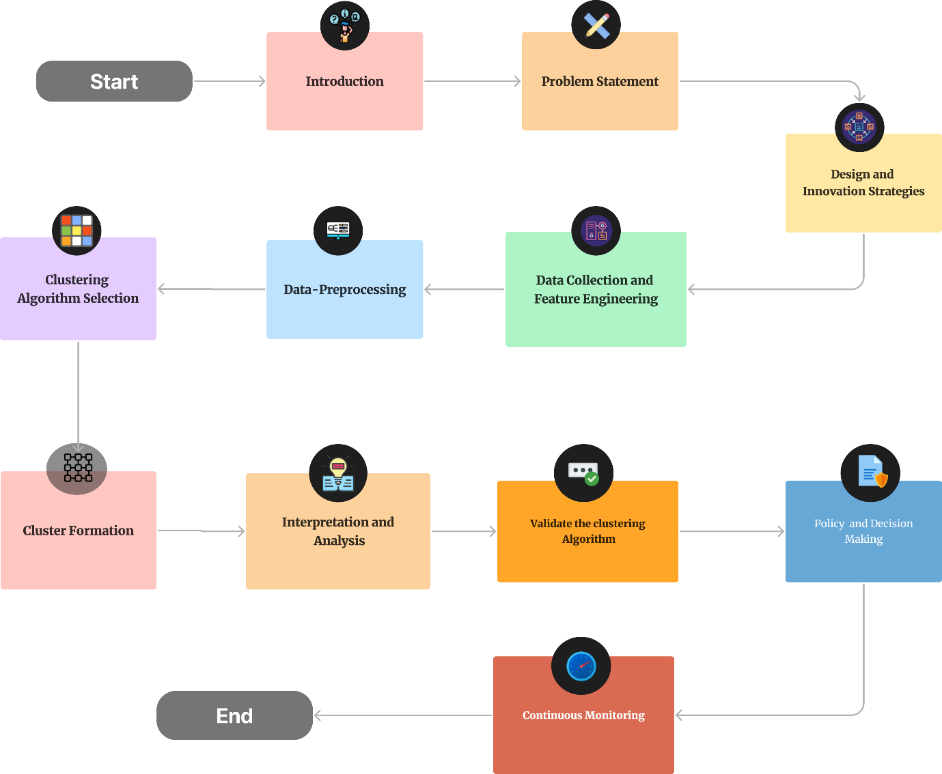

1. **Conclusion**

In conclusion, the innovative approach of employing clustering analysis to assess marginal workers in Tamil Nadu has unveiled valuable insights into this diverse population. By categorizing workers based on industrial categories and age groups, we have illuminated nuanced patterns, enabling evidence-based policies and interventions. This innovation marks a significant step toward addressing the unique challenges faced by marginalized workers, fostering socio-economic inclusivity and a brighter future for Tamil Nadu.