DevSecOps & MLOps Technical Assessment
Question 1 Architecture & Docker Compose Implementation Report
Candidate Name: Venkatesan S M | Date: October 2026
Orchestration: Docker Compose (Multi-Service Stack)

1. Executive Summary
This technical report provides the complete architecture, implementation details, and verification evidence for Question 1 of the DevSecOps and MLOps take-home assessment. The system consists of a multi-service containerized application orchestrated using Docker Compose on local hardware. The stack integrates five core services: a PostgreSQL database, a Catalog Service, an Assistant Service, an enterprise Frontend Web Gateway, and an on-premise CPU-optimized Qwen LLM inference server. All services utilize dedicated bridge networking, health monitoring, volume persistence, and isolated environment configurations.

2. Service Architecture & Component Overview
The microservices architecture decomposes application logic into modular, highly isolated containers:
- PostgreSQL Database (postgres): Runs PostgreSQL 15 (postgres:15-alpine) hosting catalogdb and assistantdb. Configured with Automated Healthchecks (pg_isready), database initialization via init-db.sql, and named volume persistence (pgdata) on backend-net.
- Catalog Service (catalog-service): Built from ./Backend/catalog/Dockerfile. Exposes FastAPI REST endpoints for retrieving catalog items (/items, /items/{id}). Communicates directly with PostgreSQL on backend-net.
- Assistant Service (assistant-service): Built from ./Backend/assistant/Dockerfile. Handles contextual Q&A by querying catalog-service for context and forwarding prompts to the LLM inference server (http://qwen-model:8000/v1/chat/completions).
- Frontend Web Application (frontend): Built from ./Frontend/Dockerfile. Serves the web interface on host port 9090 (mapped to container port 80). Acts as the primary user interaction layer and bridges frontend-net and backend-net.
- LLM Inference Server (qwen-model): Executes the llama.cpp server image (ghcr.io/ggml-org/llama.cpp:server) hosting Qwen2.5-0.5B-Instruct-GGUF. Configured specifically for CPU execution with 2 threads, 2048 context length, and q4_0 KV quantization.

3. Implementation & Execution Evidence

3.1 Project Folder Structure
The repository is organized cleanly into backend microservices, frontend UI, CI/CD workflows, and deployment manifests:
project/
└── assesment/
├── .github/workflows/
│ └── cicd.yml
├── Backend/
│ ├── assistant/
│ └── catalog/
├── Frontend/
├── kubernetes/
│ ├── charts/
│ └── template/
├── docker-compose.yaml
├── init-db.sql
├── README.md
└── sonar-project.properties

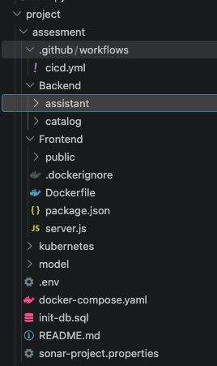
Figure: Repository & Project Directory Structure
VS Code file explorer tree displaying project layout including .github/workflows, Backend, Frontend, and kubernetes directories.

3.2 Docker Compose Build Process
The entire application stack is built and launched via Docker Compose:
docker compose up --build
The execution logs confirm successful image build and context transfer across all microservices in 55.9 seconds:
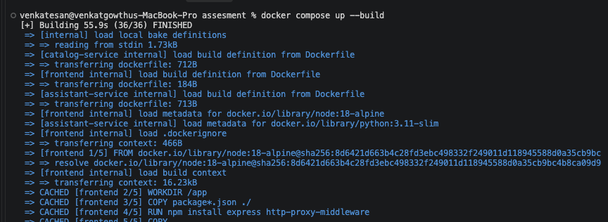
Figure: Docker Compose Build Execution Logs
Terminal window displaying successful docker compose up --build execution completing 36/36 steps.

3.3 Active Services & Container Runtime Verification
Service execution status was verified using 'docker compose ps':
NAME | IMAGE | COMMAND | SERVICE | STATUS & PORTS
assesment-assistant-service-1 | assesment-assistant-service | "python assistant.py" | assistant-service | Up 3 min (8000/tcp)
assesment-catalog-service-1 | assesment-catalog-service | "python catalog.py" | catalog-service | Up 3 min (8000/tcp)
assesment-frontend-1 | assesment-frontend | "docker-entrypoint.s..." | frontend | Up 3 min (0.0.0.0:9090->80)
assesment-postgres-1 | postgres:15-alpine | "docker-entrypoint.s..." | postgres | Up 4 min (healthy)
qwen-0.5b-server | ghcr.io/ggml-org/llama.cpp:server | "/app/llama-server" | qwen-model | Up 4 min (8003->8000)

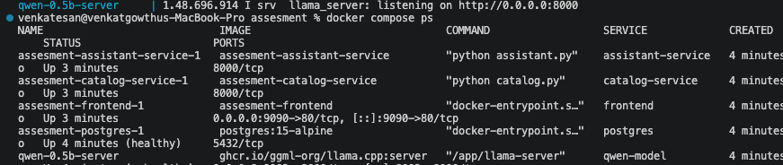
Figure: Container Runtime Status (docker compose ps)
Terminal execution output listing all 5 active containers, image tags, commands, and port mappings.

3.4 Web Application Gateway & AI Assistant Verification
Accessing http://localhost:9090 renders the Enriched Catalog Items interface alongside the live AI Assistant chat panel.
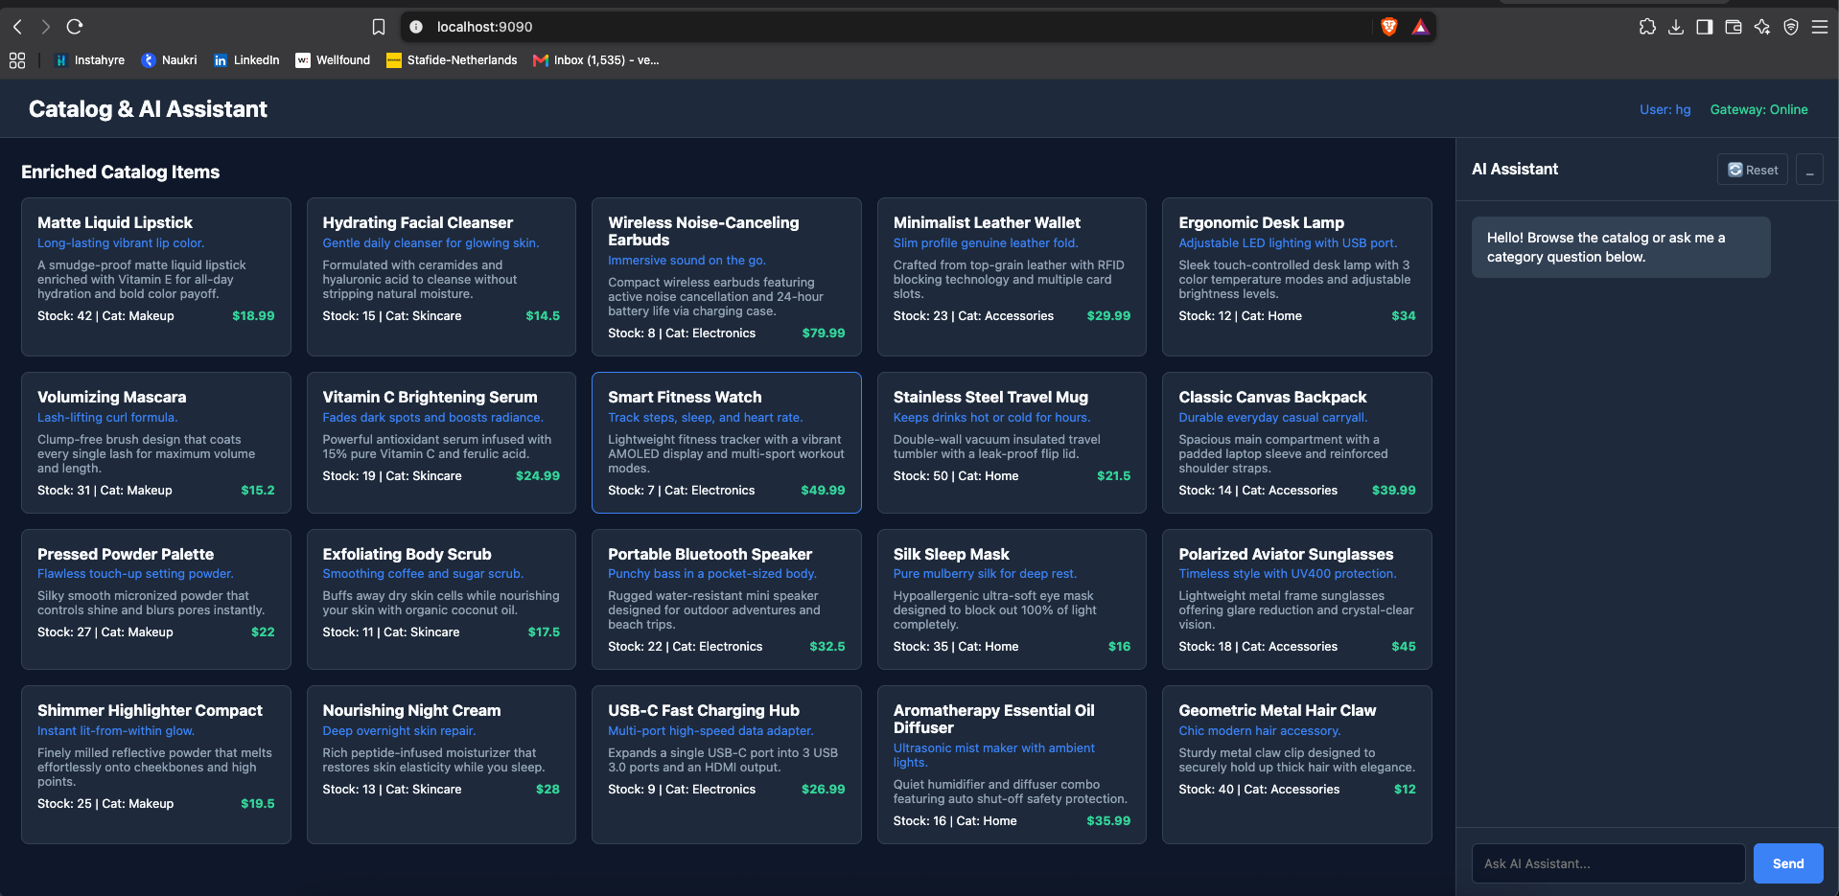
Figure: Enriched Catalog Items & Web Gateway Interface
Web browser interface at http://localhost:9090 showing catalog cards and AI Assistant panel.

When a user sends the prompt 'list me the items', the Assistant Service fetches catalog context and queries the Qwen LLM server, successfully outputting the numbered item list:
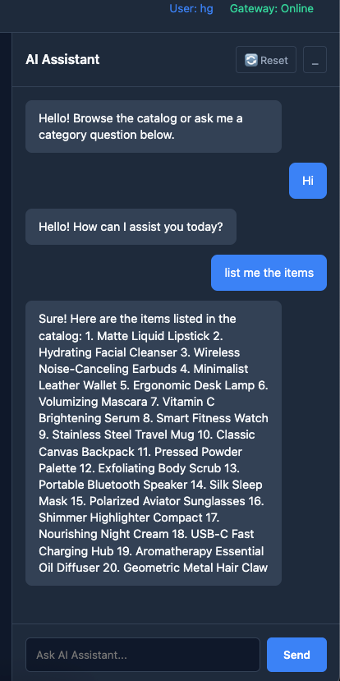
Figure: End-to-End AI Assistant Contextual Query Response
AI Assistant chat window displaying model-generated response listing catalog items.

3.5 API Endpoint & Health Check Validation
API routing and health endpoints were verified directly via cURL:
curl http://localhost:9090/api/v1/items
curl http://localhost:9090/healthz
1. /api/v1/items: Returns JSON catalog metadata containing product IDs, names, categories, prices, and stock numbers.
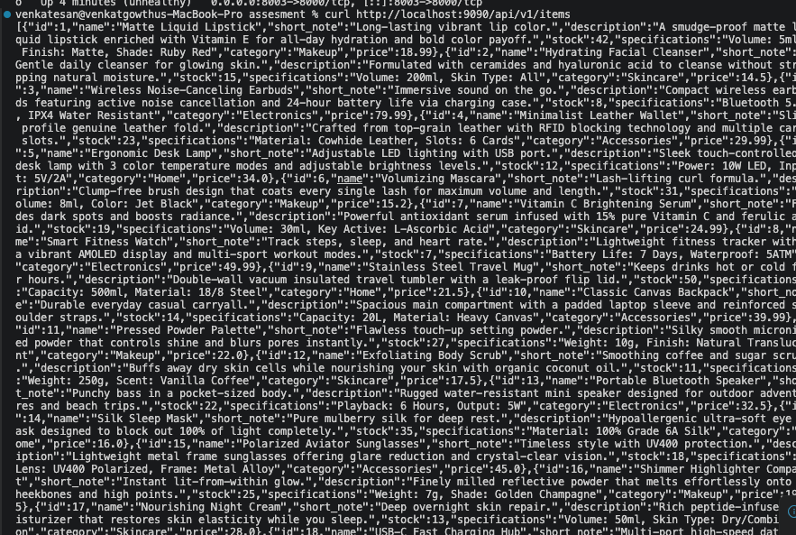
Figure: cURL Output - Catalog Items API Endpoint
Terminal cURL execution returning structured JSON array of catalog items.

2. /healthz: Returns {"status":"healthy"} confirmation.
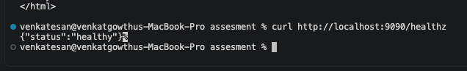
Figure: cURL Output - System Health Check Endpoint
Terminal cURL command output confirming healthz status response.

