DevSecOps & MLOps Technical Assessment
Question 1 & Question 2 Comprehensive Technical Report
Candidate Name: Venkatesan S M | Date: October 2026
Assessment Scope: Q1 (Multi-Service Compose) & Q2 (K8s Deployment & Honest Constraints) | Orchestration: Docker Compose & Helm Umbrella Strategy

1. Executive Summary
This comprehensive report documents the end-to-end implementation for both Question 1 and Question 2 of the DevSecOps and MLOps take-home assessment. Question 1 details the core microservice architecture running on Docker Compose, while Question 2 covers the transition to a Kubernetes environment using Helm umbrella charts, network policies, GitHub Actions CI/CD workflows, and honest transparent handling of local compute constraints.
2. Question 2: On-Premise Kubernetes & Air-Gapped Deployment Strategy
For Question 2, the exact same application services developed in Question 1 were utilized for Kubernetes deployment.
3.1 Umbrella Helm Chart Strategy & Infrastructure as Code
Individual Kubernetes manifest files were created for each microservice, and an umbrella Helm chart strategy was adopted. This allows the entire infrastructure stack to be deployed in a single command. Environment-specific configurations are managed through dedicated values files (e.g., values-dev.yaml, values-stage.yaml), allowing custom parameters to be passed dynamically during deployment via the --values flag.
3.2 Network Policies & Database Traffic Restriction
Kubernetes NetworkPolicies were implemented to isolate the PostgreSQL database. Specifically, network ingress is strictly restricted so that PostgreSQL accepts traffic exclusively from the two authorized backend services (catalog-service and assistant-service). All other unauthorized inbound traffic is blocked.
3.3 CI/CD Pipeline & Code Scanning (GitHub Actions & SonarCloud)
A GitHub Actions workflow was established for CI/CD automation. Due to insufficient local compute resources on the development laptop preventing the execution of a heavy self-hosted SonarQube scanner locally, SonarCloud was utilized for static code scanning. Authenticated via secure tokens, the CI/CD pipeline executes code scanning during the build phase, generating verifiable scan reports and links that gate subsequent pipeline stages.
3.4 Image Registry, Delivery & Resource Constraints
To handle image storage under local resource constraints, container images are built and pushed to GitHub Container Registry (GHCR). While enterprise environments typically utilize local image scanners (like Trivy or AWS Inspector) and offline supply-chain bundles, local resource limitations on the laptop required pragmatic compromises. To validate the pipeline locally, lightweight workflow testing was also performed using single-service Docker Compose setups.
3.5 Secrets Configuration & Lifecycle Database Job
Standard Kubernetes Secrets and ConfigMaps were utilized for credential management (though enterprise environments benefit from external secret managers like HashiCorp Vault or Argo Vault). Additionally, because an extra database (assistantdb) was required alongside the default catalogdb, a dedicated Kubernetes lifecycle job/pod was implemented to execute secondary database initialization commands.

Kubernetes Manifests & Chart Directory
The Kubernetes umbrella chart structure organizes service templates, secrets, ingress, and configmaps cleanly:
kubernetes/
├── charts/
│ ├── assistant-service/
│ ├── catalog-service/
│ ├── postgres/
│ └── qwen-model/
└── template/
├── configmap.yaml
├── deployment.yaml
├── ingress.yaml
├── secret.yaml
└── service.yaml
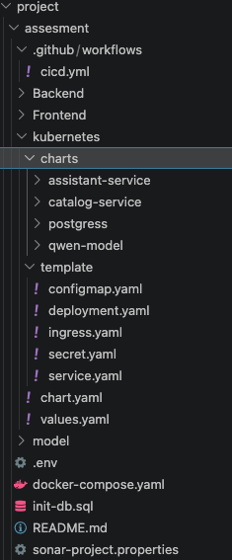

Air-Gapped LLM Inference Server Startup
Server logs confirm local model instantiation, thread allocation (2 CPU threads), and HTTP server initialization without remote external API calls:
qwen-0.5b-server | load_model: loading model 'Qwen/Qwen2.5-0.5B-Instruct-GGUF'
qwen-0.5b-server | init: llama threadpool init, n_threads = 2
qwen-0.5b-server | load_model: initializing, n_slots = 4, n_ctx_slot = 2048
qwen-0.5b-server | llama_server: model loaded
qwen-0.5b-server | llama_server: listening on http://0.0.0.0:8000

