User Manual - Domestic Travel system

**Document ID:** UM-TRS-IS-V2.0

**Author(s):** Bala.B, Ganesh V

**Version:** 1.0

**Date:** May 15, 2023

© Copyrights 2023 Aspire Systems. All rights reserved. The contents on this document are not to be reproduced or duplicated in any form or kind, either in part or full, without written consent from Aspire Systems.

CONTENTS

1 Introduction 3

2 Permissions 3

3 Traveler home 3

4 Domestic travel request 4

5 Domestic travel request approval 7

6 Executive workbench 8

7 Travel request closed 9

7.1 Adding comments 9

7.2 Closing the request 9

8 Search requests 9

9 Modification history 10

# Introduction

This document explains the feature and steps involved in the domestic travel system workflow.

# Permissions

|  |  |
| --- | --- |
| **Pages** | **Users** |
| **Home** | All users |
| **Domestic** | Aspire India users (User locations as per IDM) |
| **International** | All users |
| **Visa Request (Alone)** | All users |
| **Approval** | Department heads / DU owner and above |
| **Executive workbench** | Configured users |
| **Reports** | Configured users |

# Traveler home

After successful authentication, the first landing page seen by the user is **Home**.

**Types of users**

Requestor: A requestor can view their own request and its details in the ‘My Request(s)’ section available to all users. The request type column differentiates the international and domestic travel requests.

Approver: An approver has an additional section called ‘My approval(s)’ where the list of requests waiting for their approval and requests approved/rejected by them are seen. The approver can approve/reject requests by clicking the ‘Waiting for approval’ status.

#### 

# Domestic travel request

Aspirians can access the Domestic Travel Request page under the menu, ‘Domestic’.

The users can save their request multiple times by clicking the ‘Save’ button. The request can also be edited by clicking the My request(s) section in the home page.

After the request is submitted by clicking the **Submit** button, the user will not able to edit this request. The submitted request is sent to the approver for approval.

**Domestic request page – Fields and uses**

|  |  |
| --- | --- |
| **Fields** | **Descriptions** |
| **Purpose of the travel** | Travel purpose to be selected here. The options are Business, Short term, Long term and Relocation |
| **Department** | The user must select the appropriate department for which he/she is travelling. (The user department is auto-loaded by default) |
| **Customer name** | The customers’ list gets auto populated based on chosen department. The requester has to select the appropriate customer name for which the request travel is indented. The requestor can select New customer, Sales, Functional, Marketing and Management if they are traveling for these purposes. |
| **Project name** | The requestor must provide the project name for which they are travelling. Project name is mandated only for delivery customer travels. |
| **Travel type** | The 3 types of travel are - One way, Return and Multiple routes.  The requestor can add multiple travel routes by choosing ‘Multiple route’. |
| **Request for** | Self – If the travel request is for self, then the requestor has to choose ‘Self’  New Joinee – If the travel request is for a new Aspirian, then the requestor has to choose ‘New Joinee’.  Customer – If the travel request is for customers, then the requestor has to choose ‘Customer’.  Raising for Family – If the request is for the requestor and their family, then the requestor has to choose ‘Raising for Family’ |
| **Departure City** | Departure city to be entered here |
| **Arrival City** | Arrival city to be entered here |
| **Travel dates** | Travel start and end date to be selected here |
| **Ticket required** | Yes/No – Mandatory field |
| **Family traveling** | Yes/No – Mandatory field |
| **Accomodation required** | Yes / No – Mandatory field |
| **Preferred address** | If accommodation is selected as ‘Yes’, then the requestor has to enter the preferred address details for accommodation. |
| **Working from** | Aspire office/Customer office/Other |
| **Traveler address** | This field will be loaded by default from IDM. Also, it can be edited, if required. |
| **Mobile number** | This field will be loaded by default from IDM. Also, it can be edited, if required. |
| **Remarks** | Any remarks or comments regarding the travel request to be mentioned here. |
| **Approver** | The approver name will load depending upon the project/department selected. |
| **ID Proof details** | The requestor can add Aadhar/Passport/Pancard/Driving license as proof.  The user must select whether the proof is for Self/Family member/Customer/New Joinee based on whom they have requested for and update the mandatory fields in proof details section.  Once the details are updated for the travel, the same will be auto loaded for any future travel request. |

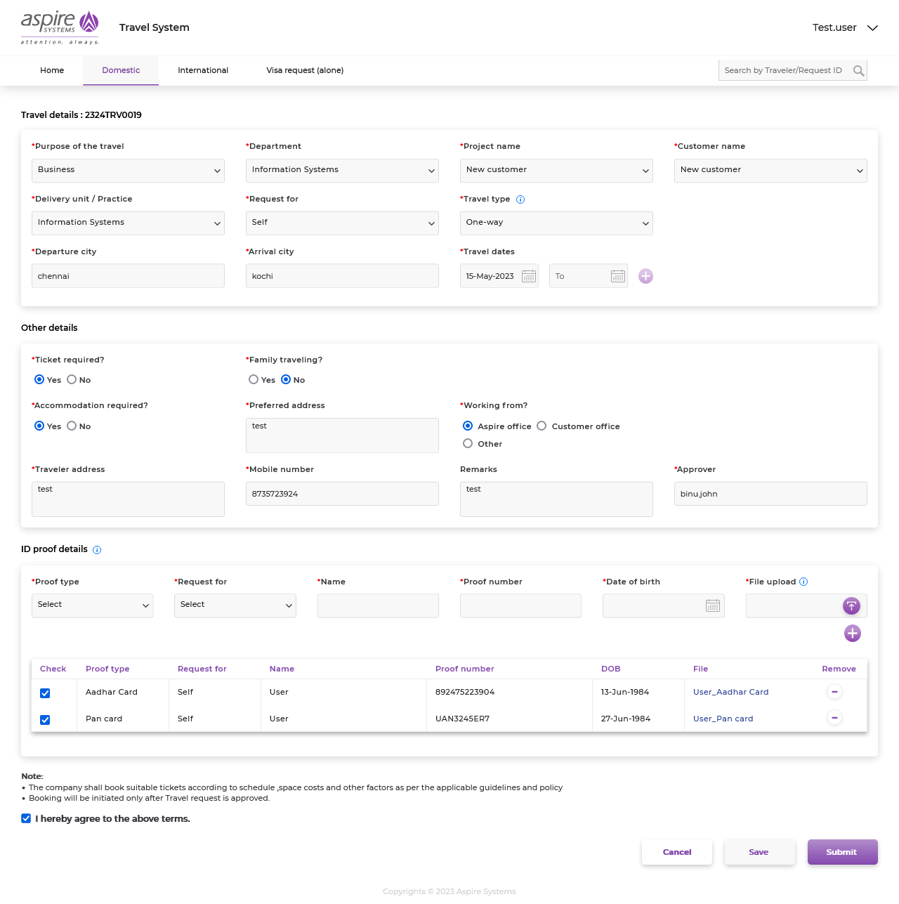

# Domestic travel request approval

Once the domestic travel request is submitted, an email notification is sent to the approver to approve/ reject the travel request.

Approvals can be done in two ways.

1. The approver can approve/reject this request by simply forwarding the email to [trs.approval@aspiresys.com](mailto:trs.approval@aspiresys.com) with subject mentioned in the approval notification mail.

For example, if the travel request id is 2324TRV0009, the mail has to be sent by the approver to [trs.approval@aspiresys.com](mailto:trs.approval@aspiresys.com) with any one of the following subject lines, as applicable:

* + - TravelRequested-Test User -2324TRV0009-Approved-Yes
    - TravelRequested-Test User. -2324TRV0009-Approved-No
    - TravelRequested-Test User. -2324TRV0009-Rejected

*Yes/No denotes the billed to client option.

1. In the **Travel** system, navigate to ‘Waiting for approval’ in the Home page/Approval page. Here, the approver has the option to approve/reject the request. The approver should mention whether the travel is billed to client before approving the request. They can also add their comment while approving/rejecting the request.

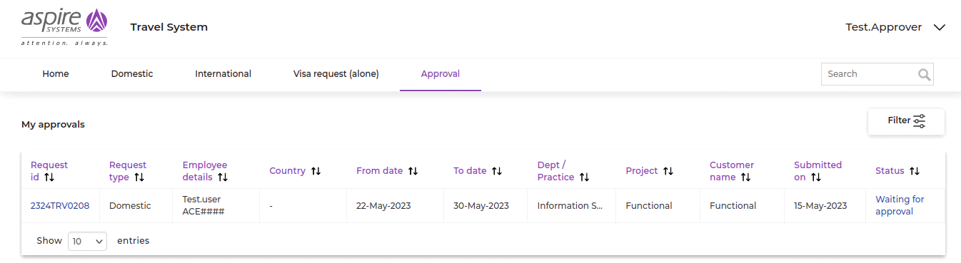

#### 

If the domestic travel request is rejected, the status of the request will be ‘Rejected’. The request rejection mail with the reason provided by the approver will be triggered to the requestor. The requestor can view this detail in the system.

# Executive Workbench

Once the domestic request is approved, the request mail will be notified to the ticket admins to process the ticket. Approver & requestors can view the ticket updates on their Dashboard page in the system

# Travel Request Closed

## Adding comments

The Ticket team can add comments related to the request. The requestor will receive notifications about these comments via email.

The requestor, ticketing team and approver can also view the previously entered comments in this tab.

## Closing the request

The Ticket team closes the process by checking the ‘Ticket Processed’ check box and clicking the save button.

Once the request is ‘Processed’, the requestor and approver are notified via email.

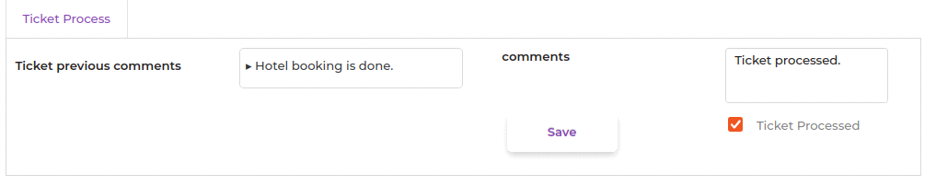

After the Ticket is fulfilled/processed by the respective team, the domestic travel request is moved to **Closed** status.

# Search requests

Users can search for related requests either by typing the travel request ID or traveler name in the seach bar. Search results may vary depending upon the current user’s permissions. For example, a Requestor can view only their own requests, an Approver can view their own request and that of approval / approved requests.



# Modification History

|  |  |  |  |
| --- | --- | --- | --- |
| **Date** | **Author(s)** | **Change Description** | **Version** |
| 09-May-2023 | Bala B | Initial Version | 0.1 |
| 10-May-2023 | Ganesh V | Reviewed and updated | 0.2 |
| 11-May- 2023 | Venkatesh K | Reviewed and baselined | 1.0 |