- College Management System

The College Management System is a software solution designed to meet the needs of the Crisp Educational Groups, a network of leading colleges focused on providing high-quality education and career opportunities. One of the colleges within this group, the Crisp Institute of Technology, is experiencing a significant increase in student enrollment, making the manual management of admissions and fee payments increasingly challenging and resource-intensive. To address this, the college has decided to implement an automated system to streamline the student admission and registration processes while maintaining essential student information, including personal, academic, and fee-related data.

Requirements for College Management System Project

1. Register Student

- During the registration process, candidates provide their personal details, year of study, 10th and 12th-grade marks, first graduate status, etc. A clerk enters this information into the system.
- Students can pay their fees during registration or at a later date. Once a student pays the fee, the system automatically updates the fee status to "paid." Partial payments are not allowed. So fee status can be either paid/not paid.
- The fee amount is determined by the candidate's 12th-grade marks and whether they are a first graduate or not.
- Upon successful registration, the system issues a unique ID to the student.

2. Modify details

Clerk can make updates to student and course details on receiving a request.

3. Update Student Marks

Clerk can update the student marks for each semester.

4. Update Student’s Attendance

Using this module, clerk can update the attendance of the student.

5. Add a New Course

Clerk can add a new course to the database.

6. Update Course Fee

Using this module Clerk can update the fees of the existing course.

Generate Report

The system supports the generation of various reports to provide insights and information, including:
- Viewing a list of all students.
- Accessing details of a specific student.
- Displaying students enrolled in a particular year of study.
- View students who have not paid their fees.
- Generating deposit bills for fee payments.

Required Software

- Eclipse IDE: An integrated development environment for software development.
- Xampp/MySQL: A software stack for local web development, including the MySQL database.

Required Jar files

MySQL connector based on the MySQL database version.

Modules Required

The application should consist of 6 modules

- Student Module
- Course Module
- Enrollment Module
- Attendance Module
- Mark Module
- Payment Module

Tables required

Student

Column Name | Data Type
ADMISSION_NUMBER | VARCHAR(25)
STUDENT_ID | VARCHAR(25) primary_key
STUDENT_NAME | VARCHAR(25)
DOB | DATE
YEAR_OF_STUDY | INT
YEAR_OF_JOINING | INT
TENTH_GRADE_MARK | INT
TWELFTH_GRADE_MARK | INT
FIRST_GRADUATE | VARCHAR(20)
EMAIL_ID | VARCHAR(25)
PHONE_NUMBER | BIGINT(20)

Course

Column Name | Data Type
COURSE_ID | VARCHAR(25) primary_key
COURSE_NAME | VARCHAR(25)
COURSE_COORDINATOR | VARCHAR(30)
DEPARTMENT | VARCHAR(50)
COURSE_FEE | DOUBLE

Enrollment (link table)

Column Name | Data Type
ENROLLMENT_ID | VARCHAR(20) primary_key
STUDENT_ID | VARCHAR(20) foreign_key
COURSE_ID | VARCHAR(20) foreign_key
FEE_STATUS | VARCHAR(20) not paid

Attendance

Column Name | Data Type
ATTENDANCE_ID | VARCHAR(30) primary_key
STUDENT_ID | VARCHAR(30) foreign_key
ENROLLMENT_ID | VARCHAR(30) foreign_key
SEMESTER | INT
TOTAL_WORKING_DAYS | INT
PRESENT_DAYS | INT
ABSENT_DAYS | INT
ATTENDANCE_PERCENTAGE | INT

Mark

Column Name | Data Type
MARK_ID | VARCHAR(20) primary_key
STUDENT_ID | VARCHAR(25) foreign_key
SEMESTER | INT
SUBJECT1 | VARCHAR(40) subjectName 56
SUBJECT2 | VARCHAR(40)
SUBJECT3 | VARCHAR(40)
SUBJECT4 | VARCHAR(40)
SUBJECT5 | VARCHAR(40)
SUBJECT6 | VARCHAR(40)
SUBJECT7 | VARCHAR(40)
SUBJECT8 | VARCHAR(40)
GPA | DOUBLE
CGPA | DOUBLE

Payment

Column Name | Data Type
PAYMENT_ID | VARCHAR(30) primary_key
ENROLLMENT_ID | VARCHAR(30) foreign_key
PAYMENT_DATE | DATE
PAYMENT_MODE | VARCHAR(30)
AMOUNT | DOUBLE

Project Structure

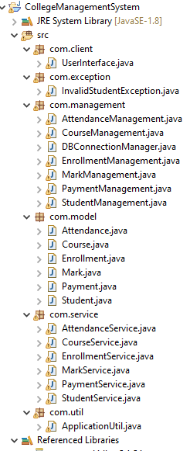
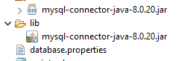

Project Flow:

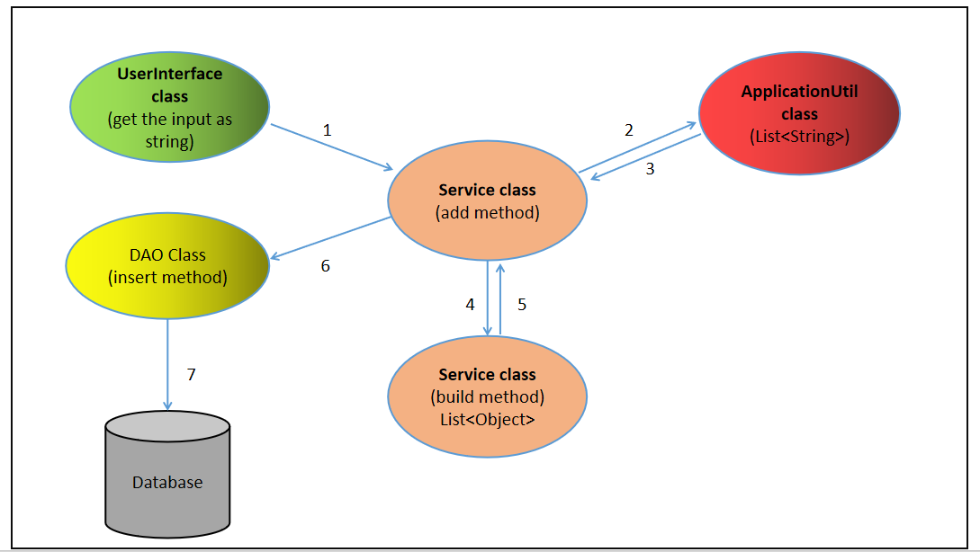

Scope of the service modules:

Module | Responsibilities
Student Service | - Student Data Management:  - This module is responsible for managing student-related data, including their personal information, academic records, and contact details.  - Student Registration:  - It allows the registration of new students, collecting and storing their information in the system's database.  - Student Identification:  - The system must generate and assign a unique student ID to each registered student. The student ID must be generated based on a specific format (e.g., "CRISP" followed by a numeric count), ensuring uniqueness.  - Student Details Modification:  - This module enables the modification of a student's contact information, such as their phone number.  - Retrieval of Student Data:  - It provides the ability to retrieve student records based on various criteria, such as year of study and student ID.  - Student Record Deletion:  - It allows the deletion of student records based on the student's ID.
Course Service | - Course Data Management:  - This module is responsible for managing course-related data, including course details and fees.  - Course Registration:  - It allows the registration of new courses, collecting and storing their information in the system's database.  - Course Fee Management:  - It manages and updates the course fees, allowing for modifications when needed.  - Data Retrieval:  - It provides the ability to retrieve course records based on criteria such as the course ID.  - Record Deletion:  - It allows the deletion of course records based on the course ID.
Enrollment Service | - Enrollment Data Management:  - This module is responsible for managing enrollment-related data. An enrollment represents a student's registration in a specific course.  - Enrollment Registration:  - It allows the registration of students into courses, collecting and storing their enrollment information in the system's database.  - Fee Status Management:  - It manages the fee status of enrolled students, marking whether the course fee has been paid or not.  - Data Retrieval:  - It provides the ability to retrieve enrollment records based on various criteria, such as the course ID or fee status.  - Record Deletion:  - It allows the deletion of enrollment records based on the enrollment ID.
Mark Service | The MarkService module in the college management system is responsible for managing student marks, calculating GPAs and CGPAs, and providing functionalities related to student academic records. Here are the responsibilities of the MarkService module:  - Build Mark List: Parse and construct a list of Mark objects from raw mark records. It splits the mark record data, calculates GPA for each student, and initializes CGPA to 0.  - Add Mark List: Register student mark records, update CGPA, and store the data. It inserts the list of Mark objects into the database and updates CGPA for each student based on their semester GPA.  - Retrieve Mark Record: Retrieve and format academic records for a specific student based on their student ID. This includes mark data, GPA, and CGPA for various semesters.  - Retrieve Mark Record Based on Semester: Retrieve and format academic records for students based on a specific semester. This includes mark data, GPA, and CGPA for students in a particular semester.  - Calculate GPA: Calculate the GPA (Grade Point Average) for a student based on subject marks. It processes subject marks, calculates the total marks, and computes the GPA.
Attendance Service | The AttendanceService module in the college management system is responsible for managing student attendance records, calculating attendance percentages, and providing functionalities related to attendance information. Here are the responsibilities of the AttendanceService module:  - Build Attendance List: Parse and construct a list of Attendance objects from raw attendance records. It splits the attendance record data, calculates attendance percentage based on present and total working days, and initializes other related fields.  - Add Attendance List: Register student attendance records and store the data. It inserts the list of Attendance objects into the database.  - Calculate Attendance Percentage: Calculate the attendance percentage for a student based on the number of present days and total working days. This is a critical step in understanding a student's attendance performance.  - Retrieve Attendance Record: Retrieve and format attendance records for a specific student based on their student ID. This includes attendance data such as the total working days, present days, and attendance percentage.  - Retrieve Attendance Record Based on Attendance ID: Retrieve and format attendance records for students based on a specific attendance ID. This allows for more precise tracking of attendance records.
Payment Service | The PaymentService module in the college management system is responsible for managing student payments, calculating the bill amount, and providing functionalities related to payment information. Here are the responsibilities of the PaymentService module:  - Build Payment List: Parse and construct a list of Payment objects from raw payment records. It splits the payment record data, calculates the bill amount, and initializes other related fields. Additionally, it updates the fee status to "paid" for the corresponding enrollment.  - Retrieve Student and Course Details: Retrieve and store the details of the student and the course associated with a particular enrollment ID. This information is crucial for calculating the bill amount. The details include the year of study, whether the student is a first graduate, twelfth-grade marks, and the course fee.  - Add Payment List: Register student payment records and store the data. It inserts the list of Payment objects into the database and calculates the bill amount for each payment.  - Calculate Bill Amount: Calculate the bill amount for a payment based on various factors, including the student's year of study, twelfth-grade marks, first graduate status, and the course fee. This calculation can help determine the amount a student needs to pay for their courses.  - Retrieve Payment Record: Retrieve and format payment records for a specific payment ID. This includes payment data such as the payment date, the name of the student who made the payment, the amount paid, and the payment mode.

Scope of the management modules:

Module | Responsibilities
Student Management | The StudentManagement module in the college management system is responsible for managing student-related operations, including inserting, updating, retrieving, and deleting student records. Here are the responsibilities of the StudentManagement module:  - Insert Student List: Insert a list of student records into the database. This operation adds multiple students' information, such as admission numbers, student IDs, names, dates of birth, year of study, year of joining, academic grades, first graduate status, email IDs, and phone numbers. It handles transactions to ensure data consistency and records the number of inserted rows.  - Update Student Detail: Update the phone number of a student based on their student ID. This operation allows for the modification of a student's phone number.  - Check If Student ID Exists: Check whether a given student ID already exists in the database. This function helps avoid duplicate student records.  - Retrieve Student List Based on Year of Study: Retrieve a list of student records for a specific year of study. This function returns student details for a particular year of study, including the aforementioned student information fields.  - Retrieve Student List Based on Student ID: Retrieve student records based on a specific student ID. This function allows for the retrieval of student details for a given student ID.  - Delete Student List: Delete a student record based on the student ID. This operation allows for the removal of a specific student's information from the database.
Course Management | The CourseManagement module in the college management system is responsible for managing course-related operations, including inserting, updating, retrieving, and deleting course records. Here are the responsibilities of the CourseManagement module:  - Insert Course List: Insert a list of course records into the database. This operation adds multiple courses' information, such as course IDs, course names, course coordinators, departments, and course fees. It handles transactions to ensure data consistency and records the number of inserted rows.  - Retrieve Course List Based on Course ID: Retrieve course records based on a specific course ID. This function allows for the retrieval of course details for a given course ID.  - Update Course Fee: Update the course fee of a specific course based on the course ID. This operation allows for the modification of a course's fee.  - Delete Course List: Delete a course record based on the course ID. This operation allows for the removal of a specific course's information from the database.
Enrollment Management | The EnrollmentManagement module in the college management system is responsible for managing enrollment-related operations, including inserting, updating, retrieving, and deleting enrollment records. Here are the responsibilities of the EnrollmentManagement module  - Insert Enrollment List: Insert a list of enrollment records into the database. This operation adds multiple enrollment records, including enrollment IDs, student IDs, course IDs, and fee statuses. It handles transactions to ensure data consistency and records the number of inserted rows.  - Update Enrollment: Update the fee status of a specific enrollment record based on the enrollment ID. This operation allows for the modification of the fee status for an enrollment.  - Retrieve Enrollment List Based on Course ID: Retrieve enrollment records based on a specific course ID. This function allows for the retrieval of enrollment details for a given course.  - Retrieve Enrollment List Based on Fee Status: Retrieve enrollment records based on a specific fee status. This function allows for the retrieval of enrollment details for a particular fee status.  - Delete Enrollment: Delete an enrollment record based on the enrollment ID. This operation allows for the removal of a specific enrollment record from the database.
Mark Management | The MarkManagement module in the college management system is responsible for managing student mark records, including inserting, retrieving, and updating student marks, GPAs, and CGPAs. Here are the responsibilities of the MarkManagement module:  - Insert Mark List: Adds multiple mark records with GPAs and CGPAs.  - Retrieve by Student ID: Gets marks for a specific student.  - Retrieve by Semester: Fetches marks for a particular semester.  - Calculate CGPA: Computes Cumulative Grade Point Average based on previous semesters.  - Update CGPA: Modifies CGPA for a student in a specific semester.
AttendanceManagement | The AttendanceManagement module in the college management system is responsible for managing and handling attendance records. Its main responsibilities are:  - Insert Attendance List: Allows the insertion of multiple attendance records, including details like student ID, enrollment ID, semester, total working days, present days, absent days, and attendance percentage.  - Retrieve Attendance List by Student ID: Retrieves attendance records for a specific student based on their student ID.  - Retrieve Attendance List by Attendance ID: Retrieves attendance records based on the attendance ID.
PaymentManagement | The PaymentManagement module in the college management system is responsible for managing and handling payment records. Its main responsibilities are:  - Retrieve Enrollment Information: It retrieves enrollment information based on the enrollment ID, which includes details like student ID, course ID, and fee status. It uses this information to create an Enrollment object.  - Calculates Bill Amount: Does the computation  - Insert Payment List: Allows the insertion of multiple payment records, including details like payment ID, enrollment ID, payment date, payment mode, and payment amount.  - Retrieve Payment List by Payment ID: Retrieves payment records based on the payment ID, including information such as enrollment ID, payment date, payment mode, and payment amount.  This module is responsible for maintaining and managing payment data, providing features for recording, storing, and retrieving payment information related to student enrollments.Top of Form

Scope of the Utility module:

Module | Responsibility
ApplicationUtil | Data Extraction and Validation  Extracts and validates student details, particularly the admission number, ensuring they meet specific criteria.  Date Conversion: It offers methods for converting date formats between java.util.Date and java.sql.Date objects and vice versa, making it easier to work with dates in various contexts.  Overall, this module assists in data processing, validation, and date manipulation, which can be helpful in various parts of an application dealing with student records and related information

Scope of Database module:

Module | Responsibilities
DBConnectionManager | The DBConnectionManager module is responsible for managing and providing database connections to other modules in the application. Its primary responsibilities include:  Loading Database Properties: It reads the database connection properties from a configuration file, such as database.properties, which typically contains details like the database URL, driver name, username, and password.  Establishing Database Connection: It establishes a connection to the database using the properties loaded from the configuration file. This connection is created through the Java Database Connectivity (JDBC) API.  Handling Exceptions: It handles exceptions related to file IO (e.g., IOException), database drivers (e.g., ClassNotFoundException), and SQL errors (e.g., SQLException) that may occur during the connection process.

Scope of the Exception module

Module Name | Responsibility
InvalidStudentException | The InvalidStudentException class is a custom exception class used to handle exceptions related to invalid student records in the application. It extends the standard Exception class and includes a single-argument constructor to set the exception message. The exception message is passed to the super class constructor.

