**React**

**Exercise:9**

**IndianPlayer.js/**

import React from 'react';

function IndianPlayers() {

  const T20players = ["Kohli", "Rohit", "Hardik", "Pant"];

  const RanjiPlayers = ["Pujara", "Rahane", "Iyer", "Sundar"];

  const allPlayers = [...T20players, ...RanjiPlayers];

  const oddPlayers = allPlayers.filter((_, index) => index % 2 === 0);

  const evenPlayers = allPlayers.filter((_, index) => index % 2 !== 0);

  return (

    <div>

      <h2>Merged Players</h2>

      <p>{allPlayers.join(', ')}</p>

      <h3>Odd Team Players</h3>

      <ul>

        {oddPlayers.map((player, index) => (

          <li key={index}>{player}</li>

        ))}

      </ul>

      <h3>Even Team Players</h3>

      <ul>

        {evenPlayers.map((player, index) => (

          <li key={index}>{player}</li>

        ))}

      </ul>

    </div>

  );

}

export default IndianPlayers;

**ListofPlayers.js**

import React from 'react';

function ListofPlayers() {

const players = [  
 { name: "Kohli", score: 98 },  
 { name: "Rohit", score: 92 },  
 { name: "Shami", score: 60 },  
 { name: "Rahul", score: 85 },  
 { name: "Sachin", score: 97 },  
 { name: "Jadeja", score: 82 },  
 { name: "Bumrah", score: 55 },  
 { name: "Ashwin", score: 90 },  
 { name: "ADB", score: 99 },  
 { name: "Gill", score: 80 },  
 { name: "Jithesh", score: 78 }  
];

  const lowScorers = players.filter(player => player.score < 70);

  return (

    <div>

      <h2>All Players</h2>

      <ul>

        {players.map((player, index) => (

          <li key={index}>{player.name} - {player.score}</li>

        ))}

      </ul>

      <h3>Players with score below 70</h3>

      <ul>

        {lowScorers.map((player, index) => (

          <li key={index}>{player.name}</li>

        ))}

      </ul>

    </div>

  );

}

export default ListofPlayers;

**App.js**

import React from 'react';

import ListofPlayers from './ListofPlayers';

import IndianPlayers from './IndianPlayers';

function App() {

  const flag = false;

  return (

    <div className="App">

      <h1>Cricket App</h1>

      {flag ? <ListofPlayers /> : <IndianPlayers />}

    </div>

  );

}

export default App;

**Output:**

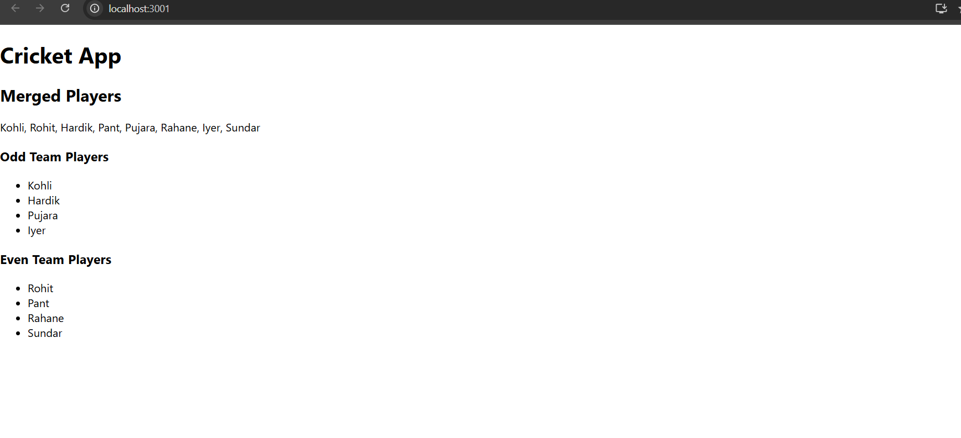

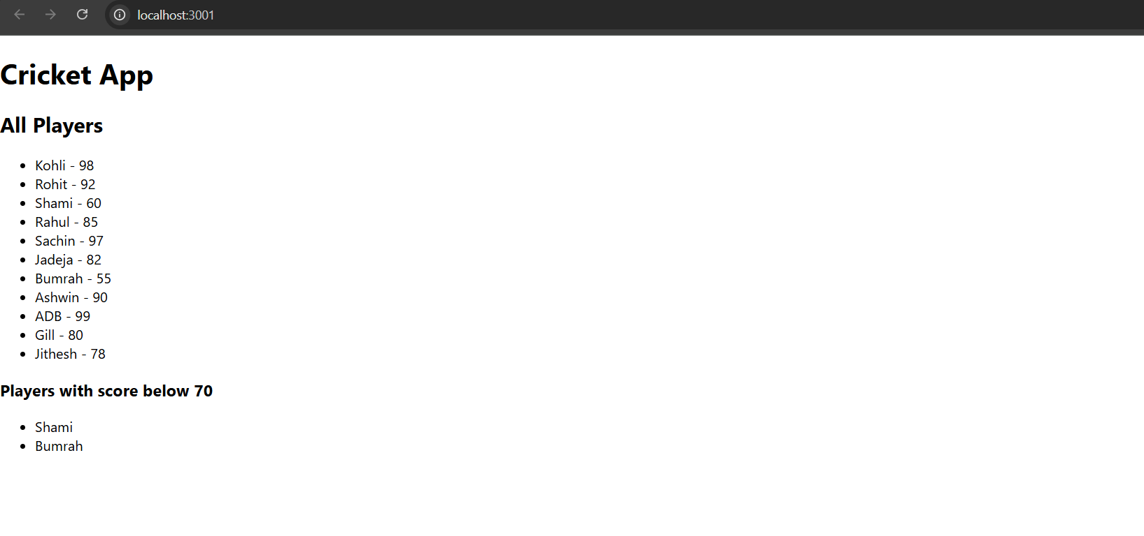

**Exercise:10**

**App.js/**

import React from 'react';  
function App() {  
 const heading = <h1>Office Space Rental App</h1>;  
  
 const office = {  
 name: 'DBS',  
 rent: 45000,  
 address: '123 Porur, Chennai',  
 image: 'https://images.pexels.com/photos/380768/pexels-photo-380768.jpeg'  
 }  
 const officeList = [  
 { name: 'Tech Hub', rent: 55000, address: 'Sector 5, Noida' },  
 { name: 'Startup Bay', rent: 68000, address: 'Koramangala, Bengaluru' },  
 { name: 'Cowork Junction', rent: 62000, address: 'Hitech City, Hyderabad' }  
 ];  
  
 const getRentStyle = (rent) => {  
 return {  
 color: rent < 60000 ? 'red' : 'green',  
 fontWeight: 'bold'  
 };  
 };  
 return (  
 <div style={{ padding: '20px', fontFamily: 'Arial' }}>  
 {heading}  
 <img src={office.image} alt="Office" style={{ width: '300px', height: '200px', marginBottom: '10px' }} />  
 <h2>{office.name}</h2>  
 <p><strong>Address:</strong> {office.address}</p>  
 <p><strong>Rent:</strong> <span style={getRentStyle(office.rent)}>{office.rent}</span></p>  
 <h3>Other Office Listings</h3>  
 <ul>  
 {officeList.map((item, index) => (  
 <li key={index} style={{ marginBottom: '10px' }}>  
 <strong>{item.name}</strong><br />  
 Address: {item.address}<br />  
 Rent: <span style={getRentStyle(item.rent)}>{item.rent}</span>  
 </li>  
 ))}  
 </ul>  
 </div>  
 );  
}  
  
export default App;

**Output:**

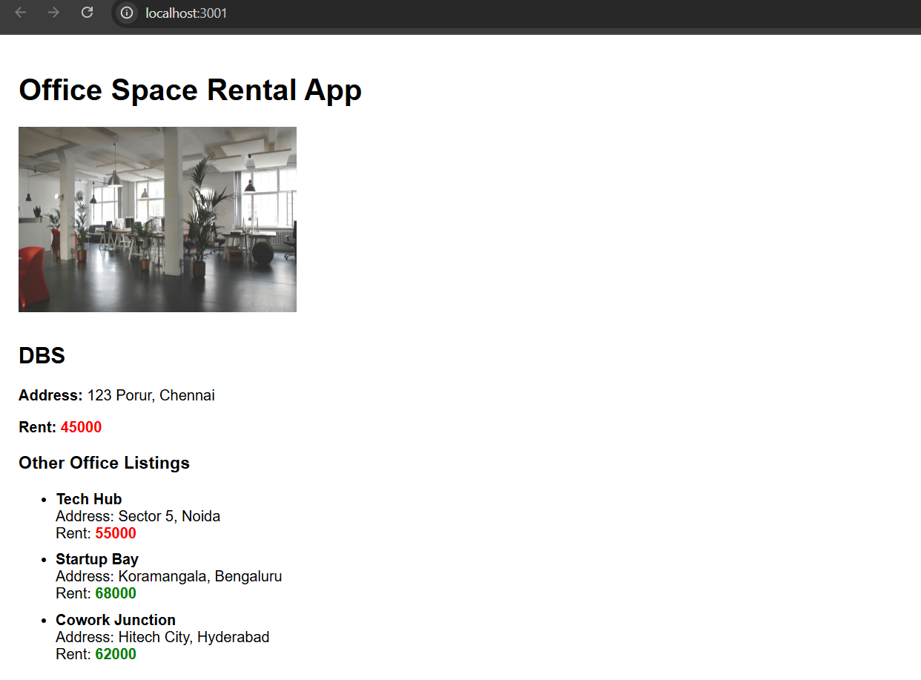

**Exercise:11**

**CurrencyConvertor.js/**

import React, { useState } from 'react';

function CurrencyConvertor() {

  const [rupees, setRupees] = useState('');

  const [euro, setEuro] = useState('');

  const handleSubmit = () => {

    const conversionRate = 0.011; // example: 1 INR = 0.011 Euro

    const result = (parseFloat(rupees) * conversionRate).toFixed(2);

    setEuro(result);

  };

  return (

    <div>

      <h2>Currency Converter (INR ➝ Euro)</h2>

      <input

        type="number"

        value={rupees}

        onChange={(e) => setRupees(e.target.value)}

        placeholder="Enter amount in INR"

      />

      <button onClick={handleSubmit}>Convert</button>

      <p>Equivalent in Euro: <strong>{euro}</strong></p>

    </div>

  );

}

export default CurrencyConvertor;

**App.js/**

import React, { useState } from 'react';

import CurrencyConvertor from './CurrencyConvertor';

function App() {

  const [count, setCount] = useState(0);

  const sayHello = () => {

    console.log("Hello! This is a static message.");

  };

  const increment = () => {

    setCount(prev => prev + 1);

    sayHello();

  };

  const decrement = () => {

    setCount(prev => prev - 1);

  };

  const sayWelcome = (message) => {

    alert(`Say: ${message}`);

  };

  const handlePress = (event) => {

    alert("I was clicked (Synthetic Event)");

    console.log("Synthetic Event:", event);

  };

  return (

    <div style={{ padding: '20px' }}>

      <h1>React Event Handling Example</h1>

      <h2>Counter: {count}</h2>

      <button onClick={increment}>Increment</button>

      <button onClick={decrement}>Decrement</button>

      <hr />

      <button onClick={() => sayWelcome("Welcome!")}>Say Welcome</button>

      <hr />

      <button onClick={handlePress}>OnPress</button>

      <hr />

      <CurrencyConvertor />

    </div>

  );

}

export default App;

**Output:**

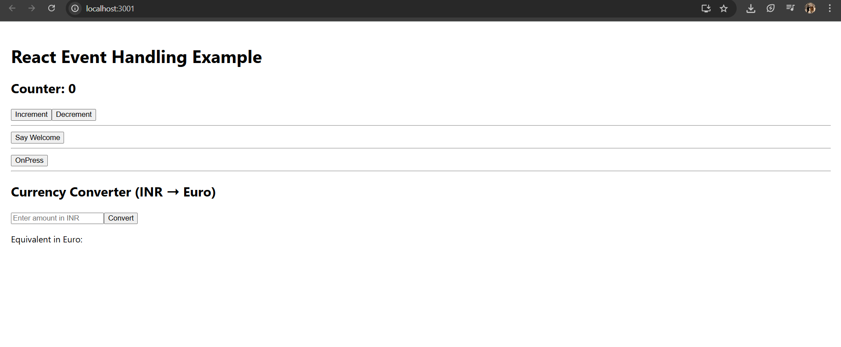

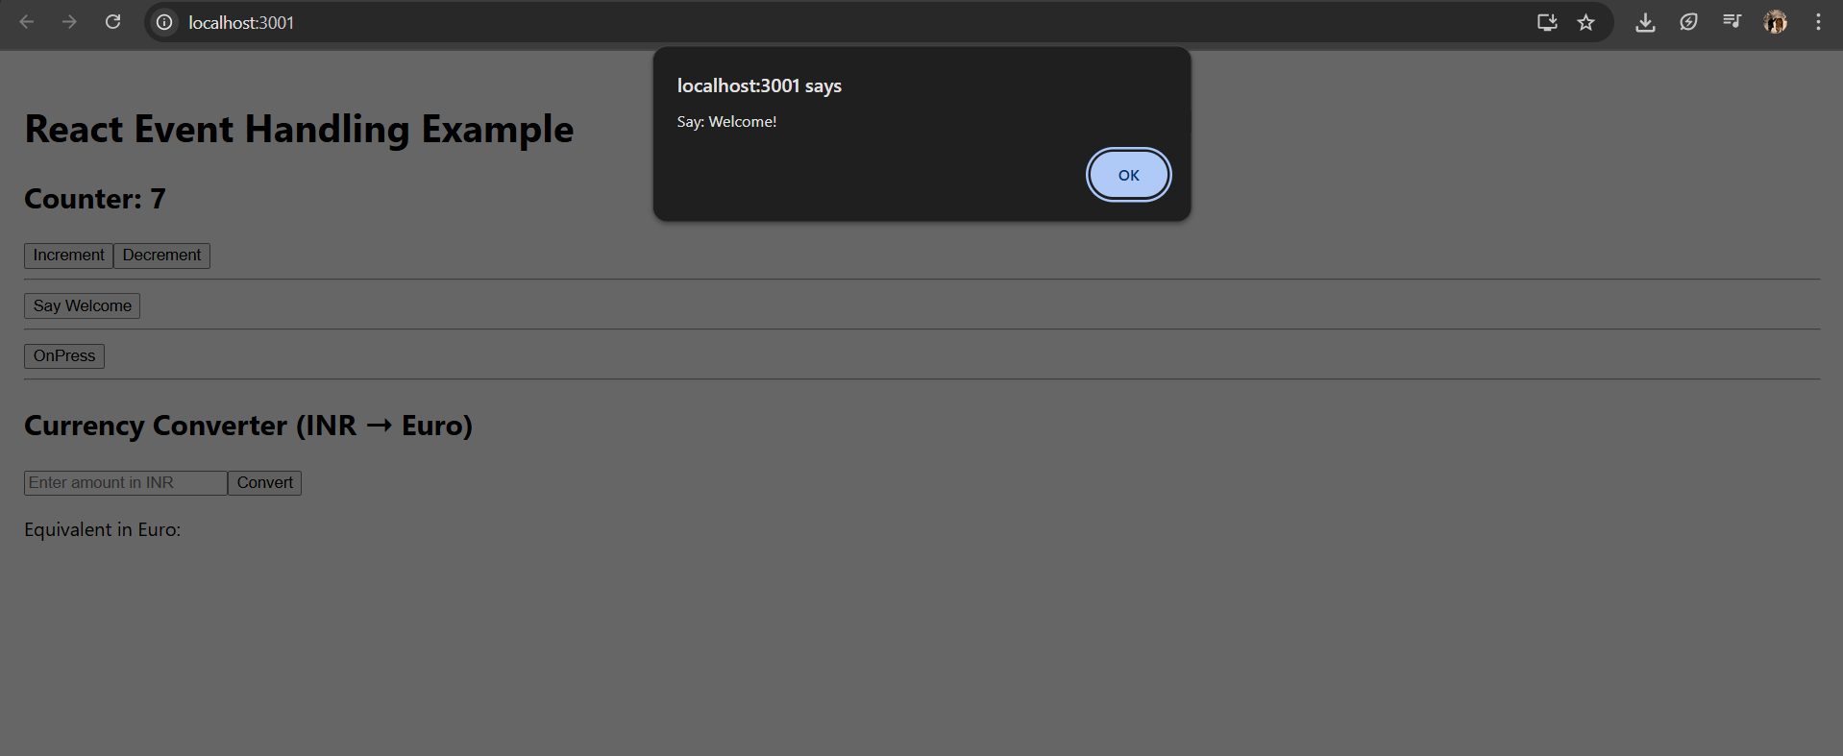

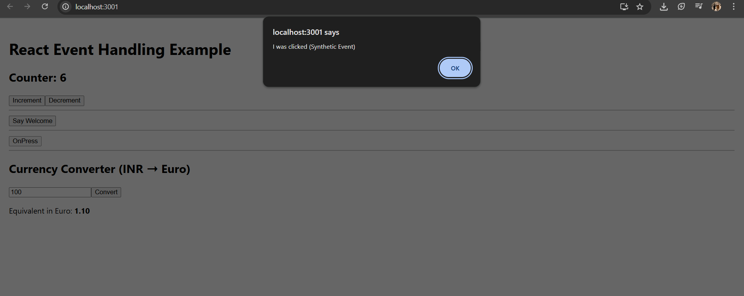

**Exercise:12**

**App.js/**

import React, { useState } from 'react';

function App() {

  const [isLoggedIn, setIsLoggedIn] = useState(false);

  const [username, setUsername] = useState('');

  const [inputName, setInputName] = useState('');

  const handleLogin = (e) => {

    e.preventDefault();

    if (inputName.trim() !== '') {

      setUsername(inputName);

      setIsLoggedIn(true);

    }

  };

  const handleLogout = () => {

    setIsLoggedIn(false);

    setUsername('');

    setInputName('');

  };

  const flightList = [

    { id: 1, airline: "IndiGo", route: "Chennai → Delhi", price: 5000 },

    { id: 2, airline: "Air India", route: "Bangalore → Mumbai", price: 4800 },

    { id: 3, airline: "SpiceJet", route: "Hyderabad → Goa", price: 3700 }

  ];

  const renderFlights = () => (

    <div>

      <h3> Flight Details</h3>

      <table border="1" cellPadding="8" cellSpacing="0">

        <thead>

          <tr>

            <th>Airline</th>

            <th>Route</th>

            <th>Price (₹)</th>

          </tr>

        </thead>

        <tbody>

          {flightList.map(flight => (

            <tr key={flight.id}>

              <td>{flight.airline}</td>

              <td>{flight.route}</td>

              <td>{flight.price}</td>

            </tr>

          ))}

        </tbody>

      </table>

    </div>

  );

  return (

    <div style={{ padding: "30px", fontFamily: "Arial" }}>

      <h1>🛫 Ticket Booking App</h1>

      {!isLoggedIn ? (

        <form onSubmit={handleLogin}>

          <h2>Sign In</h2>

          <input

            type="text"

            placeholder="Enter your name"

            value={inputName}

            onChange={(e) => setInputName(e.target.value)}

            style={{ padding: "8px", width: "250px" }}

          />

          <br /><br />

          <button type="submit" style={{ padding: "8px 20px" }}>Login</button>

        </form>

      ) : (

        <div>

          <h2>Welcome, <span style={{ color: "green" }}>{username}</span>!</h2>

          {renderFlights()}

          <button style={{ marginTop: "20px", backgroundColor: "orange", padding: "10px" }}>

            Book Ticket

          </button><br /><br />

          <button onClick={handleLogout}>Logout</button>

        </div>

      )}

    </div>

  );

}

export default App;

**Output:**

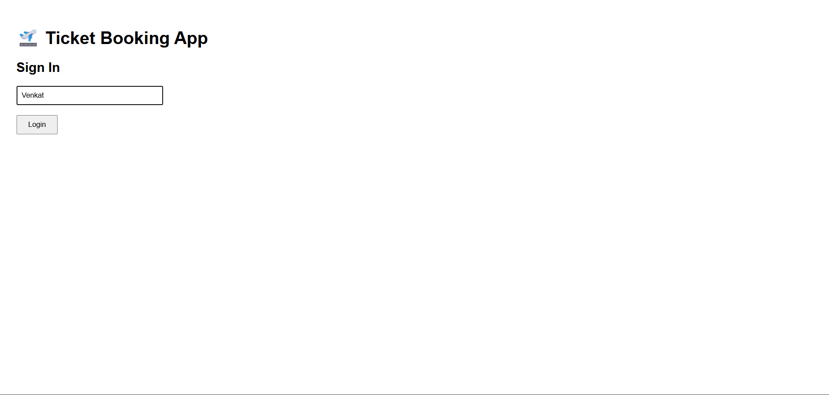

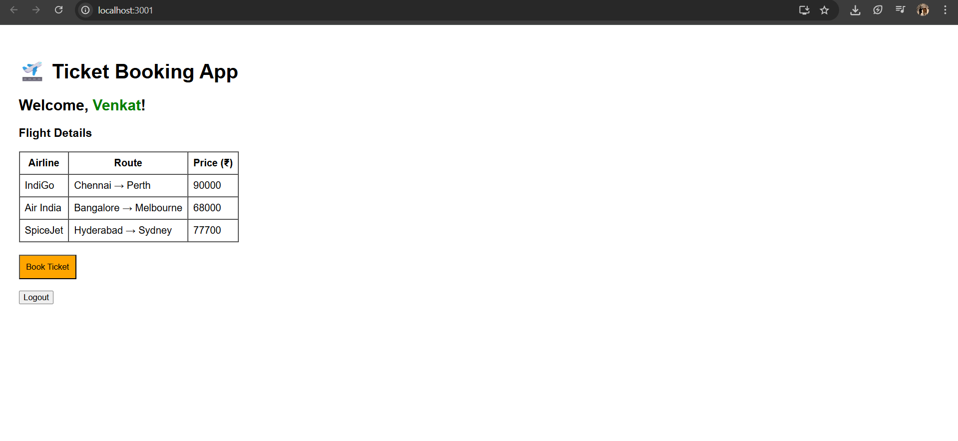

**Exercise:13**

**App.js/**

import React from 'react';

import CourseDetails from './CourseDetails';

import BookDetails from './BookDetails';

import BlogDetails from './BlogDetails';

import './App.css';

function App() {

  return (

    <div className="container">

      <CourseDetails />

      <div className="divider"></div>

      <BookDetails />

      <div className="divider"></div>

      <BlogDetails />

    </div>

  );

}

export default App;

**BlogDetails.js /**

import React from 'react';

function BlogDetails() {

  const blogs = [

    {

      title: "React Learning",

      author: "Stephen Biz",

      content: "Welcome to learning React!"

    },

    {

      title: "Installation",

      author: "Schewzdenier",

      content: "You can install React from npm."

    }

  ];

  return (

    <div className="section">

      <h2>Blog Details</h2>

      {blogs.map((blog, index) => (

        <div key={index}>

          <strong>{blog.title}</strong><br />

          <em>{blog.author}</em><br />

          <span>{blog.content}</span><br /><br />

        </div>

      ))}

    </div>

  );

}

export default BlogDetails;

**BookDetails.js/**

import React from 'react';

function BookDetails() {

  const books = [

    { title: "Master React", price: 670 },

    { title: "Deep Dive into Angular 11", price: 800 },

    { title: "Mongo Essentials", price: 450 }

  ];

  return (

    <div className="section">

      <h2>Book Details</h2>

      {books.map((book, index) => (

        <div key={index}>

          <strong>{book.title}</strong><br />

          <span>{book.price}</span><br /><br />

        </div>

      ))}

    </div>

  );

}

export default BookDetails;

**CourseDetails.js/**

import React from 'react';

function CourseDetails() {

  const courses = [

    { name: "Angular", date: "4/5/2021" },

    { name: "React", date: "6/3/20201" }

  ];

  return (

    <div className="section">

      <h2>Course Details</h2>

      {courses.map((course, index) => (

        <div key={index}>

          <strong>{course.name}</strong><br />

          <span>{course.date}</span><br /><br />

        </div>

      ))}

    </div>

  );

}

export default CourseDetails;

**App.css/**

.container {

  display: flex;

  justify-content: space-between;

  align-items: flex-start;

  padding: 40px;

  font-family: Arial, sans-serif;

}

.section {

  width: 30%;

}

.divider {

  width: 2px;

  background-color: green;

  min-height: 300px;

  height: 100%;

  margin: 0 15px;

}

**Output:**

