**Create a Spring Web Project using Maven**

package com.cognizant.springlearn;  
  
import java.text.ParseException;  
import java.text.SimpleDateFormat;  
  
import org.springframework.boot.SpringApplication;  
import org.springframework.boot.autoconfigure.SpringBootApplication;  
import org.springframework.context.ApplicationContext;  
import org.springframework.context.support.ClassPathXmlApplicationContext;  
  
@SpringBootApplication  
public class SpringLearnApplication {  
  
 public static void displayDate() {  
 ApplicationContext context = new ClassPathXmlApplicationContext("date-format.xml");  
 SimpleDateFormat format = context.getBean("dateFormat", SimpleDateFormat.class);  
 try {  
 System.out.println(format.parse("10/07/2025"));  
 } catch (ParseException e) {  
 e.printStackTrace();  
 }  
 }  
  
 public static void main(String[] args) {  
 displayDate();  
 SpringApplication.run(SpringLearnApplication.class, args);  
 }  
}

package com.cognizant.springlearn;  
  
import org.junit.jupiter.api.Test;  
import org.springframework.boot.test.context.SpringBootTest;  
  
@SpringBootTest  
class SpringLearnApplicationTests {  
  
 @Test  
 void contextLoads() {  
 }  
}

}

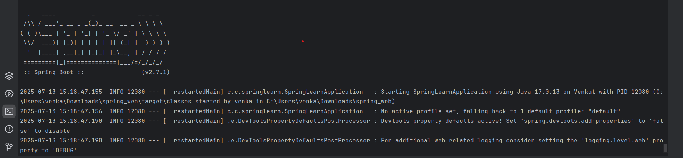

**Spring Core – Load Country from Spring Configuration XML**   
  
package com.cognizant.springlearn;  
  
import org.slf4j.Logger;  
import org.slf4j.LoggerFactory;  
import org.springframework.boot.SpringApplication;  
import org.springframework.boot.autoconfigure.SpringBootApplication;  
import org.springframework.context.ApplicationContext;  
import org.springframework.context.support.ClassPathXmlApplicationContext;  
  
@SpringBootApplication  
public class SpringLearnApplication {  
  
 private static final Logger LOGGER = LoggerFactory.getLogger(SpringLearnApplication.class);  
  
 public static void displayCountry() {  
 LOGGER.debug("START: displayCountry");  
  
 ApplicationContext context = new ClassPathXmlApplicationContext("country.xml");  
 Country country = context.getBean("country", Country.class);  
 LOGGER.debug("Country: {}", country);  
  
 LOGGER.debug("END: displayCountry");  
 }  
  
 public static void main(String[] args) {  
 SpringApplication.run(SpringLearnApplication.class, args);  
 displayCountry();  
 }  
}

package com.cognizant.springlearn;  
  
import org.junit.jupiter.api.Test;  
import org.springframework.boot.test.context.SpringBootTest;  
  
@SpringBootTest  
class SpringLearnApplicationTests {  
  
 @Test  
 void contextLoads() {  
 }  
  
}

