**React**

**Exercise-1:**

App.js/

import './App.css'

function App() {

  return (

    <h1>Welcome the firat session of React</h1>

  );

}

export default App;

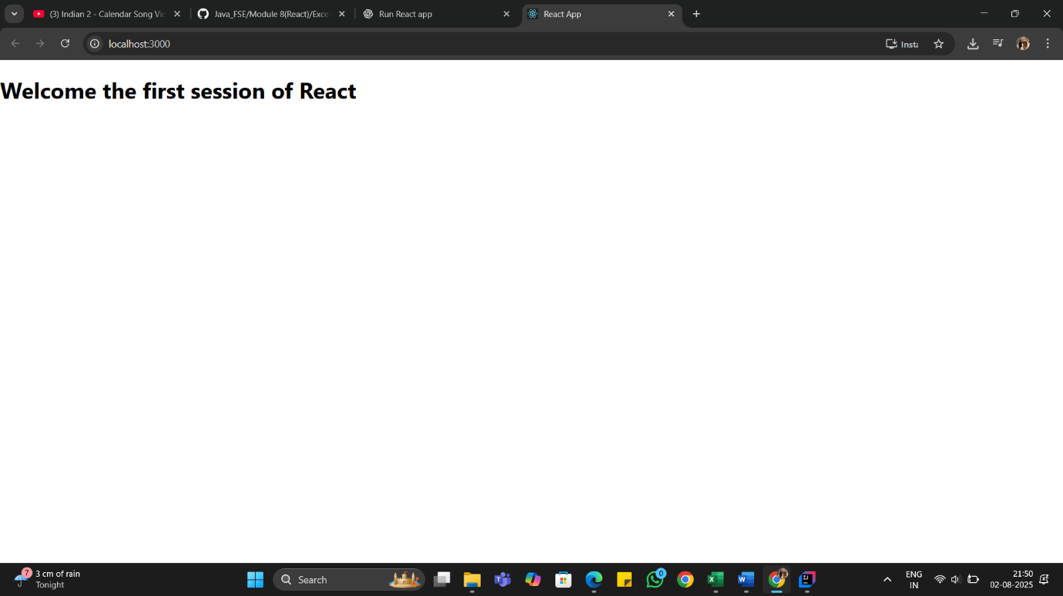

**Exercise-2:**

**App.js/**  
  
import './App.css';  
import Home from './Home';  
import About from './About';  
import Contact from './Contact';  
  
function App() {  
 return (  
 <div className="App">  
 <Home />  
 <About />  
 <Contact />  
 </div>  
 );  
}  
  
export default App;

**About.js/**

import React, { Component } from "react";

class About extends Component {

  render() {

    return (

      <div>

        <h3>Welcome to the about Page of Student Management Portel</h3>

      </div>

    );

  }

}

export default About;

**Home.js/**

import React, { Component } from "react";

class Home extends Component {

  render() {

    return (

      <div>

        <h3>Welcome to Home Page of student Management Portel</h3>

      </div>

    );

  }

}

export default Home;

**Contact.js/**

import React, { Component } from "react";

class Contact extends Component {

  render() {

    return (

      <div>

        <h3>Welcome to the Contact page of the student Management Portel</h3>

      </div>

    );

  }

}

export default Contact;

