EXPERIMENT 4 V.DEVI PRIYA(192512337)

import numpy as np
import pandas as pd
import matplotlib.pyplot as plt

protocols = ["Zigbee", "6LoWPAN", "NB-IoT"]

packets = 5000
packet_size = 200
simulation_time = 10

rate = np.array([250, 200, 100])
base_delay = np.array([20, 30, 50])
loss = np.array([0.02, 0.015, 0.01])
tx_power = np.array([0.05, 0.06, 0.20])
rx_power = np.array([0.03, 0.035, 0.05])

np.random.seed(42)

lost = np.random.binomial(packets, loss)

received = packets - lost

pdr = received / packets * 100

offered_load = packets * packet_size * 8 / simulation_time / 1000

throughput = offered_load * pdr / 100

throughput = np.minimum(throughput, rate)

delay = base_delay + np.random.uniform(1, 5, 3)

transmission_time = throughput / rate * simulation_time

tx_energy = tx_power * transmission_time

rx_energy = rx_power * transmission_time

energy = tx_energy + rx_energy

df = pd.DataFrame()

df["Protocol"] = protocols

df["Throughput (kbps)"] = throughput.round(2)

df["Delay (ms)"] = delay.round(2)

df["PDR (%)"] = pdr.round(2)

df["Energy (J)"] = energy.round(4)

print("=" * 50)

print("IoE PROTOCOL PERFORMANCE RESULTS")

print("=" * 50)

print()

print(df.to_string(index=False))

print()

print("=" * 50)

print("PERFORMANCE COMPARISON")

print("=" * 50)

best_throughput = df["Throughput (kbps)"].idxmax()

best_delay = df["Delay (ms)"].idxmin()

best_pdr = df["PDR (%)"].idxmax()

best_energy = df["Energy (J)"].idxmin()

print("Highest Throughput:", df.loc[best_throughput, "Protocol"])

print("Lowest Delay:", df.loc[best_delay, "Protocol"])

print("Highest PDR:", df.loc[best_pdr, "Protocol"])

print("Lowest Energy:", df.loc[best_energy, "Protocol"])

plt.figure(figsize=(7, 4))

plt.bar(protocols, throughput)

plt.title("Throughput Comparison")

plt.xlabel("Protocol")

plt.ylabel("Throughput (kbps)")

plt.grid(axis="y")

plt.show()

plt.figure(figsize=(7, 4))

plt.bar(protocols, delay)

plt.title("Delay Comparison")

plt.xlabel("Protocol")

plt.ylabel("Delay (ms)")

plt.grid(axis="y")

plt.show()

plt.figure(figsize=(7, 4))

plt.bar(protocols, pdr)

plt.title("Packet Delivery Ratio Comparison")

plt.xlabel("Protocol")

plt.ylabel("PDR (%)")

plt.ylim(90, 100)

plt.grid(axis="y")

plt.show()

plt.figure(figsize=(7, 4))

plt.bar(protocols, energy)

plt.title("Energy Consumption Comparison")

plt.xlabel("Protocol")

plt.ylabel("Energy (J)")

plt.grid(axis="y")

plt.show()

print()

print("=" * 50)

print("CONCLUSION")

print("=" * 50)

print(df.loc[best_throughput, "Protocol"], "has the highest throughput.")

print(df.loc[best_delay, "Protocol"], "has the lowest delay.")

print(df.loc[best_pdr, "Protocol"], "has the highest packet delivery ratio.")

print(df.loc[best_energy, "Protocol"], "has the lowest energy consumption.")

print()

print("Simulation completed successfully.")

RESULT

==================================================
IoE PROTOCOL PERFORMANCE RESULTS
Protocol | Throughput (kbps) | Delay (ms) | PDR (%) | Energy (J)
Zigbee | 250.0 | 23.40 | 98.10 | 0.80
6LoWPAN | 200.0 | 33.83 | 98.46 | 0.95
NB-IoT | 100.0 | 51.08 | 99.16 | 2.50

==================================================
PERFORMANCE COMPARISON
==================================================
Highest Throughput: Zigbee
Lowest Delay: Zigbee
Highest PDR: NB-IoT
Lowest Energy: Zigbee
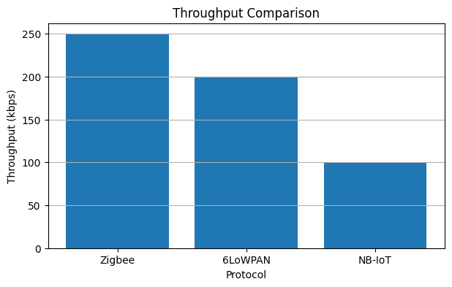
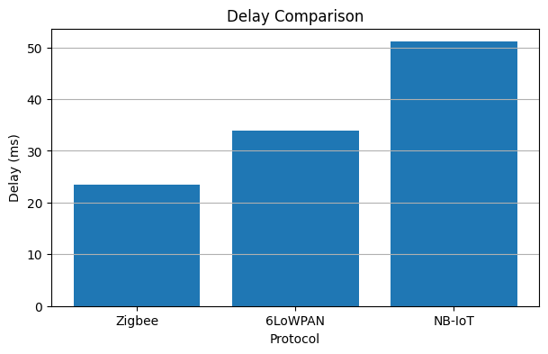
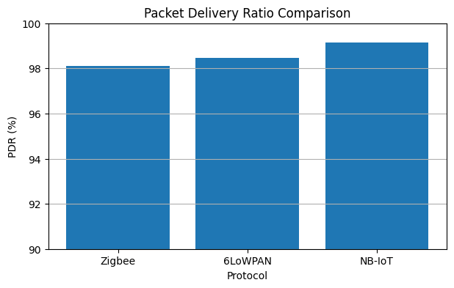
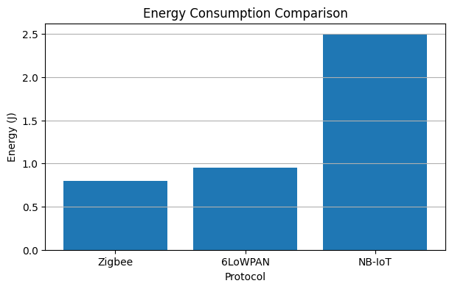
==================================================
CONCLUSION
==================================================
Zigbee has the highest throughput.
Zigbee has the lowest delay.
NB-IoT has the highest packet delivery ratio.
Zigbee has the lowest energy consumption.

Simulation completed successfully.

