React hook:

1. useState:

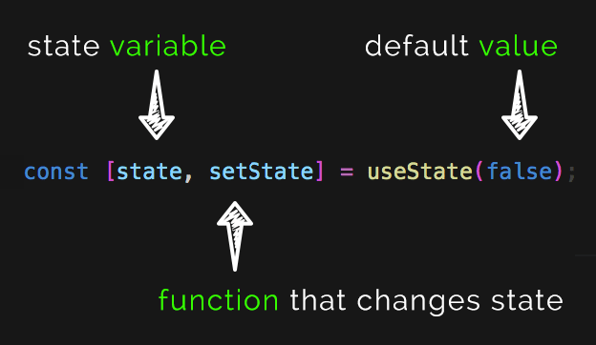

1. useref
2. useReducer
3. useMemo
4. useCallback

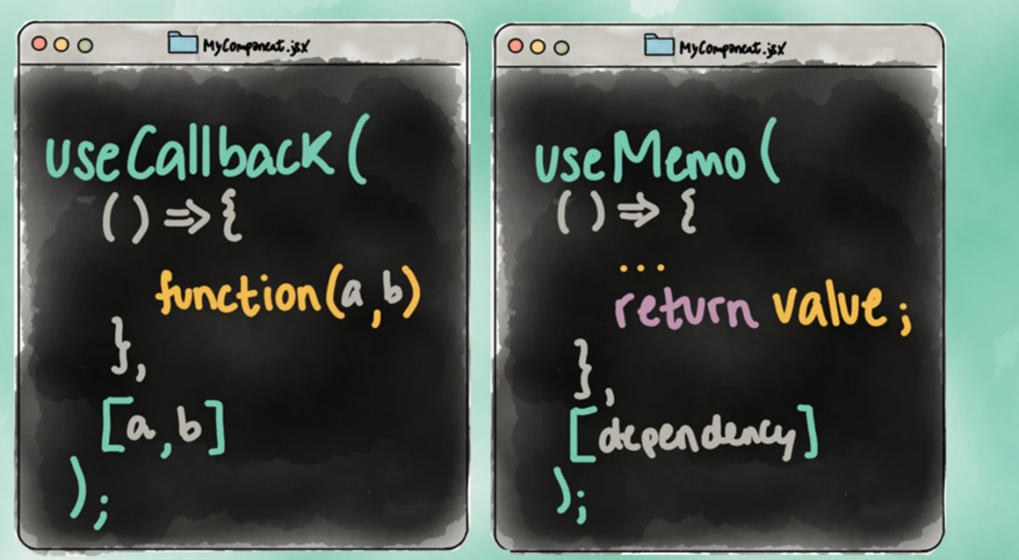

Are you going to render or not?

Render:

1. useState
2. useReducer
3. useMemo

Whether raw data or derived data?

Derived data : Ex: (first name + last name)

* useMemo

Raw data:

* useState : (simple data)
* useReducer : ( multiple data or more action)

No Render:

* useRef

useReducer :

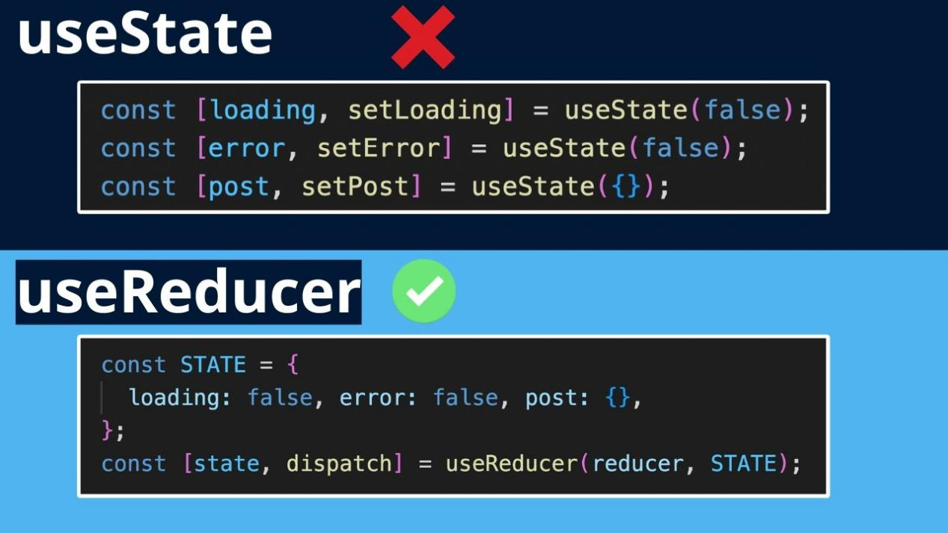

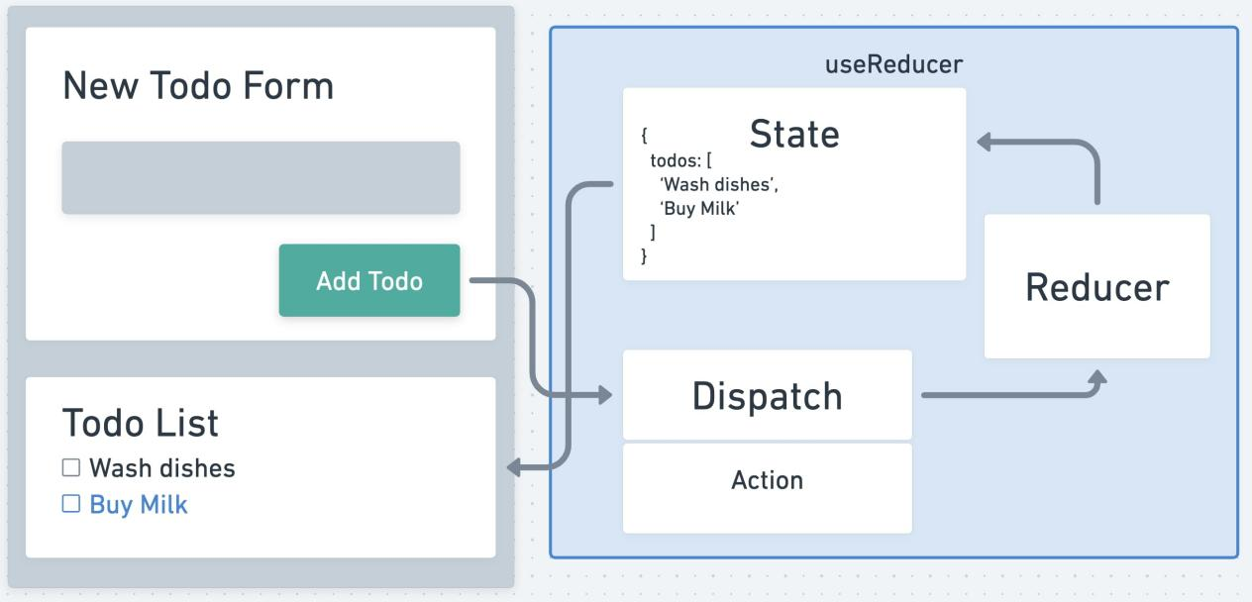

useContext:

Keyword:

1. useContext - receiver
2. Provider - sender

**step-by-step**

* Planned the structure of provider components.
* Wrap all the component with provider component.
* Send the shared the data to the provider useing “value” attribute.
* Go the child component where need the shared data and use the useContext hook to the received shared data.

useEffect:

