**1) Create web pages using Basic HTML Tags, Table, List, Image, and Frame Tags.**

**main.html**

<!DOCTYPE html>

<html>

<head>

<title>EXP1</title>

</head>

<body style="background-color: lightgreen">

<center >

<a href="basic.html">BasicHTMl</a>

<br>

<br>

<a href="lists.html">Lists</a>

<br>

<br>

<a href="wttables.html">Tables</a>

<br>

<br>

<a href="images.html">Images</a>

<br>

<br>

<a href="wt3.1.html">Frames</a>

<br>

<br>

</center>

</body>

</html>

**Output:**

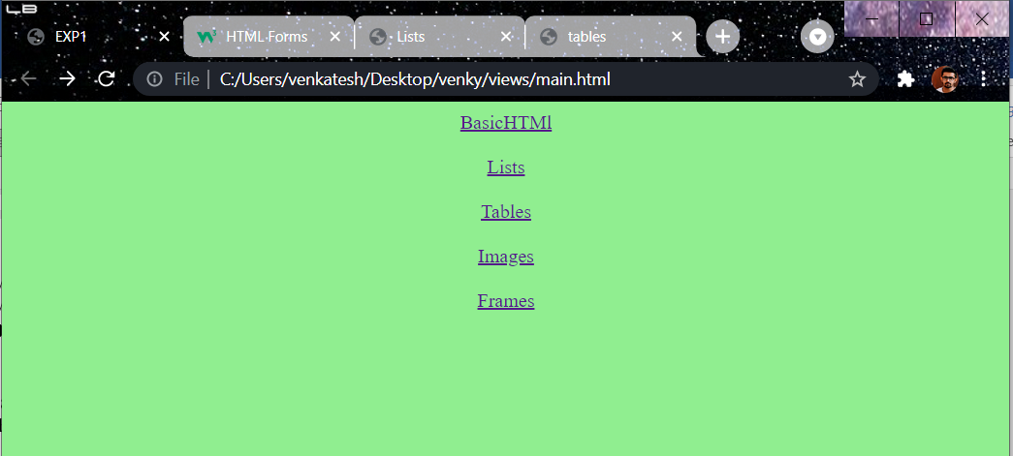

**basic.html**

<!DOCTYPE html>

<html>

<head>

<title>basic</title>

</head>

<body style="background-color:mediumseagreen">

<h3 align="center">HEADING TAGS</h3>

<pre>

<B>H1,H2,H3,H4,H5,H6</B>

</pre>

<h3 align="center">LIST TAGS</h3>

<b><pre>

TWO TYPES

----> LIST

----> UNORDERED LIST

----> ORDERED LIST

</pre></b>

<h3 align="center">EDITING TAGS</h3>

<pre>

<B>---> ITALIC </B>

<B>---> BOLD </B>

<B>---> EM </B>

<B>---> STRONG </B>

<B>---> SMALL </B>

<B>---> BIG </B>

</pre>

<button style="background-color: yellow;align-self: : center;" ><a href="main.html">return</a></button>

</body>

</html>

**Output:**

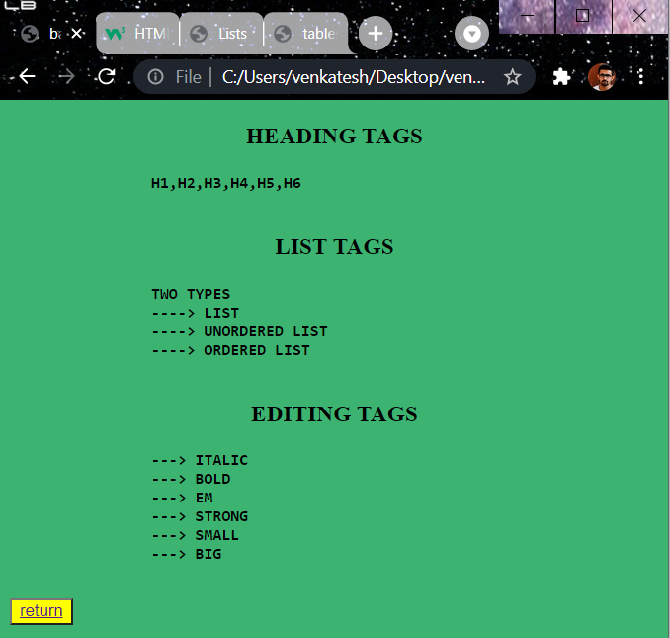

**lists.html**

<!DOCTYPE html>

<html>

<head>

<title>Lists</title>

</head>

<body style="background-color:slateblue ">

<h1>Unordered list</h1>

<ul type="square"><h2>Tea</h2>

<b>

<li>WebTechnologies</li>

<li>ComputerNetwork</li>

<li>DMDW</li>

</b>

</ul>

<h1>Ordered list</h1>

<b>

<li>ArtificialIntelligence</li>

<li>RedHat</li>

<li>MEANSTACK</li>

</b>

</ol>

<h1>Definition list</h1>

<dl>

<dt>WT</dt>

<dd>Web Technologies</dd>

<dt>HTML</dt>

<dd>HyperTextMarkupLanguage</dd>

</dl>

<h1>Miscallenous list</h1>

<ul>

<li><h3>SUB</h3>

<ol>

<li>HCI</li>

<li>ECom</li>

<li>ComputerNetworks</li>

</ol>

</li>

<li><h3>LABS</h3>

<ol>

<li>C</li>

<li>CPP</li>

<li>JAVA</li>

</ol>

</li>

<li><h3>LABS01</h3>

<ol>

<li>WT Lab</li>

<li>CN Lab</li>

<li>DMDW Lab</li>

</ol>

</li>

</ul>

<button style="background-color: yellow"><a href="main.html">return</a></button>

</body>

</html>

**Output:**

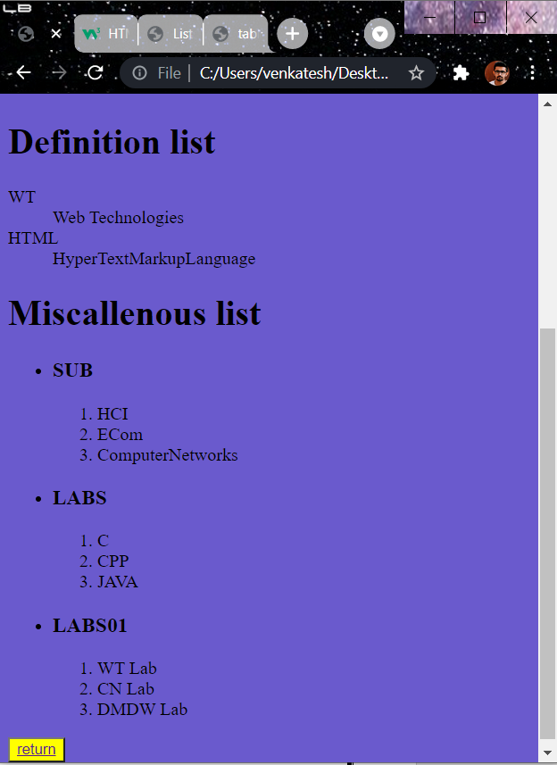

**tables.html**

<!DOCTYPE html>

<html>

<head>

<title>tables</title>

<style type="text/css">

td{

border: 0px;

text-align: center;

}

tr{

text-align: center;

}

</style>

</head>

<body bgcolor="pink">

<center>

<h1>TIME TABLE</h1>

</center>

<table border="0 px" align="center">

<tr>

<th>Day</th>

<th>9:30 - 10:20</th>

<th>10:20 - 11:10</th>

<th>11:00 - 12:00</th>

<th>12:00 - 12:50</th>

</tr>

<tr>

<td>MONDAY</td>

<td>DMDW</td>

<td>WT</td>

<td>E.COM</td>

<td>HCI</td>

</tr>

<tr>

<td>TUESDAY</td>

<td>CN</td>

<td>WT</td>

<td>E.COM</td>

<td>HCI</td>

</tr>

<tr>

<td>WEDNESDAY</td>

<td>DMDW</td>

<td>WT</td>

<td>E.COM</td>

<td>CN</td>

</tr>

<tr>

<td>THURSDAY</td>

<td>DMDW</td>

<td>WT</td>

<td>E.COM</td>

<td>HCI</td>

</tr>

<tr>

<td>FRIDAY</td>

<td>DMDW</td>

<td>WT</td>

<td>E.COM</td>

<td>HCI</td>

</tr>

<tr>

<td>SATURDAY</td>

<td>DMDW</td>

<td>WT</td>

<td>E.COM</td>

<td>HCI</td>

</tr>

</table>

<button style="background-color: yellow;align-self: : center;"><a href="main.html">return</a></button>

</body>

</html>

**Output:**

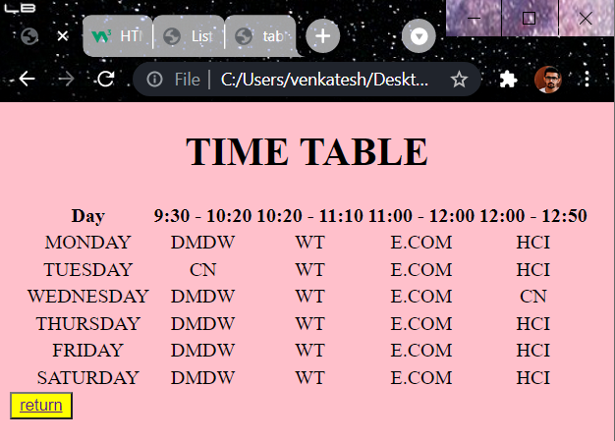

**images.html**

<!DOCTYPE html>

<html>

<head>

<title>Images</title>

</head>

<body bgcolor="lightgreen">

<div style="height: 315px;width:100%">

<img src="nature.jpeg" height="300px" width="50%" align="center">

</div>

<div style="height: 315px;width:100%">

<img src="nature2.jpeg" height="300px" width="50%" align="center">

</div>

<button style="background-color: yellow;align-self: : center;"><a href="main.html">return</a></button>

</body>

</html>

**Output:**



**frames.html**

<!DOCTYPE html>

<html>

<head>

<title>Working with Tables</title>

</head>

<frameset rows="20%,70%,10%" noresize="noresize" >

<frame style="background-color: coral" src="top.html">

</frame>

<frameset cols="20%,*">

<frame style="background-color: coral" src="middle.html">

<frame style="background-color: coral" src="right.html" name="rf">

</frameset>

<frame style="background-color: lightgreen" src="bottom.html">

</frame>

</frameset>

</html>

**top.html**

<!DOCTYPE html>

<html>

<head>

<title></title>

</head>

<body>

<h1 align="center">Aditya Engineering College</h1>

</body>

</html>

**middle.html**

<!DOCTYPE html>

<html>

<head>

<title></title>

</head>

<body>

<h3><a href="Mobileproject1.html" target="rf">projects</a></h3><br>

<h3><a href="planets.html" target="rf">planets</a></h3><br>

<h3><a href="login.html" target="rf">login</a></h3><br>

<h3><a href="table.html" target="rf">table</a></h3><br>

</body>

</html>

**right.html**

<!DOCTYPE html>

<html>

<head>

<title></title>

</head>

<body style="background-color: white">

<h1 align="center">WELCOME</h1>

<footer>

<div align="center">

<button style="background-color: yellow;align-self: : center;"><a href="main.html">return</a></button>

</div>

</footer>

</body>

</html>

**bottom.html**

<!DOCTYPE html>

<html>

<head>

<title></title>

</head>

<body>

<h4 align="center">CopyRights@Venkatesh, allrightsreserved</h4>

</body>

</html>

**Output:**

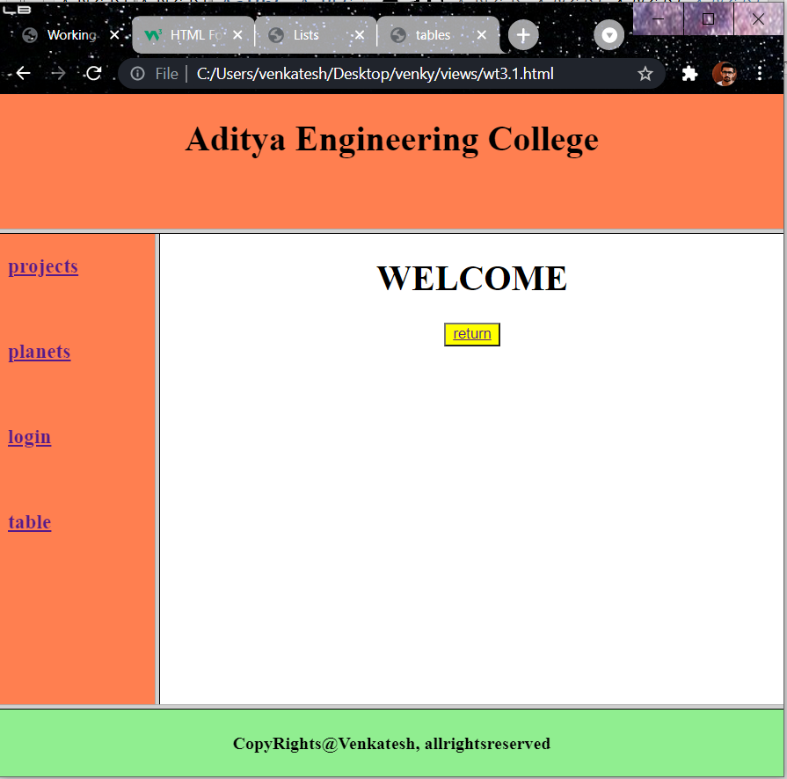

**2)Using Form Tags**

**2.1) Create a Login Form**

<!DOCTYPE html>

<html>

<head>

<meta charset="utf-8">

<title>myproject/formpage</title>

<style>

body {

background-color:lightcoral;

margin: 0px;

padding: 16px;

}

.social-icon {

width: 50px;

height: 50px;

padding-top: 16px;

padding-bottom: 16px;

padding-left: 32px;

padding-right: 32px;

}

form {

background-color: mintcream;

width: 600px;

margin-left: auto;

margin-right: auto;

text-align: center;

border: 1px solid #ccc;

}

#form-heading {

font-size: 32px;

padding-top: 56px;

padding-bottom: 32px;

}

#social-wrapper {

background-color: #f2f6ff;

padding: 24px;

}

#input-wrapper {

padding-top: 80px;

padding-bottom: 40px;

padding-left: 80px;

padding-right: 80px;

}

.input-box {

font-size: 18px;

padding-bottom: 12px;

margin-bottom: 36px;

border: 0;

border-bottom: 1px solid #ccc;

width: 100%

}

#btn-submit {

background-color: #0056ff;

padding-top: 12px;

padding-bottom: 12px;

padding-left: 24px;

padding-right: 24px;

font-size: 18px;

color: white;

border: none;

}

</style>

</head>

<body>

<form autocomplete="on">

<h1 id="form-heading">LOGIN</h1>

<div id="social-wrapper">

<img class="social-icon" src="https://ubs.iilm.edu/wp-content/uploads/2016/03/Google-logo.png" alt="Google" >

<img class="social-icon" src="https://1000logos.net/wp-content/uploads/2016/11/Facebook-logo.png" alt="Facebook" >

<img class="social-icon" src="https://i.pinimg.com/600x315/2c/b6/70/2cb670b6ddd8922a1c1b2fee4f6f758c.jpg" alt="Github" >

<img class="social-icon" src="https://pngimg.com/uploads/linkedIn/linkedIn_PNG38.png" alt="Linkedin" >

</div>

<div id="input-wrapper">

<div >

<input class="input-box" type="text" name="username" placeholder="Username">

</div>

<div>

<input class="input-box" type="email" name="email" placeholder="Email">

</div>

<div>

<input class="input-box" type="password" name="password" placeholder="Password">

</div>

<div>

<input id="btn-submit" type="submit" value="LOGIN">

</div>

</div>

</form>

</body>

</html>

**Output:**

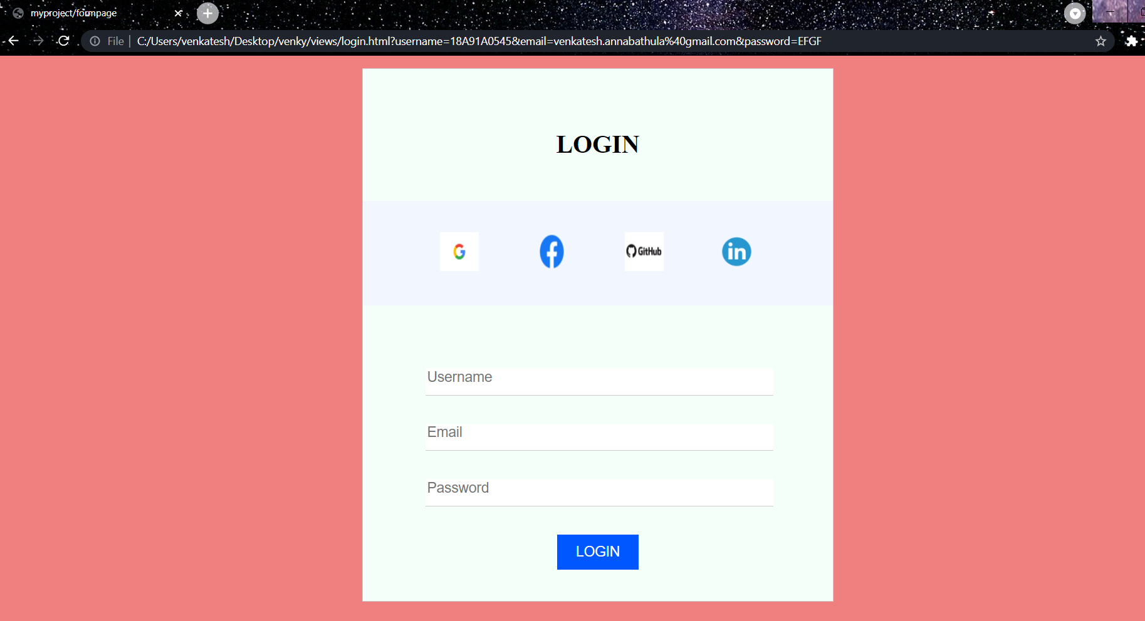

**2.2) Create a “Registration Form ”**

<!DOCTYPE html>

<html>

<head>

<title>wtforms</title>

</head>

<body>

<h1 align="center" style="">Registration Form</h1>

<form autocomplete="on" action="#">

<fieldset style="border:0px;">

<table align="center" style="border: 1px solid;height: 600px;width: 400px; background-color:mediumseagreen;" >

<tr>

<td><label for="username"><b>USERNAME</b></label></td>

<td><input type="text" name="username" id="un" placeholder="Enter User Name"></td>

</tr>

<tr>

<td><label for="password"><b>PASSWORD</label></td>

<td><input type="Password" name="Password" id="pwd" placeholder="Enter Password" minlength="9"></td>

</tr>

<tr>

<td><label for="email"><b>EMAIL</b></label></td>

<td><input type="email" name="email" id="em" required="email"></td>

</tr>

<tr>

<td><label for="tel"><b>PHONE NUMBER</b></label></td>

<td><input type="tel" name="tel" id="tel" required="on"></td>

</tr>

<tr>

<td><label for="date"><b>DOB</b></label></td>

<td><input type="date" name="date" id="date" required="on" placeholder=" "></td>

</tr>

<tr>

<td><label for="gender"><b>GENDER</b></label></td>

<td>

<input type="radio" name="gender" id="male" value="male"><label>Male</label>

<input type="radio" name="gender" id="female" value="female"><label>Female</label>

<input type="radio" name="gender" id="other" value="other"><label>Other</label>

</td>

</tr>

<tr>

<td><label for="lang"><b>LANGUAGES</b></label></td>

<td>

<input type="checkbox" name="te" id="te" value="Telugu"><label>Telugu</label>

<br>

<input type="checkbox" name="hi" id="hi" value="Hindi"><label>Hindi</label>

<br>

<input type="checkbox" name="en" id="en" value="English"><label>English</label>

<br>

<input type="checkbox" name="ta" id="ta" value="Tamil"><label>Tamil</label>

</td>

</tr>

<tr>

<td><label for="Qual"><b>QUALIFICATION</b></label></td>

<td >

<select name="Qual">

<option value="">BTech</option>

<option value="">MTech</option>

<option value="">Phd</option>

<option value="">BSc</option>

<option value="">B.Pharm</option>

<option value="">M.pharm</option>

</select>

</td>

</tr>

<tr>

<td><label for="address">ADDRESS</label></td>

<td>

<textarea rows="5" cols="25" placeholder="Type u r address" style="text-align: center;"></textarea>

</td>

</tr>

<tr>

<td align="right"><input type="submit" value="submit"></td>

<td align="center"><input type="reset" value="reset"></td>

</tr>

</table>

</fieldset>

</form>

</body>

</html>

**Output:**

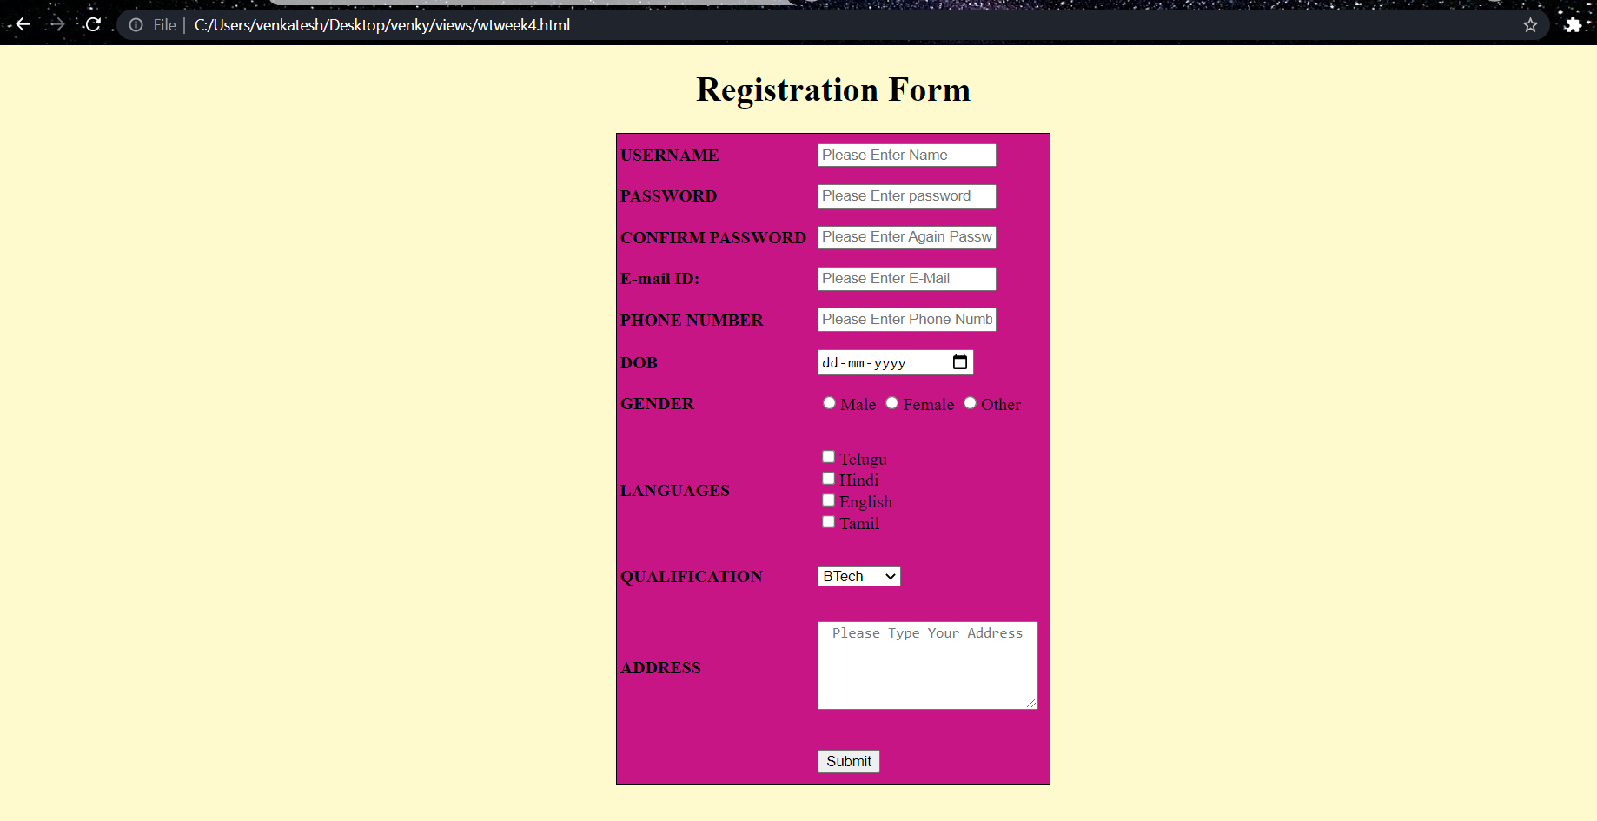

**3) CSS & Java Script**

**3.1) Design a web page using CSS (Cascading Style Sheets) which includes the following:**

**3.1.1) Use different font, styles: In the style definition you define how each selector should work (font, color etc). Then, in the body of your pages, you refer to these selectors to activate the styles.**

**Style.css**

<!DOCTYPE html>

<html>

<head>

<meta charset="utf-8">

<title>Usage of different font,styles and colors</title>

<link rel="stylesheet" type="text/css" href="style.css"/>

</head>

<body>

<h1>This header is H1</h1>

<h2>This header is H2</h2>

<h3>This header is H3</h3>

<p>This is normal text</p>

</body>

</html>

**31.html:**

h1

{

color:indigo;

font-family:caStellar;font-size:20pt;

text-decoration:underline;

}

h2

{

color:coral;

font-family:Chiller;font-size:18pt;

text-decoration:overline;

}

h3

{

color:greenyellow;

font-family:Trebuchet MS;font-size:18pt;

text-decoration:blink;

}

p

{

color:magenta;

font-family:fantasy;font-size:16pt;

font-style:italic;

}

**Output:**

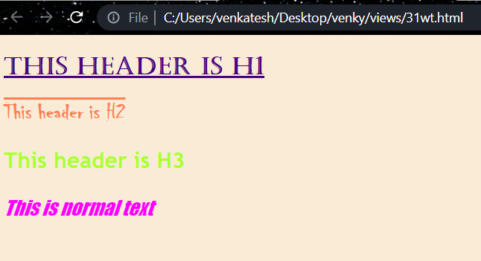

**3.1.2) Set a background image for the web page and control the repetition of the image with the background-repeat property.**

<!DOCTYPE html>

<html>

<head>

<meta charset="utf-8">

<title>Controlling background image</title>

<style type="text/css">

body

{

background-image:url("newwp.jpg");

background-repeat:no-repeat;

}

</style>

</head>

<body bgcolor="bisque">

<body text="antiquewhite">

<h1>Life is beautiful!!!</h1>

</body>

</html>

**Output:**

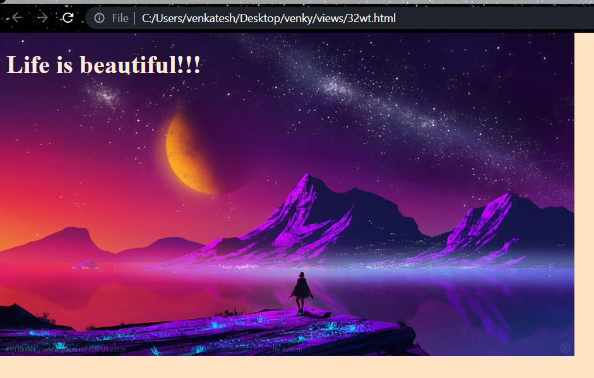

**3.1.3) Define styles for link as visited, active, hover & link**.

<!DOCTYPE html>

<html>

<head>

<meta charset="utf-8">

<title>CSS Webpage</title>

<style type="text/css">

body{background-image:url(planetnew.jpg);background-repeat:no-repeat;}

p{color:yellow;font-size:20pt;font-family:chiller;background-image:url(newwp.jpg);}

a:link{font-size:20pt;background-color:white;}

a:hover{font-size:20pt;background-color:pink;cursor:crosshair;}

a:active{font-size:20pt;background-color:cyan;cursor:help;}

a:visited{font-size:20pt;background-color:tan;}

</style>

</head>

</head>

<body>

<br>

<p>

Welcome to Web page using CSS where CSS means Cascading Style Sheets!

Using CSS we can apply the common styles to different tags and also different styles to same tag ie repeated more than once in the html file

</p>

<a href="wtforms.html"><center>Register</center></a>

<br>

</body>

</html>

**Output:**

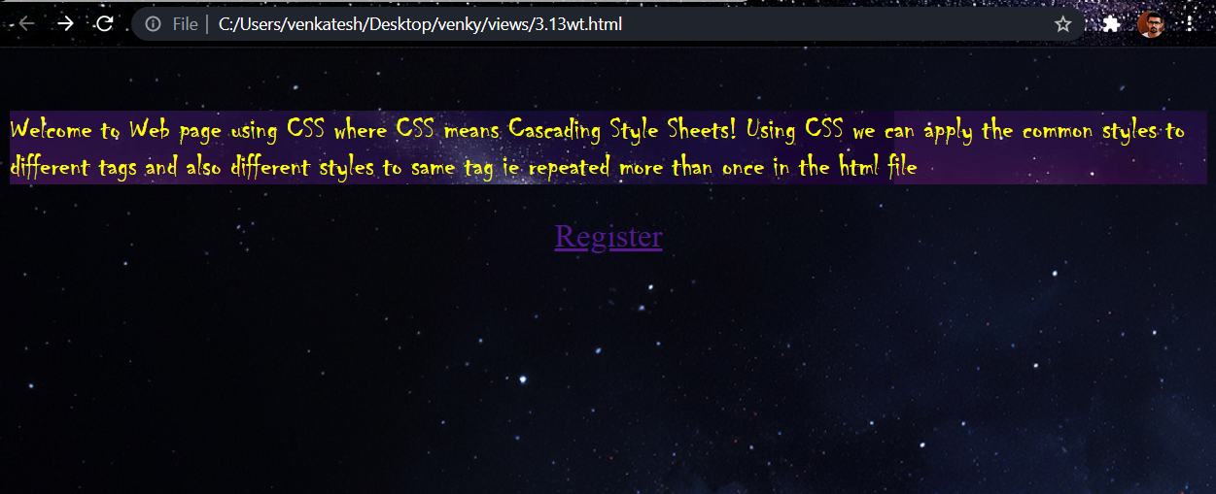

**3.2) Write a JavaScript that takes a number from one text field in the range of 0-999 and display it in other text field in words. If the number is out of range, it should show “out of range” and if it is not a number, it should show “not a number” message in the result box.**

<!DOCTYPE html>

<html>

<head>

<meta charset="utf-8">

<title></title>

<script language="javascript">

function convert_number_to_words(number)

{

hyphen='-';

conjunction='and';

separator='.';

dictionary={0:'zero',1:'one',2:'two',3:'three',4:'four',5:'five',6:'six',7:'seven',8:'eight',

9:'nine',10:'ten',11:'eleven',12:'twelve',13:'thirteen',14:'fourteen',15:'fifteen',16:'sixteen',

17:'seventeen',18:'eighteen',19:'nineteen',20:'twenty',30:'thirty',40:'fourty',50:'fifty',

60:'sixty',70:'seventy',80:'eighty',90:'ninety',100:'hundred',};

if(number<0 || number>999)

{

alert("enter a number range between 0 and 999");

return "";

}

switch(true)

{

case(number<21):

string=dictionary[number];

break;

case(number<100):

tens=parseInt(number/10)*10;

units=number%10;

string=dictionary[tens];

if(units){

string+=hyphen+dictionary[units];

}

break;

case(number<1000):

hundreds=parseInt(number/100);

remainder=number%100;

string=dictionary[hundreds]+ ' ' +dictionary[100];

if(remainder){

string+=conjunction+convert_number_to_words(remainder);

}

break;

default:

break;

}

return string;

}a=prompt("Enter a number");

num=parseInt(a);

document.write(convert_number_to_words(num));

</script>

</head>

<body bgcolor="bisque">

<h2 align="center"><i>WELCOME TO JAVASCRIPT</i></h1>

</body>

</html>

**Output:**

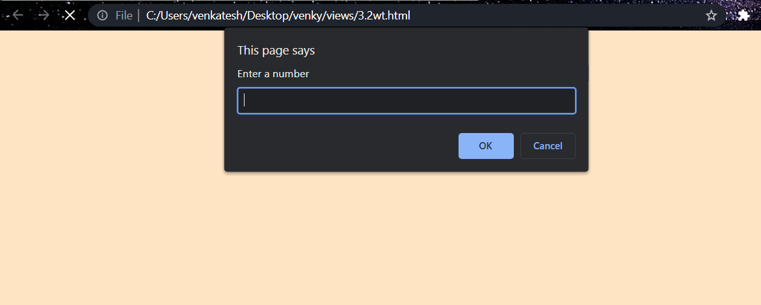

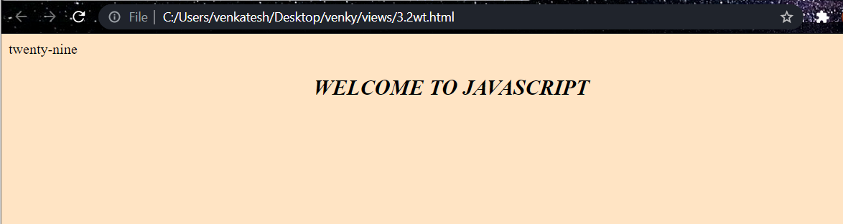

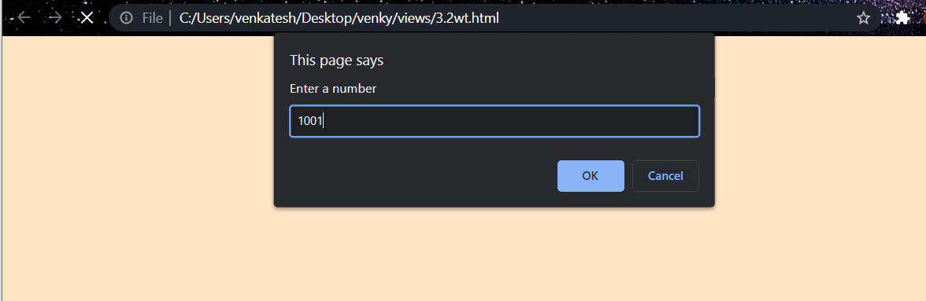

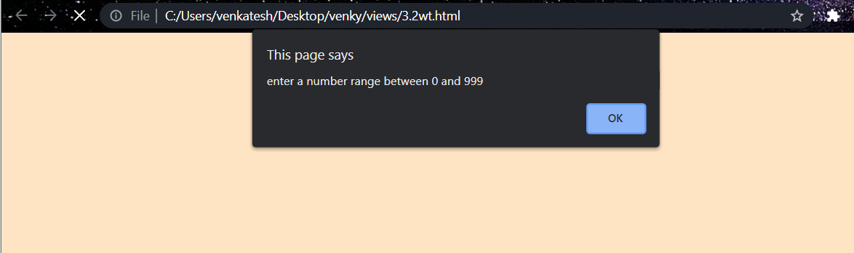

**4) Java Script & XML**

**4.1) Write a JavaScript to validate the following fields in a registration page created in week 2**

**a. Name (start with alphabet and followed by alphanumeric and the length should not be less than 6 characters)**

**b. Password (it allows alphanumeric, special symbols and should not be less than 6 characters)**

**c. E-mail (should not contain invalid email addresses)**

<!DOCTYPE html>

<html>

<head>

<meta charset="utf-8">

<title>form validation</title>

<script language="javascript">

function validation()

{

var x=f.un.value;var len=x.length;

var val=x.charCodeAt(0); var p=f.pw.value;

var c=f.cpw.value;var a=f.email.value;

var atpos=a.indexOf("@");var dotpos=a.lastIndexOf(".");

if(len<6||x==""||x==null)

{

alert("check your username! must be minimum 6 characters");

}

else if(val<65 || val>90&&val<97 || val>122)

{

alert("username must be begin with an alphabet");

return fasle;

}

else if(p==" || c==" || p.length<6 || c.length<6 || p!=c)

{

alert("password and confirm password should be same and greater than 6 characters!");

return false;

}

else if(atpos<6 || dotpos<atpos+6 || dotpos+2>=a.length)

{

alert("Not a Valid email id");

return false;

}

else

alert("Congratulations!you have submitted successfully");

</script>

</head>

<body bgcolor="lemonchiffon">

<h1 align="center" style="">Registration Form</h1>

<table align="center" style="border: 1px solid;height: 600px;width: 400px; background-color:mediumvioletred;" >

<form name="f" action="wtweek4.html" onsubmit="return validation();" method="post">

<tr>

<td><b>USERNAME</b></td>

<td><input type="text" name="un" placeholder="Please Enter Name"></td>

</tr>

<tr>

<td><b>PASSWORD</b></td>

<td><input type="password" name="pw" placeholder="Please Enter password"></td>

</tr>

<tr>

<td><b>CONFIRM PASSWORD</b></td>

<td><input type="password" name="cpw" placeholder="Please Enter Again Password "></td>

</tr>

<tr>

<td><b>E-mail ID:</b></td>

<td><input type="text" name="email" placeholder="Please Enter E-Mail"></td>

</tr>

<tr>

<td><label for="tel"><b>PHONE NUMBER</b></label></td>

<td><input type="tel" name="tel" id="tel" required="on" placeholder="Please Enter Phone Number"></td>

</tr>

<tr>

<td><label for="date"><b>DOB</b></label></td>

<td><input type="date" name="date" id="date" required="on" placeholder=" "></td>

</tr>

<tr>

<td><label for="gender"><b>GENDER</b></label></td>

<td>

<input type="radio" name="gender" id="male" value="male"><label>Male</label> <input type="radio" name="gender" id="female" value="female"><label>Female</label>

<input type="radio" name="gender" id="other" value="other"><label>Other</label>

</td>

</tr>

<tr>

<td><label for="lang"><b>LANGUAGES</b></label></td>

<td>

<input type="checkbox" name="te" id="te" value="Telugu"><label>Telugu</label>

<br>

<input type="checkbox" name="hi" id="hi" value="Hindi"><label>Hindi</label>

<br>

<input type="checkbox" name="en" id="en" value="English"><label>English</label>

<br>

<input type="checkbox" name="ta" id="ta" value="Tamil"><label>Tamil</label>

</td>

</tr>

<tr>

<td><label for="Qual"><b>QUALIFICATION</b></label></td>

<td >

<select name="Qual">

<option value="">BTech</option>

<option value="">MTech</option>

<option value="">Phd</option>

<option value="">BSc</option>

<option value="">B.Pharm</option>

<option value="">M.pharm</option>

</select>

</td>

</tr>

<tr>

<td><label for="address"><b>ADDRESS</b></label></td>

<td>

<textarea rows="5" cols="25" placeholder="Please Type Your Address" style="text-align: center;"></textarea>

</td>

</tr>

<tr>

<td></td>

<td><input type="Submit" name="Submit"/></td>

</tr>

</form>

</table>

</body>

</html>

**Output:**

